Abstract— These instructions provide you with the basic guidelines for preparing the one or two page digests for the 6th International Conference on Scientific Computing in Electrical Engineering SCEE 2006, which will be held in Sinaia, Romania, September 17 – 22. Accepted digests will be included in the conference record. Please carefully follow these instructions to ensure legibility and uniformity of digests in the conference record.
Preparation of Digests for SCEE 2006
Sinaia, Romania
First A. Author, Second B. Author, and Third C. Author
Affiliation
Street Address, Postal Code, Country
E-mail Address

Keywords— write here a list of 5-7 free keywords

Usage of the MSWord Template
For MSWord users, one template file is provided for the preparation of the digest for SCEE 2006: SCEE06_DigestTemplate.doc. It describes the general layout of the digest as well as the digest/paper submission information. If you are LaTeX users, use the LaTeX template file SCEE06_DigetstTemplate_Latex.tar instead.
Open SCEE06_DigestTemplate.doc, select “Reveal Formatting” or “Styles and Formatting” from the “Format” menu in the menu bar (Format>Reveal Formatting), which shows you the details of the format adopted in this template. Type over sections of SCEE06_DigestTemplate.doc or cut and paste from another document and then use markup styles. The pull-down style menu is at the left of the Formatting Toolbar at the top of your Word window. Highlight a section that you want to designate with a certain style; then select the appropriate name on the style menu. The style will adjust your fonts and line spacing.
To insert images in Word, position the cursor at the insertion point and either use Insert > Picture > From File or copy the image to the Windows clipboard and then use Edit > Paste Special > Picture (with “Float over text” unchecked).
After completing your digest, you will need to convert it to PDF format. Archive the doc and the pdf file (zip) and upload them on the conference website.

General Layout of the Digest
Please prepare the camera–ready copy of your digest on regular size paper (8.5in x 11in = 21.6cm x27.9cm) or A4 paper (21.0cm x29.7cm). The digest should be prepared in double-column format. The total text height should be 9.6in (24.4cm). The total width should be 7.2in (18.3cm) with a separation of 0.2in (0.5cm) between the columns. Please provide a top margin of 0.7in (1.8cm) and a left margin of 0.65in (1.65cm). Paragraphs follow the indented paragraph format with left and right justification. Use 0.2in (0.5cm) for paragraph indentation. Don’t leave space between the paragraphs. Please number section headings with Roman numerals and center them in column. The spacing before and after the section headings should be 12pt and 4pt respectively. Please number the subheadings with alphabetical letters. The spacing before and after the subheadings is 6pt and 3pt, respectively. The indentation for subheadings is 0.1in.

Type and Size of Fonts
Please use Times New Roman typeface and following the type size specified in Table I as closely as possible.
TABLE I
TYPES SIZES FOR CAMERA-READY PAPERS
Item | Type Size  (points) | Appearance
Title | 14 | Bold
Author’s Name | 12 | Regular
Author’s Affiliations ,mailing address, and E-mail | 10 | Regular
Abstract | 9 | Bold
Sections Titles | 10 | Small capitals, centered in column, Roman Numerals
Subheadings | 10 | Italics, alphabetical numerals
Main Text | 10 | Regular
Subscripts and Superscripts in the Main Text | 8 | Regular
Equations | 10 | Regular
Figure Captions | 8 | Regular, centered in column, Arabic numerals
Table Captions | 10 | Small capitals, title case, centered in column, Roman numerals
Table Name/Description | 8 | Small capitals, title case, centered in column, Roman numerals
Table Text | 8 | Regular
Subscripts and Superscripts in Table Text | 6 | Regular
References | 8 | Regular

Useful Hints

Abbreviations and Acronyms
Define abbreviations and acronyms the first time they are used, even after they have been defined in the abstract. Abbreviations such as IEEE, SI, MKS, CCG, ac, and dc do not have to be defined. Don’t use abbreviations in the title unless they are unavoidable (for example, the title of this article).

Figures and tables
Place figures and tables in the middle of columns. Figure captions should be centered below the figures; table captions should be centered above the tables. Please use words rather than symbols to label the axis. As an example, write the quantity “Magnetization,” or “Magnetization, M,” not just “M.” Put units in parentheses. Do not label axes only with units. As in Fig. 1, for example, write “Magnetization (A/m)” or “Magnetization (Am⁻¹),” not just “A/m.” Do not label axes with a ratio of quantities and units. For example, write “Temperature (K),” not “Temperature/K.” Multipliers can be especially confusing. Write “Magnetization (kA/m)” or “Magnetization (10³A/m).” Do not write “Magnetization (A/m1000)” because the readers would not know whether the top axis label in Fig. 1 meant 15000A/m or 0.015A/m.
Figure labels should be legible, approximately 8 to 12 point type when reduced to column width. Note that “Fig.” is abbreviated. There is a period after the figure number, followed by two spaces.

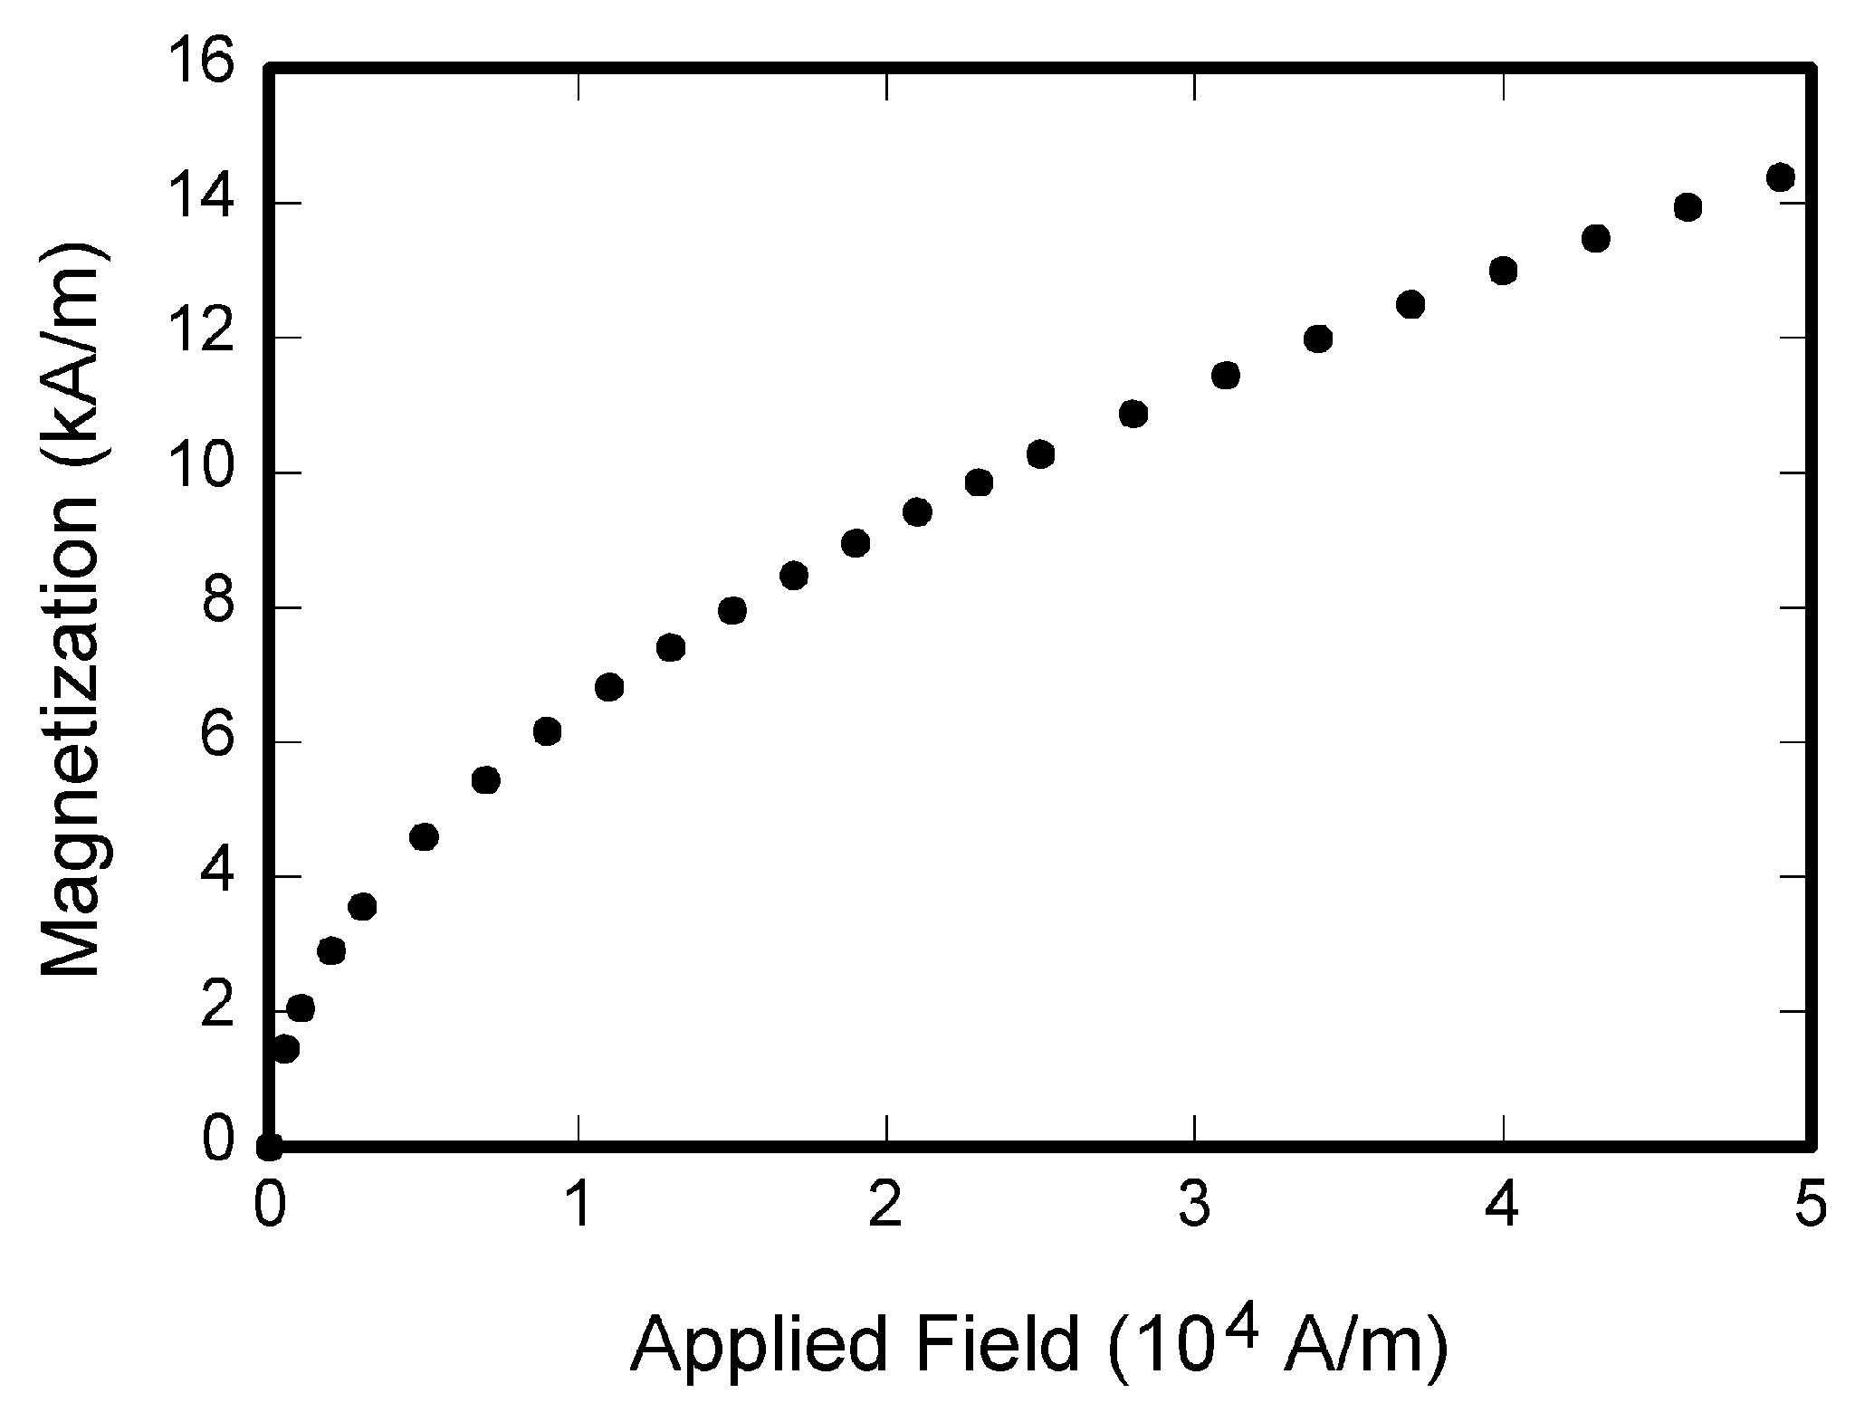
Fig. 1. Magnetization as a function of applied field

Equations
Use either the Microsoft Equation Editor or the MathType add-on for equations in your digests. Number equations consecutively with equation numbers in parentheses flush with the right margin, as in (1). First use the equation editor to create the equation. Then select the “Equation” markup style. Press the tab key and write the equation number in parentheses. To make your equation more compact, you may use the solidus (/), the exp function, or appropriate exponents. Use parentheses to avoid ambiguities in denominators. Punctuate equations when they are part of a sentence, as in
. (1)
Be sure that the symbols in your equation have been defined before the equation appears or immediately following. Refer to “(1),” not “Eq. (1)” or “equation (1)” except at the beginning of a sentence: “Equation (1) is… .”
Please confine equations to one column width and break equations at appropriate algebraic symbols.

Units
Use either SI (MKS) or CGS as primary units. SI units are strongly recommended. Avoid combining SI and CGS units, such as current in amperes and magnetic field in oersteds. If you must use mixed units, clearly state the units for each quantity in an equation.

Conclusion
A conclusion section is not required. Although a conclusion may review the main points of the paper, do not replicate the abstract in the conclusion. A conclusion might elaborate on the importance of the work or suggest applications and extensions.

References
Number citations consecutively in square brackets [1]. The sentence punctuation follows the brackets [2]. Multiple references [1], [2] are each numbered with separate brackets [1],[2]. When citing a section in a book, please give the relevant page numbers [2]. In sentences, refer simply to the reference number, as in [1]. Do not use “Ref. [3]” or “reference [3]” except at the beginning of a sentence. You may also refer to “unpublished”, “submitted for publication” or “to be published” papers.

Language
The use of grammar and spelling checker is strongly recommended. It is also suggested that you get the digest proof read by a native English-speaking colleague if you native language is not English.

Conference and Paper Submission Information
The SCEE 2006 “Call for Papers” is available on the conference website, http://scee06.org. Digests are required in a one-page or two-pages double-column format. The submission is on-line, on the conference web site. The absolute deadline for the digest submission is March 1st, 2006. All contributions will undergo peer review to determine their suitability for the inclusion in the conference record. Notification of acceptance will be given on April 15, 2006. Authors who are interested in submitting their papers for the possible publication in the Springer Series are asked to upload their extended manuscripts by September 21, 2006 via the conference web and submit three prints of the manuscripts at the conference. Paper formatting should follow the Springer standard which can also be downloaded from the conference website at http://scee06.org. Questions concerning the digest preparation may be addressed by e-mail to lmn@lmn.pub.ro.

Acknowledgement
Write acknowledgement here.

References
- J. Clerk Maxwell, A Treatise on Electricity and Magnetism, 3rd ed., vol. 2. Oxford: Clarendon, 1892, pp. 68-73.
- G. Eason, B. Noble, and I. N. Sneddon, “On certain integrals of Lipschitz-Hankel type involving products of Bessel functions,” Phil. Trans. Roy. Soc. London, vol. A247, pp. 529-551, Apr. 1955.

