Abstract— This paper presents a modality of analysis for complex multi-layers structures using the scattering matrix. The results are utilized for a analysis of VHF filters .
Scattering matrix analysis of cascaded periodic surfaces

Adriana Savin, Raimond Grimberg, Rozina Steigmann
National Institute of R&D for Technical Physics
47 D.Mangeron Blvd, Iasi, 700050, Romania
grimberg@phys-iasi.ro

Keywords— strip gratings, scattering and transmission matrix, cascaded periodic layers.

The strip gratings allow complete transmission at certain frequencies and complete reflection at other frequencies and, then are a simple type of frequency-selective surface. A vide variety of filter characteristics can be obtained by cascading multiple layers of frequency-selective surfaces. To efficiently analyze multilayered structures, each periodic surface can be modeled as a multiport network which each port representing one Floquet harmonic [1] of a given polarization. The coefficients of each propagating Floquet harmonic determine the “far-field’ reflection and transmission characteristics of periodic surfaces. A complete near-zone model will generally require a combination of propagating and evanescent harmonics. Generalized scattering and transmission matrices representing each individual surface can subsequently be employed as a building block in the electromagnetic model of a multilayered structure.
For TM excitation, the scattering matrix arising from the strip grating problem is a 2-by-2 block matrix of the form (in the context of a two-port network in Fig.1)

$\bar{S}=\left[\begin{matrix}S_{\text{11}} & S_{\text{12}} \\ S_{\text{21}} & S\text{22}\end{matrix}\right]$ (1)
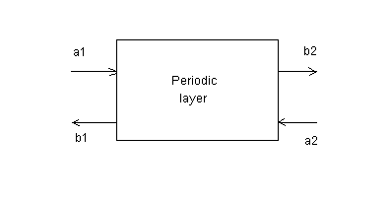
Fig.1 Two- port scattering equivalence
Where
$\left[\begin{matrix}b_{1} \\ b_{2}\end{matrix}\right]=\left[\begin{matrix}S_{\text{11}} & S_{\text{12}} \\ S_{\text{21}} & S_{\text{22}}\end{matrix}\right]\left[\begin{matrix}a_{1} \\ a_{2}\end{matrix}\right]$ (2)
Each block comprising in (1) are infinite-dimensional matrices relating the coefficients of the scattered Floquet harmonics to those of the incident harmonics. In practice, these matrices are truncated to finite dimension. The entries of the generalized scattering matrices depend on the location of reference planes as indicated in Figure 2.

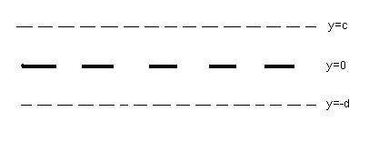

Fig. 2. Location of reference planes for the definition of S-parameters

The (m,n) entry in the scattering matrix of Eq.(1) is a complex-valued quantity having magnitude

$\text{mag}(s_{\text{mn}}^{\text{11}})=\sqrt{\frac{\int_{0}^{a}{{\left|{\bar{E}}_{m}^{s}×{\bar{H}}_{m}^{\text{st}}∗\hat{y}\right|}_{y=−d}\text{dx}}}{\int_{0}^{a}{{\left|{\bar{E}}_{n}^{\text{inc}}×{\bar{H}}_{n}^{\text{inct}}∗\hat{y}\right|}_{y=−d}\text{dx}}}}$ (3)

(4)The entries of the S₂₁, S₁₂ and S₂₂ matrices are defined in an analogous manner. For cascading several layers, the transmission matrix representation
$$\left[\begin{matrix}b_{2} \\ a_{2}\end{matrix}\right]=\left[\begin{matrix}T_{\text{11}} & T_{\text{12}} \\ T_{\text{21}} & T_{\text{22}}\end{matrix}\right]\left[\begin{matrix}a_{1} \\ b_{1}\end{matrix}\right]$$

(5) is more convenient than the scattering matrix description, and can be found from the elements of the scattering matrix according to
$\begin{aligned}T_{\text{11}}=S_{\text{21}}−S_{\text{22}}S_{\text{12}}^{−1}S_{\text{11}} \\ T_{\text{12}}=S_{\text{22}}S_{\text{12}}^{−1} \\ T_{\text{21}}=−S_{\text{12}}^{−1}S_{\text{11}} \\ T_{\text{22}}S_{\text{12}}^{−1}\end{aligned}$ (5)

The process of cascading may become numerically unstable if higher order (evanescent) harmonics are cascaded over large distance. This method is utilized for analysis of a few filter’s type.

Acknowledgement
This paper is supported by Romanian Ministry of Education and Research, Excellence Research Program, under Contract 9 CEEX I 03 / 06.10.2005, acronym nEDA .and Contract No.6610/2005 acronym SINERMAT

References
- A.F.Peterson,S.L.Ray,R.Mittra – Computational Method for Electromagnetics, IEEE Press,,N.J.,1998

