Abstract— This paper presents a few applications of 2_D nonuniform FFT at analysis of shielded microstrip circuits with applications for hairpin resonators and microstrip interdigital capacitors.
Application of 2D nonuniform fast Fourier transforms technique to analysis of shielded microstrip circuits

Raimond Grimberg, Adriana Savin, Sorin Leitoiu
National Institute of R&D for Technical Physics
47 D.Mangeron Blvd, Iasi, 700050, Romania
grimberg@phys-iasi.ro

Keywords—microstrip, MoM matrix, fast Fourier transforms

The method of moments (MoM) is a core engine for analysis of microstrip circuits [1]. Most of CPU time is consumed in evaluation of the MoM matrix elements since the Green’s functions converge slowly and a large number of basis functions are required for expending surface current densities on conductors. The MoM matrix elements are linear combination of elements of precomputed index tables that are computed from the two-dimensional discrete fast Fourier transform. In this method, however, the mesh scheme is restricted to be uniform. Obviously, uniform grids are very inefficient for analysis of a general microstrip edges, thus, fine local discretization becomes a must accurate analysis of the whole circuit. In [2], microstrip discontinuities on a lossy multilayered substrate are analyzed based on the electric-field integral equation (EFIE) formulation. The conductors are uniformly discretized. At least two important points in regard to converge of results are reported. One is that required number of summation terms in calculating the MoM matrix elements must be at least 1.25 times the total number of segments, and the other is that the mesh sizes must be no larger than λ_{g}/175 andλ_{g}/25, respectively, in transverse and longitudinal directions for accurate calculations.
Nonuniform meshes are used in the mixed-potential integral equation (MPIE) [4] to overcome the large-size matrix problem caused by uniform discretization. The acceleration procedure is at a Green’s function level, and efficient MoM technique with rectangular, but nonuniform and nonfixed meshes can be constructed.
In this paper, a two-dimensional nonuniform fast Fourier transform (2-D NUFFT) incorporated with the spectral-domain approach (SDA) is developed for analysis of microstrip circuits. The mesh scheme for the microstrip circuit can be very flexible, although each subdivision must be rectangular.
The concept for evaluating the FFT of 1-D nonuniform data is to approximate the exponential function at each nonuniform sampled point by interpolating oversampled uniform Fourier bases with q+1 coefficients. The order of arithmetic operations is found to be O(cNlog₂N) with c being the oversampling rate and N being the FFT size.
The 2-D NUFFT for two-dimensional nonuniform data in the x-y-plane can be established by employing two 1-D NUFFTs in the x- and y-directions. The (q+1)² interpolated coefficients of oversampled 2-D FFT bases are simply the products of two sets of q+1 coefficients, which decay exponentially, as the bases are far away from the sample point.
For a microstrip circuit enclosed in a rectangular shielded box of dimensions a x b x c, one of the spatial-domain Green’s functions can be written as
(1)
Where k_{xm}=mπ/a, k_{yn}=nπ/b, and ${\tilde{G}}_{\text{xx}}$ is the Green’s function in the spectral domain. Other Green’s functions of the structure can be expressed in a similar manner.
In this paper asymmetric rooftop functions are used to expand current densities on conductors, and the half rooftop functions are used for modeling those at source and load terminals. Let the current densities be expressed as
(2)
where a_{xα} and b_{yβ} are unknown constants to be determined. Let the α-th basis function for the current in the x-direction be
$J_{xα}=J_{\text{xx}}\left(x,x_{α}\right)J_{\text{xy}}(y,y_{α})$ (3)
Where

$J_{\text{xx}}\left(x,x_{α}\right)=\left\{\begin{matrix}\frac{x−xα}{{Δx}_{α1}}+1,x_{α}−{Δx}_{α1}≤x≤x_{α} \\ \frac{x_{α}−x}{{Δx}_{α2}}+1,x_{α}≤x≤x_{α}+{Δx}_{α2} \\ 0,\text{otherwise}\end{matrix}\right.$ (4a)
$J_{\text{xy}}=\left\{\begin{matrix}1,y_{α}−{{Δy}_{α}}/2≤y≤y_{α}+{{Δy}_{α}}/2 \\ 0,\text{otherwise}\end{matrix}\right.$ (4b)
Their 2-D Fourier transforms can be simply derived.
The Galerkin’s procedure is used to set up the final MoM matrix, of which the (d,e)^{th} element can be expressed as
$Z_{\text{xx}}\left(d,e\right)=\sum_{m}{\sum_{n}{{\tilde{G}}_{\text{xx}}(m,n){\tilde{J}}_{\text{xd}}(m,n){\tilde{J}}_{\text{xe}}(m,n)}}$ (5)
Figure 1 summarizes the procedure for establishing the final MoM matrix.

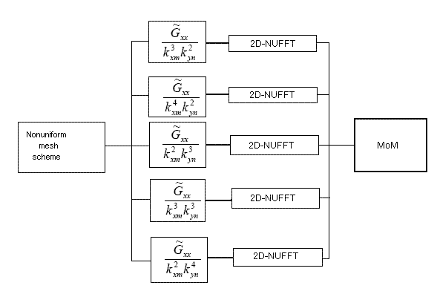

Fig. 1. The procedure for establishing the final MoM matrix.

Two examples are used to demonstrate the proposed technique for analyses of microstrip circuits. They include a compact miniaturized hairpin resonator and a microstrip interdigital capacitor.

Acknowledgement
This paper is supported by Romanian Ministry of Education and Research, Excellence Research Program, under Contract 9 CEEX I 03 / 06.10.2005, acronym nEDA .and CNCSIS Grant 982.

References
- R.F.Harrington-Field Computation by Moment Methods,Malabar,FL,Krieger,1982
- E.S.Tony-Analysis of Shielded Lossy Multilayered-Substrate Microstrip Discontinuities, IEEE Trans.on Microwave Theory and Tech.,49,4,(2001),pp701-711

