Abstract— The paper describes a software package set-up for multi-objective optimal design of the electromagnetic devices. The computation algorithm combines a Strength Pareto Evolutionary Algorithm (SPEA) optimization module with a numerical field analysis module based on the Boundary Elements Method (BEM). The package is suitable for optimal design of integrated electromagnetic devices from minimisation of the parasitic coupling effects point of view. The main advantages and disadvantages of the proposed solution will be outlined in the end of the paper.
Software Package for Multi-Objective Optimal Design
of Electromagnetic Devices
Calin Munteanu, Gheorghe Mates, Vasile Topa
Electrotechnics Department, Technical University of Cluj-Napoca
Baritiu 26-28, 400027 Cluj-Napoca, Romania
Email: Calin.Munteanu@et.utcluj.ro

Keywords— multi-objective, Strength Pareto Algorithm, BEM, parasitics minimization, integrated technologies.

Introduction
Resistive, capacitive and inductive parasitic coupling effects are very important in integrated circuit technology development and must be taken into account in the global circuit analysis and design. These values are seldom possible to be computed analytically because often we deal with complex multi-route layout geometries. Optimizing the placement of the routes inside the integrated design, in accordance with imposed constraints, one may lead to the decrease of the coupling effects.
Due to the high number of the design parameters involved, stochastic optimization methods based on Genetic Algorithms (GA) have been previously involved. First solution proposed consisted in using a basic GA in which a single global fitness function is built up from the partial objectives. The main drawback of this method is that even if the global fitness function decreases during the optimal design process, there are partial objectives that got an important increase.
A first trial to eliminate this drawback has been done using the method of objective weighting. The drawback of this method is the fact that it requires some prior knowledge about the partial objectives behaviour in order to proper selects the weighting values. This is quite difficult to be done in practice. Therefore the best solution would be to built up an algorithm that takes into account the information from partial objectives behaviour during the optimization process without any prior knowledge and also to take into account the global fitness function behaviour. The solution consists of setting-up a multi-objective optimal design algorithm based on Strength Pareto Evolutionary Algorithms (SPEA). The software package developed based on the above mentioned method, together with several practical application examples, will be presented in the final paper.

elitist multi – objective optimal design
Many industrial problems involve simultaneous optimization of several competing objectives. Usually, there is no single optimal solution, but rather a set of alternative solutions. These solutions are optimal in the wider sense that no other solutions in the search space are superior to them when all objectives are considered. They are known as Pareto – optimal solutions. Mathematically, the concept of Pareto optimality can be defined as follows.
If one considers a multi – objective minimisation problem with m parameters (decision variables) and n objectives:
Minimize: (1)
where , .
A decision vector is said to dominate a decision vector (also written as ) if:
(2)
All decision vectors that are not dominated by any other decision vector are called non-dominated or Pareto – optimal. Often, there is a special interest in finding or approximating the Pareto – optimal set, mainly to gain deeper insight into the problem and knowledge about alternate solutions respectively. Evolutionary Algorithms (EA) seems to be especially suited for this task, because they process a set of solutions in parallel, eventually exploiting similarities of solutions by crossover.
The algorithm implemented is based on the Strength Pareto Evolutionary Algorithms (SPEA). This algorithm introduces elitism by explicitly maintaining an external population. This population stores a fixed number of the non-dominated solutions that are found until the beginning of a simulation. At every generation, newly found non-dominated solutions are compared with the existing external population and the resulting non-dominated solutions are preserved. The SPEA does more than just preserving the elites; it also uses these elites to participate in the genetic operations along with the current population in the hope of influencing the population to steer towards good regions in the search space.
Details about the SPEA steps for implementation will be presented in the final paper.

The SPEA Algorithm
The shape of the software package developed, during an optimal design simulation process, is presented in Figure 1.
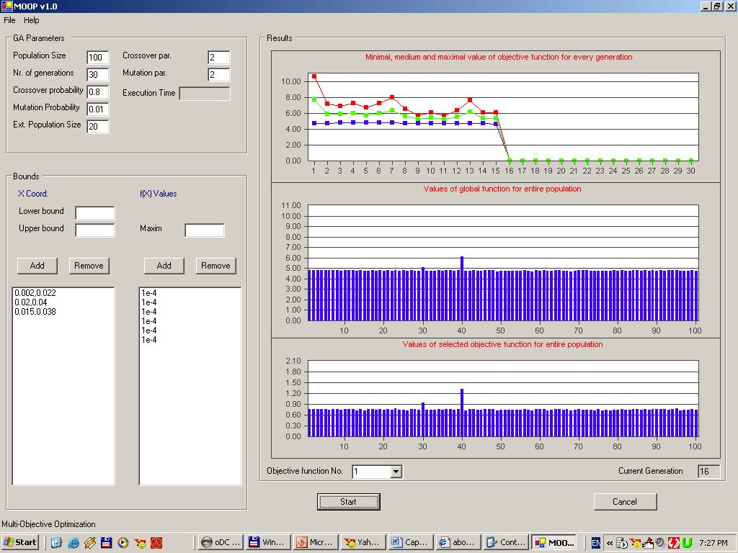
Fig. 1. The shape of the developed software package, MOOP 1.0

One can notice the setting that can be done at the beginning of the optimization process and the on-line displays of the global and selected objective functions for the entire population during the optimal design.

Preliminary Example

The SPEA algorithm developed was used for the shape optimization of the multi-terminal resistor presented in Figure 2 in order to decrease the partial resistances between its terminals. The resistor has 8 terminals (represented by the thick segments numbered with the white bullets in Figure 2) and the y coordinates of 8 corners (numbered with the black bullets in Figure 2) are considered as variables during the optimization process. In this way, the optimal design problem consists of n = 28 partial objectives (the partial resistances between each pair of terminals) and m = 8 design parameters. In order to have a better relevance about the shape optimization process and results, the resistance values corresponding to the initial shape of the resistor are considered as reference values. Thus one can notice that for the starting process, the sum of all objectives is F_{SUM} = 28.

Fig. 2. The initial shape of the multi-terminal resistor
The results using simple GA are presented in Table I. One can notice that the overall sum decreases to F_{SUM} = 24.98, which means a global reduction of 11%. One can notice significant reduction of few partial resistances, for instance R₅₈ and R₆₈ with a factor of 0.6. In spite of these very good results, there are two resistances R₁₂ and R₄₅ with a high increasing factor of value 1.48, while another 8 resistances have also increased values but with smaller factors. Thus, as expected, the simple GA optimal design algorithm is suitable for global optimization but it does not take into consideration the variation of the partial objectives. For the actual problem this fact represents an important drawback.
Using the SPEA optimal design algorithm, the interpretation of the results at the end of the optimization process is very much depending on the user interests. Of course, the overall decrease of the objectives sum value is a general indicator that the objectives are decreasing in ensemble but as it was proven in the case of the simple GA algorithm, this indicator is not relevant for partial objectives behavior during optimization process. The best result obtained is the one presented in Table II and Figure3, where F_{SUM} = 24.395. As it can be noticed in this case, the resistances decreased up to factor 0.63, while a single resistance has a very small increase, with the factor 1.05.
TABLE I
Partial resistance ratios, results using simple GA
 |  | ② | ③ | ④
 |  | 1.48 | 0.76 | 0.80 | ①
⑦ | 0.73 |  | 1.06 | 1.15 | ②
⑥ | 0.60 | 0.73 |  | 1.06 | ③
⑤ | 0.60 | 0.73 | 0.67
④ | 0.84 | 1.13 | 1.17 | 1.48
③ | 0.81 | 1.05 | 0.82 | 0.76
② | 1.12 | 1.10 | 0.83 | 0.81
① | 0.69 | 0.76 | 0.62 | 0.62
 | ⑧ | ⑦ | ⑥ | ⑤
TABLE II
Partial resistance ratios, results using SPEA
 |  | ② | ③ | ④
 |  | 0.95 | 0.93 | 0.94 | ①
⑦ | 0.76 |  | 0.97 | 0.93 | ②
⑥ | 0.63 | 0.75 |  | 0.97 | ③
⑤ | 0.75 | 0.87 | 0.78
④ | 0.76 | 0.98 | 0.95 | 0.80
③ | 0.84 | 1.05 | 0.84 | 0.88
② | 0.96 | 0.98 | 0.76 | 0.83
① | 0.88 | 0.92 | 0.76 | 0.90
 | ⑧ | ⑦ | ⑥ | ⑤

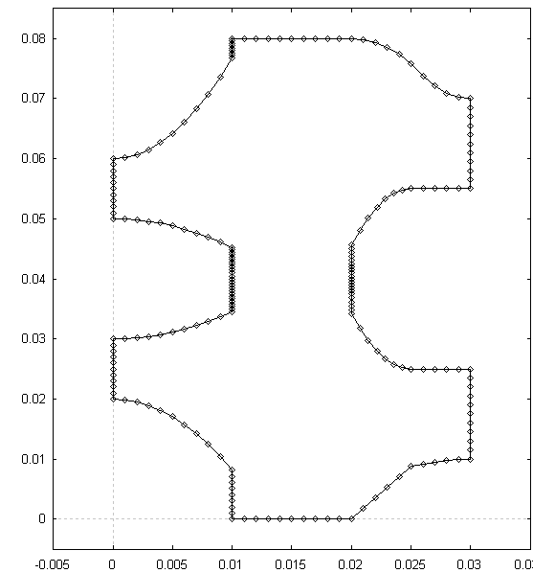
Fig. 3. The optimal shape of the resistor, results using SPEA

Conclusions
The main purpose of the paper is to outline a software package for multi-objective optimal design of electromagnetic devices. The algorithm is suitable for optimal design of integrated devices in order to minimise the parasitics effects. A preliminary example is proposed that emphasize the advantages of the method with respect to the ordinary GA algorithms.

Acknowledgement
Write acknowledgement here.

References
- Z. Wang, Q. Yu, “A Two-Dimensional Resistance Simulator Using the Boundary Element Method”, IEEE Transactions on Computer-Aided Design, Vol. 11, No. 4, pp. 497 – 504, 1992.
- C. Munteanu, V. Topa, Gh. Mates, M. Purcar, Laura Grindei, E. Simion, G. De Mey, “Optimal Design of Electromagnetic Devices by Multi-Objective Optimization”, Proceedings of the 6th International Workshop on Electric and Magnetic Fields, From Numerical Models to Industrial Applications, Aachen, Germany, pp. 133 – 137, 2003.
- V. Topa, C. Munteanu, G. De Mey, J. Deconinck, E. Simion, Optimal Design of the Electromagnetic Devices using Numerical Methods, VUB University Press, Brussels, Belgium, 2000.
- K. Deb, Multi – Objective Optimization using Evolutionary Algorithms, John Wiley & Sons, 2001.

