14. ELECTRIC HEATING

- 14.1. Heat generation, transmission and accumulation
Electric heating is the name of a technical discipline dealing with the transformation of electromagnetic energy into heat and the main applications of this phenomenon. The main theoretical objects of study are those indicated in the section title: the generation, transmission and accumulation of heat. The practical aspects are mainly concerned with specific ways of heat generation from electromagnetic energy, but also with adequate heat transmission and eventually accumulation. Moreover, it is only the electromagnetic aspects of the electric heating that are dealt with here – the constructive details, as well as those related to the exploitation of electric heating equipment, are matters of interest for other disciplines.
The theoretical basis of the electric heating is represented by the general principles of thermodynamics.
The first principle of thermodynamics states that for a physical system there exists a function of the state parameters, named internal energy, such that its increase during a state variation equals the sum of the (equivalent in) mechanical work acting upon the system and the heat received by it,
$\text{dU}=δW+δQ$ .
It is important to note that the internal energy U is a function of state, uniquely determined by the state parameters, while both the mechanical work and the heat transfer to or from a system are process–dependent quantities. Moreover, the mechanical work W is characterising the energy transfer associated to reversible actions exerted by or on the system, and the heat Q is characterising the irreversible transfer of energy to or from the system.
It is an immediate consequence of the first principle of thermodynamics which is invoked in the study of electric heating: under general isocore conditions (no change in the position state parameters), when δW = 0 , the increase in internal energy of a system equals the heat received by it. The important points here are the fact that, among other state parameters, the internal energy is an increasing function of temperature,
$U=U\left(T\right)$ ,
and the fact that the heat received by the system is either provided directly by the electro-magnetic energy dissipated into the very system or is received by transmission from another electromagnetically heated system (heater). Thus, the consequence discussed above is then simply expressed as
$\text{dU}\left(T\right)|_{ δW=0}=\left\{ \begin{matrix}{\text{dW}}_{\text{el}−\text{mg}\text{.} \text{dissipated}} , \text{direct} \text{heating} \\ {δQ}_{\text{transmitted}} , \text{indirect} \text{heating}\end{matrix}\right.$ .
The second principle of thermodynamics is applied to the study of the electric
heating in the form of a consequence, stating that the heat transfer is always naturally
directed from a system of a higher temperature to a system of a lower temperature,
$T_{1} \vec{Q} T_{2} , T_{1}>T_{2}$ .

14.1.1. Electromagnetic heat generation
The electromagnetic generation of heat is associated with the electric conduction or with hysteretic effects.
1°. Joule’s effect consists in the irreversible transfer of the electromagnetic energy into the heat developed in a current carrying conductor. The volume density of the rate of heat generation is
$p_{J}=ρ J^{2} \text{or} σ E^{2}$ ,
and the rate of heat generation in a current carrying segment of conductor is
$\frac{\text{dQ}}{\text{dt}}=P_{J}=R i^{2}=G u^{2}$ .
It follows that the elementary heat generated by Joule’s effect in a passive conductor during an elementary time interval is
$\text{dQ}=P_{J} \text{dt}=R i^{2} \text{dt}=G u^{2} \text{dt}=u i \text{dt}$ .
2°. The completion of a hysteresis cycle – electric or magnetic – in an alternating electromagnetic field is accompanied by an irreversible transfer of electromagnetic energy into heat developed in the hysteretic substance. The volume density of energy transfer (and heat generation) per hysteresis cycle equals the area of the hysteresis cycle (fig. 14.1),
$\frac{\text{dQ}}{\text{dV}}|_{ \text{hyst}\text{.} \text{cycle}}=w_{\text{hyst}\text{.} \text{cycle}}=\left\{ \begin{matrix}\int{\vec{E}⋅d\vec{D}}=A_{ \text{el}\text{.} \text{cycle}} \\ \int{\vec{H}⋅d\vec{B}}=A_{ \text{mg}\text{.} \text{cycle}}\end{matrix}\right.$ .
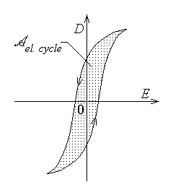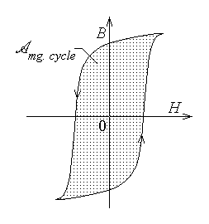
Fig. 14.1.
Correspondingly, if f is the frequency of the periodic alternating electromagnetic field, the average volume power density of electromagnetic energy transferred into heat in a
hysteretic substance is
$\tilde{p}=f⋅\left( A_{ \text{el}\text{.} \text{cycle}}+A_{ \text{mg}\text{.} \text{cycle}}\right)$ ,
and the average heat generated during a time interval τ in a domain D is
$Q=τ f \int{\left( A_{ \text{el}\text{.} \text{cycle}}+A_{ \text{mg}\text{.} \text{cycle}}\right) \text{dV}}$
Two remarks are worth mentioning at this point.
First, Joule’s effect is permanently associated with the electric conduction, even under steady state conditions, while the heat generation in hysteretic substances is only present in alternating – or, more generally, time–varying – electromagnetic fields.
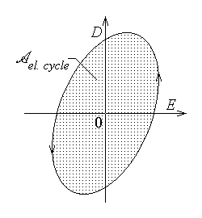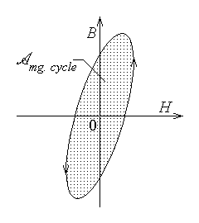
Fig. 14.2.
Second, there is a so called electric or magnetic viscosity of the substance that can be detected in high–frequency alternating electromagnetic fields. The electric viscosity consists in the fact that a sudden change in the applied electric field strength E induces a corresponding change in the (electric) polarisation (and, hence, in the electric displacement D ), but only after a certain delay. Similarly, the magnetic viscosity consists in the fact that a sudden change in the applied magnetic field strength H induces a corresponding change in the magnetisation (and, hence, in the magnetic flux density B ), but only after a certain delay. These phenomena can be described by hysteresis–like cycles D(E) or B(H) as those in fig. 14.2, and result in an irreversible transfer of electromagnetic energy into heat, developed in the electrically or magnetically viscous substance just like for hysteretic substances. If the electric or magnetic field vectors have a harmonic time variation, then the electric or magnetic viscosity is translated into a phase difference of the electric displacement after the electric field strength or of the magnetic flux density after the magnetic field strength. In turn, this is described by a so called complex permittivity
$\underline{ε}=ε'−jε\text{= lline \{underline \{ε\}\} rline `e rSup \{ size 8\{` - `j`δ\} \} \} \{}$
or a so called complex permeability
$\underline{μ}=μ'−jμ\text{= lline \{underline \{μ\}\} rline `e rSup \{ size 8\{` - `j`ϑ\} \} \} \{}$ .
The heat can be electromagnetically generated in the substance intended to be heated or in a specially designed heater, whence the heat is transmitted to the body intended to be heated.
A direct heating process is present when the heat is developed in the very object to be heated. This can be achieved by different methods: resistive heating, obtained by Joule’s effect when the conducting object is carrying an electric current, arc heating, when the object to be heated plays the part of an electrode for an electric arc, inductive heating, obtained by Joule’s effect associated with the so called eddy currents induced in a conducting object by electromagnetic induction, dielectric heating, obtained by the irreversible energy transfer associated with the electric hysteresis or electric viscosity in an alternating electric field.
An indirect heating process is present when the object to be heated receives the heat transmitted from a heater where the heat is electromagnetically generated, usually as resistive or arc heating.
There are, in principle, some other modern heating methods, such as electron beam or laser beam heating, associated with modern technologic processes. The physical phenomena associated with such processes are beyond the scope of this book and are not treated here.

14.1.2. Heat transmission
There are three mechanisms of heat transmission: thermal conduction, thermal convection, and radiation.
1. In the simplest one–dimensional case, the transmission of heat by thermal conduction is described by Fourier’s law (the diffusion’s law),
${\text{dP}}_{q}=\frac{{\text{dQ}}_{\text{trans}}}{dt}=−λ \text{dS} \frac{\text{dT}}{\text{dx}}$ ,
where dP_{q} is the transmitted heat power, that is the rate of heat transfer, dT is the temperature difference, along the direction of temperature decrease indicated by the normal unit vector $\vec{n}$ , between the surface areas dS placed at a distance dx (fig. 14.3), and λ ⟨W/m⋅deg⟩ is the thermal conductivity of the heat conducting medium.
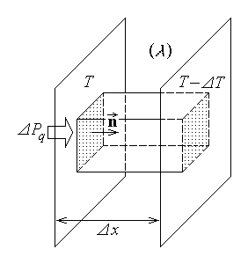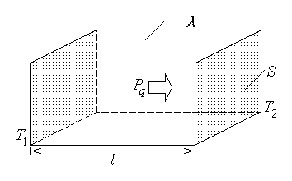
Fig. 14.3. Fig. 14.4.
A simple Ohm’s theorem for heat conduction can be readily obtained for a segment of a homogeneous medium, of thermal conductivity λ , length l and cross section area S , where the heat is transmitted between the terminal surfaces only, of temperatures T₁ and T₂ , (T₁ > T₂) , in the direction of temperature decrease (fig. 14.4). Indeed, going from elementary to finite dimensions and temperature differences, Fourier’s law is rewritten as
$P_{q}=−λ S\frac{T_{1}−T_{2}}{l}$ ,
whence, by defining the thermal resistance as
$R_{T}=\frac{l}{λ S}$ ,
Ohm’s theorem for heat conduction is obtained as
$T_{1}−T_{2}=R_{T} P_{q}$ .
The analogy between heat conduction and electric current conduction is then straightforward, as illustrated in the table below,
Thermal conduction | T | $$P_{q}={\text{dQ}}_{\text{trans}}/\text{dt}$$ | R_{T} | λ
Electric conduction | V | I | R | $$σ=1/ρ$$
By virtue of this analogy, equivalent thermal resistances can be defined, for instance. If the heat is transmitted by conduction, with no accumulation, across different successive strata of thermal resistances R₁ , … , R_{k} , … , R_{n} , then the total (equivalent) thermal resistance of such a series connection is
$R=\sum_{k=1}^{n}{ R_{k}}$ .
Similarly, if the heat is transmitted by conduction, with no accumulation, across adjacent strata of thermal resistances R₁ , … , R_{k} , … , R_{n} , between the same two walls of temperatures T₁ and T₂ , then the total (equivalent) thermal resistance of such a parallel connection is given by
$\frac{1}{R}=\sum_{k=1}^{n}{ \frac{1}{R_{k}}}$ .
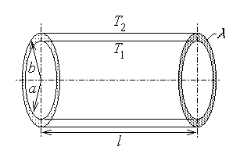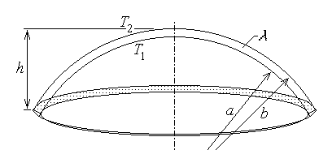
Fig. 14.5. Fig. 14.6.
The above derived expression of the thermal resistance is valid for a plane wall of cross section area S , thickness t and thermal conductivity λ ,
$R_{T}=\frac{t}{λ S}$ ,
and can be extended for curved walls only if these are very thin $\left( t≪\sqrt{S} \right)$ . Useful formulae are derived for common cases. For instance, the thermal resistance of a cylindrical wall of length l and thermal conductivity λ , between the inner cylinder of radius a and the outer cylinder of radius b (fig. 14.5) is
$R_{T}=\frac{\text{ln}b/a}{2πλ l}$ .
As well, the thermal resistance of the wall of a spherical cap of height h and thermal conductivity λ , between the inner surface of radius a and the outer surface of radius b (fig. 14.6) is
$R_{T}=\frac{1/a−1/b}{2πλ} \frac{r_{\text{av}}}{h}=\frac{b^{2}−a^{2}}{4πλ h \text{ab}}$ .
2. The transmission of heat by thermal convection consists in the heat transfer at a solid–fluid interface, where the fluid flow carries away heat along with substance. The natural convection is that convection where the fluid flow is determined by variation of fluid density associated with the temperature inhomogeneity; the forced convection is the convection facilitated by the fluid flow imposed by appropriate equipment (such as pumps or fans).
The heat power transmitted across an area S (fig. 14.7) of the solid–fluid interface, in the normal direction, between the solid wall of temperature T₁ and the adjacent fluid of temperature T₂ (T₁ > T₂) , is

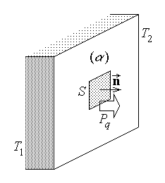
Fig. 14.7.
$P_{q}=α S \left(T_{1}−T_{2}\right)$ ,
where α ⟨W/m²deg⟩ is the convection coefficient dependent on the wall shape (plane, cylindrical, spherical, etc.), the wall orientation (horizontal, vertical, inclined, above or under the fluid, etc.), surface ruggedness, the nature of fluid flow (laminary or turbulent), and temperature. Of course, the heat transfer is reversed if the fluid temperature is greater than the solid temperature.

3. The transmission of heat by radiation is related to the fact that any system (body) of a nonzero temperature (T > 0 °K) evacuates energy towards its surroundings as an electromagnetic radiation of any wavelength λ ∈ (0,∞) . According to its wavelength, the radiation can be classified as visible in the interval λ = (0.39 … 0.77) μm , ultraviolet in the interval λ = (0.001 … 0.39) μm , and infrared in the interval λ = (0.77 … 400) μm ; the rest of wavelengths fall outside the scope of heat transmission. Some important facts regarding the electromagnetic (often also called thermal) radiation are summarised below.
The radiated energy presents a certain spectral distribution, dependent on the system temperature: the energy density radiated in the wavelength interval ( λ , λ + dλ ) is a function w(λ,T) of the radiation wavelength and the system (body) temperature, and is independent on the nature of the body, when the system (body) and the radiation are at thermodynamic equilibrium. The total energy radiated in a surrounding volume V is then given by
$W=V \int{w \left(λ,T\right) dλ}$ .
Let the thermal radiation be incident on the surface of a system (body) and let J be its power flux density, that is the power radiated over the unit surface normal to the radiation direction. The part J_{R} of the incident power flux density is reflected, the part J_{A} of the incident power flux density is accumulated (stored as internal energy), and the part J_{T} of the incident power flux density is transmitted further (fig. 14.8); correspondingly,

the power balance is
$J=J_{R}+J_{A}+J_{T}$ .
Let the reflection coefficient, the absorbtion coefficient, and the transmission coefficient be defined respectively as
$R=\frac{J_{R}}{J} , A=\frac{J_{A}}{J} , T=\frac{J_{T}}{J}$ ;
then the above power balance results in the equation satisfied by the radiation coefficients
$R+A+T=1$ .
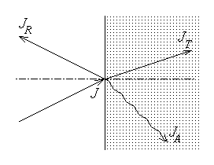
Fig. 14.8.

It must be noted, however, that the quantities entering the above equation are wavelength–dependent, implying that the radiation coefficients are also wavelength–dependent.
Some ideal bodies (systems) can be defined, as associated to ideal values of the radiation coefficients: the black body is the perfectly absorbant body, characterised by the radiation coefficients
$A=1 , R=T=0$ ,
the perfectly reflectant body is characterised by the radiation coefficients
$R=1 , A=T=0$ ,
and the perfectly transparent body is characterised by the radiation coefficients
$T=1 , R=A=0$ .
There are actual cases which are very near the ideal ones: the soot or the black matt varnish presents an absorbtion coefficient $A≃0\text{.}\text{94}$ , and polished metallic surfaces present a reflection coefficient $R≃0\text{.}\text{94}$ . It is important to remember that the surface of different substances present different wavelength–dependent values of the radiation coefficients; in particular, the colour of an illuminated surface is determined by the wavelengths of the reflected visible radiation. Similarly, the colour of a radiation source is determined by the wavelengths of the emitted visible radiation.
Thermodynamic considerations result in Kirchhoff’s theorem: over any given spectral interval (λ,λ+dλ) , the power flux density the radiated by a body is proportional to the power flux density the radiated by a black body at the same temperature, the proportionality coefficient being the absorbtion coefficient,
$J_{E}|_{ \left(λ , λ+dλ\right)}=A\left(λ\right) J_{E B}|_{ \left(λ , λ+dλ\right)}$ .
The spectral energy density radiated by the black body within the spectral interval (λ,λ+dλ) is given by Planck’s law as
$w_{B}\left(λ,T\right)=\frac{2π h c^{2}}{λ^{5}} \frac{1}{\text{exp}\left(\frac{h c}{λ k T}\right)−1}$ ,
where $k=1\text{.}\text{38}⋅{\text{10}}^{ −\text{23}} J/\text{deg}$ is Boltzman’s constant, $h=6\text{.}\text{6256}⋅{\text{10}}^{ −\text{34}} J⋅s$ is Planck’s constant, and $c≃3⋅{\text{10}}^{8} m/s$ is the speed of light in free space. A graphical represen-tation of this function (fig. 14.9) shows that the spectral energy density increases, at any wavelength, as the temperature increases, and the wavelength where the maximum spectral energy density is radiated moves toward lower wavelengths as the temperature increases.
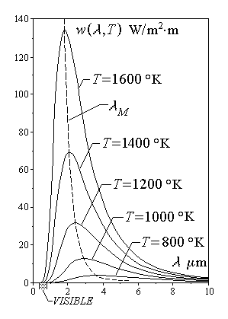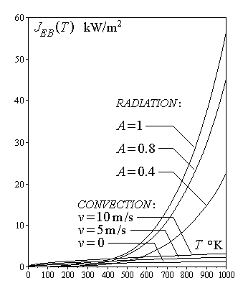
Fig. 14.9. Fig. 14.10.
Wien’s law describes the last feature mentioned above: the spectral energy density radiated by the black body reaches its maximum at a wavelength that is inversely proportional to the absolute temperature of the black body,
$λ_{M}=\frac{A}{T} , A=2\text{.}\text{8978}⋅{\text{10}}^{ −9} m⋅\text{deg}$ .
Stefan–Boltzman’s law states that the power flux density radiated across the surface of the black body is given by
$J_{E B}=σ T^{4}$ ,
where $σ=5\text{.}\text{71}⋅{\text{10}}^{ −8} W/m^{2}{\text{deg}}^{4}$ is the Stefan–Boltzman’s constant. This law shows that the radiated power increases quite rapidly with the temperature increase. As it is illustrated in fig. 14.10, for different values of the absorbtion – and, implicitly, radiation – coefficients A and different values of the convection coefficient corresponding to different values of the speed v of forced convection), the thermal power emitted by radiation is greater than the thermal power evacuated by convection for temperatures comparable with normal ambient temperatures, and their difference increases very rapidly as the temperature increases.
Finally, Lambert’s theorem states that the power flux density that is emitted from or absorbed by a surface under an angle θ with respect to the normal direction is given by
$J\left(θ\right)=J \frac{\text{cos}θ}{π}$ .

14.1.3. Transient heat accumulation
Let a definite part of a homogeneous object, of volume V , surrounded by a closed surface Σ , be considered, and let this domain exchange energy with external systems by heat transfer only (that is, any mechanic work transfer is absent). Under these circumstances, the internal energy increase associated with a temperature increase dT equals the received heat and is simply expressed as
$\text{dU}=\text{dQ}=M c \text{dT}=γ V c \text{dT}$ ,
where M is the mass of the considered domain, γ ⟨Kg/m³⟩ is the mass density, and c ⟨J/Kg⋅deg⟩ is the specific heat of the substance in the considered domain.
The transient heat accumulation – meaning the transient heating or cooling phenomenon – is described by the temperature variation associated with the internal energy variation resulting from the difference between the heat generated in the considered domain and the heat evacuated from it across its surrounding surface. For such a process, the rate of internal energy variation is obviously given by the first principle of thermodynamics as
$\frac{\text{dU}}{\text{dt}}=P_{q \text{generated}}−P_{q \text{evacuated}}$ .
1. The heating of an object (system) is studied first.
Let first the case when the heat is evacuated from a system (object) by convection be considered. The (suposedly uniform) object temperature T is assumed to be the same as the external temperature T_{e} up to the initial moment t = 0 , when the heat begins to be generated inside it at a constant rate. Let $P_{q \text{generated}}$ be denoted simply as P ; the heat evacuated from the object by convection is $P_{q \text{evacuated}}=α S \left(T−T_{e}\right)$ , where α is the convection coefficient, S is the area of the object surface, T is its surface temperature, and T_{e} is the external (surrounding) temperature at the object surface. The energy balance equation now becomes
$γ c V\frac{\text{dT}}{\text{dt}}=P−α S \left(T−T_{e}\right)$ ,
or, by denoting $θ=T−T_{e}$ ,
$γ c V \frac{dθ}{\text{dt}}+α S θ=P , θ\left(0\right)=0$ .
The solution is determined as a sum of its free and forced components, $θ=θ^{0}+θ^{F}$ . The free solution is the general solution, of the form $θ^{0}=A e^{ r t}$ , of the homogeneous equation
$γ c V \frac{{dθ}^{0}}{\text{dt}}+α S θ^{0}=0$ ;
simple substitutions result in
$γ c V r A e^{ r t}+α S A e^{ r t}=0 ⇔ A e^{ r t}\left(γ c V r+α S\right)=0$ ,
whence
$r=− \frac{α S}{γ c V}=− \frac{1}{τ} ⇔ τ=\frac{γ c V}{α S}$
gives the thermal time constant of the heating process. The forced solution, of the form $θ^{F}=B$ , is a particular solution of the complete (inhomogeneous) equation
$γ c V \frac{{dθ}^{F}}{\text{dt}}+α S θ^{F}=P$ ;
simple substitutions result in
$γ c V r⋅0+α S B=P$ ,
whence
$B=\frac{P}{α S}$ .
The complete solution is thus
$θ\left(t\right)=A e^{ − t/τ}+\frac{P}{α S}$ .
Let the initial object temperature be equal to the external temperature, T = T_{e} , such that
$θ\left(0\right)=0$ ;
by imposing this initial condition to the solution above, it follows that
$0=A+\frac{P}{α S} ⇔ A=−\frac{P}{α S}$ .
The time–dependence of the object temperature is finally obtained as
$θ=\frac{P}{α S}\left(1−e^{ − t/τ}\right)$ ,
whence
$T=T_{e}+\frac{P}{α S}\left(1−e^{ − t/τ}\right) , τ=\frac{γ c V}{α S}$ .
The object temperature increases exponentially from T_{in} = T_{e} towards
$T_{\text{fin}}=T\left(\right)=T_{e}+\frac{P}{α S}$ ,
so that, after a time interval
$t_{h}≃3 τ=3 \frac{γ c V}{α S}$ ,
the temperature practically reaches its final (limit) value (fig. 14.11).
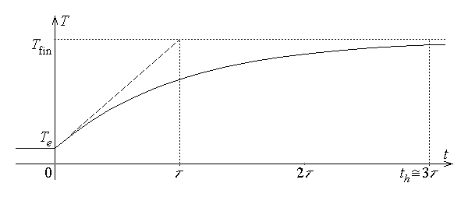
Fig. 14.11.
In the case when the heat is evacuated from a system (object) by thermal conduction, under the same initial conditions, let the simple case be considered when a homogeneous wall of total surface S , thickness l , and thermal conductivity λ surrounds the heated object. The heat evacuated from the system by conduction is now $P_{q \text{evacuated}}=\frac{λ S}{l} \left(T−T_{e}\right)$ , so that the energy balance equation now becomes
$γ c V\frac{\text{dT}}{\text{dt}}=P−\frac{λ S}{l} \left(T−T_{e}\right)$ ,
or, by denoting $θ=T−T_{e}$ ,
$γ c V \frac{dθ}{\text{dt}}+\frac{λ S}{l} θ=P , θ\left(0\right)=0$ .
This equation is perfectly analogous to the corresponding equation in the case when the heat was transferred by convection, if α is substituted by λ/l . The solution is therefore immediate, as
$T=T_{e}+\frac{P l}{λ S}\left(1−e^{ − t/τ}\right) , τ=\frac{γ c V l}{λ S}$ .
The object temperature increases exponentially from T_{in} = T_{e} towards
$T_{\text{fin}}=T\left(\right)=T_{e}+\frac{Pl}{λ S}$ ,
so that, after a time interval
$t_{h}≃3 τ=3 \frac{γ c V l}{λ S}$ ,
the temperature practically reaches its final (limit) value.
It may be noted that
$R_{T}=\frac{l}{λ S}$
is just the thermal resistance of the surrounding wall across which the thermal conduction takes place, and
$C=γ c V=M c$
is the thermal capacitance of the considered object. The temperature time–dependence is then (fig. 14.11)
$T=T_{e}+P R_{T} \left(1−e^{ − t/τ}\right) , τ=R_{T} C$ ,
so that the final temperature
$T_{\text{fin}}=T\left(\right)=T_{e}+P R_{T}$
is reached approximately after a time interval
$t_{h}≃3 τ=3 R_{T} C$ .
2. Let now the cooling of a object (system) be studied.
The first case to be approached is again that when the heat is evacuated from a system (object) by convection. The initial object temperature is assumed to be maintained at the value
$T_{\text{in}}=T_{e}+ΔT$ ,
different from the external temperature T_{e} , up to the initial moment t = 0 , when the heat generation inside it is terminated. The heat evacuated from the object by convection is again $P_{q \text{evacuated}}=α S \left(T−T_{e}\right)$ , where α is the convection coefficient, S is the area of the object surface, T is its surface temperature, and T_{e} is the external (surrounding) temperature at the body surface. The energy balance equation now becomes
$γ c V\frac{\text{dT}}{\text{dt}}=−α S \left(T−T_{e}\right)$ ,
or, by denoting $θ=T−T_{e}$ ,
$γ c V \frac{dθ}{\text{dt}}+α S θ=0 , θ\left(0\right)=ΔT$ .
The solution is now represented by its free component only, $θ=θ^{0}$ , which is the general solution, of the form $θ^{0}=A e^{ r t}$ , of the homogeneous equation
$γ c V \frac{{dθ}^{0}}{\text{dt}}+α S θ^{0}=0$ .
Simple substitutions result in
$γ c V r A e^{ r t}+α S A e^{ r t}=0 ⇔ A e^{ r t}\left(γ c V r+α S\right)=0$ ,
whence
$r=− \frac{α S}{γ c V}=− \frac{1}{τ} ⇔ τ=\frac{γ c V}{α S}$
gives the thermal time constant of the heating process. The complete solution,
$θ\left(t\right)=A e^{ − t/τ}$ ,
is further determined by imposing the initial condition,
$ΔT=θ\left(0\right)=A$ .
The time–dependence of the object temperature is finally obtained as
$θ=ΔT e^{ − t/τ}$ ,
whence
$T=T_{e}+ΔT e^{ − t/τ} , τ=\frac{γ c V}{α S}$ .
The object temperature decreases exponentially from T_{in} = T_{e} + ΔT towards
$T_{\text{fin}}=T\left(\right)=T_{e}$ ,
so that, after a time interval
$t_{c}≃3 τ=3 \frac{γ c V}{α S}$ ,
the temperature practically reaches its final (limit) value (fig. 14.12).
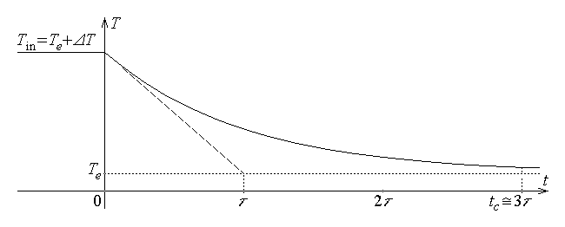
Fig. 14.12.
In the case when the heat is evacuated from a system (object) by thermal conduction, under the same initial conditions, let again the simple case be considered when a homogeneous wall of total surface S , thickness l , and thermal conductivity λ surrounds the heated object. The heat evacuated from the object by conduction is now $P_{q \text{evacuated}}=\frac{λ S}{l} \left(T−T_{e}\right)$ , so that the energy balance equation now becomes
$γ c V\frac{\text{dT}}{\text{dt}}=−\frac{λ S}{l} \left(T−T_{e}\right)$ ,
or, by denoting $θ=T−T_{e}$ ,
$γ c V \frac{dθ}{\text{dt}}+\frac{λ S}{l} θ=0 , θ\left(0\right)=ΔT$ .
The same analogy with the preceding (heat transfer by convection) is noticed, if α is substituted by λ/l . The solution is therefore immediate, as
$T=T_{e}+ΔT e^{ − t/τ} , τ=\frac{γ c V l}{λ S}$ .
The object temperature decreases exponentially from T_{in} = T_{e} + ΔT towards
$T_{\text{fin}}=T\left(\right)=T_{e}$ ,
so that, after a time interval
$t_{c}≃3 τ=3 \frac{γ c V l}{λ S}$ ,
the temperature practically reaches its final (limit) value.
It may be noted again that, by introducing the thermal resistance of the surrounding wall across which the thermal conduction takes place,
$R_{T}=\frac{l}{λ S}$ ,
and the thermal capacitance of the considered object,
$C=γ c V=M c$ ,
the temperature time–dependence can be simply expressed as (fig. 14.12)
$T=T_{e}+ΔT e^{ − t/τ} , τ=R_{T} C$ .
The final temperature
$T_{\text{fin}}=T\left(\right)=T_{e}$
is again reached approximately after a time interval
$t_{c}≃3 τ=3 R_{T} C$ .
3. Some typical heating processes are discussed below.
When an object (system) is heated at a constant rate of heat generation (fig. 14.13.a), the actual heating is practically terminated after a time interval t_{h} , after which the heat generation is used to cover the heat loss and thus maintain the desired final temperature T_{f} for a desired duration t_{M} . As well, after the heat generation is terminated, the cooling to the external (surrounding) temperature T_{e} is practically finished after a time interval t_{c} . The heating process is slow, and the constant temperature is maintained with an important heat consumption.
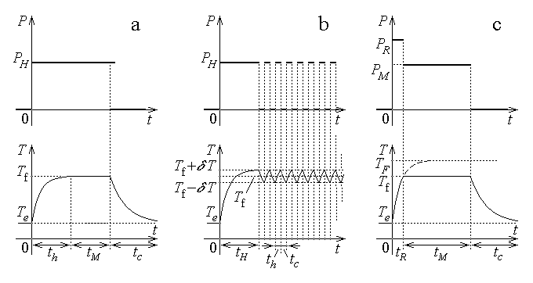
Fig. 14.13.
An object (system) can be maintained at a constant temperature by using an intermittent rate of heat generation (fig. 14.13.b). The prescribed rate of heat generation is first maintained for approximately a time interval t_{H} , after which the temperature T_{f} + δT is reached. The heat generation is interrupted for a time interval t_{c} , during which the body is cooled to a temperature T_{f} – δT , and then again applied for another time interval t_{h} , sufficient for the temperature to reach again the value T_{f} + δT . This sequence is repeated, so that the temperature follows a periodic variation around the desired final temperature T_{f} . The resulted energy savings represent an important advantage of this heating process.
A hastened rate of the heat generation (fig. 14.13.c) can be used in order to reduce the energy consumption. A rather high initial rate of heat generation P_{R} , corresponding to a final temperature T_{F} greater than the desired final temperature T_{f} , is first applied for a time interval t_{R} until the desired temperature is reached. Afterwards, the rate of heat generation is reduced to a lower constant value P_{M} , sufficient to cover the heat loss and thus maintain the desired constant temperature T_{f} for a desired duration t_{M} . This process is especially advantageous when a rapid heating is of main interest, with less regard to the energy consumption.

14.2. Indirect heating
The indirect heating is the process where a system (object) receives the heat from an electric heater contained in the same enclosure. In order to improve the efficiency, the heat loss is reduced by surrounding the common enclosure by thermally insulating walls.
The equipment for indirect electric heating is thus a furnace where the heat comes from a current carrying conductor placed as close as possible to the object to be heated. The generated heat is just the dissipated electromagnetic energy associated with the electric conduction (Joule’s effect),
$Q_{\text{gen}}=R I^{2}t=\frac{U^{2}}{R} t$ .
Apart from the power and the temperature involved in the operation, other important parameters of such an electric furnace characterise its efficiency. The electric efficiency is the ratio of the developed heat versus the energy consumption,
$η_{\text{el}}=\frac{Q_{\text{gen}}}{W}$ ;
it is influenced by the components of the electric circuit and the operating parameters. The thermal efficiency is the ratio of the heat received by the load (the object to be heated) versus the total developed heat,
$η_{\text{th}}=\frac{Q_{\text{load}}}{Q_{\text{gen}}}$ ;
it depends on the constructive and operating parameters of the furnace, the load and heater relative placement, the type of heat transmission.

14.2.1. Resistive indirect heating
The resistive indirect heating is the indirect heating process where the heater is represented by resistors made of adequate conducting materials. The electrically generated heat is transferred to the heated object mainly by radiation and convection.
It is important to notice that the operating value of the heater resistance, which enters in the above formula, corresponds to its operating temperature. Since the resistivity of common substances used in manufacturing heaters is temperature–dependent according to a relation of the type
$ρ=ρ_{0}\left(1+a θ+b θ^{2}+\text{.}\text{.}\text{.}\right)$
in terms of its value ρ₀ at θ = 0°C , where θ is the temperature (in degrees Celsius), it follows that the starting value of the heater resistance is significantly lower than its value at the operating temperature.
A maximum admissible temperature of the heater must be observed during operation, in order to preserve its chemical and physical characteristics by avoiding distructive chemical reactions with the surrounding atmosphere and operation too close to the melting temperature. This limiting condition corresponds to a maximum admissible power flux density, defined as the ratio of the developed heat P to the lateral surface S_{L} of the (supposedly cylindrical) heater,
$p_{S}=\frac{P}{S_{L}}=\frac{ρ l}{π r^{2}}I^{2}/ 2π r l=\frac{ρ I^{2}}{2π^{2}r^{3}}=\frac{ρ I^{2}}{2 \sqrt{π} π^{3/2}r^{3}}=\frac{ρ I^{2}}{2 \sqrt{π} S^{3/2}}$ ,
where S = πr² is the cross section area of the heater conductor of resistivity ρ carrying the electric current I . This condition imposes an upper limit to the current carried by the heater conductor,
$I_{\text{max}}=\sqrt{ \frac{2 \sqrt{π} S^{3/2}}{ρ}p_{S} }$
and to the rate of heat generation,
$P_{q \text{max}}=R I_{\text{max}}^{2}=\frac{ρ l}{S} \frac{2 \sqrt{π} S^{3/2}}{ρ}p_{S}=2 \sqrt{π} S^{3/2} l p_{S}$ .

14.2.2. Indirect heating by electric arc
The indirect heating by electric arc is the indirect heating process where the heat is generated, again by Joule’s effect, in an electric arc developed in the enclosure containing also the object to be heated.
1. The electric arc is an electric discharge – an electric current – developed in a plasma medium between two electrodes, under an appropriate applied voltage. The plasma is a state of the matter consisting in electrons and ionised atoms in thermal equilibrium – such a state is maintained by repetitive collisions of these particles at sufficiently large temperatures.
An electric arc is ignited between two electrodes (for instance, graphite electrodes) when an appropriate voltage is applied between them, sufficient to initiate the avalanche ionisation process of the molecules of a gaseous atmosphere surrounding the electrodes. The electrons, normally released by any solid substance by thermoelectronic emission, are accelerated in the applied electric field, from the emitting negative electrode (cathode) toward the positive electrode (anode). These electrons ionise by collision the atoms and molecules of the gas between the electrodes and release more electrons and so on. The process is then self–sustaining and consists essentially in an electric conduction carried along by the arc plasma, at temperatures varying from around 1000°C in the central region to about 500°C toward the arc borders. Finally, the accelerated electrons collide strongly with the anode, which, reaching high temperatures, is quickly worn out. Such an asymmetric behaviour of the electrodes can be avoided if the electric arc is sustained by an alternating voltage.
The heat is transmitted from the electric arc to the object to be heated – commonly a charge of molten metal – mainly by radiation. Moreover, the tank containing the charge is usually rotated in order to ensure a uniform heating.
From an electrical standpoint, the electric arc is a nonlinear resistance, characterised by a generally decreasing U(I) relationship (fig. 14.14),
$U=a+b l+\frac{c+d l}{I}$ ,
dependent on the arc length l . The coefficients a , b , c , d depend on the gas composition, pressure and circulation, electrode composition, shape and dimensions and on the conditions of heat transmission.
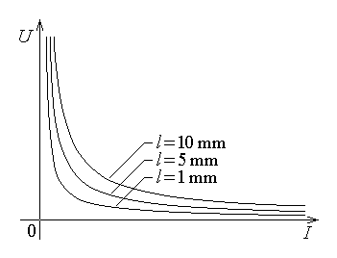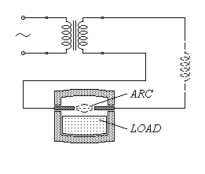
Fig. 14.14. Fig. 14.15.
Such a voltage–current characteristic is unstable. Indeed, considering a practically resistive arc circuit, let the electric arc be maintained by a nonideal voltage source of given e.m.f E and internal impedance z , so that the simplified operating equation is
$E−z I=U\left(I\right) ⇔ I=\frac{E−U\left(I\right)}{z}$ .
Let now some perturbation determine an increase ΔI of the arc current I ; then the arc voltage U(I+ΔI) decreases with respect to the voltage U(I) . Consequently, the available current is
$I'=\frac{E−U\left(I+ΔI\right)}{z}>\frac{E−U\left(I\right)}{z}$ ,
meaning a further increase of the current. Such a behaviour can be compensated by an adequate regulating equipment, which would adjust correspondingly the arc length l (that is, the distance between the electrodes), provided that the current variations are not too rapid. In turn, the current variation is slowed down in the presence of an inductance, which also contributes to maintaining the arc voltage under alternating current conditions even when the source voltage crosses zero values. That is why, in the circuit of an electric arc, a so called reactance coil (a coil with a large inductance) is sometimes series connected with the usual step–down transformer (which reduces the voltage and increases the current).
2. The equivalent circuit of an equipment for indirect heating by electric arc (fig. 14.15) consists in the series connection of the resistances and inductive reactances of the connecting line (L) , the transformer and reactance coil (T) , the connecting conductors (C) , and the electric arc itself (A) , as in fig. 14.16. The equivalent impedance of the circuit is
$\underline{Z}=\left[\left(R_{L}+R_{T}+R_{C}\right)+R_{A}\right]+j \left[\left(X_{L}+X_{T}+X_{C}\right)+X_{A}\right]=\left(R+R_{A}\right)+j \left(X+X_{A}\right)$ ,
where the arc equivalent resistance,
$R_{A}=R_{A}\left(I\right)$ ,
is current–dependent. The effective current contributing to the heat generation is then given by
$I=\frac{U}{\sqrt{{\left(R+R_{A}\right)}^{2}+{\left(X+X_{A}\right)}^{2}}}$ .
Care must be taken, however, of the fact that the equipment has to withstand the short–circuit current that is present at the moment of the arc ignition or, accidentally, when the electrodes touch one another. The short–circuit current corresponds to U_{A} = 0 or, in the equivalent circuit, to R_{A} = 0 , X_{A} = 0 , so that
$I_{S}=\frac{U}{\sqrt{R^{2}+X^{2}}}≃\frac{U}{X}$ .
The electric power consumption of the electric arc is (neglecting phase differences)
$P_{A}=U_{A} I=U\left(I\right) I=\left(a+b l\right) I+\left(c+dl\right)=\left(b I+d\right) l+\left(a I+c\right)$ .
It follows that at constant arc length, l = const., the power consumption increases linearly with the increasing current, and under constant current conditions, I = const., the power consumption increases linearly with the arc length. The second expression of the electric power includes a first term, (bI + d)l , corresponding to the voltage drop across the column of positive ions in the arc plasma and a second term, (aI + c) , corresponding to the voltage drops at the electrode surfaces.
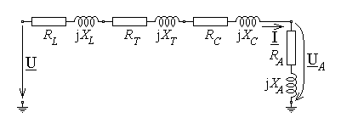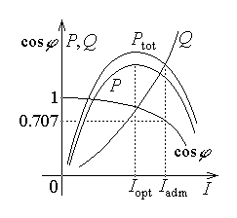
Fig. 14.16. Fig. 14.17.
Actually, under alternating current conditions, the inductances present in the equivalent circuit impose a phase difference ϕ between the arc voltage and the arc current, so that the active (actual) power consumption is
$P=U_{A} I \text{cos}ϕ<P_{A}$ ,
corresponding to a power factor cos ϕ < 1 , and there is also a reactive power consumption
$Q=U_{A} I \text{sin}ϕ>0$ .
The typical variations of the total active power P_{tot} , the arc active power P (transformed into heat), the reactive power Q , and the power factor cosϕ , as functions of the current I (fig. 14.17) show that there exists an optimum value of the current, I_{opt} , around which the equipment must operate, and a maximum admissible value of the current I_{adm} , above which the power factor is inadmissible low.

14.3. Direct heating
The direct heating is the process where the heat is electromagnetically generated within the very object to be heated. In order to improve the efficiency, the heating process takes place in enclosures that are especially electromagnetically and thermally insulated.

14.3.1. Resistive direct heating
1. The resisitive direct heating is the direct heating process where the heat is generated, in a conducting object carrying an electric conduction current, from the dissipated electromagnetic energy associated with the electric conduction (Joule’s effect),
$Q=U I t=R I^{2}t=\frac{U^{2}}{R} t$ .
The heat transfer process to be accounted for in this case regards the temperature distribution within the heated object, associated with the heat loss across its boundary.
If the conducting material is not intended to be melted, then care must be taken so that the nonuniform temperature distribution remains under the melting temperature, everywhere within the heated conductor. Supposing that direct or low frequency alternating current is carried by the conductor, the current is uniformly distributed over the cross section of the conductor. Consequently, the heat is generated uniformly in the conductor carrying a current of intensity I , at a rate given by
$P=\frac{ρ l}{π a^{2}} I^{2}$ ,
in the case of a cylindrical conductor of length l , radius a and resistivity ρ , and
$P=\frac{ρ l}{2a b} I^{2}$ ,
in the case of a conductor of length l , resistivity ρ , and rectangular cross section of dimensions 2a and b . The generated heat is used first to increase locally the internal energy and, consequently, the conductor temperature, and then it is transmitted to regions of lower temperature or is lost to the surrounding medium, across the conductor surface.
2. The analysis of the process of heat generation and transmission results in the steady–state temperature distribution (that is, after a sufficiently long time interval, so that the temperature reaches a time–invariant final value). Convection conditions, of convection coefficient α , are normally considered at the conductor lateral surface, where the surrounding temperature is Te . The results are the following: (1) the temperature–versus–radius distribution over the cross section of a cylindrical conductor of radius a (fig. 14.18.a) is
$T\left(r\right)=T_{e}+\frac{p a}{2 α}+\frac{p a^{2}}{4 λ} \left[1−{\left(\frac{r}{a}\right)}^{2}\right]$ ;
(2) the temperature distribution versus the distance from the axial plane, over the rectangular cross section of thickness 2a and width b (where $2 a≪b$, as in fig. 14.18.b) is
$T\left(x\right)=T_{e}+\frac{p a}{α}+\frac{p a^{2}}{2 λ} \left[1−{\left(\frac{x}{a}\right)}^{2}\right]$ .
In the above relations the power density associated with Joule’s effect was used,
$p=\frac{P}{V}=\frac{ρ l}{S}I^{2}/l S=ρ {\left(\frac{I}{S}\right)}^{2}=ρ J^{2}$ .
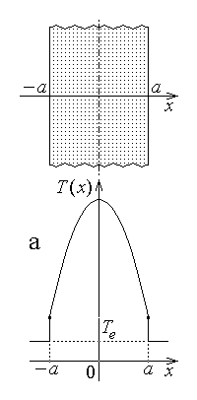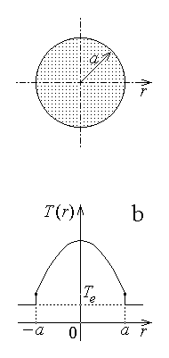
Fig. 14.18.
Such a quadratic space distribution of the temperature indicates that its maximum value is reached on the conductor axis; consequently, the operating condition of the resistive direct heating process is
$T_{\text{max}}=T\left(0\right)≤K T_{\text{melt}}$ ,
where K < 1 is a safety factor and the maximum temperature is
$T_{\text{max}}=\left\{ \begin{matrix}T_{e}+\frac{p a}{2 α}+\frac{p a^{2}}{4 λ} \text{for} \text{cylindrical} \text{cross} \text{section} \\ T_{e}+\frac{p a}{α}+\frac{p a^{2}}{2 λ} \text{for} \text{rectangular} \text{cross} \text{section}\end{matrix}\right.$ .
3. It is now possible to give details on the power flux density, used as a limiting factor in the operation of a resistive indirect heating process. Let the perimeter and the
area of the cross section be introduced, respectively as
$L=2π a , S=π a^{2}$ for cylindrical cross section ,
$L=2 \left(2a+b\right) , S=2 ab$ for rectangular cross section .
The power flux density is then
$p_{S}=\frac{P}{S_{\text{lat}}}=\frac{ρ l}{S}I^{2}/L l=\frac{ρ I^{2}}{S L}=ρ {\left(\frac{I}{S}\right)}^{2}\frac{S}{L}=ρ J^{2}\frac{S}{L}=p \frac{S}{L}$ ,
that is
$p_{S}=\left\{ \begin{matrix}p \frac{a}{2} \text{for} \text{cylindrical} \text{cross} \text{section} \\ p \frac{a}{1+2a/b} \text{for} \text{rectangular} \text{cross} \text{section}\end{matrix}\right.$ .
In the above relations regarding the power flux density, the value of the power (volume) density p must be taken as p_{max} , corresponding to the maximum admissible temperature in the current carrying conductor. These considerations result in the following relations:
$T_{e}+\frac{p a}{2 α}+\frac{p a^{2}}{4 λ}≤{KT}_{\text{melt}}$ ,
whence
$p=\frac{{KT}_{\text{melt}}−T_{e}}{\frac{a}{2 α}+\frac{a^{2}}{4 λ}} ⇔ p_{S}=\frac{{KT}_{\text{melt}}−T_{e}}{\frac{1}{α}+\frac{a}{2 λ}}$
for a cylindrical cross section, and
$T_{e}+\frac{p a}{α}+\frac{p a^{2}}{2 λ}≤{KT}_{\text{melt}}$ ,
whence
$p=\frac{{KT}_{\text{melt}}−T_{e}}{\frac{a}{α}+\frac{a^{2}}{2 λ}} ⇔ p_{S}≃\frac{{KT}_{\text{melt}}−T_{e}}{\frac{1}{α}+\frac{a}{2 λ}}$
for a rectangular cross section, where the approximation
$p_{S}=\frac{{KT}_{\text{melt}}−T_{e}}{\frac{1}{α}+\frac{a}{2 λ}}\frac{1}{1+2a/b}≃\frac{{KT}_{\text{melt}}−T_{e}}{\frac{1}{α}+\frac{a}{2 λ}} \text{for} 2a≪b$
was considered.
4. The resistive direct heating implies that an electric current is injected into the object to be heated. The current injection is applied across special contacts between the object to be heated and the current source terminals. Such a conductive configuration implies the presence of contact resistances at the object–contact and contact–terminal interfaces, and supplementary power dissipation in these contacts. The heat dissipated (and lost) in a contact is
$Q_{C}=R_{C}I^{2}t=\frac{ρ_{C}l_{C}}{S_{C}}I^{2}t \text{\sim } \frac{1}{S_{C}}$ ,
that is inversely proportional to the contact surface (fig. 14.19.a). Such losses are reduced if a number of parallel–placed contacts carry the current from the current source terminals and the object to be heated (fig. 14.19.b). It is readily seen that, when n such parallel placed contacts are used,
$Q_{C ; n}=n \left[R_{C}{\left(\frac{I}{n}\right)}^{2}t\right]=\frac{1}{n}\left(\frac{ρ_{C}l_{C}}{S_{C}}I^{2}t\right)=\frac{1}{n}Q_{C}$
a corresponding reduction results in the heat loss due to the reduction of the current carried by each individual contact.
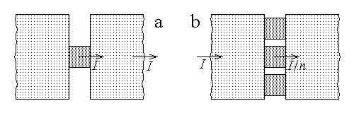
Fig. 14.19.
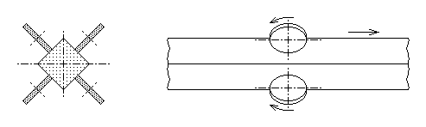
Fig. 14.20.
An example of such a multi–contact connection to the current source is illustrated in fig. 14.20, where the object to be heated is represented by an advancing beam of square cross section and the revolving contacts are pressed on the lateral faces of the beam.

14.3.2. Direct heating by electric arc
1. The direct heating by electric arc is the direct heating process where the heat is generated, by Joule’s effect, associated to the presence of an electric current injected in the object to be heated through an electric arc developed between this (conducting) object and some appropriate electrode(s). As it was the case with the indirect heating by electric arc, alternating currents are commonly used for heating, in order to avoid unbalanced erosion phenomena associated with the electric arc. As well, the object to be heated is usually a charge of molten metal contained in a thermally insulated tank. The bottom of the tank is made of a graphite layer, and is connected to one of the source terminals; the other source terminal is connected to the electrode, usually made also of graphite.
The equivalent electric circuit of the equipment for direct heating by electric arc is quite similar to that analysed in the case of the indirect heating by electric arc (fig. 14.21). The complex impedances related to the source, connecting line, transformer and connecting conductors are assembled into a single external complex impedance ${\underline{Z}}_{E}=R_{E}+j X_{E}$ ; as well, the arc complex impedance and the charge equivalent complex impedance are assembled into the load complex impedance, ${\underline{Z}}_{L}=R_{L}+j X_{L}=$ $=\left(R_{A}+R_{C}\right)+j \left(X_{A}+X_{C}\right)$ . These impedances are obviously series connected, so that the current across the load is given by the equation
$\underline{U}=\underline{Z} \underline{I}=\left({\underline{Z}}_{E}+{\underline{Z}}_{L}\right) \underline{I}=\left[\left(R_{E}+R_{L}\right)+j \left(X_{E}+X_{L}\right)\right] \underline{I}=\left(R+j X\right) \underline{I} ⇔$
$⇔ I=\frac{U}{\sqrt{R^{2}+X^{2}}}=\frac{U}{\sqrt{{\left(R_{E}+R_{L}\right)}^{2}+{\left(X_{E}+X_{L}\right)}^{2}}}$ .
The heat generated by Joule’s effect depends on the current carried across the electric arc and the object to be heated,
$Q=U_{L}I t=R_{L}I^{2}t=\frac{U_{L}^{2}}{R_{L}}t$ ;
therefore, the heating equipment is designed to operate as efficiently as possible, meaning the larger generated heat under minimum energy losses. As discussed above, the electrode(s) that support the electric arc are worn out during the operation of the heating equipment, the arc length increases, and the arc equivalent resistance R_{A} also increases. Correspondingly, the load resistance R_{L} also increases, along with the total complex impedance, and the arc current decreases, according to current equation above. The influence of these phenomena on the generated heat is briefly analysed in the following.
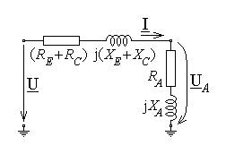 . 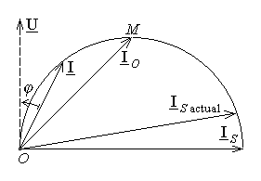.
Fig. 14.21. Fig. 14.22.
2. Let it be assumed that the equivalent resistances R_{E} of the external circuit and R_{C} of the charge are negligible, and that the total reactance is approximately constant,
$R_{E} , R_{C}≃0 , X_{E}+X_{L}=X≃\text{const}\text{.}$
These assumptions are consistent with the fact that the additional equipment is so designed as to minimise the dissipation losses; the charge presents a large cross section area, and the total reactance is determined by the total circuit inductance, related in turn to the magnetic field distribution, which is almost independent on the presence of the electric arc. An important current value in the equipment operation is the (ideal) short–circuit current, associated to a zero value of the complex arc impedance,
${\underline{I}}_{S}=\frac{\underline{U}}{\left(R_{E}+R_{A}+R_{C}\right)+j \left(X_{E}+X_{A}+X_{C}\right)} |_{ R_{A}=X_{A}=0 , R_{E}+R_{C}≪X_{E}+X_{C}}≃$

$\frac{\underline{U}}{j \left(X_{E}+X_{C}\right)}≃\frac{\underline{U}}{j X}$ ;
this value is present under arc ignition conditions or under breakdown conditions, when the electrode is in direct contact with the charge to be heated. Let the voltage be taken with zero initial phase, so that $\underline{U}=U$ ; under the above considered assumptions the complex current
$\underline{I}=\frac{U}{R_{A}+j X}=\frac{U \left(R_{A}−j X\right)}{R_{A}^{2}+X^{2}}=\frac{U R_{A}}{R_{A}^{2}+X^{2}}−j \frac{U X}{R_{A}^{2}+X^{2}}$
has the real and imaginary components respectively given by
$I_{R}\left(R_{A}\right)=\text{Re} \left\{ \underline{I} \right\}=\frac{U R_{A}}{R_{A}^{2}+X^{2}} , I_{X}\left(R_{A}\right)=\text{Im} \left\{ \underline{I} \right\}=− \frac{U X}{R_{A}^{2}+X^{2}}$ .
A comprehensive view on the heating equipment operation is obtained by studying the current–versus–arc resistance dependence in terms of the real and imaginary components of the current. Elimination of the arc resistance R_{A} between the equations of the current components,
$\left\{ \begin{matrix}I_{R}=\frac{U R_{A}}{R_{A}^{2}+X^{2}} \\ I_{X}=− \frac{U X}{R_{A}^{2}+X^{2}}\end{matrix}\right. ⇔ \left\{ \begin{matrix}I_{R}^{2} {\left(R_{A}^{2}+X^{2}\right)}^{2}=U^{2} R_{A}^{2} \\ R_{A}^{2}=− \frac{U X}{I_{X}}−X^{2} \end{matrix}\right. ⇔$
$⇔ I_{R}^{2} {\left(− \frac{U X}{I_{X}}−X^{2}+X^{2}\right)}^{2}=U^{2} \left(− \frac{U X}{I_{X}}−X^{2}\right) ⇔$
$⇔ I_{R}^{2} \frac{U^{2}X^{2}}{I_{X}^{2}}=U^{2}X \left(− \frac{U}{I_{X}}−X\right) ⇔ I_{R}^{2}=\frac{I_{X}^{2}}{X}\left(− \frac{U}{I_{X}}−X\right) ⇔$
$⇔ I_{R}^{2}=− \frac{U}{X}I_{X}−I_{X}^{2} ⇔ I_{R}^{2}+I_{X}^{2}+\frac{U}{X}I_{X}=0$ ,
results in
$I_{R}^{2}+{\left(I_{X}+\frac{U}{2 X}\right)}^{2}={\left(\frac{U}{2 X}\right)}^{2}$ ,
which is the equation of a circle (in the complex plane), of radius $r=\frac{U}{2 X}$ and centered at the (complex) point $\underline{C}=0−j\frac{U}{2 X}$ (fig. 14.22, where the reference real axis is rotated counter–clockwise by a π/2 angle).
It thus follows that, under constant source voltage conditions U = const. and constant total reactance conditions X = const., when the arc resistance R_{A} changes , the point of the current phasor $\underline{I}$ describes the semicircle of phase $ϕ ∈\left[0,π/2\right]$ of the circle defined above, between the limit points $\underline{O}=0+j 0$ , corresponding to open–circuit conditions (R = ∞ , $\underline{I}$ = 0) and $\underline{S}=0−j \frac{U}{X}$ , corresponding to short–circuit conditions (R = 0 , $\underline{I}={\underline{I}}_{S}$) . The active power – that is, the average power transformed into heat –
$P=U I \text{cos}ϕ$ ,
reaches its maximum value (under constant voltage conditions) for a maximum value of the active component (I cosϕ)_{max} , which corresponds to the point $\underline{M}=\frac{U}{X}−j \frac{U}{X}$ , that is for a phase difference ϕ_{M} = π/4 between the current and the voltage and to a power factor cosϕ_{M} = 0.707 . One may conclude that the operation of the heating equipment must be maintained at an operating current of phasor $\underline{I}$ with the point placed on the arc OM in the above diagram, corresponding to ϕ ≤ π/4 and to cosϕ ≥ 0.707 .
An important characteristic in the operation of an equipment for direct heating by electric arc is the short–circuit ratio, defined as the ratio of the short–circuit current to the (rated) operating current,
$K=\frac{I_{S}}{I_{R}}$ ,
in which case the (rated) power factor is
$\text{cos}ϕ_{R}=\sqrt{1−1/K^{2}}$ .
Usual values of these quantities are K = 1.8 … 2.5 and cosϕ = 0.85 … 0.92 .
3. The direct heating by electric arc implies large power consumption; therefore three–phase alternating currents are used, meaning that three electric arcs are sustained between three electrodes and the charge of null electric potential. A balanced three–phase load is achieved if the electrodes are symmetrically placed at an 120° angle on the periphery of a circle and separate transformers are used for each phase (fig. 14.23).
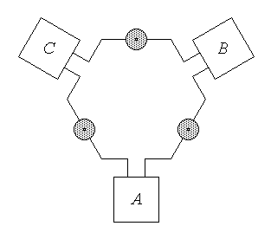 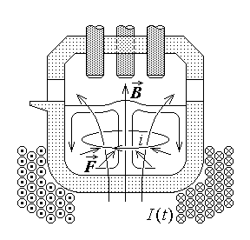.
Fig. 14.23. Fig. 14.24.
The heating uniformity is improved if a convection process is imposed in the melted charge under the action of electromagnetic forces (fig. 14.24). A coil is placed around the bottom of the tank, carrying a very low frequency alternating current I(t) . The time varying magnetic field of approximately vertical flux density B(t) induces an electric field of circular field lines which, in turn, determines induced currents i(t) of circular paths. The conducting metal carrying the induced currents in the inductor magnetic field is the subjected to electromagnetic forces $d\vec{F}=i d\vec{r}×\vec{B}$ which push the melted charge toward the tank axis and imposes an ensuing convection within the charge.
A steady–state heating process is achieved when a constant electric power consumption is maintained. Such conditions are ensured by an appropriate automatic control of the electric arc length (via the electrode position) and, eventually, the source voltage: if the arc voltage U_{A} decreases with respect to the rated value U_{R} , then the electrode–charge distance is increased; if the current I decreases with respect to the rated value I_{R} , then the electrode–charge distance is decreased.

14.3.3. Direct induction heating
1. The direct induction heating is the direct heating process where the heat is generated, by Joule’s effect, associated with the presence of electric currents induced by an external time–varying (usually alternating) magnetic field.
The process develops as follows: the conducting object to be heated is placed in an alternating time–varying inductor magnetic field, generated by appropriate coils carrying the inductor currents. The time variation of the inductor magnetic field induces into the conducting object an induced electric field of closed field lines and this, in turn, determines an induced current along the same closed paths. The Joule’s effect associated with the induced currents – also named eddy currents – is then responsible with the heat generation in the body to be heated.
The induced eddy currents generate an associated induced magnetic field which is added to the inductor magnetic field, so that, finally, it is the total time–varying magnetic field which is to be considered as the cause of the induction phenomenon. The analysis of such a processes leads to the conclusion that the distribution of the electromagnetic field quantities – the magnetic field, the electric field and the electric conduction current – are non–uniformly distributed within the conducting object subjected to the electromagnetic induction process. Specifically, these quantities are more intense toward the object surface and decrease with the distance from the surface – this is the skin effect.
2. The simplest case where the eddy currents and the skin effect can be easily analysed is the penetration of the harmonic time–varying electromagnetic field into a conducting half–space, as studied in Section 10.2.

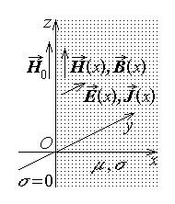
Fig. 14.25.
It is reminded that if a conducting half–space x > 0 is considered (fig. 14.25), of conductivity σ and permeability μ , and a harmonic time–varying magnetic field, of magnetic field strength
${\vec{H}}_{0}= \hat{z} H_{0}\sqrt{2} \text{sin}ωt$ ,
is applied parallel to the z axis, then the processes briefly described above determine an electromagnetic field which penetrates the conducting half–space. The field quantities inside the conductor are time– and coordinate–dependent, according with equations

$\vec{H}=\hat{z} H\left(x,t\right)=\hat{z} H_{0} \sqrt{2} e^{− α x} \text{sin} \left(ω t−α x\right) , x>0$ ,
$\vec{B}=\hat{z} B\left(x,t\right)=μ \vec{H}=\hat{z} μ H_{0} \sqrt{2} e^{− α x} \text{sin} \left(ω t−α x\right) , x>0$ ,
$\vec{E}=\hat{y} E\left(x,t\right)=\hat{y} E_{0} \sqrt{2} e^{− α x} \text{sin} \left(ω t−α x−π/4\right) , x>0$ ,
$\vec{J}=\hat{y} J\left(x,t\right)=σ \vec{E}=\hat{y} J_{0} \sqrt{2} e^{− α x} \text{sin} \left(ω t−α x−π/4\right) , x>0$ ,
where the effective values of the induced electric field and current density at the interface are
$E_{0}=\sqrt{\frac{ωμ}{2σ}} H_{0} , J_{0}=σ E_{0}=\sqrt{\frac{ωμσ}{2}} H_{0}$ ,
and the attenuation (and phase) constant is
$α= \sqrt{\frac{ωμσ}{2}}$ .
The effective values of the electromagnetic field quantities decrease exponentially with the distance x from the half–space surface as, for instance in the case of the electric current density (fig. 14.26.a),
$J\left(x\right)=J\left(0\right) e^{ − x/δ}=J_{0} e^{ − x/δ}$ ,
where
$δ=\sqrt{\frac{2}{ωμσ}}$
is the skin depth or penetration depth, which corresponds to the distance after which the electric field strength decreases e times, from a value J to a value J/e (it is reminded that $e≃2\text{.}\text{71828}\text{.}\text{.}\text{.}$ is the basis of natural logarithms). The same dependence of the effective value on position is shown by the other field vectors – the electric field strength E , the (total) magnetic flux density B , and the (total) magnetic field strength H ,
$E\left(x\right)=E\left(0\right) e^{ − x/δ}=E_{0} e^{ − x/δ}$ ,
$H\left(x\right)=H\left(0\right) e^{ − x/δ}=H_{0} e^{ − x/δ}$ ,
$B\left(x\right)=B\left(0\right) e^{ − x/δ}=B_{0} e^{ − x/δ}$ .
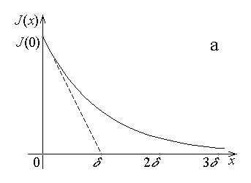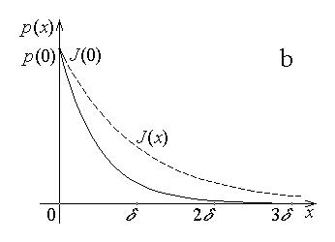
Fig. 14.26.
This nonuniform distribution of the harmonic time–varying electromagnetic field, with a steep decrease from the magnitude on the conductor surface towards its interior, constitutes the skin effect. As an illustration, at the usual main frequency f = 50 Hz, the penetration depth is δ_{Cu} ≈ 9.5 mm in copper and δ_{Fe} ≈ 1.8 mm in common iron.
3. Taking into account the rapidly decreasing non–uniform distribution of eddy currents in the conducting half–space, the dissipated power associated with their presence is also non–uniformly distributed, with a volume density
$p=σ E^{2}=σ E_{0}^{2} e^{ − 2x/δ}=p_{0} e^{ − 2x/δ}$ .
This means that the volume density of the generated heat decreases twice as rapidly as the electromagnetic field, and becomes negligible for x > 3δ (fig. 14.26.b).
Such a very rapidly decreasing distribution of the dissipated power density can be treated in a simplified manner. An equivalent distribution of the current density is considered, with a constant value over a certain depth from the conductor interface and with zero value in the rest of the conductor, so that the same power is dissipated as for the actual current density distribution. The computation gives the equivalent effective current density distribution as (fig. 14.27)
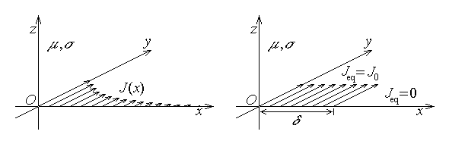
Fig. 14.27.
$J_{\text{eq}\text{.}}=\left\{ \begin{matrix}J_{0} , x<δ \\ 0 , x>δ\end{matrix}\right.$ ,
where the constant value of the effective current density is distributed up to the penetration depth
$δ=\sqrt{\frac{2}{ωμσ}}=\frac{1}{α}$
and is zero at any larger distance from the conductor surface.
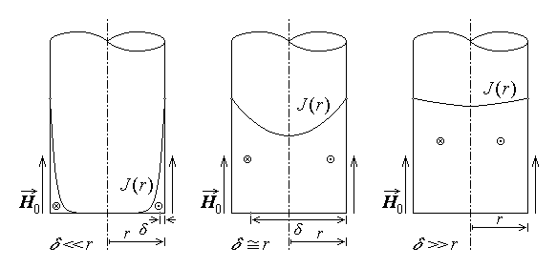
Fig. 14.28.
4. The skin effect, consisting in the concentration of the time–varying electro-magnetic field and the induced eddy currents towards the conductor periphery is present whenever an external time–varying electromagnetic field is applied on a conductor or when a time–varying electric current is carried by a conductor. A strong skin effect is present when a very important nonuniformity in the electromagnetic field distribution (in particular, the current density) occurs across the direction normal to the conductor surface – this corresponds to the case when $δ≪r$ , where r is the transverse dimension of the conductor (fig. 14.28 left). A negligible skin effect is present when the electromagnetic field distribution is practically uniform over the transverse direction of the conductor – this corresponds to the opposite inequality $δ≫r$ (fig. 14.28 right). Finally, a weak skin effect is present in a conductor when the penetration depth is comparable with the transverse dimensions of the conductor, δ ≈ r (fig. 14.28 middle).
Due to its exponential variation, the nonuniform current distribution in a conductor placed in a time–varying electromagnetic field results in an even more nonuniform distribution of the heat generated by Joule’s effect: it is practically generated into a surface layer up to a depth δ starting from the surface. However, even such a strong nonuniformity of the heat generation and its associated temperature is attenuated in time, due to the heat conduction toward the interior of the conductor and the heat losses at the conductor surface (fig. 14.29).
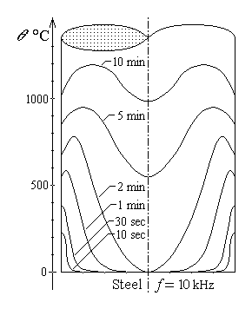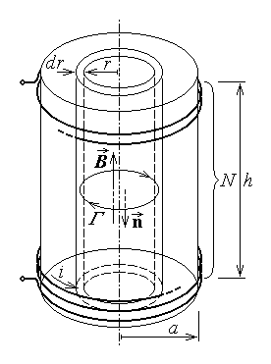
Fig. 14.29. Fig. 14.30.
5. The uniform direct induction heating represents the heating of a conductor placed in an external time–varying magnetic field, under the condition that the skin depth of the electromagnetic field generated in the conductor is large compared to the transverse dimensions of the conductor.
The inductor time–varying magnetic field is generated by a coil wound around the conductor to be heated and carrying a time–varying – usually harmonic – electric current.
Let the N turns of a solenoidal coil of length h and radius a carry a harmonic time–varying inductor current
$i\left(t\right)=I\sqrt{2} \text{sin}ωt$ ,
and let a coaxial cylindrical conducting core of radius a , permeability μ , and conductivity σ , be placed inside the coil (fig. 14.30). These data are supposed to satisfy the condition of a weak skin effect,
$δ\text{\sim }a ⇔ \sqrt{\frac{2}{ωμσ}}\text{\sim }a$ .
It is obvious that the axial magnetic field generated by the electric current – as in a solenoid – induces an electric field with circular lines in transversal planes inside the coil. With respect to the indicted reference directions, Faraday’s law invoked for such a circular electric field line Γ of radius r results successively in
$e_{Γ}=−\frac{d}{\text{dt}}Φ_{S_{Γ}} ⇔ e_{Γ}=−\frac{d}{\text{dt}}\left(−{Bπr}^{2}\right) ⇔ e_{Γ}={πr}^{2}\frac{\text{dB}}{\text{dt}}$ .
The inductor magnetic flux density of the solenoidal coil is
$B=μH=μ\frac{}{h}=\frac{μN}{h}I\sqrt{2} \text{sin}ωt$ ,
so that
$e_{Γ}={πr}^{2}\frac{μN}{h}I\sqrt{2} ω \text{cos}ωt$ .
On the other hand, the induced e.m.f along the circular field line is
$e_{Γ}=\oint{\vec{E}⋅d\vec{r}}=\oint{E \text{dr} \text{cos} 0}=E \oint{\text{dr}}=2πr E$ ,
and the electric field strength is given by
$2πr E={πr}^{2}\frac{μN}{h}I\sqrt{2} ω \text{cos}ωt ⇔ E=\frac{ωμ Nr}{2h}I\sqrt{2} \text{cos}ωt$ .
The induced electric field determines an induced current with circular closed lines and density
$\vec{J}=σ \vec{E} ⇒ J=σ E=\frac{ωμσ Nr}{2h}I\sqrt{2} \text{cos}ωt$ ,
and it is obvious that, even under such negligible skin effect conditions, the induced electric field and current density are decreasing from the conductor surface toward its interior.
The dissipated power density – that is, the density of the rate of heat generation – correspondingly is
$p=\vec{E}⋅\vec{J}=\vec{E}⋅σ\vec{E}=σ E^{2}=\frac{σ}{2} {\left(\frac{ωμ Nr}{h}I\right)}^{2} {\text{cos}}^{2}ωt$ ,
and, by using the volume element $\text{dV}=2π\text{rh} \text{dr}$ associated to the field symmetry, the rate of the heat generation, obtained by integrating the last expression over the conducting domain, is
$P=\int{p \text{dV}}=\frac{σ}{2} {\left(\frac{ωμ N}{h}I\right)}^{2} {\text{cos}}^{2}ωt \int{r^{2} 2π\text{rh} \text{dr}}=\frac{πσ}{h}$
$=\frac{πσ}{h}$ .
The (time–) average of the rate of heat generation is readily obtained since
$\frac{1}{T}\int{{\text{cos}}^{2}ωt \text{dt}}=\frac{1}{2T}\int{\left[1+\text{cos} 2ωt\right] \text{dt}}=\frac{1}{2T} t|_{ 0}^{ T}+\frac{1}{4ωT} \text{sin} 2ωt|_{ 0}^{ T}=$
$=\frac{1}{2T}T+\frac{1}{8π}\left(\text{sin} 4π−\text{sin} 0\right)=\frac{1}{2}$ .
The average rate of heat generation is thus
$P_{\text{av}}=πσ$ ,
with the density of the average rate of heat generation given by
$p_{\text{av}}=\frac{P_{\text{av}}}{V}=\frac{P_{\text{av}}}{π a^{2}h}=\frac{σ}{8} {\left(\frac{ωμ NIa}{h}\right)}^{2}$ .
6. The equivalent circuit of the (non–ideal) coil with the conducting solid core includes supplementary elements, corresponding to the power transferred to the inner conductor and dissipated as heat. The coil inductance is that of a solenoid,
$L=\frac{μ N^{2}π a^{2}}{h}$ ,
but the equivalent coil resistance includes, besides the winding resistance r , the resistance R_{loss} corresponding to the power dissipated into the core,
$R=r+\frac{P_{\text{av}}}{I^{2}}=r+\frac{πσ {\left(ωμ N\right)}^{2}a^{4}}{8h}=r+R_{\text{loss}}$ .
The phasor diagram of the inductor coil is that presented in fig. 14.31, where the phase difference of the current, lagging after the voltage, depends on the load constituted by the conducting solid core where eddy currents are induced; it varies between the extreme values
$ϕ_{\text{min}}=\text{arctan}\frac{ωL}{r+R_{\text{loss}}} , ϕ_{\text{max}}=\text{arctan}\frac{ωL}{r}$ .
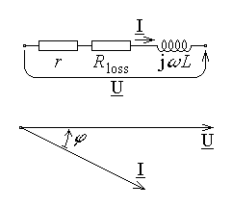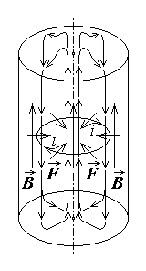
Fig. 14.31. Fig. 14.32.
Correspondingly, the power factor of the inductor coil varies from the minimum value
$\text{cos}ϕ_{\text{min}}=\frac{1}{\sqrt{1+{\left(ωL/r\right)}^{2}}}$ ,
when the load (conducting core) is not present, to the maximum value (currently around 0.8)
$\text{cos}ϕ_{\text{max}}=\frac{1}{\sqrt{1+{\left(ωL/r+R_{\text{loss}}\right)}^{2}}}$ ,
in the presence of the load. The effective power factor can be improved if capacitors are parallel connected to the inductor coil in order to compensate the reactive power associated with the coil inductance.
Finally, the electric efficiency, defined as the ratio of the (average) power dissipated into the load and the total active power received by the coil, is
$η_{\text{el}}=\frac{P_{\text{av}}}{P}=\frac{R_{\text{loss}}I^{2}}{\left(r+R_{\text{loss}}\right) I^{2}}=1−\frac{r}{R_{\text{loss}}}=1−\frac{8h r}{πσ {\left(ωμ N\right)}^{2}a^{4}}$ ,
and reaches values as high as 95% .
7. The eddy currents induced inside the conducting solid core are placed in the inductor magnetic field and the conductor is therefore subjected to electromagnetic (Laplace) forces
$d\vec{F}=\text{di} \left(d\vec{r}×\vec{B}\right)$ .
As the fig. 14.32 suggests, the electromagnetic forces are constriction forces, tending to press the conducting solid core from the periphery towards the axis. If the load is represented by a recipient containing a melted metal, then such constriction forces impose fluid currents to flow from the periphery towards the axis, then upward in the central region – determining a bump at the surface – and downward at the periphery. Such convection currents associated with the electromagnetic forces are beneficial – they result in a temperature and composition uniformisation of the melted metal.
8. The surface direct induction heating represents the heating of a conductor placed in an external time–varying magnetic field, under the condition that the skin depth of the electromagnetic field generated in the conductor is small compared to the transverse dimensions of the conductor.
The inductor time–varying magnetic field is generated by a coil wound around the conductor to be heated and carrying a harmonic time–varying electric current of high frequency. Let again a solenoidal coil of N turns, length h , and radius a be considered, which carries a harmonic time–varying inductor current
$i\left(t\right)=I\sqrt{2} \text{sin}ωt$ ,
and let a coaxial cylindrical conducting core of radius a , permeability μ , and conductivity σ , be placed inside the coil (fig. 14.33). It is obvious that the axial magnetic field generated by the electric current – as in a solenoid – is tangential to the surface of the conducting solid core and, if the skin depth of the electromagnetic field inside it is very small with respect the core radius,
$δ≪a ⇔ \sqrt{\frac{2}{ωμσ}}≪a$ ,
then the conducting solid core can be treated locally as a half–space. The induced electric field and eddy currents again follow circular lines in transversal planes inside the coil, but under these conditions of strong skin effect, they are practically concentrated into a layer of thickness δ .
The effective value of the outer magnetic field strength at the core surface is
$H_{0}=\frac{}{h}$ ,
and, according with the preceding analysis, the effective value of the induced electric field strength at the core surface is
$E_{0}=\frac{H_{0}}{σδ}=\sqrt{\frac{ωμ}{2σ}} H_{0}$ .
Under the condition of a strong skin effect, the surface effective value of the electric field strength, along with the corresponding effective value of the induced current density,
$J_{0}=σ E_{0}=σ \sqrt{\frac{ωμ}{2σ}} H_{0}=\sqrt{\frac{ωμσ}{2}} H_{0}$ ,
are practically constant over a skin depth δ , and are equal to zero after this distance to the core surface.
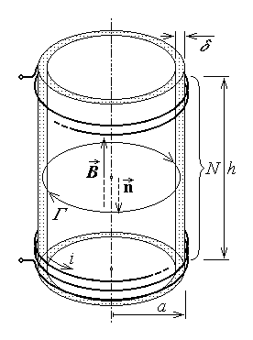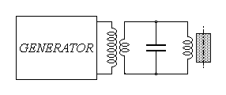
Fig. 14.33. Fig. 14.34.
The power density dissipated into heat inside the conducting core is thus
$p=\vec{E}⋅\vec{J}=E_{0}\sqrt{2} \text{cos}ωt J_{0}\sqrt{2} \text{cos}ωt=\sqrt{\frac{ωμ}{2σ}} \sqrt{\frac{ωμσ}{2}} 2H_{0}^{2}{\text{cos}}^{2}ωt=$
$=ωμ {\left(\frac{}{h}\right)}^{2} {\text{cos}}^{2}ωt$ .
The corresponding (time–) average density of the rate of heat generation is readily obtained as
$p_{\text{av}}=\frac{ωμ}{2} {\left(\frac{}{h}\right)}^{2}$ ,
where the time–average value
$\frac{1}{T}\int{{\text{cos}}^{2}ωt \text{dt}}=\frac{1}{2}$
was considered. Finally, the (time–) average rate of heat generation is obtained by integrating the above average density over the volume V_{δ} where the eddy currents are concentrated,
$P_{\text{av}}=p_{\text{av}} V_{δ}=\frac{ωμ}{2} {\left(\frac{}{h}\right)}^{2} 2πaδ h=\frac{πωμ N^{2}I^{2}a}{h}\sqrt{\frac{2}{ωμσ}}=$
$=\frac{{πN}^{2}I^{2}a}{h}\sqrt{\frac{2ωμ}{σ}}$ .
This value corresponds to an average transmitted surface power density
$p_{S \text{av}}=\frac{P_{\text{av}}}{S_{\text{lat}}}=\frac{P_{\text{av}}}{2πa h}={\left(\frac{}{h}\right)}^{2}\sqrt{\frac{ωμ}{2σ}}$ .
9. The equivalent circuit of the coil with the conducting solid core is derived under the condition of the strong skin effect. The coil inductance is similar to that of a solenoid, but one must take into consideration that the magnetic field is as well restricted to a practically constant field strength – equal to its surface value – up to a skin depth inside the core. This corresponds to an effective cross section area
$S_{\text{eff}}=2π aδ$ ,
and to an inductance
$L=\frac{μ N^{2}2π aδ}{h}=\frac{2πμ N^{2}a}{h}\sqrt{\frac{2}{ωμσ}}=\frac{2{πN}^{2}a}{h}\sqrt{\frac{2μ}{ωσ}}$ .
Similar to the case of uniform induction heating, the equivalent coil resistance includes, besides the winding resistance r at the operating (angular) frequency ω , the resistance R_{loss} corresponding to the power dissipated into the core,
$R=r+\frac{P_{\text{av}}}{I^{2}}=r+\frac{{πN}^{2}a}{h}\sqrt{\frac{2ωμ}{σ}}=r+R_{\text{loss}}$ .
The phasor diagram of the inductor coil is again that presented in fig. 14.31, where the phase difference of the current, lagging after the voltage, depends on the load constituted by the conducting solid core where eddy currents are induced; it varies between the extreme values
$ϕ_{\text{min}}=\text{arctan}\frac{ωL}{r+R_{\text{loss}}} , ϕ_{\text{max}}=\text{arctan}\frac{ωL}{r}$ .
Correspondingly, the power factor of the inductor coil varies from the minimum value
$\text{cos}ϕ_{\text{min}}=\frac{1}{\sqrt{1+{\left(ωL/r\right)}^{2}}}$ ,
when the load (conducting core) is not present, to the maximum value (currently around 0.8)
$\text{cos}ϕ_{\text{max}}=\frac{1}{\sqrt{1+{\left(ωL/r+R_{\text{loss}}\right)}^{2}}}$ ,
in the presence of the load.
The harmonic time–varying currents of high frequency (around 10 KHz) are generated by revolving electric generators or even electronic generators. An intermediary transformer is used, which reduces the voltage but increases the current injected into the inductor coil (fig. 14.34). An appropriate capacitor is parallel connected to the inductor coil in order to constitute a resonant circuit at the operating frequency, so that the transformer load is purely resistive.
Finally, the electric efficiency, defined as the ratio of the (average) power dissipated into the load and the total active power received by the coil, is
$η_{\text{el}}=\frac{P_{\text{av}}}{P}=\frac{R_{\text{loss}}I^{2}}{\left(r+R_{\text{loss}}\right) I^{2}}=1−\frac{r}{R_{\text{loss}}}=1−\frac{8h r}{πσ {\left(ωμ N\right)}^{2}a^{4}}$ .
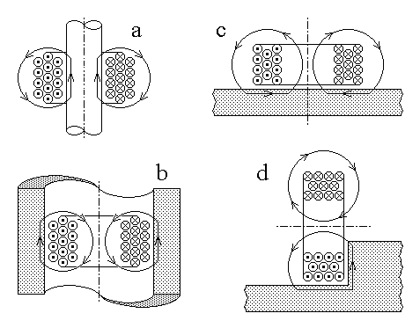
Fig. 14.35.
10. The structure of the induction heating equipment depends on the shape of the conductors to be heated and generally operate at an inductor efficiency around 70 – 85 % . Some constructive solutions are presented in fig. 14.35 : external inductor (a), internal inductor (b), upper inductor (c), lateral inductor (d).
The electric efficiency can be improved if the aspect ratios of the heating equipment are close to
$\frac{\text{Coil} \text{radius}}{\text{Load} \text{radius}}≈1 , \frac{\text{Coil} \text{height}}{\text{Load} \text{height}}≤1$ ,
and a good conductor (usually – copper) is used for the coil winding. As well, the electric efficiency is higher for loads with greater permeability μ and resisitivity ρ . It is worth mentioning that the high relative permeability of ferromagnetic substances drops to an approximately unitary value when the substance turns paramagnetic, at temperatures above the so called Curie temperature.
The surface heating is restrained near the surface for small time intervals only after the current is applied; as duration of heating increases, the heat is transmitted towards the interior of the conducting core and the temperature distribution tends to go from a strongly nonuniform toward a uniform distribution, as illustrated already in fig. 14.29.

14.3.4. Direct dielectric heating
1. The direct dielectric heating is the direct heating process where the generated heat comes from the power loss associated with the successive equivalent hysteresis loops travelled along in a time–varying (usually harmonic) electric field.
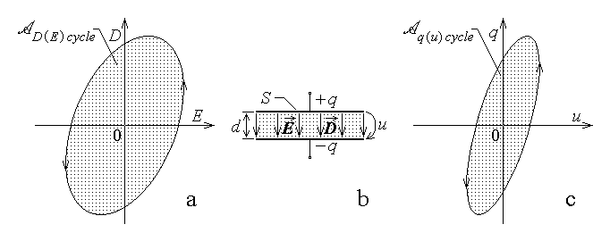
Fig. 14.36.
As discussed previously, in the first section of this chapter, the so called electric viscosity of the substance is present in high–frequency alternating electric fields . The electric viscosity consists in the fact that a sudden change in the applied electric field strength E induces a corresponding change in the (electric) polarisation (and, therefore, in the electric displacement D ), but only after a certain delay. It means that the maximum electric displacement is reached after some delay from the moment of the maximum electric field strength. In an alternating electric field, this phenomenon can be described by a hysteresis–like diagram D(E) like the one presented in fig. 14.36.a, and result in an irreversible transfer of electromagnetic energy into heat, developed in the electrically viscous substance just like for hysteretic substances. When the electric field vectors have a harmonic time variation, the electric viscosity is translated into a phase difference of the electric displacement after the electric field strength. In turn, this can be described by a so called complex permittivity
$\underline{ε}=ε'−jε\text{= lline \{underline \{ε\}\} rline `e rSup \{ size 8\{` - `j`δ\} \} \} \{}$ .
2. Essentially, the equipment for direct dielectric heating consists in a parallel–plate capacitor, of plate area S and distance d between plates, where the insulator is represented by the load – the object to be heated (fig. 14.36.b). If a voltage u is applied between the capacitor plates and corresponding charges ±q are developed on the capacitor plates, then according with the argument presented in the derivation of the capacitance of such a capacitor (section 6.1), the following relations are valid
$u=E d , q=ε E S=D S$ .
The D(E) hysteresis (fig. 14.36.a) thus turns into a similar q(u) hysteresis (fig. 14.36.c).
Supposing that a periodic alternative electric voltage of frequency f is applied to the capacitor, so that a periodic alternative electric field is applied to the load of volume V = Sd , the heat developed in the load during a time interval τ is, according with Warburg’s theorem,
$Q=τ {fA}_{ D\left(E\right) \text{cycle}} V$ .
Taking into account that the field–related quantities are linked to the circuit–related quantities so that
$q u=D S⋅E d=D E⋅S d=D E⋅V$ ,
it follows that the heat developed in the load during a time interval τ can be equivalently computed as
$Q=τ {fA}_{ q\left(u\right) \text{cycle}}$ .
A loss resistance corresponds to the electric power transferred into heat, according to the energy balance equation valid for a period,
$\frac{U^{2}}{r_{ \text{hyst}}}T=T {fA}_{ q\left(u\right) \text{cycle}} ⇔ r_{ \text{hyst}}=\frac{U^{2}}{{fA}_{ q\left(u\right) \text{cycle}}}$ .
The equivalent circuit of the equipment for direct dielectric heating is that of a nonideal capacitor: the capacitance
$C=\frac{ε S}{d}$
is parallel connected to a loss resistance R (fig. 14.37.a). The latter corresponds to the losses associated with the hysteresis–like behaviour of the electrically viscous substance and to the current carried by the nonideal insulator, of non–zero conductivity σ ,
$r_{\text{leakage}}=\frac{d}{σ S}$ ,
so that
$\frac{1}{R}=\frac{1}{r_{\text{hyst}}}+\frac{1}{r_{\text{leakage}}}$ .
Under harmonic time–varying conditions, and using complex representatives of the quantities involved, the complex operating equation is
$\underline{I}=\underline{Y} \underline{U} ⇔ \underline{I}=\left(\frac{1}{R}+jωC\right) \underline{U}$ ,
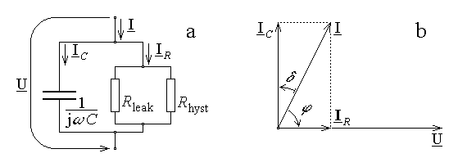
Fig. 14.37.
and the phasor diagram of the equivalent circuit is that presented in fig. 14.37.b. The current–to–voltage phase difference is expressed as
$ϕ=\frac{π}{2}−δ$ ,
where δ is the (total) loss angle of the capacitor, and the component currents are expressed as
$I_{C}=\frac{U}{X_{C}}=ω C U=2πfC U , I_{R}=\frac{U}{R}=I_{C}\text{tan}δ=2πfC U \text{tan}δ$ .
The active power developed into the load and transformed into heat there, corresponding to the resistive current, is
$P=U I_{R}=2πfC U^{2}\text{tan}δ$ ,
which means that the equivalent resistance to be considered in the heating process can be expressed as
$R_{e}=\frac{U^{2}}{P}=\frac{U^{2}}{2πfC U^{2}\text{tan}δ}=\frac{1}{2πfC \text{tan}δ}=\frac{X_{C}}{\text{tan}δ}$ .
The active power P is therefore simply related to the reactive power Q by the equation
$P=\frac{U^{2}}{R_{e}}=\frac{U^{2}\text{tan}δ}{X_{C}}=Q \text{tan}δ$ .
3. There are some additional aspects worth considering when the operation of the heating equipment is analysed.
The electric field of the capacitor is actually non–uniform: there are end effects present, consisting in the fact that toward the edges of the capacitor plates the electric field lines do not follow straight lines normal to the plates, but are curved outside the domain between the plates (fig. 14.38.a). For the same voltage u , the electric field strength is generally inversely proportional to the length of the field line,
$u=\int{\vec{E}⋅d\vec{r}}=\int{E \text{dr} \text{cos}0}≃E\int{\text{dr}}=E l ⇔ E≃\frac{u}{l}$ .
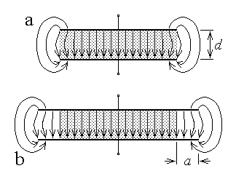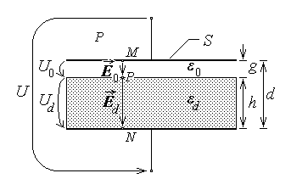
Fig. 14.38. Fig. 14.39.
Accordingly, the density of the generated heat is non–uniform, which results in a non–uniform heating of the load. One way to circumvent this difficulty is to enlarge the capacitor plates outside the limits of the load (fig. 14.38.b). The uniform heating of the load is however obtained with the price of a reduced electric efficiency, since the ratio of the load volume to the volume of active electric field is less than unity. A trade-off between heating efficiency and uniformity is represented by an enlargement of the capacitor plates outside the load limits given by
$a≥\frac{d}{2π} \text{ln}\frac{\text{135}}{p}$ ,
where d is the distance between the capacitor plates and p is the allowed percentage of heating non–uniformity.
The space between the capacitor plates is not completely filled by the load: there always remains an air gap between at least one plate (usually – the upper plate) and the load (fig. 14.39), which results again in a non–uniform field inside the capacitor. By assuming straight field lines normal to the capacitor plates in the domain between the plates, and neglecting the outer field, then an argument based on Gauss’s law, similar to that used in the derivation of the capacitance of the parallel–plate capacitor, results in a constant value of the electric displacement between the capacitor plates, namely
$D=\frac{q}{S}$ .
Accordingly, the electric field strength assumes different values E₀ in the air gap and E_{d} in the load of relative permittivity ε_{r} , since
$D=ε_{0}E_{0}=ε_{0}ε_{r}E_{d} ⇔ \frac{E_{d}}{E_{0}}=\frac{1}{ε_{r}}$ .
On the other hand, if g is the length of the airgap and h is the width of the load, such that d = g + h , then the electric voltage between the plates is
$u=\int{\vec{E}⋅d\vec{r}}=\int{E \text{dr} \text{cos}0}=\int{E_{0}\text{dr}}+\int{E_{d}\text{dr}}=E_{0}g+E_{d}h$ .
The last equations result in
$\frac{E_{d}h}{h}=\frac{E_{0}g}{ε_{r}g}=\frac{E_{d}h+E_{0}g}{h+ε_{r}g}=\frac{u}{h+ε_{r}g}$ ,
whence
$E_{d}=\frac{u}{h+ε_{r}g}=\frac{u}{h+g}\frac{d}{h+ε_{r}g}=\frac{u}{d}\frac{1}{h/d+ε_{r}g/d}=\frac{E_{d \text{full}}}{h/d+ε_{r}g/d}$ .
Thus, the electric field strength in the load E_{d} is smaller than the value E_{d full} , corresponding to the case when the load completely fills the space between the capacitor plates. A practical indication can be formulated then: under a given voltage U , a proper dielectric heating, which requires a definite value E_{d} of the electric field strength in the load, can be adjusted by controlling the air gap g . On the other hand, a large value of the relative permittivity ε_{r} of the load determines a greater electric field strength in the air gap, which imposes limits on the applied voltage, in order to avoid the electric breakdown of the air gap (that is, the ignition of an electric current in the ionised airgap).
4. The dissipated power (that is the rate of heat generation) in the load is
$P=2πfC U^{2}\text{tan}δ=2πf\frac{ε S}{d} U^{2}\text{tan}δ=2πfSd ε {\left(\frac{U}{d}\right)}^{2}\text{tan}δ=4πfV \frac{ε E^{2}}{d}\text{tan}δ$ ,
and it increases along with the increasing of loss angle δ , (average) electric field strength E , permittivity ε , and frequency f .
The increase of the (average) electric field strength is limited by the danger of dielectric breakdown – especially in the air gap. As well, the increase of the operating frequency is limited by the fact that, in order that the equipment operate efficiently, the frequency must be around the resonant frequency of the equivalent circuit,
$f_{0}=\frac{1}{2π\sqrt{LC}}$ .
Since the capacitance value C₀ is imposed by the load and there exists a minimal value of the inductance L_{min} for a given configuration of the circuit, it follows that there exists a maximum acceptable operating frequency,
$f_{\text{max}}=\frac{1}{2π\sqrt{L_{\text{min}}C_{0}}}$ ,
which lies in the range of 100 MHz .
The loss angle δ and the (relative) permittivity ε_{r} depend on the load substance and its physical state. For example, for usual casting core materials subjected to drying by dielectric heating, these parameters depend on the temperature and, consequently, on the drying level of the core (fig. 14.40). In this particular case one can notice that the load overheating is avoided, since the loss tangent tanδ decreases sharply above 100°C . The effect is a uniform heating of the load, since the heating is concentrated locally around points where the core is still wet and the loss tangent is greater, and is significantly lower where great values of temperature are already reached and the core is already dry.
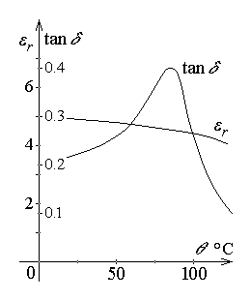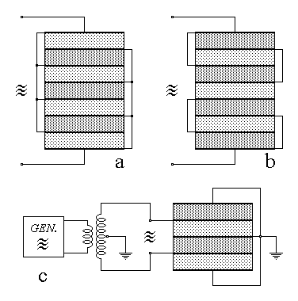
Fig. 14.40. Fig. 14.41.
The electric voltage is generated by special–purpose electronic generators of very high frequency (of the order of 10 MHz), and is applied to the load capacitor via a matching transformer, intended to compensate, by its inductive impedance, the capacitive impedance of the load. The load is energised in groups of loads, introduced in capacitors connected in different ways: parallel (fig. 14.41.a), series–parallel (fig. 14.41.b), or with centre tap transformer (fig. 14.41.c).

