13. ELECTRIC MACHINES AND APPARATUS

- 13.1. The electric transformer
1. The electric transformer is a static electric equipment which modifies the parameters of the time–varying (in particular, alternating current) electromagnetic energy (voltage and current; sometimes the number of phases). Its operation is based on the the electromagnetic induction phenomenon associated with time–varying electromagnetic quantities (in particular, harmonic time–varying quantities).
The simplest electric transformer consists in a magnetic circuit where the magnetic field is associated with two current carrying coils (fig. 13.1). The common use of the transformer supposes that one coil – named primary coil – receives electromagnetic energy at terminals, while the other coil – called secondary coil – delivers electromagnetic energy at its terminals. The electromagnetic energy is transferred between the primary and the secondary coil (and between the associated circuits) according to the following chain of phenomena: the time–varying electric current injected into the primary coil generates a magnetic flux in the magnetic circuit; the time–varying magnetic flux induces in the turns of the secondary coil an e.m.f. which determines a current in it when the secondary circuit is closed. In fact the phenomena are more complex, since the secondary current also influences the total magnetic flux in the magnetic circuit, and therefore infuences, by an associated induced e.m.f., the primary circuit.
The magnetic circuit is manufactured using ferromagnetic substances of high permeability and narrow hysteresis cycle, so that the power loss associated with the magnetic hysteresis, proportional to the area of the hysteresis cycle, is minimized. The magnetic constitutive equation characterising the B – H relationship is essentialy nonlinear; however, for the sake of simplicity, a linear magnetic constitutive equation will be considered in the following for the magnetic circuit.
2. Let a magnetic circuit with two coils be considered as in fig. 13.1: the N₁ turns of the primary coil carry the time–varying current i₁ when the voltage u₁ is applied at its terminals, and the N₂ turns of the secondary coil carry the time–varying current i₂ when delivering the voltage u₂ at its terminals. The current and voltage reference directions are associated according to the load rule for the primary coil and according to the source rule for the secondary coil.
The ampere–turns N₁i₁ and N₂i₂ of the two coils generate in the magnetic circuit a time–varying common magnetic flux φ , according with Kirchhoff’s (magnetic) voltage theorem,
$R_{m}φ=N_{1}i_{1}+N_{2}i_{2}$ ,
where R_{m} is the (magnetic) reluctance of the magnetic circuit. The magnetic fluxes of each coil include, however, additional leakage fluxes φ_{σ1} and φ_{σ2} , corresponding to leakage magnetic field lines closing around each coil only – these leakage fluxes are proportional to the current in the associated coil as for an ordinary coil. The total magnetic flux of each coil,
$φ_{1}=N_{1}φ+φ_{σ1}=N_{1}φ+L_{σ1}i_{1} , φ_{2}=N_{2}φ+φ_{σ2}=N_{2}φ+L_{σ2}i_{2}$ ,
induce in each coil, along the contours Γ ₁ and Γ ₂ , the electromotive voltages
$e_{1}=−\frac{{dφ}_{1}}{dt}=−N_{1}\frac{dφ}{dt}−L_{σ1}\frac{{di}_{1}}{dt} , e_{1}=−\frac{{dφ}_{1}}{dt}=−N_{1}\frac{dφ}{dt}−L_{σ1}\frac{{di}_{1}}{dt}$ .
On the other hand, Kirchhoff’s voltage equations along the same contours are
$r_{1}i_{1}−u_{1}=e_{1} , r_{2}i_{2}+u_{2}=e_{2}$ ,

where r₁ and r₂ are the corresponding coil resistances. This way, it results that the transformer is characterised by the following system of equations
$\left\{ \begin{matrix}R_{m}φ =N_{1}i_{1}+N_{2}i_{2}\underset{}{} \\ u_{1}=N_{1}\frac{dφ}{dt}+L_{σ1}\frac{{di}_{1}}{dt}+r_{1}i_{1} \\ u_{2}=−N_{2}\frac{dφ}{dt}−L_{σ2}\frac{{di}_{2}}{dt}−r_{2}i_{2}\end{matrix}\right.$
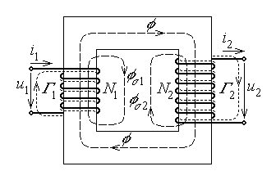
Fig. 13.1.

The transformer is designed to operate as efficiently as possible: it means that the resistive voltages are negligible with respect to the corresponding induced voltages, with a view to reduce the power dissipation in the coil resistances; as well, the leakage fluxes are negligible with respect to the common flux, with a view to reduce magnetic losses, and a corresponding relation is valid for the associated induced voltages. It follows that, with sufficient accuracy,
$u_{1}≃N_{1}\frac{dφ}{dt}$ .
Let now the applied voltage be a harmonic time–varying voltage
$u_{1}\left(t\right)=U_{1}\sqrt{2} \text{sin}ωt$ .
According with the preceding equation, the primary voltage is proportional to the time–derivative of the common magnetic flux φ , which is then also a harmonic time–varying flux. Invoking the rule of derivation of harmonic time–varying functions, the effective voltage is N₁ω times the effective flux, and the initial phase of the voltage is increased by π/2 with respect to that of the flux. By reversing these relations, it result that the common magnetic flux is
$φ\left(t\right)≃\frac{1}{N_{1}}\int{u_{1} \text{dt}}=\frac{U_{1}\sqrt{2}}{{ωN}_{1}} \text{sin}\left(ωt−\frac{π}{2}\right)$ ,
depending on the primary voltage only. On the other hand. the common flux is related to the total ampere–turns of the magnetic circuit,
$R_{m}φ=N_{1}i_{1}+N_{2}i_{2}$ ,
meaning that the latter depends on the applied voltage u₁ only, and is independent on the individual currents i₁ and i₂ ,
$N_{1}i_{1}+N_{2}i_{2}=f\left(u_{1}\right)$ .
The dependence is still valid when the transformer operates under open circuit conditions, corresponding to equations i₂ = 0 and i₁ = i₁₀ , and is usualy represented in terms of the so called open circuit ampere–turns,
$N_{1}i_{1}+N_{2}i_{2}=N_{1}i_{\text{10}}=f\left(u_{1}\right)$ .
The open circuit primary current is thus related to the common magnetic flux by an equation like
$N_{1}i_{\text{10}}=R_{m}φ$ .
It must be emphasised that this relation is valid in what concerns the effective values only; the relation between their initial phases is influenced by the fact that the ampere–turns generating the common magnetic flux have to cover also the inherent power losses present in the operation even under open circuit conditions. Indeed, there are general power losses associated with the harmonic time–varying operation of the magnetic circuit: hysteresis losses are determined in the ferromagnetic substance of the magnetic circuit by the applied alternating magnetic field, and additional dissipation losses are also present in the conducting ferromagnetic substance of the magnetic circuit, determined by the so called eddy currents generated by the voltages induced by the time–varying common magnetic flux. The open circuit primary current can be therefore decomposed into a resistive (loss) component i_{r} of the same initial phase as the applied voltage and an inductive (magnetisation) component i_{μ} with the same initial phase as the common flux,
$i_{\text{10}}=i_{r}+i_{μ}$ ,
corresponding to the applied primary voltage u₁ and to the common magnetic flux φ .
The above considerations can be included in the following time–varying equations
$\left\{ \begin{matrix}u_{1}=N_{1}\frac{dφ}{dt}+L_{σ1}\frac{{di}_{1}}{dt}+r_{1}i_{1}=−e_{1}+L_{σ1}\frac{{di}_{1}}{dt}+r_{1}i_{1} \\ −u_{2}=N_{2}\frac{dφ}{dt}+L_{σ2}\frac{{di}_{2}}{dt}+r_{2}i_{2}=−e_{2}+L_{σ2}\frac{{di}_{2}}{dt}+r_{2}i_{2} \\ R_{m}φ =N_{1}i_{1}+N_{2}i_{2}=N_{1}i_{\text{10}}=N_{1}\left(i_{r}+i_{μ}\right)\overset{}{} \end{matrix}\right.$ .
Corresponding complex equations that describe the operation of the transformer can be immediately derived, to be completed with the complex equation for the load circuit connected at the secondary terminals,
$\left\{ \begin{matrix}{\underline{U}}_{1}={jωN}_{1}\underline{Φ}+{jωL}_{σ1}{\underline{I}}_{1}+r_{1}{\underline{I}}_{1}=−{\underline{E}}_{1}+{jωL}_{σ1}{\underline{I}}_{1}+r_{1}{\underline{I}}_{1} \\ −{\underline{U}}_{2}={jωN}_{2}\underline{Φ}+{jωL}_{σ2}{\underline{I}}_{2}+r_{2}{\underline{I}}_{2}=−{\underline{E}}_{2}+{jωL}_{σ2}{\underline{I}}_{2}+r_{2}{\underline{I}}_{2} \\ R_{m}\underline{Φ} =N_{1}{\underline{I}}_{1}+N_{2}{\underline{I}}_{2}=N_{1}{\underline{I}}_{\text{10}}=N_{1}\left({\underline{I}}_{r}+{\underline{I}}_{μ}\right) \\ {\underline{U}}_{2}={\underline{Z}}_{2} {\underline{I}}_{2} \end{matrix}\right.$ .
An extremely simplified approach to the operation of a transformer takes onto account two simplifying assumptions: (1°) the voltages over the coil resistances and leakage inductances are negligible with respect to the e.m.f’s induced by the common magnetic flux; (2°) the open circuit primary current is negligible as compared with the primary current under usual operating conditions. The simplified set of complex equations of such an idealised transformer is therefore
$\left\{ \begin{matrix} {\underline{U}}_{1}≃{jωN}_{1}\underline{Φ} \\ −{\underline{U}}_{2}≃{jωN}_{2}\underline{Φ} \\ N_{1}{\underline{I}}_{1}+N_{2}{\underline{I}}_{2}≃0\end{matrix}\right.$ ,
whence the simplified input – output equations are derived as
$\frac{{\underline{U}}_{1}}{{\underline{U}}_{2}}≃−\frac{N_{1}}{N_{2}} ⇒$ $\frac{U_{1}}{U_{2}}≃\frac{N_{1}}{N_{2}}$ ,
$\frac{{\underline{I}}_{1}}{{\underline{I}}_{2}}≃−\frac{N_{2}}{N_{1}} ⇒$ $\frac{I_{1}}{I_{2}}≃\frac{N_{2}}{N_{1}}$ :
the ratio of the effective voltages or currents at terminals is approximately determined by the turns ratio.
The so called ideal transformer can now be considered (fig. 13.2), as an ideal circuit element which transfers, with no losses, all the power received at its input

terminals as the power delivered at its output terminals,
$\frac{{\underline{E}}_{1}}{{\underline{E}}_{2}}=\frac{N_{1}}{N_{2}} , \frac{{\underline{I}}_{1}}{{\underline{I}}_{2}}=− \frac{N_{2}}{N_{1}}$ .
Indeed, since
${\underline{U}}_{1}=−{\underline{E}}_{1} , {\underline{U}}_{2}={\underline{E}}_{2}$ ,
it follows that, for the ideal transformer,
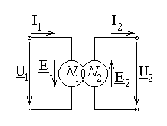
Fig. 13.2.

${\underline{S}}_{1}={\underline{U}}_{1}{\underline{I}}_{1}^{}=−\frac{N_{1}}{N_{2}}{\underline{U}}_{2} \left(−\frac{N_{2}}{N_{1}}{\underline{I}}_{2}^{}\right)={\underline{U}}_{2}{\underline{I}}_{2}^{}={\underline{S}}_{2}$ .
An equivalent circuit of the nonideal transformer can be constructed according to the complete set of equations. The first three equations are linked by the intermediary of the common magnetic flux coupling the two coils and their asssociated circuits,
$jω \underline{Φ}=−\frac{{\underline{E}}_{1}}{N_{1}}=−\frac{{\underline{E}}_{2}}{N_{2}} ⇔$
$⇔ jω \underline{Φ}=\frac{{\underline{U}}_{1}−r_{1}{\underline{I}}_{1}−{jωL}_{σ1}{\underline{I}}_{1}}{N_{1}}=\frac{−{\underline{U}}_{2}−r_{2}{\underline{I}}_{2}−{jωL}_{σ2}{\underline{I}}_{2}}{N_{2}}$ .
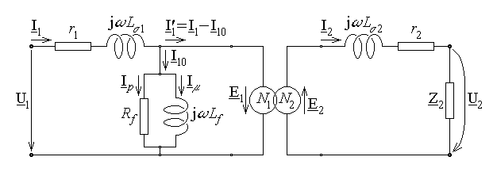
Fig. 13.3.
On the other hand, the relations on the ampere–turns provide the equations for the currents,
$N_{1}\left({\underline{I}}_{1}−{\underline{I}}_{\text{10}}\right)=N_{2}{\underline{I}}_{2} \text{and} {\underline{I}}_{\text{10}}={\underline{I}}_{r}+{\underline{I}}_{μ}={\underline{Y}}_{\text{10}}{\underline{E}}_{1}$ .
The resulting equivalent circuit of the transformer is presented in fig. 13.3, where it was taken into account the fact that the primary open circuit current ${\underline{I}}_{\text{10}}$ has to be present even under open circuit conditions at the secondary terminals, when ${\underline{I}}_{2}=0$ . The operation of this circuit is obviusly described by the system of complex equations presented before.
3. The characteristics of the main elements that appear in the equivalent circuit can be derived from specific test measurements performed on the transformer.
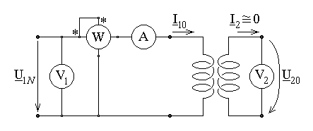
Fig. 13.4.
The primary voltage, current and active power, along with the secondary voltage, are measured under open circuit conditions $\left({\underline{I}}_{2}=0\right)$ and normal (rated) primary effective voltage U_{1N} , in a configuration as that presented in fig. 13.4. It corresponds to the reduced equivalent circuit in fig. 13.5, where the absence of a voltage over the series secondary impedance $r_{2}+{jωL}_{σ2}$ and the negligible value of the voltage over the series primary impedance $r_{1}+{jωL}_{σ1}$ , determined by a negligible primary open circuit current ${\underline{I}}_{\text{10}}$ , were taken into account. Consequently, the complex equations give
${\underline{U}}_{\text{20}}={\underline{E}}_{2}=\frac{N_{2}}{N_{1}}{\underline{E}}_{1}=\frac{N_{2}}{N_{1}}\left[−{\underline{U}}_{1N}+{\underline{I}}_{\text{10}}\left(r_{1}+{jωL}_{σ1}\right)\right]≃− \frac{N_{2}}{N_{1}}{\underline{U}}_{1N}$ .

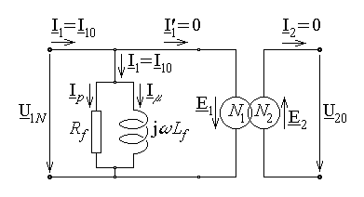
Fig. 13.5.

The turns ratio results then simply as
$K=\frac{N_{1}}{N_{2}}≃\frac{\left|{\underline{U}}_{1N}\right|}{\left|{\underline{U}}_{\text{20}}\right|}=\frac{U_{1N}}{U_{\text{20}}}$ .
Under the same assumptions, the active power measured by the wattmeter corresponds to the power dissipated into the resistance R_{f} associated to the hysteresis and eddy current losses in the magnetic circuit, so that this can be readily computed as

$P_{\text{10}}=G_{f} U_{1N}^{2} ⇔ R_{f}=\frac{1}{G_{f}}=\frac{U_{1N}^{2}}{P_{\text{10}}}$ .
Finaly, from the measured value of the open circuit admittance, the magnetising reactance (and inductance L_{μ} ) can be computed as
$Y_{0}=\frac{I_{\text{10}}}{U_{1N}}=\sqrt{G_{f}^{2}+B_{μ}^{2}} ⇔ {ωL}_{μ}=\frac{1}{B_{μ}}=\frac{1}{\sqrt{{\left(I_{\text{10}}/U_{1N}\right)}^{2}−{\left(P_{\text{10}}/U_{1N}^{2}\right)}^{2}}}$ .
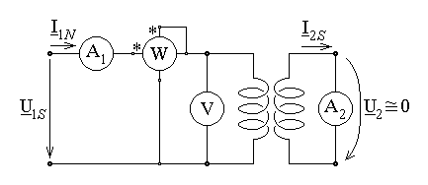
Fig. 13.6.
The primary voltage, current and active power, along with the secondary current, are then measured under short circuit conditions $\left({\underline{U}}_{2}=0\right)$ and normal (rated) primary current I_{1N} , in a configuration as that represented in fig. 13.6. It corresponds to the reduced equivalent circuit in fig. 13.7, where the negligible value (about a few percents) of the open circuit primary current with respect to the normal (rated) primary current was accounted for. Consequently, the complex equations give
$K=\frac{N_{1}}{N_{2}}=\frac{\left|{\underline{I}}_{2S}\right|}{\left|{\underline{I}}_{1N}−{\underline{I}}_{\text{10}}\right|}≃\frac{\left|{\underline{I}}_{2S}\right|}{\left|{\underline{I}}_{1N}\right|}=\frac{I_{2S}}{I_{1N}}$ ,
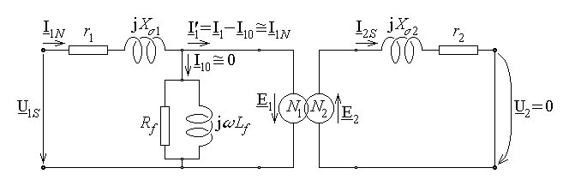
Fig. 13.7. ${\underline{U}}_{1S}=−{\underline{E}}_{1}+\left(r_{1}+{jωL}_{σ1}\right) {\underline{I}}_{1N}=−\frac{N_{1}}{N_{2}}{\underline{E}}_{2}+\left(r_{1}+{jX}_{σ1}\right) {\underline{I}}_{1N}=$
$=−\frac{N_{1}}{N_{2}}\left(r_{2}+{jωL}_{σ2}\right){\underline{I}}_{2S}+\left(r_{1}+{jX}_{σ1}\right){\underline{I}}_{1N}≃\left(r_{2}+{jX}_{σ2}\right) {\left(\frac{N_{1}}{N_{2}}\right)}^{2}{\underline{I}}_{1N}+\left(r_{1}+{jX}_{σ1}\right){\underline{I}}_{1N}=$
$=\left\{\left[r_{1}+{\left(\frac{N_{1}}{N_{2}}\right)}^{2}r_{2}\right]+j \left[X_{σ1}+{\left(\frac{N_{1}}{N_{2}}\right)}^{2}X_{σ2}\right]\right\} {\underline{I}}_{1N}=\left(r_{S}+{jX}_{S}\right){\underline{I}}_{1N}$ .
The last equation shows that the short circuit operation of the transformer corresponds to the simplified equivalent circuit of fig. 13.8, in terms of the short circuit equivalent

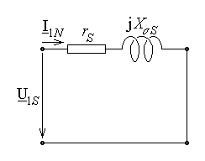
Fig. 13.8.
resistance r_{S} and short circuit equivalent (leakage) reactance X_{σS} . The values of these elements can be obtained from the measured data as follows. The active power measured by the wattmeter corresponds to the power dissipated into the short circuit equivalent resistance r_{S} , so that
$P_{1S}=r_{S} I_{1N}^{2} ⇔ r_{S}=\frac{P_{1S}}{I_{1N}^{2}}$ .

As well, from the measured value of the short circuit impedance, the short circuit equivalent (leakage) reactance X_{σS} can be computed as
$Z_{S}=\frac{U_{1S}}{I_{1N}}=\sqrt{r_{S}^{2}+X_{σS}^{2}} ⇔ {ωL}_{σS}=X_{σS}=\sqrt{{\left(\frac{U_{1S}}{I_{1N}}\right)}^{2}−{\left(\frac{P_{1S}}{I_{1N}^{2}}\right)}^{2}}$ .
4. The so called external characteristic of the transformer represents the dependence of the voltage at the secondary terminals as a function of the load current, $U_{2}=f\left(I_{2}\right)$ , at a given load power factor cosϕ₂ , under normal (rated) operating conditions U₁ = U_{1N} .
Under the simplifying hypothesis that the open circuit primary current is negligible (about a few percents) with respect to the normal (rated) primary current, the complex equations give
${\underline{I}}_{2}=−\frac{N_{1}}{N_{2}}\left({\underline{I}}_{1}−{\underline{I}}_{\text{10}}\right)≃−\frac{N_{1}}{N_{2}}{\underline{I}}_{1}$ .
As well, the secondary induced e.m.f. is
${\underline{E}}_{2}=\frac{N_{2}}{N_{1}}{\underline{E}}_{1}=\frac{N_{2}}{N_{1}}\left[−{\underline{U}}_{1N}+\left(r_{1}+{jX}_{σ1}\right) {\underline{I}}_{1}\right]$ ,
and the voltage at the secondary terminals can be derived as
${\underline{U}}_{2}={\underline{E}}_{2}−\left(r_{2}+{jX}_{σ2}\right) {\underline{I}}_{2}=\frac{N_{2}}{N_{1}}\left[−{\underline{U}}_{1N}+\left(r_{1}+{jX}_{σ1}\right) {\underline{I}}_{1}\right]−\left(r_{2}+{jX}_{σ2}\right) {\underline{I}}_{2}≃$
$\frac{N_{2}}{N_{1}}\left[−{\underline{U}}_{1N}−\left(r_{1}+{jX}_{σ1}\right)\frac{N_{2}}{N_{1}}{\underline{I}}_{2}\right]−\left(r_{2}+{jX}_{σ2}\right) {\underline{I}}_{2}=$
$−\frac{N_{2}}{N_{1}}{\underline{U}}_{1N}−{\left(\frac{N_{2}}{N_{1}}\right)}^{2}\left(r_{1}+{jX}_{σ1}\right) {\underline{I}}_{2}−\left(r_{2}+{jX}_{σ2}\right) {\underline{I}}_{2}=$
$−\frac{N_{2}}{N_{1}}{\underline{U}}_{1N}−{\left(\frac{N_{2}}{N_{1}}\right)}^{2}\left\{\left[r_{1}+{\left(\frac{N_{1}}{N_{2}}\right)}^{2}r_{2}\right]+j \left[X_{σ1}+{\left(\frac{N_{1}}{N_{2}}\right)}^{2}X_{σ2}\right]\right\} {\underline{I}}_{2}$ .
Upon introducing the notations
${\underline{U}}_{\text{20}}=−\frac{N_{2}}{N_{1}}{\underline{U}}_{1N} , r_{S2}={\left(\frac{N_{2}}{N_{1}}\right)}^{2}\left[r_{1}+{\left(\frac{N_{1}}{N_{2}}\right)}^{2}r_{2}\right]={\left(\frac{N_{2}}{N_{1}}\right)}^{2}r_{S}$ ,
$X_{S2}={\left(\frac{N_{2}}{N_{1}}\right)}^{2}\left[X_{σ1}+{\left(\frac{N_{1}}{N_{2}}\right)}^{2}X_{σ2}\right]={\left(\frac{N_{2}}{N_{1}}\right)}^{2}X_{S}$ ,
the complex voltage at the secondary terminals takes the form
${\underline{U}}_{2}={\underline{U}}_{\text{20}}−\left(r_{S2}+{jX}_{S2}\right) {\underline{I}}_{2}$ ,
similar to the equation
${\underline{U}}_{2}=\underline{E}−\left(r+jx\right) \underline{I}$
refering to the load voltage in the source–load alternating current circuit studied in section 9.7.
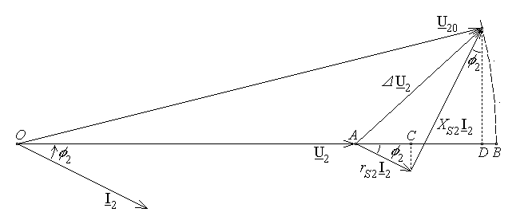
Fig. 13.9.
Under usual operating conditions the voltage difference between the secondary voltage and its open circuit value is not excessive and their phase difference is quite small. The corresponding phasor diagram in fig. 13.9 allows the derivation of the approximate value of the effective voltage U₂ as
$U_{2}=\text{OD}−\text{AD}≃\text{OB}−\text{AD}=\text{OB}−\left(\text{AC}+\text{CD}\right)=$
$=U_{\text{20}}−\left(r_{S2}⋅\text{cos}φ_{2}+X_{S2}⋅\text{sin}φ_{2}\right) I_{2}$ .
It follows that there exists a voltage drop between the open circuit voltage U₂₀ and the load voltage U₂ , of relative value
$\frac{{ΔU}_{2}}{U_{\text{20}}}=\frac{U_{\text{20}}−U_{2}}{U_{\text{20}}}=\frac{\left(r_{S2}⋅\text{cos}φ_{2}+X_{S2}⋅\text{sin}φ_{2}\right) I_{2}}{U_{\text{20}}}=$
$={\left(\frac{N_{2}}{N_{1}}\right)}^{2}\frac{\left(r_{S}I_{1N}⋅\text{cos}φ_{2}+X_{S}I_{1N}⋅\text{sin}φ_{2}\right) }{U_{\text{20}}}\frac{I_{2}}{I_{2N}}\frac{I_{2N}}{I_{1N}}=$
$=\frac{\left(r_{S}I_{1N}⋅\text{cos}φ_{2}+X_{S}I_{1N}⋅\text{sin}φ_{2}\right) }{\left(N_{1}/N_{2}\right) U_{\text{20}}}\frac{I_{2}}{I_{2N}}\frac{N_{2}}{N_{1}}\frac{I_{2N}}{I_{1N}}≃$
$\left(\frac{r_{S}I_{1N}}{U_{1N}}⋅\text{cos}φ_{2}+\frac{X_{S}I_{1N}}{U_{1N}}⋅\text{sin}φ_{2}\right) β$ ,
where the load factor was introduced as
$β=\frac{I_{2}}{I_{2N}}$ .

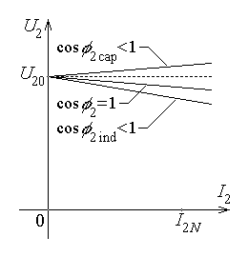
Fig. 13.10.

The analysis of the last result shows that the load voltage at the secondary terminals of a transformer is usualy decreasing with the increase in the load current (fig. 13.10). Since generaly X_{S} > r_{S} and the second term in the parantheses is determinant, the voltage drop with respect the open circuit conditions is greater in the case of an inductive load as compared to that of a resistive load due to an increase of the phase difference φ₂ . On the other hand, a capacitive load (meaning a negative value of the phase diference φ₂ ) determines a smaller voltage drop than a resistive load. Moreover, if the capacitive

load presents a capacitive phase difference satisfying the condition
$\text{tg}φ_{2}<− \frac{r_{S}}{X_{S}}$ ,
then the load effective voltage U₂ may be greater than the open circuit effective voltage U₂₀ .
5. The power balance of the transformer can be represented as power transfer diagrams (fig. 13.11). A part of the active power $P_{1}=U_{1}I_{1}\text{cos}ϕ_{1}$ received at the primary terminals is used first to cover the active losses in the coil resistances, $P_{J1}=r_{1}I_{1}^{2}$
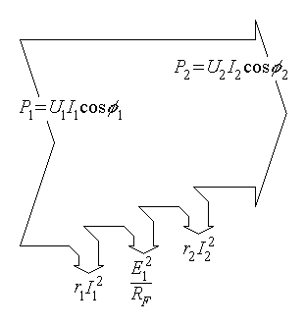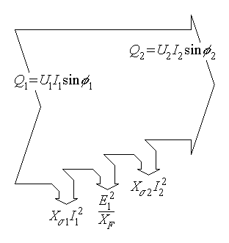
Fig. 13.11.
and $P_{J2}=r_{2}I_{2}^{2}$ , and those associated with the hystheresis and eddy currents, $P_{F}=E_{1}^{2}/R_{F}$ ; it is the reminder only that is delivered as the active power at the secondary terminals, $P_{2}=U_{2}I_{2}\text{cos}ϕ_{2}$ . Similarly, a part of the reactive power $Q_{1}=U_{1}I_{1}\text{sin}ϕ_{1}$ received at the primary terminals is used first to cover the active losses in the coil resistances, $Q_{X1}=X_{σ1}I_{1}^{2}$ and $Q_{X2}=X_{σ2}I_{2}^{2}$ , and those associated with the magnetising reactance, $Q_{μ}=E_{1}^{2}/X_{μ}$ ; it is the reminder only that is delivered as the active power at the secondary terminals, $Q_{2}=U_{2}I_{2}\text{sin}ϕ_{2}$ .
The relation expressing the active power balance,
$P_{1}=P_{J1}+P_{J2}+P_{F}+P_{2}=P_{\text{Cu}}+P_{\text{Fe}}+P_{2}$ ,
can be used to compute the efficiency of the transformer as
$η=\frac{P_{2}}{P_{1}}=\frac{U_{2}I_{2}\text{cos}ϕ_{2}}{U_{2}I_{2}\text{cos}ϕ_{2}+r_{1}I_{1}^{2}+r_{2}I_{2}^{2}+E_{1}^{2}/R_{F}}$ .
The efficiency characteristic represents the dependence of the efficiency as a function of the load current $η=f\left(I_{2}\right)$ , under normal (rated) primary voltage U_{1N} and at a given load power factor cosϕ₂ . An additional simplifying assumption is also considered – the voltage drop at the secondary terminals is neglected, that is the secondary voltage is taken as $U_{2}≃U_{\text{20}}$ .
The active power at the secondary terminals is then
$P_{2}=U_{2}I_{2}\text{cos}ϕ_{2}≃U_{\text{20}}I_{2N}\frac{I_{2}}{I_{2N}}\text{cos}ϕ_{2}=S_{2N} β \text{cos}ϕ_{2}$ ,
where $S_{N}=U_{\text{20}}I_{2N}=U_{1N}I_{1N}$ is the apparent normal (rated) power and $β=I_{2}/I_{2N}$ is the load factor. As well, the active losses in the coil resistances can be expressed as
$P_{\text{Cu}}=P_{J1}+P_{J2}=r_{1}I_{1}^{2}+r_{2}I_{2}^{2}=\left[r_{1}+{\left(\frac{N_{1}}{N_{2}}\right)}^{2}r_{2}\right]I_{1}^{2}=$
$=r_{S}I_{1N}^{2}{\left(\frac{I_{1}}{I_{1N}}\right)}^{2}=r_{S}I_{1N}^{2}{\left(\frac{I_{2}}{I_{2N}}\right)}^{2}=r_{S}I_{1N}^{2}β^{2}$ ,

while the active losses in the magnetic circuit, P_{Fe} , are practicaly constant under normal (rated) primary voltage conditions.
The efficiency results finaly as
$η=\frac{S_{N} β \text{cos}ϕ_{2}}{S_{N} β \text{cos}ϕ_{2}+r_{S}I_{1N}^{2} β^{2}+P_{\text{Fe}}}=η\left(β\right)$ ,
and presents a maximum value (fig. 13.12) at a current corresponding to a load factor
$β_{ η \text{max}}=\sqrt{\frac{P_{\text{Fe}}}{r_{S}I_{1N}^{2}}}$ ,
which usually has values between 0.5 and 0.75 .
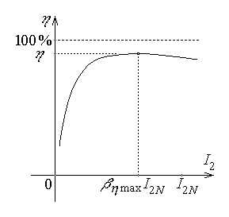
Fig. 13.12.

6. The single–phase transformer studied above is the simplest type of transformer among many other types. An extension of this transformer is that where there are more than one secondary coil – and circuit – or, eventualy, more than one primary coil; their operation can be analysed following the procedure presented above.
The three–phase transformer (fig. 13.13) is a three column transformer – one for each phase – that substitutes three separate single–phase transformers, thus resulting in important savings, especially when large power is at stake. Under fairly balanced conditions, the primary–secondary couple of coils on each magnetic circuit column operates independently for each phase, approximately similar to the case of single–phase transformers.
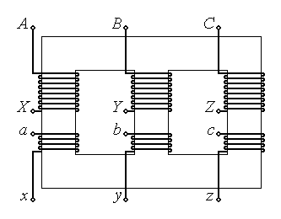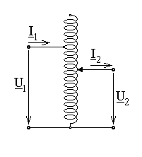
Fig. 13.13. Fig. 13.14.
The autotransformer is a particular type of a transformer, where the primary and secondary coils are parts of a single coil (fig. 13.14), provided with appropriate taps as terminals. In some cases a sliding tap is also provided with a view to adjust finely the turns ratio. The disadvantage of a direct conductive connection between the primary and secondary circuits is to be traded for the advantage of reduced size and higher efficiency, when comparing an autotransformer with a conventional transformer.
Instrumentation transformers are specialy designed transformers which provide either a precisely definite primary–to–secondary voltage ratio or a precisely definite primary–to–secondary current ratio. Such transformers are used for the purpose of bringing the voltage or current within an imposed measuring range or of extending the measuring range of other measuring instruments.
Special purpose industrial transformers can be designed to meet specific requirements imposed by specific industrial processes. For instance, the transformers used in conjunction with welding equipments or arc furnaces are characterised by large (eventualy adjustable) leakage reactances, so that they present a rapidly decreasing external characteristic, suitable to the industrial process.
Each transformer is designed to operate under certain rated conditions, expressed as a set of rated values of the main quantites characterising its operation. The usual rated values (and characteristics) are: apparent (primary) power, primary/secondary voltages and currents (line values for three–phase transformers), operating frequency, phase number and connexion, relative short circuit voltage, relative open circuit current, short circuit and open circuit active power. Additional rated valus and conditions may be given in special cases, with a view to facilitate a correct usage of the transformer.

13.2. The principle of electro–mechanic energy conversion
1. The electro–mechanic energy conversion is the process where the mechanical energy is transformed into electromagnetic energy or vice versa. The mechanical energy is transformed into electromagnetic energy in an electric machine called an electric generator; the electro-magnetic energy is transformed into mechanical energy in an electric machine called an electric motor.
The operation of most electric generators is based on the electromagnetic induction phenomenon: the movement with respect to an external magnetic field induces an electric field. The operation of most electric motors is based on the use of Laplace’s force: a current carrying conductor placed into an external magnetic field is subjected to an electromagnetic force.
The overwhelming majority of electric machines are rotating electric machines, which are characterised by compactness, material savings, and increased efficiency – these are the electric machines to be studied in the following. Some different constructive approaches are however imposed by specific applications, notably in the case of electric motors: for instance, linear motors are used in transportation equipments, or positioning devices called actuators are used in electric equipments of high precision.
A rotating electric machine is thus an electro–mechanic system where one of the following energy conversion processes is present: electromagnetic to mechanic energy in the case of an electric motor, mechanic to electromagnetic energy in the case of an electric generator, or electromagnetic and mechanic energy to heat in the case of an electric brake. In most cases the same electric machine can operate in two or all three types of operation, depending on specific operation conditions. However, each electric machine is designed to operate mainly according to a single type of operation, and under specific rated operation conditions that are indicated by the manufacturer, along with limiting operating values.
An electric rotating machine consists essentially of a stationary part, called the stator, and a rotating part, called the rotor, both made of a highly permeable substance, with a usualy narow cylindrical airgap between them – they constitute the magnetic circuit of the machine. The operation of an electric machine relies on the electromagnetic phenomenon and the electro-magnetic force, meaning that a magnetic field has to be present in the machine. The main magnetic field is imposed in the machine by appropriate coils, constituting the field structure. Other coils – that of the armature – carry the main current of the machine, either associated to an induced e.m.f, or injected with a view of determining electromagnetic forces. The details in the placement, construction and use of these parts depend on the type of electric machine, as will be subsequently discussed.
2. The operation principle of an electric generator is based on the electromagnetic induction phenomenon. Let a rectangular, partly conducting, contour of sides l and 2r be considered, which rotates at an angular speed Ω in a homogeneous external magnetic field of time–invariant magnetic flux density $\vec{B}$ normal to the rotation axis (fig. 13.15).
The extended form of Faraday’s law on electromagnetic induction applied to the contour Γ reduces to
$e_{Γ}=−\int{\frac{∂\vec{B}}{∂t}⋅\vec{n} \text{dS}}+\oint{\left(\vec{v}×\vec{B}\right)⋅d\vec{r}}=\oint{\left(\vec{v}×\vec{B}\right)⋅d\vec{r}}$ .
Along the contour sides parallel to the axis the vectors $\vec{v}×\vec{B}$ and $d\vec{r}$ are parallel and contribute with the quantities $vBl \text{sin}α$ and $vBl \text{sin}\left(π−α\right)=vBl \text{sin}α$ to the contour integral. Along the contour sides normal to the axis the vectors $\vec{v}×\vec{B}$ and $d\vec{r}$ are normal, so that their contribution to the contour integral is equal to zero. It thus follows that an electromotive force is induced in the rotating contour,
$e_{Γ}=2vBl \text{sin}α=2ΩrBl \text{sin}α=ABΩ \text{sin}α ⇒$ $e_{Γ}=Φ_{\text{max}}Ω \text{sin}Ωt$ ,
where α = Ωt is the rotation angle, A = 2rl is the area of the surface bordered by the contour, and Φ _{max} is the maximum magnetic flux over the contour surface.
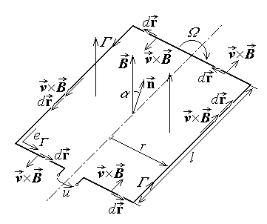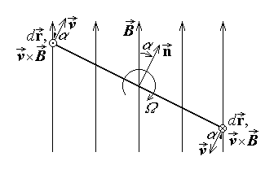
Fig. 13.15.
On the other hand, the induced e.m.f. e_{Γ} is related to the voltage developped between the (closely placed) terminals of the conductive part of the contour,
$e_{Γ}=u_{Γ}=\oint{\vec{E}⋅d\vec{r}}=\int{\vec{E}⋅d\vec{r}}+\int{\vec{E}⋅d\vec{r}}=R i+u≃u$ ,
where R is the electric resistance of the conducting part of the contour carrying the current i , u is the voltage at terminals, and the case of a negligible internal voltage drop has been considered.
It thus follows that, in the configuration under study, by rotating the contour in an external magnetic field, an electromotive force is induced, which determines a voltage at terminals
$u≃e_{Γ}=Φ_{\text{max}}Ω \text{sin}Ωt$ .
3. The operation principle of an electric motor is based on the electromagnetic force (Laplace’s force) acting on a current carrying conductor placed in an external magnetic field,
$d\vec{F}=i \left(d\vec{r}×\vec{B}\right)$ .
Let again a rectangular, partly conducting, contour of sides l and 2r be considered, carrying an electric current of intensity i , and placed in a homogeneous external magnetic field of time–invariant magnetic flux density $\vec{B}$ normal to the contour axis (fig. 13.16) and making an angle α with the unit vector $\vec{n}$ normal to the contour surface, associated with the current direction according to the right hand rule.
The resultant force acting on the current carrying contour Γ is given by
$\vec{F}=i \oint{d\vec{r}×\vec{B}}$ .
The parallel forces $F=ilB$ act on the contour sides parallel to the axis, along opposite directions as indicated in the figure. As well, opposite elementary forces $d\vec{F}=i \left(d\vec{r}×\vec{B}\right)$ act on each elementary segment of the two contour sides normal to the axis, cancelling one another.
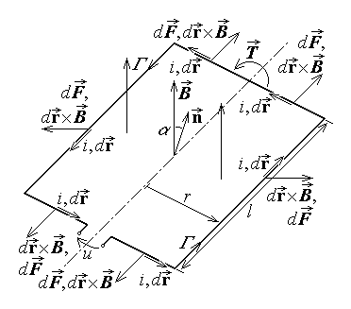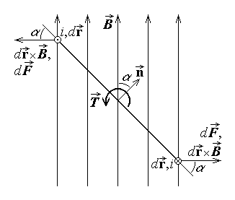
Fig. 13.16.
Consequently, while the resultant force is zero, there is an electromagnetic torque acting on the contour with respect to the axis, of a magnitude given by
$T=2rF \text{sin}α=2rilB \text{sin}α=iAB \text{sin}α ⇒$ $T=Φ_{\text{max}}i \text{sin}α$ ;
its action tends to align the normal vector $\vec{n}$ to the contour surface along the external magnetic flux desnity $\vec{B}$ .
4. The operation of an electric machine as a generator is simply described as follows.
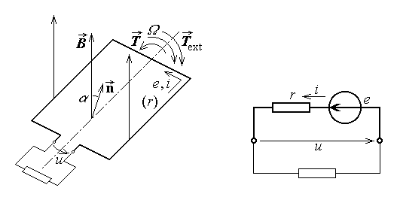
Fig. 13.17.
Suppose that an externaly applied mechanic torque T _{ext} rotates the conducting contour considered above (at subsection 2) at an angular speed Ω , in a homogeneous external magnetic field of time–invariant magnetic flux density $\vec{B}$ normal to the rotation axis (fig. 13.17 left). Supposing that the contour terminals are connected to an external circuit, the induced electromotive force e_{Γ} determines along the contour of resistance r an electric conduction current of intensity i in the direction indicated in the figure.
The equivalent electric circuit of the electric machine operating as a generator is that of a non–ideal voltage generator of e.m.f. e = e_{Γ} and internal resistance r (fig. 13.17 right). It delivers a voltage u at terminals, associated with the delivered electric current i according to the source rule, so that
$u=e−r⋅i$ .
Let a normal unit vector $\vec{n}$ to the surface contour be now considered, associated to the e.m.f. direction according to the right hand rule. As it was discussed above (subsection 3), an electromagnetic torque T is acting on the current carrying contour, opposite to the applied mechanic torque and to the rotation speed: the electromagnetic torque is thus acting as a counter–torque. A steady state rotation is imposed to the considered conducting contour when the algebraic sum of torques acting on it is zero,
$T = T_{\text{mech}}=T_{\text{ext}}−T_{\text{friction}}$ .
On the other hand, using the results of previous subsections and the above torque equillibrium condition, it follows that
$P_{\text{gen} \text{elmg}}=e⋅i=Φ_{\text{max}}Ω \text{sin}Ωt⋅i=Φ_{\text{max}}i \text{sin}α⋅Ω=T⋅Ω=T_{\text{mech}}⋅Ω=P_{\text{transf} \text{mech}}$ ,
meaning that the principle of energy conservation is verified for the operation of this electro–mechanic system,
$P_{\text{elmg}}=e⋅i=T⋅Ω=P_{\text{mech}}$ .
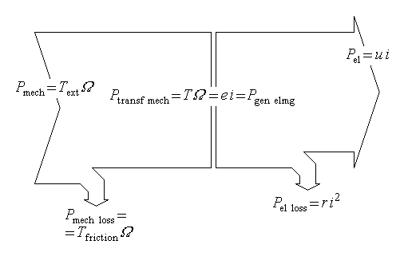
Fig. 13.18.
The above derived power balance of the electric machine operating as a generator is illustrated in fig. 13.18, where P_{transf mech} is the mechanical power transformed into electro-magnetic power and P_{gen elmg} is the generated electric power resulting by electro–mechanical conversion.
5. The operation of an electric machine as a motor is simply described as follows.
Suppose that an electric voltage u is applied at the terminals of the conducting contour of resistance r considered above (at subsection 3), placed in a homogeneous external magnetic field of time–invariant magnetic flux density $\vec{B}$ normal to the rotation axis (fig. 13.19 left). The resulting electric current i determines the action of an electromagnetic torque T on the conducting contour, which imposes a rotation at an angular speed Ω , tending to align the normal unit vector $\vec{n}$ (associated with the current according to the right hand rule) to the external magnetic flux density $\vec{B}$ . Let a (rotating) mechanic load be coupled to the contour shaft, presenting a braking mechanic torque T _{brak} opposite to the developped (driving) electromagnetic torque T ; the system reaches a uniform rotation speed Ω when the torques balance one another,
$T =T_{\text{brak}}= T_{\text{mech}}+T_{\text{friction}}$ .
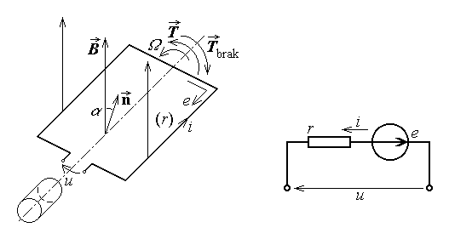
Fig. 13.19.
On the other hand, an induced e.m.f. e_{Γ} develops into the rotating contour placed in the external magnetic field, as it was discussed before in subsection 2, but in an opposite direction as compared to that case, since the rotation direction is also opposite to that considered before. Thus the direction of the induced e.m.f. is opposite to the direction of the injected current; it acts as a counter–electromotive force e = e_{Γ} .
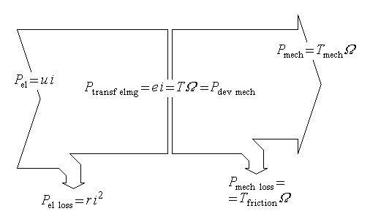
Fig. 13.18.
The resulting equivalent circuit of the electric machine operating as a motor is that oh a non–ideal voltage generator of counter e.m.f. e and internal resistance r (fig. 13.19 right). Under an applied voltage u at terminals, it receives a current i according to the load rule, so that
$u=e+r⋅i$ .
Using now the results of previous subsections and the above torque equillibrium condition, it follows that
$P_{\text{dev} \text{mech}}=T_{\text{brak}}⋅Ω=T⋅Ω=Φ_{\text{max}}i \text{sin}α⋅Ω=Φ_{\text{max}}Ω \text{sin}Ωt⋅i=e⋅i=P_{\text{transf} \text{elmg}}$ ,
meaning that the principle of energy conservation is verified for the operation of this electro–mechanic system,
$P_{\text{mech}}=T⋅Ω=e⋅i=P_{\text{elmg}}$ .
The above derived power balance of the electric machine operating as a motor is illustrated in fig. 13.20, where P _{dev mech} is the mechanical power developped by electro–mechanical conversion and P_{transf elmg} is the electromagnetic power transformed into mechanic power.
6. The external magnetic field considered above in the discussion of the fundamental aspects of the operation of a rotating electric machine is not necessarily uniform or time–invariant with respect to a fixed reference frame. Instead, it is generated by appropriate field coils carrying either a direct current or an alternating current depending on the type of the electric machine – direct current machine or alternating current machine.
An important and interesting case is that of field coils of three phase alternating current machines which generate a revolving (rotating) magnetic field. This is a magnetic field of approximately constant magnitude and of rotating direction around the machine axis at an angular speed depending on the placement of the field coils and the frequency of the alternating current.
Let the simplest case of a two–pole revolving magnetic field be considered first. It is generated by a system of three identical coils, spaced 120° (2π/3) apart on the field structure (say, stator) circumference, and carrying a symmetric system of three phase currents (fig. 13.21). If the coils 1 (AX) , 2 (BY) , 3 (CZ) are spaced as indicated, in a sequence along the counter-clockwise direction, and carry the currents
$i_{1}=I\sqrt{2} \text{sin}ωt , i_{2}=I\sqrt{2} \text{sin}\left(ωt−\frac{2π}{3}\right) , i_{2}=I\sqrt{2} \text{sin}\left(ωt+\frac{2π}{3}\right)$ ,
then they generate corresponding magnetic fields of magnetic flux density
${{\vec{B}}_{1}={\vec{B}}_{M1} \text{sin}ωt ,\text{ \{}\vec{B}}_{2}={\vec{B}}_{M2} \text{sin}\left(ωt−\frac{2π}{3}\right) ,\text{ \{}\vec{B}{}_{3}={\vec{B}}_{M3} \text{sin}\left(ωt+\frac{2π}{3}\right)$ ,
of direction associated to the source current direction according with the right hand rule and of equal magnitude $B_{M1}=B_{M2}=B_{M3}=B_{M}$ . The resultant magnetic flux density is found by vector addition,
$\vec{B} \left(t\right)={\vec{B}}_{1}\left(t\right)+{\vec{B}}_{2}\left(t\right)+{\vec{B}}_{3}\left(t\right)$ ,
performed along the coordinate directions,
$B_{x}\left(t\right)=B_{3}\left(t\right) \text{cos}\frac{π}{6}−B_{2}\left(t\right) \text{cos}\frac{π}{6}=$
$=B_{M} \text{sin}\left(ωt+\frac{2π}{3}\right) \text{cos}\frac{π}{6}−B_{M} \text{sin}\left(ωt−\frac{2π}{3}\right) \text{cos}\frac{π}{6}=$
$=B_{M}\frac{\sqrt{3}}{2}⋅2 \text{sin}\frac{2π}{3} \text{cos}ωt=B_{M}\sqrt{3} \frac{\sqrt{3}}{2} \text{cos}ωt=\frac{3}{2}B_{M} \text{cos}ωt$ ,
$B_{y}\left(t\right)=B_{1}\left(t\right)−B_{2}\left(t\right) \text{cos}\frac{π}{3}−B_{3}\left(t\right) \text{cos}\frac{π}{3}=$
$=B_{M} \text{sin}ωt−\left[B_{M} \text{sin}\left(ωt−\frac{2π}{3}\right)+B_{M} \text{sin}\left(ωt+\frac{2π}{3}\right)\right] \text{cos}\frac{π}{3}=$
$=B_{M}\text{sin}ωt−B_{M}\frac{1}{2}⋅2 \text{sin}ωt \text{cos}\frac{2π}{3}=B_{M}\text{sin}ωt \left(1+\frac{1}{2}\right)=\frac{3}{2}B_{M} \text{sin}ωt$ .
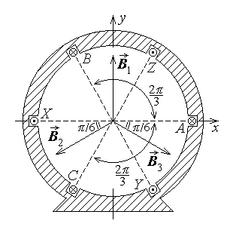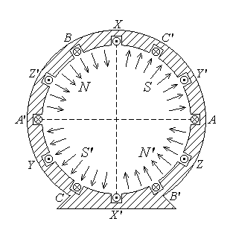
Fig. 13.21. Fig. 13.22.
The resultant magnetic flux density has thus a constant magnitude,
$B=\sqrt{B_{x}^{2}+B_{y}^{2}}=\sqrt{\frac{9}{4}B_{M}^{2}\left[{\text{cos}}^{2}ωt+{\text{sin}}^{2}ωt\right]}=\frac{3}{2}B_{M}$ ,
and makes with the Ox axis an angle given by
$\text{tg} α=\frac{B_{y}\left(t\right)}{B_{x}\left(t\right)}=\frac{B_{M}\text{sin}ωt}{B_{M}\text{cos}ωt}=\text{tg}ωt ⇒ α=ω t$ ,
meaning a rotation in the counter-clockwise direction with the angular speed
$Ω_{0}=ω$ ,
equal to the angular frequency of the alternating current.
A multipole revolving magnetic field is obtained if the three phase coils are multiplied to p identical coils per phase, which are placed in successive three phase groups, each of these covering a $2π /p$ angle along the circumference (fig. 13.22, where the poles corresponding to phase 1 are indicated). The conductors carrying opposite currents of each coil subtend then an angle $τ=π /p$ called the pole pitch. Just as over the 2π angle associated to the single three phase group, in the preceding case, there are two magnetic poles (one north pole where the field lines get out of the magnetic circuit structure and one south pole where the field lines get into of the structure), in the present case there are two magnetic poles per pole pitch, meaning a total of 2p magnetic poles – p north poles alternating with p south poles.
This way, during a single period of the three phase current, the resultant magnetic field revolves, following the phase succession, along the arc subtended by the three coils of the group, that is along a $2τ=2π /p$ angle, and it takes p electric periods for a single rotation to be completed. Consequently, the angular speed of the revolving magnetic field is p times smaller than that obtained in the case of the two pole revolving magnetic field,
$Ω_{0}=\frac{ω}{p}$ .
Correspondingly, the revolving (rotation) speed expressed in rpm (rotations per minute) is
$n_{0}=\text{60}⋅f_{\text{field}}=\text{60}\frac{Ω_{0}}{2π}=\text{60}\frac{ω}{2πp}=\text{60}\frac{2πf}{2πp} ⇒$ $n_{0}=\text{60}\frac{f}{p} \left\langle \text{rpm}\right\rangle$ ,
in terms of the alternating current frequency f expresssed in Hz .
A three phase alternating current machine operating at the European standard frequency of f = 50 Hz presents a revolving speed depending on the number of pole pairs p given in the table below,
p | 1 | 2 | 3 | 4 | 5 | 6
n₀ ⟨rpm⟩ | 3000 | 1500 | 1000 | 750 | 600 | 500
Similarly, corresponding to the American standard alternating current frequency of f = 60 Hz , the revolving speeds versus the number of pole pairs are found in the table below,
p | 1 | 2 | 3 | 4 | 5 | 6
n₀ ⟨rpm⟩ | 3600 | 1800 | 1200 | 900 | 720 | 600

13.3. Direct current machines
1. The direct current machine is a rotative electric machine characterised by time–invariant electromagnetic quantities during its operation.
A direct current machine consists essentially of a stationary stator – the field structure – that includes the coils generating the main magnetic field of the machine, and a rotating rotor – the armature – that includes the coils where an e.m.f. can be induced or currents can be injected (fig. 13.23 a). The contribution of the field structure to the magnetic circuit consists of the hollow cylinder yoke made of cast steel and the main pole cores (or shoes) made of insulated electrical–sheet steel laminations bolted to the yoke. The field (excitation) coils are wound on the pole cores and generate the time–independent magnetic field when carrying the direct excitation current. There are also some additional commutating poles needed for some corrections of the main magnetic field distribution. The armature contribution to the magnetic circuit consists in a toothed cylindrical core made of insulated electrical–sheet steel laminations. The armature coils are placed in the rotor slots and receive the direct current machine current via the so called commutator – a sequence of wedge–shaped copper bars placed on the periphery of the machine shaft, insulated from one another and from the shaft. Each commutator bar is connected to the end of an armature coil, and to the external circuit by the sliding contact realized between the bars and brush pairs pressed against them. The armature current is then established only in the coils (turns) connected to those commutator bars that are in instantaneous contact with the brushes, so that the armature current commutes from coil to coil during operation.
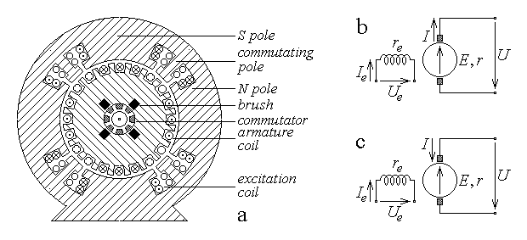
Fig. 13.23.
As it is generaly the case with all electric machines, the operation of a direct current machine is reversible. Supposing that the excitation direct current is provided, when driven by a mechanic torque an e.m.f. is induced in the armature coils, and an electric voltage is collected at the brushes and presented to the external circuit. Conversely, again supposing that the excitation direct current is provided, when the machine direct current is injected through the brushes to the armature coils an electromagnetic torque is developed, which overcomes the load torque applied to the shaft and rotates it. The conventional representation of the direct current machine operating as a generator and motor is given in fig. 13.23 a and b.
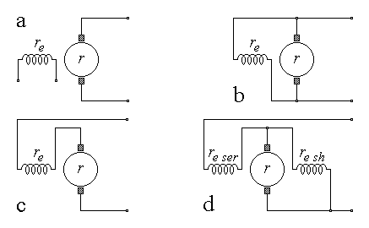
Fig. 13.24.
The direct current machines can be classified according with the manner the main magnetic field is excited. There are direct current machines with permanent magnets on the poles which provide the main magnetic field. In most direct current machines the main magnetic field is excited by electromagnets energised by the (field–) excitation current. The excitation coils can be independent from the armature coils (between the brushes) as represented in fig. 13.24 a, or they can be shunt– (parallel – fig. 13.24.b), series– (fig. 13.24.c) or compound– (shunt–series, as in fig. 13.24 d) connected with respect to the armature coils. With any connection of the excitation coils, the power needed for the field excitation structure is a few percents of the power rating of the machine. Therefore the resistance of shunt excitatin coils is high so that the excitation current is small as compared to the armature current, and the resistance of series excitation coils is low so that the associated voltage is small as compared to the voltage across the armature coils.
2. In the uniform airgap between the poles and the armature there is an approximately uniform time–invariant excitation magnetic field along the radial direction, successively from and toward the pole (fig. 13.25).
As discussed in the previous section, when the armature rotates at an angular speed Ω with respect to the excitation magnetic field of flux Φ_{e} per pole, the electromotive voltage induced, in opposite directions, in each series connected conductor pair, found in similar positions with respect to the nearest north – south poles, add to
$e_{p}=2rlBΩ \text{sin}\frac{π}{2}=ABΩ=Φ_{e}Ω$ ,
since the angle between the tangential speed $\vec{v}$ of the conductor and the radial magnetic flux density $\vec{B}$ is α = π/2 . Accordingly, a total electromotive force
$E=K Φ_{e}Ω$ ,
is generated, where K is a machine characteristic coefficient depending on the number of armature coil conductors and their interconnection between the commutator bars in contact with the brushes.
The armature conductors carrying the machine current I are placed in the excitation magnetic field of radial magnetic flux density $\vec{B}$ , so that the conductors of each series connected pair, found in similar positions with respect to the nearest north – south poles, is subjected to an electromagnetic torque
$T_{p}=2rlIB \text{sin}\frac{π}{2}=ABI=Φ_{e} I$ ,
where again Φ_{e} is the excitation magnetic flux per pole, and the angle between the armature conductors and the radial magnetic flux is α = π/2 . Accordingly, the total electromagnetic torque is acting upon the armature is
$T=K Φ_{e}I$ ,
where K is the same machine characteristic coefficient depending on the number of armature coil conductors and their interconnection between the commutator bars in contact with the brushes.
If a net driving mechanical torque T _{mech} is acting on the armature, then a total electromotive force E is generated by electromagnetic induction and, due to the current I determined by the induced voltage in the armature and the extrenal circuit, the resulting electromagnetic counter-torque T balances the applied torque, so that the rotor rotates at an uniform angular speed Ω (fig. 13.25 left). If, on the contrary, a current I is injected into the armature conductors, then the resulting electromagnetic torque T imposes a rotation at a constant angular speed Ω when the active torque is balanced by the net braking mechanic torque T _{mech} , the voltage imposing the current being oposed by the induced counter–electromotive force E (fig. 13.25 right). In any case, the energy conservation associated with the electro–mechanic energy conversion is observed,
$EI={KΦ}_{e}Ω⋅I={KΦ}_{e}I⋅Ω=TΩ=T_{\text{mech}}Ω ⇔$ $P_{\text{elmg}}=P_{\text{mech}}$ .
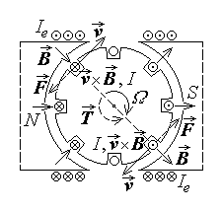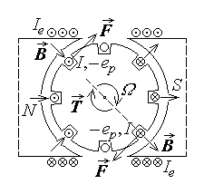
Fig. 13.25.
The commutator operation is the source of some problems. There are moments when each brush makes contact with two commutator bars, so that some turns of the armature coil are short–circuited. If there is an e.m.f. induced in these turns, they carry a short–circuit current I_{S} that may be important. When, during rotation, the short circuit offered by the brush is broken, the short–circuit current is interrupted only when the associated magnetic energy is dissipated; this determines the ignition of an electric arc between the previously short–circuited bars so that supplementary commutator power loss has to be considered. Moreover, such electric arc commutation is responsible for a premature wear of the brushes and commutator bars, and special measures are to be taken to reduce these phenomena.
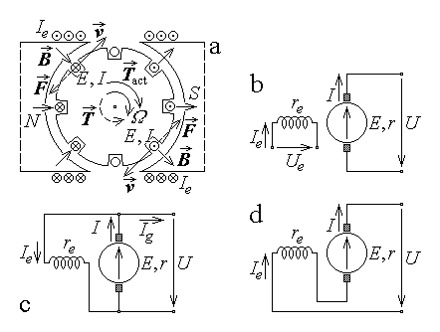
Fig. 13.26.
3. The direct current generator is a direct current electric machine operating under the conditions of given excitation direct current I_{e} and an angular speed Ω imposed by an externaly applied net mechanic torque T_{act} (fig. 13.26.a). The generated electromotive force
$E={KΦ}_{e}Ω$
is developped by electromagnetic induction in the armature conductors and provided at terminals, corresponding to one of the equivalent electric circuits in fig. 13.26.b to d, where r_{e} is the resistance of the excitation coil and r is the equivalent resistance of the armature conductors between the machine terminals (brushes). The equivalent electric circuits correspond, respectively, to the case of independent (or separate) excitation (fig. 13.26.b), series excitation (fig. 13.26.c), and shunt (parallel) excitation (fig. 13.26.d).
The self–excitation of a direct current generator needs some explanation. The generation of an e.m.f. upon rotating the armature is only possible if there is an excitation magnetic flux present in the machine, and, in the case of self–excitation, it would be provided by the excitation current determined by the induced e.m.f. At first sight, this results in no generated e.m.f. at all. However, the existence of a remanent magnetic flux density, and, consequently, a residual magnetic flux in the ferromagnetic parts of the magnetic circuit of the machine makes it possible for an initial, even small, excitation flux to be present, which is sufficient to initiate the operation of the direct current generator: the residual magnetic flux induces a small initial e.m.f. that determines a small excitation current which increases the excitation flux and so on, up to the normal operation of the generator.
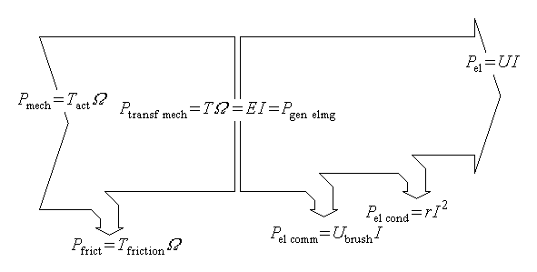
Fig. 13.27.
As stated before, when the generator circuit is closed, the presence of the generated (armature) current in the armature conductors determines a braking electromagnetic torque
$T={KΦ}_{e}I$ ,
so that the power balance
$P_{\text{transf} \text{mech}}=TΩ=EI=P_{\text{gen} \text{elmg}}$
is observed for the electro–mechanic energy conversion. The complete power balance is illustrated by the diagram in fig. 13.27. The ensuing generator efficiency is then
$η=\frac{P_{\text{el}}}{P_{\text{mech}}}=\frac{P_{\text{el}}}{P_{\text{frict}}+P_{\text{el} \text{comm}}+P_{\text{el} \text{cond}}+P_{\text{el}}}$
with usual values between 75% and 95% .
It is important to note that the use of direct current electric generators is less and less common, due to the fact that the controlled electronic rectifiers offer simpler methods of obtaining variable direct current sources.
4. The direct current motor is a direct current electric machine operating under the conditions of given excitation direct current I_{e} and given armature current I imposed by an externaly applied voltage U at terminals (fig. 13.28.a). An electro-magnetic torque,
$T={KΦ}_{e}I$ ,
is determined by electromagnetic forces acting on the current carrying armature conductors placed in the excitation magnetic field, and it balances the mechanic total braking torque T_{brak} for a uniform rotation of angular speed Ω . An associated generated counter–electromotive force
$E={KΦ}_{e}Ω$
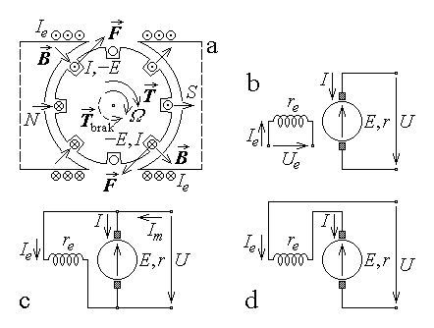
Fig. 13.28.
is developped by electromagnetic induction in the armature conductors, corresponding to one of the equivalent electric circuits in fig. 13.28.b to d, where r_{e} is the resistance of the excitation coil and r is the equivalent resistance of the armature conductors between the machine terminals (brushes). The equivalent electric circuits correspond, respectively, to the case of independent (or separate) excitation (fig. 13.28.b), series excitation (fig. 13.28.c), and shunt (parallel) excitation (fig. 13.28.d).
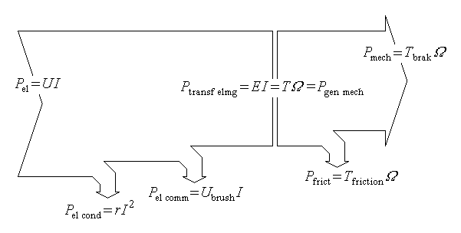
Fig. 13.29.
As discussed in the previous section, the power balance
$P_{\text{gen} \text{mech}}=TΩ=EI=P_{\text{transf} \text{elmg}}$
is observed for the electro–mechanic energy conversion. The complete power balance is illustrated by the diagram in fig. 13.29: the electromagnetic power received at terminals covers the power dissipated in the armature resistance and at the commutator contacts along with the transferred (transformed) electromagnetic power; the last term equals the generated mechanic power, which covers the friction losses and provides the net mechanic power at the machine shaft. The ensuing generator efficiency is then
$η=\frac{P_{\text{mech}}}{P_{\text{el}}}=\frac{P_{\text{mech}}}{P_{\text{el} \text{cond}}+P_{\text{el} \text{comm}}+P_{\text{frict}}+P_{\text{mech}}}$
with usual values between 70% and 95% .
The operation equations of the direct currrent motor are:
$\left\{ \begin{matrix}U_{e}=r_{e}I_{e} , Φ_{e}=Φ_{e}\left(I_{e}\right) \\ U=E+rI , E={KΦ}_{e}Ω \\ T={KΦ}_{e}I , T=T_{\text{tot} \text{mech}} \end{matrix}\right.$
for the separately excited motor (fig. 13.28.b),
$\left\{ \begin{matrix}I_{e}=I , Φ_{e}=Φ_{e}\left(I_{e}\right) \\ U=E+\left(r+r_{e}\right) I , E={KΦ}_{e}Ω \\ T={KΦ}_{e}I , T=T_{\text{tot} \text{mech}} \end{matrix}\right.$
for the series (excited) motor (fig. 13.28.c), and
$\left\{ \begin{matrix}U=r_{e}I_{e} , Φ_{e}=Φ_{e}\left(I_{e}\right) \\ U=E+rI , E={KΦ}_{e}Ω \\ I_{m}=I_{e}+I \\ T={KΦ}_{e}I , T=T_{\text{tot} \text{mech}}\end{matrix}\right.$
for the shunt (parallel excited) motor (fig. 13.28.d). In all these cases the angular speed of the direct current motor is derived from the second row of equations.
There exists as well a so called compound direct current motor, where each pole sustains two coils – an excitation coil that is series connected to the parallel connection of the armature and the second excitation coil. The operation and the characteristics of such a compound motor are somewhere between those of the series and shunt motors and will not be discussed in the following.
The main characteristic of the direct currrent motor is the so called mechanic characteristic, meaning the speed–versus–torque characteristic n = n(T) . Another useful characteristic is the control characteristic, that is the speed–versus–excitation current dependence n = n(I_{e}) .
5. The mechanic characteristics $n=n \left(T\right)$ of the separately and shunt excited motors are similar, so that only the last is analysed below, under the conditions U = U_{N} = const. and I_{e} = const.
The angular speed is readily obtained from the operation equations as
$Ω=\frac{E}{{KΦ}_{e}}=\frac{U_{N}−rI}{{KΦ}_{e}}=\frac{U_{N}}{{KΦ}_{e}}−\frac{r}{{KΦ}_{e}}\frac{T}{{KΦ}_{e}} ⇒ Ω=\frac{U_{N}}{{KΦ}_{e}}−\frac{r}{{\left({KΦ}_{e}\right)}^{2}}T$ .
If the zero (mechanic) load angular speed and the starting (zero speed) torque are respectively introduced as
$Ω_{0}=\frac{U_{N}}{{KΦ}_{e}} , T_{0}={KΦ}_{e}I_{0N}={KΦ}_{e}\frac{U_{N}}{r}$ ,
the mechanic characteristic of the direct currrent shunt motor results as
$Ω=\frac{U_{N}}{{KΦ}_{e}}−\frac{r}{{KΦ}_{e}U_{N}}\frac{U_{N}}{{KΦ}_{e}}T=Ω_{0}−\frac{Ω_{0}}{T_{0}}T ⇒ Ω=Ω_{0}\left(1−\frac{T}{T_{0}}\right)$ .
This mechanic characteristic is usually expressed in terms of the revolving speed
$n=\frac{\text{60}}{2π}Ω \left\langle \text{rpm}\right\rangle$
as a function of the torque (fig. 13.30),
$n=n_{0}\left(1−\frac{T}{T_{0}}\right)$ ,
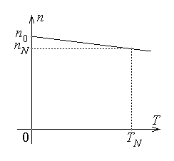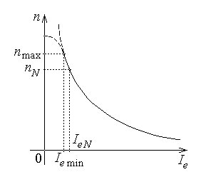
Fig. 13.30 Fig. 13.31.
where
$n_{0}=\frac{\text{60}}{2π}\frac{U_{N}}{{KΦ}_{e}} , T_{0}={KΦ}_{e}\frac{U_{N}}{r}$ .
Such a mechanic characteristic, where the drop in speed with increasing torque is small, is called a flat mechanic characteristic. In this case the generated mechanic power $P_{\text{gen} \text{mech}}=TΩ$ depends essentialy on the torque T provided at the shaft (since the revolving speed is practicaly constant).
The control characteristic $n=n \left(I_{e}\right)$ is of significance for the separately excited motors; it is defined under the conditions U = U_{N} = const., T = const. If the simplifying hypothesis of a linear $Φ_{e}=Φ_{e}\left(I_{e}\right)$ relationship of the form
$Φ_{e}=\frac{N_{e}I_{e}}{R_{m}}$
is considered in terms of the reluctance R_{m} and the total ampere–turns N_{e}I_{e} of the magnetic circuit of the machine, then the mechanic characteristic of the motor can be reformulated as
$n=\frac{\text{60}}{2π}\left[\frac{U_{N}}{{KΦ}_{e}}−\frac{r}{{\left({KΦ}_{e}\right)}^{2}}T\right]=\frac{\text{60}}{2π}\frac{U_{N}}{{KΦ}_{e}}\left(1−\frac{r T}{{KΦ}_{e}U_{N}}\right)=$
$=\frac{\text{60}}{2π}\frac{R_{m} U_{N}}{{KN}_{e}I_{e}}\left(1−\frac{r R_{m} T}{{KN}_{e}I_{e} U_{N}}\right)=\frac{\text{60}}{2π}\frac{R_{m} U_{N}}{{KN}_{e}I_{eN}}\frac{I_{eN}}{I_{e}}\left(1−\frac{r R_{m} T}{{KN}_{e}I_{eN} U_{N}}\frac{I_{eN}}{I_{e}}\right) ⇒$
⇒ $n=n_{0N}\frac{I_{eN}}{I_{e}} \left(1−\frac{T}{T_{0N}}\frac{I_{eN}}{I_{e}}\right)$ ,
where I_{eN} is a rated (normal) value of the excitation current and
$n_{0N}=\frac{\text{60}}{2π}\frac{U_{N}}{{KΦ}_{eN}} , T_{0N}={KΦ}_{eN}\frac{U_{N}}{r} , Φ_{eN}=\frac{N_{e}I_{eN}}{R_{m}}$ .
The theoretic expression derived above is no longer valid at small values of the excitation current, when the nonlinearity of the $Φ_{e}\left(I_{e}\right)$ equation makes that, in fact, the revolving speed reaches a quite great limit value n_{L} at zero excitation current (fig. 13.31).
The control characteristic obtained here shows the broad range of controlling the revolving speed of the motor by changing the value of the excitation current. It must be noted, however, that a minimum limit value of the excitation current exists, under which the revolving speed would reach dangerously high values.
6. Since the excitation current of a series excited motor is just the machine (armature) current, I_{e} = I , the mechanic characteristic $n=n \left(T\right)$ of the series excited motor is analised below under the single condition U = U_{N} = const.
Let the excitation magnetic flux be expressed in terms of an equivelent (magnetic) reluctance R_{m} and the total ampere–turns N_{e}I_{e} of the magnetic circuit of the machine as
$Φ_{e}=\frac{N_{e}I_{e}}{R_{m}}$ ;
the torque equation consequently gives
$T={KΦ}_{e}I=K\frac{N_{e}I_{e}}{R_{m}}I=\frac{{KN}_{e}I^{2}}{R_{m}} ⇔ I=\sqrt{\frac{R_{m}}{{KN}_{e}}T}$ .
The angular speed is then readily obtained from the power balance and operation equations as
$Ω=\frac{EI}{T}=\frac{\left[U_{N}−\left(r+r_{e}\right)I\right] I}{T}=\frac{U_{N}I}{T}−\frac{\left(r+r_{e}\right)I^{2}}{T}=\frac{U_{N}}{T}\sqrt{\frac{R_{m}}{{KN}_{e}}T}−\frac{\left(r+r_{e}\right)R_{m}}{{KN}_{e}}=$
$=\frac{\left(r+r_{e}\right)R_{m}}{{KN}_{e}}\left[\frac{U_{N}}{r+r_{e}}\sqrt{\frac{{KN}_{e}}{R_{m}}}\frac{1}{\sqrt{T}}−1\right]=\frac{\left(r+r_{e}\right)R_{m}}{{KN}_{e}}\left(\sqrt{\frac{{KN}_{e}I_{0N}^{2}}{R_{m}}}\frac{1}{\sqrt{T}}−1\right) ⇒$
$⇒ Ω_{∞} \left(\sqrt{\frac{ T_{0}}{T}}−1\right)$ ,
where
$Ω_{∞}=−Ω|_{ T → ∞}=\frac{\left(r+r_{e}\right)R_{m}}{{KN}_{e}} , T_{0}=\sqrt{\frac{{KN}_{e}I_{0N}^{2}}{R_{m}}}=\frac{U_{N}}{r+r_{e}}\sqrt{\frac{{KN}_{e}}{R_{m}}}$ .
Correspondingly, the mechanic characteristic expressed in terms of the revolving speed is
$n=n_{∞} \left(\sqrt{\frac{ T_{0}}{T}}−1\right)$ ,
where
$n_{∞}=−n|_{ T → ∞}=\frac{\text{60}}{2π}Ω_{∞}=\frac{\text{60}}{2π}\frac{\left(r+r_{e}\right)R_{m}}{{KN}_{e}} \left\langle \text{rpm}\right\rangle$
is the limit (opposite) revolving speed.
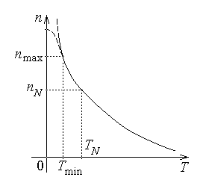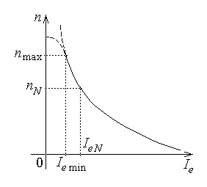
Fig. 12.32. Fig. 13.33.
Such a mechanic characteristic, presenting a significant drop in speed with increasing torque, is called a falling mechanic characteristic. The theoretic expression derived above is no longer valid at small values of the torque and of the current, when their relationship is affected by the nonlinearity of the $Φ_{e}\left(I_{e}\right)$ equation; in fact, the revolving speed reaches a quite great limit value n_{L} at zero torque (fig. 13.32). In this case significant values of the starting torque can be obtained, which is an important advange in driving most mechanic loads. On another hand, very small load torques, at no mechanic load, can determine inadmissibly large values of the revolving speed, so that apropriate protection measures must be provided.
The control characteristic $n=n \left(I_{e}\right)$ of the series excited motors is defined as well under the single condition U = U_{N} = const., and is derived by taking into account the fact that the excitation current is just the machine (armature) current, I = I_{e} . The condition of constant torque makes no sense here since, supposing for instance a linear $Φ_{e}\left(I_{e}\right)$ relationship as before, according to the torque equation
$T={KΦ}_{e}I=K\frac{N_{e}I_{e}}{R_{m}}I_{e}=K\frac{N_{e}}{R_{m}}I_{e}^{2}=\text{const}\text{.}$
this would also imply a constant excitation current. The mechanic characteristic of the motor can be reformulated as
$n=\frac{\text{60}}{\text{22}π}\left[\frac{U_{N}I}{T}−\frac{\left(r+r_{e}\right)I^{2}}{T}\right]=\frac{\text{60}}{2π}\left[\frac{U_{N}I_{e}}{{KN}_{e}I_{e}^{2}/R_{m}}−\frac{\left(r+r_{e}\right)I_{e}^{2}}{{KN}_{e}I_{e}^{2}/R_{m}}\right]=$
$=\frac{\text{60}}{2π}\left[\frac{U_{N}R_{m}}{{KN}_{e}I_{e}}−\frac{\left(r+r_{e}\right)R_{m}}{{KN}_{e}}\right]=\frac{\text{60}}{2π}\left[\frac{U_{N}R_{m}}{{KN}_{e}I_{eN}}\frac{I_{eN}}{I_{e}}−\frac{\left(r+r_{e}\right)R_{m}}{{KN}_{e}}\right] ⇒$
⇒ $n=n_{0N}\frac{I_{eN}}{I_{e}}−n_{∞}$ ,
where
$n_{0N}=\frac{\text{60}}{2π}\frac{U_{N}}{{KΦ}_{eN}} , Φ_{eN}=\frac{N_{e}I_{eN}}{R_{m}} , n_{∞}=\frac{\text{60}}{2π}\frac{\left(r+r_{e}\right)R_{m}}{{KN}_{e}}$ .
As discussed before, the theoretic expression derived above is no longer valid at small values of the excitation current, when the nonlinearity of the $Φ_{e}\left(I_{e}\right)$ equation makes that, in fact, the a limit value n_{L} of the revolving speed is reached at zero excitation current (fig. 13.33).
The control characteristic obtained here shows again thet there is a broad range of controlling the revolving speed of the motor by changing the value of the excitation current. And again it must be noted that a minimum limit value of the excitation current exists, under which the revolving speed would reach inadmissibly high values.
7. A very important problem in the usage of an electric machine is the control of its operation: the starting and the stoppage, the speed regulation and the reversal of rotation direction.
The starting of a direct current motor is associated with a significantly large current, corresponding to the large power needed to accelerate the motor and its eventual load up to a steady state revolving speed. Moreover, the low value of the counter–electromotive force at the starting contributes to the increase in the starting current. Considering, for instance, the case of the separately excited motor, the starting current is
$I_{s}=\frac{U−E}{r}|_{ Ω=0}=\frac{U−{KΦ}_{e}Ω}{r}|_{ Ω=0}=\frac{U}{r}$ ,
and is 25 to 40 times greater than the steady state value. In order to reduce the damaging effect of such a large current on the supply network and the machine itself, a starting rheostat is series connected with the machine armature (fig. 13.34). The rheostat is a resistor of variable resistance, that can be manually or automaticaly regulated, starting from the large total resistance R_{s} at the initial moment to zero resistance when the steady state has been reached. The starting current is then reduced to the value
$I_{s}'=\frac{U}{r+R_{s}}<\frac{U}{r}=I_{s}$ ,
which can be sustained by the machine circuit. Depending on the type of excitation, the starting rheostat may include additional features designed to supply from the beginning a sufficiently large excitation current that contributes to an increased counter–electromotive voltage, thus diminishing further the starting current.
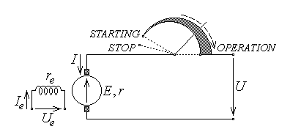
Fig. 13.34.
In the case of direct current motors of large power the starting rheostat would be extremely cumbersome and inefficient, so that the motor is started at a reduced supply voltage, which is later on increased in steps to the steady state operating value.
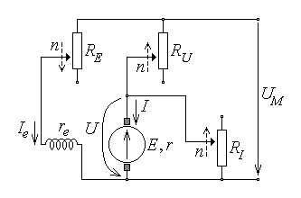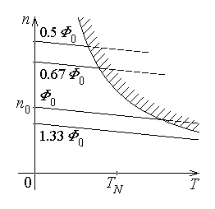
Fig. 13.35. Fig. 13.36.
The stoppage of a direct current motor is done simply by disconecting the motor from the supply network. However, care must be taken not to disconnect the excitation supply before the main supply, thus ensuring the presence of the counter–electromotive force in the machine armature, with a braking effect.
The reversal of the rotation direction is simply achieved by reversing the current direction in the field (excitation) circuit or in the armature circuit of the motor. It is obvious that if the current is reversed in both these circuits, then the machine will keep rotating as before.
The speed regulation of an operating direct current motor can be achieved by adequately controling the quantities which influence the revolving speed of the machine,
$n=\frac{\text{60}}{2π} \frac{U−r I}{K Φ_{e}\left(I_{e}\right)}$ .
Let a fixed supply voltage U_{M} be given; the figure 13.35 illustrates the fact that the revolving speed can be changed by modifying the voltage U at the machine terminals associated with the control resistance R_{U} , by modifying the armature current I associated with the control resistance R_{I} , or by modifying the excitation (field) current I_{e} associated with the control resistance R_{E} . The simplest way of regulating the motor speed is the control of the excitation current I_{e} , resulting in a family of mechanic characteristics as presented in fig. 13.36. Care must be taken, however, that, if the torque T = KΦ_{e}I is to be maintained constant, the armature current must be increased. Normal limits imposed on the machine current related to the associated dissipated power define an admissible domain in the n – T plane, outside the hatched region. The range of speed regulation by controling the excitation current is between 0.5 and 3 times the rated revolving speed. Large possibilities of speed regulation of the direct current motor are offered by electronic methods of controling the voltage at the machine terminals, the armature current, and the excitation current within very large limits.

13.4. Asynchronous machines
1. The asynchronous (alternating) current machine is a rotative electric machine characterised by a revolving speed that is in no fixed ratio with respect to the alternating current frequency in the circuit where the machine is connected. Moreover, the asynchronous machine is also named an induction machine since one winding only (usually the stator coil) is supplied with the alternating current, while in the other winding (normaly the rotor coil) the current is imposed by an induced electro-motive force.
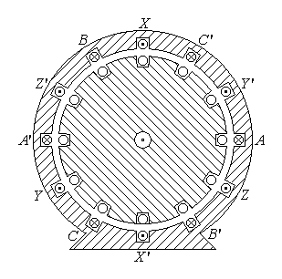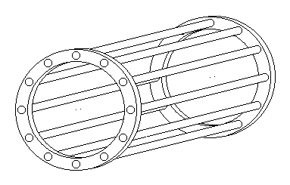
Fig. 13.37.
An asynchronous (three–phase) alternating current machine consists essentially of a stationary stator that includes the coils generating the revolving magnetic field of the machine, and a rotating rotor that includes the coils where an e.m.f. can be induced (fig. 13.37). The stator part of the magnetic circuit consists of a hollow cylinder yoke made of insulated electrical–sheet steel laminations, with slots cut on its inner periphery, where the conductors of a three–phase winding are placed. These field coils can be star or delta connected, and generate a revolving magnetic field when carrying the three–phase alternating currents of a symmetric system. The rotor part of the magnetic circuit consists in a toothed cylindrical core made of insulated electrical–sheet steel laminations mounted on the machine shaft. The rotor coils, placed in the rotor slots, are short-circuited. Most asynchronous machines use a so called squirrel–cage rotor (fig. 13.37), where the rotor windings are simply solid uninsulated copper or aluminium bars, shorted together at the two ends of the rotor by end rings – the resulted structure resembles indeed a cage. The windings of the so called wound rotor (or the slip–ring rotor) are placed in the rotor slots and usually are assembled in the same number of three–phase coils as the stator coils. Star connected at one end, the other ends of the three–phase rotor coils are connected at three slip rings mounted on, and insulated from, the shaft. Sliding brushes make the contact between the rotor coils and outer control devices – usually a three–phase star connected variable resistor (rheostat).
The asynchronous (alternating current) machine is mostly used as a motor, and this type of operation is discussed in the following.
The rated operation values of the asynchronous motor generaly are: rated power – meaning the mechanical power available at the motor shaft, rated line voltage and current, rated efficiency and power factor, rated alternating current frequency, rated revolving (rotation) speed, connection (star or delta) of the stator windings.
2. When the three–phase stator coils, assembled in p pole pairs, carry the alternating currents of a symmetric three phase system of angular frequency $ω_{1}=2{πf}_{1}$ , a revolving magnetic field is generated in the machine airgap, of a synchronous angular speed $Ω_{0}=$ $=ω_{1}/p$ , that is of a synchronous revolving speed
$n_{0}=\frac{\text{60} f_{1}}{p} \left\langle \text{rpm}\right\rangle$ .
Let it be supposed that the rotor revolves, in the same direction as the revolving magnetic field, at an angular speed Ω , that is at a revolving speed
$n=\frac{\text{60} Ω}{2π} \left\langle \text{rpm}\right\rangle$ .
It follows that the revolving magnetic field rotates at an angular speed $Ω_{0}−Ω$ , that is at a revolving speed n₀ – n with respect to the rotor. The slip is defined as the relative departure of the two revolving or angular speeds,
$s=\frac{n_{0}−n}{n_{0}}=\frac{Ω_{0}−Ω}{Ω_{0}}$ ,
so that
$n=n_{0}\left(1−s\right) , Ω=Ω_{0}\left(1−s\right)$ .
The rotor windings are thus rotating in the revolving magnetic field of the stator, which therefore presents itself as an alternating time–varying magnetic field of frequency
$f_{2}=\frac{p \left(Ω_{0}−Ω\right)}{2π}=\frac{p}{2π} sΩ_{0}=s f_{1}=s n_{0} \frac{p}{\text{60}}$ .
Consequently, the angular frequency of the revolving magnetic field with respect to the rotating rotor is
$ω_{2}=s ω_{1}$ .
The rotor windings are wound in the same way as the stator windings – and the bars of the squirrel–cage rotor can be assimilated in the same manner – so that the time–dependent magnetic flux induces in the rotor coils alternating electromotive forces which, in turn, determine the rotor induced alternating currents of frequency f₂ . The rotor currents constitute a symmetric system of three–phase alternating currents and are carried by rotor coils similar to the stator coils; consequently, they generate a rotor revolving magnetic field of angular and revolving speeds
$Ω_{2}=\frac{2{πf}_{2}}{p} , n_{2}=\frac{\text{60} f_{2}}{p}$ ,
respectively, with respect to the rotor. It is then easy to see that, since
$n_{2}=\frac{\text{60}f_{2}}{p}=\frac{\text{60}}{p} {sn}_{0}\frac{p}{\text{60}}={sn}_{0}=n_{0}−n$
the rotor magnetic field rotates with the revolving speed
$n+\left(n_{0}−n\right)=n_{0}$
with respect to the stator, the same as the stator revolving magnetic field. It thus follows that the resultant magnetic field in the airgap – the sum of the stator and the rotor magnetic fields – is a revolving magnetic field rotating at the revolving speed n₀ with respect to the stator and n₀ – n = sn with respect to the rotor.
3. The magnetic flux Φ across any stator or rotor winding is a harmonic time–varying flux and induces, just like in the transformer coils, electromotive forces – the difference is that in the present case one has to deal with motion–induced electromotive forces and with different frequencies in the stator or rotor coils.
A complex electromotive force
${\underline{E}}_{1}=−{jω}_{1}N_{1}\underline{Φ}$
is induced in each stator phase coil with N₁ turns, and a complex electromotive force
${\underline{E}}_{2}=−{jω}_{2}N_{2}\underline{Φ}=−j {sω}_{1}N_{2}\underline{Φ}$
is induced in each stator phase coil with N₂ turns. If the stator and rotor coil resistances r₁ and r₂ , along with the stator and rotor disperssion reactances $X_{σ1}=ω_{1}L_{σ1}$ and $X_{σ2}=ω_{2}L_{σ2}=s ω_{1}L_{σ2}$ are accounted for, the operation equations of each phase of the asynchronous (alternating current) motor can be written in a similar manner to those of the transformer,
$\left\{ \begin{matrix}{\underline{U}}_{1}=r_{1}{\underline{I}}_{1}+{jω}_{1}L_{σ1}{\underline{I}}_{1}+{jω}_{1}N_{1}\underline{Φ}=r_{1}{\underline{I}}_{1}+{jX}_{σ1}{\underline{I}}_{1}−{\underline{E}}_{1} \\ 0=r_{2}{\underline{I}}_{2}+j {sω}_{1}L_{σ2}{\underline{I}}_{2}+j {sω}_{1}N_{2}\underline{Φ}=r_{2}{\underline{I}}_{2}+j s X_{σ2}{\underline{I}}_{2}−{\underline{E}}_{2} \\ \frac{{\underline{E}}_{1}}{{\underline{E}}_{2}}=\frac{N_{1}}{s N_{2}} \\ R_{m}\underline{Φ} =N_{1}{\underline{I}}_{1}+N_{2}{\underline{I}}_{2}=N_{1}{\underline{I}}_{\text{10}}=N_{1}\left({\underline{I}}_{r}+{\underline{I}}_{μ}\right) \end{matrix}\right.$ .
The above phase equations, where the short circuit operation of the rotor coils, ${\underline{U}}_{2}=0$ , was considered, can be rewritten as
$\left\{ \begin{matrix}{\underline{U}}_{1}=\left(r_{1}+{jX}_{σ1}\right) {\underline{I}}_{1}−{\underline{E}}_{1} \\ 0=\left(r_{2}+j s X_{σ2}\right) {\underline{I}}_{2}−{\underline{E}}_{2} \\ \frac{{\underline{E}}_{1}}{{\underline{E}}_{2}}=\frac{N_{1}}{s N_{2}} \\ N_{1}{\underline{I}}_{1}+N_{2}{\underline{I}}_{2}=N_{1}{\underline{I}}_{\text{10}}=N_{1}\left({\underline{I}}_{r}+{\underline{I}}_{μ}\right)\end{matrix}\right.$ ,
and correspond to the equivalent circuit in fig. 13.38. The symbolic representations of the squirrel–cage and the wound rotor asynchronous three–phase motor are usually those given in fig. 13.39.
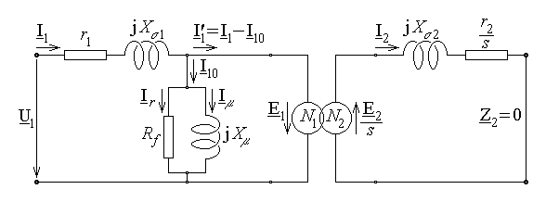
Fig. 13.38.
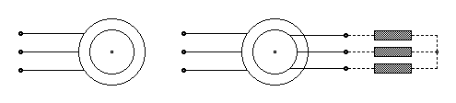
Fig. 13.39.
The operation of the asynchronous motor can be described briefely as follows: The stator revolving magnetic field induces in the rotor coils – initially at rest – electromotive forces that determine induced currents in these short circuited windings. The rotor windings, carrying the induced currents, are placed in a magnetic field which rotates at the synchronous revolving speed and are therefore subjected to an electromagnetic torque, which tends to align the rotor magnetic field along the revolving magnetic field. The rotor begins to rotate, following the revolving magnetic field in the machine and tending to catch it. However, the rotor angular speed Ω cannot reach the synchronous angular velocity Ω₀ of the revolving magnetic field since, if that would happen, then there would be no induced electromotive force in the rotor windings, no rotor induced currents and no electromagnetic torque to act on the rotor. This way, the rotor can only rotate at an angular speed Ω < Ω₀ , whence the term asynchronous assigned to such a motor. As well, it all happens as if the rotor would trail the revolving magnetic field as if slipping from it, whence the name given to the relative difference of corresponding angular speeds, s . The asynchronous motors are designed to operate at very low values of the slip,
$s=\frac{n_{0}−n}{n_{0}}≃1 \text{.}\text{.}\text{.} 5\text{\%}$ ,
under rated conditions.
The energy transfer processes are consistent with the general analysis presented in section 13.2. The active electromagnetic power corresponding to the complex induced electro-motive force ${\underline{E}}_{1}$ equals the generated mechanic power assciated with the electromagnetic torque T , rotating at the synchronous angular speed Ω₀ . On the other hand, the available mechanic power corresponds to the same electromagnetic torque T rotating at the rotor angular speed Ω , the difference representing the power loss in the rotor windings. The (active) power balance of the asynchronous motor is represented in fig. 13.40, and includes all other losses.
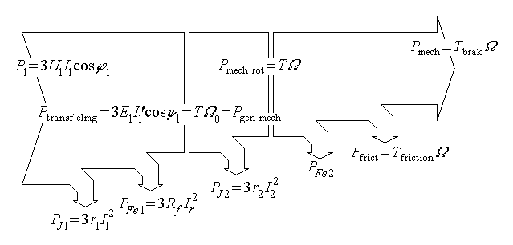
Fig. 13.40.
4. The essential operation characteristics of the asynchronous (three–phase) motor are derived from the power balance equation and the operation equations of the machine.
The electromagnetic torque is obtained from equation
$P_{\text{gen} \text{mech}}−P_{\text{mech} \text{rot}}=TΩ_{0}−TΩ=3 r_{2}I_{2}^{2}$ ,
whence
$T=\frac{3 r_{2}I_{2}^{2}}{Ω_{0}−Ω}=\frac{3 r_{2}I_{2}^{2}}{sΩ_{0}}$ .
Assuming that, as in the case of a transformer, $\left|{\underline{I}}_{\text{10}}\right|≪\left|{\underline{I}}_{1}\right|$ , it follows that
$\frac{{\underline{I}}_{2}}{{\underline{I}}_{1}}≃− \frac{N_{1}}{N_{2}}$ ,
and then
${\underline{I}}_{2}=\frac{{\underline{E}}_{2}}{r_{2}+j s X_{σ2}}=\frac{{\underline{E}}_{2}/s}{r_{2}/s+{jX}_{σ2}}=\frac{N_{2}}{N_{1}}\frac{{\underline{E}}_{1}}{r_{2}/s+{jX}_{σ2}}=\frac{N_{2}}{N_{1}}\frac{−{\underline{U}}_{1}+\left(r_{1}+{jX}_{σ1}\right) {\underline{I}}_{1}}{r_{2}/s+{jX}_{σ2}}≃$
$\frac{N_{2}}{N_{1}}\frac{−{\underline{U}}_{1}+\left(r_{1}+{jX}_{σ1}\right) \left(N_{2}/N_{1}\right) {\underline{I}}_{2}}{r_{2}/s+{jX}_{σ2}}$ .
Let the turns ratio
$w=\frac{N_{2}}{N_{1}}$
be introduced, so that the rotor current is obtained from
${\underline{I}}_{2}\left(\frac{r_{2}}{s}+{jX}_{σ2}\right)=−w {\underline{U}}_{1}−w^{2}\left(r_{1}+{jX}_{σ1}\right) {\underline{I}}_{2} ⇔$
$⇔ {\underline{I}}_{2}=\frac{−w {\underline{U}}_{1}}{\left(w^{2}r_{1}+\frac{r_{2}}{s}\right)+j \left(w^{2}X_{σ1}+X_{σ2}\right)}=\frac{−w {\underline{U}}_{1}}{\left(w^{2}r_{1}+\frac{r_{2}}{s}\right)+j X}$ ,
where the notation $X=w^{2}X_{σ1}+X_{σ2}$ was considered.
The electromagnetic torque can be expressed successively as
$T=\frac{3 r_{2}I_{2}^{2}}{sΩ_{0}}=\frac{3 r_{2}}{sΩ_{0}}\frac{w^{2}U_{1}^{2}}{{\left(w^{2}r_{1}+\frac{r_{2}}{s}\right)}^{2}+X^{2}} ⇔$
$T=\frac{3 w^{2}U_{1}^{2}\overset{}{}}{Ω_{0} \left[\frac{r_{2}}{s}+2w^{2}r_{1}+s \left(\frac{w^{4}r_{1}^{2}}{r_{2}}+\frac{X^{2}}{r_{2}}\right)\right]}$ ,
where the torque–versus–speed relationship is hidden in the torque–versus–slip relationship.
The maximum value of the torque corresponds to the minimum value of the denominator in the last equation; this so called critical torque is
$T_{M}=\frac{3w^{2}U_{1}^{2}}{2Ω_{0} \left(2w^{2}r_{1}+\sqrt{w^{4}r_{1}^{2}+X^{2}}\right)}$ ,
which is independent on the rotor resistance r₂ , and is developped at the so called critical slip
$s_{M}=\frac{r_{2}}{\sqrt{w^{4}r_{1}^{2}+X^{2}}}$ ,
which is proportional with the rotor resistance r₂ . Using these critical values, the torque–versus–slip relationship is rewritten approximately as
$T≃\frac{2\overset{}{ }T_{M}}{\frac{s}{s_{M}}+\frac{s_{M}}{s}}$ ;
corresponding approximate limit expressions are
$T≃\left\{ \begin{matrix}2 T_{M}\frac{s}{s_{M}} \text{for} s≪s_{M} \\ 2 T_{M}\frac{s_{M}}{s} \text{for} s≫s_{M}\end{matrix}\right.$ .
5. The mechanic characteristic of the asynchronous (three–phase) motor is expressed as T = T(s) instead of n = n(T) , as in fig. 13.41: the former independent variable T is no longer represented along the abscissa axis but along the ordinate axis; moreover, the former dependent variable, represented here along the abscissa axis instead of the ordinate axis, is now the slip s and not directly the revolving speed n . The mechanic characteristic T = T(s) is represented under the rated conditions U₁ = U_{1N} and f₁ = f_{1N} . The motor operation of the machine corresponds to the domain $s∈\left[0 , 1\right]$ , where the limit values are s = 0 , corresponding to n = n₀ and s = 1 , corresponding to n = 0 .
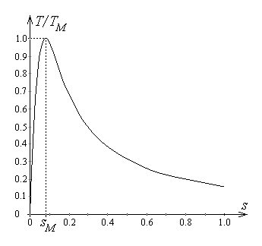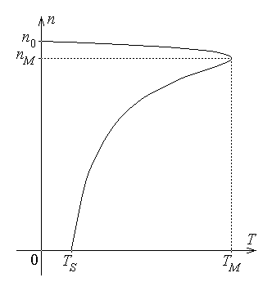
Fig. 13.41.
The mechanic characteristic is split into two branches by the critical point (s_{M} , T_{M} ) associated to the maximum electromagnetic torque: the domain $s∈\left[0,s_{M}\right]$ corresponding to a stable operation and the domain $s∈\left[s_{M}, 1\right]$ corresponding to unstable operation. Indeed, let a resistant (mechanic) torque T₀ be applied at the motor shaft, and let A be the operating point on the increasing part $s∈\left[0 , s_{M}\right]$ of the mechanic characterisitc. If even a small increase of the resistant torque from T₀ to $T_{0}'$ occurs, then the resistant torque is greater than the initial active torque, the motor decelerates and the slip increases; according to the mechanic characteristic, the active electromagnetic torque increases to a new value that balances the new resistant torque at a new, greater slip value. Let now a resistant (mechanic) torque T₀ be applied at the motor shaft, and let B be the operating point on the decreasing part $s∈\left[0 , s_{M}\right]$ of the mechanic characterisitc. If a small increase of the resistant torque from T₀ to $T_{0}'$ occurs, then the resistant torque is greater than the initial active torque, the motor decelerates and the slip increases; according to the mechanic characteristic, the active electromagnetic torque decreases to a new value that is even more departed from the resistant torque at a new, inducing a still greater deceleration – the motor finaly stops.
The shape of the mechanic characteristic of the asynchronous motor depends essentially on position of the critical point (s_{M} , T_{M} ) , which, in turn, is influenced by the value of the rotor resistance r₂ : an increase of the rotor resistance r₂ determines the increases of the critical slip s_{M} without changing the critical (maximum) torque T_{M} (fig. 13.42). This observation is the essential argument for using the slip–ring rotor machine, where an externaly connected three phase variable resistor introduces a variable rotor resistance.
The efficiency characteristic efficiency–versus–mechanic power, η = η(P₂) , under the rated conditions U₁ = U_{1N} and f₁ = f_{1N} , is very much like the efficiency characteristic of a transformer (fig. 13.43), and can be derived by following a similar argument.
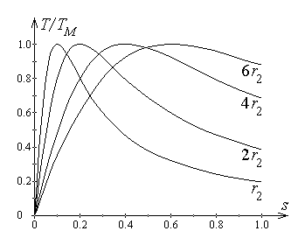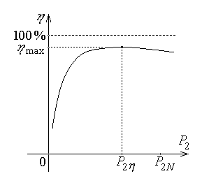
Fig. 13.42. Fig. 13.43.

Finaly, the power factor characteristic cosϕ ₁ = F(P₂) , under the rated conditions U₁ = U_{1N} and f₁ = f_{1N} (fig. 13.44), is sometimes significant in the usage of the motor. This chracteristic can be derived easily from the operation equations and shows that lower mechanic loads reduce the power factor, that is increase the phase difference at the machine terminals. Consequently, when large power values are at stake, appropriate measure have to be taken with a view to increase the overall power factor.
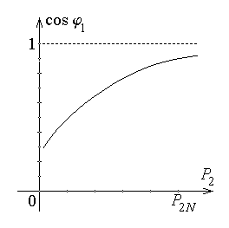
Fig. 13.44.

6. The single–phase asynchronous (alternating current) motor is similar to the three–phase motor, but its windings correspond to a single phase instead of three phases.
When the stator single–phase coils carry an alternating current, a similar alternating magnetic field is generated in the machine airgap along a fixed direction,
$B=B\left(α\right) \text{sin}ωt$ ,
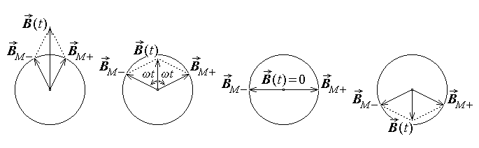
Fig. 13.45.
where α is the angle measured along the stator periphery. As illustrated in fig. 13.45, such a harmonic time–varying magnetic field can be decomposed into – or result from the composition of – two equal magnetic fields revolving in opposite directions at a constant angular speed $Ω_{0}=ω/p$, where p is the number of pole pairs of the stator winding. This intuitive observation is validated by the equation
$B_{M}\text{sin}\left(ωt−pα\right)+B_{M}\text{sin}\left(ωt+pα\right)=2B_{M}⋅\text{cos}pα ⋅\text{sin}ωt=B\left(α\right) \text{sin}ωt$ ,
whence the revolving speeds of the two components are derived from their corresponding phase as
$Ω=\frac{∂α}{∂t}=\frac{∂ϕ/∂t}{∂ϕ/∂α}=\frac{ω}{∓p}=∓Ω_{0}$ .
By the same mechanism as that analysed for the three–phase asynchronous motor, two opposite electromagnetic torques, T_{direct} and T_{reverse} , are acting on the rotor windings, so that the rotor remains at rest. This corresponds to summing up the mechanic characteristics corresponding to the opposite electromagnetic torques, as in fig. 13.46, where the slip value s = 0 , corresponding to the rotor at rest (n = 0), is the common point of the two curves. If, for some reason, the rotor begins rotating in one direction, then the corresponding direct torque T_{direct} would be significantly greater than the opposite reverse torque T_{reverse} , and the machine would operate as a motor under the influence of the active electromagnetic torque
$T=T_{\text{direct}}−T_{\text{reverse}}≃T_{\text{direct}}$ ,
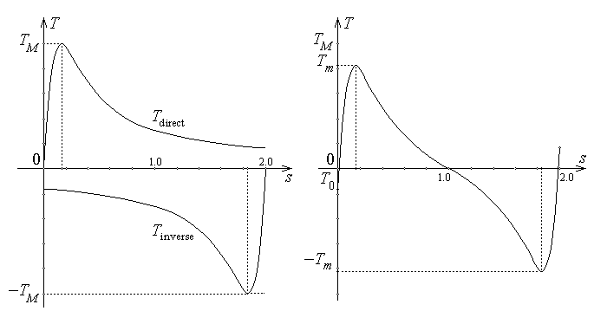
Fig. 13.46.
corresponding to only one of the revolving components of the alternating magnetic field. Some method has to be found to increase one revolving component with respect to the other, in view to get the rotor rotations started.
The capacitor–start induction motor is, in fact, a two–phase asynchronous (alternating current) motor where the stator windings includes two identic coils placed in the stator slots in successive groups spaced π/2p along the stator periphery. Considering, for instance, the simplest case p = 1 , the axes of the main (AX/ax) and displaced (BY/by) coils subtend a π/2 angle (fig. 13.47 left). Supposing that a capacitor is series connected in the displaced coil circuit (fig. 13.47 right), so that an approximately π/2 phase difference can be considered between the coil currents ${\underline{I}}_{a}$ and ${\underline{I}}_{b}$ , the magnetic flux densities are
$B_{x}\left(t\right)=B_{M}\text{sin} \left(ωt+\frac{π}{2}\right)=B_{M}\text{cos}ωt , B_{y}\left(t\right)=B_{M}\text{sin}ωt$ .
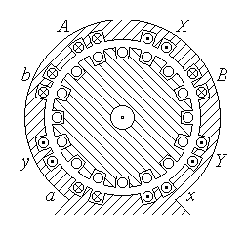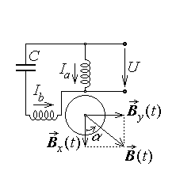
Fig. 13.47.
Consequently, the resultant magnetic flux density has thus a constant magnitude,
$B=\sqrt{B_{x}^{2}+B_{y}^{2}}=\sqrt{B_{M}^{2}\left[{\text{cos}}^{2}ωt+{\text{sin}}^{2}ωt\right]}=B_{M}$ ,
and makes with the Ox axis an angle given by
$\text{tg} α=\frac{B_{y}\left(t\right)}{B_{x}\left(t\right)}=\frac{B_{M}\text{sin}ωt}{B_{M}\text{cos}ωt}=\text{tg}ωt ⇒ α=ω t$ ,
meaning a rotation in the direct (counter-clockwise) direction with the angular speed
$Ω_{0}=ω$ ,
equal to the angular frequency of the alternating current. Just as in the case of the three–phase asynchronous machine, the synchronous revolving speed of the magnetic field of the single–phase (in fact, two–phase) motor with p pole pairs is
$Ω_{0}=\frac{ω}{p}$ .
Correspondingly, the revolving (rotation) speed expressed in rpm (rotations per minute) is
$n_{0}=\text{60}\frac{f}{p} \left\langle \text{rpm}\right\rangle$ ,
in terms of the alternating current frequency f expresssed in Hz . In fact, the addition of the displaced (capacitor) coil corresponds to adding two oppositely rotating magnetic field components, one of which adds to, and the other subbtracts from, the corresponding rotating magnetic field components of the main coil – the result, as shown above – is the revolving magnetic field of the machine, which determines the operation of the asynchronous motor as explained before.
In the shaded–pole induction motor, one side of each stator pole is surrounded by a solid contour of copper or brass (fig. 13.48 left), called shading ring (shading coil). The magnetic flux density ${\vec{B}}_{1}$ under the unshadded part of the pole can be considered in phase with the applied current; the magnetic flux under the shadded part of the pole is the resultant field of the above and the field of the shading coil. The processes are the following: the alternating magnetic flux ${\underline{Φ}}_{1}$ (corresponding to the magnetic flux density ${\vec{B}}_{1}$ ) induces in the short-circuited ring an e.m.f. ${\underline{E}}_{2}$ with a phase difference of about π/2 with respect to the inductor magnetic field and, thus, a current ${\underline{I}}_{2}$ with a phase difference ϕ with respect to the induced voltage. The magnetic flux ${\underline{Φ}}_{2}$ (corres-ponding to the magnetic flux density ${\vec{B}}_{2}$ of the induced current ${\underline{I}}_{2}$ and the inductor magnetic flux ${\underline{Φ}}_{1}$ under the shading coil sum up to a resultant magnetic flux ${\underline{Φ}}_{S}$ that is significantly out of phase from the main magnetic flux density ${\underline{Φ}}_{1}$ (fig. 13.48 right). In the machine airgap there are thus two magnetic fluxes displaced from one another in space and with a phase difference Δφ in time; as a result a rotating magnetic field is developped in the machine and, by the processes already studied above, an electromagnetic torque acts on the rotor.
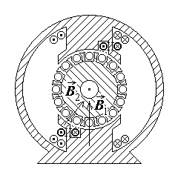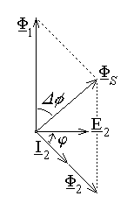
Fig. 13.48.
The single–phase (two–phase) asynchronous motors are less efficient than the three–phase induction motors; they are used at reduced power levels, especially in domestic appliances and low power drives.
7. The problem of controling the operation of the asynchronous motor is quite important: the starting and the stoppage, the speed regulation, and the reversal of rotation direction are to be discussed below.
A first difficulty associated with the starting of the asynchronous motor is due to the fact that the starting torque,
$T_{s}=T\left(n\right)|_{ n=0}=T\left(s\right)|_{s=0}≃\frac{2 T_{M} s_{M}}{1+s_{M}^{2}}$ ,
has reduced values as compared to the rated torque values. Moreover, as for any motor, the starting of the asynchronous motor is associated with a large starting current, around 5 to 10 times the rated current, corresponding to the large power needed to accelerate the motor and its eventual load up to the steady state rotating speed. As the supply network and eventually the machine coils can not sustain such large currents, special methods are to be devised for the sarting of the asynchronous motor.
Low–power squirel–cage asynchronous motors can be started using a so called star–delta switch: the stator windings are first star–connected so that the equivalent voltage applied to each phase coil is reduced adlong with the received current; after the rated revolving speed is reached, the stator windings are delta–connected, thus increasing the applied voltage, and the maximum torque. In order to use such a starting procedure, the stator coils must be designed with both terminal accessible.
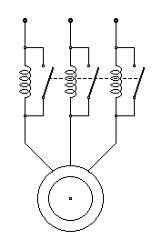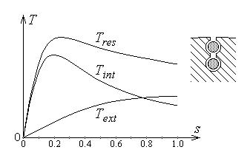
Fig. 13.49. Fig. 13.50.
Large–power squirel–cage asynchronous motors are started using starting coils or autotransformers which are series–connected with the stator coils, so that the self–induction effect prevents a steep current increase when the supply voltage is applied (fig. 13.49). After the rated revolving speed is reached, the additional starting elements are short–circuited and do not influence the motor operation. A much better starting performance is displayed by asynchronous motors with a double squirrel–cage rotor. As its name implies, the rotor includes two squirel–cage structures, placed in the same slots, the outer cage made of a higher resistivity conductor being used for starting, and the inner cage made of a higher conductivity conductor being used for normal running. Moreover, due to their placement, the outer cage has a significantly lower leakage inductance, since the field lines of the latter coil are mostly passing through ferromagnetic media. As a consequence, the mechanic characteristic of the asynchronous motor is the sum of the characteristics associated with each squirrel–cage (fig. 13.50): the characteristic corresponding to the outer cage, of larger resistance, has the maximum torque displaced to higher values of the slip as compared to the characteristic associated with the inner cage. The starting torque is therefore significantly increased and the starting procedure is thus facilitated.
The starting of the wound–rotor asynchronous motor is simplified due to the fact that so called artificial mechanic charcteristics can be readily obtained by series–connecting additional resistances to the rotor coils (fig. 13.51 left). Quite commonly the operating torque T_{o} is greater than the starting torque T_{S} and is the latter that can be modified. The maximum (critical) torque is independent on the rotor coil resistance, but the corresponding critical slip is proprtional to the rotor coil resistance. If, at the starting moment, an adequate resistance is series connected to each rotor coil, the maximum torque can be displaced to the slip s = 1 corresonding to the speed n = 0 , and the starting is quite simpe. As the rotor accelerates, the slip decreases, so that, at a certain moment, part of the additional series resistance is short–circuted by closing the switches S₁ , and the mechanic characteristic is modified to an intermediate version corresponding to an increased torque (fig. 13.51 right). The process is repeated, and finally all the additional serie resistance is short–circuited, so that the operating point of the motor places itself on the proper mechanic characteristic of the machine.
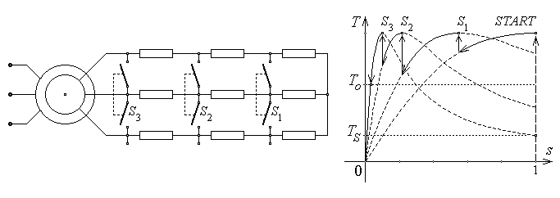
Fig. 13.51.
The stoppage of the asynchronous motor is simply done by disconnecting the motor from its supply voltage.
The reversal of the rotation direction of the asynchronous motor can be obtained by reversing the rotation direction of the revolving magnetic field, which can be realized by inter-changing two of the supply network phases.

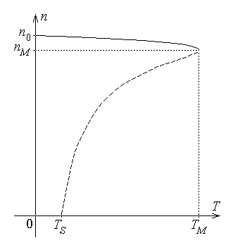
Fig. 13.52.
The proper n – T mechanic characteristic of the asynchronous motor can be obtained, as discussed previously, by simply interchanging the axes of the usual torque–slip characteristic of the motor (fig. 13.41). Since the (stable part of the) mechanic characteristic is quite flat (fig. 13.52), the speed control of an asynchronous motor can only be done by modifying the parameters associated to the whole characteristic. Indeed, the operating speed lies somewhere between the synchronous revolving speed
$n_{0}=\frac{\text{60} f_{1}}{p}$

and the revolving speed corresponding to the critical slip, depending essentially on the rotor coil resistance,
$n_{M}=n_{0} \left(1−s_{M}\right)=\frac{\text{60} f_{1}}{p} \left(1−\frac{r_{2}}{\sqrt{w^{4}r_{1}^{2}+X^{2}}}\right)$ ,
so that there are four possible ways of controling the speed of the asynchronous motor.
The speed control by modifying the supply voltage U₁ would only change the value of the critical torque T_{M} (which depends quadratically on the supply voltage), with an insignificant influence on the machine speed. The speed control by changing the number of pole pairs p would only change by large steps the synchronous revolving speed n₀ and, thus, the operating speed. Moreover, such changes can only be realized with the price of sophisticated connections of the stator windings and significantly higher costs. The speed control by modifying the rotor resistance – called rheostat speed control – can only be used with three–phase wound–rotor asynchronous motors. The rotor coils are series connected with (star–connected) rheostats in much the same way as the starting resistances (fig. 13.53 left). By changing the series resistance of the rotor coils, different artificial mechanical characteristics are obtained, with the same critical torque T_{M} , but with different critical slip s_{M} , so that different slips s and different speeds – down to full stop – can be obtained, corresponding to the same given torque (for instance, T₀ = 0.65 T_{M} , as in fig. 13.53 right). In contrast to a starting rheostat, a speed–control rheostat must be designed to carry a sustained rather than a short–duration rotor current, meaning that this form of speed control involves relatively large power losses.
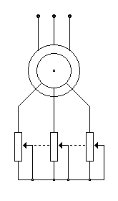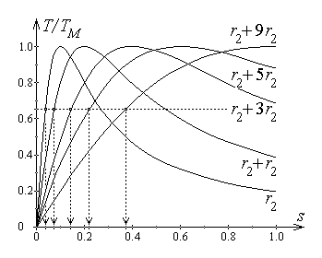
Fig. 13.53.
Modifying the frequency f₁ of the alternating current supply to the stator windings is the most promising method of speed control. A change in frequency modifies accordingly the speed n₀ of the revolving stator magnetic field, and the mechanic characteristic. When performing such a speed control, the same electromagnetic torque must be preserved. So, by neglecting the leakage reactances and the stator coil resistances, and accounting for the relations $Ω_{0}=2π f_{1}/p$ and $s=ω_{2}/ω_{1}=f_{2}/f_{1}$ , the torque might be approximated as
$T=\frac{3 r_{2}}{sΩ_{0}}\frac{w^{2}U_{1}^{2}}{{\left(w^{2}r_{1}+\frac{r_{2}}{s}\right)}^{2}+X^{2}}≃\frac{3 r_{2}}{sΩ_{0}}\frac{w^{2}U_{1}^{2}}{{\left(\frac{r_{2}}{s}\right)}^{2}}=\frac{3\text{ps}w^{2}U_{1}^{2}}{2{πf}_{1}r_{2}^{2}}=\frac{3{\text{pf}}_{2}w^{2}U_{1}^{2}}{2{πf}_{1}^{2}r_{2}^{2}}=K {\left(\frac{U}{f_{1}}\right)}^{2}$ ,
which shows that a constant torque is maintained if the ratio $U_{1}/f_{1}$ is maintained constant. A change of the supply frequency – not to mention the associated change in voltage – is difficult to be realised by pure electric means; modern electronic supply sources can be successfully used with this purpose. It must be mentioned that, under almost constant torque conditions, according to equation
$P=T Ω=T\left(1−s\right) Ω_{0}=T\left(1−s\right) \frac{2π}{p} f_{1}$ ,
the output power of the motor will change proportional to the frequency.

13.5. Synchronous machines
1. The synchronous (alternating current) machine is a rotative electric machine characterised by a revolving speed that is in a fixed ratio with respect to the alternating current frequency in the circuit where the machine is connected. The synchronism is achieved owing to the fact that the rotor of a synchronous machine is usually an electromagnet (or, more seldom, a permanent magnet) with as many pole pairs p as there are in the revolving magnetic field of the machine.
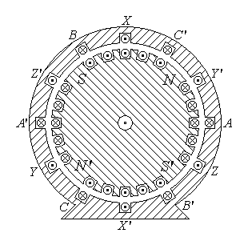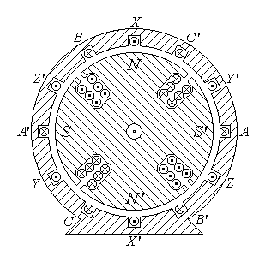
Fig. 13.54.
A synchronous three–phase (alternating current) machine consists essentially of a stationary stator that includes a system of three–phase coils, and a rotating rotor that includes the coils generating a constant magnetic field (fig. 13.54). The stator part of the magnetic circuit is similar to that of an asynchronous machine; it consists of a hollow cylinder yoke made of insulated electrical–sheet steel laminations, with slots cut on its inner periphery, where the conductors of a three–phase winding are placed. In the case of a synchronous generator, the stator coils are the place where an e.m.f. is induced in the revolving magnetic field of the rotating rotor. In the case of a synchronous motor, the stator coils can be star or delta connected, and generate a revolving magnetic field when carrying the three–phase alternating currents of a symmetric system. The rotor part of the magnetic circuit may consist in a toothed cylindrical core made of insulated electrical–sheet steel laminations mounted on the machine shaft (fig. 13.54 left). Alternatively, it may consist in a so called salient pole electromagnet, where the rotor coils are wound around pole cores mounted via the rotor core on the machine shaft (fig. 13.54 right). The rotor coils represent the (field) excitation coils, and are connected to a couple of slip rings, where sliding brushes allow the injection of the energising current. In the case of a synchronous generator the rotor coils can be directly connected to a direct current generator mounted on the same shaft as the alternating current machine.
The rated operation values of the synchronous (alternating current) machine generaly are: rated power – meaning the electromagnetic power at the terminals in the case of a generator, or the mechanical power available at the motor shaft in the case of a motor, rated line voltage and current, rated efficiency and power factor, rated line voltage and current under load, rated alternating current frequency, rated revolving (rotation) speed, connection (star or delta) of the stator windings.
2. The synchronous generator (represented in fig. 13.55 for the case of p = 1 pole pairs and a nonsalient pole rotor) operates as follows.
The rotor coils carry the direct current injected at the slip rings, so that a time–invariant magnetic field of given distribution with respect to the rotor is generated. The rotor is rotated by a net mechanic torque T_{mech} at a uniform angular speed Ω , so that harmonic time–varying magnetic fluxes are determined in the stator coils AX , BY , CZ . Since the stator coils are spaced apart by a 2π/3p = 2π/3 angle, the same phase

difference exists between the (complex) magnetic fluxes ${\underline{Φ}}_{1}$ , ${\underline{Φ}}_{2}$ , ${\underline{Φ}}_{3}$ , and between the associated (complex) electromotive forces ${\underline{E}}_{1}$ , ${\underline{E}}_{2}$ , ${\underline{E}}_{3}$ , induced in these coils – this way a symmetric system of electromotive forces of frequency ω equal to the rotor angular speed Ω is induced in the generator and supplied to the outer alternating current circuit. The complex induced electromotive force of each phase is obviously related to the complex inductor magnetic flux by the relation
${\underline{E}}_{0}=−jω{\underline{Φ}}_{0} ⇔ E_{0}={ωΦ}_{0}$ .
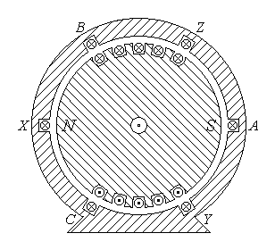
Fig. 13.55.

If both the stator and the rotor have p pole pairs, then the rotor rotation by a 2π/p angle during the p-th part of the mechanical (rotation) period T_{m} corresponds to an electrical period T_{e} . Consequently, the (angular) frequency of the generated alternating current is
$\frac{T_{m}}{p}=T_{e} ⇔ \frac{2π/Ω}{p}=\frac{2π}{ω} ⇔ ω=pΩ ⇔$
$⇔ 2π f=p⋅2{πf}_{m}=p⋅2π \frac{n}{\text{60}} ⇔ f \left\langle \text{Hz}\right\rangle =\frac{p n}{\text{60}} \left\langle \text{rpm}\right\rangle$ .
In particular, this means that, in order to generate an alternating current of 50 Hz rated frequency, one needs a large number of pole pairs p at reduced rotor revolving speed n , and less pole pairs p at large rotor revolving speeds n . In a hydraulic–turbine generator running at small revolving speeds around a hundred revolutions per minute, one needs tens of pole pairs and a salient pole rotor can be used. In a steam–turbine generator running at great revolving speeds around a thousand revolutions per minute, one needs a few pole pairs and, because of large centrifugal forces, a non-salient pole rotor must be used.
When the synchronous generator is connected to a balanced three–phase load, it supplies a symmetric system of three–phase currents of effective value I , lagging at a phase difference ε after the corresponding phase electromotive force of effective value E₀ . The stator currents generate a stator revolving magnetic field, which exerts an electromagnetic counter–torque T_{elmg} on the current carrying rotor coils. It is the balance of this torque and the active mechanic torque T_{mech} that maintains a uniform rotation of the rotor, so that the power conservation associated with the electro–mechanic conversion gives
$T_{\text{elmg}}Ω=3 E_{0} I \text{cos}ε ⇔ T_{\text{elmg}}=\frac{3 E_{0} I \text{cos}ε}{Ω}$ .
Since all harmonic time–varying electromagnetic quantities of the same kind constitute a symmetric three–phase system, it is sufficient to discuss the quantities corresponding to a single phase. The (complex) equivalent electric circuit of a phase is represented in fig. 13.56.a, with the phasors relevant to the energy generation and the power transfer at terminals presented in figs. 13.56.b and 13.56.c, respectively.
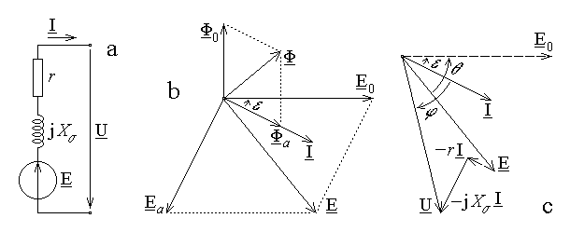
Fig. 13.56.
The (complex) inductor magnetic flux ${\underline{Φ}}_{0}$ induces the (complex) electromotive force ${\underline{E}}_{0}=−jω{\underline{Φ}}_{0}$ , lagging at a phase difference of π/2 . The (complex) current $\underline{I}$ determined in the stator coils and the external circuit lags after the electro-motive force ${\underline{E}}_{0}$ at a phase difference ε depending on the circuit parameters. The stator current $\underline{I}$ generates a reaction (complex) magnetic flux ${\underline{Φ}}_{a}$ , which, added to the inductor flux, determines the total (complex) magnetic flux $\underline{Φ}={\underline{Φ}}_{0}+{\underline{Φ}}_{a}$ in the machine airgap. The corresponding induced electomotive forces add up similarly in the resultant (complex) electromotive force of the machine, $\underline{E}={\underline{E}}_{0}+{\underline{E}}_{a}$ (fig. 13.56.b).
The (complex) electromotive force $\underline{E}$ of the synchronous generator covers the internal (complex) voltage drop corresponding to the stator coil resistance r and leakage reactance X_{σ} and the voltage at terminals supplied to the external circuit. The phase difference ϕ between the (complex) voltage at terminals $\underline{U}$ and the (complex) current $\underline{I}$ is obviously determined by the complex impedance of the stator coils and the external circuit (fig. 13.56.c). The phase angle θ between the stator induced electromotive force ${\underline{E}}_{0}$ and the resultant electromotive force $\underline{E}$ is called the internal or the load angle of the machine since it depends on the machine load, due to the influence of the latter on the current–to–voltage phase difference ϕ .
3. The synchronous motor has the same structure as the synchronous generator (for instance, that represented in fig. 13.55 for the case of p = 1 pole pairs and a nonsalient pole rotor, or that represented in fig. 13.54 for the case of p = 2 pole pairs) but operates as follows.
The three–phase stator coils of p pole pairs, spaced apart by a 2π/3p = 2π/3 angle, carry the currents of a three–phase symmetric system, so that a synchronous revolving magnetic field of angular speed
$Ω_{0}=\frac{ω}{p}$
is present in the machine airgap. The rotor coils of p pole pairs carry the direct excitation current I_{e} injected at the slip rings and, placed in the stator revolving field, is subjected to an electromagnetic torque tending to align the own rotor time–invariant field along the stator revolving magnetic field. When the rotor rotates at an angular speed Ω different from the synchronous angular speed Ω₀ , the stator revolving magnetic flux Φ_{0M} crossing the rotor windings is sensed as a harmonic time–varying magnetic flux of angular frequency $ω_{2}=p\left(Ω_{0}−Ω\right)$ and acts on the rotor with an electromagnetic torque
$T\left(t\right)=K I Φ_{0M}\text{sin}\left[p\left(Ω_{0}−Ω\right) t+α\right]$ .
The time–average value of this electromagnetic torque is zero, so that this torque only is unable to determine a strady state rotation of the machine rotor.
However, if in some way the rotor is driven to synchronism, meaning that it reaches an angular speed Ω = Ω₀ , then a non zero electromagnetic torque T_{elmg} is acting on the machine rotor. At the same time, the time–invariant magnetic flux of the rotor, revolving at the synchronous angular speed Ω₀ , induces in the stator three–phase coils a symmetric system of counter–electromotive forces of effective value $E_{0}={ωΦ}_{0}$ . The magnitude of the (active) electromagnetic torque is given by the power balance equation
$T_{\text{elmg}}Ω_{0}=3 E_{0} I \text{cos}ε ⇔ T_{\text{elmg}}=\frac{3 E_{0} I \text{cos}ε}{Ω_{0}}$ ,
where ε is the phase difference between the (complex) induced counter – electromotive force ${\underline{E}}_{0}$ and the complex current $\underline{I}$ injected in the stator phase coil. Under these conditions, the rotor is revolving at the synchronous revolving speed which, as it was previously discussed, is
$n_{0}=\text{60}\frac{Ω_{0}}{2π}=\text{60}\frac{ω/p}{2π} ⇔$ $n_{0}=\text{60}\frac{f}{p}$ .
The synchronous motor is a receiver of electromagnetic power, and the (complex) phase voltage $\underline{U}$ applied at terminals has to cover not only the phase (complex) counter–electromotive force ${\underline{E}}_{0}$ but also the (complex) voltage drop on the stator coil resistance r and leakage reactance X_{σ} . Accordingly, the phase (complex) equivalent circuit is presented in fig. 13.57.a and the phasor diagram corresponding to the operation equation
$\underline{U}={\underline{E}}_{0}+\left(r+{jX}_{σ}\right) \underline{I}$
is presented in fig. 13.57.b. Since under normal operating conditions the stator coil resistance is negligible with respect to the stator coil leakage reactance, $r≪X_{σ}$ , the approximate operation equation is
$\underline{U}={\underline{E}}_{0}+{jX}_{σ} \underline{I}$ ,
corresponding to the phasor diagram presented in fig. 13.57.c.
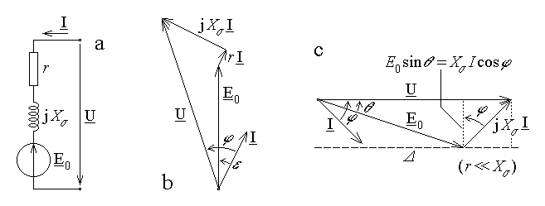
Fig. 13.57.
The last phasor diagram indicates the relationship between the internal (load) angle θ of the synchronous motor (between the (complex) counter–electromotive force ${\underline{E}}_{0}$ and the (complex) voltage at terminals $\underline{U}$ ) and the angle ε between the (complex) current $\underline{I}$ and the (complex) counter–electromotive force ${\underline{E}}_{0}$ ,
$X_{σ}I \text{cos}ε=U \text{sin}θ$ .
Using this equation and the equation of power conservation associated with the electro–mechanic conversion, the electromagnetic torque can be computed as
$T_{\text{elmg}}=\frac{3 E_{0} I \text{cos}ε}{Ω_{0}}=\frac{3 E_{0}}{Ω_{0}}\frac{U \text{sin}θ}{X_{σ}} ⇒$ $T=\frac{3 E_{0} U \text{sin}θ}{Ω_{0} X_{σ}}$ .

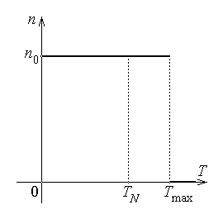
Fig. 13.58.
4. The mechanic characteristic of the synchronous motor is the function n = n(T) , under the rated conditions U = U_{N} and f = f_{N} at the stator terminals.
It was shown above that the rotor of the synchronous motor rotates at the constant synchronous revolving speed as long as the torque maintains under a maximum value; this corresponds to a so called perfectly flat mechanic charateristic (fig. 13.58),
$n=n_{0}=\text{60}\frac{f}{p} \text{for} T≤T_{\text{max}}$ .

The so named V–curves represent the functions I = I(I_{e}) and cosϕ = F(I_{e}) under the rated conditions U = U_{N} and f = f_{N} at the stator terminals and T = const. Using the (approximate) operation equation and the corresponding phasor diagram under the specified conditions, a change in the excitation current I_{e} determines a change in the induced counter–electromotive force ${\underline{E}}_{0}=−jω{\underline{Φ}}_{0}\left(I_{e}\right)$ . The (approximate) phasor diagram in fig. 13.57.c gives
$E_{0} \text{sin}θ=X_{σ} I \text{cos}ϕ$ ,
so that, by considering also equation
$\frac{3 U E_{0} \text{sin}θ}{Ω_{0} X_{σ}}=T=\text{const}\text{.}$ ,
it follows that
$\frac{E_{0} \text{sin}θ}{X_{σ}}=I \text{cos}ϕ=\frac{T Ω_{0}}{3 U}=\text{const}\text{.}$ .
This means that a change in the excitation I_{e} induces such a corresponding change in the counter–electromotive force E₀ that
$X_{σ} I \text{cos}ϕ=\text{const}\text{.}$ :
the point of the phasor ${\underline{E}}_{0}$ moves along a straight line Δ parallel to the phasor $\underline{U}$ (fig. 13.57.c). When the excitation current I_{e} increases, the inductor magnetic flux Φ₀ and the induced counter–electromotive force E₀ increase as well, so that, under constant voltage conditions U = U_{N} = const., the voltage drop X_{σ}I decreases. Now, since according to the previous discussion,
$I \text{cos}ϕ=\text{const}\text{.}$ ,
a decrease in the machine (stator) current I is accompanied by an increase in the power factor cosϕ , up to the maximum unitary value, when the normally inductive phase difference becomes ϕ = 0 . A subsequent increase in the excitation current I_{e} , accompanied by an associate increase of the counter–electromotive force E₀ , implies now an increase of the voltage drop X_{σ}I for a capacitive phase difference ϕ < 0 – the (stator) machine increases and, correspondingly, the power factor cosϕ decreases.
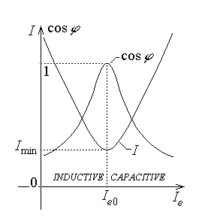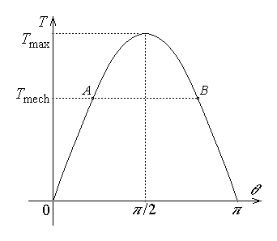
Fig. 13.59. Fig. 13.60.
The resulting V–curves (fig. 13.59) illustrate an important feature of the synchronous motor operation: under constant voltage and constant torque operation, the excitation current I_{e} can be so controlled that a capacitive power factor is presented by the motor to the alternative current main network – the asynchronous motor is acting as a source of reactive power.
The torque–versus–angle characteristic T = T(θ ) , under the rated conditions U = U_{N} , f = f_{N} , and I_{e} = const., was already derived as
$T=\frac{3 E_{0} U}{Ω_{0} X_{σ}} \text{sin}θ$ ,
where all coefficients of the angle–dependent function are constant (fig. 13.60). This characteristic allows the derivation of the maximum torque – also named the drop out torque,
$T_{\text{max}}=\frac{3 E_{0} U}{Ω_{0} X_{σ}}$ ,
and the conditions of a stable operation.
It is obvious that there are two possible operating points, A and B , at a given constant load torque T_{mech} , but it is the point A only, on the increasing branch of the characteristic, that corresponds to a stable operation. Indeed, if the load torque T_{mech} increases, starting from point A , then the electric power
$P_{\text{el}}=3 E_{0} I \text{cos}ε=T_{\text{elmg}} Ω_{0}=T_{\text{mech}} Ω_{0}$
also increases. It means a correspnding increase of the (stator) machine current I and, according to the equation
$E_{0} \text{sin}θ=X_{σ} I \text{cos}ϕ$ ,
an increase of the internal (load) angle θ . At larger internal angle θ the motor provides a greater active electromagnetic torque, which compensates the increase in the load torque, thus maintaining the constant revolving speed Ω₀ . If, starting from point B on the decreasing branch of the characteristic, the load torque T_{mech} increases, then a greater demanded current I implies a greater internal angle θ , for which the motor would provide a reduced electromagnetic torque T . The increased difference between the demanded mechanic torque and the active electromagnetic torque induces a greater and greater deceleration, until the motor stops – this is an unstable operation.
5. An important problem is that of controling the operation of the asynchronous motor: the starting and the stoppage, the speed regulation, and the reversal of rotation direction are to be discussed below.
The starting of the synchronous (alternating current) motor is a difficult problem, since, as it was argued, the starting torque of a synchronous motor is zero and the motor supplies an active torque at its shaft only if it is driven to the synchronous speed.
The use of an additional motor just to drive a synchronous motor up to the synchronous speed, and releasing it afterward, is an immediate but impractical solution to the problem. The so called asynchronous starting of a synchronous motor is instead the prefered starting method. The rotor of the synchronous motor is provided with an additional squirrel cage designed for a certain value of the starting torque. The excitation current is not supplied to the rotor coil, which is initially series connected to a power resistor of high resistance. The stator coils are connected to the three–phase network – by steps or directly at the rated perating voltage – and the rotor is accelerated up to a revolving speed close to the synchronous speed. Then the rotor coils are suddenly switched from the resistor to the direct current supply: a synchronous torque is developped which, added to the asynchronous torque, accelerates the machine rotor up to its synchronous revolving speed.
The stoppage of the synchronous motor is simply done by disconnecting the motor from its supply voltage.
The reversal of the rotation direction of the asynchronous motor can be obtained by reversing the rotation direction of the revolving magnetic field, which can be realized by inter-changing two phases of the supply network. The reversal of the synchronous motor is not a simple matter: it supposes the stoppage, interchanging of phases, and re–starting of the motor.
Since the mechanic characteristic is absolutely flat, with
$n=n_{0}=\frac{\text{60} f_{1}}{p}$
as long as the torque remains under its maximum admissible value, the speed control of a synchronous motor can only be done by modifying the synchronous speed of the stator revolving magnetic field. The change of the number of pole pairs p could be, in principle, a method of changing in steps the synchronous speed, but it is not advisable. The change of the supply frequency f₁ is the method of choice for controling the synchronous speed of the motor, and this is done by using apropriate electronic supply sources, under conditions similar to those discussed with reference to the speed control of the asynchronous motor .

13.6. Electric apparatus
1. The operation of an electric equipment involves the use of a large variety of electric apparatus for control and protection.
Different items of electric equipment are connected to one another or to the main supply network by means of bare buses set up on appropriate insulators or by means of power cables. The reliable operation of an ellectric installation is to a large extent dependent on the quality of conductor contacts.
The most commonly used contacts are permanent contacts such as when leads are joined to the terminals of an electric equipment. Sliding contacts as those between the slip rings and the brushes of a rotating electric machine are also common. Switching contacts are those made when pressing or depressing two conductors under properly applied forces, with a view to closing or opening a conducting link between different electric installations.
In any form of contact, two conductors actally touch each other at a number of elementary areas produced as their microscopic irregularities or asperities on the touching

surface are crushed by pressure (fig. 13.61). Since the current is carried between the two conductors across the contacting areas, the cross section of the current path is reduced and an increase of the electric resistance results, which is named the contact resistance. The contact resistance decreases with increasing contact pressure, since the
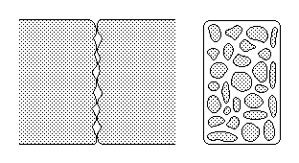
Fig. 13.61.

asperities are crushed more, the contacting area increases along with the cross section of the current path.
The contact resistance between two mating surfaces may augment significantly due to their oxidation. This often happens when the contacting surfaces are heated over 70°C and, for this reason, it is important to take precautions against heating and oxidation at contact areas.
Opening an electric circuit takes some time when the circuit was carrying a current. This is due to the fact that the cancellation of the electric current means the cancellation of the associated magnetic flux, and a time–varying magnetic flux generates in the very circuit a self–induced electromotive force. The electric field corresponding to the joint action of the supply voltage and the induced electromotive force is sufficient to ignite an electric arc between the parting contact surfaces. As it has a very high temperature, the electric arc may rapidly destroy or weld together the contacts. Especially hazardous is the occurrence of electric arcs in high–voltage switches or breakers intended to interrupt large short–circuit currents.
Breaking an alternating current circuit is a simpler matter because the alternating voltage passes through a zero value every half–cycle, and this can extinguish the electric arc. The alternating current switches must then be designed and constructed so as to prevent re–ignition of the electric arc after it was extinguished in the preceding half–cycle. Direct current circuits are more difficult to interrupt. The direct current switches must be able to dissipate the very large amounts of energy released by a sustained electric arc.
The preceding considerations are illustrated in the ensuing discussion of the most common electric apparatus: thermal protection equipment, mechanic and automatic circuit breakers, and relays.
2. The electric equipment as well as the connecting conductors must be protected against overheating that might be caused by sustained overloads or short–circuits.
A short–circuit is an abnormal connection of very low resistance between two points of normaly different potentials in the circuit. A short–circuit may occur inadvertently when two uninsulated parts of a circuit, placed under non–zero voltages, touch each other, or may result from damage to the installation due to ageing, wear, puncture, etc. A short–circuit leads to a sudden increase in current and, since the energy dissipated as heat in conductors is proportional to the square of the carried current, the ensuing thermal action may lead to the destruction of the insulation and a fire. As well, large short–circuit currents develop excessive electrodynamic forces between current carrying conductors, which might also damage the installation. Finally, a short–circuit changes drasticaly the operation of the circuit often resulting in closing down any equipment operation.
The prevention of all damaging effects associated with a short–circuit consists in the removal of the energy sources supplying the short–circuit current – most often by disconnecting the involved equipment from its main supply.
The simplest way to interrupt short–circuit currents is to use the very thermal effect they determine in a protective device called a fuse. The active element in a fuse is a purposedly designed conductor, named the fuse link, that would melt when the current in the protected circuit exceeds a definite rated value (fig. 13.62. left). The fuse link is made from a conductor of sufficiently high resistivity (such as an lead–tin alloy) or a very thin wire of a well conducting metal (such as copper or silver). The melting of a fuse link is determined by an important unbalance between the rate of temperature increase associated with the heat dissipated in the fuse link and the rate of heat release from it to the surrounding environment. A fuse is thus characterised by a melting characteristic like that in fig. 13.62. right, giving the melting duration as a function of the current intensity in the fuse link. The limit current I_{lim} is the current intensity associated to a fuse temperature very close to the melting temperature; exceeding this limit initiates the fuse link melting, which happens more rapidly for larger currents. The typical interrupt time provided by a common fuse is of the oder of 1 milisecond.
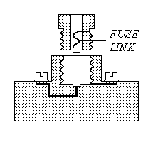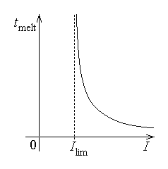
Fig. 13.62.
Short–circuit protection should not be taken as sustained–overload protection: the current rating of a fuse intended to protect an installation or equipment should be chosen so as to allow for a short time overload such as it may occur when starting a motor.
The termal protection is also used in so called thermal relays. The active part of a thermal relay is a bimetallic element – a couple of two metal plates differing in their

thermal expansion, laminated together and pressed into a concave shape (fig. 13.63). When heated to a predetermined temperature by a heater element, carrying the same current I as the protected circuit, the more rapid expansion of one metal increases the tension in the laminated couple until it suddenly snaps to its convex position and engages a spring mechanism to break two contacts thereby disconnect-ting the overloaded line.
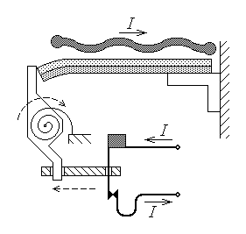
Fig. 13.63.

The operation of a thermal relay is associated with a considerable thermal lag, so that thermal relays can not provide short–circuit protection. Fuses are therefore needed to be series connected with thermal relays in order to insure necessary protection.
3. Since fuses can not protect the electric equipment against sustained overloads, high–power electric installations are additionally equipped with automatic circuit breakers. In fact, such automatic circuit breakers can be designed to break the connection to the main electric network in the case of an overcurrent or overvoltage, but as well in the case of an undercurent or undervoltage, or a reverse current, not to mention special–purpose circuit breakers.
The actuation of an automatic circuit breaker in the case of a predetermined abnormal condition ca be performed by means of electromagnetic, thermal or a joint action of electromagnetic and thermal tripping mechanisms. In the case of a combined tripping mechanism, each of the two elements may open the circuit breaker independently. In particular, an electromagnetic tripping mechanism, based on the operation of an electromagnet, can act instantaneously, so that no additional fuses need be provided. The choice of the tripping mechanism for a circuit breaker depends on the function it is expected to perform, as it is briefly presented in the following.
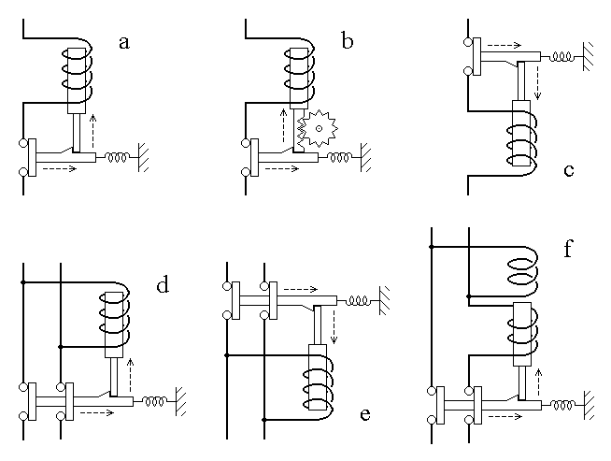
Fig. 13. 64.
The automatic overcurrent circuit breaker is the most common air circuit breaker (fig. 13.64.a). When the current in the protected circuit reaches its limiting value, the electromagnet coil draws in an iron plunger and a latch which releases a spring; the latter pulls the contacting piece away from the contacts in the main circuit and breaks its continuity. It is common that such low–power circuit breakers allow re–closing by hand and, with a view to avoid reclosure of a faulted circuit, it is customary to equip overcurrent circuit breakers with a release–free mechanism. Its function is to open the closing circuit of the circuit breaker even though the operator is holding the operating handle or button in the closed position.
Some automatic circuit breakers may include a time–delay feature: the automatic circuit breaker is allowed to open a definite time after an abnormal condition has occurred in the protected circuit. In this way some short–duration increase in current, which is not dangerous to the concertned installation, such as the starting current of a motor, can be sustained until it damps down by itself. The time delay is usually introduced in the form of some braking mechanism associated with the actuation of the latch. For instance (fig. 13.64.b), a pinion may engage in a rack so that the drawing of the plunger into the electromagnet and the release of the latch is delayed for an adjustable time. If the rise in current ceases before the time–delay assembly releases the latch, the plunger regains its original position and the circuit breaker will not work. Other braking mechanisms can be provided by an oil or an air dash–pot or a similar device.
An automatic undercurrent circuit breaker is used in the case where a circuit must be de–energised whenever the current in a specific branch drops under a predetermined value. The operation of an undercurrent circuit breaker (fig. 13.64.c) is quite the opposite of that of the overcurrent circuit breaker. When the current in the protected circuit drops under its limiting value, the electromagnet coil releases the iron plunger which falls by gravity and the associated latch releases a spring; the latter pulls the contacting piece away from the contacts in the main circuit and breaks its continuity.
Automatic overvoltage (fig. 13.64.d) or undervoltage (fig. 13.64.e) circuit breakers operate on about the same principles as the corresponding overcurrent or undercurrent circuit breakers; a difference is that that the release of the breaker spring breaks the two conductors providing the energizing voltage.
An automatic discriminating or reverse current circuit breaker (fig. 13.64.f) employs a differential action upon the plunger of the combination of a current coil and a voltage coil of the same electromagnet. When the current (and the associated power transfer) is in the normal direction, the lower current coil of the electromagnet sets up a magnetic field which opposes, and is compensates by, that due to the upper, voltage coil; as a result the plunger and the latch are not actuated. In the case where the current is reversed, the magnetic fields of the two coils are combined to draw in the plunger and the actuated latch releases the spring to pull the contacting pieces away from the contacts in the main circuit and breaks its continuity.
4. Isolators or disconnectors are mechanical isolating or disconnecting switching devices used primarily for the purpose of isolating an equipment from the power source, for isolating different parts of an installation from one another, for transfer, testing or grounding purposes. Their main feature is that they are not usually intended to break load curents, except under special conditions and in limited amounts.
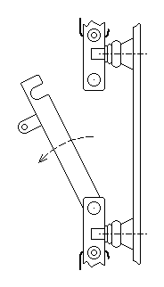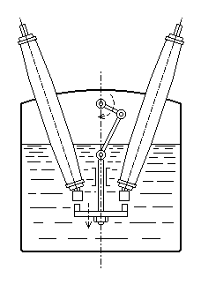
Fig. 13.65. Fig. 13.66.
An isolator has fixed and movable contacts set up on insulators – the contacts may be of the flat (knife–blade) type or of the turning type. Low–power isolators can be operated manually by handling insulated hooks or rings (fig. 13.65); heavy–duty isolators are usually operated by motor or by air–actuated devices.
If an isolator were used to break a current carrying circuit, an electric arc – a gas carried electric discharge – would strike between the contacts and destroy them. To avoid such circumstanes, the operating mechanism of isolators are customarily fitted with an interlock which would not let the isolator be opened before the circuit has been opened by a circuit breaker.
When, howerer, the need arises to interrupt low–power loads at currents not exceeding the normal operating value a so called load–breaking isolator can be used instead of an expensive and bulky circuit breaker. A load–breaking isolator is similar to a knife–blade off–load isolator, but includes an additional arc–extinguishing device.
5. High–voltage circuit breakers are just non–automatic circuit breakers used for opening or closing electric circuits under both normal and abnormal conditions.
These circuit breakers have often to operate on short circuits, so that it is important to know the short–circuit current that is likely to be handled. The designer can then assess the electromagnetic and thermal endurance of a prospective circuit breaker in terms of the rated power breaking capacity and the rated current breaking capacity.
An oil circuit breaker uses a mineral oil as the arc–extinguishing medium. A plain–break oil circuit breaker (operating at 6–10 KV with a power breaking capacity of 150 MVA) consists of an oil–filled tank through the cover of which are carried porcelain or composition terminal bushings (fig. 13.66). The fixed contacts at the bottom of the bushings are bridged by a pair of movable contacts on a conducting crosshead which is carried by an insulated lift rod. The lift rod can be lifted by a lever system in turn coupled to a long shaft rotated by a handweel or a similar device. In the closed position the crosshead carrying the movable contacts is held locked by a latch incorporated in the operating mechanism.
When the latch is released, the lift rod and the crosshead move downward, acted on by gravity and supplementary accelerating springs, and give two beaks per pole. More often, a plain–break oil circuit breaker has more contacts and crossheads so as to give four or six breaks per pole. As the current circuit is interrupted, an electric arc ignites between the contacts. The high temperature of the arc causes some oil to evaporate and to form an gas bubble arouns the parting contacts – the electric arc is thus sustained in a gas medium under high pressure. This speeds up the arc extinction because the rise in pressure improves the electric insulating properties of the gas medium. As the contacts move apart, the length of the arc is increased, and this calls for a higher voltage to maintain the arc. In alternating current circuits, where plain–break oil circuit breakers are mostly used, the current interruption and the arc extinction are sped up when the voltage approaches the zero crossing which happens every half–cycle.
More elaborate designs of oil circuit breakers might include intermediate contacts allowing the arc transfer between different pair of contacts durring circuit opening. A still better performance is achieved when using arc–controlling devices in the form of ruptors or expulsion chambers: the arc is extinguished quicly in a confined space by forcing oil through or along the arc by means of the gas pressure generated by the gas.
An air circuit breaker using the air as the arc–extinguishing medium is employed at voltages above 35 KV. The air–break units use atmospheric air, and the air–blast units employ compressed air. In the latter type of construction, one or both parting contacts are made hollow, and compressed air under a pressure of 0.7 – 2 Mpa is forced through the space thus formed, and its blast blows the arc off the contact faces. The air–blast circuit breakers are lighter and quicker than oil cicuit breakers; however, they need an additional air compressor for their oparation, and a particularly purified and dried air to be used.
After it has opened a circuit, a circuit breaker remains under voltage, which is a hazardous inconvenience because the operation of the circuit breaker asks for inspection and, more often, servicing or repair of the circuit and the breaker. To make this safe, it is customary to add an isolator to each circuit breaker – the operated circuit breaker can thus be readily disconnected from the voltage source.
6. An electromagnetic relay is an electromagnetic control apparatus that causes a switching operation in a controlled circuit when it is acted on adequately by a controlling circuit.
Electromagnetic relays are used to control the operation of an electric equipment or installation and to protect apparatus, parts or entire electromagnetic systems from dangerous conditions that can arise during operation (short circuits, faults to ground, abnormal changes in voltage or current, reversal of power flow, etc.). To perform these functions, such relays are arranged in what are often extremely sophisticated protection systems acting not only over entire installation, but also on specific parts of them.
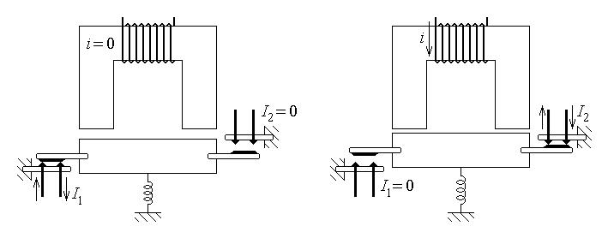
Fig. 13.67.
The most common electromagnetic relay is essentially a magnetic circuit with a fixed armature, on which a controlling coil is wound, and a movable armature, which operates directly or indirectly on a group of controlled contacts (fig. 13.67). When the controlling current carried by the controlling coil exceeds a certain limit value, a magnetic force attracts the movable armature to the fixed armature and closes (or opens) the controlled contacts.
The operation of an electromagnetic relay is easily understood if the study of the magnetic circuit approached before, in section 7.2, is extended to cover energy and force related questions, as it was done in section 7.3. Let then a very simple magnetic circuit be considered, consisting of an upper U–shaped and an lower I–shaped ferromagnetic parts separated by identical air gaps (fig. 13.68.a as a simple version of the construction in fig. 12.68.b). Let $μ=μ_{0} μ_{r}$ be the permeability of the ferromagnetic pieces, S their cross section surface, l_{f} the length of the median field line in the ferromagnetic pieces of the magnetic circuit, and $δ≪\sqrt{S}$ the length of the air gaps. Let also a coil of N turns carying the electric conduction current of intensity i be wound around the upper piece of the magnetic circuit. The study of this magnetic circuit resulted in determining first the magnetic flux over any cross section of it,
$Φ=\frac{μ_{0} S N i}{2δ+l_{f}/μ_{r}}$ ,
and then the coil inductance
$L=\frac{μ_{0} S N^{2}}{2δ+l_{f}/μ_{r}}$ .
Noting that the generalised coordinate is obviously the air gap length δ , the theorem of generalised magnetic forces can be used, under the form
$F=\frac{∂W_{\text{mg}\text{.}}\left(i,δ\right)}{∂d}|_{ i=\text{const}\text{.}}=\frac{∂}{∂d} \frac{L\left(δ\right) i^{2}}{2}|_{ i=\text{const}\text{.}}=\frac{i^{2}}{2} \frac{∂L}{∂δ} =\frac{i^{2}}{2} \frac{∂}{∂δ} \frac{μ_{0} S N^{2}}{2δ+l_{f}/μ_{r}}=$
$= − \frac{i^{2}}{2} \frac{μ_{0} S N^{2}}{{\left(2δ+l_{f}/μ_{r}\right)}^{2}} ⋅2=− \frac{μ_{0} S N^{2} i^{2}}{{\left(2δ+l_{f}/μ_{r}\right)}^{2}}$ .
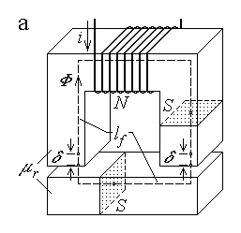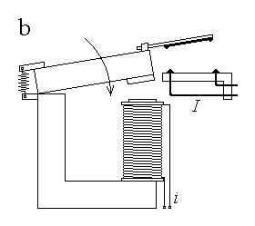
Fig. 13.68.
The negative sign of the result indicates that the force is acting in the direction of decreasing generalised coordinate δ , meaning an attraction force of magnitude
$F=\frac{μ_{0} S N^{2}}{{\left(2δ+l_{f}/μ_{r}\right)}^{2}} i^{2}$ .
By using the constitutive equation of the coil, it can be expressed as
$F=\frac{μ_{0} S N^{2}}{{\left(2δ+l_{f}/μ_{r}\right)}^{2}} \frac{φ^{2}}{L^{2}}=\frac{μ_{0} S N^{2}}{{\left(2δ+l_{f}/μ_{r}\right)}^{2}} \frac{φ^{2} {\left(2δ+l_{f}/μ_{r}\right)}^{2}}{{\left(μ_{0} S N^{2}\right)}^{2}}=$
$=\frac{1}{μ_{0} S N^{2}} φ^{2}=\frac{S}{μ_{0} N^{2}} {\left(\frac{φ}{S}\right)}^{2}=\frac{S}{μ_{0} N^{2}} B_{0}^{2}$ ,
stressing the direct link of the magnetic force with the magnetic flux density in the airgap.
The performance of a relay is usually described in terms of its control characteristic – the dependence of the controlled output quantity (be it a current I_{O} ) on the controlling input quantity (be it also a current I_{I} ). There are two appearances of the characteristic, depending on the action performed by the relay – it can open some normally closed contacts, in which case the output value decreases upon operating the relay (current I₁ in fig. 13.67), or it can close some normally open contacts, in which case the output value increases upon operating the relay (current I₂ in fig. 13.67). The corresponding control characteristics are presented in fig. 13.69.
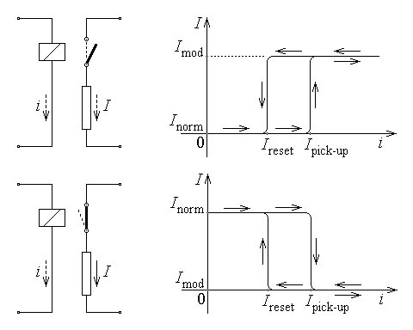
Fig. 13.69.
As long as the control quantity i remains below an operating or pick–up value, I_{pick–up} , the relay is not operating (its movable part is at rest in the dead position) and the controlled quantity remains unchanged at its normal I_{norm.} value. When the control quantity equals or even exceeds its pick–up value, the relay operates (by displacing its movable part into the live position) and, by switching on or off the attached contacts, brings about a stepwise variation of the controlled quantity to its modified final or sealing I_{mod.} value. Any further increase in the control quantity leaves the controlled quantity unchanged. The latter likewise remains unchanged as long as the control quantity is not lowered to a reset or dropout value, I_{reset} . At the instant when the control quantity drops under the reset value, the relay disengages its movable part, the attached contacts are switched back to their initial normal position, and the controlled quantity falls back to its original value.
Such a hysteresis–type control characteristic is in turn evaluated by its reset ratio, defined as
$k_{\text{reset}}=\frac{I_{\text{reset}}}{I_{\text{pick}−\text{up}}}$ .
Depending on the design, the reset ratios of common relays are between 0.3 and 0.98 .
To assure the reliable functioning of a relay, its operating (value of the control) quantity, I_{op.} , needed to activate the relay, must somewhat exceed the pick–up value. The safety factor is the ratio of these quantities,
$k_{\text{safe}}=\frac{I_{\text{op}\text{.}}}{I_{\text{pick}−\text{up}}}$
and ranges usually between 1 and 3 .
In some cases need arises for delaying the action of a relay for some time interval after the pick–up value has been exceeded. The time–delay, introducing a time–lag in the relay action, can be introduced in the operation of a relay by mechanical means (damping or inertial devices) or by electromagnetic means (a short–circuit turn around the electromagnet core introducing a reaction of the induced currents).
The resilience of a relay is linked to the ability of its contacts to perform a switching and can reach some millions of operations, at a switching frequency of the order up to a few thousands per minute. Finally, the active power consumption of the relay coil(s) is about one watt.
Relays can be classified according to the function performed by them. An overcurrent relay operates when the actuating (control) current exceeds its operate or pick–up value. Similarly, an overvoltage relay operates when the actuating voltage exceeds its operate or pick–up value. An undercurrent relay operates when the actuating (control) current falls below its reset or dropout value. An undervoltage relay operates when the actuating voltage falls below its reset or dropout value. A differential relay functions by reasons of the difference between two quantities of the same kind (two currents or two voltages). The automatic circuit breakers previously described are operating, in fact, as relays controlling the main current or voltage applied to the protected installation or equipment.
Accordding to the actuating quantity used, relays may be classified into current relays, voltage relays, resistance relays (responding to variations in the voltage–to–current ratio), or power–directional relays (responding to reversal in the direction of the power flow).
As well, direct–acting relays cause the associated circuit breaker to trip directly. In contrast, indirect–acting relays do so through the intermediary of an auxilliary control current which energizes the trip coil of the associated circuit breaker.
Finally, primary relays are connected directly in the circuits they are to protect. This arrangement simplifies the protection system, but the primary relay remains always under voltage, and this may hinder the detection of its actual operational status. On the contrary, secondary relays are connected to the circuit to be protected via current or voltage instrument transformers, so that the relays can be serviced under more safe conditions.
Complex control and/or protection relay systems are intended to perform definite actions under specified conditions. In addition to connecting/disconnecting devices, equipments or installations, the relay system usually provides an indication on the operating status of the controlled or protected circuit. The performance of a protective relay system is stated in terms of adequate parameters.
The selectivity of a protective relay system consists in its ability to affect as small a part of the protected circuit as possible around the faulted piece, device or equipment, leaving the rest of the protected installation operate normally.
The high speed of response of the protective relay system is essential so as to keep to a minimum the extent of damage caused by the fault to the affected part of the circuit and to impede that the fault influence significantly the rest of the circuit.
The sensitivity of a protective relay system consists in its ability to respond at the earliest possible time, preferably at the very onset, to the smallest sign of improper operation.
The reliability of the protective relay system characterises its ability to operate under faulty conditions without a hitch. The redundancy of the system, meaning the provision of back–up elements that would go into action should the main ones fail to function properly, could serve to enhance this characteristic.
The proper sequence of comands to different electric parts of an equipment can be governed by an electromagnetic device called a controller. The functions it can perform include starting, frequency and/or speed control, reversals, braking, and stopping. A controller is usually actuated by rotation of a handweel or a knob.
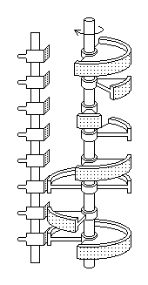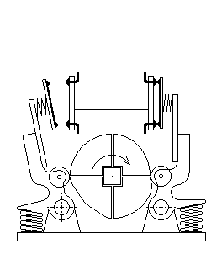
Fig. 13.70. Fig. 13.71.
The most commonly used electric controller is the drum controller (fig. 13.70). It comprises a rotatable drum, which carries movable contact strips usually made of copper and displaced through different angles with respect to one another. Some contact strips can be electrically connected if demanded by the intended comands. Heavy contact fingers, secured to a stationary base, bear on the respective contact strips needed to make the required electrical connections as the drum is rotated. The contact fingers are insulated from one another and soldered to the wires that connect the controller to the controlled units.
Drum controllers may only be used for infrequent switching operations. More frequent operations are performed with cam controllers, built around cam–type contactors. A simple cam controller for two circuits, as that presented in fig. 13.71, includes a rotatable shaft on which the insulated control cams are mounted. The necessary pressure of bridge–type movable contacts against the stationary contacts set up on an insulating baseboard is provided by springs. As the shaft is rotated, the lobe of the cam brings pressure upon a roller, and this pushes away the movable contacts, thus breaking the controlled circuit at two points. As the shaft is further rotated, the lobe of the cam comes off the roller, an attached spring rotates the arm carrying the movable contacts, and the circuit is closed.
Similar automatic controllers can be activated by a motor shaft, rotating at a precise revolving speed, if the sequence of comands is to be periodically repeated.
The advances in electronics have determined a switch from electric devices to electronic circuits able to perform some tasks covered before by electric apparatus. This is especially true for low–power relays, controllers, control and protection systems; in contrast, electric apparatus needed to control high–voltage and large–power applications remained essentially unchanged.

13.7. Electric drives
1. An electric drive system is a set of interconnected and interdependent electro-magnetic and mechanical equipments which perform the electro–mechanical energy conversion associated with a definite technology process. Such an electric drive system usually consists of an adequate electromagnetic energy source, a drive motor (or motors), a driven machine, a (mechanical) transmission from the former to the latter, and associated switchgear and controls (fig. 13.72, where a tyristor bridge, a D.C. motor, a transmission gear and a fan illustrate an electric drive system). An electric drive system is used to achieve a certain position or speed – linear or angular – of relevant parts of the driven machine, in relation with definite characteristics of the force or torque developed by both the driving electric motor and the driven machine, under specific operation conditions. The typical drive system to be analized in the following supposes rotational driving motors and driven machines, but a similar approach can be used in the study of linear driving motors and driven machines.
The electromagnetic energy source of a drive system is the element that supplies the electromagnetic energy needed by the system to operate properly. It provides the adequate type of electromagnetic quantities – direct or alternate current – of proper values for the voltage, curent, or frequency, and usualy includes associate equipment to control the operation of the system. Modern drive systems use extensively specific electronic equipments to achieve such tasks.
The driving element of a drive system is an electric motor where the electromagnetic energy is transformed into mechanic energy. It is chosen with a view to fit to the requirements of the driven load and its operating conditions imposed by the technology process.
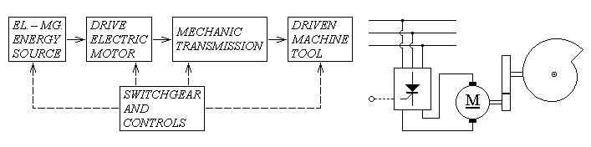
Fig. 13.72.
The mechanic transmission is that part of the drive system which provides the mechanic coupling between the motor and the load at adequate mechanic parameters such as torque or angular speed. The simplest mechanic transmission is the direct coupling of the motor and the load. Even if the shaft alignment of the motor and load is properly insured, a stiff coupling imposes a heavy duty on the bearings. Moreover, the control of the load torque and speed can be achieved by directly controling the electric motor performance only. The common transmission methods use gear or worm reducers, friction, hydraulic or even electromagnetic clutches, and quite rarely driving belts or chains. The main parameter of a transmission equipment is the gear ratio, that is, the ratio of angular speeds of the driving and driven shafts determined, for instance, as the ratio of gear tooths,
$k=\frac{Ω_{\text{motor}}}{Ω_{\text{load}}}=\frac{N_{\text{motor} \text{gear}}}{N_{\text{load} \text{gear}}}$ ;
if the mechanic losses in the gear are neglected, so that $Ω_{\text{motor}}T_{\text{motor}}=Ω_{\text{load}}T_{\text{load}}$ , the gear ratio imposes the reciprocal ratio between the corresponding torques,
$k=\frac{Ω_{\text{motor}}}{Ω_{\text{load}}}=\frac{T_{\text{load}}}{T_{\text{motor}}}$ .
The driven machine is the mechanic equipment where the mechanic energy is used to perform some specific technology task. It could include some additional devices for transforming a rotation movement of the primary shaft into a translation or a more complex movement of its mobile parts. There are the operating conditions of the driven machine which impose the most important restrictions on the design and exploitation of a drive system.
Some parameters are of particular importance when analysing an electric drive system. The mechanic characteristics T(n) of both the electric motor and the mechanic load are essential in evaluating the operating range of the drive system. The range of revolving speed of the mechanic load, imposed by the technology process, is also important. The operation may impose a single speed (as for hydraulic pumps, compressors or fans), a number of fixed speeds (as for crans or cutting machines), or a variable speed (as for rail mills or electric vehicles). In the last cases, the range of revolving speeds is characterised by the speed ratio
$γ=\frac{n_{\text{max}}}{n_{\text{min}}}$ .
Finally, in some particular cases, the technology process may impose a specific precision of revolving speed, defined as the maximum admissible departure
${Δn}_{\text{max}}=\left| \frac{n−n_{\text{imp}\text{.}}}{n_{\text{imp}\text{.}}} \right|⋅\text{100} \left\langle \text{\%} \right\rangle$ ,
with respect to the imposed speed n_{imp.} .
2. The first step in the analysis of the operation of an electric drive system is the study of the equation of motion for the drive system. The equation of motion consists essentialy in equating the active electromagnetic torque, provided to the shaft by the electric motor, and the load torque, applied to the same shaft by the rest of the driving system,
$T_{\text{act}\text{.}}=T_{\text{st}\text{.}}+T_{\text{dyn}\text{.}}$ .
where the load torque includes the static load, which refers to the friction and the forces exerted in the technology process, and the dynamic load, which arises from accelerations – changes of speed – of different parts of the system.
The active electromagnetic torque T_{act.} generaly depends on the revolving speed of the machine shaft as
$T_{\text{act}\text{.}}=T\left(n\right)$ ,
and this determines an associated dependence of the developped power on the revolving speed,
$P\left(n\right)=T⋅Ω ⇔$ $P\left(n\right)=\frac{2π}{\text{60}} T\left(n\right)⋅n$ .
Some typical torque–versus–speed (and power–versus–speed) characteristics of electric motors are presented below.
A perfectly flat mechanic characteristic is represented by a constant torque – independent on the revolving speed – as long as the torque remains under a limit value (fig. 13.73.a). The operation of a synchronous motor presents such a mecanic characteristic.
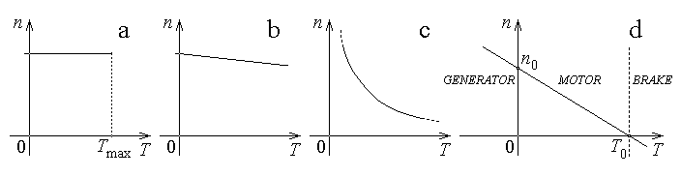
Fig. 13.73.
A flat mechanic characteristic supposes that the revolving speed is slowly decreasing with the increasing torque (fig. 13.73.b). The separately– or shunt–excited direct current current and the three–phase asynchronous motors present such a mechanic characteristic.
A falling mechanic characteristic is characterised by a significantly steep reduction of the revolving speed as the developped torque increases (fig. 13.73.c). Such a mechanic characteristic is presented by the series–excited direct current motor.
There are circumstances when the electric machine provides an electromagnetic torque in a direction opposite to that of the revolving speed of the drive system shaft; in such cases the machine is not operating as a motor (n > 0 , T > 0) but either as a brake (n < 0 , T > 0) or a generator (n > 0 , T < 0 , as suggested in fig. 13.73.d).
The so called static load torque T_{st.} (meaning the torque under steady state conditions) also presents some typical dependences on the revolving speed of the machine shaft, and the same is true for the associated power–versus–speed dependence.
An (ideally) constant mechanic characteristic corresponds to a constant load torque presented at any revolving speed (fig. 13.74.a). The actual torque due to friction is approximately constant (with a starting value somewhat greater than the drift value); as well, the load torque presented by elevators and cranes, uniformly loaded belt conveyors, pumps and piston compressors, or constant advance cutting machines can be approximated as constant load torques.
A linear mechanic characteristic is typical for a so called viscous friction (fig. 13.74.b). Such a linear load mechanic characteristic is approximated by the operation of belt calenders, eddy–current electromagnetic brakes, or constant load direct current generators.
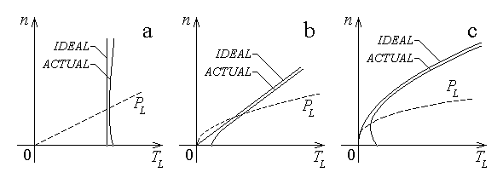
Fig. 13.74.
A quadratic mechanic characteristic (fig. 13.74.c) is approximated by the operation of centrifugal pumps, fans and air–blowers, ship propellers.
The actual load mechanic characteristics may be influenced by the angular position of the shaft (locmotive engines, elevators). As well, if the load torque is greater than the motor torque, then the load torques may perform as an active torque, as it is the case with downhill moving electric vechicles, or back–pressure compressors and pumps. The relationship between the mechanic load power P_{L} = T_{L}n and the revolving speed n is also represented in fig. 13.74.
The dynamic load torque is the torque associated with the (angular) acceleration of the rotating parts of the drive system,
$T_{\text{dyn}\text{.}}=J \frac{dΩ}{dt}$ ,
where J is the (equivalent) moment of inertia of the moving parts, generally expressed as
$J=\sum_{k=1}^{n}{m_{k}R_{k}^{2}}$
in terms of the masses m_{k} and their rotation radiuses R_{k} .
3. The equation of motion for the drive system,
$J \frac{dΩ}{dt}=T_{\text{act}\text{.}}\left(Ω\right)−T_{\text{st}\text{.}}\left(Ω\right)$
has to be integrated in order to obtain the time variation of the rotating speed Ω , and this not a simple matter. It is however obvious that the system accelerates when the active torque is greater than the load torque, and decelerates in the opposite case.
The most important case of a driving system operation is that when it moves at a constant speed, meaning that
$Ω=\text{const}\text{.} ⇔ \frac{dΩ}{dt}=0$ ;
this steady state operation is present when the active and load torques balance each other,
$T_{\text{act}\text{.}}\left(Ω\right)=T_{\text{st}\text{.}}\left(Ω\right)$ .
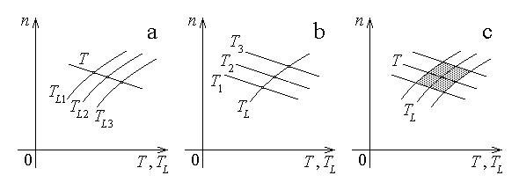
Fig. 13.75.
The steady state operation corresponds to the (steady state) operating point S (n_{S},T_{S}) where the mechanic characteristics of the motor and drive cross (fig. 13.75). When fixing the steady state operating point, an immediate condition is that it fall within the operating ranges of torque and speed for both the motor and load. There are situations when the technology process imposes the operation in a number of different steady state operating points. The change between different operating points can be achieved by modifying the mechanic characteristic of the load, by using some external mechanic means; in this case the operating point goes over a segment of the motor mechanic characteristic (fig. 13.75.a). As well, the change between different operating points can be achieved by modifying the mechanic characteristic of the motor, by using some electric means; in this case the operating point goes over a segment of the load mechanic characteristic (fig. 13.75.b). Finally, the mechanic characteristics of both the load and the motor can be modified, in which case the operating point is to be found somewhere onto a definite surface of the T – n plane (fig. 13.75.c).
An essential characteristic of a steady state operating point is its stability with respect to perturbations; it is related to the dynamic performance of the driving system and the aspect of the mechnic characteristics of the motor and load.
Let the steady state operating point be characterised by the (angular) speed Ω₀ = const., associated with the balance of the active torque and load torque, T_{0act.} = T_{0st.} . Let then a perturbation be acting on the drive system, such that the speed and torques change respectively to Ω₀ + ΔΩ , T_{0act.} + ΔT_{act.} , T_{0st.} + ΔT_{st.} . The equation of motion of the system becomes
$J \frac{d\left(Ω_{0}+ΔΩ\right)}{dt}=\left(T_{0 \text{act}\text{.}}+{ΔT}_{\text{act}\text{.}}\right)−\left(T_{0 \text{st}\text{.}}+{ΔT}_{\text{st}\text{.}}\right)$
and can be succssively rewritten as
$J \frac{d\left(ΔΩ\right)}{dt}={ΔT}_{\text{act}\text{.}}−{ΔT}_{\text{st}\text{.}} ⇔ J \frac{d\left(ΔΩ\right)}{dt}=\left(\frac{{ΔT}_{\text{act}\text{.}}}{ΔΩ}−\frac{{ΔT}_{\text{st}\text{.}}}{ΔΩ}\right) ΔΩ ⇔$
$⇔ \frac{d\left(ΔΩ\right)/dt}{ΔΩ}=\frac{1}{J}\left(\frac{{ΔT}_{\text{act}\text{.}}}{ΔΩ}−\frac{{ΔT}_{\text{st}\text{.}}}{ΔΩ}\right) ⇔ \frac{\left(ΔΩ\right)'}{ΔΩ}=\frac{1}{J}\left(\frac{{ΔT}_{\text{act}\text{.}}}{ΔΩ}−\frac{{ΔT}_{\text{st}\text{.}}}{ΔΩ}\right)$ ,
where
$\left(ΔΩ\right)'=\frac{d\left(ΔΩ\right)}{dt}$
is the rate of time variation of the speed departure from its steady state value.
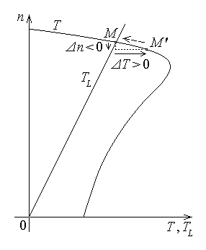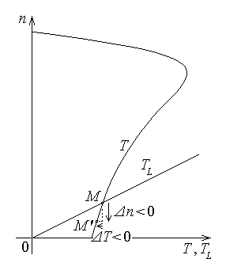
Fig. 13.76.
An instable operation is characterised by the fact that a perturbation results in a continuous departure of the system from its initial operation point. On the contrary, a stable operation is characterised by the fact that, when a perturbation is applied to the system, it reaches a new, stable, steady state operating point. For a stable operation the signs of the speed perturbation and its rate of time variation must be opposite, that is
$\frac{\left(ΔΩ\right)'}{ΔΩ}<0$ .
Considering the perturbed equation of motion for the drive system, the stable operation condition becomes
$\frac{{ΔT}_{\text{act}\text{.}}}{ΔΩ}<\frac{{ΔT}_{\text{st}\text{.}}}{ΔΩ} ⇔ \frac{{ΔT}_{\text{act}\text{.}}}{Δn}<\frac{{ΔT}_{\text{st}\text{.}}}{Δn} ⇔$ $\frac{Δn}{{ΔT}_{\text{act}\text{.}}}<\frac{Δn}{{ΔT}_{\text{st}\text{.}}}$ .
It means that for a stable operation of a drive system the slope of the mechanic characteristic n(T) of the electric motor has to be greater than the slope of the mechanic characteristic n(T) of the mechanic load at the steady state operating point. For comparison, in fig. 13.76.a a stable operating point is represented, while the case of instable operating point is illustrated in fig. 13.76.b.
The dynamic operation of a drive system includes the starting, stoppage, braking, inversion of rotation direction, control of the revolving speed, or the change of the load torque. There are some restrictions to be considered when performing such dynamic operations, such as acceleration limits (linked to large moments of inertia), speed limits (linked to dangerous centrifugal forces), stroke limits (linked to the construction of the load machine).
4. The operation of a drive system supposes a sequence of load and no–load, idle or energized periods, referred to as system duty.
The continuous duty supposes the operation at a substantially constant load for a duration sufficiently long for all the components of the drive motor to achieve a steady state temperature (fig. 13.77.a). Such an operation is typical for centrifugal pumps, fans, air–blowers, compressors, conveyors, smoke exhausters, paper–making machines or textile–finishing machines.
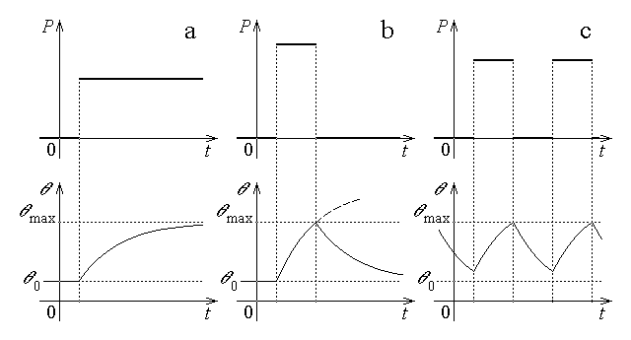
Fig. 13.77.
The short–time duty supposes the operation at a constant load for a duration significantly shorter than that needed for the drive motor to achieve the steady state temperature under a continuous duty at the same load, followed by a rest period long enough for the motor to regain the ambient temperature (fig. 13.77.b). Such an operation can be found in the case of motor drives for navigation locks, drawbridges, or aircraft landing gear.
The intermitent duty supposes the operation of the drive motor for alternate load and no–load periods, load and rest periods, or load, no–load and rest periods (fig. 13.77.c). The duration of these periods is such that during the load periods the drive motor does not reach a steady state temperature, whereas during the no–load or rest periods it has no time to regain the ambient temperature. Such an operation is common to cranes and travelling cranes, rolling mills, oil drilling rigs, or metal–working machine tools. A very important characteristic of an intermitent duty is the duty cycle, defined as the ratio of the load period to the sum of load, no–load and rest periods, expressed as a percentage.
There are some another versions of system duty, consisting in typical sequences of periods of specific operation conditions, idle periods and braking periods, each corresponding to a particular evolution of the machine temperature. Knowledge of the expected form of duty is important as it determines the selection – and even the design – of a drive motor in terms of its power rating.
Every motor is designed so that it is capable of developing more than its rated power for some time without damage to itself – this characteristic is referred to as overload capacity.
The instantaneous overload capacity characterizes the ability of the motor to sustain an overload for a very short time interval. It is mostly determined by the electrical properties of the motor, such as the maximum torque in the case of asynchronous motors, or the commutation condtions in the case of direct current motors. The instantaneous overload capacity is customarily defined in terms of the overload torque ratio, between the maximum instantaneous safe torque and the rated torque,
$λ_{T}=\frac{T_{\text{max}}}{T_{\text{rated}}}$ ,
and reaches extreme values around 4 for special purpose motors only.
The short–time overload capacity is a significant characteristic for motors operated under certain service conditions, customarily defined as the maximum power output considered safe for a specified time interval (usually 5, 10, 15, or 30 minutes). At the end of the specified overload period the motor must be de–energized for a time sufficiently long for it to regain the ambient temperature.
5. The selection of power rating for a drive motor is a primary step in the design of a drive system. The main considerations to be accounted for are economy, efficiency, and reliability. The use of an overrated motor would entail a waste of powe, unwarranted capital outlays, and an increase in the required floor area. On the other hand, an underrated motor would reduce the efficiency of the driven machine, impair overall reliability, and might result in early damage.
The drive motor has to be chsen so that its power output is utilised to the best advantage. In operation it should be heated to about the maximum safe temperature, but never exceed it. It should perform normally in the case of likely short–time overloads, and develop the starting torque required by the driven machine. Accordingly, the power rating of the driving motor is mostly chosen with regard to its heat capacity (or temperature rise); aftewards the overload capacity of the motor is checked with a view to meet the expected starting conditions and to sustain short–time overloads. In some cases, when the short–time overload is very great, the drive motor would be chosen to meet the maximum power requirements, even if its continuous–duty power is not fully utilised.
The selection of the power rating for a drive motor operating under a continuous duty service is quite simple. No check needs to be made for heat capacity or overload under running conditions, and the power output of the drive motor should be equal to the demanded power. The demanded power is simply computed by accounting for the driven machine output power P_{dr. mach.} and efficiency η_{dr. mach.} , and thetransmission efficiency η_{trans.} , so that the rated power of the drive motor results as
$P=\frac{P_{\text{dr}\text{.} \text{mach}\text{.}}}{η_{\text{dr}\text{.} \text{mach}\text{.}}⋅η_{\text{trans}\text{.}}}$ .
However, it is important to see if the motor so chosen can develop sufficient torque at starting in order to start the load satisfactorily under the most severe estimated starting conditions imposed by the technology process.
The selection of the power rating for a drive motor operating under short–time and intermitent duty service requires some discussion. In any class of duty it is important to know how the temperature rise θ of the motor varies with time under given operating conditions. The accurate computation of the heat build–up in the motor is a very complex problem, since an electric machine is an extremely heterogeneous system. Yet, in cases which do not call for an especially high accuracy, the electric machine can be treated as an equivalent homogeneous thermal system.
Let C be the heat capacity of the machine, H be its heat transfer coefficient (under supposedly linear conduction/convection), and q be the (constant) rate of heat generation within the machine (generated heat per unit time) applied from the initial moment t = 0 on. The simplified heating equation (see also the next chapter) is then
$q \text{dt}=C dθ+H θ \text{dt}$ ,
where θ is the difference between the actual machine temperature and the reference ambient temperature. The steady state is reached when the temperature remains constant, meaning that dθ = 0 when the rate of heat generation is balanced by the rate of heat transfer to the surrounding medium,
$q \text{dt}=H θ_{\text{max}} \text{dt}$ ,
which corresponds to a maximum temperature
$θ_{\text{max}}=\frac{q}{H}$ .
The simplified heating equation of the drive motor can be rewritten as
$θ_{\text{max}} \text{dt}=\frac{C}{H} dθ+θ \text{dt} ⇔$ $\frac{C}{H} \frac{dθ}{dt}+θ=θ_{\text{max}}$ .
The solution is sought for as
$θ=θ^{0}+θ^{F}$ ,
that is the sum of the free and forced solution to the inhomgeneous linear differential equation. The free solution, i.e. the general solution of the type
$θ^{0}=A e^{r t}$
satisfying the homogeneous equation
$\frac{C}{H} \frac{{dθ}^{0}}{dt}+θ^{0}=0$ ,
is immediately found to be
$θ^{0}=A e^{− \left(H/C\right) t}=A e^{− t/τ}$ ,
where the time constant
$τ=\frac{C}{H}$
of the heat build–up can be found as well by experiment. The forced solution, i.e. the particular solution of the complete inhomogeneous equation
$\frac{C}{H} \frac{{dθ}^{F}}{dt}+θ^{F}=θ_{\text{max}}$ ,
is immediately found to be the constant
$θ^{F}=θ_{\text{max}}$ .
The integration constant remained in the complete solution
$θ\left(t\right)=A e^{−\left(H/C\right) t}+θ_{\text{max}}$
is found by imposing the continuity of the time–variation of temperature,
$θ\left(0−\right)=θ\left(0+\right)$
in terms of the initial temperature rise θ₀ = θ(0–) . Substituting the needed values,
$θ_{0}=A+θ_{\text{max}} ⇔ A=θ_{0}−θ_{\text{max}}$ ,
one readily finds out that the temperature variation of the drive motor is given by (fig. 13.78)
$θ\left(t\right)=\left\{ \begin{matrix}θ_{0}, , t<0 \\ θ_{\text{max}}−\left(θ_{\text{max}}−θ_{0}\right) e^{− t/τ} , t>0\end{matrix}\right. , τ=\frac{C}{H} , θ_{\text{max}}=\frac{q}{H}$ .
In particular, if the initial temperature equals the ambient temperature, that is θ₀ = 0 , the temperature variation of the motor is simply
$θ\left(t\right)=θ_{\text{max}} \left(1−e^{− t/τ}\right)$ .
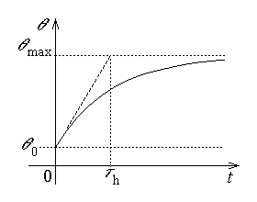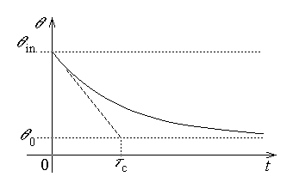
Fig. 13.78. Fig. 13.79.
In a similar manner, the cooling process of the de–energized motor is described by the simplified equation in terms of the temperature diference with respect to the ambient temperature θ₀
$0=C dθ+H θ \text{dt} ⇔ \frac{C}{H} \frac{dθ}{dt}+θ=0$ ,
with the immediate solution for t > 0 (fig. 13.79)
$θ\left(t\right)=θ_{0}+\left(θ_{\text{in}\text{.}}−θ_{0}\right) e^{− t/τ} , τ=\frac{C}{H} , q=0$ ,
in terms of the initial temperature rise
$θ |_{ t=0}=θ_{\text{in}\text{.}}−θ_{0}$
at the initial moment t = 0 taken when the heat generation inside the motor has stopped. It must be noted, however, that the heat transfer coefficient H is different when the motor stops, since the heat transfer is strongly influenced by different factors such as the action of fans attached to the motor shaft. As a general rule, the time constant τ = τ_{c} of the cooling process is larger than the time constant τ_{h} of the heating process.
Let, for the sake of argument, the continous duty operation of a given motor be first considered, starting from a zero temperature rise. The power output P , delivered from the initial moment t = 0 on, determines a proportional rate of heat generation q = q(P) within the motor and, consequently, a corresponding maximum temperature rise θ_{max} and heating curve, as illustrated in fig. 13.80. The maximum safe temperature rise θ_{rtd.} is reached at different moments t_{k} , corresponding to different loads P_{k} sustained by the motor. The curve which tends asymptotically to the maximum safe temperature θ_{rtd.} corresponds to the power rating P_{rtd.} of the motor. At loads less than the rated power, the temperature remains within a safe range, but the power of the motor is not fully utilised. At loads greater than the rated power, the time duration from t = 0 to t_{k} defines the overload duration over its continuous–duty power rating. In fact, it is advisable to overload the motor for a short time, with the overload being progressively increased as the duration of the overload is decrease, until the instantaneous overload capacity is reached.
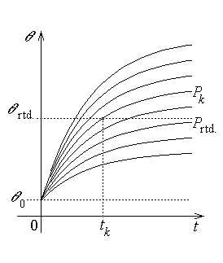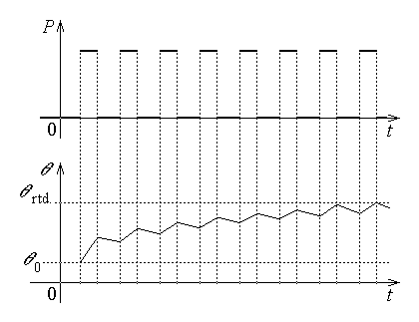
Fig. 13.80. Fig. 13.81.
In the case of an intermitent duty service, heat is alternatively generated into and evacuated from the drive motor, and the temperature variations during each load / no–load cycle depend on the heat balance during the previous cycle. The temperature variation of the motor is illustrated in fig. 13.81 in the case of an intermitent duty periodic operation, where the final temperature rise in a given cycle is the initial temperature rise for the following cycle. The cycles of temperature variations tend to become periodic after some time, and the maximum temperature reached duing such periodic cycles must remain under the maximum safe temperature rise θ_{rtd.} .
6. The practice of determining the power requirements for the drive motor are based on simpler methods.
The equivalent current method is based on determining a load current equivalent to the sequence of intermitent–duty load currents, from the viewpoint of the overall power loss resulting in the heating of the motor. Let P_{fixed} be the fixed (constant) power loss (including friction losses, core losses in asynchronous alternating current motors and shunt direct current motors, and excitation losses in synchronous alternating current motors and shunt direct current motors) and let for simplicity the variable power loss, in an equivalent winding resistance r , depend quadratically on the motor current I . If t₁ , … , t_{n} are the durations of periods when the motor currents are respectively I₁ , … , I_{n} , and T = t₁ + … + t_{n} , then the equivalence of power loss is expressed simply as
$\sum_{k=1}^{n}{\left(P_{\text{fixed}}+r I_{k}^{2}\right)⋅t_{k}}=\left(P_{\text{fixed}}+r I_{\text{eq}\text{.}}^{2}\right)⋅T ⇔ \sum_{k=1}^{n}{r I_{k}^{2}⋅t_{k}}=r I_{\text{eq}\text{.}}^{2}⋅T$ ,
whence the equivalent current results as
$I_{\text{eq}\text{.}}=\sqrt{\frac{\sum_{k=1}^{n}{I_{k}^{2} t_{k}}}{T}}$ .
Once the equivalent current, the rated voltage and the rated power factor are known, the power rating of the drive motor is given by
$P_{\text{rtd}\text{.}}≥k⋅U_{\text{rtd}\text{.}}I_{\text{eq}\text{.}}⋅\text{cos}ϕ_{\text{rtd}\text{.}}$ ,
where k = 3 for an alternating current motor, and k = 1 , cosϕ_{rtd.} = 1 , for a direct current motor. The equivalent current method is no longer applicable when the hypotheses – especially those regarding the fixed losses – are not satisfued, as it is the case with the series–excited direct current motor.
The equivalent torque method is applied when the demanded torque is the main quantity to be observed. Let t₁ , … , t_{n} be the durations of periods when the motor torque must be respectively T₁ , … , T_{n} , and T = t₁ + … + t_{n} . The method starts from the observation that in all electric motors the electromagnetic torque is proportional to the product of motor current and the excitation flux. Moreover, the excitation magnetic flux can be taken as constant in all motors with the exception of series– and compound–excited direct current motors, and the power factor may be assumed to be approximately constant. The torque can then be deemed as proportional to the motor current, so that
$T_{\text{eq}\text{.}}=K I_{\text{eq}\text{.}}=K \sqrt{ \frac{\sum_{k=1}^{n}{I_{k}^{2} t_{k}}}{T}}=K \sqrt{\frac{\sum_{k=1}^{n}{{\left(\frac{T_{k}}{K}\right)}^{2} t_{k}}}{T}}=K \sqrt{ \frac{\sum_{k=1}^{n}{T_{k}^{2} t_{k}}}{K^{2}T}}$ ,
whence
$T_{\text{eq}\text{.}}=\sqrt{\frac{\sum_{k=1}^{n}{T_{k}^{2} t_{k}}}{T}}$ .
Knowing the equivalent torque and the rated angular speed Ω_{rtd.} , the rated power of the drive motor is readily computed as
$P_{\text{rtd}\text{.}}=T_{\text{eq}\text{.}} Ω_{\text{rtd}\text{.}}$ .
After the power rating of the motor has been determined by the equivalent current or the equivalent torque method, it is important to verify that the maximum torque of the motor is sufficient to meet the short–time overload requirements of the driven machine. The overload factor must be greater than the ratio of the maximum load torque to the rated motor torque,
$λ_{\text{rtd}\text{.}}>\frac{T_{\text{max}}}{T_{\text{rtd}\text{.}}}$ .
7. The rated power is an important criterion in the choice of the motor of a drive system. It has to be completed, however, with other aspects regarding the operation of the motor during the intended technology process it is designed to energize. Indeed, during operation, a motor has to start, to have its speed regulated to certain values, to stop or to reverse its rotation direction. The choice of a certain type of motor – direct current, asynchronous or synchronous – is therefore related to the possibilities to control of the motor performance and needs to be discussed at this point, in relation with the preceding discussions of the control possibilities of different types of electric motors.
The selection of the motor type is a relatively simple task in the case of a continuous, time–invariant load. This usage does not call for speed control, and, since a modern synchronous motor is started in the same manner as an asynchronous motor, the best choice is a synchronous motor. The advantages are a smaller size and more economical operation as compared to an asynchronous motor of the same power rating, since the former has a higher power factor and a higher maximum torque. Typical applications where the use of synchronous motors is advisable are: centrifugal or piston pumps, compressors, fans, air–blowers, exhausters, crushers and crushing mills.
In applications involving speed control, frequent starting and stopping, a variable load, and so on, however, the decision as to which motor type should be preferred must

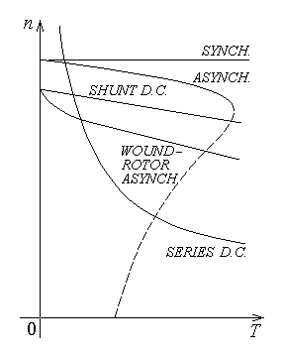
Fig. 13.82.
be taken by considering the operation of the drive system and the mechanic characteristics n(T) of various motors. The mechanic characteristics may be natural – obtained when the motor is started under its rated conditions, is connected to the main supply in a normal way, and there are no additional elements in the motor circuit – or controlled – obtained when the motor circuits include some additional elements and the circuits are connected in some special manner. An important consideration with regard to the mechanic characteristic of a motor is its flattness, defined as
$α=\frac{ΔT}{Δn}$ .

In terms of flattness (fig. 13.82), one may distinguish absolutely flat mechanic characteristics ( α = ∞ ) , as it is the case with the synchronous motor, flat mechanic
characteristics ( α = 10 … 40 ) , as for the asynchronous motor in the stable region) or the shunt–excited direct current motor, and falling mechanic characteristics ( α ≤ 10 ) , as it is the case with the controlled wound–rotor asynchronous motor or the series–excited direct current motor.
In some cases the degree of flattness of the mechanic characteristic is the main consideration in the selection of a motor. For instance, the motors used to drive hoisting and conveying machinery should preferably have a falling mechanic characteristic, while the drive motors of cold–rolling steel mills should have a very flat mechanic characteristic.
In applications involving frequent starting/stopping and a varying load up to 100 KW, preference is given to squirrel–cage asynchronous motors as they are the most reliable, simple to service, and relatively inexpensive. In contrast, wound–rotor asynchronous motors are more expensive, involve more servicing, are large in size, and have a lower power factor due to a larger air gap. Moreover, the advantages of the wound–rotor asynchronous motor in terms of starting torque are insignifiant when compared with the double–cage asynchronous motor. This is the reason why wound–rotor asynchronous motors are used only in cases of special requirements for starting torque or starting current, particularly for large loads.
As mentioned before, present day drive systems rely less and less on electric means of controling te motor performance and use extensively electronic – thyristor based – supply sources and control equipment. One of their advantages is that they can change the frequency of the alternating current, so that the angular velocity of the revolving magnetic field of an alternating current motor can be varied continuously and over a broad range. As a corolary, the speed of asynchronous and synchronous motors can likewise be controlled at will.
Direct current motors are more expensive, are more difficult to service, and wear out earlier than alternating current motors. , and wear out earlier than alternating current motors. Yet, preference in many cases is given to direct current motors because their speed can be varied between broad limits (up to the ratios 5 to 1) by simple means. Moreover, the thyristor based electronic equipment used to energize and control direct current motors is simpler than that for alternating current motors. Typical applications where a direct current drive motor is preferable are reversible rolling mills, adjustable nonreversible multidrive rolling mills, machinery operating in intermitent duty, blast–furnace skip hoists, special–purpose lathes.
Another important criterion in selecting a drive motor regards its enclosure as related to the ambient of the motor location.
An open motor has ample openings in the end shields and the frame that sustain the shaft bearings in order to facilitate the passage of external cooling air over and around the machine windings. It is only suitable for few applications, because the motor might easily be fouled by dirt in an industrial environment and attending personnel runs the risk of an electric shock because the live parts of the machine (placed under voltage) are readily accessible.
A screen–protected (or guarded) motor has all openings covered by wire–mesh screens so manufactured that rain drops, foreign matter, filings, saw–dust, and the like cannot enter the machine, but dust particles can. Motors of this type of enclosure may be installed outdoors.
A totally enclosed motor is so enclosed as to prevent the free exchange of air between the inside and the outside of the motor case. For better cooling, air is forced into the machine, for wich purpose inlet and outlet air conduits might be provided. Totally enclosed motors are installed in locations where the atmosphere may contain dust, vapours, corrosive fumes, and the like.
An explosion–proof motor is a totally enclosed machine whose enclosure is designed and constructed to withstand an explosion of a specified gas or vapour which may occur within it and to prevent the ignition of the surrounding medium by sparks, flashes or explosions occuring inside the machine case.
Finally, damp–proof and moisture–proof insulation must be provided to motors intended for use in damp locations.

