12. MEASUREMENT OF NON–ELECTROMAGNETIC QUANTITIES

- 12.1. Electric measurement of non–electromagnetic quantities
The electric measurement of a non–electromagnetic quantity is a measurement procedure where the change of a non–electromagnetic physical quantity or parameter determines a measurable change of a related electromagnetic quantity or parameter.
The electric measurement of a non–electromagnetic quantity is thus based on a conversion of the non–electromagnetic quantity into an electromagnetic quantity according to a one–to–one correspondence; such a conversion process is realized in a device named a transducer.
The conversion of non–electromagnetic quantities into electromagnetic quantities can be active or passive: an active conversion is that where the non–electromagnetic quantity influences a process of electromagnetic energy generation, while a passive conversion is that where the non–electromagnetic quantity affects the magnitude of a certain circuit parameter in a circuit operating under given sources.
Typical active processes used in transducers are:
- the induction of an electromotive force in an externally applied magnetic field,
- the generation of opposite electric charges on opposite faces of a piezoelectric crystal subjected to an appropriate mechanical stress,
- the generation of an interface thermoelectric voltage into a chain of different conductors with contacts at different temperatures,
- the generation of a photovoltaic current around an appropriately illuminated P–N semiconductor junction,
- the generation of an impressed voltage between electrodes submersed asymmetrically into solutions with different ionic osmotic/dissolution pressures.
Typical passive processes where non–electromagnetic quantities influence electro-magnetic quantities are:
- changes of the electric resistance of a resistor due to changes of its geometric parameters,
- changes of the electric resistivity of a resistor due to changes of its temperature, humidity, salinity, illumination, etc.,
- changes of the electric capacitance of a capacitor due to changes of its geometric parameters,
- changes of the permittivity of a capacitor insulator due to changes of its composition, humidity, etc.,
- changes of the electric inductance of a coil due to changes of its geometric parameters,
- changes of the permeability of a coil core due to changes of its composition, temperature, pressure, etc.
The electric signal associated to the variation of an electric quantity corresponding to a change of the non–electromagnetic quantity to be measured is usually very small, so that it has to be amplified by adequate electronic circuits, and then processed in order to be displayed, registered, or even used in automatic control equipments.
In the following, only the principles of the typical active or passive processes used in the most common transducers are presented, with no specific details on their actual realization.

12.2. Active electromagnetic transducers
An active electromagnetic transducer is a transducer where electromagnetic energy is generated by a process depending on some non–electromagnetic quantity.
12.2.1. Induction transducers
The operation of induction transducers is based on the induction phenomenon, consisting in the generation of an electromotive force (e.m.f.) along a contour by the time variation of a magnetic flux, as given by Faraday’s law,
$e_{Γ}=−\int{\frac{∂\vec{B}}{∂t}⋅\vec{n} \text{dS}}+\oint{\left(\vec{v}×\vec{B}\right)⋅d\vec{r}}$ .
Two main ways of sensing non–electromagnetic influences upon the induced e.m.f. can be identified: (1) in an external time–varying (usually harmonic) magnetic field, the magnetic flux density or the magnetic flux over the surface S_{Γ} is influenced by the non–electromagnetic quantity to be measured; (2) in an external magnetic field (constant or time–varying), some points of the contour Γ where the e.m.f. is developped are moving at a rate (a velocity v) depending on the the non–electromagnetic quantity to be measured.
1. The first version of the induction–based transducer is more a passive than an active transducer, since it supposes the existence of an external source of a time–varying magnetic field. The transducer is essentially a transformer, that is a system of two coupled coils, where the primary coil carries a time–varying (usually, harmonic) current determining in the secondary coil a time–varying magnetic flux, which induces a voltage in this secondary coil. In terms of circuit elements, the induced voltage is that corresponding to the mutual (coupling) inductance between the two coils, and the induced voltage depends on the parameters which influence the value of this mutual inductance. The study of the first version of the induction–based transducer is therefore postponed for the next section.
2. The second version of the induction based transducer can use a permanent magnet as the source of the externally applied magnetic field or, as before, a current carrying coil as the external source of a (time–varying) magnetic field. The transducer is essentially measuring the velocity – either the rotation, or the translation speed – of an object.
Let a rectangular conducting circuit be considered, with a sliding side moving in a region where, say, a constant magnetic field density, normal to the rectangle surface is present (fig. 12.1). According with Faraday’s law, since $∂\vec{B}/∂t=0$ , the induced e.m.f. is given by
$e_{Γ}=\oint{\left(\vec{v}×\vec{B}\right)⋅d\vec{r}}=\int{\left(\text{vB}\text{sin}\frac{π}{2}\right)⋅\text{dr}\text{cos}0}=v B \int{\text{dr}}=v B l$ ,
and is proportional to the translation velocity v of the moving side of the circuit. If r is the resistance per unit length of the two sliding rails and R is the supposedly constant resistance of the other parts of the circuit, and an electronic amplifier is included in the circuit, then the voltage u applied to it results from Kirchhoff’s voltage equation,
$e_{Γ}=\left(r x+R\right) i+u ⇔ u=B l⋅v−\left(R+r⋅\text{vt}\right) i=u\left(v\right)$ .
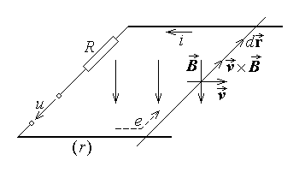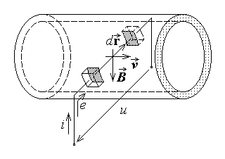
Fig. 12.1. Fig. 12.2.
3. In an interesting version of this transducer, the moving part of the contour Γ is traced in a conducting fluid flow in a duct (fig. 12.2). and a time–invariant magnetic field is applied normal to the fluid flow. The induced e.m.f. along the contour Γ consisting in the duct diameter between two conducting contacts inserted in the insulating duct walls and the external circuit including the electronic amplifier is, as above,
$e_{Γ}=\oint{\left(\vec{v}×\vec{B}\right)⋅d\vec{r}}=\int{\left(\text{vB}\text{sin}\frac{π}{2}\right)⋅\text{dr}\text{cos}0}=B \int{v \text{dr}}=e\left(v_{\text{av}}\right)$ ,
that is a function of the average fluid velocity. If R is the total electric resistance of the external circuit between the amplifier terminals, including that of the fluid between the contacts, then the voltage u applied to the amplifier terminals results as
$e_{Γ}=R i+u ⇔ u=e\left(v_{\text{av}}\right) −R i=u\left(v_{\text{av}}\right)$ .
In particular, the voltage can be so scaled that it measures directly the fluid flow in the duct, $Q≃S v_{\text{av}}$ , where S is the duct cross section area. Moreover, using an alternative inductor magnetic field results in an alternative induced e.m.f., which is processed more easily, and avoids accidental electrolysis phenomena.
4. Let now a conducting circular disk of radius a be rotating at an angular velocity ω in an external magnetic field of constant magnetic flux density $\vec{B}$ parallel to the axis (fig. 12.3). Let two conducting brushes make the contact between the external circuit, where an electronic amplifier is introduced – on one side – and the conducting axis and the disk periphery – on another side. Again, along the indicated contour Γ consisting in the external circuit, the radius, and the axis between the brushes, Faraday’s law gives for the induced e.m.f.
$e_{Γ}=\oint{\left(\vec{v}×\vec{B}\right)⋅d\vec{r}}=\int{\left(\text{vB}\text{sin}\frac{π}{2}\right)⋅\text{dr}\text{cos}0}=\int{ω r B \text{dr}}=ω B\frac{ r^{2}}{2}|_{ 0}^{ a}=\frac{ω B a^{2}}{2}$ .
If R is the resistance of the external circuit, the axis, and disk between the brushes, then the voltage applied to the amplifier terminals is given by
$e_{Γ}=R i+u ⇔ u=\frac{B a^{2}}{2} ω−R i=u \left(ω\right)$ .
The system described above is just one type of a tahogenerator – an instrument able to indicate the rotation velocity ω .
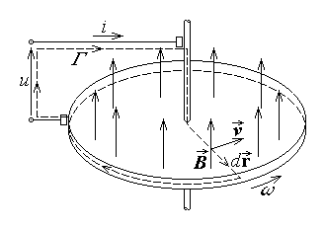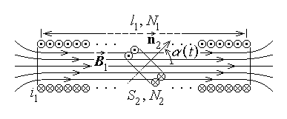
Fig. 12.3. Fig. 12.4.
5. There are as well some other – more common – constructive versions of electromagnetic transducers that generate an electric voltage depending on the angular velocity of a moving part of the system. A simple example is represented by a system of two coupled coils as that studied previously in section 7.1 (figs. 7.15 – 7.17), where the inner coil of N₂ turns of cross section area S₂ is supposed to be attached to the rotating object under observation, and the outter coil (assimlated to a solenoid) of N₁ turns wound along a length l₁ is at rest.
The mutual inductance in this system of coupled coils, studied previously in section 7.1 (fig. 12.4) is
$L_{\text{21}}=\frac{μ N_{1}N_{2}S_{2}}{l_{1}} \text{cos}α=L_{\text{21}}^{0}\text{cos}α$ ;
it depends on the angle α between the coil axes. Let the external coil carry a direct current of intensity I₁ , and the inner coil be rotating at an angular speed ω . The angle between the coil axes is then $α=α \left(t\right)=α_{0}+ωt$, so that, by neglecting the magnetic field generated by the induced current i₂ , the magnetic flux in the inner coil is
$Φ_{2}≃L_{\text{21}} I_{1}=L_{\text{21}}^{0} I_{1}\text{cos}\left(ωt+α_{0}\right)$ .
This time–varying magnetic flux induces in the second coil a harmonic time–varying e.m.f.,
$e_{2}=−\frac{{dΦ}_{2}}{dt}=ω L_{\text{21}}^{0} I_{1}\text{sin} \left(ωt+α_{0}\right)$ ,
of amplitude
$E_{2}=ω L_{\text{21}}^{0} I_{1}=K⋅ω$ ,
directly proportional to the angular velocity ω of the rotating inner coil.
12.2.2. Piezoelectric transducers
1. The operation of piezoelectric transducers is based on the piezoelectric effect, consisting in the relationship between electric and mechanic quantities occuring in so called piezoelectric crystals, associated to their particular structure. The direct piezoelectric effect implies that, if a specific mechanic stress $\vec{X}$ (force–versus–surface), which may be extension /compression, torsion, or shearing, is applied along a so called mechanical axis, then a permanent polarization ${\vec{P}}_{p}$ is generated along the so called electrical axis. If, for the sake of simplicity, the mechanical and the electrical axes are supposed to coincide, then the (direct) piezoelectric effect is described by
${\vec{P}}_{p}=− d⋅\vec{X}$ ,
where d is the piezoelectric coefficient (or modulus), of the order of 10^{–9} m/V . Conversely, the inverse piezoelectric effect implies that, if an electric field of strength $\vec{E}$ is applied along the electrical axis, then a specific mechanic relative strain (extension/compression, torsion, shearing) $\vec{x}$ is applied to the crystal. Under the same simplifying hypothesis of coincidental electrical and mechanical axes, the (inverse) piezoelectric effect is described by
$\vec{x}=d⋅\vec{E}$ .
2. Let a piezoelectric crystal be placed between the plates of a parallel–plate capacitor, with the coincidental mechanical and electrical axes normal to the plates (fig.

12.5). A compression force $\vec{F}$ applied between the plates of surface S induces, by piezoelectric effect, a permanent polarization ${\vec{P}}_{p}=d⋅\vec{F}/S$ , so that a corresponding electric displacement $\vec{D}=ε \vec{E}+{\vec{P}}_{p}$
is developed in the crystal. Supposing that the electric field vectors are homogeneous and restricted between the capacitor plates, Gauss’s law applied to a rectangular box closely including the upper plate gives for the electric charge on this plate
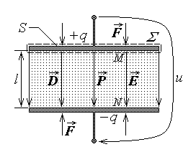
Fig. 12.5.

$\oint{\vec{D}⋅\vec{n} \text{dS}}=q_{D_{Σ}} ⇔ \int{D \text{dS}}=q ⇔ D S=q$ .
Similarly, the opposite charge is induced on the lower plate. On the other hand, the voltage between the plates placed at the distance l is
$u=\int{\vec{E}⋅d\vec{r}}=\int{E⋅\text{dr}\text{cos}0}=E\int{\text{dr}}=E l=\frac{D−P_{p}}{ε} l$ ,
where $\vec{D}$ is the electric displacement between the plates corresponding to the electric charge q . It follows that
$u=\frac{q/S−d⋅F/S}{ε} l=q \frac{ l}{ε S}−\frac{l d}{ε S}F=\frac{1}{C}\left(q−d⋅F\right)=u\left(F\right)$ .
The actual dependence of the voltage u on the applied force F is also influenced by the u versus q (or u versus i) relationship imposed by the load – in fact, the amplifier – connected at the capacitor terminals.
It is thus obvious that such a transducer is able to measure electrically any mechanic quantity related to a force. The device is primarily used as a force transducer, but, as well, it can measure the mass by the corresponding gravity force $F=m g$ , where g is the gravitational acceleration. The piezoelectric transducer is used also as an accelerometer, measuring the acceleration linked to the inertial force $F=m a$ exerted upon a definite mass m . Finally, it can measure the pressure, related to the force exerted by a fluid on a definite surface S by the relation $p=F/S$ .
12.2.3. Thermoelectric transducers
1. The operation of a thermoelectric transducer is based on the thermoelectric effect, consisting in the generation of an electromotive force in a chain of different conductors with their contacts maintained at different temperatures.
Let two different conductors, a and b , be connected in a loop, with their two contacts at different temperatures T₁ and T₂ (T₁ > T₂), as in fig. 12.6. At each a–b interface an impressed voltage is developed due to the difference in the extraction works of the two conductors. It is known that an emission of electrons is present at the surface of any substance at any temperature T > 0°K , on the expense of some thermal energy named extraction work W_{ex} , characteristic to each substance (It is worth remembering that the extraction work can be defined as the energy difference between the free electron
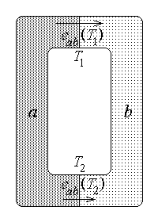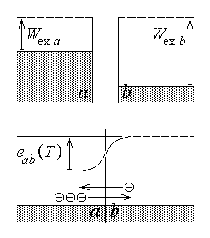
Fig. 12.6. Fig. 12.7.
out of the substance and the free electron in the substance). At the a–b interface an interchange of electrons occurs, with more electrons leaving the conductor with larger extraction work (fig. 12.7). Accordingly, the conductor with a larger extraction work acquires a positive charge, while the conductor with a smaller extraction work acquires a negative charge, these charges being concentrated practically at the interface. An impressed electric field and an impressed electric voltage e_{ab} is thus developed at the interface, oriented from the conductor named electropositive toward the conductor called electronegative. Since these processes are obviously temperature–dependent, a net impressed voltage
$e_{\text{ab}}\left(T_{1},T_{2}\right)=e_{\text{ab}}\left(T_{1}\right)−e_{\text{ab}}\left(T_{2}\right)$ ,
also named a Seebeck e.m.f., is developed along the considered chain. In most practical applications the Seebeck e.m.f. can be approximated as
$e_{\text{ab}}\left(T_{1},T_{2}\right)=S_{\text{ab}}\left(T_{1}−T_{2}\right)$ ,
where the Seebeck coefficient S_{ab} , dependent on the couple of conductors a and b (and on temperature), has values of the order of 10^{–5} V/deg for metal pairs and 10^{–3} V/deg for semiconductor pairs.
2. The temperature transducer based on the thermoelectric (Seebeck) effect is called a thermocouple (fig. 12.8). An amplifier is series–connected in the chain of the two different conductors, with its terminals at the same (ambient) temperature T_{a} , while the contacts a–b and b–a are placed at a reference temperature T₀ and the temperature T to be measured. The voltage between the amplifier terminals is then obtained from Kirchhoff’s voltage equation as
$u+R i=e ⇔ u≃S_{\text{ab}}\left(T−T_{0}\right)−R i=u\left(T\right)$ .
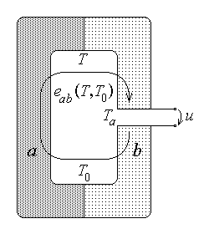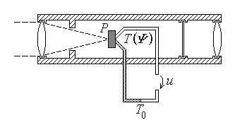
Fig. 12.8. Fig. 12.9.
The thermocouple–based temperature measurement can be used to measure indirectly other physical quantities. For instance, a pyrometer able to measure the total (energy) flux of incident radiation (fig. 12.9) consists in an optical system (objective, diaphragm, filter, ocular) for receiving and concentrating the incident radiation on a blackened plate P playing the role of a radiation absorbing black–body; the plate temperature T , dependent on the received radiated energy Ψ , is then measured by an attached termocouple.
12.2.4. Photovoltaic transducers
The operation of a photovoltaic transducer is based on the internal photoelectric effect, (or photovoltaic effect) in a P–N semiconductor junction, consisting in the generation of an electric current in the barrier region of a P–N semiconductor junction under appropriate illumination.
1. A P–N junction is the interface between two extrinsic regions of different type realized by appropriate doping of a single semiconductor monocrystal. A N–type extrinsic semiconductor is an impurified (doped) semiconductor where so called donor (pentavalent) impurities determine the presence of mobile majority electrons in the semiconductor, as compared with minority (extremely few) mobile elementary positive charges called holes. On the contrary, a P–type extrinsic semiconductor is a doped semiconductor where so called acceptor (trivalent) impurities determine the presence of majority mobile holes in the semiconductor, as compared with minority (extremely few) electrons. Each such semiconductor is however electrically neutral, since the majority mobile charge is balanced by the fixed charge of ionized impurity atoms.
A twofold process is occuring across the interface of a P–N junction (fig. 12.10), On one hand, diffusion forces push the majority electrons from the N– into the P–region, and the majority holes from the the P– into the N–region. The diffusion process leaves unbalanced fixed charges of the ionized impurity atoms in each region: positive charge in the N–region and negative charge in the P–region. In the figure circles indicate the free charges (electrons and holes) included in the charge flow and squares indicate the

unbalanced fixed charges (ionised impurities). As a result of this double charge layer, associated mainly with the unbalanced fixed charges concentrated near the interface, an impressed electric field ${\vec{E}}_{i}$ and a corresponding impressed electric voltage e (called potential barrier) is developed, oriented from the N–region towards the P–region. On another hand, electric forces
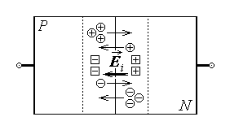
Fig. 12.10.

are determined by the very impressed electric field: minority holes are pushed from the N–region into the P–region, and minority electrons from the the P–region into the N–region.
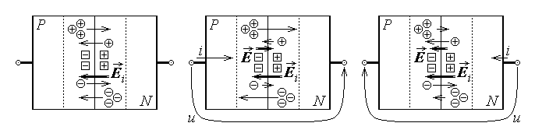
Fig. 12.11.
Under thermal equilibrium conditions the two diffusion and the two field currents associated with electrons and holes, respectively, cancel each other (fig. 12.11 left). It must be noted that the diffusion currents are flowing against the impressed electric field, while the field currents are supported by the impressed electric field. An external positive voltage applied from the P– to the N–region determines an electric field $\vec{E}$ opposite to the internal impressed electric field, which reduces its influence. As a result, the diffusion currents increase significantly, since they carry majority mobile charges, and an important current flows across the P–N junction, from the P– to the N–region (fig. 12.11 middle). On the contrary, an external negative voltage applied between the P and N regions determines an electric field $\vec{E}$ in the same direction as the internal impressed electric field, which increases its influence. As a result, the field currents increase – but insignificantly, since they carry minority mobile charges only – and a very small current flows across the P–N junction, from the N– to the P–region (fig. 12.11 right). The semiconductor where a P–N junction is present is thus characterised by a nonlinear conduction, because the current is carried much more easily in the P–N than in the N–P

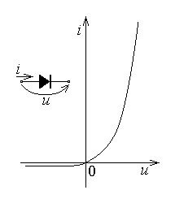
Fig. 12.12.

direction. The (approximate) voltage–current relationship of this inhomogeneous semiconductor device, called a semiconductor diode , illustrates this asymmetric conduction (fig. 12.12),
$i≃I_{0} \left[\text{exp}\left(\frac{e u}{k T}\right)−1\right]$ .
The voltage and current entering this equation are taken with reference to the P–N direction, the saturation current I₀ is a characteristic parameter of the junction, e = 1.602⋅10^{–19} C is the elementary (electron) charge, k = 1.38⋅10^{–23} J/°K is Boltzmann’s constant, and T is the absolute termperature.

2. The internal photoelectric effect is initiated when the semiconductor is illuminated by a radiation with photons of energy E_{ph} = hν (where h = 6.624⋅10^{–34} J⋅s is Planck’s constant and ν is the radiation frequency), supposed to be high enough to ionize a semiconductor atom and let free an electron–hole pair. If the pair is generated in a neutral region with no electric field present, then a quick recombination annihilates the pair. If, however, the pair is generated in the barrier region, where there is practically no free charge and the impressed electric field is present (or, more generally, in a region
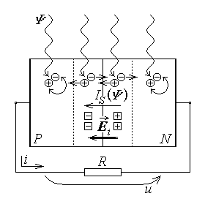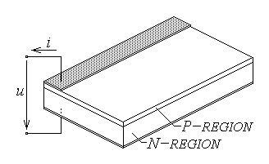
Fig. 12.13. Fig. 12.14.
where an electric field is present), then the electron–hole recombination is avoided by the action of the opposite electric forces ${\vec{F}}_{−}=− e {\vec{E}}_{i}$ on the electron and ${\vec{F}}_{+}=e {\vec{E}}_{i}$ on the hole, which separate the two charges. These same forces may eventually push the mobile charges into regions where they are majority charges: the electron is pushed into the N–region and the hole is pushed into the P–region. An impressed current $I_{S}\left(Ψ\right)$ , depending on the (energy) flux Ψ of incident radation, flowing from the N– towards the P–region, is thus generated by non–electric phenomena (fig. 12.13).
3. The photoelectric transducer is constructed as a so called photovoltaic cell (fig. 12.14), where a very thin (around 10 μm) P–region and a thicker (around 100 μm) N–region are connected to the external circuit – represented here by a simple resistor – by appropriate contacts. The upper semiconductor layer is sufficiently transparent for the radiation to reach the barrier region around the P–N junction and determine an internal photoelectric effect. The generated (impressed current) I_{S} develops a voltage u across the load R , which acts as an external voltage applied to the diode associated with the P–N junction and induces a loss current across it. As a result, the net current in the load is
$i=I_{S}\left(Ψ\right)−I_{0} \left[\text{exp}\left(\frac{e u}{k T}\right)−1\right]=i\left(Ψ\right)$ ,
dependent on the incident flux of radiation.
The photoelectric transducer can be used to measure non–electromagnetic quantities when these can influence the flux of some radiation. For instance, the light flux is absorbed as it passes through a coloured fluid according to equation
$Ψ=Ψ_{0} e^{ −ερ d}$ ,
where Ψ₀ and Ψ are the incident and the emergent flux, ε is the natural spectral module characteristic to the analysed substance, ρ is the substance concentration or density, and d is the distance travelled by the radiation in the analised substance. For given ε and d , the emergent light flux Ψ(ρ) is a measure of the substance concentration (or density) and can be converted into an electric signal by using a photoelectric transducer. The same approach can be used in order to measure the dust or suspended particle contents in some fluid.
12.2.5. Electrochemical transducers
The operation of an (active) electrochemical transducer is based on the generation of an impressed voltage between electrodes submersed asymmetrically into solutions with different ionic osmotic/dissolution pressures.
1. A qualitative picture of the development of the metal–solution potential difference is given by the exchange currents arising under the effect of the osmotic pressure of the solution and the electrolytic dissolution pressure of the metal. Usually, at the instant t₀ = 0 of immersion of a metal into a solution of its own ions, the osmotic pressure π , which pushes the metal ions from the solution into the metal electrode, is different from the dissolution pressure p , which pushes metal ions from the electrode into the solution. A transfer of (positive) ions is therefore initiated (fig. 12.15) predominantly in a definite direction, so that an electric charge is accumulated on the metal (positive when π > p and negative when π < p), and a voltage (a potential difference) is created between the metal and solution. The electric forces associated with the developed potential difference act oppositely to the forces imposed by the difference in osmotic–dissolution pressures. After a certain time interval t_{e} , an equilibrium potential difference is established, when the rate of ion transfer in both directions becomes the same: the (partial) metal–solution $i$ and solution–metal $\vec{i}$ currents become equal to each other and to the so called exchange current,
$i=\vec{i}=i_{0}$ .
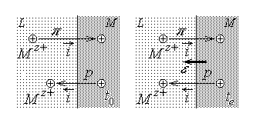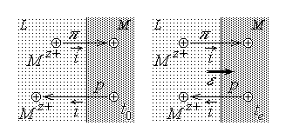
Fig. 12.15.
At equilibrium, the charge and the potential (with respect to the solution) remain unaltered, and the equilibrium value of the potential is given by
$ε_{\text{LM}}=−\frac{\text{RT}}{\text{zF}}\text{ln}\frac{p}{\text{RT}}+\frac{\text{RT}}{\text{zF}}\text{ln}c_{M^{z+}}$ ,
where R = 8.317⋅10⁷ J/mol °K is the universal gas constant, T is the absolute temperature, z is the ion valence, F = 96494 C/g–equiv is Faraday’s number, p is the partial (ion) pressure, and $c_{M^{z+}}$ is the (partial) ion concentration. The normal potential is defined as the electrode potential at $c_{M^{z+}}=1$ , namely
$ε_{\text{LM}}^{0}=−\frac{\text{RT}}{\text{zF}}\text{ln}\frac{p}{\text{RT}}$ ,
so that the equilibrium electrode potential is expressed as
$ε_{\text{LM}}=ε_{\text{LM}}^{0}+\frac{\text{RT}}{\text{zF}}\text{ln}c_{M^{z+}}$ .
The above formula has to be modified in order to fit to actual electrode processes: as usual, the concentrations are replaced by activities, so that finally, in terms of the activity coefficient f ,
$ε_{\text{LM}}=ε_{\text{LM}}^{0}+\frac{\text{RT}}{\text{zF}}\text{ln}a_{M^{z+}}=ε_{\text{LM}}^{0}+\frac{\text{RT}}{\text{zF}}\text{ln}c_{M^{z+}}f_{M^{z+}}$ .
Electrode potentials can only be measured on a relative scale, with reference to one another. Moreover, some electric contact between the two solutions of metal ions associated with the electrodes has to be provided. The conducting link between the solutions is a solution itself, and diffusion potentials develop as well at the boundary between them. The diffusion potentials at solution–solution interfaces can be reduced by using a so called salt bridge, which is a concentrated solution of an electrolyte with nearly equal cationic and anionic mobilities (for instance, saturated solutions of potassium chloride or ammonium nitrate). In this case one liquid–liquid interface is replaced by two such interfaces, but the diffusion potentials at the new interfaces are smaller than that at the original interface. Moreover, the diffusion potentials at the new interfaces are often opposite in sign and as a result the total diffusion potential is reduced.
The electrode potentials and their measurement is directly used to evaluate an important chemical parameter of solutions, namely their acidity or alcalinity.
2. The dissociation of water proceeds according to the reaction
$H_{2}O \begin{matrix}→ \\ ←\end{matrix} H^{+}+{\text{OH}}^{−}$ ,
and its dissociation constant, equal to the ratio of the product of the cations and anion concentrations to the concentration of the undissociated molecules, can be expressed as
$K=\frac{c_{H^{+}} c_{{\text{OH}}^{−}}}{c_{H_{2}O}}$ .
Since the degree of dissociation of water is very small, the denominator can be taken as a constant and included in the dissociation constant, so that the ionic product of water is obtained as
$K c_{H_{2}O}=c_{H^{+}} c_{{\text{OH}}^{−}}=K_{w}$ .
According to the theory of electrolytic dissociation, the hidrogen cations are carriers of acidic properties and the hydroxyl anions are carriers of basic properties. A solution is chemically neutral, that is neither acidic nor alkaline, if
$c_{H^{+}}=c_{{\text{OH}}^{−}}=\sqrt{K_{w}}$ .
At 25°C the ionic product of water is equal to K_{w} = 10^{–14} , so that for a neutral solution at this temperature,
$c_{H^{+}}=c_{{\text{OH}}^{−}}={\text{10}}^{ − 7} \text{gram}−\text{ions}/\text{litre}$ .
The acidity and alcalinity of a (aqueous) solution is then measured by the negative common logarithm of the hydrogen ion concentration relative to the reference concentration $c_{H_{0}^{+}}=1 \text{gram}−\text{ions}/\text{litre}$,
$\text{pH}=−\text{log}\frac{c_{H^{+}}}{c_{H_{0}^{+}}}=−\text{log} c_{H^{+}}$ .
It thus follows that a pH = 7 value corresponds to chemical neutrality, and a solution is acidic if pH < 7 and alkaline if pH > 7 . It is also worth remembering that these values hold at 25°C only. Corrections are to be made at other temperatures since the ionic product of water varies greatly with temperature, as shown in the table below.
t (°C) | 20 | 25 | 30 | 60 | 70 | 80 | 90 | 100
K_{w} ⋅ 10¹⁴ | 0.681 | 1 | 1.47 | 9.61 | 15.8 | 25.1 | 38.0 | 55.0
The hydrogen ion concentration (pH) plays an important part in many phenomena and processes and there are many situations when it must be kept constant. The resistance of a solution to pH change on addition of an acid or alkali is named buffer action, and a solution exhibiting a very strong resistance to pH change is called a buffer solution. The effectiveness of buffering of a solution is measured by its buffering capacity β , defined as the amount b in an alkali (or an acid) in gram–equivalent required to cause a unit change of pH. The computations show that the buffer capacity of pure water, or of a solution containing a salt of a strong base or acid, is very low. The buffer capacity increases in the cases of solutions of weak acids or weak bases, especially in the presence of the corresponding salts. Solutions containing mixtures of weak acids and their salts (or weak bases and their salts) are used to prepare standard buffer solutions which present a high buffer capacity. Such standard buffer solutions are used for gauging and control.
Finally, it must be noted that in actual situations it is not the concentration $c_{H^{+}}$ of hydrogen ions, but their activity $a_{H^{+}}$ which counts, and this is to be considered in evaluating the pH of a solution.
3. The electrical measurement of the pH of a solution is based on the use of a so called hydrogen electrode. This is a gas electrode, meaning a half–cell consisting of a metallic conductor in simultaneous contact with the corresponding gas and the solution containing its ions. A gas electrode cannot be designed, nor can the potential of the system composed of a gas and a solution of its ions be measured, without the provision of a metallic conductor as an electronic conductor. Besides, a metal in a gas electrode not only creates an electrical contact between the gas and the solution containing its ions, but also accelerates the evolution toward electrode equilibrium, i.e. it serves as catalyst for the electrode reaction. Gas electrodes must then use a metal with high catalytic activity, and with the potential independent on the activity of other ions present in the solution (in particular of its own metal ions). Moreover, functioning as a catalyst for the reaction between the gas and its ions in the solution, the metal must be inert with respect to other reactions which may occur in the system. Finally, the metal must provide as large an interface as possible on which the reversible reaction converting the gas to its ions could proceed. All these requirements are best met by platinum, which is most frequently used: a platinum foil is coated electrolytically with finely divided platinum black (platinized platinum Pt,Pt).
When immersed in a solution, fine hydrogen bubbles continuously develop at the platinum electrode surface, and it acquires a potential dependent on the concentration $c_{H^{+}}$ of hydrogen ions in the solution. This gaseous hydrogen electrode, represented as
H⁺ / H₂ , Pt ,
is thus associated with the reaction
2 H⁺ + 2 e = H₂ ,
and the developed electrode potential is
$ε_{H^{+}/H_{2}}=ε_{H^{+}/H_{2}}^{0}+\frac{\text{RT}}{2F}\text{ln}\frac{a_{H^{+}}^{2}}{p_{H_{2}}}=ε_{H^{+}/H_{2}}^{0}+2\text{.}\text{303}\frac{\text{RT}}{2F}\text{log}\frac{a_{H^{+}}^{2}}{p_{H_{2}}}$ .
It easily seen that the hydrogen electrode potential depends not only on the hydrogen ion activity but also on the partial hydrogen gas pressure. Now, the standard hydrogen electrode potential $ε_{H^{+}/H_{2}}^{0}$ is conventionally taken as zero at all temperatures and the above equation simplifies to
$ε_{H^{+}/H_{2}}=2\text{.}\text{303}\frac{\text{RT}}{2F}\text{log}\frac{a_{H^{+}}^{2}}{p_{H_{2}}}$ .
Finally, for a partial hydrogen pressure of one atmosphere, $p_{H_{2}}=1$ , one obtains
$ε_{H^{+}/H_{2}}=2\text{.}\text{303}\frac{\text{RT}}{F}\text{log}a_{H^{+}}$ ,
meaning that under definite conditions the hydrogen electrode potential is a direct expression of the pH value.
4. The operation of a hydrogen electrode under definite conditions can be avoided if the electrode potential is measured with respect to a reference. The common system used for measuring the pH is illustrated in fig. 12.16: it consists in two hydrogen electrodes immersed in the solution to be measured and in a reference solution, with a salt bridge making the contact between the solutions. The reference solution is prepared to present a unitary hydrogen ion concentration $c_{H_{0}^{+}}=1 \text{gram}−\text{ions}/\text{litre}$, while the solution to be measured present an arbitrary hydrogen ion concentration $c_{H^{+}}$ . The voltage between the two hydrogen electrodes is the difference of their electrode potentials, and it measures the pH of the solution under study,
$U=\frac{\text{RT}}{F}\text{ln}\frac{c_{H^{+}}}{c_{H_{0}^{+}}}=2\text{.}\text{303}\frac{\text{RT}}{F}\text{log}\frac{c_{H^{+}}}{c_{H_{0}^{+}}}=2\text{.}\text{303}\frac{\text{RT}}{F}\text{log}c_{H^{+}}=−K_{N} ⋅ \text{pH}$ .
Here again it must be noted that it is actually the activity of hydrogen ions which is taken into account in the pH measurement.
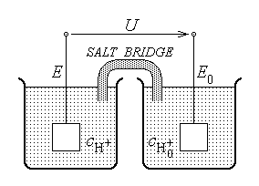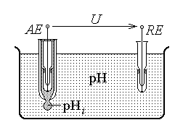
Fig. 12.16. Fig. 12.17.
In industry and laboratory work, however, there is the amalgam electrode which is largely used to measure the pH . The amalgam electrode is a half–cell where the amalgam of some metal is in contact with a solution containing the ions of this metal. The generalized amalgam electrode is reresented by
M ^{z+} / M_{m} , Hg ,
and is controlled by the reaction
m M ^{z+} + zme = M_{m} (Hg) ,
which means that mercury behaves as an inert medium in which the metal M is disolved and the ions of this metal play the role of potential–determining ions. The potential of the amalgam electrode is given by
$ε_{M^{z+}/M , \text{Hg}}=ε_{M^{z+}/M , \text{Hg}}^{0}+2\text{.}\text{303}\frac{\text{RT}}{\text{zmF}}\text{log}\frac{a_{M^{z+}}^{m}}{a_{M_{m}\left(\text{Hg}\right)}}$ ,
and depends not only on the activity of the metal ions in solution, but also on their activity in the amalgam. On the other hand, mercury is capable of reacting with a metal with the formation of intermetallic compounds,
x M ^{z+} + xze + y Hg = M_{x} Hg_{y} (Hg) .
The magnitude of the electrode potential is then a function of the composition of the resulting compounds,
$ε_{M^{z+}/M_{x}{\text{Hg}}_{y} , \text{Hg}}=ε_{M^{z+}/M_{x}{\text{Hg}}_{y} , \text{Hg}}^{0}+2\text{.}\text{303}\frac{\text{RT}}{\text{zxF}}\text{log}\frac{a_{M^{z+}}^{x}}{a_{M_{x}{\text{Hg}}_{y}\left(\text{Hg}\right)}}$ .
In both cases, the voltage in a measuring configuration as in fig. 12.17 is expressed as
$U=− U_{B}\left(T\right)−K_{N}\left(T\right) ⋅ \text{pH}$ ,
where U_{B} is the amalgam electrode potential with respect to the reference electrode potential.
The glass electrode is the most common measuring electrode. It includes an amalgam electrode submersed into a buffer solution contained in a glass recipient. Part of the glass wall is made partly of an electrically conducting glass membrane which allows the electrical contact with the solution to be analysed. The expression of the measured voltage,
$U=− U_{B}\left(T\right)+U_{A}\left(T\right)−K_{N}\left(T\right) \left(\text{pH}−{\text{pH}}_{i}\right)$ ,
includes additionally the diffusion potential (difference) U_{A} associated with the glass membrane and the pH_{i} of the buffer (intermediate) solution.

12.3. Passive electromagnetic transducers
A passive electromagnetic transducer is a transducer where a non–electromagnetic quantity affects the magnitude of some circuit parameter – resistance, capacitance, or inductance – in a circuit operating under given sources.
12.3.1. Resistance transducers
The operation of resistance transducers is based on the changes in a resistance value due to changes of its geometric parameters.
1. The simplest type of a resistive transducer uses a potentiometer, which is a resistor with a supplementary sliding contact (fig. 12.18 left). Driving the sliding contact in correspondence with the position of a moving part determines the variation of the resistance between the sliding contact and each of the resistor terminals. If l is the total length of the uniform resistor of total (terminal–to–terminal) resistance R , and x is the position of the sliding contact with respect to one terminal, then the relationship between the partial resistances and the position of the sliding contact is obviously
$R_{1}=R \frac{x}{l} , R_{2}=R \left(1−\frac{x}{l}\right)$ .
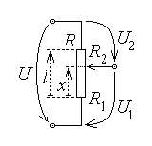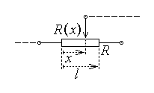
Fig. 12.18.
If U is the voltage applied between the terminals, and no current is supposed to be carried by the sliding contact, then the voltages between this contact and each of the
terminals depend on the position of the sliding contact according with
$U_{1}=U\frac{R_{1}}{R}=U \frac{x}{l} , U_{2}=U\frac{R_{2}}{R}=U \left(1−\frac{x}{l}\right)$ .
In particular, if only the sliding contact and one terminal are connected in an electric circuit, then the device is a simple resistor with variable resistance
$R\left(x\right)=R\frac{x}{l}$ ,
called a rheostat (fig. 12.18 right), that can control the current value.
2. The resistance of a homogeneous conductor of resistivity ρ , of constant cross section S and length l ,
$R=ρ \frac{l}{S}$ ,
obviously depends on the geometrical parameters S and l . If the conductor is rigidly attached to a stretched object, then a variation in the conductor length reflects in the resistance variation. One must consider, however, the fact that the conductor volume V = Sl is invariant. When l increases to l + Δl , S decreases to S – ΔS (fig.12.19), so that
$V=S l=\left(S−ΔS\right) \left(l+Δl\right)=S l \left(1−\frac{ΔS}{S}\right) \left(1+\frac{Δl}{l}\right) ⇔$
$⇔ 1−\frac{ΔS}{S}+\frac{Δl}{l}−\frac{ΔS}{S}\frac{Δl}{l}=1$ ,
meaning that, by assuming very small relative variations of length and cross section,
$1−\frac{ΔS}{S}+\frac{Δl}{l}≃1 ⇔ \frac{ΔS}{S}≃\frac{Δl}{l}$ .
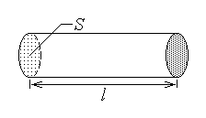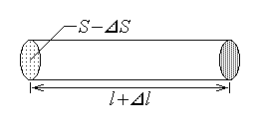
Fig. 12.19.
The associated resistance variation is
$ΔR=R '−R=ρ\frac{l+Δl}{S−ΔS}−ρ\frac{l}{S}=ρ\frac{l}{S}\left(\frac{1+Δl/l}{1−ΔS/S}−1\right)≃R \left(\frac{1+Δl/l}{1−Δl/l}−1\right)≃$
$R \left[{\left(1+Δl/l\right)}^{2}−1\right]=R\frac{Δl}{l}\left(2+\frac{Δl}{l}\right)≃2\frac{Δl}{l}R$ ,
where the approximation
$\frac{1}{1−x}≃1+x , \left|x\right|≪1$ ,
was used. The relative variation of the resistance,
$\frac{ΔR}{R}=2\frac{Δl}{l}$ ,
can thus measure the relative variation of the conductor length. This is the principle of operation of some stress/strain gauges used in mechanical measurements.
12.3.2. Resistivity transducers
The operation of resistivity transducers is based on the changes in the resistance of a conductor associated with changes of its resistivity, due to variations in the physical parameters which influence the latter.
1. A thermoresistance is a conductor whose resistance presents a known variation as a function of temperature. This is usually the case of a metallic conductor, for which the resistivity dependence on temperature (θ°C) can be approximated as
$ρ\left(θ\right)=ρ_{0}\left(1+Aθ+{Bθ}^{2}\right)$ ,
so that, by supposing that this includes the variation of geometric dimensions with the temperature,
$R\left(θ\right)=R_{0}\left(1+Aθ+{Bθ}^{2}\right)$ .
The above relationship can be re–written as the equation
$θ^{2}+\frac{A}{B}θ+\frac{1}{B}\left(\frac{R}{R_{0}}−1\right)=0 ⇔ θ^{2}+2 γ θ+β=0$ ,
where
$γ=\frac{A}{2B} , β=\frac{1}{B}\left(\frac{R}{R_{0}}−1\right)=β \left(\frac{R}{R_{0}}\right)$ .
It follows that the temperature can be directly measured in terms of the resistance (resistivity) relative variation $R/R_{0}$ according with
$θ=−γ+\sqrt{γ^{2}−β\left(R/R_{0}\right)}$ .
In the case of a semiconductor substance, the resistivity dependence on the absolute temperature (T°K) can be approximated as
$ρ=ρ_{0} e^{ − b/T}$
so that, by neglecting the variation of geometric dimensions with the temperature, the resistance of such a thermistor is
$R=R_{0} e^{ − b/T}$ .
It follows that the temperature can be directly measured in terms of the resistance (resistivity) relative variation $R/R_{0}$ according with
$T=\frac{b}{\text{ln} \left(R_{0}/R\right)}$ .
2. The resistivity of a substance depends on the concentration of free charged particles able to carry the current and this, in turn, can be influenced if the substance is subjected to a radiation flux.
The free charged particles which contribute to the current in a semiconductor are the negative electrons and the positive holes which are generated in pairs, usualy on account of the thermal energy. An electron–hole pair can also be generated by an internal photoeffect, when an incident photon has the energy
$W=h ν≥W_{f}$
greater than the semiconductor band gap energy W_{f} . The opposite free charges are immediately separated and determined to move in opposite directions by an electric field developed by an externaly applied voltage, resulting in a current increase.
The semiconductor resistivity is thus a function on the number of incident photons, that is on the incident radiation (energy) flux, $ρ=ρ\left(Ψ\right)$ , and the resistance is also directly dependent on the incident radiation flux, $R=R\left(Ψ\right)$ . If the radiation crosses a transparent substance, its flux depends on the width and the absorbtion properties of the obstacle,
$Ψ=Ψ_{0} e^{ − ε ρ d}$ ,
where Ψ₀ and Ψ are the incident and the emergent fluxes, ε is the natural spectral module characteristic to the analysed substance, ρ is the substance concentration or density, and d is the distance travelled by the radiation in the analised substance. For given ε and d , the emergent light flux Ψ(ρ) is a measure of the substance concentration (or density); for given ε and ρ , the emergent light flux Ψ(d) is a measure of the width d of the substance layer crossed by the radiation.
3. A similar approach can be used to measure the composition (density) or the width of a non–transparent substance layer, by using a flux of radioactive particles. The radiation intensity (the surface density of particle flux) depends, as well, on the width and the absorbtion properties of the obstacle,
$J=J_{0} e^{ − μρ d}$ ,
where J₀ and J are the incident and the emergent flux densities, μ is the mass absorbtion coefficient characteristic to the analysed substance, ρ is the substance density, and d is the distance travelled by the radiation in the analised substance.

The variation in the radiation flux density can be sensed by using a so called ionisation chamber, consisting in a couple of a conducting wire and a coaxial conducting cylinder, contained in a recipient filled with a rarefied gas (fig. 12.20). A high voltage is applied between the (positive) axial anode and the (negative) surrounding cathode so that the ionisation of a gas molecule (or atom) generates a pair of a free electron and an ion. These particles are separated by the electric field and pushed to the oppositely charged electrode, thus establishing a current in
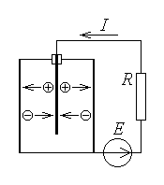
Fig. 12.20.

the ionisation chamber. The current intensity depends on the ability of the gas to carry it, which in turn depends on the number of generated free current carriers, that is on the radiation intensity.
4. The resistance presented by an electrolyte between immersed electrodes depends on the ion concentrations and their mobility. Indeed, the conduction current intensity, taken as a microscopic convection current intensity associated with the ion movement in an applied electric field, is the rate of electric charge transport across the normal surface area (fig. 12.21 left). The elementary current intensity carried by identical particles of concentration n and charge q , across an elementary cross section area ΔS , in the direction indicated by the unit vector $\vec{n}$ , is
$Δi=\frac{ΔQ}{Δt}=\frac{q ΔN}{Δt}=\frac{q n ΔV}{Δt}=\frac{q n {ΔS}_{n}Δl}{Δt}=q n {ΔS}_{n} v$ ,
whence the current density results immediately as
$J=\frac{Δi}{{ΔS}_{n}}=q n v$ .
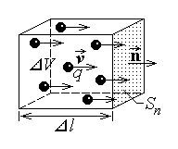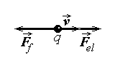
Fig. 12.21.
It is supposed that the movement of the charged particles in the solution is damped by a friction force F_{f} proportional to the particle speed, resulting from repeated collisions with the neutral molecules. The average velocity v of the charged particles is quickly reached when the electric force F_{el} applied by the external electric field is balanced by the friction force (fig. 12.21 right),
$F_{\text{el}}=F_{f} ⇔ q E=k v$ .
It results that the average speed of the curent carriers is proportional to the applied electric field strength,
$v=\frac{q}{k} E=η E$ ,
the proportionality coefficient being the particle mobility η . The expression of the current density thus becomes
$J=q n η E$ ,
which, when compared with the constitutive law of electric conduction,
$\vec{J}=σ \vec{E}$ ,
gives for the conductivity and resistivity, respectively, the expressions
$σ=q n η ⇔ ρ=\frac{1}{q n η}$ .
The concentration n of the charged particles is in direct relation with the concentration c of the solution components, so that the concentration–dependent resistivity ρ(c) results in a concentration–dependent resistance, R(c) .
5. The resistivity of a given substance depends also on the presence of specific impurities, whose contents can be measured by the variation of the resistivity, and subsequently of the resistance, induced by their presence. The measurement of the resistance of a layer of definite width d of the analysed substance, between two metallic electrodes of specified area S , gives a value
$R=ρ\left(c\right)\frac{d}{S}=R\left(c\right)$ ,
dependent on the impurity contents c . In particular, the contents in water (the humidity) of certain substances influences the solubility of different impurities and, therefore, the conductivity. Again, the resistance of specimens of a definite geometry of the analysed substance is related to, and can thus measure, its humidity.
12.3.3. Capacitance transducers
The operation of capacitance transducers is based on the changes in the capacitance value of a capacitor due to changes of its geometric parameters.
The formula giving the capacitance of the simplest – parallel plate – capacitor,
$C=\frac{ε S}{d}$ ,
illustrates the influence of the plate surface S and of the distance d between plates on the capacitance value. It is thus obvious that relating any of these geometrical parameters with the movement of some object, the capacitance value becomes dependent on the position of that object.
1. As a first example, a simple rotation transducer can be devised as a capacitor with plates rotating with respect to each other. Let two fixed capacitor plates be shaped as circular sectors of radius R , and maintained at a given potential V , and let a third plate at zero potential be shaped as a circular sector of radius b and placed at mid–distance between the fixed plates, able to rotate around its axis with respect to the fixed plates

(fig. 12.22). Supposing that the distance between the rotating plate and each fixed plate is d , and the electric field inside the structure is uniform as in the approximation of the parallel–plate capacitor, the face–to–face surface of the plates, corresponding to the rotation angle α of the mobile plate, is
$S=\frac{α R^{2}}{2}$ ,
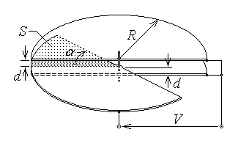
Fig. 12.22.

for each of the mobile plate – upper plate and the mobile plate – lower plate capacitor. The two capacitors are obviously parallel connected, so that the total capacitance is
$C=C_{U}+C_{L}≃2\frac{ε S}{d}=2\frac{ε}{d}\frac{α R^{2}}{2}=\frac{ε R^{2}}{d} α=K α$ ,
dependent on the angular position of the rotating plate with respect to the fixed plates.

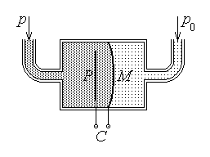
Fig. 12.23.
2. In principle, the influence of the distance d between the capacitor plates on the capacitance C can as well be used to measure the displacement of an attached object. Such a transducer is not used, due to the fact that the variation range of this geometrical parameter is much more limited than that of the plate surface. Instead, changes in the distance d between different opposite points of the capacitor plates as consequence of bending one

plate when subjected to an external force can be used as a force or, more appropriately, as a pressure transducer. For instance, let one plate of an approximately parallel–plate capacitor be an elastic metallic membrane M separating two chambers filled with a gas at the reference pressure p₀ and the gas at the pressure p to be measured, and let the other plate be a fixed plane metallic plate P unaffected by the gas pressure (fig. 12.23). A change in the pressure difference between the two chambers induces an associated bending of the elastic membrane and a corresponding capacitance change,
$C=C \left(d\left(p\right)\right)=C \left(p\right)$ .
12.3.4. Equivalent permitivity transducers
The operation of equivalent permitivity transducers is based on the changes in the capacitance value of a capacitor due to changes of the equivalent permitivity of the substances between its plates.
The formula giving the capacitance of the simplest – parallel plate – capacitor,
$C=\frac{ε\left(x\right) S}{d}=C \left(x\right)$ ,
shows that any physical or chemical parameter x (temperature, composition, humidity, etc.) significantly affecting the permittivity of the insulator between the capacitor plates also influences the capacitance value, and can thus be measured.
In the case when the space between the capacitor plates is filled with an inhomogeneous insulator, an equivalent insulator permittivity can be defined as the permittivity of a fictitious homogeneous insulator filling the same space and resulting in the same capacitance value.
1. Let a parallel–plate capacitor be considered first, with rectangular plates of dimensions a and b placed at a distance d , and the air as insulator. Let then an insulating plate of relative permittivity ε_{r} , thickness d , width b , and sufficient length,
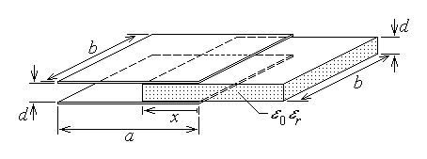
Fig. 12.24.
be sliding between the plates along the direction of the edge of length a up to a distance x < a (fig. 12.24). Assuming that the electric field is uniform in each insulator, then the capacitor can be treated as a parallel connection of two capacitors with homogeneous insulators: the air filled capacitor and the insulator plate filled capacitor. The equivalent capacitance is
$C=C_{\text{air}}+C_{\text{ins}\text{.}}=\frac{ε_{0}\left(a−x\right) b}{d}+\frac{ε_{0}ε_{r}x b}{d}=\frac{ε_{0}a b}{d}\left[\left(1−\frac{x}{a}\right)+ε_{r}\frac{x}{a}\right]=C \left(x\right)$ ,
corresponding to a distance–dependent equivalent relative permittivity
$ε_{r \text{equiv}\text{.}}=1+\frac{x}{a}\left(ε_{r}−1\right)=ε_{r \text{equiv}\text{.}}\left(x\right)$ ,
which allows that such a configuration be used as a displacement (position) transducer.
2. A similar use can be devised for a cylindrical capacitor, consisting of a central conducting cylinder of radius a and a coaxial conducting cylindrical shell of radiuses b and c , separated by a homogeneous insulator (fig. 12.25 left). If the structure length l is very great as compared to the transverse dimensions $\left(l≫c>b\right)$ , and a voltage U is applied between the conductors, then opposite charges ±Q develop on the conductors, along with an electric field in the insulator, with radial lines and the field strength depending on the distance r to the axis only,
$\vec{E}=E\left(r\right)\frac{\vec{r}}{r}$ .
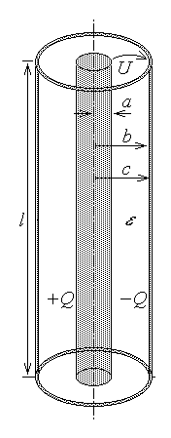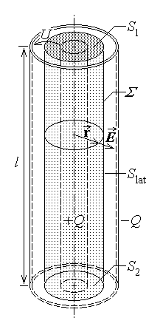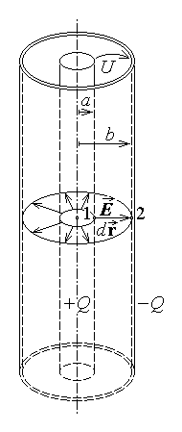
Fig. 12.25.
Neglecting the field lines outside the space between the coaxial conductors, Gauss’s law can be invoked with respect to a cylindrical surface of radius r (a < r < b) , and height l , coaxial with the structure (fig. 12.25 middle),
$\oint{\vec{D}⋅\vec{n} \text{dS}}=q_{D_{Σ}}$ .
Accounting for the radial direction of the normal $\vec{n}=\vec{r}/r$ to the cylindrical (lateral) part of surface Σ , one obtains
$\oint{\vec{D}⋅\vec{n} \text{dS}}=\int{ε E\left(r\right)⋅1⋅\text{cos}0 \text{dS}}+\int{\vec{0}⋅\vec{n} \text{dS}}=ε E\left(r\right) \int{\text{dS}}=ε E ⋅ 2π r l$
for the left–hand side, and
$q_{D_{Σ}}=Q$
for the right–hand side. Equating the last results gives for the electric field strength the expression
$E=\frac{Q}{2πε r l}$ .
The voltage between the two conductors is easily computed along a radial field line (fig. 12.25 right) as
$U=\int{\vec{E}⋅d\vec{r}}=\int{E \text{dr} \text{cos}0}=\int{\frac{Q}{2πε r l} \text{dr}}=\frac{Q}{2πε l}\int{ \frac{\text{dr}}{r}}=\frac{Q}{2πε l}\text{ln}r|_{ a}^{ b}=$
$=\frac{Q}{2πε l}\left(\text{ln}b−\text{ln}a\right)=\frac{Q}{2πε l}\text{ln}\frac{b}{a}$ .
The capacitance of the (very long) cylindrical capacitor results then simply as
$C=\frac{Q}{U}=Q\frac{2πεl}{Q \text{ln} \left(b/a\right)} ⇔ C=\frac{2πεl}{\text{ln} \left(b/a\right)}$ .
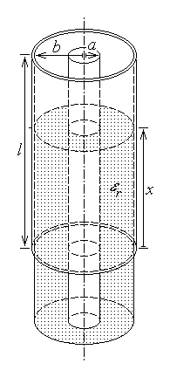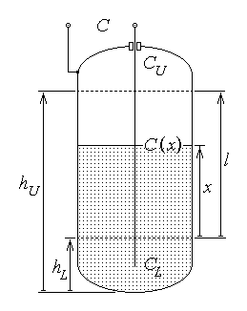
Fig. 12.26. Fig. 12.27.
3. Let now the air be the insulator of the considered cylindrical capacitor, and let an insulating shell of relative permittivity ε_{r} , radii a and b , and sufficient length, be sliding between the plates along the axial direction, up to a distance x < l (fig. 12.26). Assuming that the electric field distribution is that considered above, then the capacitor can be treated as a parallel connection of two capacitors with homogeneous insulators: the air filled capacitor and the insulator shell filled capacitor. The equivalent capacitance is
$C=C_{\text{air}}+C_{\text{ins}\text{.}}=\frac{2{πε}_{0} \left(l−x\right)}{\text{ln} \left(b/a\right)}+\frac{2{πε}_{0}ε_{r} x}{\text{ln} \left(b/a\right)}=\frac{2{πε}_{0} l}{\text{ln} \left(b/a\right)}\left[\left(1−\frac{x}{l}\right)+ε_{r}\frac{x}{l}\right]=C \left(x\right)$ ,
corresponding to a distance–dependent equivalent relative permittivity
$ε_{r \text{equiv}\text{.}}=1+\frac{x}{l}\left(ε_{r}−1\right)=ε_{r \text{equiv}\text{.}}\left(x\right)$ ,
which allows that this configuration be also used as a displacement (position) transducer.
A typical use of the last configuration is the measurement of the level of an insulating liquid in a cylindrical tank. If an axial conductor is placed inside the tank, insulated from the conducting walls (fig. 12.27), then there is a region $h_{L}≤h≤h_{U}$ where the electric field distribution is like that in the cylindrical capacitor. The capacitance between the axial conductor and the conducting wall is the parallel connection of the capacitances C_{L} , C_{U} , corresponding to the upper and lower end fields and the capacitance of a cylindrical capacitor as above, between the marked levels,
$C=C_{U}+C_{L}+C_{\text{cyl}\text{.}}\left(x\right)=C \left(x\right) , 0≤x≤h_{U}−h_{L}=l$ .
4. Let again a parallel–plate capacitor be considered, with rectangular plates of surface S = ab placed at a distance d , with the air as insulator. Let then an insulating plate of relative permittivity ε_{r} , thickness y < d , width at least b , and length l ≥ a , be sliding over the lower plate along the direction of the edge of length a (fig. 12.28 left). Let a voltage U be applied between the plates, so that opposite charges ±Q are developed on the plates, along with an electric field between them. Assuming that the electric field is uniform in each insulator between the plates, let Gauss’s law be invoked for a rectangular box closely surrounding, say, the upper plate (fig. 12.28 right),
$\oint{\vec{D}⋅\vec{n} \text{dS}}=q_{D_{Σ}}$ .
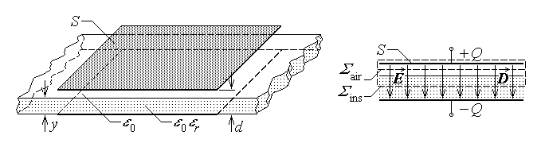
Fig. 12. 28.
Accounting for the normal direction of the electric field on the part S_{int.} of surface Σ placed between the plates, one obtains
$\oint{\vec{D}⋅\vec{n} \text{dS}}=\int{ε E ⋅1⋅\text{cos}0 \text{dS}}+\int{\vec{0}⋅\vec{n} \text{dS}}=ε E \int{\text{dS}}=ε E ⋅ a b=ε E S$
for the left–hand side, and
$q_{D_{Σ}}=Q$
for the right–hand side. Equating the last results, separately for the case when the surface Σ is traced in air and the insulator, gives for the electric field strength the expression
$E=\frac{Q}{ε S}=\left\{\begin{matrix}\frac{Q}{ε_{0} S} , \text{in} \text{the} \text{air} \\ \frac{Q}{ε_{0}ε_{r} S} , \text{in} \text{the} \text{insulator}\end{matrix}\right.$ .
The voltage between the two conductors is easily computed along a field line as
$U=\int{\vec{E}⋅d\vec{r}}=\int{E \text{dr} \text{cos}0}=\int{ \frac{Q}{ε_{0}S} \text{dr}}+\int{ \frac{Q}{ε_{0}ε_{r}S} \text{dr}}=$
$=\frac{Q}{ε_{0}S}\left(d−y\right)+\frac{Q}{ε_{0}ε_{r}S}y=\frac{Q}{ε_{0}S}\left(d−y+\frac{y}{ε_{r}}\right)$ .
The capacitance of the capacitor with a two–layer insulator results then simply as
$C=\frac{Q}{U}=Q\frac{ε_{0}S}{Q \left(d−y+\frac{y}{ε_{r}}\right)}=\frac{ε_{0}S}{\frac{d}{ε_{r}} \left[\left(1−\frac{y}{d}\right)ε_{r}+\frac{y}{d}\right]} ⇔ C=\frac{ε_{0}S}{d}\frac{ε_{r}}{1+\frac{y}{d}\left(1−ε_{r}\right)}$ ,
corresponding to a thickness–dependent equivalent relative permittivity
$ε_{r \text{equiv}\text{.}}=\frac{ε_{r}}{1+\frac{y}{a}\left(1−ε_{r}\right)}=ε_{r \text{equiv}\text{.}}\left(y\right)$ .
Such a configuration can be used as an on–line thickness transducer for a continuously translating (sliding) insulator layer.
One important remark is that a configuration of the type studied above, where the field lines in the capacitor are normal to the interface between two different insulators, is equivalent to the series connection of two capacitors, each associated with a single homogeneous insulator, as in fig. 12.29:
$\frac{1}{C}=\frac{d−y+\frac{y}{ε_{r}}}{ε_{0}S}=\frac{d−y}{ε_{0}S}+\frac{y}{ε_{0}ε_{r}S}=\frac{1}{C_{\text{air}}}+\frac{1}{C_{\text{ins}\text{.}}}$ .
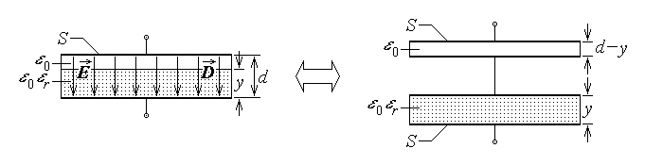
Fig. 12.29
It is as if the interface normal to the electric field lines could be replaced by an infinitely thin metallic sheet, so that an air–filled capacitor is found between the upper plate and the metallized interface and an insulator–filled capacitor is found between the metallized interface and the lower plate. This result is valid as well when the interface between any two insulators, normal to the electric field lines, has any other shape (cylindrical, for instance).

12.3.5. Inductance transducers
The operation of inductance transducers is based on the changes in the inductance value(s) of a coil (or a system of coupled coils) due to changes of the geometric parameters of the coil(s) or in their magnetic circuit.
The inductance of the very long solenoid, taken as typical for a coil inductance, given by
$L=\frac{μ N^{2}S}{l}$ ,
is influenced, letting aside the permeability μ , by the coil number of turns N , its length l , and cross section area A . It is quite difficult to imagine an easy way to modify such parameters in relation with a non–electromagnetic parameter. That is why inductance transducers are usually constructed in relation with systems of coupled coils.
1. The common inductance transducer is essentially a transformer, that is a system of two coupled coils (fig. 12.30), where the primary coil carries a time–varying current determining in the secondary coil a time–varying magnetic flux, which generates an induced voltage in this secondary coil, and an induced current as well if a load is connected at the secondary coil terminals. Under the hypothesis of linear substances, the operation equations of this transformer are
$−u_{1}+r_{1}i_{1}+L_{\text{11}}\frac{{di}_{1}}{dt}−L_{\text{12}}\frac{{di}_{2}}{dt}=0$
$r_{2}i_{2}+L_{\text{22}}\frac{{di}_{2}}{\text{dt}}−L_{\text{21}}\frac{{di}_{1}}{\text{dt}}+u_{2}=0$ ,
where u₁ is the voltage at the terminals of the non–ideal source exciting the primary coil, and u₂ is the voltage at the terminals of the load connected at the secondary terminals.
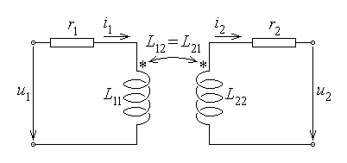
Fig. 12.30.
Under common harmonic time–varying conditions, and using complex representatives of the harmonic time–varying quantities (fig. 12.31 up), the circuit equations become
$\begin{matrix}−{\underline{U}}_{1}+\left(r_{1}+{jωL}_{\text{11}}\right) {\underline{I}}_{1}−{jωL}_{\text{12}} {\underline{I}}_{2}=0 \\ \left(r_{2}+{jωL}_{\text{22}}\right) {\underline{I}}_{2}−{jωL}_{\text{21}} {\underline{I}}_{1}+{\underline{U}}_{2}=0\end{matrix} ⇔ \begin{matrix}−{\underline{U}}_{1}+\left(r_{1}+{jωL}_{\text{11}}\right) {\underline{I}}_{1}−jωM {\underline{I}}_{2}=0 \\ \left(r_{2}+{jωL}_{\text{22}}\right) {\underline{I}}_{2}−jωM {\underline{I}}_{1}+{\underline{U}}_{2}=0\end{matrix}$ ,
where it was denoted L₁₂ = L₂₁ = M .
The complex voltage at the terminals of the non–ideal complex source placed in the primary circuit is
${\underline{U}}_{1}={\underline{E}}_{1}−{\underline{z}}_{1}{\underline{I}}_{1}$ ,
and the first circuit equation becomes
${\underline{z}}_{1}{\underline{I}}_{1}+\left(r_{1}+{jωL}_{\text{11}}\right) {\underline{I}}_{1}−jωM {\underline{I}}_{2}={\underline{E}}_{1}$ .
The impedance connected at the secondary coil terminals imposes the additional equation
${\underline{U}}_{2}={\underline{Z}}_{2}{\underline{I}}_{2}$ ,
so that the second circuit equation gives another relation between the primary and secondary complex currents,
$\left(r_{2}+{jωL}_{\text{22}}+{\underline{Z}}_{2}\right) {\underline{I}}_{2}=jωM {\underline{I}}_{1}$ .
Upon substitution of the secondary current in terms of the primary current, the complex equation of the primary circuit successively becomes
${\underline{E}}_{1}=\left({\underline{z}}_{1}+ r_{1}+{jωL}_{\text{11}}\right) {\underline{I}}_{1}−jωM \frac{jωM}{r_{2}+{jωL}_{\text{22}}+{\underline{Z}}_{2}}{\underline{I}}_{1} ⇔$
$⇔ {\underline{E}}_{1}=\left({\underline{z}}_{1}+ r_{1}+{jωL}_{\text{11}}+{\underline{Z}}_{r \text{12}}\right) {\underline{I}}_{1}$ .
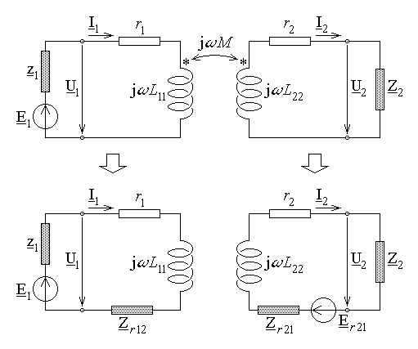
Fig. 12.31.
The last equation describes an equivalent to the primary circuit, where the secondary–to–primary reflected impedance (fig. 12.31 down left), depending on the mutual (coupling) inductance M , is
${\underline{Z}}_{r \text{12}}=\frac{{\left(ωM\right)}^{2}}{r_{2}+{jωL}_{\text{22}}+{\underline{Z}}_{2}}$ .
On the other hand, the first circuit equation gives for the primary current the expression
${\underline{I}}_{1}=\frac{{\underline{E}}_{1}+jωM {\underline{I}}_{2}}{{\underline{z}}_{1}+r_{1}+{jωL}_{\text{11}}}$ ,
which, when substituted into the second circuit equation, results successively in
$\left(r_{2}+{jωL}_{\text{22}}+{\underline{Z}}_{2}\right) {\underline{I}}_{2}−jωM \frac{{\underline{E}}_{1}+jωM {\underline{I}}_{2}}{{\underline{z}}_{1}+r_{1}+{jωL}_{\text{11}}}=0 ⇔$
$⇔ \left(r_{2}+{jωL}_{\text{22}}+{\underline{Z}}_{2}+\frac{{\left(ωM\right)}^{2}}{{\underline{z}}_{1}+r_{1}+{jωL}_{\text{11}}}\right) {\underline{I}}_{2}=\frac{jωM}{{\underline{z}}_{1}+r_{1}+{jωL}_{\text{11}}}{\underline{E}}_{1} ⇔$
$⇔ \left(r_{2}+{jωL}_{\text{22}}+{\underline{Z}}_{2}+{\underline{Z}}_{r \text{21}}\right) {\underline{I}}_{2}={\underline{E}}_{r \text{21}}$ .
The last equation describes an equivalent to the secondary circuit, where the secondary–to–primary reflected impedance, and the secondary–to–primary reflected voltage (fig. 12.31 down right), both dependent on the mutual (coupling) impedance M , respectively are
${\underline{Z}}_{r \text{21}}=\frac{{\left(ωM\right)}^{2}}{{\underline{z}}_{1}+r_{1}+{jωL}_{\text{11}}} , {\underline{E}}_{r \text{21}}=\frac{jωM}{{\underline{z}}_{1}+r_{1}+{jωL}_{\text{11}}}{\underline{E}}_{1}$ .
It is easily remarked that different electric quantities, refering to the circuit and its operation, can be used to detect changes in the mutual (coupling) inductance M through the secondary–to–primary and primary–to–secondary reflected impedances and the primary–to–secondary reflected voltage defined above. The secondary voltage ${\underline{U}}_{2}$ and the secondary current ${\underline{I}}_{2}$ are the quantities most commonly used to detect such changes. Due mainly to a better processing efficiency, the first alternative is preferred, in which case the parasitic influence of the secondary current is reduced by using as a transducer load an electronic amplifier, presenting a very large impedance between its terminals, where the voltage ${\underline{U}}_{2}$ is applied.
2. Let the system of coupled coils studied previously in section 7.1 (fig. 12.32) be taken as a model. The mutual inductance between the two coils is
$L_{\text{12}}=L_{\text{21}}=M=\frac{μ_{0}μ_{r}N_{1}N_{2}S_{2}}{l_{1}} \text{cos}α$ ,
depending on the mutual orientation α of the coil axes. If the inner (rotating) coil is attached to some object, and the outter coil is at rest, then, according to the previous analysis, the harmonic time–varying operation of this transformer is influenced by the mutual inductance, and this system of coupled coils is able to detect the rotation angle α of the object with respect to the fixed outter coil, that is, it acts as a rotation transducer.
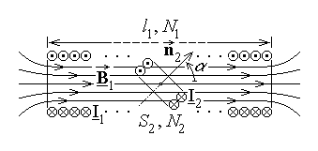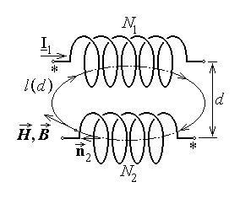
Fig. 12.32. Fig. 12.33.
3. As another example, let a system of two coupled coils be considered, where the coils, assumed for simplicity to be solenoids with parallel axes, are placed side by side (fig. 12.33). Let a harmonic time–varying current with the complex representative ${\underline{I}}_{1}$ be carried by the coil 1; under quasi–steady state conditions; the magnetic field generated by it is instantaneously proportional to the current and has a complex represennative ${\underline{H}}_{1}$ . Let also be supposed – for the sake of simplicity – that the magnetic field strength has the same magnitude along each magnetic field line. Ampere’s theorem successively gives
$\oint{\vec{H}⋅d\vec{r}}=i_{S_{Γ}} ⇔ \oint{{\underline{H}}_{1} \text{dr} \text{cos}0}=N_{1}{\underline{I}}_{1} ⇔$
$⇔ {\underline{H}}_{1}\oint{ \text{dr}}=N_{1}{\underline{I}}_{1} ⇔ {\underline{H}}_{1} l=N_{1}{\underline{I}}_{1}$ ,
where l is the length of the considered closed field line. The magnitude of the magnetic field strength,
${\underline{H}}_{1}=\frac{N_{1}{\underline{I}}_{1}}{l}$ ,
is thus inversely proportional to the length of the field line, that is it decreases with the distance to the coil 1. The magnetic flux determined by this field in the coil 2 is approximately
${\underline{Φ}}_{\text{21}}=\int{{\underline{\vec{B}}}_{1}⋅{\vec{n}}_{2} \text{dS}}≃N_{2} \int{μ{\underline{H}}_{1} \text{cos}0 \text{dS}}={μN}_{1}N_{2}{\underline{I}}_{1}\int{ \frac{\text{dS}}{l\left(d\right)}}$
and depends on the length of the field lines crossing the surface of the coil 2, that is, on the distance d between the two coils. Corespondingly, the mutual (coupling) inductance is between the two coils is dependent on the distance d ,
$M=L_{\text{21}}=\frac{{\underline{Φ}}_{\text{21}}}{{\underline{I}}_{1}}={μN}_{1}N_{2} \int{ \frac{\text{dS}}{l\left(d\right)}}$
The e.m.f. induced in the second coil by the time–varying magnetic flux,
$e_{2}=− \frac{{dφ}_{\text{21}}}{\text{dt}} ⇔ {\underline{E}}_{2}=−jω{\underline{Φ}}_{\text{21}}=−jω {μN}_{1}N_{2}{\underline{I}}_{1}\int{ \frac{\text{dS}}{l\left(d\right)}}={\underline{E}}_{2}\left(d\right)$ ,
depends on the distance d between the coils as well, and determines at the the terminals of the second coil a voltage and a current also dependent on this distance. Such a system of coupled coils can then be used as a distance or a translation transducer.
12.3.6. Equivalent permeability transducers
The operation of equivalent permeability transducers is based on the changes in the inductance value of a coil (or the inductance values in a system of coupled coils) due to changes in the equivalent permitivity of the substances in its (their) magnetic circuit. In turn, such an equivalent permeability accounts not only for changes in the very permeability of the associated magnetic circuit, but also for changes in the dimensions or relative placement of different pieces of the magnetic circuit. Such changes can occur in the magnetic circuit of a single coil or in the magnetic circuit of a system of coupled coils – therefore both such cases can be considered.
1. Let a N–turns solenoidal coil be considered, and let l be its length and S the cross section area. Let also the core consist partly of air and partly of a cylinder of the same cross section area S , made of some magnetically permeable substance (μ_{r} ≠ 1) , that can move into or out of the coil Let hypotheses similar to those used in the computation of the long solenoid inductance (section 7.1) and in the study of magnetic circuits (section 7.2) be admitted. It means supposing negligible magnetic field immediately outside the coil turns and uniform magnetic field in each region of constant cross section and constant permeability in the coil core.
Let a slice of a cylindrical flux tube Σ be considered inside the coil core, bordered laterally by the coil turns and limited by cross sections S₀ = S in the air and S_{f} = S in the magnetic substance (fig. 12.34). According with a consequence of Dirac’s law on the magnetic flux (section 3.11), the magnetic flux is conservative along a flux tube, so that
$Φ_{1}=Φ_{2} ⇔ B_{0}S_{1}=B_{f}S_{2} ⇔ μ_{0}H_{0}=μ_{0}μ_{r}H_{f}$ .
It follows that, in the two regions inside the coil core, the magnetic flux density values satisfy the equation
$B_{0}=B_{f}$ ,
while the magnetic field strength values satisfy the equation
$H_{0}=μ_{r}H_{f}$ .
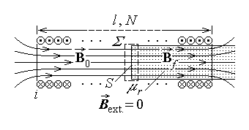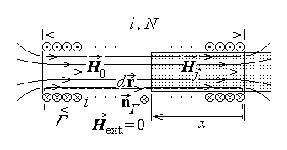
Fig. 12.34. Fig. 12.35.
Let now x be the length of the magnetically permeable core inside the coil (0 < x < l) , and let a rectangular contour be considered, going along the magnetic field line inside the coil core and immediately close to the turns outside it (fig. 12.35). Ampere’s theorem (section 3.12) applied to the contour successively gives
$\oint{\vec{H}⋅d\vec{r}}=i_{S_{Γ}} ⇔ H_{0}\left(l−x\right)+H_{f}x+0= ⇔$
$⇔ \frac{B_{0}}{μ_{0}}\left(l−x\right)+\frac{B_{f}}{μ_{0}μ_{r}}x= ⇔ \frac{B}{μ_{0}}\left(l−x+\frac{x}{μ_{r}}\right)=$ .
Using the common value of the magnetic flux density inside the coil, the total magnetic flux of it is easily computed as
$Φ=\int{\vec{B}⋅\vec{n} \text{dS}}≃Φ_{\text{ext}}+{NΦ}_{\text{turn}}≃NBS=Nμ_{0}∋\frac{}{l−x\left(1−1/μ_{r}\right)}S$ .
Consequently, the coil inductance results immediately as
$L=\frac{Φ}{i} ⇔ L=\frac{μ_{0}N^{2}S}{l−x\left(1−1/μ_{r}\right)}=\frac{μ_{0}N^{2}S}{l}\frac{l}{l−x\left(1−1/μ_{r}\right)}=L_{0}μ_{r \text{equiv}}\left(x\right)$ ,
where L₀ is the inductance of the air–core coil and
$μ_{r \text{equiv}}\left(x\right)=\frac{l}{l−x \left(1−1/μ_{r}\right)}=\frac{μ_{r}}{μ_{r}−\left(μ_{r}−1\right) x/l}$
is the distance–dependent equivalent relative permeability of the coil core.
It is thus obvious that such a device can be used as a translation or position transducer. A similar analysis can be done for a coil whith a rotating magnetically
permeable core, which can be used as a rotation position transducer.
2. Let now a magnetic circuit like that studied in section 7.2 be considered (fig. 12.36), with the magnetic circuit consisting in a U–shaped and an I–shaped ferromagnetic

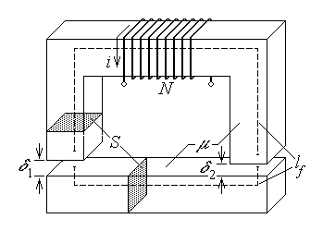
Fig. 12.36.
parts of the same cross section area S and relative permeability μ_{f} . Let l_{f} denote the length of the median field lines in ferromagnetic media, and δ₁ , δ₂ be the lengths of the two asymmetric airgaps. Finally, let a coil of N turns, wound around the U–shaped part of the magnetic circuit, carry an electric curent of intensity i .

The common magnetic flux Φ in any cross section of the magnetic circuit results from Kirchhoff’s (magnetic) voltage equation,
$\left(\frac{l_{f}}{μ_{0}μ_{f}S}+\frac{δ_{1}}{μ_{0}μ_{1}S}+\frac{δ_{2}}{μ_{0}μ_{2}S}\right) Φ=N i$ ,
where μ₁ and μ₂ are the relative permeabilities of the substance in each airgap. Assuming, as for common magnetic circuits, that the leakage magnetic flux is negligible, the total magnetic flux of the coil is
$Φ_{\text{tot}}=\int{\vec{B}⋅\vec{n} \text{dS}}≃N\int{\vec{B}⋅\vec{n} \text{dS}}=NΦ=$
$=N\frac{N i}{\frac{l_{f}}{μ_{0}μ_{f}S}+\frac{δ_{1}}{μ_{0}μ_{1}S}+\frac{δ_{2}}{μ_{0}μ_{2}S}}=\frac{N^{2}μ_{0}S}{\frac{l_{f}}{μ_{f}}+\frac{δ_{1}}{μ_{1}}+\frac{δ_{2}}{μ_{2}}} i$ .
Consequently, the coil inductance is readily derived as
$L=\frac{Φ_{\text{tot}}}{i}=\frac{N^{2}μ_{0}S}{\frac{l_{f}}{μ_{f}}+\frac{δ_{1}}{μ_{1}}+\frac{δ_{2}}{μ_{2}}}=\frac{N^{2}μ_{0}S}{l_{f}}\frac{μ_{f}}{1+\frac{δ_{1}}{l_{f}}\frac{μ_{f}}{μ_{1}}+\frac{δ_{2}}{l_{f}}\frac{μ_{f}}{μ_{2}}}=\frac{N^{2}μ_{0}μ_{r \text{equiv}}S}{l_{f}}$ ,
where the equivalent relative permeability, defined by equation
$μ_{r \text{equiv}}=\frac{μ_{f}}{1+\frac{δ_{1}}{l_{f}}\frac{μ_{f}}{μ_{1}}+\frac{δ_{2}}{l_{f}}\frac{μ_{f}}{μ_{2}}}=μ_{r \text{equiv}}\left(\frac{δ_{1}}{l_{f}} , \frac{δ_{2}}{l_{f}} , \frac{μ_{1}}{μ_{f}} , \frac{μ_{2}}{μ_{f}}\right)$ ,
includes the influence of both the airgap lengths and relative permeabilities, with respect to the length and relative permeability of the ferromagnetic parts of the magnetic circuit.
The length l_{f} of the median field line in the ferromagnetic pieces and their relative permeability μ_{f} are given, so that, for constant airgap relative permeabilities μ₁ and μ₂ , the coil inductance L is influenced by the airgap lengths δ₁ and δ₂ only, thus allowing the system to operate as a (translation) displacement transducer. On the other hand, if the airgap lengths δ₁ and δ₂ are constant, the coil inductance L is influenced by the airgap relative permeabilities μ₁ and μ₂ only, thus allowing the system to operate as a permeability transducer, and, indirectly, as a transducer for any other physical parameter that may influence the airgap permeabilities (temperature, composition, humidity, etc.).
3. Another example is that of a similar magnetic circuit with two coil windings (fig. 12.37). As for the magnetic circuit studied above, let l_{f} denote the length of the median field line in ferromagnetic media of relative permeability μ_{f} , S be the cross section area of the ferromagnetic parts of the magnetic circuit, N₁ and N₂ be the number

of turns of, say, the primary and secondary coil, δ₁ and δ₂ be the air gap lengths, and S₁ , S₂ be the effective cross section surfaces of the magnetic flux in the airgaps of relative permeabilities μ₁ and μ₂ . If the coils carry the electric currents of intensities i₁ and i₂ , respec-tively, then the common magnetic flux Φ in any cross section of the magnetic circuit resullts from Kirchhoff’s (magnetic) voltage equation,
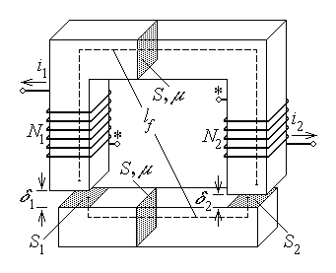
Fig. 12.37.

$\left(\frac{l_{f}}{μ_{0}μ_{f}S}+\frac{δ_{1}}{μ_{0}μ_{1}S_{1}}+\frac{δ_{2}}{μ_{0}μ_{2}S_{2}}\right) Φ=N_{1} i_{1}+N_{2} i_{2}$ .
The common magnetic flux in any cross section of the magnetic circuit can be expressed as
$Φ=\frac{N_{1} i_{1}+N_{2} i_{2}}{\frac{l_{f}}{μ_{0}μ_{f}S}+\frac{δ_{1}}{μ_{0}μ_{1}S_{1}}+\frac{δ_{2}}{μ_{0}μ_{2}S_{2}}}=\frac{μ_{0}S}{l_{f}}\frac{μ_{f} \left(N_{1} i_{1}+N_{2} i_{2}\right)}{1+\frac{μ_{f}}{μ_{1}}\frac{δ_{1}}{l_{f}}\frac{S}{S_{1}}+\frac{μ_{f}}{μ_{2}}\frac{δ_{2}}{l_{f}}\frac{S}{S_{2}}}=$
$=\frac{μ_{0}μ_{r \text{equiv}} S}{l_{f}}\left(N_{1}i_{1}+N_{2}i_{2}\right)$ ,
in terms of the equivalent realtive permeability
$μ_{r \text{equiv}}=\frac{μ_{f}}{1+\frac{μ_{f}}{μ_{1}}\frac{δ_{1}}{l_{f}}\frac{S}{S_{1}}+\frac{μ_{f}}{μ_{2}}\frac{δ_{2}}{l_{f}}\frac{S}{S_{2}}}$ .
The self and mutual (coupling) inductances can then be easily computed as:
$L_{\text{11}}=\frac{Φ_{\text{11} \text{tot}}}{i_{1}}=\frac{N_{1}Φ}{i_{1}} |_{ i_{2}=0} , L_{\text{22}}=\frac{Φ_{\text{22} \text{tot}}}{i_{2}}=\frac{N_{2}Φ}{i_{2}} |_{ i_{1}=0}$ ,
$L_{\text{12}}=\frac{Φ_{\text{12} \text{tot}}}{i_{2}}=\frac{N_{1}Φ}{i_{2}} |_{ i_{1}=0} , L_{\text{21}}=\frac{Φ_{\text{21} \text{tot}}}{i_{1}}=\frac{N_{2}Φ}{i_{1}} |_{ i_{2}=0}$ ;
the computation gives
$L_{\text{11}}=\frac{N_{1}}{i_{1}}\frac{μ_{0}μ_{r \text{equiv}} S}{l_{f}}N_{1}i_{1}=\frac{μ_{0}{SN}_{1}^{2}}{l_{f}}\frac{μ_{f}}{1+\frac{μ_{f}}{μ_{1}}\frac{δ_{1}}{l_{f}}\frac{S}{S_{1}}+\frac{μ_{f}}{μ_{2}}\frac{δ_{2}}{l_{f}}\frac{S}{S_{2}}}$ .
$L_{\text{22}}=\frac{N_{2}}{i_{2}}\frac{μ_{0}μ_{r \text{equiv}} S}{l_{f}}N_{2}i_{2}=\frac{μ_{0}{SN}_{2}^{2}}{l_{f}}\frac{μ_{f}}{1+\frac{μ_{f}}{μ_{1}}\frac{δ_{1}}{l_{f}}\frac{S}{S_{1}}+\frac{μ_{f}}{μ_{2}}\frac{δ_{2}}{l_{f}}\frac{S}{S_{2}}}$ ,
$L_{\text{12}}=\frac{N_{1}}{i_{2}}\frac{μ_{0}μ_{r \text{equiv}} S}{l_{f}}N_{2}i_{2}=\frac{μ_{0}{SN}_{1}N_{2}}{l_{f}}\frac{μ_{f}}{1+\frac{μ_{f}}{μ_{1}}\frac{δ_{1}}{l_{f}}\frac{S}{S_{1}}+\frac{μ_{f}}{μ_{2}}\frac{δ_{2}}{l_{f}}\frac{S}{S_{2}}}$ ,
$L_{\text{21}}=\frac{N_{2}}{i_{1}}\frac{μ_{0}μ_{r \text{equiv}} S}{l_{f}}N_{1}i_{1}=\frac{μ_{0}{SN}_{2}N_{1}}{l_{f}}\frac{μ_{f}}{1+\frac{μ_{f}}{μ_{1}}\frac{δ_{1}}{l_{f}}\frac{S}{S_{1}}+\frac{μ_{f}}{μ_{2}}\frac{δ_{2}}{l_{f}}\frac{S}{S_{2}}}$ .
It can first be noted that the reciprocity (symmetry) relation
$L_{\text{12}}=L_{\text{21}}=M$ ,
is satisfied. It can also be noted that the self and mutual inductances satisfy the so called perfect coupling relationship
$L_{\text{11}}L_{\text{22}}=L_{\text{12}}L_{\text{21}}=M^{2} ⇔$
$⇔ \frac{μ_{0}μ_{r \text{equiv}} {SN}_{1}^{2}}{l_{f}}\frac{μ_{0}μ_{r \text{equiv}} {SN}_{1}^{2}}{l_{f}}={\left(\frac{μ_{0}μ_{r \text{equiv}} {SN}_{1}N_{2}}{l_{f}}\right)}^{2}$ ,
corresponding to the assumption of no leakage magnetic flux.
It is now obvious that all these inductances are influenced by the airgap relative permeabilities μ₁ and μ₂ and the airgap lengths δ₁ and δ₂ as in the previous example, with a similar conclusion regarding the system capabilities to act as a (translation) displacement or a permeability transducer. Moreover, the configuration under study allows for a change of the airgap surfaces S₁ and S₂ at constant airgap lengths and, possibly, permeabilities, if the I–shaped piece of the magnetic circuit is supposed to slide under the other U–shaped piece as suggested in the figure: in this case the device operates again as a (translation) displacement transducer. However, the operation of such a transducer is much more complex that that of the previously discussed transducer, since the equivalent (relative) permeability acts on, and thus changes, three variable parameters (inductances) instead of a single one.
4. An interesting application of the two-coil equivalent permeability transducer is in fact a combination of the equivalent permeability, the resistive, and the (electro-magnetic) induction transducers. Let the configuration illustrated in fig. 12.38 be considered: a U–shaped non-conducting ferromagnetic piece of relative permeability μ_{f} and cross section S_{f} = a×b , and, at a distance δ from its arms, a conducting sheet of conductivity σ , relative permeability μ_{r} , thickness h , and width larger than either a or b . Let a single N–turns coil be wound around the U–shaped ferromagnetic piece and
carry an alternative current of effective value I and (angular) frequency ω ,
$i_{1}\left(t\right)=I \sqrt{2} \text{sin}ωt$ .
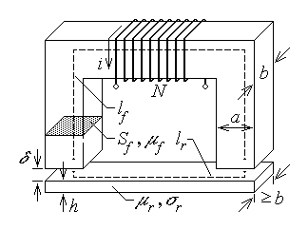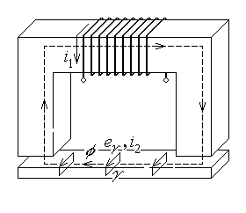
Fig. 12.38. Fig. 12.39.
Supposing, for the sake of simplicity, that the sheet relative permeability μ_{r} is sufficiently large, the configuration looks quite similar to that of the single coil equivalent permeability transducer studied previously (fig. 12.36), where the highly permeable sheet plays the part of the I–shaped piece of the magnetic circuit. However, more complex phenomena have to be considered here. The time–varying curent in the coil generates a time–varying magnetic flux φ₁ in the magnetic circuit, its median field line consisting of a length l_{f} in the ferromagnetic piece, twice the airgap length δ , and the length l_{r} in the conducting sheet. In turn, the time–varying magnetic flux induces electromotive forces (voltages) along the contour of any surface crossed by it. Such induced voltages have no effect in the non–conducting U–shaped part of the magnetic circuit or in the surrounding insulating space, but they determine induced currents along closed lines in the conducting sheet, as suggested in fig. 12.39. The induced currents generate a feedback magnetic flux which adds to the initial one in a resulting, total magnetic flux, that has to be considered in the overall process. The system, corresponding in fact to the two–coil magnetic circuit, operates as a transformer with a short–circuited secondary coil (fig. 12.40). Approximate values of the system parameters are derived in the following.

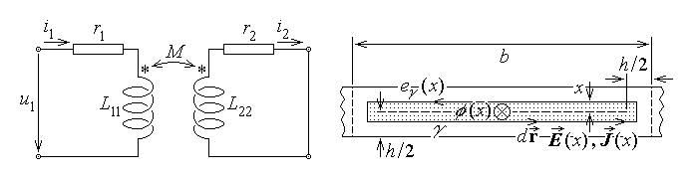
Fig. 1.40. Fig. 12.41.
Even a simplified analysis of the system operation has to deal with the induced electric fleld and the associated induced curent density in the conducting sheet. As a first simplifying hypothesis, let the induced electric field strength and current density be supposed constant along each supposedly closed rectangular field line γ in any cross section of the sheet, of maximum extension b×h , as illustrated in fig. 12.41. Such a field line goes parallel to the sheet faces at a distance x from the median plane and turns normal to the sheet faces at the same distance x with respect to points placed at a distance h/2 from the lateral limits of the induced field region. The electromotive force along the contour γ is readily computed as
$e_{γ}=\oint{\vec{E}⋅d\vec{r}}=E\left(x\right) \left[2⋅\left(b−h+2x\right)+2⋅2x\right]=2 \left(b−h+4x\right) E\left(x\right)$ As another simplifying hypothesis, let it be supposed that the feedback magnetic flux of the induced current is negligible with respect to the inductor magnetic flux, so that the total magnetic flux in the magnetic circuit is approximately $φ≃φ_{1}$ . Since, as for the magnetic circuits studied before, the magnetic flux is supposed to be uniformly distributed over any cross section, a rectangular contour γ like that considered before (fig. 12.41), borders a surface crossed by a magnetic flux
$φ\left(x\right)=\frac{2x\left(b−h+2x\right)}{bh} φ$ .
Taking into account the implied reference directions as indicated in fig. 12.41, Faraday’s (electromagnetic induction) law invoked for the contour γ successively gives
$e_{γ}=−\frac{d}{\text{dt}}φ_{S_{γ}} ⇔ e\left(x\right)=\frac{d}{\text{dt}}φ\left(x\right) ⇔$
$⇔ 2 \left(b−h+4x\right) E\left(x\right)=\frac{2x \left(b−h+2x\right)}{bh}\frac{dφ}{\text{dt}}$ ,
whence
$E\left(x\right)=\frac{x \left(b−h+2x\right)}{bh \left(b−h+4x\right)} \frac{dφ}{\text{dt}}$ .
It can be noted that the electric field, as well as the current induced in the sheet – the so called eddy current , are not uniformly distributed. The electric field strength and the current density $\vec{J}=σ \vec{E}$ are more intense toward the sheet surface and decrease with the distance from the surface – this is called the skin effect.
The total induced current i₂ can then be computed by integrating the curent density $\vec{J}$ over a cross surface of its path, of area $l_{r} h/2$ :
$i_{2}=\int{\vec{J}⋅\vec{n} \text{dS}}=\int{σ E\left(x\right) l_{r}\text{dx}}=σ \frac{l_{r}}{\text{bh}}\frac{dφ}{\text{dt}}\int{\frac{\left(b−h+2x\right) x}{b−h+4x}\text{dx}}=$
$=σ \frac{l_{r}}{\text{bh}}\frac{dφ}{\text{dt}}\int{\left[\frac{4x+b−h}{8}−\frac{{\left(b−h\right)}^{2}}{8 \left(4x+b−h\right)}\right]\text{dx}}=$
$=σ \frac{l_{r}}{\text{bh}}\frac{dφ}{\text{dt}}{\left[\frac{2x^{2}+\left(b−h\right)x}{8}−\frac{{\left(b−h\right)}^{2}}{\text{32}}\text{ln}\left(4x+b−h\right)\right]}_{ 0}^{ h/2}=$
$=σ \frac{l_{r}}{bh}\left[\frac{bh}{\text{16}}−\frac{{\left(b−h\right)}^{2}}{\text{32}}\text{ln}\frac{b+h}{b−h}\right]\frac{dφ}{\text{dt}}$ ,
where the surface element obviously is dS = l_{r} dx .
Since the electric field and current are not uniformly distributed in the conducting sheet, the parameters of the short–circuited secondary coil represented by it are computed using so called energy–based definitions. The electromagnetic power dissipated in a resistor carrying an electric current i is $P=R i^{2}$ , so that the resistance can be computed as
$R=\frac{P}{i^{2}}$ .
Similarly, the magnetic energy storred in a coil carrying an electric current i is $W=L i^{2}/2$ , whence the self inductance of the coil can be derived as
$L=\frac{2 W}{i^{2}}$ .
The dissipated electromagnetic power is computed, like the current, by integrating the coresponding dissipated power density,
$p=\vec{E}⋅\vec{J}=σ E^{2}=σ {\left[\frac{x \left(b−h+2x\right)}{bh \left(b−h+4x\right)} \frac{dφ}{\text{dt}}\right]}^{2}=$ ,
$=\frac{σ}{b^{2}h^{2}}{\left(\frac{dφ}{\text{dt}}\right)}^{2}{\left[\frac{4x+b−h}{8}−\frac{{\left(b−h\right)}^{2}}{8 \left(4x+b−h\right)}\right]}^{2}=$
$=\frac{σ}{b^{2}h^{2}}{\left(\frac{dφ}{\text{dt}}\right)}^{2}\left[\frac{\text{16}x^{2}+8\left(b−h\right)x−{\left(b−h\right)}^{2}}{\text{64}}+\frac{{\left(b−h\right)}^{4}}{\text{64}{\left(4x+b−h\right)}^{2}}\right]$ .
The volume element is obtained as the differential of the arbitrary volume,
$\text{dV}=d \left[l_{r}\left(b−h+2x\right) 2x\right]=l_{r}⋅d\left[4x^{2}+\left(b−h\right)x\right]=l_{r}\left(8x+b−h\right) \text{dx}$ ,
and the power dissipated in the conducting sheet is
$P=\int{p \text{dV}}=$
$=\int{\frac{σ}{b^{2}h^{2}}{\left(\frac{dφ}{\text{dt}}\right)}^{2}\left[\frac{\text{16}x^{2}+8\left(b−h\right)x−{\left(b−h\right)}^{2}}{\text{64}}+\frac{{\left(b−h\right)}^{4}}{\text{64}{\left(4x+b−h\right)}^{2}}\right] l_{r}\left(8x+b−h\right) \text{dx} }=$
$=\frac{σ l_{r}}{\text{64} b^{2}h^{2}}{\left(\frac{dφ}{\text{dt}}\right)}^{2}\int{\left[\text{128}x^{3}+\text{80}\left(b−h\right)x^{2}−{\left(b−h\right)}^{3}+\frac{{\left(b−h\right)}^{4}\left(8x+b−h\right)}{{\left(4x+b−h\right)}^{2}}\right] \text{dx} }=$
$=\frac{σ l_{r}}{\text{64} b^{2}h^{2}}{\left(\frac{dφ}{\text{dt}}\right)}^{2}{\left[\text{32} x^{4}+\frac{\text{80}}{3}\left(b−h\right) x^{3}−{\left(b−h\right)}^{3}x\right]}_{ 0}^{ h/2}+$
$+\frac{σ l_{r}{\left(b−h\right)}^{4}}{\text{64} b^{2}h^{2}}{\left(\frac{dφ}{\text{dt}}\right)}^{2}\int{\left[\frac{2}{\left(4x+b−h\right)}−\frac{\left(b−h\right)}{{\left(4x+b−h\right)}^{2}}\right] \text{dx} }=$
$=\frac{σ l_{r}}{\text{64} b^{2}h^{2}}{\left(\frac{dφ}{\text{dt}}\right)}^{2}{\left[\text{32} x^{4}+\frac{\text{80}}{3}\left(b−h\right) x^{3}−{\left(b−h\right)}^{3}x\right]}_{ 0}^{ h/2}+$
$+\frac{σ l_{r}{\left(b−h\right)}^{4}}{\text{64} b^{2}h^{2}}{\left(\frac{dφ}{\text{dt}}\right)}^{2}{\left[\frac{1}{2}\text{ln}\left(4x+b−h\right)−\frac{\left(b−h\right)}{4 \left(4x+b−h\right)}\right]}_{ 0}^{ h/2}=$
$=\frac{σ l_{r}}{\text{64} b^{2}h^{2}}{\left(\frac{dφ}{\text{dt}}\right)}^{2}\left\{2 h^{4}+\frac{\text{10}}{3}\left(b−h\right) h^{3}−\frac{1}{2}{\left(b−h\right)}^{3}h+\right.$
$\left.+\frac{{\left(b−h\right)}^{4}}{2}\left[\text{ln}\frac{b+h}{b−h}−\frac{\left(b−h\right)}{2 \left(b+h\right)}+\frac{1}{2}\right]\right\}$ .
The equivalent resistance of the conducting sheet is finally obtained as
$$r_{2}=\frac{P_{2}}{i_{2}^{2}}=\frac{P_{2}}{\frac{σ^{2}l_{r}^{2}}{b^{2}h^{2}}{\left[\frac{bh}{\text{16}}−\frac{{\left(b−h\right)}^{2}}{\text{32}}\text{ln}\frac{b+h}{b−h}\right]}^{2}{\left(\frac{dφ}{\text{dt}}\right)}^{2}}=$$
$=\frac{2 h^{4}+\frac{\text{10}}{3}\left(b−h\right) h^{3}−\frac{1}{2}{\left(b−h\right)}^{3}h+\frac{{\left(b−h\right)}^{4}}{2}\left[\text{ln}\frac{b+h}{b−h}−\frac{\left(b−h\right)}{2 \left(b+h\right)}+\frac{1}{2}\right]}{\text{64} σ l_{r} {\left[\frac{bh}{\text{16}}−\frac{{\left(b−h\right)}^{2}}{\text{32}}\text{ln}\frac{b+h}{b−h}\right]}^{2}}$ .
The magnetic energy stored in the field inside the conducting sheet is computed as
$W_{2}=\int{w_{m} \text{dV}}=\int{\frac{BH}{2} \text{dV}}=\int{\frac{B^{2}}{2μ_{0}μ_{r}} \text{dV}}≃\frac{{\left(φ/\text{bh}\right)}^{2}}{2μ_{0}μ_{r}} {bhl}_{r}=\frac{φ^{2}l_{r}}{2μ_{0}μ_{r} bh}$ ,
where the the magnetic flux density was taken as uniform, and where an approximated volume of the current carrying conducting sheet was taken as bhl_{r} . Consequently, the self inductance of the secondary coil represented by the conducting sheet is
$L_{\text{22}}=\frac{2W_{2}}{i_{2}^{2}}=\frac{\frac{φ^{2}l_{r}}{μ_{0}μ_{r} bh}}{\frac{σ^{2}l_{r}^{2}}{b^{2}h^{2}}{\left[\frac{bh}{\text{16}}−\frac{{\left(b−h\right)}^{2}}{\text{32}}\text{ln}\frac{b+h}{b−h}\right]}^{2}{\left(\frac{dφ}{\text{dt}}\right)}^{2}}=$
$=\frac{bh}{μ_{0}μ_{r}σ^{2}l_{r}{\left[\frac{bh}{\text{16}}−\frac{{\left(b−h\right)}^{2}}{\text{32}}\text{ln}\frac{b+h}{b−h}\right]}^{2}}\frac{φ^{2}}{{\left(\frac{dφ}{\text{dt}}\right)}^{2}}$ .
The last ratio above is to be interpreted in terms of time–average values, that is as the ratio of the corresponding effective values. As it was proved earlier (section 9.1), the effective value of the derivative of a harmonic time–varying function is ω times the effective value of the original function; so that the self inductance of the secondary coil results finally as
$L_{\text{22}}=\frac{bh}{ω^{2}μ_{0}μ_{r}σ^{2}l_{r}{\left[\frac{bh}{\text{16}}−\frac{{\left(b−h\right)}^{2}}{\text{32}}\text{ln}\frac{b+h}{b−h}\right]}^{2}}$ .
The self inductance of the primary coil can be computed quite similarly to that of the single–coil magnetic circuit studied previously, since the magnetic feedback of the secondary coil has been neglected, meaning that the magnetic flux over any cross section of the magnetic circuit is approximately that of the primary coil, $φ≃φ_{1}$ . Assuming the same approximations as those made in the computation of the self inductance of the secondary coil, regarding the transverse surfaces in and the volume of the conducting sheet, it follows that
$L_{\text{11}}=\frac{Φ_{\text{11} \text{tot}}}{i_{1}}=\frac{N_{1}}{i_{1}}\frac{N_{1}i_{1}}{\frac{l_{f}}{μ_{0}μ_{f}\text{ab}}+\frac{2δ}{μ_{0}\text{ab}}+\frac{l_{r}}{μ_{0}μ_{r}\text{bh}}}=$
$=\frac{μ_{0}\text{ab} N_{1}^{2}}{l_{f}}\frac{μ_{f}}{1+μ_{f}\frac{2δ}{l_{f}}+\frac{μ_{f}}{μ_{r}}\frac{l_{r}}{l_{f}}\frac{a}{h}}=\frac{μ_{0}μ_{r \text{equiv}}\text{ab} N_{1}^{2}}{l_{f}}$ ,
where the equivalent relative permeability (for the self inductance of the primry coil) is
$μ_{r \text{equiv}}\left(\frac{μ_{r}}{μ_{f}},\frac{δ}{l_{f}},\frac{l_{r}}{l_{f}},\frac{a}{h}\right)=\frac{μ_{f}}{1+μ_{f}\frac{2δ}{l_{f}}+\frac{μ_{f}}{μ_{r}}\frac{l_{r}}{l_{f}}\frac{a}{h}}$ .
The magnetic circuit is studied under the hypothesis of no leakage magnetic flux, so that the mutual (coupling) inductance can be derived from the relation identified above,
$L_{\text{11}}L_{\text{22}}=L_{\text{12}}L_{\text{21}}=M^{2} ⇔ L_{\text{12}}=L_{\text{21}}=M=\sqrt{L_{\text{11}}L_{\text{22}}}$ .
Consequently, the mutual (coupling) inductance between the two coils is
$M=\sqrt{\frac{μ_{0}\text{ab} N_{1}^{2}}{l_{f}}\frac{μ_{f}}{1+μ_{f}\frac{2δ}{l_{f}}+\frac{μ_{f}}{μ_{r}}\frac{l_{r}}{l_{f}}\frac{a}{h}}⋅\frac{bh}{ω^{2}μ_{0}μ_{r}σ^{2}l_{r}{\left[\frac{bh}{\text{16}}−\frac{{\left(b−h\right)}^{2}}{\text{32}}\text{ln}\frac{b+h}{b−h}\right]}^{2}}}=$
$=\frac{N_{1}}{ωσ}\sqrt{\frac{\frac{μ_{f}}{μ_{r}}}{1+μ_{f}\frac{2δ}{l_{f}}+\frac{μ_{f}}{μ_{r}}\frac{l_{r}}{l_{f}}\frac{a}{h}}⋅\frac{{ab}^{2}h}{l_{f}l_{r}{\left[\frac{bh}{\text{16}}−\frac{{\left(b−h\right)}^{2}}{\text{32}}\text{ln}\frac{b+h}{b−h}\right]}^{2}}}$ ,
and, everything else considered given, depends on the airgap length and the conducting sheet thickness, conductivity, and relative permeability.
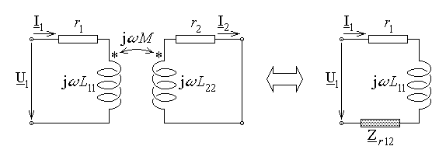
Fig. 12.42.
The operation of the magnetic circuit under study can be investigated with respect to the terminals of the primary coil only, since the secondary coil is short–circuited and, moreover, is not even accessible. As proved above, at subsection 12.3.5, the equivalent circuit of the transformer, with respect to the terminals of the primary coil (fig. 12.42), includes a series–connected secondary–to–primary reflected impedance,
${\underline{Z}}_{r \text{12}}=\frac{{\left(ωM\right)}^{2}}{r_{2}+{jωL}_{\text{22}}}$ .
The expresion of this reflected impedance can be calculated by using the results obtained above, and its dependence on the airgap length and the conducting sheet thickness, conductivity, and relative permeability can be evidenced. For given conductivity and permeability of the conducting sheet, if the distance between the bottom face of the sheet and the airgap faces of the U–shaped piece of the magnetic circuit is constant, i.e. δ + h = const. , then the system can be used to measure the thickness of the conducting sheet. As well, if the thickness of the conducting sheet is constant, a similar construction can detect variations in the conducting sheet constitutive parameters – conductivity and/or permeability. Such measurements can be performed on–line, during the manufacturing process of an advancing conducting sheet. In fact, in such a case, one has to consider also the induced e.m.f. ssociated to the sheet displacement, but such an analysis is much more complex.

12.4. Nondestructive evaluation
The nondestructive evaluation is a set of procedures aiming at the detection of defects/faults and the evaluation of their placement, dimensions and shape inside a manufactured item, without damaging the analised object. Such procedures are essential in assessing the quality of manufactured objects and preventing an eventual irreparable failure in their operation.
The typical defect (failure) to be detected and evaluated is a region where there is a departure from the supposedly homogeneous material structure of the analised object. Holes, cracks, or inclusions of some different materials are common examples. Different methods can be used with a view to detect and evaluate defects, such as investigations using radiations (acoustic, microwave, thermal, infrared, Roentgen, gamma) and electro-magnetic investigations.
The nondestructive evaluation using electromagnetic methods is based on the changes induced by a defect on the distribution of the electromagnetic field generated by appropriate field sources: the electromagnetic field developed in an homogeneous region differs from that developed if some material discontinuities are present in the region. The electromagnetic nondestructive evaluation is oriented mainly to the analysis of metallic objects and is based on the use of the magnetic field. Indeed, the great majority of manufactured objects subjected to important stresses are still metallic, and the generation and measurement of the electric field are significantly more difficult than those of the magnetic field. The evaluations are somewhat simpler when done in a constant, time–invariant, magnetic field than in a time–varying magnetic field, since the latter implies the presence of a supplementary induced magnetic field, associated with the eddy currents developed in conducting media.
12.4.1. The excitation field
The excitation field is the electromagnetic field applied to the object to be analysed; it can be either externally or internally generated. Within the previously described limits, the excitation field is considered here to be a magnetic field. A homogeneous excitation magnetic field is desirable, since it makes easier the detection of field perturbations which can be linked with the presence of defects. The computation of a time–varying magnetic field is significantly more difficult than that of a time–invariant magnetic field, due to the skin effect inherently present in the former case, so that only the latter case is approached in some detail in the following. The considerations formulated with reference to tangentially–directed time–invariant magnetic fields can be taken as approximating those valid in the the presence of the skin effect, if the decay of the electromagnetic field quantities when advancing towards the interior of the conducting object is accounted for (some details are given in the last chapter).
1. A common external source of a magnetic field could be a magnetic circuit placed in the immediate vicinity of the analised object. The evaluated object is itself part of the magnetic circuit when it is made of some ferromagnetic substance; otherwise, it represents simply a sort of an extended air gap in the magnetic circuit. In turn, the magnetic field source in the magnetic circuit is usually a current carrying coil – this allows for obtaining either a controlled constant or time–varying magnetic field. Such magnetic circuits placed in the vicinity of a plane or cylindrical boundary of a ferromagnetic object, for generating a normal magnetic field near the object–air interface, are presented in fig. 12.43, respectively: they impose a magnetic field with lines normal to the interface. The average magnetic field strength in the airgap can be approximated as follows: Let S_{fj} and S_{0k} be the cross sections of the magnetic circuit in ferromagnetic pieces of relative permeability μ_{rj} and air gaps, respectively, l_{fj} and δ_{k} be the lengths of the average field line in the corresponding pieces of the magnetic circuit, and NI be the ampere–turns of the energizing coil of the magnetic circuit. Supposing that, as it is illustrated, there is a single loop of the magnetic circuit, Kirchhoff's (magnetic) voltage theorem gives
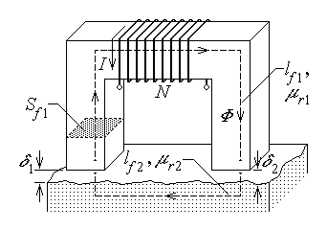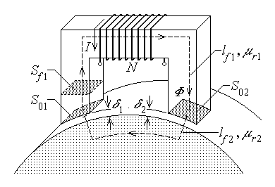
Fig. 12.43.
$\left(\sum_{j}{R_{mfj}}+\sum_{k}{R_{m0k}}\right) Φ=N I ⇔ \left(\sum_{j}{\frac{l_{fj}}{μ_{0}μ_{rj}S_{fj}}}+\sum_{k}{\frac{δ_{k}}{μ_{0}S_{0k}}}\right) Φ=N I$ ,
whence, for instance, the average magnetic field strength in the i–th airgap is
$H_{0i}=\frac{B_{0i}}{μ_{0}}=\frac{Φ}{μ_{0}S_{0i}}=\frac{N I}{μ_{0}S_{0i} \left(\sum_{j}{\frac{l_{fj}}{μ_{0}μ_{rj}S_{fj}}}+\sum_{k}{\frac{δ_{k}}{μ_{0}S_{0k}}}\right)}$ .
The esential dificulty associated with this approach is related with the correct estimation of the cross section of the magnetic flux in the analised object. In the case of a non–ferromagnetic object, there exists a region where the magnetic field imposed in the extended airgap of the magnetic circuit eventually takes a direction tangential to the object–air interface; however, it is less homogeneous than in the previous cases and distributed over a much larger cross section (fig. 12.44).
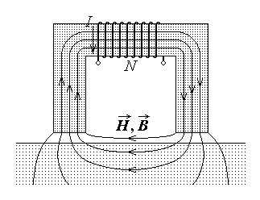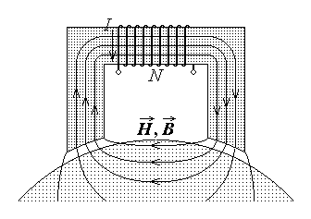
Fig. 12.44.
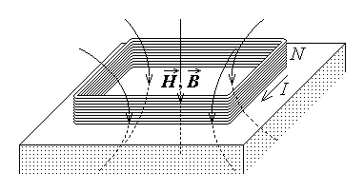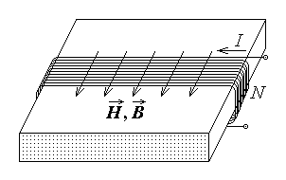
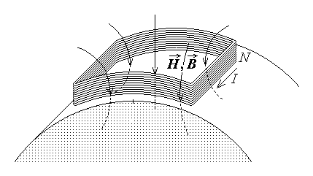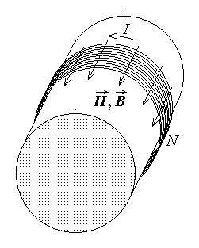
Fig. 12.45. Fig. 12.46.
2. The direct use of current carrying coils only as external sources of the magnetic field may be also necessary, depending on the needed field distribution or some particular shape of the analised object. For instance, flat or saddle–shaped coils for generating a normal magnetic field at the surface of plates or cylinders are presented in fig. 12.45, respectively, and (flat) rectangular or circular cross section solenoids for generating a tangentially–directed field are presented in fig. 12.46, respectively.
In the first case, the computation of the magnetic field strength is simple when the permeability of the analised object is μ₀ (non–ferromagnetic object): according with the Biot–Savart–Laplace's formula,

$\vec{H}=\frac{i}{4π}\int{\frac{d\vec{r}×\vec{R}}{R^{3}}}$ ,
where the direction of the elementary segment $d\vec{r}$ is that of the current i , and $\vec{R}$ is the position vector of the (fixed) point M where the field is calculated with respect to the integration point S , which travels along the current carrying conductor (fig. 12.47).
The computation of the magnetic field strength is somewhat similar in the case of an analised object of permeability μ = μ₀μ_{r} > μ₀ , but a supplementary so called image coil has to be also
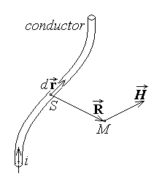
Fig. 12.47.

considered, which is the reflected image of the actual coil with respect to the air–object interface; moreover, if i is the current intensity in the actual coil, the currents in the couple of image coils are to be taken as (fig. 12.48)
$i→i_{0}=\frac{2 μ_{0}}{μ+μ_{0}} i=\frac{2}{μ_{r}+1} i , i_{\text{image}}=\frac{μ−μ_{0}}{μ+μ_{0}} i=\frac{μ_{r}−1}{μ_{r}+1} i$ .
In the case of a tangentially–directed field, the same method can be used or an approximate result can be preferred, by taking the analised object as the core of the field–generating coil. Supposing that the length l of the N–turns winding is smaller than the length of the analised object, but sufficiently large with respect to the coil diameter, and that the coil edges are placed far from the object edges, the field strength of the tangential magnetic field is approximately that in the inner region of a solenoid,
$H≃\frac{N I}{l}$ .
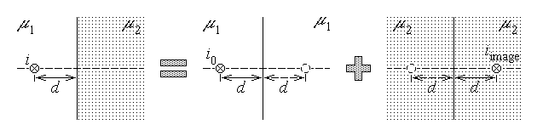
Fig. 12.48.
When the coil is placed so that it goes beyond the edge of the analised object, an approximate value of the tangential magnetic field is computed as in the first example approached above, in subsection 12.3.6. (equivalent permeability transducers), to obtain
$H≃\frac{}{l−x \left(1−\frac{1}{μ_{r}}\right)}$ ,
where x is the length of the object inside the coil.
3. The internal source of a magnetic field can be the electric current, carried by the conductive object to be evaluated, and injected through contact electrodes which are pressed upon it. Nearly homogeneous fields are obtained in sufficiently small domains in the case of homogeneous cylinders of circular or flat rectangular cross section carrying axial currents (fig. 12.49).
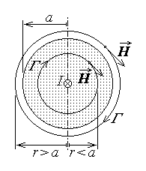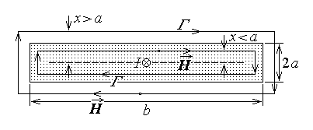
Fig. 12.49.
The magnetic field generated by a sufficiently long homogeneous cylindrical object, of radius a , carrying an axial current I , has circular field lines in transverse planes, centered on the axis, the directions of the field and current being associated according with the right–hand rule. Ampère's magnetic circuital law invoked for a field line Γ of radius r gives for the magnetic field strength inside the coil
$\oint{\vec{H}⋅d\vec{r}}=i_{S_{Γ}} ⇔ 2 π r H=\frac{I}{π a^{2}}π r^{2} ⇒ H=\frac{I r}{2 π a^{2}} , r≤a$ ,
$\oint{\vec{H}⋅d\vec{r}}=i_{S_{Γ}} ⇔ 2 π r H=I ⇒ H=\frac{I}{2 π r} , r≥a$ .
The field lines of the magnetic field generated by a sufficiently long conducting object, of rectangular cross section of dimensions 2a , b ($a≪b$) , carrying an axial current I , can be approximated as rectangular contours in transverse planes, symmetric with respect to the symetry plane parallel to the largest dimensions of the flat object, as in the fourth example approached above, in subsection 12.3.6. (equivalent permeability transducers). Supposing a constant field strength along the field line, and noticing that the directions of the field and the current are associated according with the right–hand rule, Ampère's magnetic circuital law invoked for a field line Γ with the long edges at a distance x from the plane of symmetry gives for the magnetic field strength inside the coil
$\oint{\vec{H}⋅d\vec{r}}=i_{S_{Γ}} ⇔ 2(2x+b−2a+2x)H=\frac{I}{2\text{ab}}2x(b−2a+2x) ⇒$
$⇒ H=\frac{I x \left(b−2a+2x\right)}{2ab \left(b−2a+4x\right)}≃\frac{I x }{2ab} , x≤a$ ,
$\oint{\vec{H}⋅d\vec{r}}=i_{S_{Γ}} ⇔ 2(2x+b−2a+2x)H=I ⇒$
$⇒ H=\frac{I }{\left(b−2a+4x\right)} , x≥a$ ,
The presence of a defect in such a current carrying object enhances the possibilities of detection by the very fact that the associated inhomogeneity of the current engenders even greater an inhomogeneity of the generated magnetic field, as it is dicussed later.
12.4.2. The perturbed field
The electromagnetic field applied to the analised object is perturbed by the presence of a defect. The defects can differ in their shape, dimensions and placement.
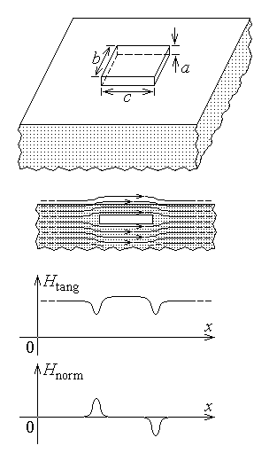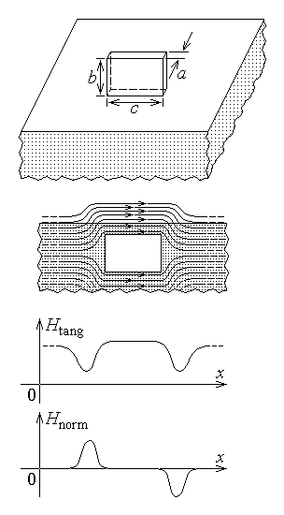
Fig. 12.50. Fig. 12.51.
Defects of a regular shape are quite rare, which makes it difficult to ascertain easily the field perturbation they determine. A preliminary analysis of the perturbations induced in the electromagnetic field by the presence of typical defects (spherical, ellipsoidal, cylindrical, conical, rectangular) is nevertheless quite useful in that it gives an insight into what is to be expected in the presence of actual defects. Associated with such a study, a simplifying assumption would be to consider that the total perturbation determined by a defect can be assembled as the sum of individual perturbations induced separately by different approximately regularly shaped parts of the actual defect. Now, even the computation of the magnetic field generated by given field sources in given non–symmetrical environments is not an easy matter, due to the complexity of the actual structure of the field domain and, quite often, to the presence of nonlinear substances.
An extremely simplified analysis is presented, concerning the way a defect influences the near–homogeneous magnetic field that would be present in the analised object when there is no defect.
1. Let a defect shaped as a rectangular box of dimensions a×b×c (a < b < c) be considered in a ferromagnetic object which is placed into a nearly homogeneous tangentially–directed external magnetic field. The main assumptions to be considered are: (1) the dispersion magnetic field in the defect is negligible; (2) the whole pattern of the magnetic field lines is repelled by the defect with no or insignificant additional alteration. These result simply in a corresponding alteration of the magnetic field near the surface of the object, which can be detected by an adequate equipment.
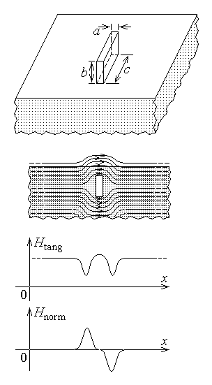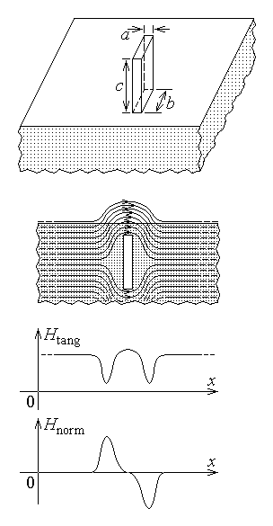
Fig. 12.52. Fig. 12.53.
Let, for the sake of simplicity, a plane object–air interface be considered. Different positions of the defect with respect to the magnetic field lines and/or object–air interface induce significantly different alterations of the magnetic field, as it is illustrated in figs. 12.50 – 53. In fig. 12.50 and 12.51 a so called longitudinal defect present in a tangential magnetic field is illustrated: the smallest cross section area a×b of the defect is presented to the field lines that go along the c edge. The perturbation of the magnetic field lines and the simplified dependence on the coordinate x (along the applied field direction) of the normal and tangential components of the perturbed magnetic field are presented. In the first case, when the largest b×c defect face is parallel to the interface, the perturbation is smaller, but is extended on a larger area at the interface; in the second case, when the medium a×b defect face is parallel to the interface, the perturbation is larger, and extended over a narrower area at the interface. A similar analysis can be done with reference to the case of a so called transversal defect present in a tangential magnetic field, when the largest cross section area b×c of the defect is presented to the field lines which go along the a edge (figs. 12.52 and 12.53). The perturbation is now concentrated in a smaller area at the interface, but it is significantly larger.
The illustrations commented on above must be taken with caution: in fact, the deformed magnetic field lines do not remain equidistant as drawn, and the field deformation atenuates as the distance to the defect increases – that is why sufficiently deep defects may remain undetected.
2. Let now the perturbation determined by a similar defect in a normally–directed external magnetic field be analysed. A time–varying excitation magnetic field, determined by a time–varying current carried by an adequate coil (with or without a magnetic circuit) is considered here. Let first the field configuration determined in the vicinity of the supposedly plane object–air interface be analised, where there is no defect present (fig. 12.54). Assuming that a uniform magnetic flux density of a symmetric distribution around a normal axis is applied to the interface and into the conducting object, the time–varying flux across any surface parallel to the interface induces an e.m.f. along the surface contour, according to Faraday's law. The symmetry imposes that the lines of the induced electric field be approximately circular and its strength be constant along each such field line. The direction of the electric field is associated here to the direction of the applied magnetic field contrary to the right–hand rule; then Faraday's law successively gives for a circular electric field line Γ of radius r
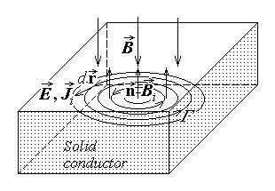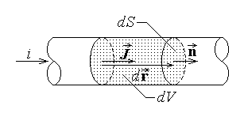
Fig. 12.54. Fig. 12.55.
$e_{Γ}=− \frac{d}{dt}Φ_{S_{Γ}} ⇔ \oint{\vec{E}⋅d\vec{r}}=− \frac{d}{dt}\int{\vec{B}⋅\vec{n} \text{dS}} ⇔ \oint{E⋅\text{dr}}=\int{\frac{∂B}{∂t} \text{dS}}$ ,
$E⋅2π r=\frac{∂B}{∂t} π r^{2} ⇒ E=\frac{∂B}{∂t} \frac{r}{2}$ .
The induced electric field determines a corresponding induced current in the conducting object, of density
$J_{i}=σ E=σ \frac{r}{2} \frac{∂B}{∂t}$ ,
in the same direction as the electric field.
The induced currents – commonly named eddy currents – determine in turn a so called reaction magnetic field that can be approximately computed by invoking a slightly modified Biot–Savart–Laplace's formula. The region with a given current density can be taken as a bundle of adjacent filamentary elementary conductors, each of cross section dS and carying an elementary current i in the direction $d\vec{r}$ of the current density $\vec{J}$ , which is the same as that of the normal $\vec{n}$ to the transverse surface dS (fig. 12.55). The integration element in the discussed formula becomes
$i d\vec{r}=\vec{J}⋅\vec{n} \text{dS} d\vec{r}=J \text{dS} d\vec{r}=\vec{J} \text{dS} \text{dr}=\vec{J} \text{dV}$ ,
where dV is the elementary volume of the current carrying conductor. It follows that the magnetic flux density generated by the induced current density distribution ${\vec{J}}_{i}$ is
$B_{i}=μ {\vec{H}}_{i}=\frac{μ}{4π}\int{\frac{{\vec{J}}_{i} \text{dV}×\vec{R}}{R^{3}}}$ ,
where the integration domain is just the part of the solid conductor (without defect) where there is an induced current ditribution. It is easily seen that the direction of the reaction magnetic field, associated with the current direction according to the right–hand rule, is opposite to the inductor magnetic field. The resultant, total magnetic field is thus the difference between that generated by the inductor field source and the one arised by electromagnetic induction in the analised object.
It is now obvious that when a defect is present (supposedly shaped as a disc coaxial with the inductor magnetic field distribution for the sake of simplicity, as in fig. 12.56), a similar analysis can be done, with the difference that the integration domain for the computation of the reaction magnetic field is significantly smaller – it is a hollow conductor – and so is the reaction magnetic flux density,
$B_{d}=μ {\vec{H}}_{i}=\frac{μ}{4π}\int{\frac{{\vec{J}}_{i} \text{dV}×\vec{R}}{R^{3}}}$ .

It would seem that the total magnetic field – the inductor minus the reaction magnetic field – is greater when a defect is present in the analised object under the inductor coil than when the analised object is faultless. However, a more carefull analysis shows that quite the opposite might be true if attention is paid to the fact that in actual cases it is a harmonic time–varying field appled for investigation.
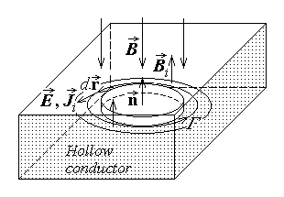
Fig. 12.56.

Let a harmonic time–variation be supposed for the inductor currents carried by the excitation coil, with the consequence that, in supposedly linear substances, all other quantities under analysis are also harmonic time–varying functions of the same frequency. Let also $\vec{u}$ be the local unit vector in the direction of the induced current – that is, in the simplified structure under study, tangential to the circular induced current lines. Each vector quantity under analysis has a definite direction and the harmonic time–varying modulus can be represented by its complex representative: it means that one can operate with complex vector such as
$\vec{B}=−\vec{n} B\left(t\right) =−\vec{n} B_{0} \text{sin}ωt ⇔ \underline{\vec{B}}=−\vec{n} \underline{B}=−\vec{n} B_{0} e^{ j 0}=−\vec{n} B_{0}$ .
Taking into account the rule for constructing the complex representation of the time–derivative of a harmonic time–varying function, the complex representative of the induced electric field strength is
$\vec{E}=\vec{u} E\left(t\right)=\vec{u} \frac{r}{2}\frac{∂B\left(t\right)}{∂t} ⇔ \underline{\vec{E}}=\vec{u} \frac{r}{2} j ω \underline{B}=\vec{u} \frac{r}{2} j ω B_{0}$
where the direction of the field was also accounted for. It immediately follows for the induced current density
${\vec{J}}_{i}=σ \vec{E} ⇔ {\underline{\vec{J}}}_{i}=σ \underline{\vec{E}}=\vec{u} \frac{r}{2} j ω σ B_{0}$ ,
and the complex representative of the reaction magnetic flux density is
$B_{i}=\frac{μ}{4π}\int{\frac{{\vec{J}}_{i} \text{dV}×\vec{R}}{R^{3}}} ⇔$
$⇔ {\underline{\vec{B}}}_{i}=\frac{μ}{4π}\int{\frac{{\underline{\vec{J}}}_{i} \text{dV}×\vec{R}}{R^{3}}}=j ω σ B_{0} \int{\frac{\vec{u} r \text{dV}×\vec{R}}{2 R^{3}}}$
for the faultless object, and
$B_{d}=\frac{μ}{4π}\int{\frac{{\vec{J}}_{i} \text{dV}×\vec{R}}{R^{3}}} ⇔$
$⇔ {\underline{\vec{B}}}_{d}=\frac{μ}{4π}\int{\frac{{\underline{\vec{J}}}_{i} \text{dV}×\vec{R}}{R^{3}}}=j ω σ B_{0} \int{\frac{\vec{u} r \text{dV}×\vec{R}}{2 R^{3}}}$
in the presence of a defect. The presence of the multiplicative term $j=e^{ j π/2}$ in the above complex representatives means that the reaction magnetic flux density is delayed by a π/2 phase difference with respect to the excitation magnetic flux density.
Let, for the sake of simplicity, the total magnetic flux density be evaluated at a point on the axis of the excitation magnetic field distribution in the case of a faultless object and at the same point when a coaxial disc–shaped defect is present in the analised object. In these cases the reaction magnetic flux density is oriented along the field axis, opposite to the excitation magnetic flux density and it is easy to make a simple comparison. The above conclusion on the reaction magnetic field is still valid: since the integration domain in the expression of the reaction magnetic field in the presence of a defect is only a part of the integration domain in the expression of the reaction magnetic field in the faultless object, the corresponding reaction magnetic fields are in the same relation. Contrary to a first impression, the complex representative of the total magnetic flux density – the difference between the complex representatives of the excitation and the reaction magnetic flux densities – has a greater modulus than the complex representative of the excitation magnetic flux density in both cases. Indeed, the complex representatives under discussion are
${\underline{\vec{B}}}_{\text{tot} \text{solid}}=\underline{\vec{B}}−{\underline{\vec{B}}}_{i}=−\vec{n} B_{0}+\vec{n} j ω σ B_{0} \int{\frac{\vec{u} r \text{dV}×\vec{R}}{2 R^{3}}}=−\vec{n} B_{0} \left(1−j ω σ I_{\text{solid}}\right)$ ,
${\underline{\vec{B}}}_{\text{tot} \text{hollow}}=\underline{\vec{B}}−{\underline{\vec{B}}}_{d}=−\vec{n} B_{0}+\vec{n} j ω σ B_{0}\int{\frac{\vec{u} r \text{dV}×\vec{R}}{2 R^{3}}}=−\vec{n} B_{0} \left(1−j ω σ I_{\text{hollow}}\right)$ ,
where
$I_{\text{solid}}=\int{\frac{\vec{u} r \text{dV}×\vec{R}}{2 R^{3}}} > \int{\frac{\vec{u} r \text{dV}×\vec{R}}{2 R^{3}}}=I_{\text{hollow}}$ .
Consequently, the magnitude of the total magnetic flux density (on the axis of the field distribution) is greater in the absence of a defect than when there is a coaxial defect present,
$B_{\text{tot} \text{solid}}=B_{0}\sqrt{1+{\left({ωσI}_{\text{solid}}\right)}^{2}} > B_{0}\sqrt{1+{\left({ωσI}_{\text{hollow}}\right)}^{2}}=B_{\text{tot} \text{hollow}}$ ,
and the defect can thus be detected. The field evaluation is significantly more complex at off–axis points, but the above conclusion remains valid.
It must be stressed that a time–varying electromagnetic field cannot have a uniform distribution in a conducting object. As it will be discussed later, in subsection 13.3.3, the time–varying electromagnetic field is concentrated towards the surface of a conducting object and decays approximately exponentially with the distance x towards its interior – this is the skin effect. If, for instance, $H\left(0\right)$ is the value of the magnetic field strength at the surface of a conductor, then its value at some distance x from the surface inside the conductor is approximately
$H\left(x\right)=H\left(0\right) e^{ − x/δ}$ ,
where
$δ=\sqrt{\frac{2}{ωμσ}}$
is the so called penetration depth of the electromagnetic field. Consequently, the nondestructive evaluation using time–varying electromagnetic fields and associated eddy currents can be applied mainly to the detection of shallow deffects, placed sufficiently near the surface of the analised object.
3. In the case of an internally generated magnetic field it is the presence of the discontinuity imposed to the current lines by the defect that has the most marked effect on the magnetic field. An approximate estimation of the perturbed magnetic field in these circumstances can be done by following a simplified procedure: (1) The absence of the current in the non–conducting defect is modelled by extending the field lines of the supposedly uniform current density $\vec{J}$ into the defect, along with a superposed opposite current density distribution ${\vec{J}}_{d}=−\vec{J}$ , restricted to the defect region only, as in fig. 12.57). (2) The magnetic field is taken as composed from the field associated with the current distribution $\vec{J}$ in the entire faultless conductor and that corresponding to the
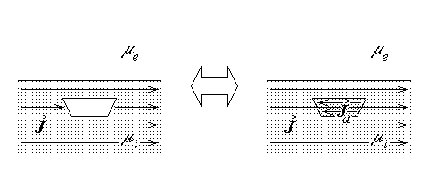
Fig. 12.57.
opposite current distribution ${\vec{J}}_{d}$ concentrated in the defect region. (3) The perturbation magnetic field generated by the equivalent current distribution ${\vec{J}}_{d}$ of the defect is computed by using the image method, as discussed previously (fig. 12.58): the magnetic field is computed as generated by two image current distributions – that placed at the
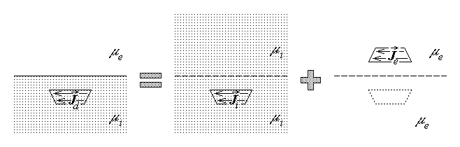
Fig. 12.58.
defect in an infinitely extended medium having the permeability μ_{i} of the inner medium, and carrying a current density
${\vec{J}}_{i}=\frac{2μ_{i}}{μ_{i}+μ_{e}}{\vec{J}}_{d}=− \frac{2μ_{i}}{μ_{i}+μ_{e}}\vec{J}$ ,
and that placed at the image of the defect with respect to the supposedly plane object–air
interface, in an infinitely extended medium having the permeability μ_{e} of the outer medium (air, for convenience), and having a current density
${\vec{J}}_{e}=− \frac{μ_{i}−μ_{e}}{μ_{i}+μ_{e}}{\vec{J}}_{d}= \frac{μ_{i}−μ_{e}}{μ_{i}+μ_{e}}\vec{J}$ .
In particular, in the case of a ferromagnetic object, when $μ_{i}=μ_{0}μ_{r}≫μ_{0}$ , μ_{e} = μ₀ ,
${{\vec{J}}_{i}=− \frac{2μ_{r}}{μ_{r}+1}\vec{J}≃−2 \vec{J} ,\text{ \{}\vec{J}}_{e}= \frac{μ_{r}−1}{μ_{r}+1}\vec{J}≃\vec{J}$ .
As well, in the case of a non–ferromagnetic object, when μ_{i} = μ_{e} = μ₀ ,
${{\vec{J}}_{i}=− \vec{J} ,\text{ \{}\vec{J}}_{e}= 0$ ,
meaning that, as it is quite normal, no image current distribution is necessary.
The above procedure can be directly applied when the defect is longitudinal with respect to the direction of the current (meaning that the smallest cross section is offered to the current, as in fig. 12.59). The supplementary perturbation magnetic field associated with the defect is illustrated for the cases of a ferromagnetic and non–ferromagnetic object to be analised. However, when the defect offers its largest cross section S_{d} transversally to the direction of the current, the cross section of the total current is diminished from its total initial value S , so that a smaller current density,
$\vec{J}'≃\frac{S−S_{d}}{S}\vec{J}=\left(1−\frac{S_{d}}{S}\right) \vec{J}$ ,
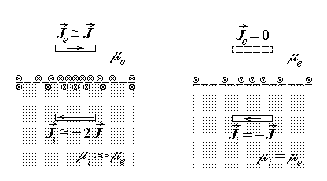
Fig. 12.59.
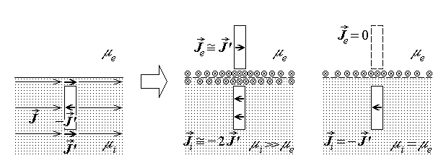
Fig. 12.60.
is to be considered at the level of the defect instead of the original current density $\vec{J}$ ,
and used in the preceding formulae. The approximate distribution of the perturbation magnetic field associated with the defect is illustrated in fig. 12.60.
The magnetic field generated by the supplementary, defect–related, current density ${\vec{J}}_{d}$ can then be computed by applying the modified Biot–Savart–Laplace's formula discussed above,
${\vec{H}}_{d}=\frac{1}{4π}\int{\frac{{\vec{J}}_{d} \text{dV}×\vec{R}}{R^{3}}}$ .
12.4.3. Detection of defects
The presence of a defect is detected by analising the perturbed magnetic field associated to it. The magnetic field can be estimated in different ways – for instance, in a direct manner, by using either a Hall probe or an induction coil, or indirectly, by using magnetisable particles.
1. A Hall probe is a device able to measure the magnetic field strength or, equivalently, the magnetic flux density, by using the Hall effect.
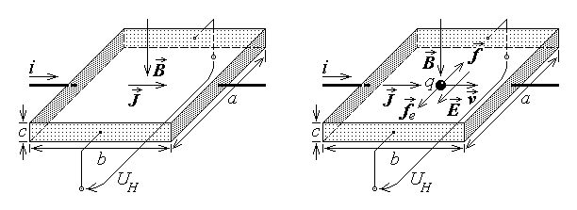
Fig. 12.61.
Let a conducting flat plate be considered, of dimensions a×b×c ($c≪a,b$) , carrying a current of intensity i along the direction of the b edges, placed in a supposedly homogeneous magnetic field of magnetic flux density $\vec{B}$ normal to the a×b faces (fig. 12.61 left). Assuming a homogeneous current distribution in any cross section of the plate, it is carrying a current density of magnitude $J=i/S=i/\text{ac}$ . As discussed previously (section 3.5, volume 1), the electric conduction current can be treated as a convection current associated with the movement of electrically charged microscopic particles with respect to the conductor, $\vec{J}≈{\vec{J}}_{C}=ρ_{V \text{micro}} \vec{v}$ . Let each microscopic particle carry a charge q , and let $n=ΔN/ΔV$ be the particle concentration; then the volume charge density of the free microscopic particles is $ρ_{V \text{micro}}=ΔQ/ΔV=$ $=q ΔN/ΔV=q n$ . Consequently, the current density in the plate can be expressed as $\vec{J}=q n \vec{v}$ . Lorentz's force $\vec{f}=q \vec{v}×\vec{B}$ acts on each particle, deflecting its movement from the direction of the b edges, so that the particle concentration is significantly enhaced at the b×c face pointed at by Lorentz's force and the particle concentration is significantly diminished at the opposite face (fig. 12.61 right). Let, for instance, the free charged particles be positive; their excess, respectively depletion, represent a positive, respectively a negative, charge at the corresponding b×c face – these faces act as the plates of a capacitor. Supposing that a homogeneous electric field of electric field strength $\vec{E}$ is determined in this transverse capacitor structure, it opposes an electric force ${\vec{f}}_{e}=q \vec{E}$ to Lorentz's force $\vec{f}$ . A steady particle flow, that is a steady current, is flowing along the plate when the two forces balance each other,
$q \vec{E}+q \vec{v}×\vec{B}=0 ⇔ q \left(E−\text{vB}\text{sin}\frac{π}{2}\right)=0 ⇔ E=v B$ .
A voltage transversal to both current and magnetic field directions can thus be sensed between opposite electrodes placed on the b×c faces,
$U_{H}=\int{\vec{E}⋅d\vec{r}}=E a=v B a=\frac{J}{q n}B a=\frac{1}{q n}\frac{i}{a c}B a=\frac{1}{q n} \frac{B i}{c}$ ,
which is proportional to the product between the current injected into the probe and the magnetic flux density applied to it, and inversely proportional to the probe thickness.
In order that the measurement of a magnetic field that is not quite homogeneous to be possible, it is important that the a×b area of the probe be small with respect to the extension over which there exists perceptible field variations. Otherwise, the Hall probe can evaluate an average magnetic flux density only.
A Hall probe like the conducting plate in the configuration analised above can be used to measure the magnetic field normal to its a×b faces, any component of the magnetic field parallel to the a×b faces being unable to contribute to the electric voltage between the electrodes placed on the b×c faces. Indeed, let the magnetic flux density have a tangential component, along the current direction (fig. 12.62 left). Lorentz's force is then $\vec{f}=q \vec{v}×\vec{B}=q \vec{v}×\left({\vec{B}}_{n}+{\vec{B}}_{t}\right)=q \vec{v}×{\vec{B}}_{n}$ , since $\vec{v}×{\vec{B}}_{t}≡0$ as the cross product of two parallel vectors. If now the magnetic flux density has a tangential component in the direction of the a edges (i.e., normal to the current direction, as in fig. 12.62 right), then Lorentz's force is given by $\vec{f}=q \vec{v}×\vec{B}=q \vec{v}×\left({\vec{B}}_{n}+{\vec{B}}_{t}\right)=q \vec{v}×{\vec{B}}_{n}−q v B_{t} \left({\vec{B}}_{n}/B_{n}\right)$ , where the second component opposite to the normal magnetic field has no influence on the particle deflection in the direction along which the electric voltage U_{H} is determined.
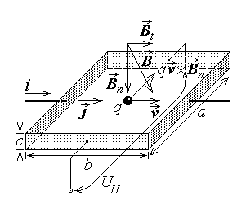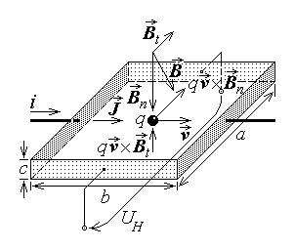
Fig. 12.62.
The placement of the Hall probe is thus extremely important for the quantity to be measured: a Hall probe placed with its a×b faces parallel to the object–air interface measures the normal component of the magnetic flux density, while such a probe placed with its a×b faces perpendicular to the object–air interface measures a tangential component of the magnetic flux density.
2. An induction coil is simply a coil displaced in the vicinity of the object–air interface, parallel to it; the time–varying magnetic flux eventually associated with the presence of a defect induces a voltage in the coil. Its operation is obviously based on Faraday's law,
$e_{Γ}=− \frac{d}{dt}Φ_{S_{Γ}}=−\frac{d}{dt}\int{\vec{B}⋅\vec{n} \text{dS}}=−\int{\frac{∂\vec{B}}{∂t}⋅\vec{n} \text{dS}}+\oint{\left(\vec{v}×\vec{B}\right)⋅d\vec{r}}$ .
The extended form of the law indicates that two components are to be considered for the signal induced in the coil: one directly linked with the time variation of the magnetic field, and other linked with the coil displacement with respect to the external magnetic field. The first term is obviously present only when the excitation magnetic field is time–varying; in which case the second term is merely a perturbation term linked with the displacement of the sensor coil with a view to explore the analised object (fig. 12.63). The second term is however the only term present when the excitation field is time–invariant, in which case it is obvious that the time–invariance of the speed $\vec{v}$ of the sensor displacement is essential in avoiding undesired alterations of the desired signal (fig. 12.64).
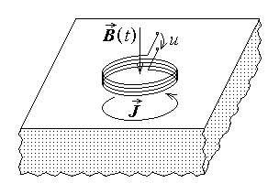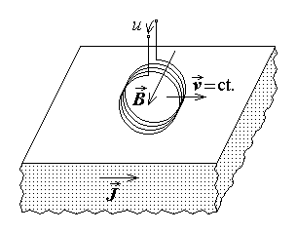
Fig. 12.63. Fig. 12.64.
There are some remarks relative to the use of induction coils for the detection of a defect. The signal sensed by an induction coil is related with the magnetic flux over a surface and/or with an integral involving the magnetic flux density along a contour – in any case these are not directly related with the magnetic field at a precise location, but with some type of average estimation of the magnetic field. That is why it is important that the dimensions of the sensing coil be as minute as possible. It is also important that the current determined in the sensor coil be very small, so that the magnetic field generated by it remains negligible with respect to the analised magnetic field. As well, in order to obtain an important signal, it is necessary that the integration domains of both integrals in the above formula be as large as possible – this is done by using coils with a large number N of turns, in wich case $S_{Γ}≃N S_{\text{turn}}$ and $Γ≃N Γ_{\text{turn}}$ . Such considerations indicate that the realisation of sensor coils is a mater of delicate and precise manufacturing.
3. The use of magnetisable particles in nondestructive evaluations is based on the magnetic force acting on a very small magnetised object placed in an inhomogeneous magnetic field.
A very small magnetised object, of magnetic moment $\vec{m}$ , placed in an external magnetic field of magnetic flux density $\vec{B}$ , is subjected to a magnetic force,
$\vec{F}=\text{grad} \left(\vec{m}⋅\underset{↑}{\vec{B}}\right)=\vec{i}\frac{∂}{∂x}\left(\vec{m}⋅\underset{↑}{\vec{B}}\right)+\vec{j}\frac{∂}{∂y}\left(\vec{m}⋅\underset{↑}{\vec{B}}\right)+\vec{k}\frac{∂}{∂z}\left(\vec{m}⋅\underset{↑}{\vec{B}}\right)$ ,
and a magnetic torque,
$\vec{T}=\vec{m}×\vec{B}$ .
These conjugate actions determine the rotation of the magnetised particles until their magnetic moment is aligned with the external magnetic field, and the translation of the magnetised particles towards the regions of a more intense magnetic field strength.
Let it be assumed, for the sake of simplicity, that the magnetised object is placed in a magnetic field of a given direction along which its modulus is varying, and let the

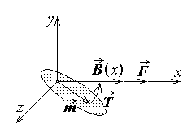
Fig. 12.65.
unit vector $\vec{i}$ of the x axis be parallel to and oriented in the direction of increasing magnetic field (fig. 12.65). The magnetic torque given by the above formula is normal to the plane of the vector terms, in the direction indicated by the right–hand rule. This corresponds to imposing on the object a rotation in the direction associated with the torque according to the right–hand rule, meaning just the alignment of the two vector vector terms, $\vec{m} \left|\right| \vec{B}$ .

Since no variation of the field is sensed in the y–z planes, the magnetic force acting on the magnetised object becomes
$\vec{F}=\vec{i}\frac{∂}{∂x}\left(\vec{m}⋅\underset{↑}{\vec{B}}\right)+\vec{j}\frac{∂}{∂y}\left(\vec{m}⋅\underset{↑}{\vec{B}}\right)+\vec{k}\frac{∂}{∂z}\left(\vec{m}⋅\underset{↑}{\vec{B}}\right)=\vec{i}\frac{∂}{∂x}\left(\vec{m}⋅\underset{↑}{\vec{B}}\right)=\vec{i}\frac{∂}{∂x}\left(m B\right)$ ,
where the parallelism of the two vectors was accounted for, and the differentiation is acting on the dependence on position of the magnetic flux density. In the case of a spontaneously magnetised particle, its magnetic moment is independent on the magnetic field and the magnetic force is
$\vec{F}=\vec{i}\frac{∂}{∂x}\left(m B\right)=\vec{i} m\frac{∂B}{∂x}$ ,
that is in the direction of increasing magnetic fields. In the usual case of a temporarily magnetised particle, of volume V and magnetic susceptibility χ , under hypothesis of linearity its magnetic moment is proportional to the external magnetic field strength,
$\vec{m}≃\vec{M} V=χ \vec{H} V=χ \frac{\vec{B}}{μ_{0}} V$ .
The magnetic force is
$\vec{F}=\vec{i}\frac{∂}{∂x}\left(\vec{m}⋅\vec{B}\right)=\vec{i} \frac{∂}{∂x}\left(χ \frac{\vec{B}}{μ_{0}} V⋅\vec{B}\right)=\vec{i} \frac{χ}{μ_{0}}V \frac{∂B^{2}}{∂x}=\vec{i} \frac{χ}{μ_{0}}V⋅2B \frac{∂B}{∂x}=2 \vec{i} m\frac{∂B}{∂x}$ ,
that is again in the direction of increasing magnetic fields.
It follows that magnetisable particles scattered at the surface of the analised object placed in a magnetic field are crowded in, and thus indicate, the regions of a more intense magnetic field. The pattern of magnetisable particles thus reproduces the pattern of the magnetic field strength which, in turn, is related to the perturbations induced by a defect in the magnetic field at the object–air interface.
4. The methods of measurement of the magnetic field presented above are used in different ingenious ways with a view to detect the presence of a defect and as many of its characteristics as possible. It means that an additional processing and interpretation of the measured data, by using appropriate procedures and devices, is needed.
A very important precaution is to be taken before any processing and interpretation of measured data are performed: the reproducibility of the measurement conditions is mandatory. This means that the magnitude of the excitation current (the source of the excitation magnetic field) and the placement of the eventual excitation coils with respect to the surface of the analised object have to be maintained constant during the investigation. The same is obvioulsy valid for the placement of the sensor coils with respect to the object–air interface. Moreover, especially in the case when induction coils are used as sensors in a time–invariant magnetic field configuration, so that the useful signal is related to the e.m.f. induced by movement, it is essential that the displacement speed of the sensor coils be maintained constant.
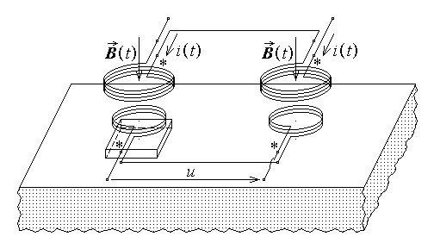
Fig. 12.66.
It is to be expected that the perturbation determined by a defect on the excitation magnetic field be quite small, so much so as the defect is smaller and farther from the excitation source and the detection device. A procedure that could handle this problem is the so called differential measurement: If the same excitation is applied in a supposedly faultless region of the analised object and in the presence of a defect, and the signals obtained in the two configurations are subtracted, then it is practically the perturbation magnetic field only, and not the total – excitation plus perturbation – field, that is analised. This corresponds to an additional series connection of the excitation coils and a differential series connection of the sensor coils (fig. 12.66), in the case of an external excitation source. The measurement arrangement is obviously reduced to the differential series connection of the sensor coils in the case of an internal source of the excitation magnetic field. The only problem left is the placement of the reference coils – those related to the absence of a defect – with respect to the active coils – those related to its presence. The reference coils can be placed to analise an object known as faultless, and the active coils only can be used to explore the analised object. A simpler solution can be considered if a reasonable assumption is admitted, namely that the defects are quite distant from one another: then a distance between the reference and the active coils larger than the largest possible defect would be a solution.
The preceding discussion of defect detection by the measurement of the perturbed magnetic field near the analised object implicitly supposes that it is the magnitude of the magnetic field which is taken into consideration. An interesting alternative can be considered in the case of the so called eddy–current testing, when the investigation is done in a harmonic time–varying electromagnetic field imposed by excitation coils carrying a harmonic time–varying current. The discussion of the simplest configuration of an investigation using a harmonic time–varying electromagnetic field (subsection 12.4.2) gave the following expressions for the total magnetic flux density near a faultless object and on the axis of a symmetric defect, respectively,
${\underline{\vec{B}}}_{\text{tot} \text{solid}}=−\vec{n} B_{0} \left(1−j ω σ I_{\text{solid}}\right) , {\underline{\vec{B}}}_{\text{tot} \text{hollow}}=−\vec{n} B_{0} \left(1−j ω σ I_{\text{hollow}}\right)$ ,
If the excitation current and, correspondingly, the (inductor) magnetic field density is taken as the phase origin,
$\underline{\vec{B}}=−\vec{n} \underline{B}=−\vec{n} B_{0} e^{ j 0}=−\vec{n} B_{0}$ ,
then the phase of the total magnetic flux density near a faultless object and on the axis of a symmetric defect are, respectively,
$ϕ_{B \text{solid}}=−\text{arctan} \left(ω σ I_{\text{solid}}\right) , ϕ_{B \text{hollow}}=−\text{arctan} \left(ω σ I_{\text{hollow}}\right)$ ,
so that
$0>ϕ_{B \text{hollow}}>ϕ_{B \text{solid}}$ .
An average value of the total magnetic flux density can be measured by using an induction coil of N turns of normal unit vector ${\vec{n}}_{S}$ ; if the movement associated term is neglected, then the induced e.m.f. is
$e=−\frac{d}{dt}Φ_{\text{sensor} \text{coil}}≃−N\frac{d}{dt}Φ_{\text{sensor} \text{coil} \text{turn}}=−N\frac{d}{dt}\int{{\vec{B}}_{\text{tot}}⋅{\vec{n}}_{S} \text{dS}}$ .
The complex representative of the sensor e.m.f. in the two cases is correspondingly
${\underline{E}}_{{\text{solid}}/{\text{hollow}}}=−N j ω {\underline{Φ}}_{\text{sensor} \text{coil} \text{turn}}=−N j ω \int{{\underline{\vec{B}}}_{\text{tot} {\text{solid}}/{\text{hollow}}}⋅{\vec{n}}_{S} \text{dS}}$ .
Let it be assumed, for the sake of simplicity, that the complex representative of the magnetic flux density has the same phase over the turn surface, so that
${\underline{B}}_{\text{tot} {\text{solid}}/{\text{hollow}}}≃\vec{b} B \left(1−j ω σ I_{{\text{solid}}/{\text{hollow}}}\right)$ ,
where $\vec{b}$ is the unit vector of of the magnetic flux density. It follows that
$\int{{\underline{\vec{B}}}_{\text{tot} {\text{solid}}/{\text{hollow}}}⋅{\vec{n}}_{S} \text{dS}}≃\left(1−j ω σ I_{{\text{solid}}/{\text{hollow}}}\right) \int{\vec{b} B⋅{\vec{n}}_{S} \text{dS}}$ ,
and, by denoting $I=\int{\vec{b} B⋅{\vec{n}}_{S} \text{dS}}$ ,
${\underline{E}}_{{\text{solid}}/{\text{hollow}}}≃−N j ω \left(1−j ω σ I_{{\text{solid}}/{\text{hollow}}}\right) I=$
$=N I ω \sqrt{1+{\left(ωσ I_{{\text{solid}}/{\text{hollow}}}\right)}^{2}} e^{ − j \left(π/2 +ϕ_{{\text{solid}}/{\text{hollow}}}\right)}$ .
There are thus differences not only between the sensor signal magnitudes, but also between the sensor signal phases, corresponding to the absence and to the presence of a defect, respectively. Correspondingly, there were developed special purpose equipments designed to evaluate the phase difference between the sensor detected e.m.f.'s and the excitation (inductor) current,
$ψ_{\text{solid}}=−\left(\frac{π}{2}+\text{arctan}ωσ I_{\text{solid}}\right) , ψ_{\text{hollow}}=−\left(\frac{π}{2}+\text{arctan}ωσ I_{\text{hollow}}\right)$ ,
or, by using directly a differential arrangement as previously discussed, the phase difference between signals corresponding to a faultless object and the presence of a defect,
$ψ_{\text{hollow}−\text{to}−\text{solid}}=\text{arctan}ωσ I_{\text{solid}}−\text{arctan}ωσ I_{\text{hollow}}$ .
The detection of signals related to the presence of a defect have also to be processed with a view to obtain as much characteristics of the defect as possible: shape, dimensions, depth. This is a very difficult problem, and the discussion of the procedures used to analyse and interpret the immediate data is beyond the scope of the present work. Two main directions can be distinguished: deterministic and non–deterministic methods. The usual approach of a deterministic method is to imagine appropriate defects and check for that one which gives the best approximation of the actual perturbation of the measured electromagnetic field. The non–deterministic methods use so called neural networks, which are electric circuits of a particular type that are believed to mimic the operation of a human brain, and can be taught to recognise the characteristics of defects starting from the measured data.

