11. ELECTRICAL MEASUREMENTS

- 11.1. Electrical measurements
1. The measurement of a physical quantity m consists in comparing it with another quantity of the same nature, u , taken as a unit, and determining their ratio,
$v=\frac{m}{u}$ ,
which constitutes the (numerical) value of the measured quantity. The (numerical) value of the measured quantity results then to be a dimensionless quantity, inversely proportional to the magnitude of the unit quantity used.
The result of a measurement is by no means exact: imperfections of the measuring instrument, inaccurate observations or other accidental events can distort the measured value v_{m} from the actual value v by an absolute measurement error
$Δv=v_{m}−v$ .
The fact is that the true actual value is not known. Instead, a reference value v₀ can be accepted, as, for instance, a value measured by using more accurate measurement instruments or procedures; the absolute error is then approximated as
$Δv≃v_{m}−v_{0}$ .
Correspondingly, the relative measurement error is
$δv≃\frac{Δv}{v_{0}}=\frac{v_{m}−v_{0}}{v_{0}}$ ,
and is often expressed as a percentage.
In most situations, after eliminating the systematic errors, the accidental errors are subjected to a normal (Gauss) distribution law. In this case, starting with a sequence of measured values ${\left\{v_{i}\right\}}_{ i=\overline{1,n}}$ of the same quantity, the most probable value of it is the average value
$v_{\text{av}}=\frac{v_{1}+\text{.}\text{.}\text{.}+v_{n}}{n}=\frac{1}{n} \sum_{i=1}^{n}{v_{i}}$ ,
with a r.m.s. error
$σ=\sqrt{ \frac{\sum_{i=1}^{n}{{\left(v_{i}−v_{\text{av}}\right)}^{2}}}{n \left(n−1\right)}}$ .
The probable value of the measured quantity consequently lies within the interval
$v_{\text{prob}}=v_{\text{av}}±σ$ ,
and the measured values v_{k} for which
$\left|v_{k}−v_{\text{av}}\right|>3 σ$
have to be discarded.
In the case of a direct measurement (when a physical quantity is directly measured by the indication of a measuring instrument), the accuracy class c of the measuring instrument (indicated on its scale) specifies the maximum admissible indication error ${Δv}_{\text{adm}}$ the instrument may present, at any point on its scale, relative to its maximum measuring domain v_{M} (corresponding to full–scale),
$c=\frac{{Δv}_{\text{adm}}}{v_{M}}⋅\text{100} \left(\text{in} \text{percents}\right)$ .
The absolute measurement error is then bounded by
${Δv}_{\text{max}}=\frac{c}{\text{100}} v_{M}$ ,
and the maximum relative error
${δv}_{\text{max}}=\frac{{Δv}_{\text{max}}}{v_{m}}=\frac{c}{\text{100}} \frac{v_{M}}{v_{m}}$
is reduced when the instrument indication approaches the full–scale indication.
In the case of an indirect measurement (when the measured value is computed as
$v=f\left(v_{1},\text{.}\text{.}\text{.}, v_{n}\right)$
depending on other directely measured quantities v₁ , … , v_{n} ) the maximum absolute error is
$Δv=\left|\frac{∂f}{∂v_{1}}\right| {Δv}_{1}+\text{.}\text{.}\text{.}+\left|\frac{∂f}{∂v_{n}}\right| {Δv}_{n}$
and the corresponding maximum relative error can be obtained simply by using the so called logarithmic differential,
$δv=\frac{Δv}{v}=\left|\frac{∂\left(\text{ln}f\right)}{∂v_{1}}\right| {Δv}_{1}+\text{.}\text{.}\text{.}+\left|\frac{∂\left(\text{ln}f\right)}{∂v_{n}}\right| Δv$ .
There are two types of measuring instruments: analogous instruments, which offer in principle the result of the measurement operation as a real number, evaluated by the position of a pointer on a marked scale, and digital instruments, which offer the result of the measurement on a screen as a decimal number with a given number of digits (decimal positions).
2. The analogous instruments were the first to be developed. The operating principle of such a classical electrical measuring instrument is the fact that an electromagnetic force or torque exerted on the mobile part of the instrument is balanced by an elastic force or torque, proportional to the departure of the mobile part from an equilibrium position. The magnitude of the active electromagnetic torque (force) depends on the electromagnetic quantity to be measured; the magnitude of the restoring elastic torque (force) is proportional with the deformation of the elastic element used. The mechanical equilibrium of the opposite torques,
$T_{\text{act}}\left(v,α\right)=T_{\text{rest}}\left(α\right) ⇔ T_{\text{act}}\left(v,α\right)=k⋅α ⇔ f\left(α\right)=g\left(v\right)$ ,
results in a definite dependence of the instrument indication (usually an angle) α as a function of the quantity v to be measured. The value of the measured quantity can thus be read as the angle α corresponding to the position of the instrument pointer with respect to an adequately calibrated scale.
On the other hand, in order to reach quickly but smoothly its final position, the mobile part of the instrument is provided with some damping device which imposes a speed–proportional friction torque (force). Let t = 0 be the moment when the active electromagnetic torque, say, is applied to the mobile part, impressing a movement towards the indication α_{m} corresponding to the measured value. This indication is reached after some time, depending on the type of movement of the mobile part (fig. 11.1): (1) – damped nonperiodical, (2) – critical nonperiodical, (3) – damped periodical. The best mechanical adjustment is that which determines a slightly overcritical behaviour (4) of the mobile part – the final indication α_{m} is reached smoothly and quickly enough.
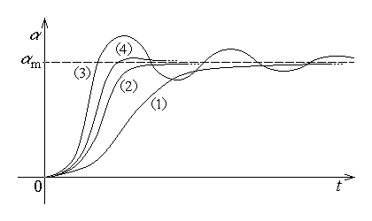
Fig. 11.1.
The above discussion is valid in the case when a constant quantity is measured. If, however, the measured quantity is time–varying, in such a way that the active electromagnetic troque, say, consists in a constant (average) component and a time–varying component,
$T_{\text{act}}\left(t\right)=T_{\text{act} \text{av}}+T_{\text{act} \text{var}}\left(t\right)$ ,
then the corresponding indication would admit a similar decomposition,
$α\left(t\right)=α_{\text{av}}+α_{\text{var}}\left(t\right)$ .
The actual indication of the measuring instrument is reached when the active torque is balanced by the elastic restoring torque
$T_{\text{rest}}=k α$ ,
provided by a spring of elastic constant k .
The average indication obviously is
$α_{\text{av}}=\frac{T_{\text{act} \text{av}}}{k}$ ,
and the time–varying indication depends on the rate of the time–variation of the time–
varying component of the active torque. If a harmonic time–variation of angular frequency ω is supposed, then the maximum value of the time–varying component of the indication is
$α_{\text{var} \text{max}}=\frac{T_{\text{act} \text{var} \text{max}}}{k} {\left(\frac{Ω}{ω}\right)}^{2}$ ,
where Ω is the proper angular frequency of the mobile part of the measuring instrument.
The modern measuring instruments offer a digitised indication: a number is displayed, along with the corresponding unit, to indicate the measured value.
The maximum absolute error of such a digital measuring instrument is generaly equal to the value corresponding to unity in the least significant position on the digital scale of the instrument.
The numerical indication usualy corresponds to the measured value at the moment when the conversion to a numerical (digital) value was achieved. This means that a digital measuring instrument provides samples of the measured quantity at a certain finite rate.
Let a simple example of a digital voltmeter be considered. The general block–diagram of the instrument is presented in fig. 11.2, where the main parts of the digital equipment are shown along with the signals of interest.
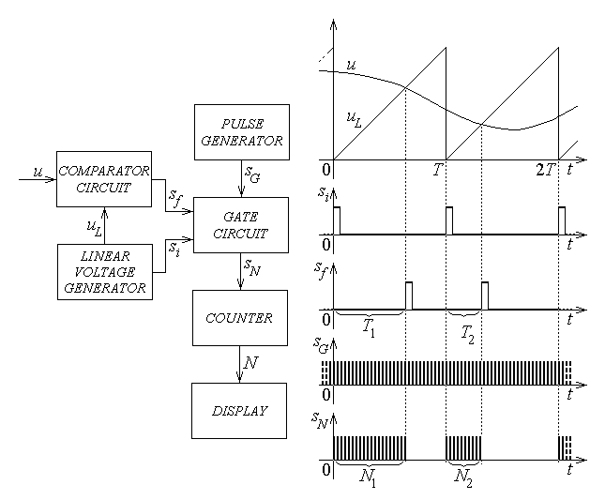
Fig. 11.2.
The operation of this digital voltmeter is based on the chain of successive conversions voltage → duration → number, as near as possible according to proportional correspondences. The voltage u to be measured is compared to a linearly increasing time–varying voltage u_{L} , periodicaly generated by the appropriate generator as
$u_{L}=U_{M}\frac{t}{T} , t∈\left[0,T\right]$
over each period of duration T . At the moment T₁ , when the linear voltage reaches the value of the measured voltage, one has
$u=U_{M}\frac{T_{1}}{T} ⇔ T_{1}=\frac{T}{U_{M}} u=k_{V→T}⋅u$ ,
corresponding to the voltage → duration (proportional) conversion. The moment T₁ is sensed by the comparator circuit, which sends the closing signal s_{F} to the gate circuit at this precise instant. The gate circuit allows the passage of a signal during the time interval between the moment of receiving an opening signal s_{I} from the generator of linearly increasing voltage at the initial moment t = 0 (of each measuring period), and the moment T₁ when the closing signal s_{F} arrives. The signal passing through the gate circuit is represented by a train s_{N} of periodic pulses of sufficiently high frequency, coming from a pulse generator and going to a pulse counter. This way, if T_{I} is the period of the generated pulses s_{G} , then their number during the time interval [ 0 , T₁ ] is
$N_{1}=\frac{T_{1}}{T_{I}}=\frac{1}{T_{I}} T_{1} ⇔ N_{1}=k_{T→N}⋅T_{1}$ ,
corresponding to the time → number (proportional) conversion. The number of pulses counted by the counter is displayed on an appropriate display as
$N_{k}=k_{T→N}⋅T_{k}=k_{T→N}⋅k_{V→T}⋅u\left(t_{k}\right) ⇔ N=K⋅u$ :
the indication provided by the instrument is proportional to, and can be expressed as, the voltage value at the measuring moment t_{k} . The measurement process is repeated during the following periods of the linearly increasing voltage, so that the displayed digital indications represent samples of the measured voltage at certain moments during these periods.
There are different types of digital instruments, but their common feature is that finaly an analog–to–digital conversion has to be performed so that a digital indication is available.

- 11.2. Electrical measuring instruments
An electrical measurement instrument is an instrument able to give an indication directly dependent on an electromagnetic quantity to be measured. The electromagnetic quantity directly measured is that which influences the active electromagnetic force or torque exerted on the mobile part of the instrument. The operating principle of the most common electrical measuring instruments is briefly presented in the following.
1. The moving–coil permanent–magnet instrument consists in a fixed magnetic circuit with a permanent magnet as magnetic field source and a rotating coil to which the mobile equipment of the instrument (pointer, damper, etc.) is attached, along with a spiral spring to provide the elastic restoring torque.
The active torque is imposed by Laplace forces acting on the current carying coil of N turns placed in the external magnetic field provided by the magnetic circuit. The magnetic circuit usualy presents two polar pieces of cylindrical contour, coaxial with a cylindrical highly permeable core (fig. 11.3), so that the magnetic flux density $\vec{B}$ is radially oriented and practicaly uniform inside the air gap. The active torque acting on the rotating coil of radius r and length l carying the current of intensity i is
$T_{\text{act}}=N⋅2 \text{rF}=N⋅2r⋅i l B=N⋅S⋅B⋅i=Φ_{\text{tot}}⋅i$ ,
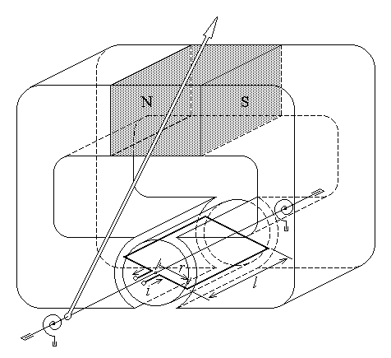
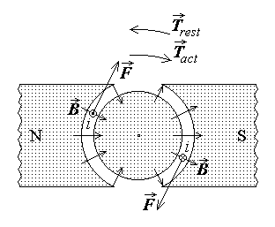
Fig. 11.3.
where S = 2rl is the turn area and Φ _{tot} is the total magnetic flux across the coil surface. This torque rotates the coil (and the mobile equipment) tending to align the magnetic field generated by the coil current with the N–S direction of the magnetic field generated in the magnetic circuit by the permanent magnet.
The restoring torque
$T_{\text{rest}}=k α$
is provided by spiral elastic spring(s) so that the indication α given by the pointer of the instrument corresponds to the mechanical equilibrium of the mobile system,
$T_{\text{act}}=T_{\text{rest}} ⇔ Φ_{\text{tot}}⋅i=k α ⇔ α=\frac{Φ_{\text{tot}}}{k} i ⇔$ $α=C⋅i$ ,
where C is the instrument constant (sensitivity).
This measuring instrument is thus essentialy a proportional ampermeter – it measures the intensity of the electric conduction current carried by the coil.
2. The moving–iron instrument consists in a fixed coil and a rotating iron armature to which the mobile equipment of the instrument (pointer, damper, etc.) is attached, along with a spiral spring (fig. 11.4).
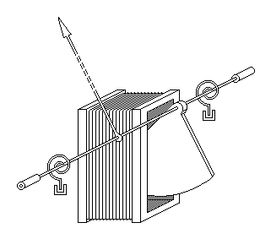
Fig. 11.4.
The active torque is imposed by the (electro-)magnetic force determined by the fact that the coil inductance depends on the position of the rotating iron armature, which plays the role of a variable ferromagnetic coil core. The coil inductance is given by a formula similar to that derived for a very long solenoid,
$L=\frac{μ_{\text{eff}}\left(α\right) N^{2}S}{l_{\text{eff}}}=L\left(α\right)$ ,
where μ _{eff} is the effective average permeability of the coil core, depending on the position of the rotating iron armature. According with the theorem of generalised magnetic forces, in such a system where the generalised coordinate characterising the relative positions of the mobile and fixed parts of the instrument is the indication angle α , the generalised force is just the active torque. It is therefore computed as
$T_{\text{act}}=\frac{∂W}{∂α}|_{ i=\text{const}\text{.}}=\frac{∂}{∂α}\frac{L\left(α\right) i^{2}}{2}|_{ i=\text{const}\text{.}}=\frac{i^{2}}{2} \frac{∂L}{∂α}=K\left(α\right)⋅i^{2}$ .
This active torque rotates the mobile armature (and the mobile equipment) by attracting it inside the current carrying coil, which acts like an electromagnet.
The restoring torque
$T_{\text{rest}}=k α$
is again provided by spiral elastic spring(s) so that the indication α given by the pointer of the instrument corresponds to the mechanical equilibrium of the mobile system,
$T_{\text{act}}=T_{\text{rest}} ⇔ K\left(α\right)⋅i^{2}=k α ⇔$ $f\left(α\right)=i^{2}$ .
In particular, if $K\left(α\right)≃K=\text{const}\text{.}$, then the mechanical equilibrium equation would give
$T_{\text{act}}=T_{\text{rest}} ⇔ K⋅i^{2}=k α ⇔ α=\frac{K}{k} i^{2} ⇔$ $α=C⋅i^{2}$ ,
where C is the instrument constant (sensitivity).
This measuring instrument is thus essentialy a quadratic ampermeter – it measures the square of the intensity of the electric conduction current carried by the coil. Actualy, by a special design of the shape of the iron armature, the multiplicative factor of the active torque $K\left(α\right)$ can be arranged to determine an almost linear $α\left(i\right)$ dependence, i.e. an almost linear indication over most of the instrument scale.
3. The electrodynamic instrument consists in a fixed outer coil and a rotating inner coil to which the mobile equipment of the instrument (pointer, damper, etc.) is attached, along with a spiral spring (fig. 11.5).
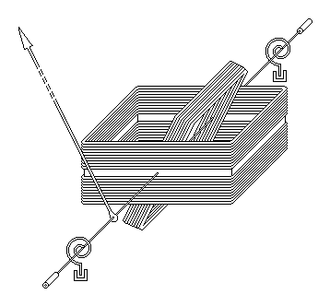
Fig. 11.5.
The active torque is imposed by the so called electrodynamic force, determined by the fact that the coupling (mutual) inductance between the two coils depends on the rotation angle of the mobile inner coil 2 (with N₂ turns of surface S₂ ) with respect to the fixed outer coil 1 (with. N₁ turns over the length l₁ ). The coupling inductance was derived earlier, in section 7.1, as
$L_{\text{12}}=\frac{μ N_{1}N_{2}S_{2}}{l_{1}} \text{cos}α$ .
According with the theorem of generalised magnetic forces, in this system the generalised coordinate characterising the relative positions of the mobile and fixed parts of the instrument is the indication angle α , so that the generalised force is just the active torque. It is therefore computed as
$T_{\text{act}}=\frac{∂W}{∂α}|_{ i=\text{const}\text{.}}=\frac{∂}{∂α}\left[\frac{L_{\text{11}}i_{1}^{2}}{2}+\frac{L_{\text{22}}i_{2}^{2}}{2}+L_{\text{12}}\left(α\right) i_{1}i_{2}\right]|_{ i=\text{const}\text{.}}=i_{1}i_{2} \frac{∂L_{\text{12}}}{∂α}=$ .
$=− i_{1} i_{2} \frac{μ N_{1}N_{2}S_{2}}{l_{1}} \text{sin}α=K\left(α\right)⋅i_{1}i_{2}$ .
This torque rotates the mobile inner coil (and the mobile equipment) tending to align with one another the magnetic fields generated by the currents carried by the two coils.
The restoring torque
$T_{\text{rest}}=k α$
is again provided by spiral elastic spring(s) so that the indication α given by the pointer of the instrument corresponds to the mechanical equilibrium of the mobile system,
$T_{\text{act}}=T_{\text{rest}} ⇔ K\left(α\right)⋅i_{1}i_{2}=k α ⇔$ $f\left(α\right)=i_{1}i_{2}$ .
In particular, if the same current $i_{1}=i_{2}=i$ is carried by both coils of the instrument, then the mechanical equilibrium equation would give
$T_{\text{act}}=T_{\text{rest}} ⇔ K\left(α\right)⋅i^{2}=k α ⇔$ $f\left(α\right)=i^{2}$ .
This measuring instrument is therefore essentialy a quadratic instrument: it can either measure a product of currents carried separately by each coil, or be used as a quadratic ampermeter to measure the square of the current carried by both coils.
4. The electrostatic instrument is essentialy a capacitor of variable capacitance, consisting in a set of fixed plates and a set of rotating plates to which the mobile equipment of the instrument (pointer, damper, etc.) is attached, along with a spiral spring (fig. 11.6). The shape of both mobile and fixed plates is a circular sector, adequate to the relative rotation of the plates. Moreover, each set includes a number of plates with a view to increase the active surface of the equivalent capacitor.
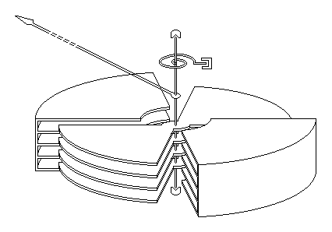
Fig. 11.6.
The active torque is an electrostatic torque determined by the fact that the capacitance depends on the position of the rotating plates with respect to the fixed plates. If the fringe effects associated with lateral field lines are neglected, the total capacitance of the capacitor corresponds to the parallel connection of capacitances corresponding to the face–to–face surfaces of each mobile and fixed plate,
$C=2 N⋅\frac{ε_{0}S}{d}=2 N⋅\frac{ε_{0}}{d} ⋅ \frac{α R^{2}}{2}=\frac{ε_{0}N R^{2}}{d}⋅α$ ,
where N is the number of mobile plates of radius R , d is the distance between a mobile and a fixed plate, α is the angle subtending the face–to–face surfaces of each mobile and fixed plate, and ε ₀ is approximately the permittivity of the air. According with the theorem of generalised electric forces, in this system where the generalised coordinate characterising the relative positions of the mobile and fixed parts of the instrument is the indication angle α , the generalised force is just the active torque. It is therefore computed as
$T_{\text{act}}=\frac{∂W}{∂α}|_{ u=\text{const}\text{.}}=\frac{∂}{∂α}\frac{C\left(α\right) u^{2}}{2}|_{ u=\text{const}\text{.}}=\frac{u^{2}}{2} \frac{∂C}{∂α}=\frac{ε_{0}N R^{2}}{2 d}⋅u^{2}=K⋅u^{2}$ .
The restoring torque
$T_{\text{rest}}=k α$
is provided as usual by spiral elastic spring(s) so that the indication α given by the pointer of the instrument corresponds to the mechanical equilibrium of the mobile system,
$T_{\text{act}}=T_{\text{rest}} ⇔ K⋅u^{2}=k α ⇔ α=\frac{K}{k} u^{2} ⇔$ $α=C⋅u^{2}$ ,
where C is the instrument constant (sensitivity).
This measuring instrument is thus essentialy a quadratic voltmeter: it measures the square of the voltage applied between the terminals – that is, between the mobile and fixed plates – of the instrument. Actualy, by a special design of the shape of the plates, the multiplicative factor K of the active torque can be designed as such a function $K\left(α\right)$ that it determines an almost linear $α\left(u\right)$ dependence, i.e. an almost linear indication over most of the instrument scale.
5. The induction instrument consists in a metallic disc that can rotate in the airgaps of two magnetic circuits where alternating magnetic fluxes are determined by different alternating currents. A counter is attached to the disk axis, so that it can count the number of rotations the disk performs (fig. 11.7).
The active torque is imposed by the electromagnetic forces determined by the interaction of each magnetic flux with the electric current determined by the e.m.f. induced by the other time–varying magnetic flux. Indeed, let the contours Γ_{a} and Γ_{b} be chosen inside the metallic disk, approximately centered with respect to the air gaps where the corresponding magnetic fluxes $Φ_{a}\left(t\right)$ and $Φ_{b}\left(t\right)$ are imposed. Let the same reference direction be chosen for the normals to the surfaces bordered by the contours and let it be the same for the magnetic fluxes as well. The magnetic fluxes are supposed to be harmonic time–varying fluxes, so that one can operate with their complex representatives ${\underline{Φ}}_{a}$ and ${\underline{Φ}}_{b}$ . According with Faraday’s law on electromagnetic induction, a time–varying magnetic flux $Φ_{S_{Γ}}\left(t\right)$ over a surface induces an induced e.m.f.
$e_{Γ}=− \frac{d}{\text{dt}} Φ_{S_{Γ}}$
along the contour of the surface. Since the time derivative of a harmonic time–varying quantity corresponds to the multiplication of the associated complex representative by jω ,
$\frac{dΦ}{dt} ⇔ jω \underline{Φ}$ ,
the complex e.m.f. induced by each complex magnetic flux along the associated contour is
${\underline{Φ}}_{a} ⇒ {\underline{E}}_{a}=−jω {\underline{Φ}}_{a} , {\underline{Φ}}_{b} ⇒ {\underline{E}}_{b}=−jω {\underline{Φ}}_{b}$ .
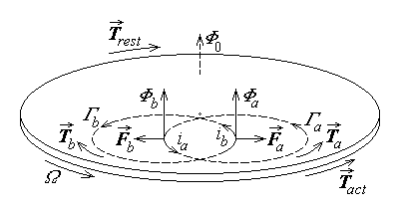
Fig. 11.7.
The currents developed by the induced e.m.f.’s in the metallic disk along their associated contours thus present a – π/2 phase difference with respect to the corresponding inductor magnetic flux. The instantaneous electromagnetic torque acting on the disk is then determined by the electromagnetic forces exerted on the disk–carried current $i_{a}\left(t\right)$ in the external magnetic flux $Φ_{b}\left(t\right)$ and on the disk–carried current $i_{b}\left(t\right)$ in the external magnetic flux $Φ_{a}\left(t\right)$ . Moreover, since the two torques are active in off–axis regions, they act in opposite directions, and calculations similar to that performed in relation with the active torque in the moving–coil permanent–magnet instrument result in the expression
$T_{\text{act}}\left(t\right)=T_{a}\left(t\right)−T_{b}\left(t\right)=K_{a}Φ_{a}\left(t\right) i_{b}\left(t\right)−K_{b}Φ_{b}\left(t\right) i_{a}\left(t\right)$
of the resulting active torque acting on the disk of the induction instrument. The average active torque over a period of the alternating currents finaly results as
${\overline{T}}_{\text{act}}=\frac{1}{T}\int{T_{\text{act}}\left(t\right) \text{dt}}=\frac{1}{T}\int{\left[K_{a}Φ_{a}\left(t\right) i_{b}\left(t\right)−K_{b}Φ_{b}\left(t\right) i_{a}\left(t\right)\right] \text{dt}}=$
$=K_{a}Φ_{a}I_{b}\text{cos} \left({\underline{Φ}}_{a} , {\underline{I}}_{b}\right)−K_{b}Φ_{b}I_{a}\text{cos} \left({\underline{Φ}}_{b} , {\underline{I}}_{a}\right)$ :
it would accelerate indefinitely the disk in the direction of the resulting torque.
The restoring torque is provided by an electromagnetic brake. A permanent magnet is placed over a region of the metallic disk outside the regions where the active torque is acting (fig. 11.8). According to the detailed expression of Faraday’s law,
$e_{Γ}=− \int{\frac{∂\vec{B}}{∂t}⋅\vec{n} \text{dS}}+\oint{\left(\vec{v}×\vec{B}\right)⋅d\vec{r}}$ ,
the movement with respect to a magnetic field induces an e.m.f. Thus, in the constant
field of magnetic flux density ${\vec{B}}_{0}$ of the permanent magnet, an elementary e.m.f.
$\text{de}=\left(\vec{v}×{\vec{B}}_{0}\right)⋅d\vec{r}=\left(v B_{0} \text{sin}\frac{π}{2}\right) \text{dr} \text{cos} 0=v B_{0} \text{dr} >0$
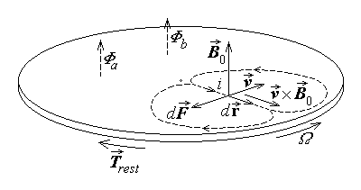
Fig. 11.8.
is induced in the outward radial direction along each elementary radial segment $d\vec{r}$ . The total e.m.f. along the disk radius a , rotating with the angular speed Ω ,
$e=\int{\text{de}}=\int{v B_{0} \text{dr}}=\int{B_{0} Ω r \text{dr}}=Ω B_{0} \frac{a^{2}}{2}$ ,
generates in the same outward radial direction a conduction current of intensity
$i=\frac{e}{R}=\frac{Ω B_{0} a^{2}}{2 R}$ ,
where R is the equivalent resistance of the current path in the metallic disk. In turn, this current determines a Laplace’s electromagnetic force
$d\vec{F}=i \left(d\vec{r}×{\vec{B}}_{0}\right)$
to act on the metallic disc in the magnetic field of the permanent magnet, opposite to the direction of rotation. The magnitude of this braking force,
$\text{dF}=i \text{dr} B_{0} \text{sin}\frac{π}{2}=i \text{dr} B_{0}=\frac{Ω B_{0} a^{2}}{2 R} B_{0} \text{dr}$ .
is proportional to the rotation speed. The same is valid for the corresponding torque, $T_{\text{rest}}=\int{r \text{dF}}=\int{r \frac{Ω B_{0}^{2} a^{2}}{2 R} \text{dr}}=\frac{Ω B_{0}^{2} a^{2}}{2 R} \int{r \text{dr}}=\frac{B_{0}^{2} a^{4}}{4 R} Ω$ ,
which is therefore a restoring torque, opposite and proportional to the rotation speed.
The disk is accelerated under the action of the active torque but, as its angular speed Ω increases, the restoring torque also increases until it becomes equal to the active torque; from that moment on, the disk rotates with a constant angular velocity Ω given by
${\overline{T}}_{\text{act}}=\frac{Ω B_{0}^{2} a^{4}}{4 R} ⇒ Ω=\frac{4 R}{B_{0}^{2} a^{4}} {\overline{T}}_{\text{act}} ⇔ Ω=k {\overline{T}}_{\text{act}}$ .
A counter mounted on the same axis as the disk counts the rotations; its indication N over a time interval τ is the number of full 2π rotations,
$N=\frac{α}{2π}=\frac{1}{2π}\int{Ω \text{dt}}=\frac{1}{2π}\int{k {\overline{T}}_{\text{act}} \text{dt}}=\frac{k {\overline{T}}_{\text{act}}}{2π} τ ⇒$ $N=C {\overline{T}}_{\text{act}} τ$ ;
this indication is proportional to the time integral of the active torque, where C is the instrument constant (sensitivity).
The electric measuring instruments briefly presented above are but the most common such instruments. There also are other measuring instruments operating on some different principles (thermal, thermoelectric, etc.) which are not discussed here. The table below presents some usual symbols found on the scale of electric measuring instruments – these symbols give important indications on the operation and performance of each instrument.

Description | Symbol
Moving coil instrument | 
Moving coil instrument with rectifier | 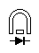
Moving–iron instrument | 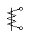
Electrodynamic instrument | 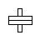
Electrostatic instrument | 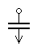
Induction instrument | 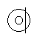
Accuracy class index (limit error as percentage  of full–scale deflection) | 1.5
Horizontal scale
Vertical scale | 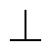
Scale inclined at 60° to the horizontal | 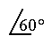
Maximum admissible voltage between the case  and the measuring circuit (in kV) | 

11.3. Measurement of electromagnetic quantities
1. The intensity of the electric conduction current is directly measured by using an ampermeter – a current measuring instrument – carrying the current to be measured. It follows that an ampermeter has to be series connected with the branch where the current is to be measured.
As it was presented in the preceding section, the moving–coil permanent–magnet instrument, the moving–iron instrument, and the electrodynamic instrument can be directly used as ampermeters. Some aspects rearding the use of an ampermeter remain to be discussed.
The moving–coil permanent–magnet ampermeter gives an indication proportional to the current. In the case of a time–varying current, however, the indication corresponds to the average current, up to an additional indication which decreases with the increase in the rate of time variation of the current. Since the average value of a harmonic time–varying quantity is zero, such an instrument gives a null indication for any value of an alternating current applied to it. For alternating current measurements, a moving–coil permanent–magnet ampermeter has to be inserted in a bridge rectifier circuit that transforms an alternating current into a pulsating current (fig. 11.9). The rectifier bridge includes semiconductor diodes, which are essentially nonlinear resistive elements with unilateral conduction; the bridge arrangement ensures that, for both positive and negative alternances of the alternative curent, the current keeps the same direction in the ampermeter. The nonzero average value of the pulsating rectified current can then be measured, giving an indication proportional to the effective value of the alternating current, namely $I_{\text{eff}}=\frac{π}{2 \sqrt{2}}I_{\text{av}}$ . There are no such problems with using the moving–iron or the electrodynamic ampermeters for the measurement of alternating currents: in this case the indication is proportional with the time average of the square of the current, which is just the square of the effective value of the alternating current.
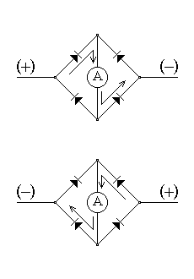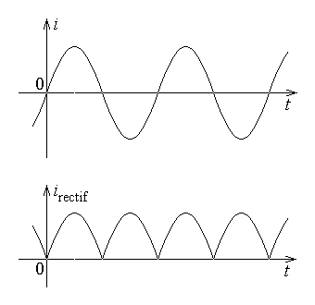
Fig. 11.9.
It is very important that the measuring instrument do not influence the quantity to be measured. Let a simple circuit be considered, consisting of a (passive) branch of resistance R carrying a current of intensity I under a given voltage U applied at terminals (fig. 11.10 left). An ampermeter of internal resistance r_{A} is series connected in the branch, which measures a value I_{m} of the current (fig. 11.10 right) for the same applied voltage. It is obvious that the two currents are different,
$I=\frac{U}{R}≠\frac{U}{R+r_{A}}=I_{m}$ .
The relative error determined by the very introduction of the measuring instrument is
$δI=\frac{ΔI}{I}=\frac{I_{m}−I}{I}=\frac{U}{R+r_{A}}\frac{R}{U}−1=\frac{R}{R+r_{A}}−1=\frac{r_{A}}{R+r_{A}}=\frac{r_{A}/R}{1+r_{A}/R}$
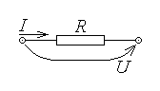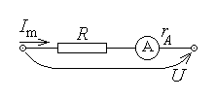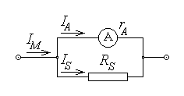
Fig. 11.10. Fig. 11.11.
and it tends to zero along with the ratio $\frac{r_{A}}{R}$ . The conclusion is that, in order to minimize the influence of the measuring instrument on the measured current, the internal resistance of an ampermeter must be negligible with respect to all other resistances (or, more general, impedances) in the circuit,
$r_{A}≪R$ .
By construction, the instrument used as an ampermeter can measure a maximum (nominal) current I_{A} corresponding to the full–scale indication. If larger currents are to be measured, the amprermeter has to be provided with a shunt resistance so that the instrument carries a definite fraction of the total current only. Let
$I_{M}=n I_{A}$
be the new desired maximum curent value to be measured; then a resistance of value R_{S} is parallel connected with the ampermeter of internal resistance r_{A} (fig. 11.11) to carry the excess current I_{S} . Since the voltage at terminals is the same for a parallel connection, it means that
$r_{A} I_{A}=R_{p} I_{M}$ ,
where
$\frac{1}{R_{p}}=\frac{1}{r_{A}}+\frac{1}{R_{S}}=\frac{r_{A}+R_{S}}{r_{A} R_{S}} ⇔ R_{p}=\frac{r_{A} R_{S}}{r_{A}+R_{S}}$ .
The value of the shunt resistance is then simply computed as
$r_{A} I_{A}=\frac{r_{A} R_{S}}{r_{A}+R_{S}} n I_{A} ⇔ n R_{S}=r_{A}+R_{S} ⇒ R_{S}=\frac{r_{A}}{n−1}$ .
2. The electric voltage between two points is directly measured by using a voltmeter. It immediately follows that if the voltage between two terminals of a circuit is to be measured, then the voltmeter has to be parallel connected with the circuit.
As it was presented in the preceding section, the electrostatic instrument measures directly the voltage between its terminals.
The moving–coil permanent–magnet instrument, the moving–iron instrument, and the electrodynamic instrument, which can directly measure the electric current intensity, can be used as voltmeters if the current they measure is proportional to the voltage to be measured. To this end an additional resistance is series connected with the current measuring instrument (fig. 11.12). Then, if the instrument of internal resistance denoted here as R_{V} can sustain a maximum (nominal) voltage U_{V} at full–scale indication, and a maximum voltage
$U_{M}=n U_{V}$
is to be measured, then the additional resistance R_{a} has to sustain the excess voltage. Since the current between the terminals is the same for a series connection, it means that
$\frac{U_{V}}{R_{V}}=\frac{U_{M}}{R_{s}}$ ,
where
$R_{s}=R_{V}+R_{a}$ .
The value of the additional resistance is then simply computed as
$\frac{U_{V}}{R_{V}}=\frac{n U_{V}}{R_{V}+R_{a}} ⇔ n R_{V}=R_{V}+R_{a} ⇒ R_{a}=\left(n−1\right) R_{V}$ .
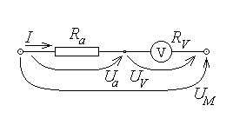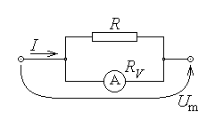
Fig. 11.12. Fig. 11.13.
A voltmeter using a moving–coil permanent–magnet instrument gives an indication proportional with the voltage. Therefore, in view to measure time–varying voltages – and, in particular, alternating voltages – the instrument has to be supplemented with a rectifier circuit, as it was discussed above. There are no such problems with using the moving–iron, the electro-dynamic, and the electrostatic instruments for the measurement of alternating voltages: in this case the indication is proportional with the time average of the square of the voltage, which is just the square of the effective value of the alternating voltage.
It is very important that the meauring instrument do not influence the quantity to be measured. Let a simple circuit be considered, consisting of a (passive) branch of resistance R where an injected current of intensity I determines the voltage U between the terminals (fig. 11.13 left). A voltmeter of internal resistance R_{V} is parallel connected with the branch, measuring a value U_{m} of the voltage (fig. 11.13 right) for the same total injected current. It is obvious that the two voltages are different,
$U=R I≠R_{p} I=\frac{R R_{V}}{R+R_{V}} I=U_{m}$ .
The relative error determined by the very introduction of the measuring instrument is
$δU=\frac{ΔU}{U}=\frac{U_{m}−U}{U}=\frac{R R_{V}}{R+R_{V}}\frac{1}{R}−1=\frac{R_{V}}{R+R_{V}}−1=\frac{R}{R+R_{V}}=\frac{R/R_{V}}{1+R/R_{V}}$
and it tends to zero along with the ratio $\frac{R}{R_{V}}$ . The conclusion is that, in order to minimize the influence of the measuring instrument on the measured voltage, the internal resistance of a voltmeter must be very great in comparison with all other resistances (or, more general, impedances) in the circuit,
$R_{V}≫R$ .
A somewhat different method to measure a voltage, which avoids the power loss across the terminals when the voltage is measured, is the compensation method. A loop is constructed, including the voltage to be measured U_{x} , the compensating voltage U_{c} ,

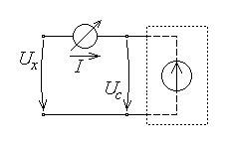
Fig. 11.14.
and a current sensing instrument – an ampermeter or even the sensor of a control equipment (fig. 11.14). The sensing instrument detects the eventual unbalance of voltages, and the compensating voltage is so modified – either by the observer, or by an automatic control equipment – as to cancel the voltage unbalance. The value of the compensating voltage is precisely equal to that of the measured

voltage when the current sensing instrument carries no current,
$I=\frac{U_{x}−U_{c}}{r}=0 ⇒ U_{x}=U_{c}$ ;
as well, at that moment there is no power transfer at the terminals of the measured voltage since there is no current there.
3. The electric power transferred at the terminals of a dipole is directly measured by using a wattmeter. It must be noted that, since the power transfer at the terminals of a dipole depends on the voltage and the current at terminals, a wattmeter has to offer two terminals between which the dipole current is to be carried and other two terminals between which the dipole voltage is to be applied.
A simple inspection of the operation of the measuring instruments presented in the preceding section indicates the electrodinamic instrument as the candidate to be used as a wattmeter. Let one of the coils – named the current coil – offer by construction a negligible resistance r_{I} , and let the other coil – called the voltage coil – offer by construction a very large resistance R_{U} (or be provided with a series additional resistance, as it was the case above with the voltmeter). If the dipole current is carried by the first coil and the dipole voltage is applied at the terminals of the second coil (fig. 11.15), then
$i_{1}=i , i_{2}=\frac{u}{R_{U}}$ .
The indication of the instrument is then given by
$f\left(α\right)=i_{1} i_{2}=i \frac{u}{R_{U}}=\frac{1}{R_{U}} u i=C⋅p$ ,
that is the instrument measures the power transferred at the dipole terminals.
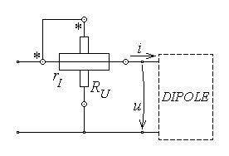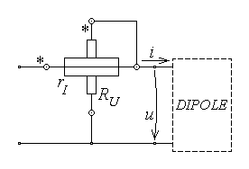
Fig. 11.15.
Some comments are to be made.
The wattmeter pointer moves in the right direction if the reference directions of the current and voltage are correctly taken care of. Therefore one terminal of each coil is marked (by an asterisk * or an arrow ↓ or some other mark) to indicate the proper reference direction for the associated quantity – current or voltage.
As illustrated in fig. 11.15, there are two possible connections of a wattmeter at the terminals of a dipole, both resulting in unavoidable systematic measurement errors. Indeed, in the first circuit, the actual voltage applied between the wattmeter terminals is $u_{m}=u+r_{I} i$ instead of the correct value u ; this results in a relative error
$δP=\frac{ΔP}{P}=\frac{P_{m}−P}{P}=\frac{u_{m}i−ui}{ui}=\frac{u_{m}}{u}−1=\frac{r_{I}i}{u}=\frac{r_{I}}{u/i}=\frac{r_{I}}{R_{\text{dipole}}}$
of the measured power value. The error becomes negligible if the resistance r_{I} of the current coil of the wattmeter is negligible with respect to the equivalent dipole resistance (impedance) R_{dipole} between its terminals. Similarly, in the second circuit, the actual current injected into the wattmeter terminals is $i_{m}=i+u/R_{U}$ instead of the correct value i ; this results in a relative error
$δP=\frac{ΔP}{P}=\frac{P_{m}−P}{P}=\frac{{ui}_{m}−ui}{ui}=\frac{i_{m}}{i}−1=\frac{u}{R_{U}i}=\frac{u/i}{R_{U}}=\frac{R_{\text{dipole}}}{R_{U}}$
of the measured power value. The error becomes negligible if the resistance R_{U} of the voltage coil of the wattmeter is very great with respect to the equivalent dipole resistance (impedance) R_{dipole} between its terminals.
The previous analysis of the wattmeter operation shows that this instrument would measure the instantaneous power if the rate of time–variation of electrical quantities is not too large and the mobile system can follow the time–dependent active torque. At quite low frequencies, however, this is no longer possible, and the electrodynamic instrument gives an indication dependent on the time–average of the instantaneous power, which is the active power. The electrodynamic instrument can thus be used as an active power wattmeter under alternating current conditions, offering an indication according to
$f\left(α\right)=C⋅\overline{u i}=C⋅\frac{1}{T}\int{u i \text{dt}} ⇔$ $f\left(α\right)=C⋅P$ .
The measurement of the reactive power under alternating current conditions can be done if the additional resistance R_{U} of the voltage coil of the electrodynamic instrument is substituted by a capacitor of sufficiently small capacitance or by a coil of sufficiently large inductance. The complex current in the voltage coil is then
${\underline{I}}_{2}=\frac{\underline{U}}{r_{2}+\frac{1}{jωC}}≃jωC \underline{U}=j \frac{\underline{U}}{Z_{U}} \text{or} {\underline{I}}_{2}=\frac{\underline{U}}{r_{2}+jωL}≃\frac{\underline{U}}{jωL}=−j \frac{\underline{U}}{Z_{U}}$ ,
meaning that the current carried by the voltage coil is
$i_{2}\left(t\right)=\frac{1}{Z_{U}} U \sqrt{2} \text{sin}\left(ωt+α±\frac{π}{2}\right)$ ,
that is, proportional to the alternating voltage with the phase changed by π/2 . The corresponding indication of this instrument – called varmeter – is then given by
$f\left(α\right)=\frac{1}{T}\int{i_{1} i_{2} \text{dt}}=\frac{1}{Z_{U}}⋅\frac{1}{T}\int{I\sqrt{2}\text{sin}\left(ωt+β\right) U\sqrt{2}\text{sin}\left(ωt+α±\frac{π}{2}\right) \text{dt}} ⇔$
⇔ $f\left(α\right)=C⋅Q$ ,
that is the instrument measures the reactive power received by the dipole.
4. The (active) electric energy transferred at the terminals of a dipole during a definite time interval is directly measured by using an energy meter. It must be noted that, since the energy transfer at the terminals of a dipole depends on the voltage and the current at terminals, an energy meter has to be connected to the dipole terminals in the same manner as the wattmeter. As well, the comments presented above remain valid, in what concerns the error made in measuring either the voltage or the current (depending on the connection of the wattmeter in the circuit), with subsequent error on the measured energy.

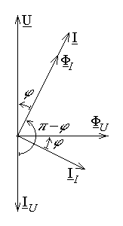
Fig. 11.16.
A simple evaluation of the measuring instruments presented in the preceding section indicates the induction instrument as the candidate to be used as an energy meter under alternating current conditions. Let the coil a – determining the magnetic flux ${\underline{Φ}}_{a}$ and named the voltage coil – offer by construction an inductance with a very large inductive impedance ${\underline{Z}}_{U}=Z_{U} e^{jπ/2}$ , and let the coil b – determining the magnetic flux ${\underline{Φ}}_{b}$ and called the current coil – offer by construction a negligible resistance r_{I}.. If the terminals of the induction instrument are connected to the dipole terminals in the same way as for the wattmeter, then, aproximately, the dipole voltage is applied at the terminals of the first coil and the dipole current is carried by the second coil, so that, since the magnetic fluxes have the same phase as the coil currents,

${\underline{Φ}}_{a}={\underline{Φ}}_{U}=k_{a} \frac{\underline{U}}{Z_{U} e^{jπ/2}}=\frac{k_{a}}{Z_{U}} \underline{U} e^{−jπ/2}$ ,
${\underline{Φ}}_{b}={\underline{Φ}}_{I}=k_{b} \underline{I}$ .
The currents determined in the metallic disk by the induced voltages ${\underline{E}}_{a}=−jω {\underline{Φ}}_{a}$ and ${\underline{E}}_{b}\text{==}−jω {\underline{Φ}}_{b}$ are delayed by the same π/2 phase difference with respect to the corresponding inductor magnetic fluxes, so that
${\underline{I}}_{a}={\underline{I}}_{U}=a⋅{\underline{Φ}}_{U} e^{−jπ/2}=\frac{{ak}_{a}}{Z_{U}}\underline{U} e^{−jπ} , {\underline{I}}_{b}={\underline{I}}_{I}=b⋅{\underline{Φ}}_{I} e^{−jπ/2}={bk}_{b} \underline{I} e^{−jπ/2}$ .
Let the dipole current $\underline{I}$ present a phase delay ϕ with respect to the dipole voltage $\underline{U}$ ; the phasor diagram in fig. 11.16 shows that just the same phase delay is found between ${\underline{Φ}}_{a}={\underline{Φ}}_{U}$ and ${\underline{I}}_{b}={\underline{I}}_{I}$ , while the phase delay between ${\underline{Φ}}_{b}={\underline{Φ}}_{I}$ and ${\underline{I}}_{a}={\underline{I}}_{U}$ equals π – ϕ . The average active torque of the induction instrument is then
${\overline{T}}_{\text{act}}=\frac{1}{T}\int{T_{\text{act}}\left(t\right)}=K_{a}Φ_{a}I_{b}\text{cos} \left({\underline{Φ}}_{a} , {\underline{I}}_{b}\right)−K_{b}Φ_{b}I_{a}\text{cos} \left({\underline{Φ}}_{b} , {\underline{I}}_{a}\right)=$
$=K_{a}⋅\frac{k_{a}}{Z_{U}}U⋅{bk}_{b} I⋅\text{cos}ϕ−K_{b}⋅k_{b} I⋅\frac{{ak}_{a}}{Z_{U}}U⋅\text{cos}\left(π−ϕ\right)=$
$=\frac{k_{a}k_{b}}{Z_{U}}\left(K_{a}b+K_{b}a\right)⋅U I\text{cos}ϕ=K⋅P$
Consequently, the indication given for a time duration τ by the counter attached to the disk axis is
$N=C {\overline{T}}_{\text{act}} τ=C K⋅Pτ ⇔$ $N=c⋅W$ ,
that is proportional to the active power transferred to the dipole during this time interval.
The reactive energy transferred to a dipole during a time interval can also be measured by an induction instrument if it is modified with respect the active energy meter in the same way as the varmeter was modified with respect to the wattmeter.
5. The resistance of a resistor can be directly measured by using an ohmmeter, that is an instrument consisting in a voltage source, a moving–coil permanent–magnet ampermeter, and an internal variable resistor, all series connected between the terminals (fig. 11.17). The resistance measurement supposes two steps. The calibration step consists in adjusting the internal variable resistor so that, when the instrument terminals

are short–circuited, the full–scale indication is reached. In this situation a maximum current I_{M} is present in the circuit, associated to a total adjusted resistance R_{adj} , and obviously corresponds to a zero value of the measured resistance between the terminals of the instrument. The measurement step consists in connecting the resistor to be measured between the terminals of the instrument and simply reading the indication of the instrument. The current measured by the ampermeter is now
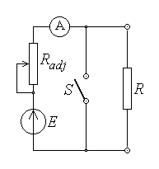
Fig. 11.17.

$I=\frac{E}{R_{\text{adj}}+R}=\frac{E}{R_{\text{adj}}\left(1+R/R_{\text{adj}}\right)}=\frac{I_{M}}{1+R/R_{\text{adj}}}=f\left(R\right)$ ,
and the instrument indication,
$α=C⋅I=C⋅f\left(R\right)$ ,
can be marked directly in resistance units.
An indirect method of measuring a resistance is based on its very definition,
$R=\frac{U}{I}$ ,
and supposes the measurement of the voltage applied at the resistor terminals and the resulting current at the same terminals (fig. 11.18). However, as it is apparent from the figure, this ampermeter–voltmeter method is necessarily associated with a measurement error.
Indeed, when the voltmeter terminals are connected directly at the resistor terminals, this instrument measures exactly the needed voltage, $U_{V}=U$ , while the current measured by the ampermeter includes the current carried by the voltmeter, $I_{A}=I+U_{V}/R_{V}=I+U/R_{V}>I$ . Using this connection, one obtains a measured value of thr resistance
$R_{m}=\frac{U_{V}}{I_{A}}=\frac{U}{I+U/R_{V}}=\frac{1}{\frac{I}{U}+\frac{1}{R_{V}}}=\frac{1}{\frac{1}{R}+\frac{1}{R_{V}}}=\frac{R R_{V}}{R+R_{V}}$ ,
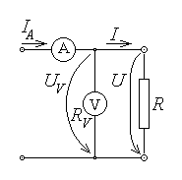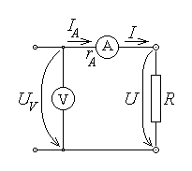
Fig. 11.18.
which is smaller than the actual value R . The measurement error is simply obtained as
$δR=\frac{ΔR}{R}=\frac{R_{m}−R}{R}=\frac{R_{V}}{R+R_{V}}−1=− \frac{R}{R+R_{V}} ⇔$ $δR=− \frac{1}{1+R_{V}/R}$ ,
and it becomes negligible when the voltmeter resistance is very great with respect to the measured resistance,
$R_{V}≫R$ .
On the other hand, if the voltmeter resistance R_{V} is known, then the actual value R of the measured resistance can be determined starting from the measured value R_{m} ,
$\frac{1}{R_{m}}=\frac{1}{R}+\frac{1}{R_{V}} ⇔ \frac{1}{R}=\frac{1}{R_{m}}−\frac{1}{R_{V}}=\frac{R_{V}−R_{m}}{R_{V}R_{m}} ⇔$ $R=\frac{R_{V}R_{m}}{R_{V}−R_{m}}$ .
In the case of the other circuit, when the voltmeter terminals are connected at the source terminals, the ampermeter measures exactly the needed current, $I_{A}=I$ , while the voltage measured by the voltmeter includes the voltage developed between the terminals of the ampermeter, $U_{V}=U+r_{A} I_{A}=U+r_{A} I>U$ . Using this connection one obtains a measured resistance
$R_{m}=\frac{U_{V}}{I_{A}}=\frac{U+r_{A}I}{I}=\frac{U}{I}+r_{A}=R+r_{A}$ ,
which is greater than the actual value R . The measurement error is simply obtained as
$δR=\frac{ΔR}{R}=\frac{R_{m}−R}{R}=\frac{R+r_{A}}{R}−1 ⇔$ $δR=\frac{r_{A}}{R}$ ,
and it becomes negligible when the ampermeter resistance is negligible with respect to the measured resistance,
$r_{A}≪R$ .
On the other hand, if the ampermeter resistance r_{A} is known, then the actual value R of the measured resistance can be determined starting from the measured value R_{m} ,
$R_{m}=R+r_{A} ⇔$ $R=R_{m}−r_{A}$ .

Another indirect method for resistance measurements uses a so called bridge circuit (fig. 11.19). The unknown resistance R₁ = R_{x} is connected along with other three known resistances, R₂ , R₃ , R₄ , as the four arms of the bridge, in loop including four nodes; the measurement diagonal includes a current sensing instrument – an ampermeter or even the sensor of a control equipment – while the source diagonal includes a direct current generator applying a voltage U_{S} at the terminals of this diagonal.
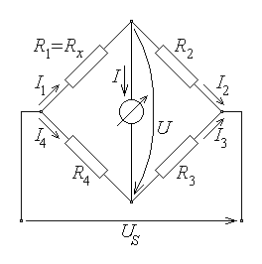
Fig. 11.19.

Suppose that the known resistances in the bridge arms are adjusted (either by the observer, or by an automatic control equipment) in such a way that there is no current in the measurement diagonal and, correspondingly, no voltage across the measurement diagonal,
$I=0 ⇔ U=0$ .
Under this balance condition, the currents in the bridge arms are
$I_{1}=I_{2}=\frac{U_{S}}{R_{1}+R_{2}} , I_{3}=I_{4}=\frac{U_{S}}{R_{3}+R_{4}}$ ,
so that the voltage across the measurement diagonal is obtained as
$R_{1}I_{1}+U−R_{4}I_{4}=0 ⇔ U=R_{4}I_{4}−R_{1}I_{1}$ .
The balance (equilibrium) condition thus becomes
$R_{4}\frac{U_{S}}{R_{3}+R_{4}} −R_{1}\frac{U_{S}}{R_{1}+R_{2}} ⇔ R_{4}\left(R_{1}+R_{2}\right)=R_{1}\left(R_{3}+R_{4}\right)$ ,
which finaly gives
$R_{1}R_{3}=R_{2}R_{4} ⇔$ $R_{x}=R_{1}=\frac{R_{2}R_{4}}{R_{3}}$ .
The balance is obtained by adjusting the value of one of the other three bridge resistances. Once the balance is reached, the value of the measured resistance is simply obtained from the values of the known resistances of the bridge. The accompanying errors are evaluated as for any indirect measurement of a physical quantity.
6. The elements of the complex impedance a passive dipole can be measured, under alternating current conditions, by using a circuit similar to that employed for the measurement of a resistance, but including also a wattmeter (fig. 11.20). The idea is, for instance, to measure the impedance as
$Z=\frac{U}{I}≃\frac{U_{V}}{I_{A}}=Z_{m}$ ,
and the phase difference according to
$P=UI \text{cos}ϕ≃P_{W} ⇒ \text{cos}ϕ=\frac{P}{UI}≃\frac{P_{W}}{U_{V}I_{A}}=\text{cos}ϕ_{m}$ ,
whence
$ϕ=\text{arccos}\frac{P}{U I}≃\text{arccos}\frac{P_{W}}{U_{V}I_{A}}=ϕ_{m}$ .
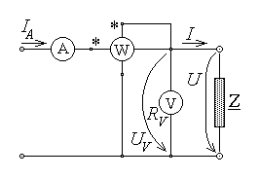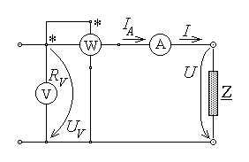
Fig. 11.20.
Quite similarly, starting from the same measured values, one can compute the dipole equivalent resistance and reactance, according with the relations
$P=R_{e}I^{2} ⇒$ $R_{e}=\frac{P}{I^{2}}≃\frac{P_{W}}{I_{A}^{2}}=R_{em}$ ,
$Z=\sqrt{R_{e}^{2}+X_{e}^{2}}=\frac{U}{I} ⇒$ $X_{e}=\sqrt{{\left(\frac{U}{I}\right)}^{2}−R_{e}^{2}}≃\sqrt{{\left(\frac{U_{V}}{I_{A}}\right)}^{2}−{\left(\frac{P_{W}}{I_{A}^{2}}\right)}^{2}}=X_{em}$ ,
or the dipole equivalent conductance and susceptance, according with the relations
$P=G_{e}U^{2} ⇒$ $G_{e}=\frac{P}{U^{2}}≃\frac{P_{W}}{U_{V}^{2}}=G_{em}$ ,
$Y=\sqrt{G_{e}^{2}+B_{e}^{2}}=\frac{I}{U} ⇒$ $B_{e}=\sqrt{{\left(\frac{I}{U}\right)}^{2}−G_{e}^{2}}≃\sqrt{{\left(\frac{I_{A}}{U_{V}}\right)}^{2}−{\left(\frac{P_{W}}{U_{V}^{2}}\right)}^{2}}=B_{em}$ .
In the first circuit, the voltmeter and the voltage coil of the wattmeter are operating correctly under the voltage U_{V} = U , while the ampermeter and the current coil of the wattmeter carry a current $I_{A}=I+\frac{U}{R_{U}}+\frac{U}{R_{V}}>I$ , larger than the correct one. The ensuing errors in the measurement of the current and power result in errors in the calculated values of the elements of the dipole complex impedance; these errors can be evaluated following procedures similar to those presented above, in relation with the measurement of electric power and resistance.
In the second circuit, the ampermeter and the current coil of the wattmeter are operating correctly, carrying the current I_{A} = I , while the voltmeter and the voltage coil of the wattmeter operate under a voltage $U_{V}=U+r_{I}I+r_{A}I>U$ , larger than the correct one. The ensuing errors in the measurement of the voltage and power result in errors in the calculated values of the elements of the dipole complex impedance; these errors can again be evaluated following procedures similar to those presented above, in relation with the measurement of electric power and resistance.

Another, more precise, method of measuring the elements of the complex impedance of a dipole operating under alternating current conditions, is using an alternating current bridge circuit. For a bridge circuit operating under alternating current conditions (fig. 11.21) in a similar manner as the direct current bridge circuit presented above, the three known complex impedances of the bridge are so adjusted that the complex current and voltage at the terminals of the measurement diagonal reach a zero value,
$\underline{I}=0 ⇔ \underline{U}=0$ .
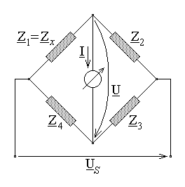
Fig. 11.21.

An argument similar to that presented above in relation with the direct current bridge circuit gives the balance condition as
${\underline{Z}}_{1}{\underline{Z}}_{3}={\underline{Z}}_{2}{\underline{Z}}_{4}$ ,
whence
${\underline{Z}}_{x}={\underline{Z}}_{1}=\frac{{\underline{Z}}_{2}{\underline{Z}}_{4}}{{\underline{Z}}_{3}}$ .
Since the complex impedance is characterised by two real parameters (for instance, resistance and reactance), the balance of such an alternanting curent bridge is usually obtained by adjusting two elements in the other three arms of it. The computation of the impedance/phase difference, or resistance/reactance, or conductance/susceptance elements of the complex impedance depends on the particular components of the bridge impedances. As well, the evaluation of errors made when computing these elements depends on the details of the circuit.

