10. TIME–VARYING ELECTROMAGNETIC FIELDS

10.1. Quasi–steady state electromagnetic fields
1. The quasi–steady state of the electromagnetic field was defined previously (see section 3.12) as the state where no electromagnetic waves are present. The physical support of such a state is represented by the circumstances where, under time–varying conditions, no induction phenomenon is strong enough to induce a significant effect: either the proper electromagnetic induction effects are negligible,
$\left| −\frac{{dΦ}_{S_{Γ}}}{\text{dt}} \right|\text{<<}\left| u_{\text{static} \text{or} \text{steady}−\text{state}} \right|$ ,
or the opposite electromagnetic induction effects are negligible,
$\left| \frac{{dΨ}_{S_{Γ}}}{\text{dt}} \right|\text{<<}\left| i_{S_{Γ}} \right|$ .
The first situation is described as the amagnetic quasi–steady state, and is characterised by the fact that the voltages induced by time–varying magnetic fields (fluxes) are negligible with respect to any static or steady–state voltage developed in the same region. Equivalently, this state can be characterised by the fact that the magnetic energy density is negligible with respect to the electric energy density.
The second situation is described as the anelectric quasi–steady state, and is characterised by the fact that the displacement currents induced by time–varying electric fields (fluxes) are negligible with respect to any conduction current in the same region. Equivalently, this state can be characterised by the fact that the electric energy density is negligible with respect to the magnetic energy density.
Most common applications of the quasi–steady state electromagnetic phenomena are associated with the presence of the electromagnetic induction, and only a few cases are encountered where significant effects of the displacement currents are to be considered. This is why the anelectric quasi–steady state only is discussed in some detail in the following. Two interesting, and important, effects are associated with this state: eddy currents are developed in conductors placed in a time–varying electromagnetic field, and the skin effect is present, which consists in a non–uniform distribution of the electromagnetic field inside conductors.
2. The eddy currents are electric conduction currents along closed paths in conductors, developed in the presence of a time–varying magnetic field. The physical mechanism of their generation is quite simple: a time–varying magnetic flux over an open surface S_{Γ} traced in a conductor induces a voltage along the surface contour, Γ ; in turn, the voltage induced in the conductor imposes an electric conduction current along the contour Γ .
The distribution of the induced eddy currents (and of the associated electro-magnetic field) is influenced by the conductor structure and the distribution of the inductor magnetic field. As a general feature, however, the induced eddy currents are pushed toward the conductor surface, resulting in a non–uniform distribution of the electromagnetic field – more intense near the conductor border than inside it.
A simple example is illustrative: let a very long cylindrical coil with a solid conducting core of radius R , permeability μ , and conductivity σ be considered (fig. 10.1), and let the time – varying current
$i \left(t\right)=I\sqrt{2} \text{sin}ωt$
be carried by the coil winding.
If the coil is characterised by the turn–per–unit–length ratio
$n=\frac{ΔN}{Δl}$ ,
then the magnetic field generated inside the core is found by following the procedure similar to that presented previously, in section 7.1. The symmetry of the structure under consideration imposes that magnetic field is restricted inside the core, its lines are parallel to the core axis, and its strength may depend at most on the distance to the axis.
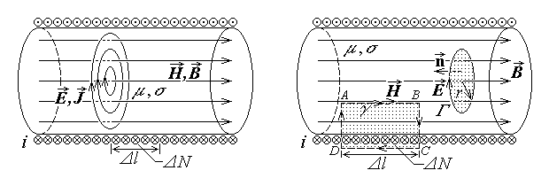
Fig. 10.1. Fig. 10.2.
In a first approximation, let any electromagnetic induction effects be ignored: Ampere's theorem invoked with respect to a rectangular contour γ as that in fig. 10.2 successively gives
$\oint{{\vec{H}}_{0}⋅d\vec{r}}=i_{S_{γ}} ⇔ \int{H_{0} \text{dr}}+\int{H_{0} \text{dr} \text{cos}\frac{π}{2}}+\int{\vec{0}⋅d\vec{r}}=i_{S_{γ}} ⇔$
$⇔ H_{0} Δl=ΔN i ⇔ H_{0}=\frac{ΔN}{Δl} i ⇔ H_{0}=n I\sqrt{2} \text{sin}ωt$ .
Accordingly, the magnetic flux over any transverse circular surface S_{Γ} of radius r , centered on the axis (fig. 10. 2), is
$Φ_{S_{Γ}}=\int{\vec{B}⋅\vec{n} \text{dS}}=\int{μ H_{0} \text{cos}π \text{dS}}=−μ H_{0} S=−μ n I\sqrt{2} \text{sin}ωt π r^{2}$ .
This time–varying magnetic flux induces a voltage along the circular contour. The symmetry of the structure under consideration imposes that the induced electric field has circular field lines and the strength depending at most on the distance to the axis. Faraday's law invoked with respect to the circular contour Γ successively gives
$\oint{\vec{E}⋅d\vec{r}}=− \frac{d}{\text{dt}}Φ_{S_{Γ}} ⇔ \oint{E_{1}\text{dr}}=− \frac{d}{\text{dt}}\left( −μ n I\sqrt{2} \text{sin}ωt π r^{2}\right) ⇔$
$⇔ E_{1} 2π r=ωμ n I\sqrt{2} \text{cos}ωt π r^{2} ⇔ E_{1} =ωμ n \frac{r}{2} I\sqrt{2} \text{cos}ωt$ .
The corresponding current density of the induced eddy currents is, according to Ohm's law,
$\vec{J}=σ \vec{E} ⇒ J_{1} =ωμσ n \frac{r}{2} I\sqrt{2} \text{cos}ωt$ ,
and it is obvious that the magnitudes of the electric field strength and current density are increasing with the distance to the axis, meaning greater values at the conductor surface than inside the conductor (fig. 10.3) .
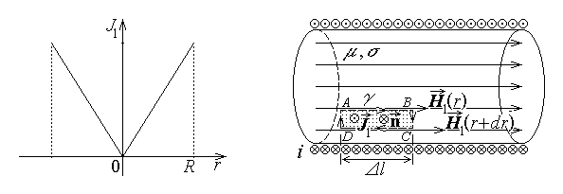
Fig. 10.3. Fig. 10.4.
It is now necessary to take into account the so called magnetic reaction of the induced eddy currents, that is their contribution to the generation of the magnetic field. By considering now again a rectangular contour γ as in fig. 10.4, Ampere's theorem for the supplementary reaction magnetic field similarly gives
$\oint{{\vec{H}}_{1}⋅d\vec{r}}=i_{S_{γ}} ⇔ \int{H_{1}\left(r\right) \text{dl}}−\int{H_{1}\left(r+\text{dr}\right) \text{dl}}=\int{{\vec{J}}_{1}\vec{n} \text{dS}} ⇔$
$\left[H_{1}\left(r\right)−H_{1}\left(r+\text{dr}\right)\right] Δl=−J_{1}Δl \text{dr} ⇔ H_{1}\left(r+\text{dr}\right)=H_{1}\left(r\right)+J_{1}\text{dr}>H_{1}\left(r\right)$ .

The total magnetic field strength inside the conducting core is thus non–uniform,
$H \left(r\right)=H_{0}+H_{1}\left(r\right)$ ,
and is increasing with the distance to the axis, meaning that it is concentrated toward the conductor surface.
The above procedure can be iterared again and again – in the limit, the distribution of the magnitude of any electromagnetic quantity (magnetic field, induced electric field, or current density) looks like that shown in fig. 10.5.
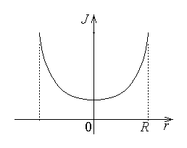
Fig. 10.5.

3. The skin effect can be illustrated by a simple example: let a very long cylindrical conductor of radius R , permeability μ , and conductivity σ be considered, carrying a harmonic time–varying current (fig. 10.6),
$i \left(t\right)=I\sqrt{2} \text{sin}ωt$ .
For the beginning, let a uniform current distribution be assumed, meaning that the axially directed current density is, in a first approximation,
$J_{0}=\frac{i}{π R^{2}}=\frac{I}{π R^{2}}\sqrt{2} \text{sin}ωt$ ;
correspondingly, the electric field strength is easily obtained as
$\vec{J}=σ \vec{E} ⇒ E_{0}=\frac{J_{0}}{σ}=\frac{I}{σ π R^{2}}\sqrt{2} \text{sin}ωt$ .
The symmetry of the structure under consideration imposes that associated magnetic field lines are circular, and its strength may depend at most on the distance to the axis.
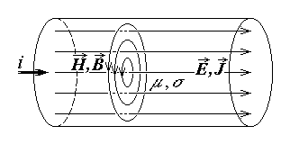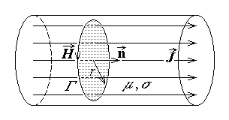
Fig. 10.6. Fig. 10.7.
In this first approximation, let any electromagnetic induction effects be ignored; Ampere's theorem invoked with respect to a circular contour Γ as that in fig. 10.7 successively gives
$\oint{{\vec{H}}_{0}⋅d\vec{r}}=i_{S_{Γ}} ⇔ \oint{H_{0} \text{dr}}=\int{\vec{J}⋅\vec{n} \text{dS}} ⇔$
$⇔ H_{0} 2π r=J_{0} π r^{2} ⇔ H_{0}=J_{0}\frac{r}{2} ⇔ H_{0}=\frac{I r}{2π R^{2}}\sqrt{2} \text{sin}ωt$ .
It is obvious that the magnitude of the magnetic field is increasing with the distance to the axis, meaning that it has greater values at the conductor surface than inside the conductor (fig. 10.8) .
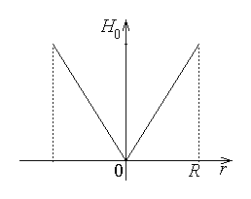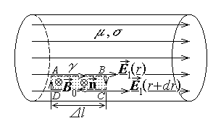
Fig. 10.8. Fig. 10.9.
It is now necessary to take into account the electromagnetic induction effects associated with the presence of a time–varying magnetic field. Again, the symmetry of the structure under consideration imposes that the supplementary induced electric field has axial lines and its strength may depend at most on the distance to the axis. By considering a rectangular contour γ as in fig. 10.9, Faraday's law successively gives
$\oint{{\vec{E}}_{1}⋅d\vec{r}}=− \frac{d}{\text{dt}}\int{\vec{B}⋅\vec{n} \text{dS}} ⇔$
$⇔ \int{E_{1}\left(r+\text{dr}\right) \text{dl}}+\int{E_{1} \text{dr} \text{cos}\frac{π}{2}}−\int{E_{1}\left(r\right) \text{dl}}= \frac{d}{\text{dt}}\int{μ H_{0} \text{dS}} ⇔$
$⇔ \left[E_{1}\left(r+\text{dr}\right)−E_{1}\left(r\right)\right] Δl=\frac{d}{\text{dt}}\frac{μ I r}{2π R^{2}}\sqrt{2} \text{sin}ωtΔl \text{dr} ⇔$
$⇔ E_{1}\left(r+\text{dr}\right)=E_{1}\left(r\right)+\frac{ω μ I r}{2π R^{2}}\sqrt{2} \text{cos}ω\text{tdr}>E_{1}\left(r\right)$ .
The total electric field strength, and the associated electric current inside the cylindrical conductor, are thus non–uniform,
$E \left(r\right)=E_{0}+E_{1}\left(r\right) , J \left(r\right)=σ E\left(r\right)=J_{0}+σ E_{1}\left(r\right)$ ,

and are increasing with the distance to the axis, meaning that they are concentrated toward the conductor surface.
The above procedure can be successively iterared – in the limit, any electro-magnetic quantity (magnetic field, electric field or total current density) has the distribution shown in fig. 10.10.
Fig. 10.10.

10. 2. Diffusion of the electromagnetic field
under anelectric quasi–steady state conditions
1. A quantitative evaluation of the degree of non–uniformity in the distribution of electromagnetic field quantities inside conductors under quasi–steady state conditions can be obtained in the simple case when a uniform harmonic time–varying magnetic field is applied parallel to the surface of a homogeneous conducting half–space (fig. 10.11).
Let a rectangular system of axes be considered, centered at the conductor surface,

with the z–axis oriented along the applied magnetic field, the y–axis oriented along the conductor surface, and the x–axis directed toward the interior of the conductor. Let $\hat{x} , \hat{y} , \hat{z}$ denote the unit vectors of the coordinate axes. It can be shown that the magnetic field in the conductor is also oriented along the z–axis, the induced electric field (and the associated induced current) is oriented along the y–axis , and their magnitudes depend at most on the distance x to the conductor surface (fig. 10.11),
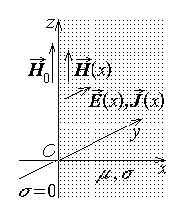
Fig. 10.11.

$\vec{H}=\hat{z} H\left(x,t\right) ,\text{ \{}\vec{B}=\hat{z} B \left(x,t\right) ,\text{ \{}\vec{E}=\hat{y} E\left(x,t\right) ,\text{ \{}\vec{J}=\hat{y} J\left(x,t\right)$ .
In the presence of a time–varying magnetic field, eddy currents are induced inside the conductor, which generate in turn a reaction magnetic field and determine a non–uniform distribution of all electromagnetic field quantities.
Ampere's theorem invoked for a rectangular contour γ as in fig. 10.12 gives
$\oint{\vec{H}⋅d\vec{r}}=i_{S_{γ}} ⇔ \int{H\left(x\right) \text{dz}}−\int{H\left(x+\text{dx}\right) \text{dz}}=\int{\vec{J}⋅\vec{n} \text{dS}} ⇔$
$⇔ \left[H\left(x\right)−H\left(x+\text{dx}\right)\right] Δz=J\left(x\right) Δz \text{dx} ⇔ \frac{H\left(x+\text{dx}\right)−H\left(x\right)}{\text{dx}}=− σ E\left(x\right)$ ,
or, in the limit as dx → 0 ,
$\frac{∂H}{∂x}=− σ E$ .
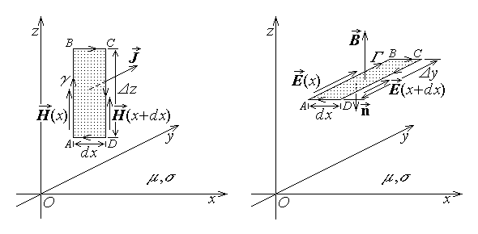
Fig. 10.12. Fig. 10.13.
Faraday's law invoked for a rectangular contour Γ as in fig. 10.13 gives
$\oint{\vec{E}⋅d\vec{r}}=− \frac{{dΦ}_{S_{Γ}}}{\text{dt}} ⇔ \int{E\left(x\right) \text{dy}}−\int{E\left(x+\text{dx}\right) \text{dy}}=−\frac{d}{\text{dt}}\int{\vec{B}⋅\vec{n} \text{dS}} ⇔$
$⇔ \left[E\left(x\right)−E\left(x+\text{dx}\right)\right] Δy=\frac{dμ H\left(x\right)}{\text{dt}}Δy \text{dx} ⇔ \frac{E\left(x+\text{dx}\right)−E\left(x\right)}{\text{dx}}=− μ \frac{\text{dH}\left(x\right)}{\text{dt}}$ ,
or, in the limit as dx → 0 ,
$\frac{∂E}{∂x}=− μ \frac{∂H}{∂t}$ .
The system of partial differential equations for the electromagnetic field $\left\{ \vec{E} , \vec{H} \right\}$ can be reduced to a single equation – for instance, the equation of the magnetic field strength,
$\frac{∂^{2}H}{∂x^{2}}=\frac{∂}{∂x}\left(−σ E\right)=−σ \frac{∂E}{∂x}=−σ \left(− μ\frac{∂H}{∂t}\right) ⇔$ $\frac{∂^{2}H}{∂x^{2}}=μσ \frac{∂H}{∂t}$ .
Similarly, the equation of the electric field strength is obtained as
$\frac{∂^{2}E}{∂x^{2}}=\frac{∂}{∂x}\left(− μ \frac{∂H}{∂t}\right)=−μ \frac{∂}{∂t}\frac{∂H}{∂x}=−μ \frac{∂}{∂t}\left(−σ E\right) ⇔$ $\frac{∂^{2}E}{∂x^{2}}=μσ \frac{∂E}{∂t}$ .
This are the diffusion equations of the magnetic, respectively electric, field penetration into the conducting half–space. The fact that both the magnetic and electric field satisfy the same equation suggests that these fields have a similar behaviour. The study of its solution is facilitated if the particular case of a harmonic time–varying electromagnetic field is considered.
2. Let a complex representation of the harmonic time–varying quantities be introduced, such that, for instance,
$H\left(x,t\right)=H\left(x\right) \text{sin} \left[ωt+ψ\left(x\right)\right] ⇔ \underline{H}\left(x\right)=H\left(x\right) e^{j ψ\left(x\right)}$ ,
$E\left(x,t\right)=E\left(x\right) \text{sin} \left[ωt+χ\left(x\right)\right] ⇔ \underline{E}\left(x\right)=E\left(x\right) e^{j χ\left(x\right)}$ ,
where
$j=\sqrt{−1}$ ,
and
$H\left(x,t\right)=\text{Im} \left\{ \underline{H}\left(x\right) e^{j ωt}\right\} , E\left(x,t\right)=\text{Im} \left\{ \underline{E}\left(x\right) e^{j ωt}\right\}$ .
It is known from the operation with complex representatives of harmonic time–varying functions that the complex representative of the time–derivative of such a function is just the product of the complex representative of the original function by the constant jω ,
$\text{If} H ⇔ \underline{H} \text{then} \frac{∂H}{∂t} ⇔ jω \underline{H}$ .
Correspondingly, the diffusion equation of the magnetic field assumes the complex form
$\frac{d^{2}\underline{H}}{{dx}^{2}}=jωμσ \underline{H}$ .
The penetration constant is introduced as
$\underline{γ}=α+j β=\sqrt{ j ωμσ}=\sqrt{\frac{ωμσ}{2}} \left(1+j\right)$ ,
where the attenuation constant α and the phase constant β = α are related to the diffusion depth δ by the equation
$α= β=\sqrt{\frac{ωμσ}{2}}=\frac{1}{δ}$ .
The complex form of the diffusion equation for the magnetic field is thus reduced to a simple differential equation,
$\frac{d^{2}\underline{H}}{{dx}^{2}}={\underline{γ}}^{2} \underline{H}$ ,
with a solution of the form
$\underline{H}\left(x\right)=\underline{A} e^{rx}$ .
The successive derivatives of the solution are
$\frac{d\underline{H}}{\text{dx}}=r \underline{A} e^{rx} , \frac{d^{2}\underline{H}}{{\text{dx}}^{2}}=r^{2} \underline{A} e^{rx}$ ,
so that a simple substitution in the diffusion equation gives
$r^{2} \underline{A} e^{rx}={\underline{γ}}^{2} \underline{A} e^{rx} ⇔ \left(r^{2}−{\underline{γ}}^{2}\right) \underline{A} e^{rx}=0$ .
Since the exponential part of the last equation is not equal to zero, it follows that
$r=±\underline{γ}$ ,
and the general solution of the diffusion equation takes the form
$\underline{H}\left(x\right)={\underline{A}}_{1} e^{− \underline{γ}x}+{\underline{A}}_{2} e^{+ \underline{γ}x}$ .
The second term above has implies an unbounded increase of the magnetic field as the distance x to the conductor surface increases indefinitely, so that a physically acceptable finite solution imposes that
${\underline{A}}_{2}=0$ ;
correspondingly, the solution is reduced to
$\underline{H}\left(x\right)={\underline{A}}_{1} e^{− \underline{γ}x}$ .
Now, if the magnetic field strength at the conductor surface and its complex representative are
$H\left(0,t\right)=H_{0} \text{sin} ωt ⇔ \underline{H}\left(0\right)=H_{0}$ ,
then a simple substitution in the solution gives
$\underline{H}\left(0\right)={\underline{A}}_{1}=H_{0}$ ,
so that the final expression for the complex magnetic field inside the conductor half–space is
$\underline{H}\left(x\right)=H_{0} e^{− \underline{γ}x}$ .
The local complex form of Ampere's theorem inside the conductor,
$\frac{∂H}{∂x}=− σ E ⇔ \frac{d\underline{H}}{dx}=− σ \underline{E}$ ,
gives for the complex electric field the expression
$\underline{E}=− \frac{1}{σ} \frac{d\underline{H}}{\text{dx}}=− \frac{1}{σ} \frac{d}{\text{dx}}H_{0} e^{− \underline{γ}x} ⇔ \underline{E}=\frac{\underline{γ}}{σ}H_{0} e^{− \underline{γ}x}=\sqrt{\frac{j ωμ}{σ}}H_{0} e^{− \underline{γ}x}$ ,
and, according with Ohm's law, the complex current density results as
$\underline{J}=σ \underline{E}=\underline{γ} H_{0} e^{− \underline{γ}x}=\sqrt{j ωμσ} H_{0} e^{− \underline{γ}x}$ .
3. The interpretation of the resulted expressions is straightforward if the translation is made to the instantaneous representation of the field quantities. The instantaneous magnetic field strength is
$H\left(x,t\right)=\text{Im} \left\{ \underline{H}\left(x\right) e^{j ωt}\right\}=\text{Im} \left\{ H_{0} e^{− \underline{γ} x} e^{j ωt}\right\}=\text{Im} \left\{ H_{0} e^{− α \left(1+j\right) x} e^{j ωt}\right\}=$
$=\text{Im} \left\{ H_{0} e^{− α x} e^{j \left(ωt−α x\right)}\right\}=H_{0} e^{− α x} \text{sin} \left(ω t−α x\right)$
The magnetic field distribution is thus described by a harmonic space– and time–varying function with the amplitude decaying exponentially with the distance from the conductor surface (fig. 10.14). The phase of the harmonic (sine) function is periodic with a period 2π , so that
$\text{sin} \left(ωt−αx\right)=\text{sin} \left(ωt−αx+2π\right)=\text{sin} \left[ω \left(t+T\right)−αx\right]$
results in the relationship between the period T and the angular frequency ω ,
$ω T=2π ⇔ T=\frac{2π}{ω}$ .
Similarly, since
$\text{sin} \left(ωt−αx\right)=\text{sin} \left(ωt−αx−2π\right)=\text{sin} \left[ωt−α \left(x+λ\right)\right]$ ,
it follows that the phase of the harmonic variation is periodic in space with a period length, named wavelength, given by
$α λ=2π ⇔ λ=\frac{2π}{α}$ ,
Moreover, the phase of the harmonic variation of the magnetic field strength also satisfies the equation
$ωt−αx=ω \left(t+Δt\right)−α \left(x+Δx\right)$ ,
that remains the same, if
$ω Δt=α Δx$ .
It means that the phase of the harmonic variation travels, in the positive direction of the x–axis with a phase velocity
$v=\frac{Δx}{Δt}=\frac{ω}{α}$ ,
This is equivalently to
$v=\frac{ω}{α}=\frac{2π}{T} \frac{λ}{2π}=\frac{λ}{T}$ ,
meaning that the wavelength is just the distance travelled during a period by the phase of the harmonic function.
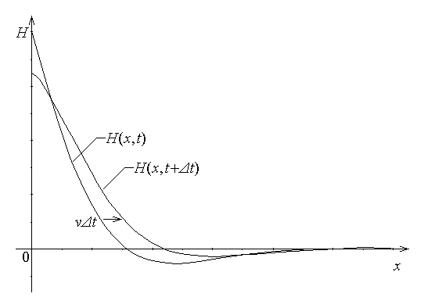
Fig. 10.14.
The complete interpretation is thus the following: The harmonic time variation of the field quantity travels in the direction of propagation of the positive x–axis with the phase velocity v , and the magnitude of the field decays exponentially with the travelled distance, as illustrated in fig. 10.14.
Similar interpretations of other field quantities are immediate. For instance, the instantaneous current density is given by
$J\left(x,t\right)=\text{Im} \left\{ \underline{J}\left(x\right) e^{j ωt}\right\}=\text{Im} \left\{ \sqrt{j ωμσ} H_{0} e^{− \underline{γ} x} e^{j ωt}\right\}=$
$=\text{Im} \left\{ \sqrt{ωμσ} \frac{1+j}{\sqrt{2}}H_{0} e^{− α \left(1+j\right) x} e^{j ωt}\right\}=\text{Im} \left\{ \sqrt{ωμσ} e^{j π/4} H_{0} e^{− α \left(1+j\right) x} e^{j ωt}\right\}=$
$=\text{Im} \left\{ \sqrt{ωμσ} H_{0} e^{− α x} e^{j \left(ωt−α x−π/4\right)}\right\}=\sqrt{ωμσ} H_{0} e^{− α x} \text{sin} \left(ω t−α x−π/4\right)$ ,
and is obvious that the previous discussion is valid for the present result as well.
The magnitude of all field quantities decays exponentially with the same characteristic length represented by the diffusion depth
$δ=\frac{1}{α}=\sqrt{\frac{2}{ωμσ}}=\frac{1}{\sqrt{π fμσ}}$ ,
meaning that the magnitude of any field quantity (say, the magnetic field strength),
$\left| \underline{H}\left(x\right) \right|=\left| H_{0} e^{− \underline{γ}x} \right|=\left| H_{0} e^{− α\left(1+j\right) x} \right|=\left| H_{0} e^{− αx} e^{− j αx} \right|=H_{0} e^{− αx}$ ,
decreases in the ratio 1/e over a distance equal to the characteristic length,
$\left| \underline{H}\left(x+δ\right) \right|=H_{0} e^{− α \left(x+δ\right)}=H_{0} e^{− α x} e^{− α δ}=H_{0} e^{− α x} e^{− 1}=\frac{1}{e}\left| \underline{H}\left(x\right) \right|$ .
Such a steep decrease of the field quantities toward the interior of the conductor is just what represents the skin effect; in particular, in the case of the conducting half–space, the magnitude of the field quantities decreases under 5% of their surface value at a distance x = 3δ from the surface.
4. The exponential variation of the magnitude of the field quantities – for instance, that of the eddy current density – can be substituted by a simpler variation, which illustrates the skin effect. The usual approximation supposes that each field quantity is distributed with a constant value over a certain distance only – named penetration depth or skin depth – and is zero in the rest of the conductor. The equivalence criterion is the equality of the overall effect – here, the average dissipated power – determined by the actual and the equivalent field distributions.
The instantaneous current density,
$J\left(x,t\right)=\sqrt{ωμσ} H_{0} e^{− α x} \text{sin} \left(ω t−α x−π/4\right)$ ,
can be expressed directly in terms of its (maximum) surface magnitude,
$J\left(0\right)=\sqrt{ωμσ} H_{0}=J_{0}$ ,
as
$J\left(x,t\right)=J_{0} e^{− α x} \text{sin} \left(ω t−α x−π/4\right)$ .
The local time average of this quantity is computed as a root mean square as for any harmonic time–varying function, and results in its effective value,
$J_{\text{eff}}\left(x\right)=\frac{J\left(x\right)}{\sqrt{2}}=\frac{J_{0} e^{− α x}}{\sqrt{2}}$ .
The total electromagnetic power dissipated by the actual eddy current carried by the conductor in an infinite volume element ΔV∞ (fig. 10.15) of length Δy , height Δz and infinite depth x ∈ [0,∞) is the integral of the time averaged dissipated power density
$p_{\text{av}}\left(x\right)=ρ J_{\text{eff}}^{2}\left(x\right)=\frac{J_{0}^{2} e^{− 2 α x}}{2 σ}$ ,
which gives
$ΔP=\int{p_{\text{av}}\left(x\right) \text{dV}}=Δy Δz \int{\frac{J_{0}^{2} e^{− 2 α x}}{2 σ} \text{dx}}=\frac{Δy Δz J_{0}^{2}}{2 σ} \frac{e^{− 2 α x}}{−2 α} |_{ 0}^{ ∞}=\frac{Δy Δz J_{0}^{2}}{4 α σ}$
for the actual current distribution.
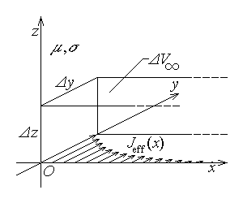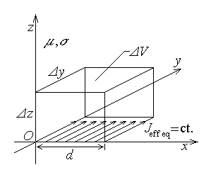
Fig. 10.15. Fig. 10.16.
On the other hand, the total eddy current carried by the conductor, parallel to its surface, along the same slice (fig. 10.15) of height Δz and infinite depth x ∈ [0,∞) is
$I=\int{J\left(x\right) \text{dS}}=Δz \int{J_{0} e^{− α x} \text{sin} \left(ω t−α x−π/4\right) \text{dx}}$ .
The integral of the form
$F=\int{e^{− α x} \text{sin} \left(ω t−α x−π/4\right) \text{dx}}=\int{e^{− α x} \text{sin} \left(θ−α x\right) \text{dx}}$
is computed by parts,
$\int{e^{− α x}\text{sin} \left(θ−α x\right) \text{dx}}=\frac{e^{− α x}}{−α}\text{sin} \left(θ−α x\right) |_{ 0}^{ ∞}−\int{\frac{e^{− α x}}{−α}\left(−α\right)\text{cos} \left(θ−α x\right) \text{dx}}=$
$=\frac{e^{− α x}}{−α}\text{sin} \left(θ−α x\right) |_{ 0}^{ ∞}−\frac{e^{− α x}}{−α}\text{cos} \left(θ−α x\right) |_{ 0}^{ ∞}+\int{\frac{e^{− α x}}{−α} α \text{sin} \left(θ−α x\right) \text{dx}}=$ .
$=\frac{e^{− α x}}{α}\left[ \text{sin} \left(θ−α x\right)−\text{cos} \left(θ−α x\right)\right] |_{ ∞}^{ 0}−\int{e^{− α x} \text{sin} \left(θ−α x\right) \text{dx}}$ .
It follows that
$F=\int{e^{− α x} \text{sin} \left(θ−α x\right) \text{dx}}=\frac{e^{− α x}}{2 α}\left[ \text{sin} \left(θ−α x\right)−\text{cos} \left(θ−α x\right)\right] |_{ ∞}^{ 0}=$
$=\frac{e^{− α x}}{2 α}\left[ \text{sin} \left(θ−α x\right)−\text{sin} \left(θ−α x+\frac{π}{2}\right)\right] |_{ ∞}^{ 0}=\frac{e^{− α x}}{2 α}2\text{sin}\frac{π}{4}\text{cos} \left(θ−α x+\frac{π}{4}\right) |_{ ∞}^{ 0}=$
$=\frac{e^{− α x}}{\sqrt{2} α} \text{cos} \left(θ−α x+\frac{π}{4}\right) |_{ ∞}^{ 0}=\frac{e^{− α x}}{\sqrt{2} α} \text{cos} \left(ωt−\frac{π}{4}−α x+\frac{π}{4}\right) |_{ ∞}^{ 0}$ .
Since the exponential goes to zero while the cosine remains bounded in the lower limit, the computed current finally is
$I=\int{J\left(x\right) \text{dS}}=Δz J_{0}\frac{e^{− α x}}{\sqrt{2} α} \text{cos} \left(ωt−\frac{π}{4}−α x+\frac{π}{4}\right) |_{ ∞}^{ 0}=Δz J_{0}\frac{1}{\sqrt{2} α} \text{cos} ωt$ ,
with the effective value
$I_{\text{eff}}=\frac{Δz J_{0}}{2 α}$ .
An approximate current density is now considered, corresponding to the total current uniformly distributed over a finite cross section ΔS , of height Δz and depth d (fig. 10.16), of effective value
$J_{\text{eff} \text{eq}}=\frac{I_{\text{eff}}}{d Δz}=\frac{Δz J_{0}}{2 α} \frac{1}{d Δz}=\frac{J_{0}}{2 dα}$
in this region and a zero value in the rest of the conductor. The power dissipated by the approximate current distribution in the volume ΔV∞ , reduced in fact to the volume ΔV of height Δz , length Δy and depth d , is
${ΔP}_{\text{appr}}=\int{p_{\text{av} \text{eq}} \text{dV}}=d Δy Δz \frac{J_{\text{eff} \text{eq}}^{2}}{σ}=d Δy Δz \frac{J_{0}^{2}}{4 d^{2}α^{2}σ}=Δy Δz \frac{J_{0}^{2}}{4 {dα}^{2}σ}$ .
Equating the values obtained for the average dissipated power corresponding to the actual and approximate current distributions,
$\frac{Δy Δz J_{0}^{2}}{4 α σ}=Δy Δz \frac{J_{0}^{2}}{4 {dα}^{2}σ}$ .
gives for the penetration (skin) depth the value
$d=\frac{1}{α}=δ=\sqrt{\frac{2}{ωμσ}}=\frac{1}{\sqrt{π fμσ}}$ ,
which coincides with the diffusion depth.
The above result shows that the penetration depth depends on the constitutive parameters of the conductor (it decreases with the square root of both the permeability and conductivity) and on the frequency of the field time–variation (it decreases with the square root of the frequency). It means that the greater the frequency, permeability and conductivity, the more the time–varying electromagnetic field and associated eddy currents are repressed toward the surface of conductors.
The computations performed above show that, instead of operating with the complex non-uniform distribution of the field quantities, one can operate with a simplified uniform distribution of these quantities, reduced to the penetration depth. This discussion is rigorously valid in the case of a plane infinite insulator–conductor interface only. It is, however, generally applied in the simplified calculation of eddy current losses for any configuration of the insulator–conductor interface, as long as the curvature radius remains greater than the penetration depth.

10.3. Time–varying electromagnetic fields
1. The electromagnetic field under general time–varying conditions represents the most general case to be studied, when no restrictions are imposed on the time variation of field quantities. In particular, this means that the presence of electromagnetic waves has to be taken into account.
The simplest electromagnetic wave is the linearly polarized plane electro-magnetic wave, and this is discussed in the following.

Let a position– and time–dependent electromagnetic field be considered in a linear insulating substance, such that (fig. 10.17)
$\vec{E}=\hat{y} E\left(x,t\right) ,\text{ \{}\vec{H}=\hat{z} H\left(x,t\right)$ .
The linear polarization of such a field is illustrated by the fact that the electric field vector is oriented along a definite, fixed direction: one says that this electromagnetic field is polarized along the y–axis. As well, each of the assumed electric and magnetic field
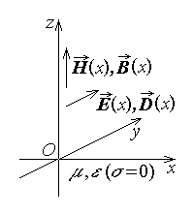
Fig. 10.17.

vectors has the same value at points on planes x = const. – this is the characteristic of a plane electromagnetic wave propagating along the x–axis. The equations that define the electromagnetic wave can be derived easily following a procedure similar to that used above, in section 10.2.
Let a rectangular contour Γ be considered in the xy–plane (fig. 10.18), of edges dx and Δy . Farady's law invoked for this contour traced in a linear substance successively gives
$\oint{\vec{E}⋅d\vec{r}}=− \frac{d}{\text{dt}} \int{\vec{B}⋅\vec{n} \text{dS}} ⇔$
$⇔ \int{E\left(x,t\right) \text{dy}}+\int{E \text{dr} \text{cos}\frac{π}{2}}−\int{E\left(x+\text{dx},t\right) \text{dy}}=\frac{d}{\text{dt}}\int{μ H\left(x,t\right) \text{dS}} ⇔$
$⇔ \left[E\left(x,t\right)−E\left(x+\text{dx},t\right)\right]Δy=\frac{dμH\left(x,t\right)}{\text{dt}}Δy\text{dx} ⇔ \frac{E\left(x+\text{dx},t\right)−E\left(x,t\right)}{\text{dx}}=−μ\frac{\text{dH}\left(x,t\right)}{\text{dt}}$
or, in the limit as dx → 0 ,
$\frac{∂E}{∂x}=− μ \frac{∂H}{∂t}$ .
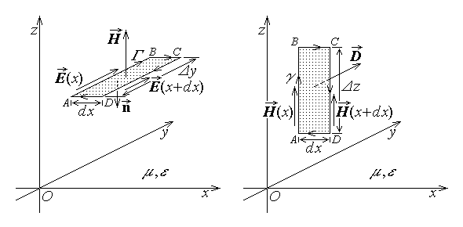
Fig. 10.18. Fig. 10.19.
Let now a rectangular contour γ be considered in the xz–plane (fig. 10.19), of edges dx and Δz . Ampere's law invoked for this contour traced in a linear insulating substance successively gives
$\oint{\vec{H}⋅d\vec{r}}=\frac{d}{\text{dt}} \int{\vec{D}⋅\vec{n} \text{dS}} ⇔$
$⇔ \int{H\left(x,t\right) \text{dz}}+\int{H \text{dr} \text{cos}\frac{π}{2}}−\int{H\left(x+\text{dx},t\right) \text{dz}}=\frac{d}{\text{dt}}\int{ε E\left(x,t\right) \text{dS}} ⇔$
$⇔ \left[H\left(x,t\right)−H\left(x+\text{dx},t\right)\right]Δz=\frac{dεE\left(x,t\right)}{\text{dt}}Δy \text{dx} ⇔ \frac{H\left(x+\text{dx},t\right)−H\left(x,t\right)}{\text{dx}}=−ε\frac{\text{dE}\left(x,t\right)}{\text{dt}}$
or, in the limit as dx → 0 ,
$\frac{∂H}{∂x}=− ε \frac{∂E}{∂t}$ .
The system of partial differential equations for the electromagnetic field $\left\{ \vec{E} , \vec{H} \right\}$ derived above can be reduced to a single equation. For instance, the equation of the magnetic field strength is obtained as
$\frac{∂^{2}H}{∂x^{2}}=−\frac{∂}{∂x}ε \frac{∂E}{∂t}=−ε \frac{∂}{∂t} \frac{∂E}{∂x}=−ε \frac{∂}{∂t}\left(−μ\frac{∂H}{∂t}\right) ⇔$ $\frac{∂^{2}H}{∂x^{2}}=με \frac{∂^{2}H}{∂t^{1}}$ .
Similarly, the equation of the electric field strength is obtained as
$\frac{∂^{2}E}{∂x^{2}}=−\frac{∂}{∂x}μ \frac{∂H}{∂t}=−μ \frac{∂}{∂t} \frac{∂H}{∂x}=−μ \frac{∂}{∂t}\left(−ε\frac{∂E}{∂t}\right) ⇔$ $\frac{∂^{2}E}{∂x^{2}}=με \frac{∂^{2}E}{∂t^{2}}$ .
These represent the wave equations of the magnetic, respectively electric, field in a linear insulating medium. The fact that the electric and magnetic fields satisfy the same equation means that they present a similar position– and time–dependence; that is why the solution of the wave equation for the electric field only is discussed in detail.
2. The study of the wave equation for the electric field strength results in the conclusion that its general solution consists in the sum of two particular solutions, which depend on certain linear combinations of the coordinate and time,
$E\left(x,t\right)=E_{d} \left(t−\frac{x}{c}\right)+E_{i} \left(t+\frac{x}{c}\right)$ ,
or, equivalently,
$E\left(x,t\right)=E_{d} \left(x−c t\right)+E_{i} \left(x+c t\right)$ ,
where c is a constant characteristic to the substance where the wave is propagating.
It is easy to verify that such a solution satisfies the wave equation. By denoting
$θ_{±}=t±\frac{x}{c}$ ,
the time derivatives are
$\frac{∂}{∂t}E \left(t±\frac{x}{c}\right)=\frac{∂E}{∂θ_{±}}\frac{∂θ_{±}}{∂t}=\frac{∂E}{∂θ_{±}}$ ,
$\frac{∂^{2}}{∂t^{2}}E \left(t±\frac{x}{c}\right)=\frac{∂}{∂t}\frac{∂E}{∂θ_{±}}=\frac{∂^{2}E}{∂θ_{±}^{2}}\frac{∂θ_{±}}{∂t}=\frac{∂^{2}E}{∂θ_{±}^{2}}$ .
Similarly, the coordinate derivatives are
$\frac{∂}{∂x}E \left(t±\frac{x}{c}\right)=\frac{∂E}{∂θ_{±}}\frac{∂θ_{±}}{∂x}=\frac{∂E}{∂θ_{±}}\left(±\frac{1}{c}\right)$ ,
$\frac{∂^{2}}{∂x^{2}}E \left(t±\frac{x}{c}\right)=\frac{∂}{∂x}\left(±\frac{1}{c}\right)\frac{∂E}{∂θ_{±}}=\left(±\frac{1}{c}\right)\frac{∂^{2}E}{∂θ_{±}^{2}}\frac{∂θ_{±}}{∂x}=\left(±\frac{1}{c}\right)\frac{∂^{2}E}{∂θ_{±}^{2}}\left(±\frac{1}{c}\right)=\frac{1}{c^{2}}\frac{∂^{2}E}{∂θ_{±}^{2}}$ .
By substituting the second derivatives into the wave equation results in
$\frac{∂^{2}E}{∂x^{2}}=με \frac{∂^{2}E}{∂t^{2}} ⇔ \frac{1}{c^{2}}\frac{∂^{2}E}{∂θ_{±}^{2}}=με \frac{∂^{2}E}{∂θ_{±}^{2}} ⇔ \left(\frac{1}{c^{2}}−με\right)\frac{∂^{2}E}{∂θ_{±}^{2}}=0$ .
Since the derivative of the electric field is generally supposed to be non–zero, it remains that
$\frac{1}{c^{2}}=εμ ⇔ c=± \frac{1}{\sqrt{ εμ}}$ .
The constant c enters with both positive and negative signs in the general solution, so that is sufficient to retain the positive value only,
$c=\frac{1}{\sqrt{ εμ}}$ ,
which is called the (phase) velocity of the electromagnetic wave.
3. The preceding discussion has to be complemented by an analysis of the terms appearing in the general solution of the wave equation.
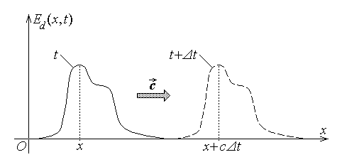
Fig. 10.20.
The first term of the general solution is named the direct (progressive) wave, and represents a field distribution which travels (propagates) in the positive direction of the x–axis. Indeed, it is obvious that
$E_{d} \left(t−\frac{x}{c}\right)=E_{d} \left(t+Δt−\frac{x+c Δt}{c}\right)$ :
the electric field distribution found at coordinate x at the moment t is found again at coordinate x+cΔt at the moment t+Δt (fig. 10.20). This is precisely the meaning of a direct wave propagation – the fact that the field distribution travels from one point to another, with a finite velocity c , in the positive propagation direction.
The second term of the general solution is named the inverse (regressive) wave, and represents a field distribution which travels (propagates) in the negative direction of the x–axis. Indeed, it is obvious that
$E_{i} \left(t+\frac{x}{c}\right)=E_{i} \left(t+Δt+\frac{x−c Δt}{c}\right)$ :
the electric field distribution found at coordinate x at the moment t is found again at coordinate x–cΔt at the moment t+Δt (fig. 10.21). It is clear then that the meaning of an inverse wave propagation is the fact that the field distribution travels from one point to another, with a finite velocity c , in the negative propagation direction.
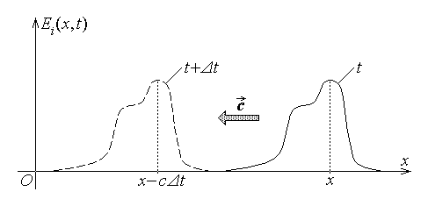
Fig. 10.21.
4. The general solution for the magnetic field is of the same form as that for the electric field,
$H\left(x,t\right)=H_{d} \left(t−\frac{x}{c}\right)+H_{i} \left(t+\frac{x}{c}\right)$ ,
or, equivalently,
$H\left(x,t\right)=H_{d} \left(x−c t\right)+H_{i} \left(x+c t\right)$ ,
However, the solutions for the electric and magnetic fields are not independent, and it can be shown that
$H\left(x,t\right)=\frac{1}{ζ} \left[E_{d} \left(t−\frac{x}{c}\right)−E_{i} \left(t+\frac{x}{c}\right)\right]$ ,
or
$H\left(x,t\right)=\frac{1}{ζ} \left[E_{d} \left(x−c t\right)−E_{i} \left(x+c t\right)\right]$ .
The constant linking the electric and magnetic, direct and inverse, waves in the above equations,
$ζ=\sqrt{ \frac{μ}{ε}}$ ,
is named the wave impedance of the medium of wave propagation.
The validity of the above expressions is easily verified. Indeed, as computed above,
$\frac{∂}{∂t}E \left(t±\frac{x}{c}\right)=\frac{∂E}{∂θ_{±}}\frac{∂θ_{±}}{∂t}=\frac{∂E}{∂θ_{±}}$ ,
$\frac{∂}{∂x}E \left(t±\frac{x}{c}\right)=\frac{∂E}{∂θ_{±}}\frac{∂θ_{±}}{∂x}=\frac{∂E}{∂θ_{±}}\left(±\frac{1}{c}\right)=±\sqrt{ εμ} \frac{∂E}{∂θ_{±}}$ .
Similarly,
$\frac{∂}{∂t}H \left(t±\frac{x}{c}\right)=\frac{∂H}{∂θ_{±}}\frac{∂θ_{±}}{∂t}=\frac{∂H}{∂θ_{±}}=∓ \frac{1}{ζ} \frac{∂E}{∂θ_{±}}=∓ \sqrt{\frac{ε}{μ}} \frac{∂E}{∂θ_{±}}$ ,
$\frac{∂}{∂x}H \left(t±\frac{x}{c}\right)=\frac{∂H}{∂θ_{±}}\frac{∂θ_{±}}{∂x}=\frac{∂H}{∂θ_{±}}\left(±\frac{1}{c}\right)=∓ \frac{1}{ζ} \frac{∂E}{∂θ_{±}}\left(±\frac{1}{c}\right)=− ε \frac{∂E}{∂θ_{±}}$ .
Let the solutions be denoted as
$E\left(x,t\right)=E_{d} \left(t−\frac{x}{c}\right)+E_{i} \left(t+\frac{x}{c}\right)=E_{d}\left(θ_{−}\right)+E_{i}\left(θ_{+}\right)$ ,
$H\left(x,t\right)=H_{d} \left(t−\frac{x}{c}\right)+H_{i} \left(t+\frac{x}{c}\right)=H_{d}\left(θ_{−}\right)+H_{i}\left(θ_{+}\right)=\frac{1}{ζ} \left[E_{d}\left(θ_{−}\right)−E_{i}\left(θ_{+}\right)\right]$ ;
substuting their derivatives in Faraday's and Ampere's equations gives
$\frac{∂E}{∂x}=− μ \frac{∂H}{∂t} ⇔ \sqrt{ εμ} \left(− \frac{∂E_{d}}{∂θ_{−}}+\frac{∂E_{i}}{∂θ_{+}}\right)≡−μ \sqrt{\frac{ε}{μ}} \left[\frac{∂E_{d}}{∂θ_{−}}+\left(−\frac{∂E_{i}}{∂θ_{+}}\right)\right]$ ,
and
$\frac{∂H}{∂x}=− ε \frac{∂E}{∂t} ⇔ −ε \frac{∂E_{d}}{∂θ_{−}}−ε \frac{∂E_{i}}{∂θ_{+}}≡−ε \left[\frac{∂E_{d}}{∂θ_{−}}+\frac{∂E_{i}}{∂θ_{+}}\right]$ ,
which shows that the above solutions do satisfy the field equations.
5. It is known that there is an electromagnetic energy associated with the electro-magnetic field, and this is valid for the electromagnetic wave as well. In the case of an electromagnetic wave, the propagating electromagnetic field is also accompanied by an energy transfer, that is a power transmission.
Let the direct wave be considered first, which consists in the couple of vectors
${\vec{E}}_{d}\left(x,t\right)=\hat{y} E_{d}\left(t−\frac{x}{c}\right)=\hat{y} E_{d}\left(x−ct\right)$ ,
${\vec{H}}_{d}\left(x,t\right)=\hat{z} H_{d}\left(t−\frac{x}{c}\right)=\hat{z} H_{d}\left(x−ct\right)=\hat{z} \frac{1}{ζ} E_{d}\left(t−\frac{x}{c}\right)=\hat{z} \frac{1}{ζ} E_{d}\left(x−ct\right)$ .
It is easy to compute the electric and magnetic energy densities as,
$w_{e d}=\frac{{\vec{E}}_{d}⋅{\vec{D}}_{d}}{2}=\frac{ε E_{d}^{2}}{2} , w_{m d}=\frac{{\vec{H}}_{d}⋅{\vec{B}}_{d}}{2}=\frac{μ H_{d}^{2}}{2}$ ,
and verify that these are equal,
$w_{m d}=\frac{{\vec{H}}_{d}⋅{\vec{B}}_{d}}{2}=\frac{μ H_{d}^{2}}{2}=\frac{μ }{2}{\left(\frac{E_{d}}{ζ}\right)}^{2}=\frac{μ }{2}{\left(\sqrt{\frac{ε}{μ}} E_{d}\right)}^{2}=\frac{ε E_{d}^{2}}{2}=w_{e d}$ .
This is explained by the fact that in the propagation process the position– and time–dependencies of the field quantities determine an alternance of energy between its electric and magnetic forms. It is obvious that the same considerations remain valid for the inverse wave of components
${\vec{E}}_{i}\left(x,t\right)=\hat{y} E_{i}\left(t−\frac{x}{c}\right)=\hat{y} E_{i}\left(x−ct\right)$ ,
${\vec{H}}_{i}\left(x,t\right)=\hat{z} H_{i}\left(t−\frac{x}{c}\right)=\hat{z} H_{i}\left(x−ct\right)=−\hat{z} \frac{1}{ζ} E_{i}\left(t−\frac{x}{c}\right)=−\hat{z} \frac{1}{ζ} E_{i}\left(x−ct\right)$ ,
due to the quadratic dependence of the energy density on the field vectors,
$w_{m i}=\frac{μ H_{i}^{2}}{2}=\frac{ε E_{i}^{2}}{2}=w_{e i}$ .
The transmission of electromagnetic power is described by the Poynting vector, which represents the surface density of the transmitted power. The flux density of the electromagnetic power transmitted by the direct wave is calculated as
${\vec{S}}_{d}={\vec{E}}_{d}×{\vec{H}}_{d}=\hat{y} E_{d}×\hat{z} H_{d}=\hat{x} E_{d}\frac{1}{ξ}E_{d}=\hat{x} \sqrt{\frac{ε}{μ} }E_{d}^{2}=\hat{x} \frac{1}{\sqrt{εμ}}ε E_{d}^{2}=$
$=\hat{x} \frac{1}{\sqrt{εμ}} \left(\frac{ε E_{d}^{2}}{2}+\frac{μ H_{d}^{2}}{2}\right)=\hat{x} c \left(w_{e d}+w_{m d}\right)=\hat{x} c w_{\text{el}−\text{mg} d}$ .
It looks like the electromagnetic power transfer associated with the wave propagation consists in the transport of the energy density of the field at the speed of the wave, in the positive direction of propagation (fig. 10.22).
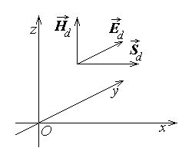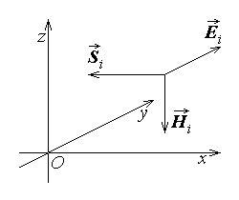
Fig. 10.22. Fig. 10.23.
Similarly, the electromagnetic power transmitted by the inverse wave is given by
${\vec{S}}_{i}={\vec{E}}_{i}×{\vec{H}}_{i}=\hat{y} E_{i}×\hat{z} H_{i}=\hat{x} E_{i}\left(−\frac{1}{ξ}E_{i}\right)=−\hat{x} \sqrt{\frac{ε}{μ} }E_{i}^{2}=−\hat{x} \frac{1}{\sqrt{εμ}}ε E_{i}^{2}=$
$=−\hat{x} \frac{1}{\sqrt{εμ}} \left(\frac{ε E_{i}^{2}}{2}+\frac{μ H_{i}^{2}}{2}\right)=−\hat{x} c \left(w_{e i}+w_{m i}\right)=−\hat{x} c w_{\text{el}−\text{mg} i}$ .
The interpretation of this result is analogous to the preceding result: the electromagnetic power transfer associated with the wave propagation represents the transport of the energy density of the field at the speed of the wave, but in the negative direction of propagation (fig. 10.23).

