7. COILS AND MAGNETIC CIRCUITS

7.1. Coils and inductances
1. The ideal coil is the ideal dipolar circuit element where the storage of magnetic energy is the single energy transfer process present.
The presence of magnetic energy within the circuit element means that a magnetic field is developed within it. The presence of the magnetic field imposes the presence, under any conditions, of externely imposed sources of such a field, i.e., the presence of some electric current. On the other hand, since by definition there are no magnetic field lines that cross the surrounding surface of a circuit element, it means that all magnetic field lines are closed within the dipolar circuit element. The structure of an ideal coil is therefore quite simple: there is a current carying conductor – supposedly filamentary – connecting the two terminals, surrounded by an insulator. Moreover, with a view to increase the generated magnetic field, the conductor is usualy wound into a number of turns, as illustrated in fig. 7.1. Since this is an ideal circuit element, there is a single energy transfer process present – namely, the storage of magnetic energy – and this means, in particular, that there is no energy transfer process associated with the electric conduction: the conductor is a perfect conductor, and the surrounding insulator is a perfect insulator.
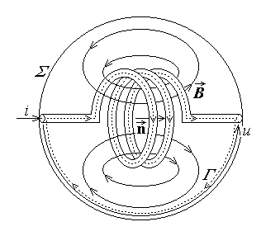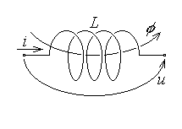
Fig. 7.1. Fig. 7.2.
The global quantity most appropriate to characterise the whole magnetic field developed within the circuit element is the magnetic flux. In turn, the magnetic flux has to be defined over an adequately defined open surface – the coil surface S_{Γ} is defined by specifying its contour Γ , which follows the conductor from one terminal to the other and closes along the voltage line traced on the surrounding surface of the circuit element (fig. 7.1). A reference direction is also defined as the reference direction of the current along the conductor of the coil. The reference direction along the contour Γ is then taken to coincide with that of the current along the conductor and the reference direction over the coil surface is associated to that along the contour according with the right–hand rule. Finaly, the refernce direction of the voltage between the terminals is associated to that of the current according with the load rule (fig. 7.2). The intensity of the electric conduction current i is a first state quantity able to characterise the electromagnetic state of the coil. On the other hand, the presence of the magnetic field in the element determines the magnetic flux
$φ=\int{\vec{B}⋅\vec{n} \text{dS}}$ ,
which naturaly appears as the other state quantity of the ideal coil.
2. The state equation (or the constitutive equation) of the ideal coil is the relationship between the state quantities φ and i . In the simplest case, when all substances inside the coil are linear, this equation is provided by the theorem of the inductance. A simple argument shows that, according with Biot–Savart–Laplace’s formula,
$\vec{H}\left(\vec{r}\right)=\frac{1}{4π} \int{\frac{i d\vec{r}× \vec{R}}{R^{3}}}$ ,
the magnetic field strength is proportional with the intensity of the electric conduction current which generates it, $\vec{H} \text{\sim } i$ . According to the linearity assumption, meaning μ = const. and ${\vec{M}}_{p}=0$ , the magnetic flux density $\vec{B}=μ \vec{H}$ is proportional to the magnetic field strength, and, consequently, to the electric current i , $\vec{B} \text{\sim } i$ . Moreover, a simple reasoning shows that the direction of the magnetic field lines is the same as that of the unit vector $\vec{n}$ normal to the coil surface. Finaly, the magnetic flux,
$φ=\int{\vec{B}⋅\vec{n} \text{dS}}$ ,
is positive and obviously proportional with the magnetic field strength, $φ \text{\sim }\text{ \{}\vec{B}$ . The immediate conclusion is that
$φ \text{\sim }\text{ \{}\vec{B} \text{\sim }\text{ \{}\vec{H} \text{\sim } i$ :
for an ideal linear coil, the coil flux is proportional to the coil current. One can therefore introduce the (positive) proportionality constant as a characteristic of the coil,
$φ=L i ⇔ i=\frac{1}{L} φ$ ,
where L is the inductance of the coil. The I.S. inductance unit is straightforward,
$\left\langle L\right\rangle =\frac{1 \text{Wb}}{1 A}=1 H (\text{henry})$ .
In the case when the substances inside the coil are not linear, one can still obtain a nonlinear relationship between the coil flux and current, for instance
$φ=L\left(i\right) i$ ,
defining a nonlinear inductance L(i) .
3. The magnetic flux is, however, hiden somewhere inside the circuit element and is difficult to be sensed from outside it. Another way of characterising the magnetic coil, with reference to quantities at terminals – current and voltage – is therefore needed. This operating equation can be derived if Faraday’s law (of electromagnetic induction) is
invoked with refernce to the contour Γ surrounding the coil surface (fig. 7.3),
$e_{Γ}=− \frac{d}{dt}φ_{S_{Γ}}$ .
On the left-hand side, the induced e.m.f. along the closed line Γ is just the total electric voltage along it, which, in turn, is the sum of electric voltages along the contour,
$e_{Γ}=u_{Γ}=u_{\text{cond}\text{.}}+\left(−u\right)$ .
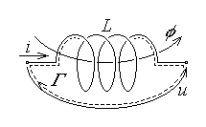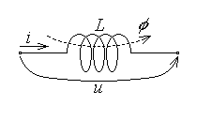
Fig. 7.3. Fig. 7.4.
According to the assumption of no power loss associated with electric conduction, there is no voltage along the perfect conductor of the coil, u_{cond.} = 0 , so that
$e_{Γ}=− u$ .
On the right-hand side, the magnetic flux over the coil surface S_{Γ} is $φ_{S_{Γ}}=φ$ . It follows that
$− u=− \frac{dφ}{dt}$ ,
whence the operating equation of the ideal coil,
$u=\frac{dφ\left(i\right)}{dt}$ ,
where the reference directions of the electric current and magnetic flux are associated according the right-hand rule (fig. 7.4). In the case of a linear coil, where φ = Li , this equation is simplified to
$u=\frac{dφ}{dt}=L \frac{di}{dt}$ .
4. The nonideal coil is a dipolar circuit element where the storage of magnetic energy is the main energy transfer process present. It means that one has to consider some additional energy transfer processes, and the first to be accounted for is obviously the energy dissipation associated with the presence of a nonideal conductor between the terminals (fig. 7.5): there is a conductive voltage u_{C} along the coil conductor, determined by the coil current i , as for an ordinary resistor of resistance r .
The operating equation of the linear nonideal coil is again obtained by invoking Faraday’s law (of electromagnetic induction) as before,
$e_{Γ}=− \frac{d}{dt}φ_{S_{Γ}}$ .
On the left-hand side, the induced e.m.f. along the closed line Γ , that is the total electric voltage along it, is now the sum of electric voltages along the contour, $e_{Γ}=u_{Γ}=u_{C}+\left(−u\right)$ ; on the right-hand side, the magnetic flux over the coil surface S_{Γ}
is again $φ_{S_{Γ}}=φ$ . It follows that
$u_{C}− u=− \frac{dφ}{dt}$ ,
whence the operating equation of the ideal coil,
$u=\frac{dφ}{dt}+u_{C} ⇔ u=L \frac{di}{dt}+r i$ ,
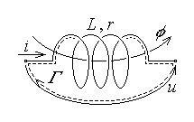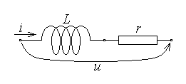
Fig. 7.5. Fig. 7.6.
where the reference directions of the electric current and voltage are associated according with the load rule (fig. 7.6). The linear nonideal coil is thus characterised by its inductance L and its conductor resistance r , and the total voltage between the terminals is composed of two components – an inductive and a resistive component – to which it corresponds the series connected equivalent circuit as in fig. 7.6.
5. The considerations presented above can be extended to the more complex configuration of a system of (ideal) coupled coils – this is a set of (ideal) coils where the lines of the magnetic field generated by any coil cross as well the surfaces of the other coils in the system (fig. 7.7).
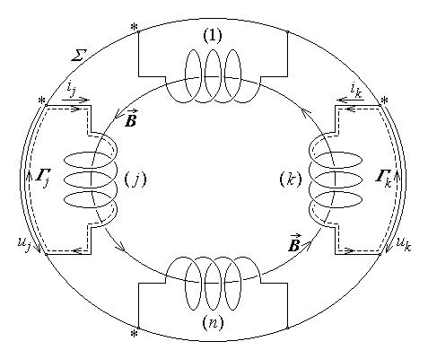
Fig. 7.7.
In order to characterise consistently such a system, the surface S_{k} of a coil k in the system is defined – as before – as the open surface bordered by the contour Γ_{k} traced along the coil conductor and closed along the voltage line across the terminals of coil k . Then the reference directions of state quantities are specified by indicating a so called marked terminal of each coil (indicated by an asterisk in fig. 7.7). The reference direction of the curent in each coil goes from the marked to the unmarked terminal, and the refernce direction of the voltage across the terminals of each coil is associated to that of the current according with the load rule. Finaly, the reference direction along the contour of each coil is the same as that of the current in the coil conductor, and the reference direction on each coil surface is associated with that on the contour according with the right-hand rule (fig. 7.7). Such a system of coupled coils is characterised by the set of self and mutual inductances, which are defined in the following for the case of linear substances.
Suppose that the current i_{j} only is injected in the marked terminal of the coil j , so that i_{j} > 0 ; it generates a magnetic field of magnetic flux density ${\vec{B}}_{j}$ with field lines crossing the surfaces of all coils in the system (fig. 7.8).
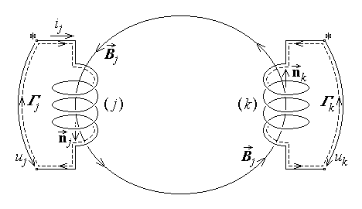
Fig. 7.8.
As in the case of a single coil, the (positive) magnetic flux of the same coil j is proportional to the (positive) generating current,
$φ_{jj}=\int{{\vec{B}}_{j}⋅{\vec{n}}_{j}} \text{dS} \text{\sim } i_{j}$ ,
so that the positive self inductance of this coil can be defined as
$L_{jj}=\frac{φ_{jj}}{i_{j}}=\frac{φ_{j}|_{ i_{s}=0 , s≠j}}{i_{j}}0$ .
The labels in the double subscript used above signify: the first – the place where the magnetic flux is computed (here – the coil j), the second – the place where the generating current is injected (here – the coil j).
On the other hand, the magnetic field lines generated by the only current i_{j} determine a so called induced magnetic flux in any another coil k , which is also proportional to the generating current,
$φ_{\text{kj}}=\int{{\vec{B}}_{j}⋅{\vec{n}}_{k}} \text{dS} \text{\sim } i_{j}$ .
This way, a mutual (or coupling) inductance between coils k and j can be defined as
$L_{\text{kj}}=\frac{φ_{\text{kj}}}{i_{j}}=\frac{φ_{k}|_{ i_{s}=0 , s≠j}}{i_{j}}$ .
It is obvious that the sign of such a mutual inductance is determined by the relative orientation of the vectors ${\vec{B}}_{j}$ and ${\vec{n}}_{k}$ – it can be positive or negative.
Suppose now that electric currents i_{j} are injected in each coil j of the system, with the algebraic sign determined relative to the corresponding reference directions; by virtue of the linearity, the magnetic flux in each coil k is the superposition (algebraic sum) of the fluxes generated by each current,
$φ_{k}=\sum_{j=1}^{n}{φ_{\text{kj}}}=\sum_{j=1}^{n}{L_{\text{kj}} i_{j} }, k=1,\text{.}\text{.}\text{.},n$ .
These linear relations are called Maxwell’s equations of the system of (linear) coupled coils and constitute the state (or constitutive) equations of such a system.
Some additional remarks are useful, relative to the set of self and mutual inductances.
First, as it was already discussed, the self inductances are always positive, as a consequence of the rules for associating the refernce directions of the generating electric current i_{j} and the resulting magnetic flux φ_{jj} , and the way the curents generate a magnetic field.
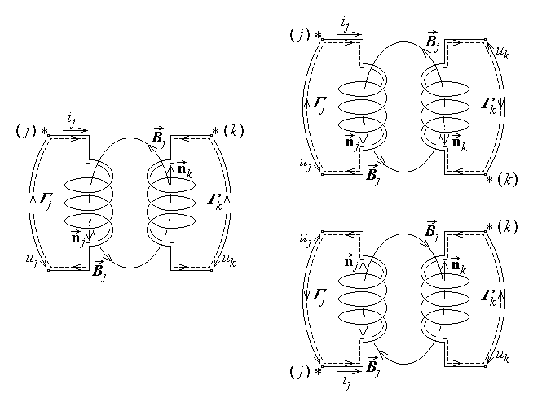
Fig. 7.9.
Second, as it was also argued, the sign of a mutual inductance depends on the
relative orientations of the terms ${\vec{B}}_{j}$ and ${\vec{n}}_{k}$ in the integrand defning the induced flux φ_{kj} . In turn, these orientations depend on the choice of the marked terminals of the coils involved: the inducing coil j and the induced coil k . Indeed, for the argument, let these two coils be considered with the marked terminals as in fig. 7.9 left. Since ${\vec{B}}_{j}$ and ${\vec{n}}_{k}$ point in the same direction, it obviously follows that ${\vec{B}}_{j}⋅{\vec{n}}_{k}>0$ , so that φ_{jk} > 0 and, with i_{j} > 0 , L_{kj} > 0 . If one changes the marked terminal of the induced coil k (fig. 7.9 up right), then the normal unit vector ${\vec{n}}_{k}$ reverses its direction and, since now ${\vec{B}}_{j}⋅{\vec{n}}_{k}<0$, it follows that φ_{jk} < 0 and, with i_{j} > 0 , L_{kj} < 0 . Moreover, by the same argument, this sign reversal happens then to all mutual inductances L_{kj} (j = 1,…,n) relative to the coil k . Returning to the initial choice (fig. 7.9 left) of marked terminals, suppose now that one changes the marked terminal of the inductor coil j (fig. 7.9 down right) and, with a view to maintain i_{j} > 0 , the generating current also reverses its direction. As a consequence, the direction of the field lines ${\vec{B}}_{j}$ reverse their orientation, so that the sign of all products ${\vec{B}}_{j}⋅{\vec{n}}_{k}$ is reversed. It follows that, as well, all magnetic fluxes φ_{kj} , determined by the current i_{j} reverse their sign and all corresponding mutual inductances L_{kj} (k = 1,…,n) also reverse their sign. As a general rule, changing the marked terminal of a coil determines the reversal of the sign of all mutual inductances relative to that coil.
Finally, by using energy related arguments, it can be proved that the mutual inductances satisfy the symmetry (or reciprocity) relation
$L_{\text{kj}}=L_{\text{jk}} , j,k=1,\text{.}\text{.}\text{.},n$
and the set of self and mutual inductances satisfy the dominance relation
$L_{\text{jj}}≥\sum_{k=1 , k≠j}^{n}{\left|L_{\text{kj}}\right|} , j=1,\text{.}\text{.}\text{.},n$ .
6. The operating equations of the system of coupled (linear) ideal coils are expressed in terms of quantities at coil terminals only: currents i_{k} and voltages u_{k} ,

associated according with the load rule. The starting point is again Faraday’s law (on electromagnetic induction) relative to the contour Γ_{k} of the surface S_{k} of an arbitrary coil k in the system (fig. 7.10),
$e_{Γ_{k}}=− \frac{d}{dt}φ_{S_{k}}$ .
On the left-hand side, the induced e.m.f. along the closed line Γ_{k} , that is the total electric voltage along it, is
$e_{Γ_{k}}=u_{Γ_{k}}=u_{C k}+\left(−u_{k}\right)=− u_{k}$ ;
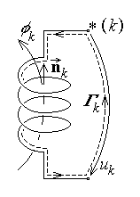
Fig. 7.10.

on the right-hand side, the magnetic flux over the coil surface S_{k} is again $φ_{S_{k}}=φ_{k}=$
$=\sum_{j=1}^{n}{L_{\text{kj}}i_{j}}$ . It follows that
$− u_{k}=− \frac{{dφ}_{k}}{dt}=− \frac{d}{dt}\sum_{j=1}^{n}{L_{\text{kj}}i_{j}}$ ,
whence the operating equations of the system of coupled (linear) ideal coils,
$u_{k}=\frac{{dφ}_{k}}{dt}=\sum_{j=1}^{n}{L_{\text{kj}} \frac{{di}_{j}}{dt}} , k=1,\text{.}\text{.}\text{.},n$ .
7. Some examples are worth discussing, for the illustration of the way the self and mutual inductances are computed.
Let a so called very long solenoid be considered as in fig. 7.11, consisting of N turns of a filamentary conducting wire, wound over a length l around a cylindrical core of permeability μ and cross section S . Such a coil is considered as very long when its length l is very large with respect to the diameter d of its cross section, written symbolicaly as $l≫\sqrt{S}$ . Let the coil conductor carry a specified electric conduction current of intensity i ; the refernce direction of the magnetic flux of the coil is then indicated by the normal unit vector $\vec{n}$ associate to the current direction according with the right-hand rule. In the core, the magnetic field lines $\vec{B}$ have the the same direction as
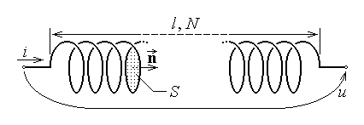
Fig. 7.11.
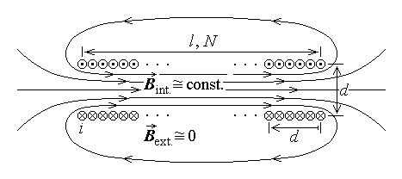
Fig. 7.12.
the normal unit vector, as it can be easily verified by invoking Biot–Savart–Laplace’s formula, and close outside the coil. This is illustrated in the simplified axial cross section in fig. 7.12, where the ×–marked small circles indicate cross sections of the coil conductor carying the curent normaly into the figure and the ⋅–marked small circless indicate cross sections of the coil conductor carying the curent normaly from the figure. In the central region of the solenoid the field lines are parallel to the axis; a curvature can be noted as one approaches the ends of the structure, and the lines of the outer field are essentially closing sufficiently far from the winding, as it is seen in the same fig. 7.12.
One can now consider an approximation of the magnetic field distribution, as follows. Accurate computations show that the the field nonuniformity towards the core extremities is sensed inside the coil on a distance of the order of d . Since d is by hypothesis negligible with respect to the core length l , one may assume a uniform inner field everywhere inside the coil core, the curvature of the field lines beginning outside the coil core in the axial direction, and a zero field immediately outside the coil plates in the radial direction (fig. 7.13). The computation of the self inductance of the very long solenoidal coil is done for this approximation of the magnetic field distribution.
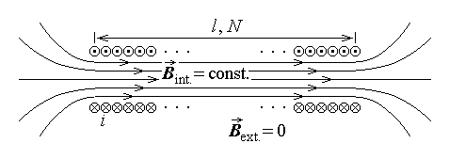
Fig. 7.13.
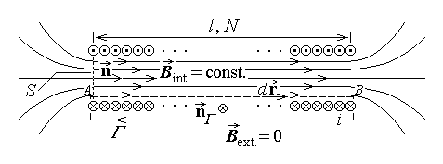
Fig. 7.14.
Let a closed rectangular line Γ be considered, following a field line inside the core and closing outside it, very near to the winding (fig. 7.14); for the indicated direction of the contour, the direction of the associated normal unit vector ${\vec{n}}_{Γ}$ to the surface S_{Γ} according to the right-hand rule points in the direction of the current i . Ampere’s law invoked for this contour under quasi–steady state conditions,
$u_{\text{mm} Γ}=i_{S_{Γ}}$ ,
gives
$u_{\text{mm} Γ}=\oint{\vec{H}⋅d\vec{r}}=\int{\text{Hdr} \text{cos}0}+\int{\text{Hdr} \text{cos}\frac{π}{2}+\int{0⋅d\vec{r}}}=$
$=H \int{\text{dr}}=H l$
for the left-hand side and
$i_{S_{Γ}}\text{=+} N i$
for the right-hand side. Equating the two sides results in the value of the inner uniform magnetic field strength,
$H=\frac{N i}{l}$ .
The total magnetic flux φ can be decomposed in the flux φ_{int.} corresponding to the inner field, which, by virtue of the preceding approximation, is N times the flux φ_{turn} over the surface of a single turn, and the flux φ_{ext.} corresponding to the outer field, supposed to be negligible in the neighbourhood of the winding. This gives
$φ=φ_{\text{int}\text{.}}+φ_{\text{ext}\text{.}}≃N φ_{\text{turn}}=N \int{\vec{B}⋅\vec{n} \text{dS}}=N \int{μH \text{cos} 0} \text{dS}=$
$=N μ \frac{N i}{l} \int{\text{dS}}=\frac{μ N^{2}i}{l}S$ .
The computation of the coil (self) inductance is now straightforward,
$L=\frac{φ}{i}=\frac{μ N^{2}i S/l}{i}$ ,
resulting in
$L=\frac{μ N^{2}S}{l}$ :
the inductance is generally proportional to the cross section surface of the coil and inversely proportional to its length; moreover, it depends quadratically on the number of turns of the coil conductor.
8. Let now a system of two coupled coils be considered, as illustrated in fig. 7.15 and let the computation of the mutual inductance between these coils be considered. The outer coil 1 is a very long solenoid of N₁ turns over a length l₁ and core permeability μ , the inner coil 2 is a very flat coil of N₂ turns of surface S₂ , and the axes of the two coils subtend an angle α . An axial cross section is presented in fig. 7.16, where the directions × and ⋅ indicate here the reference directions along the coil conductors, associated with the corresponding marked terminals. Since, according with the symmetry relation of mutual inductances, $L_{\text{12}}=L_{\text{21}}$ , it is sufficient to consider that one which can be computed more readily.
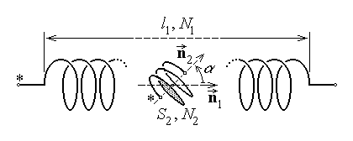
Fig. 7.15.
Let a current i₁ be injected in the marked terminal of the first coil, which determines a magnetic field ${\vec{B}}_{1}$ of approximate distribution as in the previous example (fig. 7.17). The uniform field strength in the central region of the solenoid, where the flat coil 2 is placed, is then
$H_{1}=\frac{N_{1} i_{1}}{l_{1}}$ .
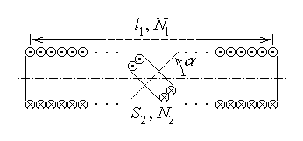
Fig. 7.16.
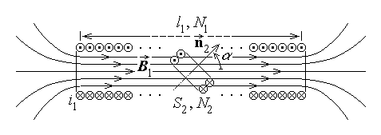
Fig. 7.17.
Assuming the same approximation as in the previous example for the computation of the magnetic flux of coil 2 determined by the current in coil 1 , one obtains
$φ_{\text{21}}=φ_{\text{int}\text{.} \text{21}}+φ_{\text{ext}\text{.} \text{21}}≃N_{2} φ_{\text{turn} \text{21}}+0=N_{2} \int{{\vec{B}}_{1}⋅{\vec{n}}_{2} \text{dS}}=N_{2} \int{{μH}_{1} \text{cos}α} \text{dS}=$
$=N_{2} μ \frac{N_{1} i_{1}}{l_{1}} \text{cos}α \int{\text{dS}}=N_{2} μ \frac{N_{1} i_{1}}{l_{1}} \text{cos}α⋅S_{2}$ .
The computation of the mutual inductance is now straightforward,
$L_{\text{12}}=L_{\text{21}}=\frac{φ_{\text{21}}}{i_{1}}=\frac{μ N_{2}N_{1} i_{1} S_{2} \text{cos}α /l_{1}}{i_{1}}$ ,
resulting in
$L_{\text{12}}=L_{\text{21}}=\frac{μ N_{1}N_{2} S_{2} \text{cos}α}{l_{1}}$ .
Thus this mutual inductance is proportional to the cross section surface of the inner coil and inversely proportional to the length of the outer coil; moreover, it is also proportional to the the number of turns of each coil and the cosine of the angle between the coil axes. This last dependence shows that the computed mutual inductance is positive if 0 < α < π/2 and negative if π/2 < α < π (for the assumed marked terminals).

7.2. Magnetic circuits
1. A magnetic circuit is a set of pieces of highly permeable (usualy – ferro-magnetic) substances and magnetic field sources, where the magnetic field is much more intense than outside it. Permanent magnets or, more often, current carying coils can be used as magnetic field sources – the latter case is considered here.
The reason for using magnetic circuits can be explained as follows. Let a uniform magnetic field be distributed in a certain domein (fig. 7.18 up); if a piece of a highly permeable (for instance, ferromagnetic) substance is placed in this domain, then the magnetic flux density $\vec{B}=μ \vec{H}=μ_{0}μ_{r} \vec{H} \left(μ_{r}≫1\right)$ is much more intense in the ferromagnetic piece than outside it. Moreover, the magnetic field lines are concentrated in this highly permeable domain (fig. 7.18 down).
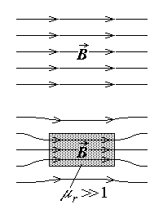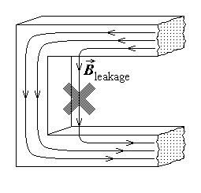
Fig. 7.18. Fig. 7.19.
The study of magnetic circuits can be simplified if the following simplifying hypotheses are assumed to hold.
1°. The leakage magnetic flux is taken as negligible.
$Φ_{\text{leakage}}≃0$ .
The meaning of this fundamental simplifying hypothesis is clarified if reference is made to the previous argument: there are generaly magnetic field lines inside and outside the highly permeable pieces of a magnetic circuit (fig. 7.19). The hypothesis simply states that the contribution to the magnetic flux coming from the field lines outside the ferromagnetic pieces (the so called leakage magnetic field) is considered to be negligible,
2°. The magnetic flux density is considered to be uniformly distributed over every cross section S of the magnetic circuit (fig. 7.20),
$\vec{B} |_{ S}≃\text{const}\text{.}$ .
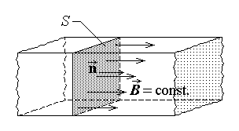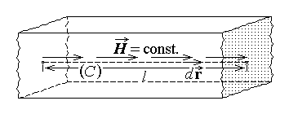
Fig. 7.20. Fig. 7.21.
An immediate consequence is a simple proportionality relationship between the magnetic flux and the magnetic flux density,
$Φ=Φ_{S}=\int{\vec{B}⋅\vec{n} \text{dS}}=\int{B \text{cos} 0⋅\text{dS}}=B \int{\text{dS}}=B S$ ,
where the normal unit vector $\vec{n}$ was taken in the same direction as the local magnetic flux density $\vec{B}$ .
3°. The magnetic field strength is considered to be constant along any field line C traced into a non-ramified part of the magnetic circuit of constant permeability μ and cross section surface S (fig. 7.21),
$\vec{H} |_{ C}≃\text{const}\text{.}$ .
An immediate consequence is a simple proportionality relationship between the magnetic voltage and the magnetic field strength,
$u_{m}=u_{m C}=\int{\vec{H}⋅d\vec{r}}=\int{H \text{dr} \text{cos} 0}=H \int{\text{dr}}=H l$ ,
where the integration element $d\vec{r}$ along the field line of length l was taken in the same direction as the local magnetic field strength $\vec{H}$ .
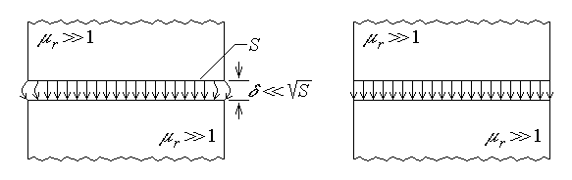
Fig. 7.22.
4°. A supplementary simplifying hypothesis often invoked refers to the so called air gaps, which are simply non-ferromagnetic gaps separating the ferromagnetic pieces of a magnetic circuit. The length δ of an airgap is taken in the direction of the field lines, while its surface is taken as the surfaces S of the limting ferromagnetic pieces (fig. 7.22 left). It can be shown that the magnetic field lines in the air gap leave or enter almost normaly the highly permeable domains. It means that, in an airgap with parallel limiting surfaces, the magnetic field lines are mostly normal to these surfaces and are curved only toward the ends of the ferromagnetic pieces, and this determines a larger cross section surface of the magnetic flux in the air gap as compared to that within the adjacent ferromagnetic pieces. The hypothesis often used states that, if the length of an airgap is negligible with respect to its transverse dimensions (symbolicaly, if $δ ≪\sqrt{S}$ ) , then the curvature of the magnetic field lines toward the edges of the air gap can be neglected, so that the cross section surface of the magnetic flux is the same in the air gap as it is in the adjacent ferromagnetic pieces of the magnetic circuit (fig. 7.22 right),
$S_{0}≃S_{f}$ .
2. Three important consequences of the preceding simplifying assumptions can be formulated now.
(1) The state of a magnetic circuit is characterised simply in terms of the magnetic fluxes over the cross section of any non-ramified piece of it. Indeed, the local magnetic flux density is simply computed as a consequence of the second simplifying hypothesis as
$B=\frac{Φ}{S}$ ,
and the magnetic field strength follows from the magnetic constitutive equation,
$H=\frac{B}{μ}$ ,
in a substance supposed free of any permanent magnetisation (${\vec{M}}_{p}=0$ ) . As well, the inductances of coils eventualy wound on ferromagnetic pieces of the magnetic circuit can be computed quite readily. According to the first simplifying hypothesis, there is no magnetic flux outside the ferromagnetic pieces (except within the air gaps), so that the total magnetic flux of such a coil is simply
$Φ_{\text{total}}=Φ_{\text{int}\text{.}}+Φ_{\text{ext}\text{.}}=N Φ$
where N is the number of turns of the coil under consideration and Φ , the magnetic flux over the cross section, is just the magnetic flux over the surface of any turn (fig. 7.23).
(2) A magnetic circuit can be studied with reference to the so called median field line in each non-ramified piece of it, i.e. the line traced through the centers of successive cross sections of such a piece. Indeed, since the magnetic flux density is distributed uniformly over any cross section, one can consder its value at any point; then, since the magnetic field strength is constant along any field line in a non-ramified part of the magnetic circuit, it is natural to consider the line of medium length, that is just the median field line defined as above.
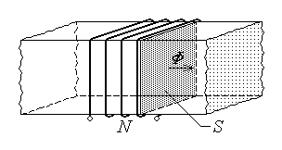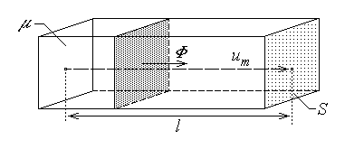
Fig. 7.23. Fig. 7.24.
(3) A simple relationship can be formulated between the magnetic voltage U_{m} along a non-ramified segment of a magnetic circuit, of constant permeability μ , length l and cross section surface S , and the magnetic flux Φ over any cross section of such a segment (fig. 7.24). The third and second simplifying assumptions, respectively, give
$U_{m}=H l , Φ=B S$ ,
whence
$\frac{U_{m}}{Φ}=\frac{H}{B} \frac{l}{S}$ .
Taking into account now the magnetic constitutive equation (in the absence of the permanent magnetisation),
$\vec{B}=μ \vec{H}$ ,
it follows that
$\frac{U_{m}}{Φ}=\frac{1}{μ} \frac{l}{S}$ .
Let the (magnetic) reluctance of the considered part of the magnetic circuit be defined as
$R_{m}=\frac{l}{μ S}$ ,
then the last equation can be rewritten as
$U_{m}=R_{m} Φ$ ,
which constitutes Ohm’s equation for magnetic circuits.
3. The state variables of a magnetic circuit – the set of magnetic fluxes over the cross section of any non-ramified part of the circuit – are determined by invoking Kirchhoff’s theorms for magnetic circuts.
Kirchhoff’s flux theorem is valid for a node, i.e. a ramification point of the median field lines; more precisely, for a ramification region in the magnetic circuit (fig. 7.25). A node a can be included into a closed surface Σ crossing all the ferromagnetic pieces of the magnetic circuit containing the median field lines concurrent in this node. Let Dirac’s law (of the magnetic flux) be invoked with reference to the surface Σ ,
$Φ_{Σ}=0$ .
Taking into account the first simplifying hypothesis, on the left-hand side, the total magnetic flux over the closed surface Σ is reduced to the algebraic sum of magnetic fluxes over the cross sections S_{k} of the ferromagnetic pieces of the magnetic circuit crossed by the surface Σ , that is the algebraic sum of magnetic fluxes Φ_{k} associated with the median field lines concurrent in the node a ,
$Φ_{Σ}=\oint{\vec{B}⋅\vec{n} \text{dS}}=\sum_{S_{k} ⊂ Σ}{\int{{\vec{B}}_{k}⋅\left(±{\vec{n}}_{k}\right) \text{dS}}}=\sum_{S_{k} ⊂ Σ}{\left(±Φ_{k}\right)}=\sum_{k ∈ \left(a\right)}{Φ_{k}}$ .
It simply follows that
$\sum_{k ∈ \left(a\right)}{Φ_{k}}=0$ ,
where the plus sign is assigned to magnetic fluxes leaving the node and the minus sign is assigned to magnetic fluxes entering the node.
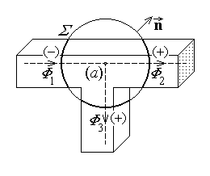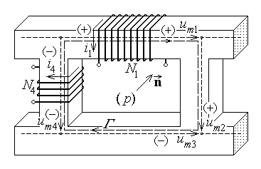
Fig. 7.25. Fig. 7.26.
Kirchhoff’s voltage theorem is formulated for a loop p (fig. 7.26) considered in a magnetic circuit as the union of branches k along a contour Γ traced along the median lines in successive branches assembled into a closed line. Ampere’s law is invoked for this contour under quasi-steady state conditions,
$u_{\text{mm} Γ}=i_{S_{Γ}}$ .
On the left-hand side, the m.m.f. is just the algebraic sum of magnetic voltages U_{mk} along the median lines C_{k} in the branches k of the contour Γ , that is in the loop p ,
$u_{\text{mm} Γ}=\oint{\vec{H}⋅d\vec{r}}=\sum_{C_{k} ⊂ Γ}{\int{{\vec{H}}_{k}⋅\left(±d{\vec{r}}_{k}\right)}}=\sum_{C_{k} ⊂ Σ}{\left(±U_{m k}\right)}=\sum_{k ∈ \left(p\right)}{U_{m k}}$ ;
by taking into account Ohm’s equation for each branch k , this reduces to
$u_{\text{mm} Γ}=\sum_{k ∈ \left(p\right)}{R_{m k} Φ_{k}}$ .
On the other hand, the total electric conduction current crossing the surface S_{Γ} in the direction $\vec{n}$ associated to that along the contour Γ according with the right-hand rule, is
$i_{S_{Γ}}≡\sum_{k ∩ S_{Γ}}{N_{k} \left(±i_{k}\right)}=\sum_{k ∈ \left(p\right)}{N_{k} i_{k}}$ .
The reference to the normal unit vector $\vec{n}$ for determining the sign of the so called ampere–turns N_{k} i_{k} of coils wound around the branches of the considered loop can be substituted by a direct reference to the direction of the loop itself: it is easy to see that positive ampere–turns (when the current crosses the surface S_{Γ} in the direction of the normal $\vec{n}$ ) correspond to the fact that the direction of the current and the reference direction of the loop are associated according with the right-hand rule, while negative ampere–turns (when the current crosses the surface S_{Γ} in the direction opposite to that of the normal $\vec{n}$ ) correspond to the fact that the direction of the current and the reference direction of the loop are associated according with the left-hand rule. Equating the expressions found for the two sides, it finally follows that
$\sum_{k ∈ \left(p\right)}{R_{m k} Φ_{k}}=\sum_{k ∈ \left(p\right)}{N_{k} i_{k}}$ .
Kirchhoff’s equations for magnetic circuits derived above, along with Ohm’s equation for magnetic circuits, are quite similar to the corresponding Kirchhoff’s equations (in the absence of current generators) and Ohm’s equation (for passive elements) for D.C. circuits:
$\begin{matrix}\sum_{k ∈ \left(a\right)}{Φ_{k}}=0 & ⇔ & \sum_{k ∈ \left(a\right)}{I_{k}}=0 \\ \sum_{k ∈ \left(p\right)}{R_{m k} Φ_{k}}=\sum_{k ∈ \left(p\right)}{N_{k} i_{k}} & ⇔ & \sum_{k ∈ \left(p\right)}{R_{k} I_{k}}=\sum_{k ∈ \left(p\right)}{E_{k}} \\ U_{m}=R_{m} Φ & ⇔ & U=R I\end{matrix}$ .
Moreover, the definition of the (magnetic) reluctance is similar to that of the (electric) resistance of a non-ramified conductor of constant cross section snd resistivity / conductivity,
$R_{m}=\frac{l}{μ S} ⇔ R=\frac{ρ l}{S}=\frac{l}{σ S}$ .
Magnetic circuits | Φ | U_{m} | N i | R_{m} | μ
D.C. circuits | I | U | E | R | σ = 1/ρ
It can be concluded that an analogy exists between magnetic circuits and D.C. circuits, under the above mentioned suppositions, as illustrated in the table above.
An immediate consequence of this analogy is that all theorems valid for linear D.C. circuits (without current generators) can be translated into similar theorems for linear magnetic circuits.
4. As an application, let a very simple magnetic circuit be considered, consisting of an upper U–shaped and an lower I–shaped ferromagnetic parts separated by identical air gaps (fig. 7.27). Let $μ=μ_{0} μ_{r}$ be the permeability of the ferromagnetic pieces, S their cross section surface, l_{f} the length of the median field line in the ferromagnetic pieces of the magnetic circuit, and $δ≪\sqrt{S}$ the length of the air gaps. Let also a coil of N turns carying the electric conduction current of intensity i be wound around the upper piece of the magnetic circuit.
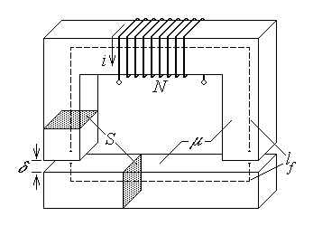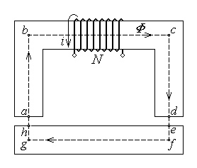
Fig. 7.27. Fig. 7.28.
The study of such a magnetic circuit consists in determining first the magnetic flux over any cross section of it. There is no ramification in the magnetic circuit, so that a single closed median field line Γ = abcdefgha can be traced in the magnetic circuit, with the direction associated to that of the current according with the right-hand rule. Invoking the analogy marked above with D.C. circuits, an equivalent circuit can be drawn, as illustrated in fig. 7.28, where the symbols used are those common in the representation of D.C. circuits. Since there is no ramification in the magnetic circuit, there is a single magnetic flux Φ to be determined, and Kirchhoff’s voltage equation is sufficient,
$R_{m \text{ab}}Φ+R_{m \text{bc}}Φ+R_{m \text{cd}}Φ+R_{m \text{de}}Φ+R_{m \text{ef}}Φ+R_{m \text{fg}}Φ+R_{m \text{gh}}Φ+R_{m \text{ha}}Φ=N i$ ,
or
$\left(R_{m \text{ab}}+R_{m \text{bc}}+R_{m \text{cd}}+R_{m \text{de}}+R_{m \text{ef}}+R_{m \text{fg}}+R_{m \text{gh}}+R_{m \text{ha}}\right) Φ=N i$ .
The (magnetic) reluctances are
$R_{m \text{ab}}=\frac{l_{\text{ab}}}{μ S} , R_{m \text{bc}}=\frac{l_{\text{bc}}}{μ S} , R_{m \text{cd}}=\frac{l_{\text{cd}}}{μ S} , R_{m \text{de}}=\frac{l_{\text{de}}}{μ S}=\frac{δ}{μ_{0} S}$ ,
$R_{m \text{ef}}=\frac{l_{\text{ef}}}{μ S} , R_{m \text{fg}}=\frac{l_{\text{fg}}}{μ S} , R_{m \text{gh}}=\frac{l_{\text{gh}}}{μ S} , R_{m \text{ha}}=\frac{l_{\text{ha}}}{μ S}=\frac{δ}{μ_{0} S}$ ,
and can be grouped into
$R_{f}=R_{m \text{ab}}+R_{m \text{bc}}+R_{m \text{cd}}+R_{m \text{ef}}+R_{m \text{fg}}+R_{m \text{gh}}=$
$=\frac{l_{\text{ab}}+l_{\text{bc}}+l_{\text{cd}}}{μ S}+\frac{l_{\text{ef}}+l_{\text{fg}}+l_{\text{gh}}}{μ S}=\frac{l_{f}}{μ S}=\frac{l_{f}}{μ_{0}μ_{r} S}$
and
$R_{0}=R_{m \text{de}}+R_{m \text{ha}}=2 \frac{δ}{μ_{0} S}$ .
The magnetic flux results then as
$Φ=\frac{N i}{R_{f}+R_{0}}=\frac{N i}{\frac{l_{f}}{μ_{0}μ_{r} S}+\frac{2 δ}{μ_{0} S}} ⇒$ $Φ=\frac{μ_{0} S N i}{\frac{l_{f}}{μ_{r}}+2 δ}$ .
It is afterwards quite simple to derive all other field quantity of interest. The magnetic flux density (the same in the ferromagnetic pieces as in the air gaps) is
$B=\frac{Φ}{S}=\frac{μ_{0} N i}{\frac{l_{f}}{μ_{r}}+2 δ}$ ,
and the magnetic field strength is
$H_{f}=\frac{B}{μ}=\frac{B}{μ_{0}μ_{r}}=\frac{N i}{l_{f}+2 μ_{r} δ} , H_{0}=\frac{B}{μ_{0}}=\frac{N i}{\frac{l_{f}}{μ_{r}}+2 δ}$
in the ferromagnetic parts and air gaps, respectively.
It is also easy to compute the inductance of the coil,
$L=\frac{Φ_{\text{total}}}{i}=\frac{N Φ}{i}=\frac{N}{i} \frac{μ_{0} S N i}{\frac{l_{f}}{μ_{r}}+2 δ} ⇒$ $L=\frac{μ_{0} S N^{2}}{\frac{l_{f}}{μ_{r}}+2 δ}$ .
The relative permeability μ_{r} of the ferromagnetic parts of a magnetic circuit is usually quite great, so that the term 2δ is often significantly greater than the term l_{f} /μ_{r} . Under the hypothesis that $μ_{r}≫1$ , the above results are rewritten as
$Φ=\frac{μ_{0} S N i}{\frac{l_{f}}{μ_{r}}+2 δ} \vec{μ_{r}≫1} Φ≃\frac{μ_{0} S N i}{2 δ}$ ,
$B=\frac{μ_{0} N i}{\frac{l_{f}}{μ_{r}}+2 δ} \vec{μ_{r}≫1} B≃\frac{μ_{0} N i}{2 δ}$ ,
$H_{f}=\frac{N i}{l_{f}+2 μ_{r}δ} \vec{μ_{r}≫1} H_{f}≃0 , H_{0}=\frac{N i}{\frac{l_{f}}{μ_{r}}+2 δ} \vec{μ_{r}≫1} H_{0}≃\frac{N i}{2 δ}$ ,
$L=\frac{μ_{0} S N^{2}}{\frac{l_{f}}{μ_{r}}+2 δ} \vec{μ_{r}≫1} L≃\frac{μ_{0} S N^{2}}{2 δ}$ .
Such results allows one to state that there are the air gaps that essentialy determine the performance of a magnetic circuit.

7.3. Magnetic energy and magnetic forces
1. The theorem of electromagnetic energy gives a method of computing the magnetic energy stored in an magnetic system, that is in a system where there is a magnetic field. The magnetic energy is computed as the volume integral of the magnetic energy density over the domain D_{Σ} of the sistem under consideration (fig. 7.29),
$W=\int{w \text{dV}}$ .
In the above relation the magnetic energy density is
$w=\frac{\vec{H}⋅\bar{B}}{2}$
in the case of linear substances and
$w=\int{\vec{H}⋅d\vec{B}}$
(that is the gray area in fig. 7.30) in the case of nonlinear substances, under the natural convention for the reference of the magnetic energy (no energy when no field is present).
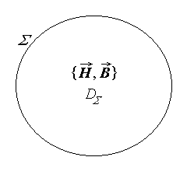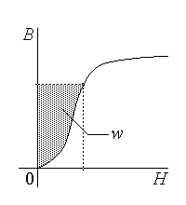
Fig. 7.29. Fig. 7.30.
This method is not so simple: it supposes that the magnetic field is known everywhere in the domain D_{Σ} and the subsequent computation of the integrals. A simpler approach is possible when the magnetic field is concentrated in magnetic systems similar to coils. The magnetic energy is then concentrated as well inside such coils and can be computed simply as the sum of contributions coming from each coil,
$W=\sum_{k}{ W_{\text{coil} k}}$ .
The problem is thus transferred to the computation of the magnetic energy stored inside a coil.
2. Let an ideal (linear) coil be considered (fig. 7.31), its conductor carrying an electric conduction i under the electric voltage u . Since the storage of magnetic energy is the only energy transfer process present, the elementary increase dW of the magnetic energy associated with the current i during an elementary time interval dt corresponds to the magnetic power P received across the surface Σ at the terminals, as given by the theorem of power transfer at the terminals of the corresponding ideal circuit element,
$\frac{dW}{dt}=P , P=u i$ .
Taking into account the operation equation of the (linear) coil,
$P=u i=L\frac{di}{dt}⋅i=\frac{d}{dt} \frac{L i^{2}}{2}$ ,
meaning that
$\frac{d}{dt}W=\frac{d}{dt} \frac{L i^{2}}{2}$ .
The equality between these derivatives results in
$W=\frac{L i^{2}}{2}+\text{const}\text{.}$ ,
where the value of the constant is determinad by assuming a conventional reference of the energy. Using again the natural convention (zero energy for a coil with no current), it is easy to see that the constant is null; the magnetic energy stored in a coil is thus
$W=\frac{L i^{2}}{2}=\frac{φ^{2}}{2 L}=\frac{φ i}{2}$ ,
where the constitutive equation of the coil was also invoked.
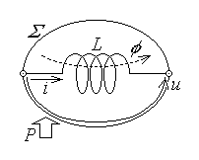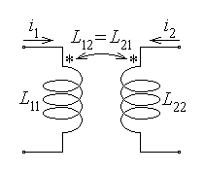
Fig. 7.31. Fig. 7.32.
The last expression can be extended in order to compute the magnetic energy stored in a system of ideal (linear) coupled coils,
$W=\sum_{k=1}^{n}{W_{\text{coil} k}} ⇒$ $W=\sum_{k=1}^{n}{\frac{φ_{k} i_{k}}{2}}$ ,
or, by using the constitutive equation of the system, under a more detailed form,
$W=\sum_{k=1}^{n}{\left(\sum_{j=1}^{n}{L_{\text{kj}} i_{j}}\right) \frac{i_{k}}{2}} ⇒ W=\sum_{k=1}^{n}{\sum_{j=1}^{n}{\frac{L_{\text{kj}} i_{k} i_{j}}{2}}}$ .
As a simple example, the magnetic energy stored in a system of only two coupled coils (fig. 7.32) is
$W=\sum_{k=1}^{2}{\sum_{j=1}^{2}{\frac{L_{\text{kj}} i_{k} i_{j}}{2}}}=\frac{L_{\text{11}}i_{1}i_{1}}{2}+\frac{L_{\text{12}}i_{1}i_{2}}{2}+\frac{L_{\text{21}}i_{1}i_{2}}{2}+\frac{L_{\text{22}}i_{2}i_{2}}{2}=$
$=\frac{L_{\text{11}}i_{1}^{2}}{2}+\frac{L_{\text{22}}i_{2}^{2}}{2}+L_{\text{12}}i_{1}i_{2}$ .
One can identify here the contributions to the magnetic energy coming from both self inductances and a contribution coming from the mutual inductance.
3. The magnetic field is a physical system that not only stores an appropriate energy but can as well exert magnetic actions on bodies placed in it.
Some formulae are already known, which express specific magnetic actions. The magnetic force acting on a point charge q moving at a speed $\vec{v}$ placed in an magnetic field of magnetic flux density $\vec{B}$ (fig. 7.33) is given by Lorentz’s formula
$\vec{F}=q \vec{v}×\vec{B}$ ;
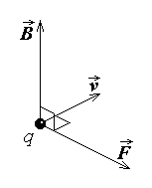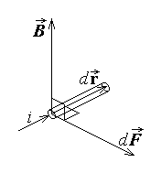
Fig. 7.33. Fig. 7.34.
the elementary magnetic force acting on an elementary segment $d\vec{r}$ of a filamentary conductor carrying the curent of intensity i placed in an magnetic field of magnetic flux density $\vec{B}$ (fig. 7.34) is given by Laplace’s formula
$d\vec{F}=i d\vec{r}×\vec{B}$ ;
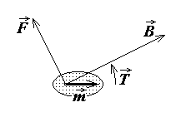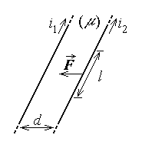
Fig. 7.35. Fig. 7.36.
the magnetic force and the magnetic torque acting on a very small magnetised body of magnetic moment $\vec{m}$ placed in an magnetic field of magnetic flux density $\vec{B}$ (fig. 7.35)
are given, respectively, by
$\vec{F}=\text{grad} \left(\vec{m}⋅\underset{↑}{\vec{B}}\right) ,\text{ \{}\vec{T}=\vec{m}×\vec{B}$ .
Finaly, Ampere’s formula expresses the force acting on the length l of each of two filamentary straight infinite conductors carrying electric currents i₁ and i₂ placed parallel at a distance d in a substance of permeability μ (fig. 7.36),
$F=\frac{μ i_{1} i_{2} l}{2 π d}$ ,
where there is an attraction force when the currents have the same direction and a repulsion force when the currents have opposite directions. These formulae are, however, very limited in scope: they refer exclusively to very small bodies or specific configurations of filamentary conductors.
The computation of the magnetic forces acting on the substance in the domain D_{Σ} in more general circumstances can be done, for instance, by performing the integration
$\vec{F}=\int{\vec{f} \text{dV}}$ ,
where the volume density of the magnetic force is
$\vec{f}=\vec{J}×\vec{B}− \frac{H^{2}}{2} \text{grad} μ +\frac{1}{2} \text{grad} \left(H^{2}τ \frac{dμ}{dτ}\right)$ .
In the above formula $\vec{B}$ is the local magnetic field density, $\vec{J}$ is the density of the electric conduction current, μ is the local permeability and τ is the local (mass) density, the last term accounting for the magnetostriction force associated to the dependence of permeability on density.
4. Another approach can be used in the case when the system with magnetic field can be decomposed into subsystems between which magnetic actions are exerted. Such a system can be characterised by appropriate state parameters – position parameters or generalised coordinates and force parameters or generalised forces, that are coupled in pairs.
A generalised coordinate is a geometric quantity able to characterise the relative position of different subsystems. A generalised force associated to a given generalised coordinate is a mechanical quantity able to modify the associated generalised coordinate. The association of a generalised coordinate x and a generalised force X is such that the elementary mechanical work done by the force for an elementary coordinate change dx is
$\text{dW}=X \text{dx}$ .
Simple examples of such couples are: In the case when the relative position of two subsystems is characterised by a position vector, that is $x →\text{ \{}\vec{r}$ , the associated generalised force is just a force, i.e. $X →\text{ \{}\vec{F}$ , so that $\text{dW}=\vec{F}⋅d\vec{r}$ . In the case when the relative position of two subsystems is characterised by a (vector) angle, that is $x → \vec{α}$ , the associated generalised force is a (vector) torque, i.e. $X →\text{ \{}\vec{T}$ , so that $\text{dW}=\vec{T}⋅d\vec{α}$ . It is recalled that a vector angle is a vector along the rotation axis, its direction being associated with the rotation according to the right–hand rule, and its modulus being equal to the rotation angle. Similarly, the vector torque is a vector along the rotation axis, its direction being associated with the rotation to be imposed according to the right–hand rule, and its modulus being equal to the magnitude of the torque. In the case when the extension of a subsystem is characterised by its volume, that is $x → V$ , the associated generalised force is a pressure, i.e. $X → p$ , so that $\text{dW}=p \text{dV}$ .
Let a magnetic system be considered, where magnetic actions are exerted by the magnetic field present. For the sake of simplicity, with no loss of generality, let the system consist of a single ideal coil (like that illustratted in fig. 7.31), where a single generalised force X is exerted.
According to the general form of the theorem of electromagnetic energy, the magnetic power received by the system across its surrounding surface Σ equals the sum between the rate of electromagnetic energy storage, the electromagnetic power transferred to the substance inside the system and the mechanical power done by the electromagnetic actions,
$P_{Σ}=\frac{{dW}_{\text{el}\text{.}−\text{mg}\text{.}}}{dt}+P_{S}+P_{\text{mech}\text{.}}$ .
In the above equation, by taking into consideration the operation equation of the ideal coil, the electromagnetic power received by the system across its surrounding surface reduces to the power received at terminals,
$P_{Σ}=P_{t}=u i=\frac{dφ}{dt} i$ ,
the electromagnetic energy reduces to the magnetic energy stored inside the coil,
$W_{\text{el}\text{.}−\text{mg}\text{.}}=W_{\text{mg}\text{.}}$ ,
the electromaagnetic power transferred to the substance inside the ideal coil is zsro,
$P_{S}=0$ ,
and the mechanical power done by the magnetic action present is the rate of time variation of the mechanical work done,
$P_{\text{mech}\text{.}}=\frac{dW}{dt}=\frac{X \text{dx}}{dt}$ .
The theorem of electromagnetic energy thus reduces to
$\frac{dφ}{dt} i=\frac{{dW}_{\text{mg}\text{.}}}{dt}+\frac{X \text{dx}}{dt}$ ,
and a simple multiplication by the elementary time interval dt gives a first energy balance equation,
$i dφ={dW}_{\text{mg}\text{.}}+X \text{dx}$ .
The last equation can be rewritten in an equivalent form, if the general formula of the magnetic energy stored in a coil is now invoked. Indeed,
${dW}_{\text{mg}\text{.}}=d \frac{φ i}{2}=\frac{i dφ+φ \text{di}}{2}$ ,
and the energy balance equation successively becomes
$i dφ=\frac{i dφ+φ \text{di}}{2}+X \text{dx} ⇔ \frac{i dφ}{2}=\frac{φ \text{di}}{2}+X \text{dx}$ .
Simple addition of the quantity $φ \text{di}/2$ to both sides results in the equation
$\frac{i dφ+φ \text{di}}{2}=φ \text{di}+X \text{dx}$ ,
where the term on the left is just the elementary increase of the magnetic energy stored inside the coil, ${dW}_{\text{mg}\text{.}}$ . This way, a second energy balance equation is obtained,
${dW}_{\text{mg}\text{.}}=φ \text{di}+X \text{dx}$ .
Let now specific processes be considered, so that the generalised force X can be computed.
Let first consider that the magnetic processes are such that the magnetic fluxes are constant: $φ=\text{const}\text{.} ⇔ dφ=0$ . The first energy balance equation then gives
$0={dW}_{\text{mg}\text{.}}|_{ φ=\text{const}\text{.}}+X \text{dx} ⇔ X \text{dx}=− {dW}_{\text{mg}\text{.}}|_{ φ=\text{const}\text{.}}$ ,
whence
$X=− \frac{∂W_{\text{mg}\text{.}}}{∂x}|_{ φ=\text{const}\text{.}}$ ,
where the partial derivatives account for the fact that, in general, the magnetic energy depends on some other parameters as well.
Let then consider that the magnetic processes are such that the magnetic voltages are constant: $i=\text{const}\text{.} ⇔ \text{di}=0$ . The second energy balance equation now gives
${dW}_{\text{mg}\text{.}}|_{ i=\text{const}\text{.}}=0+X \text{dx} ⇔ X \text{dx}={dW}_{\text{mg}\text{.}}|_{ i=\text{const}\text{.}}$ ,
whence
$X=\frac{∂W_{\text{mg}\text{.}}}{∂x}|_{ i=\text{const}\text{.}}$ ,
where again the partial derivatives are used for the same reason as before.
The two formulae obtained above represent the theorem of generalised magnetic forces that allows the computation of magnetic actions in any magnetic system, that is under more general circumstances than those under which these formulae have been derived.
Some remarks are worth mentioning.
1°. The use of the above formulae supposes that each time the magnetic energy is expressed exclussively in terms of the magnetic quantity taken as constant during derivation. In the case of a single coil, for instance, the magnetic energy is to be expressed as $W_{\text{mg}\text{.}}=\frac{φ^{2}}{2 L}$ when the flux is to be maintained constant and as $W_{\text{mg}\text{.}}=\frac{L i^{2}}{2}$ when the currrent is to be maintained constant.
2°. The two formulae represent simply two equivalent ways to compute the same generalised magnetic force. Considering again the case of a single coil, and taking into account the constitutive equation of the ideal coil, the first formula successively gives
$X=− \frac{∂W_{\text{mg}\text{.}}\left(φ,x\right)}{∂x}|_{ φ=\text{const}\text{.}}=− \frac{∂}{∂x} \frac{φ^{2}}{2 L\left(x\right)}|_{ φ=\text{const}\text{.}}=− \frac{φ^{2}}{2}\frac{∂}{∂x} \frac{1}{L\left(x\right)}=$
$=− \frac{φ^{2}}{2} \left(− \frac{1}{L^{2}}\right) \frac{∂L}{∂x}=\frac{i^{2}}{2} \frac{∂L}{∂x}$ .
On the other hand, the second formula gives
$X=\frac{∂W_{\text{mg}\text{.}}\left(i,x\right)}{∂x}|_{ u=\text{const}\text{.}}=\frac{∂}{∂x} \frac{L\left(x\right) i^{2}}{2}|_{ u=\text{const}\text{.}}=\frac{i^{2}}{2} \frac{∂L}{∂x}$ ,
which is precisely the same result.
3°. The two formulae give an algebraic result only. The direction of the

generalised force is given by the algebraic sign of the final result, relative to the reference direction indicated by the direction of the increase of the associated generalised coorcinate. This means that a positive generalised force acts in the direction of increasing generadised coordinate, while a negative generalised force acts in the direction of decreasing generalised coordinate (fig. 7.37).
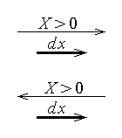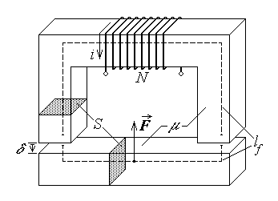
Fig. 7.37. Fig. 7.38.
5. An illustrative example is the computation of the force between the two ferromagnetic parts of the simple magnetic circuit analysed in the preceding section (fig. 7.38), when an electric current is injected into its coil.
The theorem of generalised magnetic forces can be used, for instance under its second form. One has to start by noticing that the subsystems in magnetical interaction are the two ferromagnetic parts and the corresponding generalised coordinate is obviously the air gap length δ . The generalised force is then a pure force, and it is given by
$F=\frac{∂W_{\text{mg}\text{.}}\left(i,δ\right)}{∂d}|_{ i=\text{const}\text{.}}=\frac{∂}{∂d} \frac{L\left(δ\right) i^{2}}{2}|_{ i=\text{const}\text{.}}=\frac{i^{2}}{2} \frac{∂L}{∂δ} =\frac{i^{2}}{2} \frac{∂}{∂δ} \frac{μ_{0} S N^{2}}{\frac{l_{f}}{μ_{r}}+2 δ}=$
$=\frac{i^{2}}{2} \frac{− μ_{0} S N^{2}}{{\left(\frac{l_{f}}{μ_{r}}+2 δ\right)}^{2}} ⋅2=− \frac{μ_{0} S N^{2} i^{2}}{{\left(\frac{l_{f}}{μ_{r}}+2 δ\right)}^{2}}$ .
The negative sign is easily interpreted as indicating a force acting in the direction of decreasing generalised coordinate δ . It means that between the ferromagnetic parts of the considered magnetic circuit there acts an attraction force. The magnitude of the magnetic force is
$\left|F\right|=\frac{μ_{0} S N^{2}}{{\left(\frac{l_{f}}{μ_{r}}+2 δ\right)}^{2}} i^{2}$ ,
which, if use is made of the constitutive equation, becomes
$F=\frac{μ_{0} S N^{2}}{{\left(\frac{l_{f}}{μ_{r}}+2 δ\right)}^{2}} \frac{φ^{2}}{L^{2}}=\frac{μ_{0} S N^{2}}{{\left(\frac{l_{f}}{μ_{r}}+2 δ\right)}^{2}} \frac{φ^{2} {\left(\frac{l_{f}}{μ_{r}}+2 δ\right)}^{2}}{{\left(μ_{0} S N^{2}\right)}^{2}} ⇔ F=\frac{1}{μ_{0} S N^{2}} φ^{2}$ .
Sometimes this last expression is also written as
$F=\frac{1}{μ_{0} S N^{2}} φ^{2}=\frac{S}{μ_{0} N^{2}} {\left(\frac{φ}{S}\right)}^{2}=\frac{S}{μ_{0} N^{2}} B_{0}^{2}$ ,
stressing the direct link of the magnetic force with the magnetic flux density in the airgap.
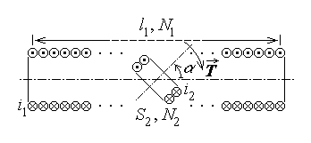
Fig. 7.39.
6. Another illustrative example is the computation of the torque acting on the inner coil of the system of two coupled coils studied in section 7.1. (fig. 7.39), when electric currents i₁ and i₂ respectively are injected in the marked terminals of the two coils and the inner coil can rotate around its diameter.
The theorem of generalised magnetic forces can be used again under its second form. The subsystems in magnetical interaction are obviously the two coils and the corresponding generalised coordinate is the angle α between the axes of the two coils. The generalised force associated with an angle as generalised coordinate is now a torque, and it is given by
$T=\frac{∂W_{\text{mg}\text{.}}\left(i,α\right)}{∂α}|_{ i=\text{const}\text{.}}=\frac{∂}{∂α} \left(\frac{L_{\text{11}}i_{1}^{2}}{2}+\frac{L_{\text{22}}i_{2}^{2}}{2}+L_{\text{12}}\left(α\right) i_{1}i_{2}\right)|_{ i=\text{const}\text{.}}=i_{1}i_{2}\frac{∂}{∂α} L_{\text{12}}\left(α\right)$ ,
since both self inductances L₁₁ and L₂₂ are obviously independent of the relative position of the two coils. Using the expression of the mutual inductance calculated before results in
$=i_{1}i_{2} \frac{∂}{∂α}\frac{μ N_{1}N_{2} S_{2} \text{cos}α}{l_{1}}=− i_{1} i_{2} \frac{μ N_{1}N_{2} S_{2} }{l_{1}} \text{sin}α$ .
Since all quantities entering the final result are positive, the negative sign is easily interpreted as indicating a torque acting in the direction of decreasing generalised coordinate α . It means that the magnetic interaction between the two coils tends to align their axes with an aligning torque of magnitude
$T=i_{1} i_{2} \frac{μ N_{1}N_{2} S_{2} }{l_{1}} \text{sin}α$ .

