6. CAPACITOR CIRCUITS

6.1. The electric capacitor
1. The ideal (electric) capacitor is the ideal dipolar circuit element where the storage of electric energy is the single energy transfer process present.
The presence of electric energy within the circuit element means that an electric field is developed within it. The presence of the electric field imposes the presence, under any conditions, of sources of such a field, i.e., the presence of some electric charge or charges. On the other hand, since there are no electric field lines that cross the surrounding surface of a circuit element, it means that all electric field lines begin and end within the dipolar circuit element, and this imposes the presence of two charges inside the element. The structure of an ideal capacitor is therefore quite simple: there are two charge carrying conductors, each connected at one of the two terminals, and separated by an insulator (fig. 6.1). Moreover, since this is an ideal circuit element, no other energy transfer process – except storage of electric energy – is present, and this means, in particular, that there is no energy transfer process associated with the electric conduction: the conductors – named plates – are perfect conductors, and the surrounding insulator is a perfect insulator.
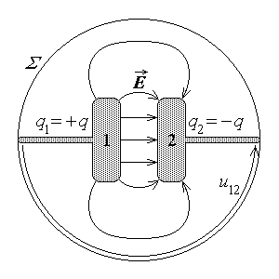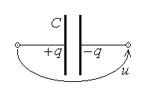
Fig. 6.1. Fig. 6.2.
The absence of electric field lines crossing the surrounding surface Σ of the ideal capacitor means that the electric flux over this surface equals zero, Ψ_{Σ} = 0 , and this means – according with Gauss’s law, $Ψ_{Σ}=q_{D_{Σ}}$ – that the total electric charge within the capacitor equals zero, $q_{D_{Σ}}=0$ . Taking into account the presence of the two charged plates, it follows that $q_{D_{Σ}}=q_{1}+q_{2}=0$ , whence the electric charge
$q_{1}=−q_{2}=q$
is the immediate state quantity able to characterise the electric state of the ideal
capacitor. On the other hand, the presence of an electric field in the insulator between the plates determines an electric voltage
$u=u_{\text{12}}=− u_{\text{21}}=\int{\vec{E}⋅d\vec{r}}$ ,
which appears as the other state quantity of the ideal capacitor. It is to be noted that the reference direction of the electric voltage is taken as going from the reference positive to the reference negative charge of the capacitor (fig. 6.2).
2. The state equation (or the constitutive equation) of the ideal capacitor is the relationship between the state quantities q and u . In the simplest case, when all substances inside the capacitor are linear, this equation is provided by the theorem of the electric capacitance. A simple argument shows that, according with Coulomb’s formula,
$\vec{E}\left(\vec{r}\right)=\frac{1}{4πε} \int{\frac{\text{dq} \vec{R}}{R^{3}}}$ ,
the electric field strength is proportional with the electric charge which generates it, $\vec{E} \text{\sim } q$ . In turn, the electric voltage,
$u=\int{\vec{E}⋅d\vec{r}}$ ,
is obviously proportional with the electric field strength, $u \text{\sim }\text{ \{}\vec{E}$ . Moreover, according with a consequence of Gauss's law of the electric flux, the electric field lines are directed from the positively (1) to the negatively (2) charged plate. The immediate conclusion is that, for an ideal linear capacitor,
$u \text{\sim }\text{ \{}\vec{E} \text{\sim } q$ :
the capacitor (positive) charge is proportional to the capacitor (positive) voltage. One can therefore introduce the (positive) proportionality constant as a characteristic of the capacitor,
$q=C u ⇔ u=\frac{1}{C} q$ ,
where C is the capacitance of the capacitor. The I.S. capacitance unit is straightforward,
$\left\langle C\right\rangle =\frac{1 C}{1 V}=1 F (\text{farad})$ .
In the case when the substances inside the capacitor are not linear, one can still obtain a nonlinear relationship between the capacitor charge and voltage, for instance
$q=C\left(u\right) u$ ,
defining a nonlinear capacitance C(u) .
3. The electric charge is, however, hiden somewhere inside the circuit element and is difficult to be sensed from outside it. Another way of characterising the electric capacitor, with reference to quantities at terminals – current and voltage – is therefore needed. This operating equation can be derived if the law of the electric charge conservation is invoked with reference to the surface σ surrounding the positive plate (fig. 6.3),
$i_{σ}=− \frac{d}{dt}q_{D_{σ}}$ .
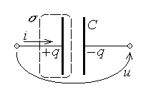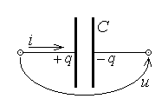
Fig. 6.3. Fig. 6.4.
On the left-hand side, the total electric current leaving the closed surface σ is i_{σ} = – i ; on the right-hand side, the electric charge inside the surface σ is $q_{D_{σ}}=q$ . It follows that
$− i=− \frac{d}{dt}q$ ,
whence the operating equation of the ideal capacitor,
$i=\frac{dq\left(u\right)}{dt}$ ,
where the reference directions of the electric current and electric voltage are associated according the load rule (fig. 6.4). In the case of a linear capacitor, where q = Cu , this equation is simplified to
$i=\frac{dq}{dt}=C \frac{du}{dt}$ .
4. The nonideal capacitor is a dipolar circuit element where the storage of electric energy is the main energy transfer process present. It means that one has to consider some additional energy transfer processes, and the first to be accounted for is obviously the energy dissipation associated with the presence of a nonideal insulator between the (perfectly conducting) plates (fig. 6.5): there is a leakage current i_{L} flowing between the capacitor plates through the insulator, determined by the capacitor voltage u , as for an ordinary resistor.
The operating equation of the linear nonideal capacitor is again obtained by invoking the law of electric charge conservation as before (fig. 6.5),
$i_{σ}=− \frac{d}{dt}q_{D_{σ}}$ .
On the left-hand side, the total electric current leaving the closed surface σ is now i_{σ} = – i + i_{L} ; on the right-hand side, the electric charge inside the surface σ is $q_{D_{σ}}=q$ . It follows that
$− i+i_{L}=− \frac{d}{dt}q$ ,
whence the operating equation of the ideal capacitor,
$i=\frac{dq}{dt}+i_{L} ⇔ i=C \frac{du}{dt}+\frac{u}{R}$ ,
where the reference directions of the electric current and voltage are associated according with the load rule (fig. 6.6). The linear nonideal capacitor is thus characterised by its
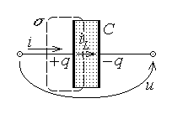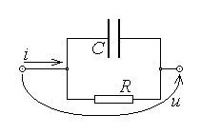
Fig. 6.5. Fig. 6.6.
capacitance C and its leakage resistance R , and the total electric current is composed of two components – a capacitive and a resistive component – to which it corresponds the parallel connected equivalent circuit as in fig. 6.6.
5. The considerations presented above need some clarifications. The electric capacitor is essentialy characterised in terms of its operation under static conditions. The electric field presents some interesting features under such conditions, with consequences in the operation of the electric capacitor and the computation of the electric capacitance.
First, according with the constitutive law of the electric conduction,
$\vec{J}=σ \vec{E}+{\vec{J}}_{i} ⇔\text{ \{}\vec{E}= \frac{\vec{J}−{\vec{J}}_{i}}{σ} → 0 \text{when} σ→ ∞$ :
the electric field strength is equal to zero in a (homogeneous) perfect conductor, where $σ=∞$ , even in the presence of an electric current.
Second, any (homogeneous) perfect conductor is an equipotential domain, V = const., since for any two points M and N in such a conductor (fig. 6.7), the potential difference between them is always zero,
$V\left(M\right)−V\left(N\right)=u_{\text{MN}}=\int{\vec{E}⋅d\vec{r}}=0$ .
This is the reason for computing the capacitor voltage as the potential difference between any two points on the two capacitor plates – in particular, between terminals.
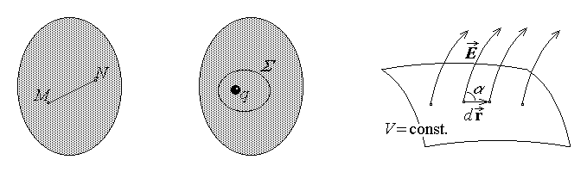
Fig. 6.7. Fig. 6.8. Fig. 6.9.
Third, under static conditions, there is no electric charge inside a perfect (homogeneous) conductor, which means that the charge of any such conductor is superficially distributed only. Indeed, if one assumes that there could be an internal distribution of charge q (fig. 6.8), then, according with Gauss’s law, for a closed surface surrounding this charge,
$Ψ_{Σ}=\oint{ε\vec{E}⋅\vec{n} \text{dS}}=q_{D_{Σ}}=q≠0$ .
This, however, would contradict the fact that, since the internal field strength is zero, then the electric flux over the surface Σ must also be zero. It folows that the assumption of a possible internal distribution of charge is false.
Fourth, the electric field lines are normal to any equipotential surface – in particular, the electric field lines in the insulator are normal to the equipotential surface of a conductor. Indeed, let M and N be two extremely close points on an equipotential surface (fig. 6.9); the voltage between these points is obtained either as
$u_{\text{MN}}=V\left(M\right)−V\left(N\right)=V−V=0$ ,
or as
$u_{\text{MN}}=\int{\vec{E}⋅d\vec{r}}≃\vec{E}⋅d\vec{r}=E \text{dr} \text{cos}α$ .
Equating the two results simply yields, since $E≠0 , \text{dr}≠0$ ,
$E \text{dr} \text{cos}α=0 ⇒ \text{cos}α=0 ⇔ α=\frac{π}{2}$ .
6. An example is worth discussing, for the illustration of the way to compute the electric capacitance of a simple linear capacitor.
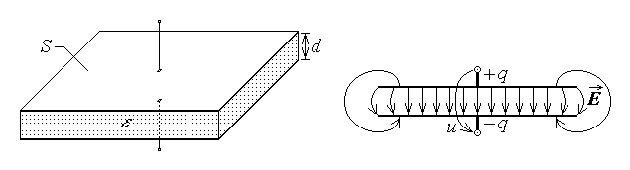
Fig. 6.10. Fig. 6.11.
Let a so called parallel–plate capacitor be considered as in fig. 6.10, where the distance d between the plates of area S is negligible with respect to the plate dimensions – simbolicaly, $d≪\sqrt{S}$ . Let also the capacitor be charged with opposite electric charges ± Q on the two plates. The electric field lines in the insulator start normaly from and arrive normaly to the plates, according with the previous discussion. In the central region between the plates the field lines are approximately normal to the plates; however, the field lines start to bend as one approaches the ends of the structure (the plates), being essentially curved outside the capacitor plates, as it is seen in fig. 6.11. Since the voltage U between the plates is the same along any field line, a simple argument shows that the outer field strength is negligible with respect to the inner field strength. Supposing, for the sake of simplicity, that the electric field strength is constant along any field line, the voltage along such a line is given by
$U=\int{\vec{E}⋅d\vec{r}}=\int{E \text{dr} \text{cos}0}≃E \int{\text{dr}}=E l$ ,
where l is the length of the field line between the plates. It is therefore obvious that the longer the field line l , the lower the electric field strength E is. That is why the most intense electric field is the inner field, where the field lines are almost straight lines and the field is nearly uniform, while the outer field is quite negligible.
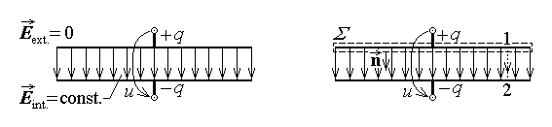
Fig. 6.12. Fig. 6.13.
One can now consider an approximation of the electric field distribution, as follows. Accurate computations show that the the field nonuniformity towards the plate extremities is sensed inside the plates on a distance of the order of d . Since d is by hypothesis negligible with respect to the plate dimensions, one may assume a uniform field everywhere between the plates and a zero field outside the capacitor plates (fig. 6.12). This way, the extension of the larger uniform field to the whole region between the plates compensates for neglecting the outside electric field. The computation of the capacitance of the parallel–plate capacitor is done for this approximate distribution of the electric field.
Let a closed surface Σ closely surrounding the upper plate be considered, with the shape of a very flat rectangular box (fig. 6.13). Gauss’s law invoked for this surface,
$Ψ_{Σ}=q_{D_{Σ}}$ ,
gives
$Ψ_{Σ}=\oint{\vec{D}⋅\vec{n} \text{dS}}=\int{ε\text{EdS} \text{cos}0}=εE \int{\text{dS} }=εE S$
for the left-hand side and
$q_{D_{Σ}}=q$
for the right-hand side. Equating the two sides results in the value of the uniform electric field strength,
$E=\frac{q}{εS}$ .
The voltage U betveen the plates can be computed along a field line 12 , giving
$U=\int{\vec{E}⋅d\vec{r}}=\int{E \text{dr} \text{cos}0}=E \int{\text{dr}}=\frac{q}{εS} d$ .
The computation of the capacitor capacitance is now straightforward,
$C=\frac{q}{U}=\frac{q}{q d/εS}$ ,
resulting in
$C=\frac{εS}{d}$ :
the capacitance is generally proportional to the insulator permittivity and plate surface and is generally inversely proportional to the distance between the plates.

6.2. Capacitor circuits
1. A capacitor circuit is a set of interconnected ideal capacitors and ideal voltage
sources operating under static state conditions. This means that all physical quantities are supposed to be constant (i.e., time–invariant) and no electric current is present.
The state of a capacitor circuit is defined by the set of state variables for each component element. Since the source e.m.f.’s E_{k} are supposed to be given and all currents are admitted to be zero, it remains to determine the electric charge and voltage for each capacitor. On the other hand, since the state equation of a capacitor links these two variables, it remains to determine a single quantity – either the charge Q_{k} , or the voltage U_{k} – for each capacitor. The equations that allow the computation of these state variables of a capacitor circuit are given by Kirchhoff’s theorems for capacitor circuits.
2. Kirchhoff’s charge theorem is valid for a so called insulated node. An insulated node is a node where all connected branches contain at least a capacitor. For instance, neither of the two nodes m and n in fig. 6.14, connected by a branch (mn) containing an ideal voltage source only, is an insulated node. On the contrary, a node a as that in fig. 6.15 is an insulated node – such a node can be included into a closed surface Σ traced in insulators only, since the surface can cross the connected branches in the insulating space between capacitor plates. Let the law of electric charge conservation be invoked with reference to the surface Σ ,
$i_{Σ}=− \frac{d}{dt}q_{D_{Σ}}$ .
On the left-hand side, the total electric conduction current leaving the closed surface is zero, i_{Σ} = 0 , since the surface is traced in insulators only. It follows that, at any moment,
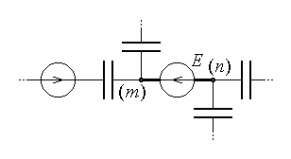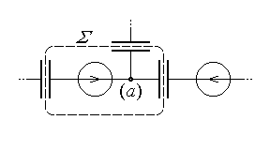
Fig. 6.14. Fig. 6.15.
$\frac{d}{dt}q_{D_{Σ}}=0 ⇔ q_{D_{Σ}}=\text{const}\text{.} ⇔ q_{D_{Σ}}\left(t\right)=q_{D_{Σ}}\left(t_{0}\right)$ .
On the other hand, the electric charge inside the closed surface is just the algebraic sum of electric charges on the capacitor plates connected to the node a under consideration,
$q_{D_{Σ}}=\sum_{k ∈ \left(a\right)}{ Q_{k}}$ ,
so that the preceding result can be written as
$\sum_{k ∈ \left(a\right)}{ Q_{k}\left(t\right)}=\sum_{k ∈ \left(a\right)}{ Q_{k}\left(t_{0}\right)} \text{for} \text{any} t \text{and} t_{0}$ .
It is usual to take the initial moment t₀ as the moment immediately before connecting the (initially charged or uncharged) capacitors into the circuit. By using the notation $Q_{k}^{0}$ for such initial capacitor charges, and neglecting any other reference to the time, Kirchhoff’s charge theorem is finally written as
$\sum_{k ∈ \left(a\right)}{ Q_{k}}=\sum_{k ∈ \left(a\right)}{ Q_{k}^{0}}$ .
It is worth noticing that an equation somewhat similar to Kirchhof’s current theorem for D.C. circuits is valid only when all capacitors are initially uncharged, $Q_{k}^{0}=0 , ∀k$ :
$\sum_{k ∈ \left(a\right)}{ Q_{k}}=0 \text{only} \text{if} \text{all} Q_{k}^{0}=0$ .
Kirchhoff’s voltage theorem is obtained by following the same argument as that used previously in section 5.2. Let a loop p be considered in a capacitor circuit, as in fig. 6.16, and let the contour Γ of the loop be traced along the voltage lines across the branches of the loop. Faraday’s law invoked for this contour,
$e_{Γ}=− \frac{d}{dt}Φ_{S_{Γ}}$ ,
gives, since no time–variation is admitted ( $\frac{d}{dt}≡0$ ) ,
$e_{Γ}=0$ .
On the other hand,
$e_{Γ}≡u_{Γ}=\sum_{k ∈ Γ}{u_{ t k}}=\sum_{k ∈ \left(p\right)}{U_{ t k}}$
is just the algebraic sum of the (constant) voltages between the terminals of the branches of the loop p under consideration. It finally follows that
$\sum_{k ∈ \left(p\right)}{U_{ t k}}=0$ .
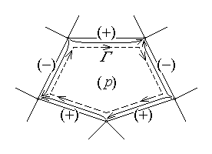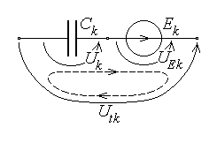
Fig. 6. 16. Fig. 6.17.
The set of Kirchhoff’s theorem has to be completed with a relationship between the variables Q_{k} and U_{tk} present in these equations – this is Joubert’s theorem for capacitor circuits. Let the most general branch of a capacitor circuit be considered, that is one containing an ideal capacitor and an ideal voltage source (fig. 6.17). The voltage lines at the terminals of the circuit elements and the voltage line between the terminals of the branch k constitute a contour Γ , for which the previous Kirchhoff’s voltage theorem can be invoked. Taking all voltages in the same direction, it gives
$U_{k}+U_{E k}−U_{ t k}=0 ⇔ U_{k}−E_{k}−U_{ t k}=0$ ,
and this finally results in Joubert’s theorem,
$U_{ t k}=U_{k}−E_{k}$ .
The substitution of the above expresion of the voltage at the terminals of a branch into the original expression of the theorem,
$\sum_{k ∈ \left(p\right)}{U_{ t k}}=0 ⇒ \sum_{k ∈ \left(p\right)}{\left(U_{k}−E_{k}\right)}=0$ ,
followed by a simple transfer of the e.m.f. terms to the right-hand side, results in the extended form of Kirchhoff’s voltage theorem,
$\sum_{k ∈ \left(p\right)}{U_{k}}=\sum_{k ∈ \left(p\right)}{E_{k}}$ .
Kirchhoff’s theorems for capacitor circuits derived above have to be completed with the constitutive equation of each capacitor,
$Q_{k}=C_{k} U_{k} ⇔ U_{k}=\frac{Q_{k}}{C_{k}}$ ,
in view of obtaining the complete set of equations needed to solve a cpacitor circuit. It is to be noted, however, that the eventual initial charges $Q_{k}^{0}$ are also needed for obtaining a correct solution.
3. As an application, two equivalence theorems are derived for capacitor circuits. The equivalence is understood here, as before, in the sense of equivalence at the terminals: two capacitor circuits are said to be equivalent if the same set of electric voltages applied between corresponding terminals determines the same set of electric charges associated with corresponding terminals, or vice-versa, for any such set. Equivalence theorems are derived in the following for a set of series– or parallel–connected initially uncharged capacitors,
$Q_{k}^{0}=0 , ∀k$ .
Let a set of n initially uncharged capacitord be considered, which are series–connected (fig. 6.18); one is interested to obtain a formula for the equivalent capacitance of such a capacitor circuit.
Kirchhoff’s voltage theorem invoked for the loop consisting of the total voltage U and the sequence of series–connected capacitors immediately gives
$U_{1}+U_{2}+\text{.}\text{.}\text{.}+U_{n}−U=0 ⇔ U=\sum_{k=1}^{n}{U_{k}}$ .
The connection point of the first two capacitors can be considered as an insulated node; Kirchhoff’s charge theorem gives
$−Q_{1}+Q_{2}=−Q_{1}^{0}+Q_{2}^{0}=0 ⇔ Q_{1}=Q_{2}$ .
A simple repetition of this argument results in the equality of charges of (initially uncharged) series–connected capacitors,
$Q_{1}=Q_{2}=\text{.}\text{.}\text{.}=Q_{n}$ .
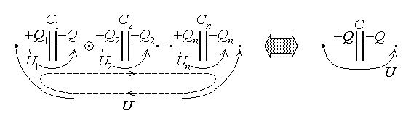
Fig. 6.18.
Using the constitutive equation of the capacitor and performing some algebraic manipulations, the last equation can be reformulated in terms of voltages as
$Q_{1}=Q_{2}=\text{.}\text{.}\text{.}=Q_{n}=C_{1}U_{1}=C_{2}U_{2}=\text{.}\text{.}\text{.}=C_{n}U_{n}=\frac{U_{1}}{\frac{1}{C_{1}}}=\frac{U_{2}}{\frac{1}{C_{2}}}=\text{.}\text{.}\text{.}=\frac{U_{n}}{\frac{1}{C_{n}}}=\frac{\sum_{k=1}^{n}{U_{k}}}{\sum_{k=1}^{n}{\frac{1}{C_{k}}}}$ .
Taking into account the consequence of Kirchhoff’s voltage equation, one finally obtains
$Q_{1}=\frac{U}{\sum_{k=1}^{n}{\frac{1}{C_{k}}}}$ .
The constitutive equation of the equivalent capacitor is simply written as
$Q=C U ⇔ Q=\frac{U}{\frac{1}{C}}$ .
The equivalence criterion can now be applied: the two circuits in fig. 6.18 are equivalent if the same voltage U applied between their terminals determines the same charge associated, say, with the terminal on the left:
$\text{The} \text{same} U ⇒ Q_{1}=Q ⇔ \frac{U}{\sum_{k=1}^{n}{\frac{1}{C_{k}}}}=\frac{U}{\frac{1}{C}}$ .
From the last equation it follows finally the equivalence relation, giving the value of the equivalent capacitance of the set of series–connected (initially uncharged) capacitors,
$\frac{1}{C}=\sum_{k=1}^{n}{\frac{1}{C_{k}}}$ .
One can note that, in the sum of positive terms, $\frac{1}{C}>\frac{1}{C_{k}} , ∀k$ , resulting in
$C<C_{k} , ∀k$ .
Let a set of n initially uncharged capacitord be considered, which are parallel
connected (fig. 6.19); one is interested to obtain a formula for the equivalent capacitance of such a capacitor circuit.
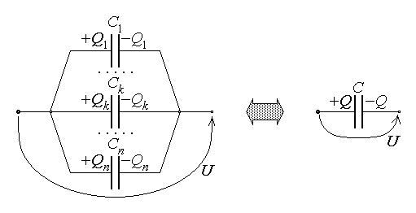
Fig. 6.19.
Kirchhoff’s voltage theorem applied to the parallel connection of capacitors consists simply in the statement that the same voltage U is applied at the terminals of any capacitor in the circuit. On the other hand, using the constitutive equation of each capacitor, and performing some algebraic manipulations, one can write that
$U=\frac{Q_{1}}{C_{1}}=\text{.}\text{.}\text{.}=\frac{Q_{k}}{C_{k}}=\text{.}\text{.}\text{.}=\frac{Q_{n}}{C_{n}}=\frac{\sum_{k=1}^{n}{Q_{k}}}{\sum_{k=1}^{n}{C_{k}}}$ .
The constitutive equation of the equivalent capacitor is simply written as
$U=\frac{Q}{C}$ .
The equivalence criterion can now be applied: the two circuits in fig. 6.19 are equivalent if the same charge associated with, say, the terminal on the left, determines the same voltage between the terminals of the circuits. The charge associated with the left terminal of the set of parallel–connected capacitors is obviously $\sum_{k=1}^{n}{Q_{k}}$ , so that the equivalence criterion is expressed as
$\sum_{k=1}^{n}{Q_{k}}=Q ⇒ \text{The} \text{same} U ⇔ \frac{\sum_{k=1}^{n}{Q_{k}}}{\sum_{k=1}^{n}{C_{k}}}=\frac{Q}{C}$ .
From the last equation it follows finally the equivalence relation, giving the value of the equivalent capacitance of the set of parallel–connected (initially uncharged) capacitors,
$C=\sum_{k=1}^{n}{C_{k}}$ .
One can note that, in the sum of positive terms,
$C>C_{k} , ∀k$ .
As a final remark, it is obvious that associated theorems of charge or voltage
dividers can be derived for such series– and parallel–connected capacitors, respectively, which are quite similar to those derived previously for series– and parallel–connected resistors.

6.3. Electric energy and electric actions
1. The theorem of electromagnetic energy gives a method of computing the electric energy stored in an electric system – in particular, in a capacitor circuit. The electric energy is computed as the volume integral of the electric energy density over the domain D_{Σ} of the sistem under consideration (fig. 6.20),
$W=\int{w \text{dV}}$ .
In the above relation the electric energy density is
$w=\frac{\vec{E}⋅\vec{D}}{2}$
in the case of linear substances and
$w=\int{\vec{E}⋅d\vec{D}}$
(that is the gray area in fig. 6.21) in the case of nonlinear substances, under the natural convention for the reference of the electric energy: zero electric energy for zero electric field.
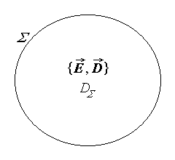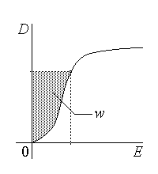
Fig. 6.20. Fig. 6.21.
This method is not so simple: it supposes to know the electric field everywhere in the domain D_{Σ} and to compute afterwards the integrals. A simpler approach is possible when the electric field is concentrated in electric systems similar to capacitors. The electric energy is then concentrated as well inside such capacitors, and can be computed simply as the sum of contributions coming from each capacitor,
$W=\sum_{k}{ W_{\text{capacitor} k}}$ .
The problem is thus transferred to the computation of the electric energy accumulated inside a capacitor.
2. Let an ideal (linear) capacitor be considered (fig. 6.22), that is charged with a charge q under the voltage u . Since the storage of electric energy is the only energy transfer process present, the elementary increase dW of the electric energy associated with the current i during an elementary time interval dt corresponds to the electric power P received across the surface Σ – that is at the terminals – as given by the theorem of power transfer at the terminals of the corresponding ideal circuit element,
$\frac{dW}{dt}=P , P=u i$ .
Taking into account the operation equation of the (linear) capacitor, it follows that
$P=u i=u⋅C\frac{du}{dt}=\frac{d}{dt} \frac{{Cu}^{2}}{2}$ ,
meaning that
$\frac{d}{dt}W=\frac{d}{dt} \frac{{Cu}^{2}}{2}$ .
The equality between these derivatives results in
$W=\frac{{Cu}^{2}}{2}+\text{const}\text{.}$ ,
where the value of the constant is determined by assuming a conventional reference of the energy. Using again the natural convention (zero energy for an uncharged capacitor), it is easy to see that the constant is null; the electric energy stored in a capacitor is thus
$W=\frac{{Cu}^{2}}{2}=\frac{q^{2}}{2 C}=\frac{q u}{2}$ ,
where the constitutive equation of the capacitor was again invoked.
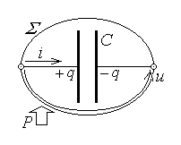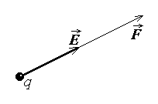
Fig. 6.22. Fig. 6.23.
3. The electric field is a physical system that not only stores an appropriate energy but can as well exert electric actions on bodies placed in it.
Some formulae are already known, which express specific electric actions. The electric force acting on a point charge q placed in an external electric field of strength $\vec{E}$ (fig. 6.23) is given by Coulomb’s formula
$\vec{F}=q \vec{E}$ ;
the electric force and the electric torque acting on a very small polarised body of electric moment $\vec{p}$ placed in an external electric field of strength $\vec{E}$ (fig. 6.24) are given, respectively, by
$\vec{F}=\text{grad} \left(\vec{p}⋅\underset{↑}{\vec{E}}\right) ,\text{ \{}\vec{T}=\vec{p}×\vec{E}$ .
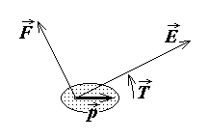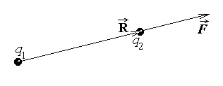
Fig. 6.24. Fig. 6.25.
Finaly, another Coulomb’s formula expresses the force acting on each of two point charges q₁ and q₂ placed at a distance R in a substance of permittivity ε (fig. 6.25),
$\vec{F}=\frac{q_{1} q_{2} \vec{R}}{4 π ε R^{3}}$ ,
where $\vec{F}$ is the force acting on the charge pointed to by the relative position vector $\vec{R}$ . These formulae are, however, very limited in scope: they refer exclusively to point charges or very small polarised bodies.
The computation of the electric forces acting on the substance in the domain D_{Σ} in more general circumstances can be done, for instance, by performing the integration
$\vec{F}=\int{\vec{f} \text{dV}}$ ,
where the volume density of the electric force is
$\vec{f}=ρ_{V}\vec{E}− \frac{E^{2}}{2} \text{grad} ε +\frac{1}{2} \text{grad} \left(E^{2}τ \frac{dε}{dτ}\right)$ .
In the above formula $\vec{E}$ is the local electric field strength, ρ_{V} is the volume density of the electric charge, ε is the local permittivity and τ is the local (mass) density, the last term accounting for the electristriction force associated to the dependence of permittivity on density.
4. Another approach can be used in the case when the system with electric field can be decomposed into subsystems between which electric actions are exerted. Such a system can then be characterised by appropriate state parameters – position parameters or generalised coordinates and force parameters or generalised forces, which are coupled in pairs.
A generalised coordinate is a geometric quantity able to characterise the relative position of different subsystems. A generalised force associated to a given generalised coordinate is a mechanical quantity able to modify the associated generalised coordinate. The association of a generalised coordinate x and a generalised force X is such that the elementary mechanical work done by the force for an elementary coordinate change dx is
$\text{dW}=X \text{dx}$ .
Simple examples of such couples are: In the case when the relative position of two subsystems is characterised by a position vector, that is $x →\text{ \{}\vec{r}$ , the associated generalised force is just a force, i.e. $X →\text{ \{}\vec{F}$ , so that $\text{dW}=\vec{F}⋅d\vec{r}$ . In the case when the relative position of two subsystems is characterised by a (vector) angle, that is $x → \vec{α}$ , the associated generalised force is a (vector) torque, i.e. $X →\text{ \{}\vec{T}$ , so that $\text{dW}=\vec{T}⋅d\vec{α}$ . It is recalled that a vector angle is a vector along the rotation axis, its direction being associated with the rotation according to the right–hand rule, and its modulus being equal to the rotation angle. Similarly, the vector torque is a vector along the rotation axis, its direction being associated with the rotation to be imposed according to the right–hand rule, and its modulus being equal to the magnitude of the torque. In the case when the extension of a subsystem is characterised by its volume, that is $x → V$ , the associated generalised force is a pressure, i.e. $X → p$ , so that $\text{dW}=p \text{dV}$ .
Let an electric system be considered, where electric actions are exerted by the electric field present. For the sake of simplicity, with no loss of generality, let the system consist of a single ideal capacitor (like that illustrated in fig. 6.22), where a single generalised force X is exerted.
According to the general form of the theorem of electromagnetic energy, the electric power received by the system across its surrounding surface Σ equals the sum between the rate of electromagnetic energy storage, the electromagnetic power transferred to the substance inside the system and the mechanical power done by the electromagnetic actions,
$P_{Σ}=\frac{{dW}_{\text{el}\text{.}−\text{mg}\text{.}}}{dt}+P_{S}+P_{\text{mech}\text{.}}$ .
In the above equation, by taking into consideration the operation equation of the ideal capacitor, the electromagnetic power received by the system across its surrounding surface reduces to the power received at terminals,
$P_{Σ}=P_{t}=u i=u \frac{dq}{dt}$ ,
the electromagnetic energy reduces to the electric energy stored inside the capacitor,
$W_{\text{el}\text{.}−\text{mg}\text{.}}=W_{\text{el}\text{.}}$ ,
the electromagnetic power transferred to the substance inside the ideal capacitor is zsro,
$P_{S}=0$ ,
and the mechanical power done by the electric action present is the rate of time variation of the mechanical work done,
$P_{\text{mech}\text{.}}=\frac{dW}{dt}=\frac{X \text{dx}}{dt}$ .
The theorem of electromagnetic energy thus reduces to
$u \frac{dq}{dt}=\frac{{dW}_{\text{el}\text{.}}}{dt}+\frac{X \text{dx}}{dt}$ ;
a simple multiplication by the elementary time interval dt gives a first energy balance equation,
$u \text{dq}={dW}_{\text{el}\text{.}}+X \text{dx}$ .
The last equation can be rewritten in an equivalent form, if the general formula of the electric energy stored in a capacitor is now invoked. Indeed,
${dW}_{\text{el}\text{.}}=d \frac{q u}{2}=\frac{u \text{dq}+q \text{du}}{2}$ ,
and the energy balance equation successively becomes
$u \text{dq}=\frac{u \text{dq}+q \text{du}}{2}+X \text{dx} ⇔ \frac{u \text{dq}}{2}=\frac{q \text{du}}{2}+X \text{dx}$ .
Simple addition of the quantity $q \text{du}/2$ to both sides results in the equation
$\frac{u \text{dq}+q \text{du}}{2}=q \text{du}+X \text{dx}$ ,
where the term on the left is just the elementary increase of the electric energy stored inside the capacitor, ${dW}_{\text{el}\text{.}}$ . This way, a second energy balance equation is obtained,
${dW}_{\text{el}\text{.}}=q \text{du}+X \text{dx}$ .
Let now specific process be considered, so that the generalised force X can be computed.
Let first consider that the electric processes are such that the electric charges are constant: $q=\text{const}\text{.} ⇔ \text{dq}=0$ . The first energy balance equation then gives
$0={dW}_{\text{el}\text{.}}|_{ q=\text{const}\text{.}}+X \text{dx} ⇔ X \text{dx}=− {dW}_{\text{el}\text{.}}|_{ q=\text{const}\text{.}}$ ,
whence
$X=− \frac{∂W_{\text{el}\text{.}}}{∂x}|_{ q=\text{const}\text{.}}$ ,
where the partial derivatives account for the fact that, in general, the electric energy depends on some other parameters as well.
Let then consider that the electric processes are such that the electric voltages are constant: $u=\text{const}\text{.} ⇔ \text{du}=0$ . The second energy balance equation now gives
${dW}_{\text{el}\text{.}}|_{ u=\text{const}\text{.}}=0+X \text{dx} ⇔ X \text{dx}={dW}_{\text{el}\text{.}}|_{ u=\text{const}\text{.}}$ ,
whence
$X=\frac{∂W_{\text{el}\text{.}}}{∂x}|_{ u=\text{const}\text{.}}$ ,
where again the partial derivatives are used for the same reason as before.
The two formulae obtained above represent the theorem of generalised electric forces that allows the computation of electric actions in any electric system, that is under more general circumstances than those under which these formulae have been derived.
Some remarks are worth mentioning.
1°. The use of the above formulae supposes that each time the electric energy is expressed exclussively in terms of the electric quantity taken as constant during derivation. In the case of a single capacitor, for instance, the electric energy is to be expressed as $W_{\text{el}\text{.}}=\frac{q^{2}}{2 C}$ when the charge is to be maintained constant and as $W_{\text{el}\text{.}}=\frac{C U^{2}}{2 }$ when the voltage is to be maintained constant.
2°. The two formulae represent simply two equivalent ways to compute the same generalised electric force. Considering again the case of a single capacitor, and taking into account the constitutive equation of the ideal capacitor, the first formula successively gives
$X=− \frac{∂W_{\text{el}\text{.}}\left(q,x\right)}{∂x}|_{ q=\text{const}\text{.}}=− \frac{∂}{∂x} \frac{q^{2}}{2 C\left(x\right)}|_{ q=\text{const}\text{.}}=− \frac{q^{2}}{2}\frac{∂}{∂x} \frac{1}{C\left(x\right)}=$
$=− \frac{q^{2}}{2} \left(− \frac{1}{C^{2}}\right) \frac{∂C}{∂x}=\frac{u^{2}}{2} \frac{∂C}{∂x}$ .

On the other hand, the second formula gives
$X=\frac{∂W_{\text{el}\text{.}}\left(u,x\right)}{∂x}|_{ u=\text{const}\text{.}}=\frac{∂}{∂x} \frac{C\left(x\right) u^{2}}{2}|_{ u=\text{const}\text{.}}=\frac{u^{2}}{2} \frac{∂C}{∂x}$ ,
which is precisely the same result.
3°. The two formulae give an algebraic result only. The direction of the generalised force is given by the algebraic sign of the final result, relative to the reference direction indicated by the direction of the increase of the associated generalised coorcinate. This means that a positive generalised force acts in the direction of increasing generalised coordinate, while a negative generalised force acts in the direction of decreasing generalised coordinate (fig. 6.26).
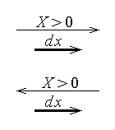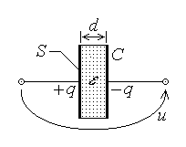
Fig. 6.26. Fig. 6.27.
5. An illustrative example is the computation of the force between the plates of a charged parallel–plate capacitor. Let such a capacitor be considered, with the plates of area S separated by an insulator of thickness d and permittivity ε , charged under a voltage u corresponding to charges ± q on the opposite plates (fig. 6.27).
Coulomb’s formula $F=\frac{q_{1}q_{2}}{4{πεR}^{2}}=\frac{−q^{2}}{4πε d^{2}}$ is inappropriate, since the plates carry no point charges but distributed charges. The theorem of generalised electric forces is therefore to be used, for instance under its second form. One has to start with identifying the subsystems in electrical interaction and the corresponding generalised coordinate: the two plates are the implied subsystems and the generalised coordinate is obviously the distance d between the plates. The generalised force is now a pure force, and it is given by
$F=\frac{∂W_{\text{el}\text{.}}\left(u,d\right)}{∂d}|_{ u=\text{const}\text{.}}=\frac{∂}{∂d} \frac{C\left(d\right) u^{2}}{2}|_{ u=\text{const}\text{.}}=\frac{u^{2}}{2} \frac{∂C}{∂d} =\frac{u^{2}}{2} \frac{∂}{∂d} \frac{εS}{d}=−\frac{εS}{d^{2}} \frac{u^{2}}{2}$ .
The negative sign is easily interpreted as indicating a force acting in the direction of decreasing generalised coordinate d . It means that between the plates of a charged parallel–plate capacitor there acts an attraction force of magnitude
$F=\frac{εS}{2 d^{2}} u^{2}$ ,
or, by using the constitutive equation,
$F=\frac{ε S}{2 d^{2}} \frac{q^{2}}{C^{2}}=\frac{ε S}{2 d^{2}} q^{2} {\left(\frac{d}{ε S}\right)}^{2} ⇔ F=\frac{1}{2ε S} q^{2}$ .

