5. DIRECT CURRENT CIRCUITS

5.1. Elements of direct current circuits
1. A direct current circuit (or network), shortly referred to as a DC circuit, is a set of interconnected conductors operating under steady–state conditions, which is represented as a set of interconnected ideal elements of DC circuits.
The ideal element of circuit is a circuit element where only a single kind of power transfer process is taking place.
Invoking the consequences of the conduction constitutive law,
u = R i – e or i = G u + a ,
when no impressed quantities are present, a segment of so called purely passive conductor can be described by the equation
$u=R i \text{or} i=G u$ ,
where the voltage across terminals, u , and the current at terminals, i , have the reference directions associated according the load rule (i.e., in the same direction, as in fig. 5.1).
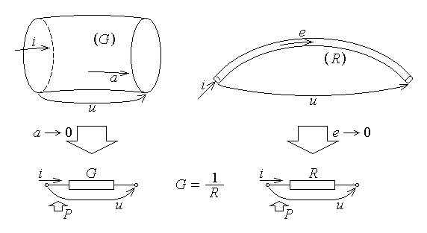
Fig. 5.1.
If now Joule's law of power transfer associated to conduction is invoked under the same assumptions, it is obtained that the power received at terminals by the considered segment of purely passive conductor is
$P=u i=R i^{2}=G u^{2}=P_{J}$ .
This means that a single kind of power transfer process, namely the dissipation of the received power into heat, is taking place in the considered conductor: it thus represents an ideal circuit element, called ideal resistor. Essentially, an ideal (linear) resistor imposes a certain proportionality relationship between the current along it and the voltage across it.
Invoking another consequence of the conduction constitutive law, when an impressed voltage is present, the segment of conductor can be described by the equation
u = e – R i ,
where the reference directions of the voltage across terminals and current at terminals are associated according the source rule (i.e., opposite directions). If the resistance of the considered segment of conductor is negligible, R → 0 , meaning that the second term in the right–hand side is negligible with respect to the first, one obtains a purely active element, where
$u=e \text{for} \text{any} i$ .
If now Joule's law of power transfer associated to conduction is invoked under the same assumptions, it is obtained that the power delivered at terminals by the considered segment of conductor is
$P=u i=e i=P_{G}$ .
This means that a single kind of power transfer process, namely generation of power to be delivered at terminals, is taking place in the considered conductor: it thus represents an ideal circuit element, called ideal voltage source (generator). Essentially, an ideal voltage source imposes a certain voltage across its terminals, equal to the electromotive force e , regardless of the current flowing along the element (fig. 5.2). As well, according to the supposition made before, it is said that the ideal voltage generator presents a null internal resistance.
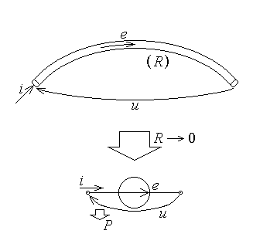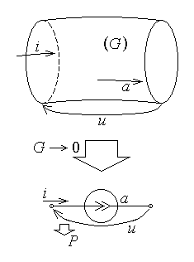
Fig. 5.2. Fig. 5.3.
Finally, invoking yet another consequence of the conduction constitutive law, when an impressed current is present, the segment of conductor can be described by the equation
i = a – G u ,
where the reference directions of the voltage across terminals and current at terminals are associated according the source rule (i.e., opposite directions). If the conductance of the considered segment of conductor is negligible, G → 0 (or, equivalently, if its resistance increases to infinity, R → ∞ ), meaning that the second term in the right–hand side is negligible with respect to the first, one obtains a purely active element, where
$i=a \text{for} \text{any} u$ .
If now Joule's law of power transfer associated to conduction is invoked under the same assumptions, it is obtained that the power delivered at terminals by the considered segment of conductor is
$P=u i=u a=P_{G}$ .
This means that a single kind of power transfer process, namely generation of power to be delivered at terminals, is taking place in the considered conductor: it thus represents an ideal circuit element, called ideal current source (generator). Essentially, an ideal current source imposes a certain current flowing through its terminals, equal to the generated current a , regardless of the voltage across the element terminals (fig. 5.3). According to the supposition made before, it is said that the ideal current generator presents a null internal conductance (or an infinite internal resistance).
2. The operation of a DC circuit supposes that all interconnected circuit elements act interactively: the operation of any single element is influenced by all other elements of the same circuit. The interaction depends on the way the elements are interconnected into the circuit, or network, and therefore it is important a discussion of the characterisation of how the elements are interconnected, or of the so called topological elements.
A node is a ramification point of the circuit, where more circuit elements are interconnected at the same terminal. A branch is a non–ramified conductor, or a non–ramified part of the circuit. Finally, a loop is a sequence of successive (i.e., adjacent) branches, constituting a contour ( a closed line), as illustrated in fig. 5.4.
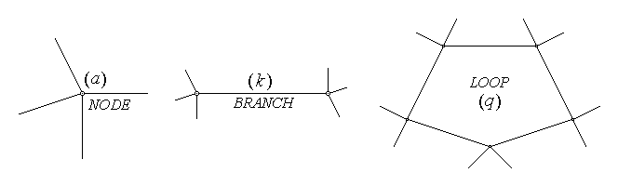
Fig. 5.4.
When a branch contains more circuit elements, one may well choose to consider a node between two such different elements of the same branch: the number of nodes and branches is thus – up to a point – arbitrary. Moreover, if the same sequence of branches constituting a contour is travelled a different number of times, it would give different loops: the number of loops is also arbitrary. One is interested, however, in keeping these numbers at a minimum; therefore, it is usual to take as branches only non–ramified parts of a circuit which contain at least a circuit element, and as nodes only terminals where at least three branches are connected. As for loops, it is quite natural to consider only so–called independent loops, that is loops that differ at least in an uncommon branch. Coverage of all the circuit is then achieved by considering a complete set of independent loops, in the sense that any branch of the circuit belongs at least to a loop.
Let thus N denote the number of nodes and B denote the number of branches of a given network. Euler's theorem states that the number of independent loops of a complete set is then given by
$L=B−N+1$ .

5.2. Fundamental theorems for direct current circuits
1. The state of a direct current circuit is given by the set of voltages and currents relative to each element of the circuit. In the case of a resistor the voltage can be computed from the current which has to be known, or vice–versa; however, in the case of a voltage source, even when taking the electromotive force as given, and so the voltage as known, the current remains to be determined, as influenced by the rest of the network. Similarly, in the case of a current source, even when taking the generated current as given, and so the current as known, the voltage remains to be determined, again as influenced by the rest of the network. The values in this set of voltages and currents are thus not independent since the interconnection of circuit elements in a network implies reciprocal influence between elements. Kirchhoff's theorems give precisely the interdependence relations between the state variables in a direct current circuit.
2. Kirchhoff's current theorem (KCT) is referring to a node, and is a consequence of the law of electric charge conservation. Let a node denoted as (a) be considered and let it be included in a closed surface Σ of outer normal unit vector $\vec{n}$ (fig. 5.5). Under steady–state conditions ($\frac{d}{\text{dt}}≡0$) , the law of electric charge conservation, $i_{Σ}=−\frac{{\text{dq}}_{D_{Σ}}}{\text{dt}}$ , imposes the charge conservation in node (a) and null total current crossing the surface and leaving the node, iΣ = 0 . On the other hand, the total current crossing the surface is the algebraic sum of current along branches that cross the surface, i.e., connected to the node under consideration, $i_{Σ}=\sum_{k∩Σ}{\left(±i_{k}\right)}=\sum_{k∈\left(a\right)}{i_{k}}$ . Using upper case letters for denoting constant quantities, it thus follows that
$\sum_{k∈\left(a\right)}{I_{k}}=0$ :
the algebraic sum of all currents along branches connected to any given node is equal to zero. In this sum a current exiting the node is to be taken with a plus sign, while a current entering the node is to be taken with a minus sign.
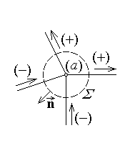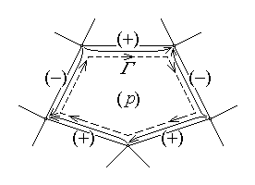
Fig. 5.5. Fig. 5.6.
Kirchhoff's voltage theorem (KVT) is referring to a loop, and is a consequence of Faraday's law on electromagnetic induction. Let a loop denoted as (p) be considered, along with the lines of voltages across the terminals of each branch of it: the union of all these voltage lines obviously constitutes a contour, denoted for convenience as Γ , along which the line element $d\vec{r}$ gives the loop reference direction (fig. 5.6). Under steady–state conditions ($\frac{d}{\text{dt}}≡0$), Faraday's law on electromagnetic induction, $e_{Γ}=−\frac{{dΦ}_{S_{Γ}}}{\text{dt}}$ , results in a null electromotive force along the contour Γ , eΓ = 0 . On the other hand, the electromotive force is the algebraic sum of voltages along the contour, that is the algebraic sum of voltages across terminals of all branches of the loop, $e_{Γ}=\oint{\vec{E}⋅d\vec{r}}=\sum_{k∈Γ}{\int{\vec{E}⋅\left(±d{\vec{r}}_{k}\right)}}=\sum_{k∈\left(p\right)}{ u_{t k}}$ . Using again upper case letters for denoting constant quantities, it thus follows that
$\sum_{k∈\left(p\right)}{ U_{t k}}=0$ :
the algebraic sum of all voltages across branches of any given loop is equal to zero. In the sum a voltage in the direction of the loop is to be taken with a plus sign, while a voltage in the direction opposite to that of the loop is to be taken with a minus sign.
3. Let the usual formulation of a DC circuit be considered, where the circuit topology is given, along with the characteristic values of elements: resistances Rk of resistors, electromotive voltages Ek of ideal voltage sources, generated currents Ak of ideal current sources. Therefore, the state of the circuit remains to be characterised by the current Ik along each voltage source, the voltage Uk across each current source, and, say, the current Ik along each resistor (since the constitutive equation of the element allows calculation of the corresponding voltage). Under the above usual formulation, one may then reduce the characterisation of the state of a DC circuit to the computation of currents Ik along each branch without an ideal current source and voltages Uk across each ideal current source: there are B unknown quantities to be determined, one for each branch.
The number of independent state equations, as given by Kirchhoff's theorems is easily established for an isolated direct current circuit (that is, a circuit not connected to other external network): Kirchhoff's current theorem simply enforces the charge conservation for each node; therefore, if charge conservation is ensured for N–1 independent nodes, it automatically follows for the remaining N−th node. Indeed, its invalidation would mean a net non−zero current along branches connecting this node to the remaining part of the network and the corresponding invalidation of charge conservation for the whole group of remaining nodes. Similarly, Kirchhoff's voltage theorem for the loops in a complete set of independent loops allows coverage of voltages across terminals of each branch: each such loop differs from other in containing at least a different branch, and each branch is contained in at least one loop. Kirchhoff's voltage theorem is therefore to be used for L = B–N+1 independent loops. It thus follows that the number of independent equations to describe the state of an isolated direct current circuit is (N–1) + (B–N+1) = B independent equations. The number of equations is thus equal to the number of unknown quantities and the solution is expected to exist and be unique. However, the formulation of Kirchhoff's theorems as derived above is not suited to the present problem formulation and some developments are still needed.
4. A more convenient, expanded form of Kirchhoff's voltage theorem can be derived if reference is made to the elements contained in each branch. Let the most complete branch be considered: it contains a resistor Rk , a voltage source of electro-motive force Ek , and a current source of generated current Ak (fig. 5.7). Let all oriented quantities related to this branch be taken in the same direction: the voltage between terminals Ut k , the current Ik along the branch, the electromotive force Ek and the generated current Ak . Let also the voltages at terminals of each element be considered with respect to the same reference direction; according to their constitutive equations, these are the voltage across the resistor UR k = RkIk , the voltage across the voltage source UE k = – Ek and the voltage across the current source Uk . The voltage lines across the elements on branch (k) and the voltage line across terminals constitute a contour, and Kirchhoff's voltage theorem may be invoked to yield

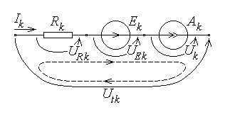
Fig. 5.7.
UR k + (– Ek) + Uk – Ut k = 0 ,
whence
$U_{t k}=R_{k} I_{k}+U_{k}−E_{k}$ .
This equation is called Joubert's theorem for direct current circuits, and represents the constitutive equation for an arbitrary branch of the circuit.

Upon substitution of the above expression for voltages across terminals of a branch into Kirchhoff's voltage theorem it follows
$\sum_{k∈\left(p\right)}{ \left(R_{k}I_{k}+U_{k}−E_{k}\right)}=0$ ,
or, equivalently,
$\sum_{k∈\left(p\right)}{ \left(R_{k}I_{k}+U_{k}\right)}=\sum_{k∈\left(p\right)}{ E_{k}}$ .
This is the expanded form of Kirchhoff's voltage theorem: the algebraic sum of voltages across elements in a loop equals the algebraic sum of electromotive forces in the same loop, with the signs of terms taken as plus or minus according to the coincidence or non−coincidence of the direction of the implied oriented quantity and the direction of the loop.
Kirchhoff's theorems are now expressed in a way which highlights precisely the unknown quantities corresponding to the usual formulation of a direct circuit: for any branch one either has a current source, so that the unknown Uk is present (while the current is known as Ik = Ak) , or else no current source is present (and no unknown Uk appears for that branch), and the unknown Ik appears in the corresponding equation.
5. There is a very important quadratic consequence of Kirchhoff's theorems, which allows an interpretation in terms of power conservation. However, for the sake of simplicity, it will be not derived from Kirchhoff's equations, but following another line of arguments, based on the electromagnetic energy theorem.
Let an unisolated DC circuit be considered, meaning that it is linked to external systems (circuits): connection currents I_{a} are carried by the connecting conductors attached to some connection nodes of potentials V_{a} of the circuit under consideration.
The electromagnetic energy theorem invoked for this system (circuit),
$P_{Σ}=−\frac{\text{dW}}{\text{dt}}+P_{S}+P_{\text{mec}}$
can be simplified if account is taken of the fact that steady–state operation is supposed. Since no time–variation is allowed, the time–derivative $− dW/dt$ of the electromagnetic energy is cancelled, and since all elements in the system are at rest, the mechanical power done by electromagnetic actions is absent, P_{mec} = 0 . The component of the electromagnetic power P_{S} transferred to the substance inside the system which refers to the power transfer associated to hysteresis phenomena also vanishes, P_{hyst} = 0 , since there is no alternating electromagnetic field with no time–variation of electromagnetic quantities. On the other hand, the component of the electromagnetic power P_{S} transferred to the substance inside the system which refers to the power transfer to conductors, associated to electric conduction, can be expressed as the difference P_{C} = P_{J} – P_{G} , between the dissipated and the generated power. Finally, as an interconnection of ideal circuit elements, the DC circuit is itself a circuit element, and according to the theorem of power transfer at the terminals of a multipole, the electromagnetic power received by the system across its surrounding surface, P_{Σ} , reduces to P_{t} , the power received at its terminals (i.e., connection nodes). The electromagnetic energy theorem reduces thus to P_{t} = P_{J} – P_{G} or, equivalently,
$P_{t}+P_{G}=P_{J}$ :
the sum between the power received by a DC circuit at its terminals and the power generated in the circuit equals the power dissipated in the same circuit.
The last equation can be detailed if one accounts for the known expressions of the terms entering it. The power received at the terminals of a multipole is the (algebraic) sum of products between the potential of the connection node (terminal) and the connection current entering the node; the generated power is the (algebraic) sum of contributions from all sources (generators) of the circuit, and the dissipated power is the (arithmetic) sum of dissipated powers in all resistors of the circuit. It follows then
$\sum_{a=1}^{N}{ V_{a}I_{a}}+\sum_{k=1}^{B}{ \left(E_{k}I_{k}+U_{k}A_{k}\right)}=\sum_{k=1}^{B}{ R_{k}I_{k}^{2}}$ ,
which is the explicate formulation of the power conservation theorem in a DC circuit.
6. A simple example is presented here, illustrating the procedure of solving a typical problem of a DC circuit. The given data characterising the elements of the circuit represented in fig. 5.8 are: A₁ = 6 A , E₂ = 100 V , R₂ = 5 Ω , E₃ = 30 V , R₃ = 5 Ω , R₄ = 4 Ω , R₅ = 5 Ω . One has to determine the values of unknown quantities and check the power balance.
A first preliminary step is that of identifying, labelling, and, the most important, indicating the reference direction of each unknown quantity. These reference directions are arbitrarily chosen but, once chosen, they have to remain fixed, as what they represent – a reference. As well, it is useful to count the topological elements and compute the number of independent equations to be written. The circuit seems to have 4 nodes and 6 branches. However, the apparent vertical branch on the left (marked with a thick line in the figure), with no source neither load, is merely a convenient way of drawing the circuit by using horizontal and vertical lines only. In fact, this apparent branch is just the convenient representation of what could be named an extended node (fig. 5.9), and has to be treated as such. Since there are 3 nodes in the circuit, there are 2 independent Kirchhoff's current equations only; since there are 5 branches in the circuit, then there are 5 – 3 + 1 = 3 independent Kirchhoff's voltage equations.
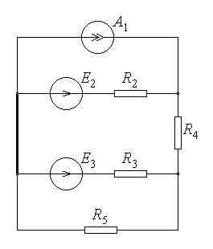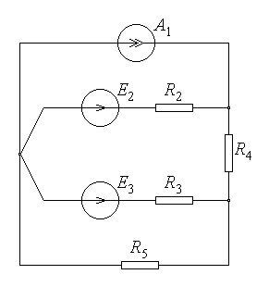
Fig. 5.8. Fig. 5.9.
In the second step the independent Kirchhoff's equations are formulated for the nodes and loops indicated in fig. 5.10 and solving the resulted algebraic system for the unknown quantities U₁ , I₂ , I₃ , I₄ , I₅ ,

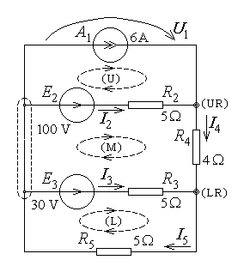
Fig. 5.10.
$\left\{\begin{matrix}−A_{1}−I_{2}+I_{4}=0 \left(\text{upper} \text{right} \text{node}\right) \\ −I_{3}−I_{4}+I_{5}=0 \left(\text{lower} \text{right} \text{node}\right) \\ U_{1}−R_{2}I_{2}=−E_{2} \left(\text{upper} \text{loop}\right) \\ R_{2}I_{2}+R_{4}I_{4}−R_{3}I_{3}=E_{2}−E_{3} \left(\text{middle} \text{loop}\right) \\ R_{3}I_{3}+R_{5}I_{5}=E_{3} \left(\text{lower} \text{loop}\right)\end{matrix}\right.$ .
In cases as that studied here, it is better to compute the solution by operating directly with numerical values. By doing right this, and solving the first two equations for the unknowns I₂ and I₃ , to be used in the remaining equations, one obtains

$\left\{\begin{matrix}I_{2}=I_{4}−6 \\ I_{3}=I_{5}−I_{4} \\ U_{1}−5 \left(I_{4}−6\right)=−\text{100} \\ 5 \left(I_{4}−6\right)+4 I_{4}−5 \left(I_{5}−I_{4}\right)=\text{100}−\text{30} \\ 5 \left(I_{5}−I_{4}\right)+5 I_{5}=\text{30} \end{matrix}\right. ⇔ \left\{\begin{matrix}I_{2}=I_{4}−6 \\ I_{3}=I_{5}−I_{4} \\ U_{1}=−\text{130}+5 I_{4} \\ \text{14} I_{4}−5 I_{5}=\text{100} \\ −5 I_{4}+\text{10} I_{5}=\text{30}\end{matrix}\right.$ .
It remains thus to solve the system of the last two equations, which easily gives
$\left\{\begin{matrix}\text{14} I_{4}−5 I_{5}=\text{100} \\ −5 I_{4}+\text{10} I_{5}=\text{30}\end{matrix}\right. ⇔ \left\{\begin{matrix}\text{28} I_{4}−\text{10} I_{5}=\text{200} \\ −5 I_{4}+\text{10} I_{5}=\text{30}\end{matrix}\right. ⇒ \text{23} I_{4}=\text{230} ⇒ I_{4}=\text{10}A$ ,
then
$I_{5}=\frac{\text{30}+5 I_{4}}{\text{10}}=\frac{\text{30}+5⋅\text{10}}{\text{10}} ⇒ I_{5}=8A$ .
The remaining unknown quantities are easily found as
$\begin{matrix}I_{2}=I_{4}−6=\text{10}−6 ⇒ I_{2}=4A \\ I_{3}=I_{5}−I_{4}=8−\text{10} ⇒ I_{3}=− 2A \\ U_{1}=−\text{130}+5 I_{4}=−\text{130}+5⋅\text{10} ⇒ U_{1}=− \text{80}V\end{matrix}$ .
The third step (not always required, but worth considering as a proof of correct results) is the check of the power balance. Since the circuit is isolated, the power received at its terminals is zero, so that the equation of power conservation is simply written as
$−U_{1}A_{1}+E_{2}I_{2}+E_{3}I_{3}=R_{2}I_{2}^{2}+R_{3}I_{3}^{2}+R_{4}I_{4}^{2}+R_{5}I_{5}^{2}$
for the reference directions considered with circuit under study. Numerical computation of each side gives
$P_{G}=−\left(−\text{80}\right)⋅6+\text{100}⋅4+\text{30}⋅\left(−2\right)=\text{480}+\text{400}−\text{60}=\text{820}W$ ,
$P_{J}=5⋅4^{2}+5⋅{\left(−2\right)}^{2}+4⋅{\text{10}}^{2}+5⋅8^{2}=5⋅\text{16}+5⋅4+4⋅\text{100}+5⋅\text{64}=$
$=\text{80}+\text{20}+\text{400}+\text{320}=\text{820}W$ .
The conclusion,
$P_{G}=P_{J}=\text{820}W$ ,
is the check of the power balance in the circuit and, as well, a proof that the solution is correct.

5.3. Theorems on direct current circuits
1. An important equivalence theorem for linear active circuits is represented by the superposition theorem: the state { Ik , Uk } of a linear active circuit is the superposition (algebraic sum) of particular states $\left\{I_{k}^{\left(α\right)},U_{k}^{\left(α\right)}\right\}$ corresponding to maintaining, in turn, a single generator in the circuit while all other are passivated. A passivated generator is a generator whose active part (electromotive force E or generated current A) is equated to zero, so that its internal resistance (or conductance) only remains to be considered. This is equivalent to saying that passivating an ideal source means short–circuiting each ideal voltage source and open–circuiting each ideal current source (fig. 5.11). In a more compact way,
E(α) or A(α) → $\left\{I_{k}^{\left(α\right)},U_{k}^{\left(α\right)}\right\}$ ⇒
⇒ all E(α) and A(α) → $\left\{I_{k}=\sum_{α}{I_{k}^{\left(α\right)}},U_{k}=\sum_{α}{U_{k}^{\left(α\right)}}\right\}$ .
The proof is based on using Crammer's rule for solving the algebraic system of equations for the circuit under consideration: the determinant in the numerator of the solution for each Ik and Uk is expanded along the column of sources as a sum of determinants in terms of each single source present solely in the circuit, and the resulted sum of particular solutions is interpreted accordingly. A simple example is illustrated in
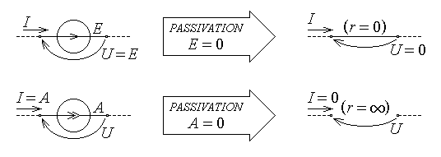
Fig. 5.11.
fig. 5.12, where the application of the superposition theorem means that
$I_{1}=I_{1}'−I_{2}' , U_{2}=U_{2}'+U_{2}\text{,}\text{I rSub \{ size 8\{3\} \} =I rSub \{ size 8\{3\} \} '+I rSub \{ size 8\{3\} \} }$ .
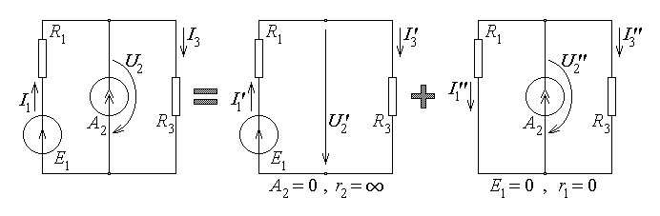
Fig. 5.12.
2. A group of important theorems in the study of direct current circuits consists in equivalence theorems – they specify conditions under which a given circuit can be approached in terms of another simpler or more convenient circuit (or circuits). In most cases, when a circuit with apparent terminals is considered, the equivalence criterion is: two circuits are said to be equivalent if, under the same set of voltages at terminals, one obtains the same set of currents through terminals, or vice–versa, for any such given set.
Equivalence theorems for passive circuits are first considered: these refer to circuits including resistors only.
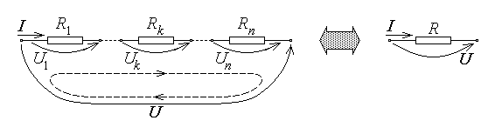
Fig. 5.13.
Let a series connection of n resistors be considered (fig. 5.13), for which a single resistor equivalent to the given circuit is sought. It is reminded that a series connection of dipolar elements means their successive connection in a single non–ramified branch: this obviously implies that the current is the same for all series connected elements. The same current I is supposed to be injected into the given (series) circuit and the equivalent resistor; it follows that
and .
On the other hand, Kirchhoff's voltage theorem written for the series circuit, along with the equivalence condition to have the same voltage U for both circuits result in
U1 +..+ Uk +..+ Un – U = 0 ⇔ U = U1 +..+ Uk +..+ Un .
One thus obtains
$\frac{U}{R_{1}+\text{.}\text{.}+R_{k}+\text{.}\text{.}+R_{n}}=\frac{U}{R}$ ,
whence the first theorem of equivalent resistance follows:
$R=\sum_{k}{ R_{k}}$ .
It may be noted that the equivalent resistance of a series connection of resistors is greater that of each component resistor, R > Rk .
In a series connection of resistors, the total applied voltage is distributed – it is also said divided – across the connected resistors. Related to this connection, the theorem of the voltage divider can be proved, which gives the ratio of the voltage across each series connected resistor to the total applied voltage. Indeed, from the sequence of equal ratios above and the equivalence criterion it immediately follows that
$\frac{U_{k}}{R_{k}}=I=\frac{U}{R} ⇒$ $U_{k}=U\frac{R_{k}}{R}$ :
in a voltage divider, the voltage is distributed proportionally to the corresponding resistance.
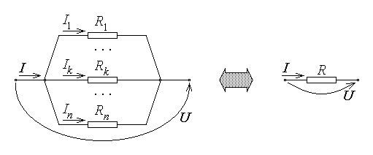
Fig. 5.14.
Let a parallel connection of n resistors be considered (fig. 5.14), for which again a single resistor equivalent to the given circuit is sought. It is reminded that a parallel connection of dipolar elements means their connection between the same two terminals: this obviously implies that the voltage is the same for all parallel connected elements. The same voltage U is supposed to be applied to the given (parallel) circuit and the equivalent resistor; it follows that
$U=U_{1}=\text{.}\text{.}=U_{k}=\text{.}\text{.}=U_{n}=R_{1}I_{1}=\text{.}\text{.}=R_{k}I_{k}=\text{.}\text{.}=R_{n}I_{n}=\frac{I_{1}}{\frac{1}{R_{1}}}=\text{.}\text{.}=\frac{I_{k}}{\frac{1}{R_{k}}}=\text{.}\text{.}=\frac{I_{n}}{\frac{1}{R_{n}}}=$
$=\frac{I_{1}+\text{.}\text{.}+I_{k}+\text{.}\text{.}+I_{n}}{\frac{1}{R_{1}}+\text{.}\text{.}+\frac{1}{R_{k}}+\text{.}\text{.}+\frac{1}{R_{n}}}$ and .
On the other hand, Kirchhoff's current theorem written for one of the parallel circuit terminals, along with the equivalence condition to have the same current I for both circuits result in
I1 +..+ Ik +..+ In – I = 0 ⇔ I = I1 +..+ Ik +..+ In – I .
One thus obtains
$\frac{I}{\frac{1}{R_{1}}+\text{.}\text{.}+\frac{1}{R_{k}}+\text{.}\text{.}+\frac{1}{R_{n}}}=\frac{I}{\frac{1}{R}}$ ,
whence the second theorem of equivalent resistance follows:
$\frac{1}{R}=\sum_{k}{ \frac{1}{R_{k}}} ⇔ G=\sum_{k}{G_{k}}$ .
One may note that, since obviously $\frac{1}{R}>\frac{1}{R_{k}}$ , the equivalent resistance of a parallel connection of resistors is lower than the resistance of each component resistor, R < Rk .
In a parallel connection of resistors, the total injected current is distributed – it is also said divided – along the connected resistors. Related to this connection, the theorem of the current divider can be proved, which gives the ratio of the current along each parallel connected resistor to the total injected current. Indeed, from the sequence of equal products above and the equivalence criterion it immediately follows that
$R_{k}I_{k}=U=R I ⇒$ $I_{k}=I\frac{R}{R_{k}}$ :
in a current divider, the current is distributed inversely proportional to the corresponding resistance.
There exist passive circuits where connection different from series or parallel connections are encountered. Two examples are represented by the so called star (wye) connection, where three resistors are connected to a common point and presenting three terminals for external connection, and triangle (delta) connection, where three resistors are connected in a loop between three accessible terminals (fig. 5.15). The star–delta and delta–star equivalence theorems give the values of resistances R12 , R23 , R31 of the equivalent delta connection in terms of the values of resistances R1 , R2 , R3 of the (given) star connection,
$R_{\text{12}}=\frac{R_{1}R_{2}+R_{2}R_{3}+R_{3}R_{1}}{R_{3}} , R_{\text{23}}=\frac{R_{1}R_{2}+R_{2}R_{3}+R_{3}R_{1}}{R_{1}} , R_{\text{31}}=\frac{R_{1}R_{2}+R_{2}R_{3}+R_{3}R_{1}}{R_{2}}$ ,
or vice–versa, the values of resistances R1 , R2 , R3 of the equivalent star connection, in terms of the values of resistances R12 , R23 , R31 of the (given) delta connection,
$R_{1}=\frac{R_{\text{12}}R_{\text{31}}}{R_{\text{12}}+R_{\text{23}}+R_{\text{31}}} , R_{2}=\frac{R_{\text{23}}R_{\text{12}}}{R_{\text{12}}+R_{\text{23}}+R_{\text{31}}} , R_{3}=\frac{R_{\text{31}}R_{\text{23}}}{R_{\text{12}}+R_{\text{23}}+R_{\text{31}}}$ .
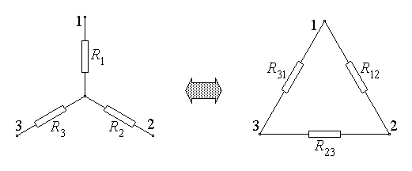
Fig. 5.15.
One may note that in each case a single relation is sufficient to be retained, since the other two can be derived by applying a cyclic permutation of subscripts, 1 → 2 → 3 → 1 . The proof of these theorems is based on enforcing the equivalence criterion for specific systems of voltages at terminals or currents into terminals, which reduce the circuits to some simpler series/parallel connection.
3. Equivalence theorems for active circuits can be then approached: these refer to circuits including sources as well as resistors, connected in any way. If equivalence of two active circuits is sought with reference to their behaviour relative to some terminals, then the same equivalence criterion as above is considered: two circuits are said to be equivalent if under the same set of voltages at terminals one obtains the same set of currents through terminals, or vice–versa, for any such given set.
The equivalence theorem of non–ideal sources states the conditions, which ensure that a non–ideal voltage source and a non–ideal current source are equivalent. A non–ideal source is a source (generator) where electromagnetic power dissipation is present along with the generation of electromagnetic power. A non–ideal voltage source $\left\{E,r\right\}$ consists in the series connection of an ideal voltage source and a so-called internal resistance; similarly, a non–ideal current source $\left\{A,g\right\}$ consists in the parallel connection of an ideal current source and a so called internal conductance (fig. 5.16). The operating equations of these non–ideal sources (when connected to an external circuit) are immediately obtained by invoking Kirchhoff's voltage and current theorems, respectively.
The operating equations are
$U=E−r I$
for the voltage source, and
$I=A−g U$
for the current source, and correspond to the global (integral) forms of the constitutive conduction law.
These equations can be solved for the other electrical quantity at terminals to give
$I=\frac{E}{r}−\frac{U}{r}$
for the voltage source, and
$U=\frac{A}{g}−\frac{I}{g}$
for the current source, respectively. Now by just equating the voltages delivered by the

sources for the same current,
$E−r⋅I=\frac{A}{g}−\frac{1}{g}⋅I$ ,
results in the following equivalence conditions,
$E=\frac{A}{g} , r=\frac{1}{g}$ .
Conversely, by equating the currents delivered by the sources for the same voltage,
$A−g⋅U=\frac{E}{r}−\frac{1}{r}⋅U$ ,

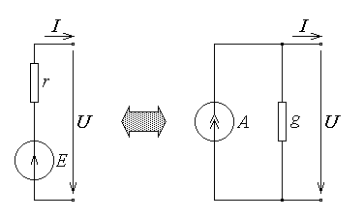
Fig. 5.16.

yields the following equivalence conditions,
$A=\frac{E}{r} , g=\frac{1}{r}$ .
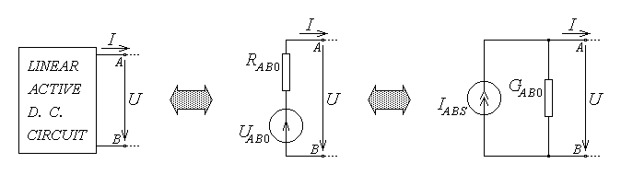
Fig. 5.17.
A very common situation is that of a linear active circuit of arbitrary complexity which delivers power or signals to a load or to another circuit, to which is connected at two terminals. The analysis of the operation of the resulting complex circuit can be greatly simplified if the given linear active circuit is substituted by a much simpler equivalent circuit, according to the theorem of equivalent generators: with respect to a pair (A , B) of its terminals, a linear active circuit is equivalent either to a non–ideal voltage generator or to a non–ideal current generator (fig. 5.17). The electromotive force of the equivalent voltage source is equal to the open–circuit voltage UAB0 of the given circuit with respect to the terminals A and B , the generated current of the equivalent current source is equal to the short–circuit current IABS of the given circuit with respect to the terminals A and B , and the internal resistance (or conductance) of either one of the equivalent generators, $R_{\text{AB}0}=\frac{1}{G_{\text{AB}0}}$ , is the equivalent resistance (or conductance) of the passivated circuit, taken with respect to the terminals A and B (fig. 5.18). It must be recalled that passivating a circuit means substituting each ideal source by its internal resistance (conductance), that is substituting a short–circuit for each ideal voltage source and an interruption (open–circuit) for each ideal current source.
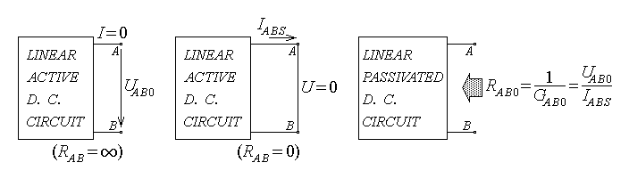
Fig. 5.18.
The proof for the first part of the theorem begins with the remark that there are four quantities to be found in view to define the equivalent generators: E and r for the voltage source, A and g for the current source. However, according to the equivalence theorem of non–ideal sources previously proved, there are already two equations linking these four quantities, so that it remains only two unknown quantities to be determined. In this respect, the equivalence criterion is to be applied twice, according to the most suitable conditions for the current or voltage at the terminals.
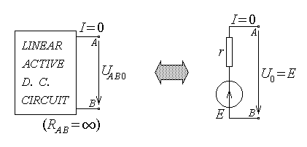
Fig. 5.19.
Let first the given circuit and the non–ideal voltage source be imposed the same operation under open–circuit conditions (fig. 5.19), meaning zero current, I = 0 , between terminals A and B (or, equivalently, corresponding to an infinite resistance, RAB = ∞ , connected between A and B) . The given circuit then presents a certain open–circuit voltage, denoted by UAB0 , between terminals A and B (which can be measured or calculated), which is to be equal to the open–circuit voltage of the equivalent generator, U0 = E , according to the equivalence criterion. It simply follows that the electromotive force of the equivalent voltage generator is E = UAB0 . Let now the given circuit and the non–ideal current source be imposed the same operation under short–circuit conditions (fig. 5.20), meaning zero voltage, U = 0 , between terminals A and B (or, equivalently, corresponding to a zero resistance, RAB = 0 , connected between A and B) . The given circuit then presents a certain short–circuit current, denoted by IABS , between terminals A and B (which can be calculated or eventually measured), which is to be equal to the short–circuit current of the equivalent generator, IS = A , according to the equivalence criterion. It then follows that the generated current of the equivalent current generator is A = IABS . Finally, according to the equivalence theorem mentioned above, the internal resistance and conductance of the equivalent generators are given by
$R_{\text{AB}0}=\frac{1}{G_{\text{AB}0}}=\frac{U_{\text{AB}0}}{I_{\text{ABS}}}$ .
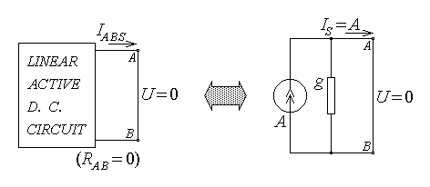
Fig. 5.20.
For the second part of the theorem an analogy argument will be used. It is readily seen that the internal resistance of the (equivalent) non−ideal voltage generator, as well as the internal conductance of the (equivalent) non−ideal current generator, are immediately obtained as the resistance (respectively, conductance) of the corresponding passivated circuit between its terminals. It can be shown that the same is valid for the given linear active circuit: by just passivating it, one obtains a passive circuit whose resistance (or conductance) with respect to terminals A and B gives precisely the needed value found above for RAB0 (or GAB0) .
4. An interesting application is now presented, relative to the simplest connection used in practice: a given non–ideal source delivering electromagnetic power (or signals) to an arbitrary load (fig. 5.21). Let then a voltage generator of given electromotive force E and given internal resistance r be considered, connected to some load of arbitrary resistance R ∈ [0 , ∞] . One is interested in finding the dependence upon R of several quantities which characterise the operation of such a system: the (common) current I along the circuit, the (common) voltage U across terminals, the generated (available) power PG , the delivered (useful) power P , the power loss Pi inside the generator, and the efficiency η in using the available electric power.

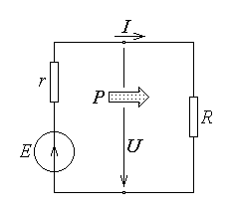
Fig. 5.21.
Since the circuit consists in a single loop, Kirchhoff's current theorem is not needed, and Kirchhoff's voltage theorem r I + R I = E results in
$I\left(R\right)=\frac{E}{r+R}$ .
The constitutive relations of the resistor load or the non–ideal voltage source, U = R I = E – r I , give
$U\left(R\right)=\frac{E R}{r+R}$ .

The generated power PG = E I has the expression
$P_{G}\left(R\right)=\frac{E^{2}}{r+R}$ ,
and the power loss inside the source Pi = r I2 is then simply
$P_{i}\left(R\right)=\frac{E^{2} r}{{\left(r+R\right)}^{2}}$ .
The power delivered to the load is $P=U I=R I^{2}=\frac{U^{2}}{R}$ , that is
$P\left(R\right)=\frac{E^{2} R}{{\left(r+R\right)}^{2}}$ ,
and accordingly the efficiency $η=\frac{P}{P_{G}}$ is
$η\left(R\right)=\frac{R}{r+R}$ .
The analysis of the above equations highlights some important limits of the expected performance of this simple source–load connection. It is to be noted that, while theoretically admitted, the limiting values of the load resistance do not represent useful loads: zero load resistance for short–circuit operation or infinite load resistance for open–circuit operation. The current I is a decreasing function of R , limited by the short–circuit current (fg. 5.22); the range of useful currents is then
$0<I<I_{S}=\frac{E}{r}$ .
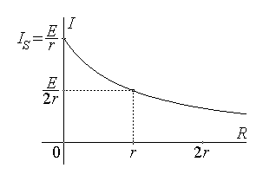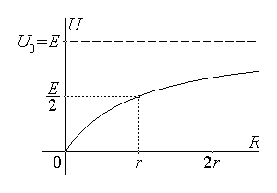
Fig. 5.22. Fig. 5.23.
The voltage U is an increasing function of R , limited by the open–circuit voltage (fig. 5.23); the range of useful voltages is then
0 < U < U0 = E .
The generated (available) power PG and the power loss Pi inside the source are both decreasing functions of R and over the same range of values, the latter showing a steeper decrease with increasing load resistance (fig. 5.24),
$0<P_{G}<P_{\text{GS}}=\frac{E^{2}}{r} , 0<P_{i}<P_{\text{iS}}=\frac{E^{2}}{r}$ .
The useful power delivered to the load, P , which is a positive quantity with zero limiting values under both short–circuit (R = 0) and open–circuit (R = ∞) conditions (fig. 5.24), necessarily reaches at least one maximum value, which is found by equating to zero its derivative:
$P'\left(R\right)=E^{2}\frac{{\left(r+R\right)}^{2}−R⋅2\left(r+R\right)}{{\left(r+R\right)}^{4}}=E^{2}\frac{r−R}{{\left(r+R\right)}^{3}}=0$ .
It follows an important result, expressed as the theorem on the maximum power transfer: a given non–ideal source delivers the maximum power to a load resistance equal to the internal source resistance:
$R=r ⇒ P=P_{\text{max}}=\frac{E^{2}}{4r}$ .
The load is said to be matched to the source when operating under maximum power transfer conditions, which are therefore also named (load) matching conditions.
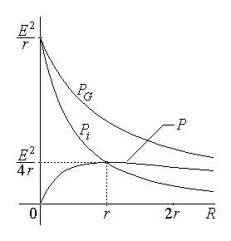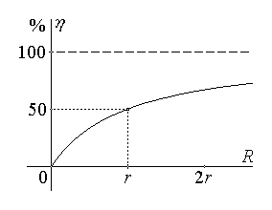
Fig. 5.24. Fig. 5.25.
The efficiency η of power delivery is an increasing function of R , with a theoretical 100% value under open–circuit operating conditions (fig. 5.25), which gives the effective operating range
0 < η < 100% .
It is to be noted that under matching conditions the efficiency is a mere 50% ; therefore normal operating conditions suppose load resistances greater than the internal source resistance, so that the delivered power is greater than the power loss, and the efficiency is greater than 50% .

