3. LAWS AND THEOREMS OF
ELECTROMAGNETIC PHENOMENA

3.1. The electric constitutive law
1. The electric constitutive law represents the relationship between the field quantities which characterise the electric field in substance. It also highlights the influence of the electric polarisation on this relationship. Such an equation can be proved in the case of the electrostatic field; experiments support the extension of the definitions of the electric field quantities and the validity of this relationship to any state.
The law is stated as follows: in any substance and any state, the electric field strength, electric displacement and electric polarisation at the same point and instant satisfy the relation
$\vec{D}=ε_{0}\vec{E}+\vec{P}$ ,
where
$ε_{0}≈8\text{.}\text{865}⋅{\text{10}}^{−\text{12}}F/m≈\frac{1}{4π⋅9⋅{\text{10}}^{9}}F/m$
is the absolute permittivity of the free space.
2. The main use of such a relationship would be to simplify the study of the electric field: instead of operating with two vector quantities, $\vec{E}$ and $\vec{D}$ , the above equation allows the use of a single vector, say $\vec{E}$ , when studying the electric field, the other one being obtained according with the discussed equation. However, in view to obtain a proper relationship between $\vec{E}$ and $\vec{D}$ , the precise knowledge of the electric polarisation $\vec{P}$ is needed. It is found out that the polarisation can generally be split in two additive components:
$\vec{P}={\vec{P}}_{p}+{\vec{P}}_{t}$ .
The permanent (spontaneous) polarisation ${\vec{P}}_{p}$ is the part of the polarisation which is independent on the electric field. It may depend on nonelectric quantities; for instance, some crystallised substances present permanent polarisation induced by mechanical stresses (piezoelectricity) or by thermal nonuniformity (pyroelectricity). Permanent polarisation can also be obtained if certain polarizable melted substances are solidified in a high electric field (electrets – the electric equivalent of permanent magnets). The temporary (induced) polarisation ${\vec{P}}_{t}$ is the part of the polarisation which does depend on the electric field; this is usually expressed as a dependence upon the electric field strength, ${\vec{P}}_{t}\left(\vec{E}\right)$ . Since the permanent polarisation is to be given, as external to electromagnetic causes, the temporary polarisation remains to be discussed.
Substituting the discussed expression of the polarisation into the electric constitutive law, one can separate the part of the electric displacement which is influenced by the electric field strength from the part which is independent on the electromagnetic phenomena,
$\vec{D}=ε_{0}\vec{E}+{\vec{P}}_{p}+{\vec{P}}_{t}\left(\vec{E}\right)=\left[ε_{0}\vec{E}+{\vec{P}}_{t}\left(\vec{E}\right)\right]+{\vec{P}}_{p}$ .
It is of particular interest to study that relationship between the electric field strength and the electric displacement which is independent on the eventual contribution of the permanent polarisation,
$\vec{D} |_{ {\vec{P}}_{p}=0}=ε_{0}\vec{E}+{\vec{P}}_{t}\left(\vec{E}\right)$ ,
named the electric constitutive equation. This study implies the discussion of the relationship between the electric field strength and the temporary polarisation.

3.2. The law of temporary polarisation
1. The law of temporary polarisation is a statement related to the preceding comment: for any given substance there exists a part of the polarisation, named temporary polarisation, which depends on the electric field strength at the same point and instant according to a function specific to that substance,
${\text{ \{}\vec{P}}_{t}={\vec{P}}_{t}\left(\vec{E}\right)$ .
In this respect, the statement is general since it covers any substance; nevertheless, since the precise functional relationship depends on the substance, this is called a substance–related law.
Different specific functional relations between the temporary polarisation and the electric field strength can be classified into linear, when ${\vec{P}}_{t}$ is proportional with $\vec{E}$, or nonlinear, when this is not the case. As well, these functional relations can be classified also into isotropic, when ${\vec{P}}_{t} \left|\right| \vec{E}$ , or anisotropic, when this is not the case. Since the first term in the electric constitutive equation, $ε_{0}\vec{E}$ , is proportional to and parallel with $\vec{E}$ , it is obvious that the type of the ${\vec{P}}_{t}\left(\vec{E}\right)$ relationship results in the same type of relationship in the electric constitutive equation $\vec{D} \left(\vec{E}\right) |_{ {\vec{P}}_{p}=0}$ .
2. In the case of linear isotropic substances the relationship ${\vec{P}}_{t}\left(\vec{E}\right)$ is simply
${\vec{P}}_{t}=ε_{0}χ_{e} \vec{E}$ ,
where χ e is a numeric constant, specific to the substance under consideration, called electric susceptibility. Particular cases are the diaelectric media, where χe is independent on temperature, and paraelectric media, where χe depends on temperature approximately according to an inverse proportionality equation, χe ∼ C / T.
An immediate consequence is the electric constitutive equation, in the case of linear isotropic substances,
$\vec{D} \left(\vec{E}\right) |_{ {\vec{P}}_{p}=0}=ε_{0}\vec{E}+{\vec{P}}_{t}\left(\vec{E}\right)=ε_{0} \left(1+χ_{e}\right) \vec{E}=ε_{0}ε_{r}\vec{}E ⇒$
⇒ $\vec{D} \left(\vec{E}\right) |_{ {\vec{P}}_{p}=0}=ε \vec{E} , ε=\text{const}\text{.}, \text{independent} \text{on} \vec{E}$ ,
where
$ε_{r}=1+χ_{e}$
is a numeric constant, called relative permittivity of the considered substance, and
$ε=ε_{0}ε_{r}$
is the absolute permittivity or electric constant of the substance under consideration.
3. In the case of non–linear isotropic substances the functional relationship of the temporary polarisation law, that is characteristic to each considered substance, can be reduced to the relationship between the magnitudes of the parallel vectors implied,
${\vec{P}}_{t}={\vec{P}}_{t}\left(\vec{E}\right) ⇒ P_{t}=P_{t}\left(E\right)$ .
The non–linear relationship is obviously homogeneous, i.e., it has the property that
${\vec{P}}_{t}\left(0\right)=0$ ,
and, since it can not be expressed in terms of simple functions, is usually given in graphic form (fig. 3.1, where the saturation of the polarisation is also illustrated).
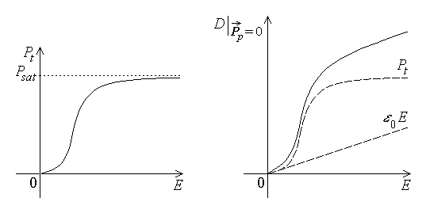
Fig. 3.1. Fig. 3.2.
As an immediate consequence, the electric constitutive equation is derived: since both terms in the equation are parallel, their sum is also parallel to them, and the electric constitutive equation reduces to a relation between the magnitudes of the implied vectors (fig. 3.2),
$\vec{D} \left(\vec{E}\right) |_{ {\vec{P}}_{p}=0}=ε_{0}\vec{E}+{\vec{P}}_{t}\left(\vec{E}\right) ⇒ D \left(E\right) |_{ P_{p}=0}=ε_{0}E+P_{t}\left(E\right)$ ,
The resulted relationship, is written, for convenience, in a form somewhat similar to that used in the case of linear isotropic substances, where ε is no longer a constant,
$\vec{D} \left(\vec{E}\right) |_{ {\vec{P}}_{p}=0}=ε \left(E\right)⋅\vec{E}$ .
A particular case of a non–linear dependence of $\vec{D}$ on $\vec{E}$ , which is not even one–to–one, is characteristic to the so called hysteretic media. Let a piece of such an isotropic hysteretic substance be considered, which has never been placed in an electric field before, and let it be subjected to an alternating electric field of constant direction, whose projection upon this direction varies between –EM to +EM , starting from a zero initial value. The corresponding values of the electric displacement D are followed and the associated curve (graph) is constructed (fig. 3.3). When the electric field strength E is increased from 0 to EM , the corresponding electric displacement D also increases, following a non–linear monotonous curve (called first polarisation curve) from 0 to a maximum value DS . If the maximum applied field is sufficiently great, the final part of

the curve is almost horizontal: it is said that a saturation is reached. When the electric field strength is reduced from EM to 0 , the corresponding electric displace-ment also decreases, but follows a curve that is above the preceding one, so that at zero electric field strength a so called remanent electric displacement DR is still present. The direction of the electric field is then reversed and its magnitude is again increased up to EM (i.e., its projection is decreased to –EM); a point symmetric to the extreme point reached before is attained, namely (–EM , –DS) . The corresponding part of the curve crosses the electric field strength axis (i.e., the electric displacement is zero) at a certain value –EC of the field, called coercive field strength. The subsequent variation of
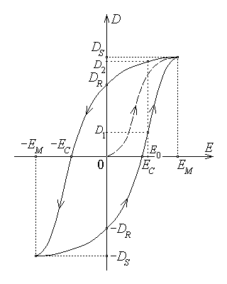
Fig. 3.3.

the applied electric field strength from –EM to 0 to EM results in a corresponding variation of the electric displacement from –DS to –DR to DS , crossing the zero value of electric displacement at the point (EC , 0) . If the alternative electric field continues its variations, the described symmetric closed hysteresis cycle is travelled along by the characteristic point (E , D) . It is now obvious that to a given electric field strength E₀ it corresponds two different electric displacements, D1 and D2 (D1 < D2) , each one being reached depending on the previous variation of the applied field – by increasing or by decreasing values of E .
It is to be noted that the completion of each hysteresis cycle in an alternating electric field is accompanied by an irreversible energy transfer from the electromagnetic field to the hysteretic substance.
In the case of anisotropic substances, the temporary polarisation ${\vec{P}}_{t}$ and induced electric displacement $\vec{D}$ are no longer parallel to the applied electric field $\vec{E}$ , for both linear and non–linear cases. It means that, in the electric constitutive equation, each component of the electric displacement depends on all three components of the field strength,
$D_{x} |_{ {\vec{P}}_{p}=0}=D_{x}\left(E_{x},E_{y},E_{z}\right) , \text{etc}\text{.}$
All the preceding remarks are still generally valid, but the analysis of such a situation is much too difficult to be presented here.

3.3. Faraday's law on the electromagnetic induction
1. Experimental evidence indicates that a time–varying magnetic flux generates an electromotive force or, more generaly, a time–varying magnetic field generates an electric field: this phenomenon is named electromagnetic induction. The cause in such a phenomenon is the so called inductor quantity (time–varying magnetic flux or magnetic field); the effect is called the induced quantity (electromotive force or electric field). Experiments show that the mere presence of a magnetic field is not sufficient; it is its variation that induces an electric field, dependent on the first time–derivative of the inductor quantity. Moreover, by its eventual magnetic effects, the induced quantity tends to oppose the variation of the inductor quantity.
The conclusions of many experiments on electromagnetic induction result in the following statement of the law: in any substance and any state, the induced electromotive force (e.m.f.) along a contour is equal to the rate of decrease (in time) of the inductor magnetic flux across any surface bordered by the contour (fig. 3.4),
$e_{Γ}=−\frac{{dΦ}_{S_{Γ}}}{\text{dt}} ; \oint{\vec{E}⋅d\vec{r}}=−\frac{d}{\text{dt}}\int{\vec{B}⋅\vec{n} \text{dA}}$ .

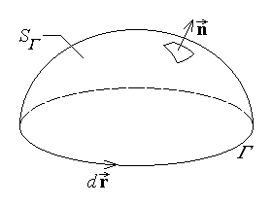
Fig. 3.4.
Some remarks are to be made, related to the preceding statement and integral formulations: (1) The reference directions of the induced electromotive force ($d\vec{r}$) and inductor magnetic flux ($\vec{n}$) are associated according to the right hand rule. (2) The electromagnetic induction supposes that a time–varying inductor magnetic flux generates an induced electromotive force and not an induced current; the second quantity may be

present only when the closed path of the electromotive force is entirely traced along

conductors, which is not generally the case. (3) The direction of the induced electromotive force is such that the eventual induced current could generatee in turn an induced magnetic flux opposite to the variation of the inductor magnetic flux (Lenz's rule). (4) In taking the time–derivative of the surface integral of the magnetic flux density the interpretation stated by Hertz is to be observed: the geometric elements (contour, surface) are time–dependent as well, taken as attached to the eventually moving media.
The last remark is the basis of some vector analysis manipulations, resulting in an extended integral formulation of the law,
$\oint{\vec{E}⋅d\vec{r}}=−\int{\frac{∂\vec{B}}{∂t}⋅\vec{n} \text{dA}}+\oint{\left(\vec{v}×\vec{B}\right)⋅d\vec{r}}$ ,
which takes into account the inductive electromotive force generated by the mere time– variation of the magnetic field, and the motional electromotive force induced solely by the movement of the contour with respect to the magnetic field, $\vec{v}$ being the speed of the line element $d\vec{r}$ .
2. The most important consequence of this law is the theorem on the electric potential, that can be expressed in three equivalent statements. First, under static and steady–state conditions, the electromotive force is zero along any closed path,
$\frac{d}{dt}≡0 ⇒ e_{Γ}=\oint{\vec{E}⋅d\vec{r}}=0 \text{for} \text{any} Γ$ .
An alternative (equivalent) formulation of this theorem is: under static and steady–state conditions, the electric voltage does not depend on the integration path but on the extreme points only,
$\frac{d}{dt}≡0 ⇒ u_{\left(C\right) \text{AB}}=u_{\text{AB}} , \text{idependent}\text{on} C$ .
The name of the theorem is justified by a third alternative formulation: under static and steady–state conditions, there exists a continuous function of position, V(M) , called electric potential, such that the electric voltage between two points is the potential difference between the points,
$\frac{d}{dt}≡0 ⇒ ∃ V\left(M\right) \text{such} \text{that} u_{\text{AB}}=V\left(A\right)−V\left(B\right)$ .
For the proof of the first formulation it is obvious that in the case of time–invariant conditions,
$e_{Γ}=−\frac{{dΦ}_{S_{Γ}}}{\text{dt}} \text{and} \frac{d}{\text{dt}}≡0 ⇒ e_{Γ}=\oint{\vec{E}⋅d\vec{r}}=0$ .
The first formulation implies the second: Suppose that eΓ = 0 for any Γ ; then by taking two lines AMB and ANB between points A and B on Γ = AMBNA (fig. 3.5), one obtains
0 = eΓ = eAMBNA = uAMB + uBNA = uAMB – uANB ,
whence the desired result,
uAMB = uANB = uAB .
The second formulation implies the third: Indeed, by taking point A as arbitrary, say M , and point B as a fixed reference point, say M₀ , then the voltage between A and B , that is between M and M₀ , depends on M solely,
$u_{\text{AB}} → u_{{\text{MM}}_{0}}=f\left(M\right)$ ,
where the function can be written as
f(M) = V(M) + const. = V(M) – V(M₀) .
The electric potential at point M results then as
$V\left(M\right)=V\left(M_{0}\right)+u_{{\text{MM}}_{0}}=V\left(M_{0}\right)−u_{M_{0}M}$ ⇒ $V\left(M\right)=V\left(M_{0}\right)−\int{\vec{E}⋅d\vec{r}}$
with respect to the potential value V(M₀) at the reference point M₀ . Under the conditions of the theorem, the voltage between two points A and B , independent on the integration path, can then be computed along a path AM₀B passing through the reference point (fig. 3.6), so that
$u_{\text{AB}}=u_{{\text{AM}}_{0}B}=u_{{\text{AM}}_{0}}+u_{M_{0}B}=u_{{\text{AM}}_{0}}−u_{{\text{BM}}_{0}}=$
= [V(A) – V(M₀)] – [V(B) – V(M₀)] = V(A) – V(B) .
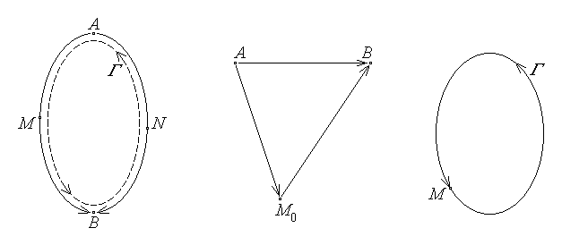
Fig. 3.5. Fig. 3.6. Fig. 3.7.
The third formulation implies the first: Suppose now that the potential is defined so that the voltage between any two points is the potential difference; then, for an arbitrary contour Γ , by taking a point M ∈ Γ as the initial and the final point (fig. 3.7),
eΓ = uΓ = uM→M = V(M) – V(M) = 0 .
Finally, under the same static or steady state conditions, when an electric potential can be introduced, the concept of equipotential surface is defined as the set of points of the same potential value. As well, under the same conditions, the electric field strength can be shown to derive from the electric potential, according with the relation
$\vec{E}=− \text{grad} V= − \left(\vec{i}\frac{∂V}{∂x}+\vec{j}\frac{∂V}{∂y}+\vec{k}\frac{∂V}{∂z}\right)$ .
3. An illustrative consequence of the theorem on the electric potential is the fact that under static or steady–state conditions the electric field lines are open. Indeed, one may notice that the electric field, as any field, can have closed as well as open lines. But under static or steady–state conditions there are no closed electric field lines, since otherwise, by taking a contour Γ along such a closed line, it would mean that $e_{Γ}=u_{Γ}=\oint{\vec{E}⋅d\vec{r}}=$ $=\oint{E \text{dr} \text{cos}0}>0$ , which is contradicted by the theorem of the electric potential, e_{Γ} = 0 for any contour Γ .
Another important consequence of the theorem of electric potential, extensively used in the study of electric circuits, is Kirchhoff's voltage theorem, that will be discussed later.
A final remark: the theorem on the electric potential and all its consequences remain valid under amagnetic quasi–steady state conditions, characterised, as it is discussed in a subsequent section, by the equation
$\left|\frac{dΦ}{\text{dt}}\right|≃0$ .

3.4. Gauss's law on the electric flux
1. Gauss's law represents a relationship between the flux of the electric displacement across a closed surface and the electric charge; on this basis the electric charge can be perceived as a source of electric field.
Under static conditions, some experimental formulae can be used to prove such a relationship in a particular case. Let a point charge q , placed in a linear isotropic homogeneous medium, be considered as the only field source, and let the electric flux be computed across (over) a sphere Σ centered on it (fig. 3.8). Since then $\vec{D}=ε \vec{E}$ , the electric flux is
$Ψ_{Σ}=\oint{\vec{D}⋅\vec{n} \text{dS}}=\oint{ε \vec{E}⋅\vec{n} \text{dS}}=ε \oint{\vec{E}⋅\vec{n} \text{dS}}$ .
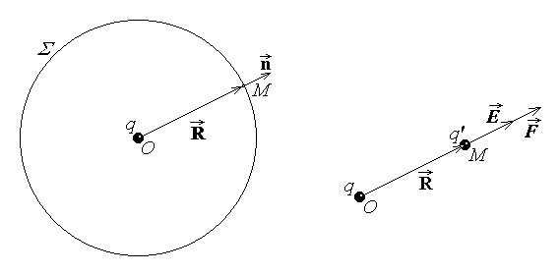
Fig. 3.8. Fig. 3.9.
The electric field $\vec{E}$ at the point M on the sphere, indicated by the position vector $\vec{R}$ , can be determined from the electric force acting on a point charge q' at rest at point M (fig. 3.9), by using the formula of Coulomb's force along with Coulomb's formula:
$\vec{F}=q' \vec{E} \text{and}\text{ \{}\vec{F}=\frac{q q' \vec{R}}{4π ε R^{3}} \text{result}\text{in}\text{ \{}\vec{E}=\frac{q \vec{R}}{4π ε R^{3}}$ .
Since the (external) normal unit vector to the surface Σ at point M is obviously $\vec{n}=\vec{R}/R$ , and R = const. over the sphere, one can easily compute
$Ψ_{Σ}=ε \oint{\vec{E}⋅\vec{n} \text{dS}}=ε \oint{\frac{q \vec{R}}{4\text{πε} R^{3}}⋅\frac{\vec{R}}{R} \text{dS}}=\frac{q}{4π}\oint{\frac{R^{2}}{R^{4}} \text{dS}}=\frac{q}{4π R^{2}}\oint{\text{dS}}=$
$=\frac{q}{4π R^{2}} S_{Σ}=\frac{q}{4π R^{2}} 4π R^{2}=q$ .
2. Using the same experiment–based formula of the electric field strength, such a relationship can be proved under static conditions for any electric field source and any closed surface; on the other hand, experimental evidence allows the extension of its validity to more general states. The statement of the law is then the following: in any substance and any state, the electric flux across any closed surface is equal to the electric charge contained in the domain bordered by the surface (fig. 3.10),
$Ψ_{Σ}=q_{D_{Σ}} ; \oint{\vec{D}⋅n \text{dS}}=q_{D_{Σ}}$ .
It is recalled that the electric flux across the considered closed surface is taken with respect to the reference direction of the outward pointing normal unit vector $\vec{n}$ .
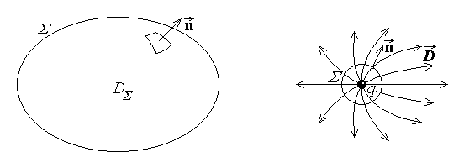
Fig. 3.10. Fig. 3.11.
3. An immediate consequence of Gauss's law is that under static or steady–state conditions, the lines of the electric field are open, beginning at positive charges and ending at corresponding opposed, negative charges. It is known from the previous section that, under static or steady–state conditions, the electric field lines are open. Let now a positive point charge be considered; it can be included inside a closed surface – say, a sphere – as close to the point as possible (fig. 3.11). The charge inside the surface is positive and, according to Gauss's law, so is the electric flux, $\oint{\vec{D}⋅\vec{n} \text{dS}}=q_{D_{Σ}}>0$ . This, in turn, accounting for the symmetry of the configuration, implies for the elementary fluxes that $dΨ=\vec{D}⋅\vec{n} \text{dS}=\left|\vec{D}\right|⋅\left|\vec{n}\right|⋅\text{cos}α⋅\text{dS}>0$ , i.e., $\text{cos}α>0$ , so that the angle $α\text{=∠}\left(\vec{D},\vec{n}\right)<π/2$ . That means exactly that the lines of electric displacement generally point in the same outward direction as the outward unit normal vector $\vec{n}$ : they originate at the positive charge. A similar argument shows that the lines of electric displacement are incident at negative charges.
A more important consequence can be derived, which follows from all the laws regarding the electric field – the Coulomb's formula of the electrostatic (or steady−state)

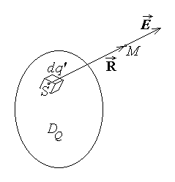
Fig. 3.12.
field in a boundless homogeneous isotropic linear medium. This is the direct generalisation of the above formula of the electric field strength generated in a linear homogeneous medium by a point charge. If now the point charge is taken as the elementary contribution dq' at the source point S in an arbitrary distribution of charge, then its elementary contribution to the electric field strength at the observation point M then its elementary contribution to the electric field at the observation point M (fig. 3.12) is
$dE=\frac{dq' \vec{R}}{4\text{πε} R^{3}}$ .

The total electric field strength at point M is then the sum of such elementary contributions, which results in an integral computed over the domain D_{Q} with any charge distribution,
$\vec{E}=\frac{1}{4\text{πε}}\int{\frac{\text{dq}' \vec{R}}{R^{3}}}$ .
The explicite formula for an arbitrary distribution of electric charge generating electrostatic field in a boundless homogeneous isotropic linear medium is obtained by taking the elementary point charge dq' as corresponding to specific charge distributions, dq' = ρV dV' or dq' = ρS dS' or dq' = ρL dr' . The electric field strength generated at the observation point M at the fixed end of the position vector $\vec{R}$ is obtained as the integral of the elementary contributions given by different elementary parts of the source, at varying source points S , taken as the mobile origin of the position vector $\vec{R}$ ,
$\text{ \{}\vec{E}=\frac{1}{4\text{πε}}\left[\int{\frac{ρ_{V}\vec{R} \text{dV}'}{R^{3}}}+\int{\frac{ρ_{S}\vec{R} \text{dS}'}{R^{3}}}+\int{\frac{ρ_{L}\vec{R} \text{dr}'}{R^{3}}}+\sum_{M_{k}}{\frac{q_{k}\vec{R}}{R^{3}}}\right]$ ,
when this later point S moves over the domain with charge distribution.

3.5. The conservation law of the electric charge
1. Simple experiments can be imagined, which result in conclusions regarding the conservation of the electric charge. Suppose that two metallic objects carrying opposite

charges (indicated by attached electrometers) can be connected via a metallic wire (including an ammeter – i.e. an instrument for measuring the electric current intensity) interrupted by a switch (fig. 3.13). If the switch is open, it is easily noted that both charges remain constant and the wire does not carry any current. If the switch is closed, one can note that: (1) both charges tend to zero; (2) a current is carried by the conducting wire, from the positively to the negatively charged metallic objects; (3) the current intensity is proportional to the rate of the time–variation of charges. On the other hand, it is obvious that the variation of both
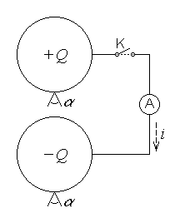
Fig. 3.13.

charges can be achieved by simply carrying it on a third metallic body, successively touching the original charged bodies.
The conclusion of many such experiments result in the following formulation of the law: in any substance and any state, the total electric current exiting any closed surface is equal to the rate of decrease (in time) of the electric charge contained in the domain bordered by the surface,
$i_{Σ}=−\frac{{\text{dq}}_{D_{Σ}}}{\text{dt}} ; \oint{\vec{J}⋅\vec{n} \text{dA}}=−\frac{d}{\text{dt}}\int{ρ_{V} \text{dV}}$ .
Some remarks are to be made related to the preceding statement and integral formulations: (1) The reference direction of the total current across the closed surface is the outward pointing unit normal vector $\vec{n}$ ; (2) In taking the time derivative of the volume integral of the electric charge density the interpretation stated by Hertz is to be observed: the geometric elements (surface, volume) are to be taken as attached to the eventually moving media. The last remark is the basis of some vector analysis manipulations, resulting in an extended integral formulation of the law,
$\oint{\vec{J}⋅\vec{n} \text{dA}}=−\int{\frac{∂ρ_{V}}{∂t} \text{dV}}−\oint{ρ_{V}\vec{v}⋅\vec{n} \text{dS}}$ ,
which is usually written as
$\oint{\left(\vec{J}+ρ_{V}\vec{v}\right)⋅\vec{n} \text{dS}}=−\int{\frac{∂ρ_{V}}{∂t} \text{dV}} ; i_{Σ}+i_{CΣ}=−\frac{∂q_{D_{Σ}}}{∂t}$ .
This formulation takes into account that charge variation can be associated to both the electric current carried by conductors crossing the closed surface and the macroscopic movement of the electric charge at some speed $\vec{v}$ across the same surface; this last contribution is accounted for by the electric convection current, of intensity expressed as
$i_{\text{CS}}=\int{ρ_{V}\vec{v}⋅\vec{n} \text{dS}}$
in terms of the electric convection current density
${\vec{J}}_{C}=ρ_{V}\vec{v}$ .
The fact that the conduction and convection currents are additively contributing to the time variation of the electric charge suggests the interpretation of the conduction current along a conductor as the flow rate of electric charge across a transverse surface in the conductor. Such an interpretation supports the microscopic interpretation of the electric conduction current as a relative movement of some microscopic charged particles with respect to the conductor, i.e., as a microscopic electric convection current relative to the conductor.
2. The most important consequence of this law is the theorem on current continuity: under steady–state conditions the total current exiting any closed surface is zero:
$\frac{d}{\text{dt}}≡0 ⇒ i_{Σ}=\oint{\vec{J}⋅\vec{n} \text{dS}}=0 \text{for} \text{any} Σ$ .
The proof is obvious, so that a consequence of this theorem is now of interest: under steady–state conditions the electric current is constant along a current (flux) tube: i1 = i2 = i. A current (or flux) tube is a cylinder–like surface, with the lateral surface taken along current lines, so that $\vec{J}⋅\vec{n}=0$ on SL (fig. 3.14). Taking the normal unit vectors to the bases ${\vec{n}}_{1}$ and ${\vec{n}}_{2}$ as pointing in the same direction, the theorem on current continuity yields
$0=i_{Σ}=\int{\vec{J}⋅\vec{n} \text{dS}}+\int{\vec{J}⋅\left(−{\vec{n}}_{1}\right) \text{dS}}+\int{\vec{J}⋅{\vec{n}}_{2} \text{dS}}=−i_{1}+i_{2}$ ,
which proves the consequence. In particular, under the same steady–state conditions, the current intensity is conservative along a non–ramified conductor, since the conductor surface constitutes a current tube.
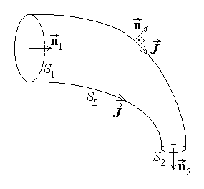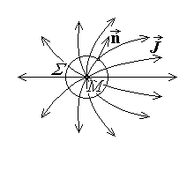
Fig. 3.14. Fig. 3.15.
A particular case of the last consequence can be analysed, to result in an alternative formulation of the theorem on current continuity, which justifies its name: under steady–state conditions the current lines are closed (are not open). For the proof, let the opposite be supposed, i.e., that under the specified conditions, the curent lines would be open, going from a source to a sink point. Let M be a source point of such open current lines, tightly surrounded by a closed surface Σ of outward normal unit vector $\vec{n}$ (fig. 3.15). Then, since $α\text{=∠}\left(\vec{J},\vec{n}\right)<π/2$ , the total electric conduction current exiting the surface would be $i_{Σ}=\oint{\vec{J}⋅\vec{n} \text{dS}}>0$ , which contradicts the theorem on current continuity. It follows that the supposition is false, so that the current lines are to be closed under steady–state conditions.
Another important consequence of the theorem on current continuity, extensively used in the study of electric circuits: is Kirchhoff's current theorem, that will be discussed later.
A final remark: the theorem on current continuity and its consequences remain valid under anelectric quasi–steady state conditions, characterised, as it is discussed in a subsequent section, by the equation
$\left|\frac{d}{\text{dt}}Ψ_{Σ}\right|=\left|\frac{d}{\text{dt}}q_{D_{Σ}}\right|≃0$ .

3.6. The constitutive law of electric conduction
1. The constitutive law of electric conduction represents the relationship between the field quantities which characterise the electric conduction in conducting substances, on one hand, and other quantities involved with the conduction process, on the other hand. It also highlights the influence brought by the impressed electric quantities within this relationship. Such a relationship can be proved in the case of simple microscopic models of the conduction process and experiments support the extension of its validity for other cases as well.
The law is stated as follows: in any (conducting) substance and any state, the electric current density, electric field strength, and impressed electric current density at the same point and instant satisfy the conduction constitutive equation
$\text{ \{}\vec{J}=σ \vec{E}+{\vec{J}}_{i}$ .
The interpretation of this formulation is straightforward: the electric current is contributed to by both electrically and non electrically induced movement of charge.
An alternative formulation of the law is: in any (conducting) substance and any state, the electric field strength, impressed electric field strength, and electric current density at the same point and instant satisfy the conduction constitutive equation
$\vec{E}+{\vec{E}}_{i}=ρ \vec{J}$ .
Here, too, the interpretation is immediate: the charge movement along the conductor, which represents the electric current, is generated by both electric and nonelectric forces.
In the above formulations the coefficients characteristic to the conduction substance are the conductivity σ and resistivity ρ ; the peculiar case when no impressed quantities are present,
$\vec{J}=σ \vec{E} ⇔\text{ \{}\vec{E}=ρ \vec{J}$ ,
shows that the two conduction coefficients satisfy the equation
$σ=\frac{1}{ρ}$ .
2. There are integral formulations, associated to the above local formulations, that are more extensively used in engineering applications.
Let a sufficiently thin slice of a solid conductor be considered (fig. 3.16), bounded by two transverse equipotential surfaces S and S' at a sufficiently small distance l along the normal unit vector $\vec{n}$ to, say, surface S , so that $\vec{n} \left|\right| \vec{l}$ and the voltage between any corresponding points M ∈ S and M' ∈ S' in the conductor can be expressed as
$u_{C}=\int{\vec{E}⋅d\vec{r}}=\vec{E}⋅\vec{l}$ .
If the first local formulation of the conduction constitutive law is integrated over the transverse surface S , one obtains
$\int{\vec{J}⋅\vec{n} \text{dS}}=\int{σ\vec{E}⋅\vec{n} \text{dS}}+\int{{\vec{J}}_{i}⋅\vec{n} \text{dS}}$ .
The first and last integrals are the current and impressed current across the conductor, respectively,
$i_{S}=\int{\vec{J}⋅\vec{n} \text{dS}} ; a_{S}=\int{{\vec{J}}_{i}⋅\vec{n} \text{dS}}$ ;
since the voltage u_{C} between any two corresponding points on surfaces S and S' is the same, the second integral can be written
$\int{σ\vec{E}⋅\vec{n} \text{dS}}=\int{σ\vec{E}⋅\frac{\vec{l}}{l} \text{dS}}=\int{\frac{σ}{l}\vec{E}⋅\vec{l} \text{dS}}=\int{\frac{σ}{l}u_{C} \text{dS}}=u_{C} \int{\frac{σ}{l}\text{dS}}$ .
The (electric) conductance of the considered slice of conductor is defined as
$G=\int{\frac{σ}{l}\text{dS}}≈\frac{σ S}{l}$ ,
so that, by dropping the reference to the transverse surface S , the integral formulation of the conduction constitutive law is obtained as
$i=G u_{C}+a$ ,
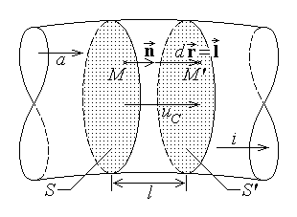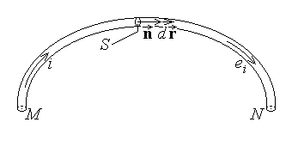
Fig. 3.16. Fig. 3.17.
Let now a segment MN of a filamentary conductor be considered (fig. 3.17), which can be taken as coincident with its median line: if $d\vec{r}$ denotes the line element along the wire and $\vec{n}$ denotes the normal unit vector to the transverse surface of area A , then for the infinitely thin conductor one may take $\vec{n} \left|\right| d\vec{r}$ , and note that
$i=\int{\vec{J}⋅\vec{n} \text{dS}}=\int{J_{n} \text{dS}}=J_{n} S$ .
If the second local formulation of the conduction constitutive law is integrated along the wire, one obtains
$\int{\vec{E}⋅d\vec{r}}+\int{{\vec{E}}_{i}⋅d\vec{r}}=\int{ρ\vec{J}⋅d\vec{r}}$ .
The first two terms are the voltage and the impressed voltage along the conductor, respectively,
$u_{C,\text{MN}}=\int{\vec{E}⋅d\vec{r}} ; e_{i,\text{MN}}=\int{{\vec{E}}_{i}⋅d\vec{r}}$ ;
As well, since the wire is a current tube, the current is constant along it, and the right hand term can be written
$\int{ρ\vec{J}⋅d\vec{r}}=\int{ρ\vec{J}⋅\vec{n} \text{dr}}=\int{{ρJ}_{n} \text{dr}}=\int{ρ \frac{i}{S}\text{dr}}=i⋅\int{\frac{ρ}{S}\text{dr}}$ .
The (electric) resistance of the considered piece of conductor is defined as
$R=\int{\frac{ρ}{S}\text{dr}}≈\frac{ρ l}{S}$ ,
and, dropping the reference to extremities M and N , and the index to the impressed voltage, the integral formulation of the conduction constitutive law is obtained as
$u_{C}+e=R i$ ,
If in the above integral formulations the peculiar case is considered, when no impressed quantities are present,
i = G⋅uC , uC = R⋅i ,
then the coefficients characteristic to the conductor, i.e., the resistance and conductance, result to be related through the equation
$G=\frac{1}{R}$ .
It is to be noted that the above integral formulations are written with respect to the same reference direction for all quantities – the common direction of the current, voltage in the conductor and impressed quantities.
3. Important consequences can be derived from the above integral formulations in the case of steady–state conditions (and amagnetic quasi–steady state conditions as well). The purpose of the derivations below is to make reference to the voltage between terminals M and N (in the case of a filamentary conductor) or terminal surfaces S and S' (in the case of a solid conductor),
$u=\int{\vec{E}⋅d\vec{r}}$ ,
instead of the voltage along the conductor,
$u_{C}=\int{\vec{E}⋅d\vec{r}}$ .
Recalling that the reference direction of the voltage along the conductor uC is the same as the reference direction of the current i , two configurations are now possible.
(1) The reference direction of both these voltages can be taken to be the same (i.e., from the same initial point/surface to the same final point/surface), as in fig. 3.18. In this case, by invoking the theorem of electric potential, one has
uC = u ;
it is said the voltage at terminals u and the current i are associated according to the load rule . Using this load rule, the integral formulations of the conduction constitutive law can now be written respectively as
$i=a+G u , u+e=R i$ .
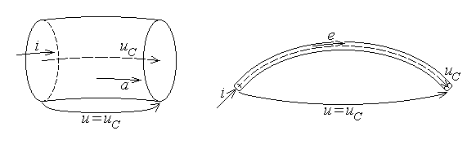
Fig. 3.18.
A particular case is that of so called purely passive conductors, i.e., conductors with no impressed voltage or generated current (a = 0 , e = 0) ; the corresponding equation is known as Ohm's theorem,
i = G u , u = R i ,
for a so called ideal resistor.
(2) The reference direction of both these voltages can be taken to be opposite (i.e., the initial point of one voltage is the final point of the other voltage and vice versa), as in fig. 3.19. In this case, invoking again the theorem of electric potential, one has
uC = – u ;
it is said the voltage at terminals u and the current i are associated according to the source rule . Using now the source rule, the integral formulations of the conduction constitutive law can be written as
$i=a−G u , u=e−R i$ .
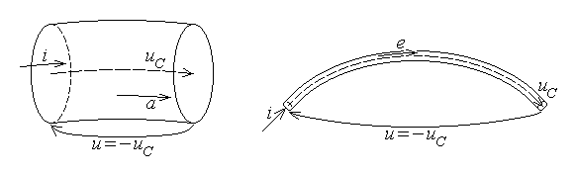
Fig. 3.19.
Particular cases of these equations can be obtained when dealing with so called purely active conductors, when there is no contribution from the conductive part of the conductor (G = 0 in the presence of an impressed current or R = 0 in the presence of an impressed voltage); one then obtains so called ideal sources, described by the equations
i = a , independent on u ,
and respectively
u = e , independent on i .
The particular cases considered above are important in the circuit theory.

3.7. The law of power transfer associated to electric conduction
1. Electromagnetic processes are not an isolated group of phenomena: for instance, mechanic actions are acting upon objects placed in an electromagnetic field, but there are also other links with the rest of physical phenomena. Of utmost importance are energy transfer processes, associated to electromagnetic phenomena, which allow the thermodynamic approach to these processes.
In the case of simple microscopic models of the conduction process, simple evaluations can be made of the power transfer from the electromagnetic field to the conductor, associated to the conduction state. Indeed, the mechanical power done by the electromagnetic field on the microscopic charges moving in a conductor, is proportional with the acting electric force and the rate of charge transport. The former is in turn proportional with the electric field strength , $\vec{E}$ , and the latter is proportional with the electric current density, $\vec{J}$ . Experimental evidence supports the extension of such evaluations for other cases, too, and the statement of the law results as: in any (conducting) substance and any state, the volume density of the power transferred from the electromagnetic field to the substance, associated to electric conduction, is
$p=\vec{E}⋅\vec{J}$ .
Immediate consequences of this local formulation are derived with the help of the conduction constitutive law. If the current density form is used, one obtains
$p=σ E^{2}+\vec{E}⋅{\vec{J}}_{i}$ ;
if the field strength form is used, it follows that
$p=ρ J^{2}−{\vec{E}}_{i}⋅\vec{J}$ –
each one of these results can be writen as the difference of two terms,
$p=p_{J}−p_{G}$ .
The first term in both equations above is always positive; it describes the volume density of the power transfer associated to Joule's effect: heat is developed in any conductor carrying a current, meaning irreversible dissipation (loss) of electromagnetic power,
pJ = σE2 > 0 , pJ = ρJ2 > 0 .
The second term in both equations above is linked to the presence of nonelectric actions having conductive effects, that is resulting in some electromagnetic outcome. Since the power densities under consideration correspond to a transfer from the field to the substance, negative terms correspond to transfer from the substance to the field, and such terms are called volume density of generated power,
$p_{G}=−\vec{E}⋅{\vec{J}}_{i} , p_{G}=\vec{E}⋅{\vec{J}}_{i}$ .
2. An integral formulation can be obtained starting either from the segment of a filamentary conductor or from the slice of a solid conductor, as considered above when discussing the integral formulations of the conduction constitutive law. For convenience,

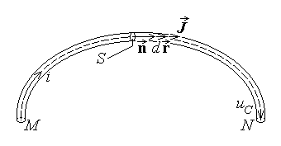
Fig. 3.20.
the first case is studied: let a piece MN of a filamentary conductor be considered, which can be taken as coincident with its median line (fig. 3.20); if $d\vec{r}$ denotes the line element along the wire and $\vec{n}$ denotes the normal unit vector to the (very small) transverse surface of area S , then one may take $\vec{J} \left|\right| \vec{n} \left|\right| d\vec{r}$ . The local form of the present law is integrated

over the volume of the conductor, taking into account that the conductor is a current tube, and the expressions of the volume element, current intensity, and electric voltage,
$\text{dV}={\text{dS}}_{n}\text{dr}=S \text{dr}$ ,
$i=\int{J⋅\vec{n} \text{dS}}=\int{J \text{dS}}=J S , u_{C}=\int{\vec{E}⋅d\vec{r}}$ .
One obtains for the power transferred from the electromagnetic field to the conductor, associated to the electric conduction, the expression
$P=\int{p\text{dV}}=\int{\left(\vec{E}⋅\vec{J}\right)\left(S \text{dr}\right)}=\int{\left(\vec{E}⋅d\vec{r}\right) \left(J S\right)}=\int{i \left(\vec{E}⋅d\vec{r}\right)}=i \int{\vec{E}⋅d\vec{r}}=i u_{C}$ ,
that is the desired integral formulation of the law,
$P=u_{C} i$ ,
where the same reference direction was considered for both the current and the voltage.
Immediate consequences are also obtained from the integral formulation, if the integral forms of the conduction constitutive law are invoked. If the current form is used, one obtains
P = G + uC a ;
while use of the voltage form yields
P = R i2 – e i .
3. The steady–state (and amagnetic quasi–steady state) case will be now considered, and the voltage at terminals will be introduced, associated with the current according to the source rule (fig. 3.21); then uC = – u and the above equations become
$P=G u^{2}−u a , P=R i^{2}−e i$ .
Fig. 3. 21.
The electromagnetic power received by a current carrying conductor can thus be generally expressed as
$P=P_{J}−P_{G}$ .
The first term in both equations above is always positive; it describes the power transfer associated to Joule's effect: heat is developed in any conductor carrying a current, meaning irreversible dissipation (loss) of electromagnetic power:
$P_{J}=G u^{2}>0 , P_{J}=R i^{2}>0$ .
The second term in both equations above is linked to the presence of nonelectric actions having conductive effects, that is resulting in some electromagnetic outcome. Since the equations describe the power transfer from the field to the substance, negative terms in it correspond to a transfer from the substance to the field, and then such terms represent a generated power,
$P_{G}=u a , P_{G}=e i$ .
Another consequence is obtained directly from the integral formulation of the law. Supposing again steady–state (or amagnetic quasi–steady state) conditions, but applying now the load rule for associating the reference directions of the current i and the voltage u at terminals (fig. 3.22), one has uC = u , and the power received by the conductor (substance) from the electromagnetic field associated to conduction results in
$P=u i$ .
Fig. 3.22.
This result will be again justified under more general conditions, and will be extensively used in the study of electric circuits.

3.8. Faraday's law on electrolysis
1. There exist another kind of processes that allow the treatment of electro-
magnetic phenomena within the more general thermodynamic approach, besides energy transfer: in some circumstances, electric conduction phenomena are associated to substance transport processes. Such processes take place in a special kind of conductors, called conductors of second class, or electrolytes (such as, for instance, acid, base, or salt solutions or melted salts). Indeed, when dissolved in appropriate solutions or melted, the molecules of such substances are split into oppositely charged fragments, called ions. The splitting of electrolyte molecules into ions on dissolution is termed electrolytic dissociation. If two metallic plates are immersed in an electrolyte and a voltage is applied between these so called electrodes, then a current is carried through the electrolyte, associated to the movement of charged ions under the action of electric forces (fig. 3.23).

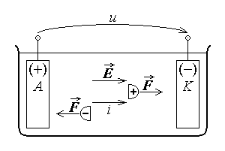
Fig. 3.23.
The positive ions, called cations, move toward the negative electrode, named cathode, while the negative ions, called anions, move toward the positive electrode, named anode. On arrival at the corresponding electrode, the charge of ions is compensated, and a mass deposition of molecule fragments results at the electrodes.

The process of charge transport and mass deposition at electrodes, associated to conduction phenomena taking place in electrolytes, is called electrolysis. Experimental evidence and theoretical arguments based on microscopic models of phenomena resulted in the following integral formulation of the law: in any electrolyte and any state, the

mass deposition at each electrode during electrolysis is proportional to the electric charge carried by the corresponding current,
$m=k q=\frac{1}{F}\frac{A}{n}\int{i \text{dt}}$ .
In the equation above, k is the electrochemical equivalent of the concerned type of deposed ions, A/n is its chemical equivalent (where A is the kilomol and n is the valence), while
$F≈\text{96}\text{.}5⋅{\text{10}}^{6} C/\text{equiv}\text{.}\text{kg}$
is a universal constant, called Faraday's number. As well, since according to the charge conservation law the electric current intensity is associated with the rate of charge transport, $i=\text{dq}/\text{dt}$ , in the above equation the electric charge q was expressed in terms of the direct current intensity i .
An alternative instantaneous integral formulation of Faraday's law on electrolysis is immediately obtained if the processes ocurring in an elementary time interval are considered: an elementary mass dm is deposited at each electrode corresponding to the transport of the elementary charge dq = i dt , so that dm = k i dt . It follows that
$\frac{\text{dm}}{\text{dt}}=k i=\frac{1}{F}\frac{A}{n} i$ :
in any electrolyte and any state, the rate of mass deposition at each electrode during electrolysis is proportional to the intensity of the electric current carried by the electrolyte.
2. The local formulation of the electrolysis law is immediately obtained if the current is expressed in terms of its density. Indeed, let an elementary area dS of an electrode with the normal unit vector $\vec{n}$ be considered, which injects into or collects from the electrolyte the elementary curent intensity $\text{di}=\left|\vec{J}⋅\vec{n}\right| \text{dS}$ to which it corresponds the transport of an elementary charge dq = di dt during the elementary time

interval dt (fig. 3.24). Let also $τ=\frac{\text{dm}}{\text{dS}}$
be defined as the surface mass density of the deposition at the electrode surface. The integral form of Faraday's law on electrolysis is now written successively as
$\text{dm}=k \text{di} \text{dt}=k \left|\vec{J}⋅\vec{n}\right| \text{dS} \text{dt}$ ,
whence it results the local formulation of the law,
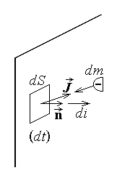
Fig. 3.24.

$\frac{\text{dm}/\text{dS}}{\text{dt}}=k \left|\vec{J}⋅\vec{n}\right| ⇔$ $\frac{dτ}{\text{dt}}=k \left|\vec{J}⋅\vec{n}\right|=\frac{1}{F}\frac{A}{n} \left|\vec{J}⋅\vec{n}\right|$ :
in any electrolyte and any state, the rate of deposition of the surface mass density at each electrode during electrolysis is proportional to the electric charge carried by the corresponding current.
3. The electrolysis is associated with supplementary processes which, even with no direct relevance to the process itself, are relevant to the electric conduction and deposition phenomena and energy transfer as well. The fact is that the deposition alters the electrochemical system from the initial configuration (anode / electrolyte / cathode) to another, (anode / deposition / electrolyte / deposition / cathode) . Additional impressed electric fields and voltages, specific to the electrolytic system and its evolution, appear at new interfaces, (fig. 3.25). Such impressed voltages (usually taken distinct as e_{A} and e_{K} for anode and cathode interfaces, respectively) are named polarisation voltages, and since they are usually opposite to the flow of electric current, the total impressed voltage is also called a counter–electromotive force , e_{c} = e_{A} + e_{K} .
The integral formulation of the conduction constitutive law, expressed according to the load rule, u = R i – e , supposes that all quantities are considered with respect to

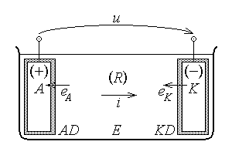
Fig. 3.25.
the same reference direction, namely that of the current. However, as discussed above, the counter−electromotive force is opposite to the current, so that the conduction processes in an electrolytic cell are described by the equation
u = R i + e_{c} ,
and the current
$i=\frac{u−e_{c}}{R}>0$

is flowing through the electrolytic cell in the desired direction only if the applied voltage u is greater than the polarisation voltage e_{c} .
If the above conduction constitutive equation is multiplied by the current intensity i , one obtains the relation
u i = R i² + e_{c} i ,
that can be easily interpreted in terms of energy transfer as
P_{t} = P_{J} + P_{chem} .
According with the reference direction chosen before, the term on the left hand side is the electric power received by the electrolytic cell at its terminal, while the terms on the right hand side are respectively the power dissipated in the electrolyte and the chemical decomposition power, corresponding to the electrolysis process.

3.9. The magnetic constitutive law
1. The magnetic constitutive law represents the relationship between the field quantities which characterise the magnetic field in substance. It also highlights the influence of the magnetisation on this relationship. Such an equation can be proved in the case of the steady–state magnetic field; experiments support the extension of the definitions of the magnetic field quantities and the validity of this relationship to any state.
The law is stated as follows: in any substance and any state, the magnetic field strength, magnetic flux density, and magnetisation at the same point and instant satisfy the equation
$\text{ \{}\vec{B}=μ_{0}\left(\vec{H}+\vec{M}\right)$ ,
where
$μ_{0}=4π⋅{\text{10}}^{−7}H/m$
is the free space absolute permeability.
2. The main use of such a relationship would be to simplify the study of the magnetic field: instead of operating with two vector quantities, $\vec{H}$ and $\vec{B}$ , the above equation allows the use of a single vector, say $\vec{H}$ , when studying the magnetic field, the other one being obtained according with the discussed equation. However, in view to obtain a proper relationship between $\vec{H}$ and $\vec{B}$ , the precise knowledge of the magnetisation $\vec{M}$ is needed. It is found out that the magnetisation can generally be split in two additive components:
$\text{ \{}\vec{M}={\vec{M}}_{p}+{\vec{M}}_{t}$ .
The permanent (spontaneous) magnetisation ${\vec{M}}_{p}$ is the part of the magnetisation which is independent on the magnetic field. It may depend on nonmagnetic quantities; for instance, some substances present a permanent magnetisation induced by mechanical stresses (magnetostriction). Permanent magnetisation is also naturaly present in certain substances, related to their microscopic structure (magnets). The temporary (induced) magnetisation ${\vec{M}}_{t}$ is the part of the magnetisation which does depend on the magnetic field – this is usually expressed as a dependence upon the magnetic field strength, ${\vec{M}}_{t}\left(\vec{H}\right)$ . Since the permanent magnetisation is to be given, as external to electromagnetic causes, the temporary magnetisation remains to be discussed.
Substituting the discussed expression of the magnetisation into the magnetic constitutive law, one can separate the part of the magnetic flux density which is influenced by the magnetic field strength from the part which is independent on the electromagnetic phenomena,
$\vec{B}=μ_{0}\left[\vec{H}+{\vec{M}}_{p}+{\vec{M}}_{t}\left(\vec{H}\right)\right]=μ_{0}\left[\vec{H}+{\vec{M}}_{t}\left(\vec{H}\right)\right]+μ_{0}{\vec{M}}_{p}$ .
It is of particular interest to study that relationship between the magnetic field strength and the magnetic flux density which is independent on the eventual contribution of the permanent magnetisation,
$\vec{B} |_{ {\vec{M}}_{p}=0}=μ_{0}\left[\vec{H}+{\vec{M}}_{t}\left(\vec{H}\right)\right]$ ,
named the magnetic constitutive equation. This study implies the discussion of the relationship between the magnetic field strength and the temporary magnetisation.

3.10. The law of temporary magnetisation
1. The law of temporary magnetisation is a statement related to the preceding comment: for any given substance there exists a part of the magnetisation, named temporary magnetisation, which depends on the magnetic field strength at the same point and instant according to a function specific to that substance,
${\text{ \{}\vec{M}}_{t}={\vec{M}}_{t}\left(\vec{H}\right)$ .
In this respect, the statement is general since it is valid for any substance; nevertheless, since the precise function relationship depends on the substance, this is called a substance–related law.
Different specific functional relations between the temporary magnetisation and the magnetic field strength can be classified into linear, when ${\vec{M}}_{t}$ is proportional with $\vec{H}$, or nonlinear, when this is not the case. As well, these functional relations can be classified also into isotropic, when ${\vec{M}}_{t} \left|\right| \vec{H}$ , or anisotropic, when this is not the case. Since the first term in the magnetic constitutive equation, $μ_{0}\vec{H}$ , is proportional to and parallel with $\vec{H}$ , it is obvious that the type of the ${\vec{M}}_{t}\left(\vec{H}\right)$ relationaship results in the same type of relationship in the magnetic constitutive equation $\vec{B} \left(\vec{H}\right) |_{ {\vec{M}}_{p}=0}$ .
2. In the case of linear isotropic media the dependence is simply
${\vec{M}}_{t}=χ_{m}\vec{H}$ ,
where χ m is a numeric constant, specific to the substance under consideration, called magnetic susceptibility. Particular cases are the diamagnetic substances, where χ m is very small negative number, independent on temperature, and paramagnetic substances, where χ m is a positive number and depends on temperature according to an approximate inverse proportionality equation, χ m ∼ C / T .
An immediate consequence is the magnetic constitutive equation, in the case of linear isotropic substances,
$\vec{B} |_{{\vec{M}}_{p}=0}=μ_{0}\left(\vec{H}+{\vec{M}}_{t}\right)=μ_{0}\left(1+χ_{m}\right) \vec{H}=μ_{0}μ_{r}\vec{}H ⇒$
⇒ $\vec{B} |_{{\vec{M}}_{p}=0}=μ \vec{H} , μ=\text{const}\text{.} \text{independent} \text{on} \vec{H}$ ,
where
μ r = 1 + χ m
is a numeric constant, called relative permeability of the considered substance, and
$μ=μ_{0}μ_{r}$
is the absolute permeability or magnetic constant of the substance under consideration.
3. In the case of non–linear isotropic substances, the functional relationship of the temporary magnetisation law, that is characteristic to each considered substance, can be reduced to the simpler relationship between the magnitudes of the parallel vectors implied
${\vec{M}}_{t}={\vec{M}}_{t}\left(\vec{H}\right) ⇒ M_{t}=M_{t}\left(H\right)$ ,
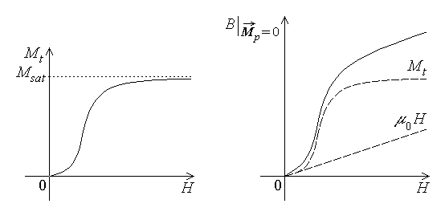
Fig. 3. 26. Fig. 3. 27.
The non–linear relationship is homogeneous, i.e., it has the property that
${\vec{M}}_{t}\left(0\right)=0$ ,
and, since it can not be expressed in terms of simple functions, is usually given in graphic form (fig. 3.26).
As an immediate consequence, the magnetic constitutive equation is easily derived: since both terms in the equation are parallel, their sum is also parallel to them, and the magnetic constitutive equation reduces to a relation between the magnitudes of
the implied vectors (fig. 3.27),
$\vec{B}\left(\vec{H}\right) |_{{\vec{M}}_{p}=0}=μ_{0}\left[\vec{H}+{\vec{M}}_{t}\left(\vec{H}\right)\right] ⇒ B\left(H\right) |_{{\vec{M}}_{p}=0}=μ_{0}\left[H+M_{t}\left(H\right)\right]$ .
The resulted relationship, is written, for convenience, in a form somewhat similar to that used in the case of linear isotropic substances, where ε is no longer a constant,
$\vec{B}\left(\vec{H}\right) |_{{\vec{M}}_{p}=0}=μ\left(H\right) \vec{H}$ .
A particular case of a non–linear dependence of $\vec{B}$ on $\vec{H}$ , which is not even one–to–one, is characteristic to so called ferromagnetic substances, which are therefore also named hysteretic substances. Let a piece of such an isotropic hysteretic substance be

considered, which has never been placed in a magnetic field before, and let it be subjected to an alternating magnetic field of constant direction, whose projection upon its direction varies between –HM and +HM , starting from a zero initial value. The corresponding values of the magnetic flux density B are followed and the associated curve (graph) is constructed (fig. 3.28). When the field H is increased from 0 to HM , the associated flux density also increases, following a non–linear monotonous curve, called the first magnetisation curve, from 0 to a maximum value BS . If the maximum applied field is sufficiently great, the final part of the curve is almost horizontal: it is said that a saturation is
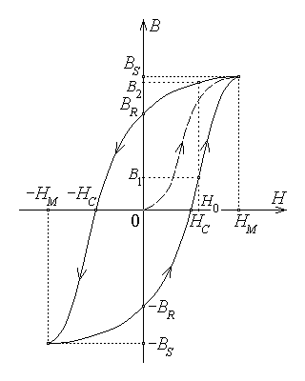
Fig. 3. 28.

reached. When the magnetic field is reduced from HM to 0 , the corresponding flux density also decreases, but follows a curve that is above the preceding one, so that at zero magnetic field a so called remanent magnetic flux density BR is still present. When the direction of the magnetic field is reversed and its magnitude is again increased up to HM (i.e., its projection is decreased to –HM) , a point symmetric to the extreme point reached before is attained, namely (–HM , –BS) . The corresponding part of the curve crosses the field axis (i.e., the flux density is zero) at a certain value –HC of the field, called coercive field. The subsequent variation of the applied magnetic field from –HM to 0 to HM induces a corresponding variation of the magnetic flux density from –BS to –BR to BS , passing through the point (HC , 0) . If the alternative magnetic field continue its variations, the symmetric closed hysteresis cycle is travelled by the characteristic point (H , B) . It is now obvious that to a given field H₀ it corresponds two different flux densities, B1 and B2 (B1 < B2) , reached depending on the previous variation of the applied field: by following increasing or by following decreasing values of the magnetic field strength.
It is to be noted that the completion of each hysteresis cycle in an alternating electric field is accompanied by an irreversible energy transfer from the electromagnetic field to the hysteretic substance. Moreover, apart from ferromagnetic substances, such a hysteretic behaviour is also present in so called ferimagnetic, anti–ferromagnetic, and anti–ferimagnetic substances, the difference between them being related to somewhat different microscopic mechanisms that explain such a behaviour.
In the case of anisotropic substances, the induced magnetic flux density $\vec{B}$ is no longer parallel to the applied magnetic field $\vec{H}$ , for both linear and non–linear cases. It means that, in the magnetic constitutive equation, each component of the flux density depends on all three components of the field strength,
$B_{x}|_{{\vec{M}}_{p}=0}=B_{x}\left(H_{x},H_{y},H_{z}\right) , \text{etc}\text{.}$ .
All the preceding remarks are still generally valid, but the analysis of such situations is much too difficult to be presented here.

3.11. Dirac's law on the magnetic flux
1. Starting from experimentally based date, a relationship can be derived for the flux of the magnetic flux density over a closed surface, under steady–state conditions. Moreover, experiments show that this relation also holds under the most general conditions, so it can be stated as the magnetic flux law: in any substance and any state, the magnetic flux across any closed surface is equal to zero (fig. 3.29),
$Φ_{Σ}=0 ; \oint{\vec{B}⋅\vec{n}\text{dA}}=0 , ∀ Σ$ .
It is recalled that the magnetic flux across the considered closed surface is taken with respect to the reference direction of the outward pointing normal unit vector $\vec{n}$ .
A comparison with the similar law on the electric flux,
$Ψ_{Σ}=q_{D_{Σ}}$ ,
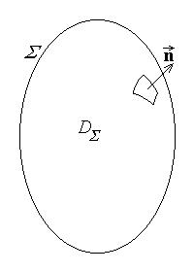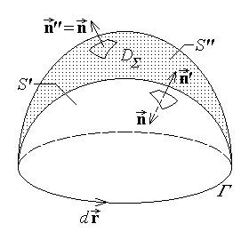
Fig. 3. 29. Fig. 3. 30.
suggests that there are no such thing as a magnetic charge or, as it is also named, a magnetic mono–pole. The law is here named after the scientist who studied precisely the
possibility of the existence of such magnetic mono–poles.
2. An important consequence of the magnetic flux law is the following: the magnetic flux is the same over any open surface bordered by the same contour, Φ ' = Φ " = Φ . Let the contour Γ be considered, which borders two open surfaces, S' and S" , of normal unit vectors $\vec{n}'$ and $\vec{n}\text{\} \{}$ , both associated with the reference direction $d\vec{r}$ along the contour according to the same right hand rule (fig. 3.30). The union of these surfaces is then a closed surface, say Σ , of outward pointing normal (unit vector) $\vec{n}$ which coincides with $\vec{n}\text{\} \{}$ on S" and is opposite to $\vec{n}'$ on S' . Invoking the magnetic flux law, one obtains
$0=\oint{\vec{B}⋅\vec{n} \text{dS}}=\int{\vec{B}⋅\left(−\vec{n}'\right) \text{dS}}+\int{}$ ,
which proves the statement. It is to be remarked that this result was already used in the statement of Faraday's law on electromagnetic induction.
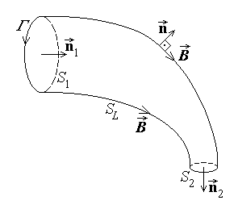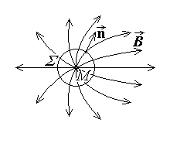
Fig. 3.31. Fig. 3.32.
A re–formulation of this consequence can be stated, relative to a magnetic flux tube, i.e., a cylinder–like surface, with the lateral surface taken along magnetic flux lines: $\vec{B}⋅\vec{n}=0$ on SL . Let S₁ and S₂ be two cross sections in the flux tube, of normal unit vector $\vec{n}$ in the direction of the field lines (fig. 3.31). Taking the surface S' as the first cross section S1 , S' = S1 and the surface S" as the union of the lateral and second cross section of the flux tube, S" = SL ∪ S2 , and considering the definition of the flux tube, the preceding theorem gives Φ 1 = Φ ' = Φ " = Φ L + Φ 2 = 0 + Φ 2 . This means that the magnetic flux is constant along a flux tube, Φ 1 = Φ 2 .
An immediate consequence of this re–formulation is the theorem on magnetic flux lines continuity: the lines of magnetic flux density are closed (more precisely, they are not open). For the proof, let the opposite be supposed, i.e., that under the specified conditions, the magnetic field lines would be open. Let M be a source point of such open field lines, tightly surrounded by a closed surface Σ of outward normal unit vector $\vec{n}$ (fig. 3.32). Then, since $α\text{=∠}\left(\vec{B},\vec{n}\right)<π/2$ , the total magnetic flux over the closed surface would be $Φ_{Σ}=\oint{\vec{B}⋅\vec{n} \text{dS}}>0$ , which contradicts the magnetic flux law. It follows that the supposition is false, so that the field lines of the magnetic flux density are to be closed.

3.12. Ampere's magnetic circuital law
1. Experimental evidence indicates that current carrying conductors generate a magnetic field, and theoretic rigorous results describing such a relationship can be derived under steady–state conditions. However, simple extension of these results to general time–varying conditions is not straightforward: for instance, the convection current, associated with the macroscopic movement of electric charge has similar magnetic effects and would also have to be considered. It was Maxwell who noted that such a charge movement can be associated with the time variation of the electric flux accompanying this charge, and proposeded a truly general relationship, which was subsequently confirmed by Hertz's experiments.
The integral formulation of Ampere's magnetic circuital law is: in any substance and any state, the magnetomotive force (m.m.f.) along any contour is equal to the sum between the total current across any surface bordered by the contour and the rate of increase (in time) of the electric flux over the same surface (fig. 3.33),
$u_{\text{mm}Γ}=i_{S_{Γ}}+\frac{{dΨ}_{S_{Γ}}}{\text{dt}} ; \oint{\vec{H}⋅d\vec{r}}=i_{S_{Γ}}+\frac{d}{\text{dt}} \int{\vec{D}⋅\vec{n} \text{dS}}$ .

Fig. 3.33.
Some remarks are to be made related to the preceding statement and integral formulations: (1) The reference direction of the magnetomotive force ($d\vec{r}$) , on one hand, and that of the total current and electric flux ($\vec{n}$) , on the other hand, are associated according to the right hand rule. (2) The total current across the surface bordered by the contour under consideration is the

algebraic sum of all contributions to such a current; in most cases this can be expressed as
$i_{S_{Γ}}=\sum_{k ∩ S_{Γ}}{N_{k}i_{k}}+\int{\vec{J}⋅\vec{n} \text{dS}}$ ,
where the contribution of some Nk turns of coils carrying filamentary currents ik – named the ampere–turns of the considered coil – was accounted for, along with solid conductors eventually crossing the surface SΓ . (3) In taking the time derivative of the surface integral of the electric displacement, also named displacement current,
$i_{D,S_{Γ}}=\frac{{dΨ}_{S_{Γ}}}{\text{dt}}=\frac{d}{\text{dt}}\int{\vec{D}⋅\vec{n} \text{dS}}$ ,
the interpretation given by Hertz is to be observed: the geometric elements (contour, surface) are to be taken as attached to the eventually moving media, in a way similar to that considered for Faraday's law on electromagnetic induction.
2. An important consequence of this law, which in a way justifies its name, is Ampere's theorem: under steady–state or anelectric quasi–steady state conditions, the magnetomotive force along any contour is equal to the total current across any surface bordered by the contour. In the case of steady–state conditions, when all quantities are time–invariant, the proof is obvious,
$\frac{d}{\text{dt}}≡0 ⇒ u_{\text{mm}Γ}≡\oint{\vec{H}⋅d\vec{r}}=i_{S_{Γ}} \text{for} \text{any} Γ$ .
The quasi–steady state was defined as the state where the rate of time–variation of quantities is sufficiently low so that no electromagnetic waves are present. Moreover, an electromagnetic wave was defined as a position– and time–dependent electromagnetic field that is self–sustaining, even in the absence of other field sources. Therefore the analysis of the generating mechanism of electromagnetic waves could suggest a way to formulate a quantititative criterion for the quasi–steady state conditions. The accompanying diagram (fig. 3.34) indicates the mechanism of self–sustaining of a time– and position–dependent electromagnetic field:
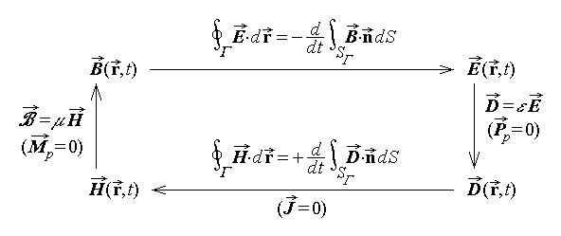
Fig. 3. 34.
The diagram makes it clear that a time– (and position–) dependent magnetic flux density $\vec{B}\left(t\right)$ finds itself supported by an additional induced contribution $\vec{B}\left(t\right)$ , resulting from the chain of phenomena related to the electromagnetic induction, the electric constitutive equation, the displacement current, and the magnetic constitutive equation.
The quasi–steady state thus corresponds to breaking such a chain of phenomena. Since the constitutive equations can not be broken, it is solely the links containing time– derivatives that can eventualy be broken, resulting into two quasi–steady state conditions.
When the induced electromotive force $−{dΦ}_{S_{Γ}}/\text{dt}$ is negligible, the generating mechanism of electromagnetic waves is broken; the so called amagnetic quasi–steady state is thus defined by the condition
$\left|−\frac{{dΦ}_{S_{Γ}}}{\text{dt}}\right|\text{<<}\left|u_{\text{static} \text{or} \text{steady}−\text{state}}\right|$ .
Experiments show that the generating mechanism of electromagnetic waves is even more easily broken when the displacement current ${dΨ}_{S_{Γ}}/\text{dt}$ is negligible; the so called anelectric quasi–steady state is thus defined by the condition
$\left|\frac{{dΨ}_{S_{Γ}}}{\text{dt}}\right|\text{<<}\left|i_{S_{Γ}}\right|$ .
Thus, coming back to Ampere's theorem that involves reference to currents, the proof is straightforward for (anelectric) quasi–steady state conditions as well,
$\frac{{dΨ}_{S_{Γ}}}{\text{dt}}≪i_{S_{Γ}} ⇒ u_{\text{mm}Γ}\oint{\vec{H}⋅d\vec{r}}=i_{S_{Γ}}$ for any Γ .
3. In a manner similar to that used in the study of the electric field, but following a much more difficult reasoning, a consequence of all the laws regarding the magnetic field can be derived, which allows the computation of the magnetic field strength under steady–state conditions in a boundless homogeneous linear isotropic medium. This result, called Biot–Savart–Laplace's formula, is here given without demonstration,
$\text{ \{}\vec{H}=\frac{1}{4π} \left[\sum_{k}{\int{\frac{i_{k} d\vec{r}×\vec{R}}{R^{3}}}}+\int{\frac{\vec{J}×\vec{R} \text{dV}}{R^{3}}}+\int{\frac{{\vec{J}}_{S}\vec{R} \text{dS}}{R^{3}}}\right]$ ,

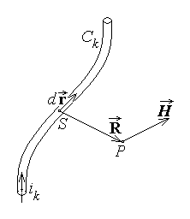
Fig. 3.35.
as applied for filamentary conductors, solid conductors, and current sheets. The magnetic field strength generated at the observation point P at the fixed end of the position vector $\vec{R}$ (fig. 3.35) is obtained as the sum, i.e., integral, of the elementary contributions coming the current carrying conductors, taken as the mobile origin S of the position vector $\vec{R}$ , when this origin source point S moves over the current distribution.

3.13. The system of laws of electromagnetic phenomena
1. The set of laws of electromagnetic phenomena discussed up to this point describes the state and evolution of the electromagnetic field.
The electromagnetic field laws can be grouped according to the particular aspect of the field they describe. The group of laws regarding the electric field is
$\vec{D}=ε_{0}\vec{E}+\vec{P} \text{and}\text{ \{}\vec{P}={\vec{P}}_{p}+{\vec{P}}_{t}\left(\vec{E}\right) ⇒\text{ \{}\vec{D}=ε \vec{E}+{\vec{P}}_{p}$ ,
$\oint{\vec{E}⋅d\vec{r}}=−\frac{d}{\text{dt}} \int{\vec{B}⋅\vec{n} \text{dS}}=− \int{\frac{∂\vec{B}}{∂t}⋅\vec{n} \text{dS}}+\oint{\left(\vec{v}×\vec{B}\right)⋅d\vec{r}}$ ,
$\oint{\vec{D}⋅\vec{n} \text{dS}}=q_{D_{Σ}}$ .
The similar group of laws regarding the magnetic field is
$\vec{B}=μ_{0}\left(\vec{H}+\vec{M}\right) \text{and}\text{ \{}\vec{M}={\vec{M}}_{p}+{\vec{M}}_{t}\left(\vec{H}\right) ⇒\text{ \{}\vec{B}=μ \vec{H}+μ_{0}{\vec{M}}_{p}$ ,
$\oint{\vec{H}⋅d\vec{r}}=i_{S_{Γ}}+\frac{d}{\text{dt}} \int{\vec{D}⋅\vec{n} \text{dS}}$ ,
$\oint{\vec{B}⋅\vec{n} \text{dS}}=0$ .
Finally, the group of so called (electric) conduction laws is
$\vec{J}=σ \vec{E}+{\vec{J}}_{i} \text{or}\text{ \{}\vec{E}+{\vec{E}}_{i}=ρ \vec{J}$ ,
$i_{Σ}=−\frac{d}{\text{dt}}q_{D_{Σ}} \text{or} i_{Σ}+i_{C Σ}=−\frac{∂}{∂t}q_{D_{Σ}}$ ,
$p=\vec{E}⋅\vec{J}$ ,
$\frac{\text{dm}}{\text{dt}}=k i$ .
2. Some remarks are to be made regarding these equations:
1°. A vector field is determined if its flux is known over any closed surface (thus determining its open field lines) and its circulation is known along any contour (thus determining its closed field lines). As it is seen, such data are given by the previously presented laws, separately for one or the other of the electric / magnetic field vectors. Moreover, internal links between the field vectors – the so called constitutive laws or equations – complete the approach.
2°. The above equations allow also to identify the causes generating the electric or magnetic fields, or the electric conduction phenomena.
The electric field laws show that an electric field (either $\vec{D}$ or $\vec{E}$) is present if one of the following causes is present: electric charge q (as indicated by Gauss's law), polarised bodies of (electric) polarisation $\vec{P}$ (as indicated by the electric constitutive law), and time–varying magnetic field $∂\vec{B}/∂t$ or movement across magnetic field lines $\vec{v}×\vec{B}$ (as indicated by Faraday's law on electromagnetic induction).
The magnetic field laws show that a magnetic field (either $\vec{B}$ or $\vec{H}$) is present if one of the following causes is present: electric currents (conduction currents i or convection currents i_{C} , as indicated by Ampère's law), magnetised bodies of magnetisation $\vec{M}$ (as indicated by the magnetic constitutive law), time–varying electric field $∂\vec{D}/∂t$ or movement across electric field lines $\vec{v}×\vec{D}$ (as indicated by an explicite extension of Ampère's law, similar to that given to Faraday's law on electromagnetic induction).
The electric conduction laws show that electric conduction is generated by the presence of an electric field $\vec{E}$ or impressed quantities (impressed electric field ${\vec{E}}_{i}$ or impressed electric current ${\vec{J}}_{i}$ ) as follows from the conduction constitutive law. On the

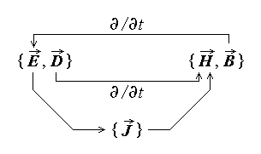
Fig. 3.36.
other hand, as the law of electric charge conservation suggests, electric currents are always related to an electric charge variation $∂q/∂t$ or movement $i_{C}=\int{ρ_{V}\vec{v}⋅\vec{n} \text{dS}}$ . The remaining electric conduction laws are relating electromagnetic phenomena to the more general thermodynamic approach, by characterising energy and mass transfer processes related to electric conduction.

3°. The above comments show that the equations under consideration constitute a system of equations for the determination of the electromagnetic field: each aspect of the electromagnetic field is related to the other aspects of it, as illustrated in fig. 3.36: The electric field directly determines conduction phenomena in conductors and, when time–dependent, generates a magnetic field. The electric conduction currents, in turn, generate a magnetic field. Finaly, when time–dependent, the magnetic field generates an induced electric field.
4°. The electromagnetic field is therefore to be treated as a set of four field vectors $\left\{ \vec{E},\vec{D} ;\vec{H},\vec{B} \right\}$ , defined at any point in the domain D_{Σ} of interest and over the time interval of interest t ∈ [ 0 , T ] . Indeed, according with the above discussed laws, the electromagnetic states of the substance can be determined from the field vectors: the electric charge in any domain D_{σ} results as $q_{D_{σ}}=\oint{\vec{D}⋅\vec{n} \text{dS}}$ , the electric conduction current across any surface S_{Γ} results as $i_{S_{Γ}}=\oint{\vec{H}⋅d\vec{r}}−\frac{d}{\text{dt}} \int{\vec{D}⋅\vec{n} \text{dS}}$ , the (electric) polarisation results as $\vec{P}=\vec{D}−ε_{0}\vec{E}$ , and the magnetisation results as $\vec{M}=\frac{\vec{B}}{μ_{0}}−\vec{H}$ .
5°. The electromagnetic field $\left\{ \vec{E},\vec{D} ;\vec{H},\vec{B} \right\}$ is uniquely determined at any point in the domain D_{Σ} of interest and over the time interval of interest t ∈ [ 0 , T ] if its ultimate sources are given (known): internal sources, represented by permanent and impressed quantities ${{\vec{P}}_{p} \text{and}\text{ \{}\vec{M}}_{p} ,\text{ \{}\vec{E}{}_{i} \text{or}\text{ \{}\vec{J}{}_{i}$ in D_{Σ} for t ∈ [ 0 , T ] , external sources which influence the field in the domain of interest through the boundary conditions ${\vec{E}}_{\text{tang}}$ or ${\vec{H}}_{\text{tang}}$ on Σ for t ∈ [ 0 , T ] , and the initial state represented by the initial conditions $\vec{E} |_{ t=0}$ and $\vec{H} |_{ t=0}$ in D_{Σ} .

3.14. Theorems on the electromagnetic energy
1. The concept of electromagnetic field as a physical system implies the fact that it
is able to exchange, store, and transfer energy. A consequence of the whole set of laws of electromagnetic phenomena can be derived, called Poynting's theorem or the electro-magnetic energy theorem, which allows an energy interpretation. This theorem expresses the principle of energy conservation (the first principle of thermodynamics) as applied to the electromagnetic phenomena taking place in a domain DΣ bounded by a closed surface Σ of outward normal (unit vector) $\vec{n}$ ,
$P_{Σ}=\frac{\text{dW}}{\text{dt}}+P_{S}+P_{\text{mec}}$ .
The corresponding statement is: the electromagnetic power received by a system across the closed surface surrounding it is equal to the sum between the rate of increase (in time) of the electromagnetic energy stored inside the system, the electromagnetic power transferred to the substance inside the system, and the mechanical power done by the electromagnetic actions inside the system.
The electromagnetic power transferred across the enveloping surface is taken with the reference direction of (−$\vec{n}$) , i.e., as a received power. The surface density of electro-
magnetic power transfer is the so called Poynting's vector,
$\text{ \{}\vec{S}=\vec{E}×\vec{H}$ ,
so that
$P_{Σ}=\oint{\left(\vec{E}×\vec{H}\right)⋅\left(−\vec{n}\right) \text{dS}}$
and it is important to note that the surface integral of such a vector makes sense for closed surfaces only.
The electromagnetic energy stored inside the domain DΣ is expressed in terms of the volume densities of electric and magnetic energies,
$W=W_{e}+W_{m}=\int{\left(w_{e}+w_{m}\right) \text{dV}}$ .
The energy densities are given by
$w_{e}=\frac{\vec{E}⋅\vec{D}}{2} , w_{m}=\frac{\vec{H}⋅\vec{B}}{2}$ ,
for linear media, and by
$w_{e}=\int{\vec{E}⋅d\vec{D}} , w_{m}=\int{\vec{H}⋅d\vec{B}}$ ,
in the case of non–linear media.
The electromagnetic power transferred to the substance inside the system is composed from the electromagnetic power thansferred to conductors and the electro-magnetic power transferred to hysteretic substances inside the system,
$P_{S}=P_{C}+P_{\text{hyst}}$ .
According with Joule's law, the power transferred to conductors is, in turn, the difference between the dissipated power (by Joule's effect) and the generated power (asociated to the impressed electric field or current),
$P_{C}=\int{\vec{E}⋅\vec{J} \text{dV}}=P_{J}−P_{G}$ .
The power transfer phenomena taking place in hysteretic media, in an alternating time–varying electromagnetic field, are described by Warburg's theorem. As it is known, in such a case, each of the couples $\left\{\vec{E},\vec{D}\right\}$ and $\left\{\vec{H},\vec{B}\right\}$ follow a variation described by the local electric and magnetic hysteresis cycles. The electromagnetic power transferred to the substance associated to each hysteresis cycle performed by the electromagnetic field is
$P_{\text{hyst}}=\int{p_{\text{hyst}} \text{dV}}$ ,
This quantity is expressed in terms of the volume density of this power transfer,
$p_{\text{hyst}}=f⋅\left(A_{ \text{electric} \text{cycle}}+A_{ \text{magnetic} \text{cycle}}\right)$ ,
where f is the frequency of the alternating field and $A_{ \text{electric} \text{cycle}}$ and $A_{ \text{magnetic} \text{cycle}}$ represent the area of the corresponding electric or magnetic hysteresis cycles, respectively (fig. 3.37).
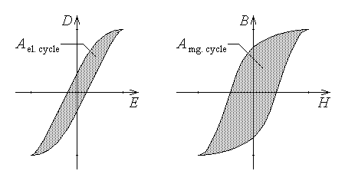
Fig. 3.37.
Finaly, the mechanical power done by the electromagnetic actions inside the system is simply
$P_{\text{mec}}=\frac{\text{dL}}{\text{dt}}=\frac{{\text{dL}}_{e}+{\text{dL}}_{m}}{\text{dt}}$
that is the rate of mechanical work done by the electric and magnetic forces (or more general – actions) inside the system. This last term of the electromagnetic energy theorem is obviously equal to zero if the media are at rest inside the electromagnetic system under consideration.
2. An important particular case of an electromagnetic system is a system at rest whose interaction with its exterior under quasi–steady state conditions can be described in terms of a finite number of integral quantities at terminals. Such an electromagnetic system is called a (multipolar) element of circuit, or a circuit element, or simply a multipole.
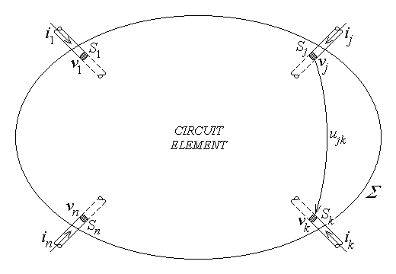
Fig. 3.38.
The multipole is defined by its surface at terminals, that is, a closed surface Σ at rest which surrounds the system, traced in insulating media, with the exception of a finite number of filamentary conductors linking the system to its exterior: the parts Sk of surface Σ where it crosses such connecting conductors are called the terminals of the multipole (fig. 3.38). The surface Σ has to satisfy the following defining conditions: no interaction between the system and the exterior world via the magnetic field across the surface at terminals Σ is admitted, no interaction between the system and the exterior world via the electric field across the surface at terminals Σ is admitted, and the electric field is normal to the terminal surfaces Sk .
This definition of the surface at terminals has some very important consequences: (1) There is no interaction between the system and its exterior across its surface at terminal either by magnetic or electric field, except at terminals; (2) An electric potential v(M,t) can be defined on the surface Σ even under time−varying quasi−steady state conditions, and each terminal Sk is equipotential: this means that each terminal can be characterised by its potential
$v_{k}\left(t\right)$ , k = 1,2,..,n ;
(3) The electric conduction currents entering the system across terminals,
$i_{k}\left(t\right)=\int{\vec{J}⋅\left(−\vec{n}\right) \text{dS}}$ , k = 1,2,..,n ,
satisfy the completeness equation,
$\sum_{k=1}^{n}{ i_{k}}=0$ .
(4) The electromagnetic power received by the system across its surface at terminals can be expressed as a the power received at terminals:
$P_{Σ}=\oint{\left(\vec{E}×\vec{H}\right)⋅\left(−\vec{n}\right) \text{dS}}=\sum_{k=1}^{n}{ v_{k}i_{k}}=p_{t}$ ;
this is precisely the statement of the theorem of power transfer at the terminals of a multipole. It is important to note that the reference direction of the currents implied in this equation is that of the inward pointing normal (unit vector) (−$\vec{n}$) .
3. An immediate application of the above theorem of power transfer at the terminals of a multipole refers to a dipole (fig. 3.39). A dipole is a two–terminal multipole; in this case the voltage between terminals can be associated to the current according to either the load or source rule. If i1 is the current entering the dipole at terminal 1 and i2 is the current leaving the dipole at terminal 2 , then the current completeness equation implies that
i1 + (–i2) = 0 ⇒ i1 = i2 = i ,
that is the current has the same value at the dipole terminals.
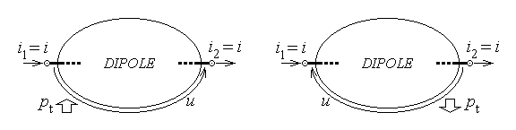
Fig. 3.39.
Let the load rule be considered: the voltage between terminals is u = v1 – v2 and the power received by the dipole at its terminals is
pt received = v1⋅i1 + v2⋅(–i2) = i⋅(v1 – v2) = u⋅i .
This expression extends a result obtained before when discussing the law of conduction associated power transfer.
Let now the source rule be considered: the voltage between terminals is u = v2 – v1 and the power received by the dipole at its terminals is
pt received = v1⋅i1 + v2⋅(–i2) = i⋅(v1 – v2) = – u⋅i .
If the sign is changed, what reults is a power transfer in the opposite direction: therefore, the power delivered by the dipole at its terminals is
pt delivered = u⋅i .
It is therefore very important to pay attention to the association of reference directions of the current and voltage: the same expression,
$p_{t}=u i$ ,
represents either a received or a delivered power when the quantities at terminals are associated according the load or source rule, respectively.

