2. ELECTROMAGNETIC QUANTITIES

2.1. Primary electromagnetic quantities
The primary electromagnetic quantities are those electromagnetic quantities which are introduced on the basis of specific (idealised) experiments that can be used as (idealised) means of measuring such quantities. Appropriate experiments offer evidence of a new state of the field or the substance, as distinct from previously known states (mechanical, thermal, chemical), and allow for the estimation of the degree in which the new state is manifest.
Some conditions are to be observed in view to introduce a physical quantity that characterises a new property (or state): (1) The property under study has to be such that objects exhibiting it can be classified in sets of equivalent objects; (2) The analysed property has to be such that the equivalence sets can be ordered; (3) The property under discussion has to be such that some composition rule can be experimentally identified; (4) The property under study has to be such that a correspondence can be constructed between the ordered equivalence sets and a certain interval of real numbers. This rigorous procedure used to introduce a primary quantity will be illustrated briefly for a first case, and only important features will be mentioned afterwards for the remaining cases.
2.1.1. The electric charge
Simple experiments show that in certain circumstances a very small object at rest in free space (in vacuum) is acted upon by a force, which is supplementary with respect to known mechanical or thermal forces. Such a force is called electric force, and the objects subjected to such forces have to be in a new state, named electrification state, distinct from previously known mechanical or thermal states; such objects are said to be electrified.
Let the folowing experiment be considered: a glass rod is rubbed against a piece of fur and the two objects are afterwards placed in their previous positions, waiting for them to regain their previous thermal state as well. It easy to see that the two objects exibit a new state, called electrification state – they are said to be electrified. Indeed, if very small objects are placed, for instance, in the neigbourhood of the electrified glass rod, then new, supplementary phenomena can be identified. A very small metallic object is attracted by the electrified rod and, after an instantaneous contact, is repelled; afterwards, the small object is itself electrified, that is it behaves just in the same manner as the original electrified rod (fig. 2.1). Substances – such as metals – with this behaviour are called conductors, since they can transmit the electrification state: if a conductor wire makes contact between an initially electrified conductor and an initially unelectrified onductor, the second object finds itself electrified after such a contact (fig. 2.2). On the other hand, there are different, non–metallic small objects that are attracted by the electrified rod and, after contact, remain stuck to the rod (fig. 2.3). Moreover, such non–metallic small objects are subjected not only to a force, but also to a torque, when placed in the neighbourhood of the electrified rod. Substances with this behaviour are called insulators, and experiments show they do not transmit the electrification state.
A similar experiment can be done by using a resin rod rubbed against a piece of cloth – after that both objects achieve an electrified state.
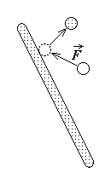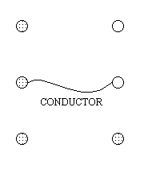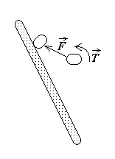
Fig. 2.1. Fig. 2.2. Fig. 2.3.
Let now a so called probe be considered, as the typical small object whose electrification state is to be studied. It consists of a very small light object, covered with a thin metallic foil and suspended by a thin silk thread for manipulation (fig. 2.4). The electrification of the probe is achieved by touching it to a glass rod previously rubbed with fur or a resin rod previously rubbed with cloth.
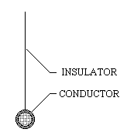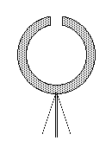
Fig. 2.4. Fig. 2.5.

The degree of exhibiting the electrification state may be estimated by using an appropriate measuring apparatus, namely the electrometer. The electrometer consists of a hollow metallic sphere, with a hole to enter the probe into the cavity. A pair of thin metallic ribbons is attached to the hollow sphere so that they can rotate with respect to one another around their common point of
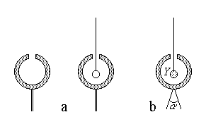
Fig. 2.6.

suspension on the sphere (as in fig. 2.5, where the supporting structure is not shown).
The experiment shows that the foils are normally touching when the electrometer cavity is either void or contains an unelectrified probe (fig. 2.6.a), but the foils depart from one another when an electrified probe is introduced in the cavity, even without touching its walls (fig. 2.6.b). The relationship between the electrification state Y of the probe and the deviation angle α determined by it on the electrometer is afterwards investigated.
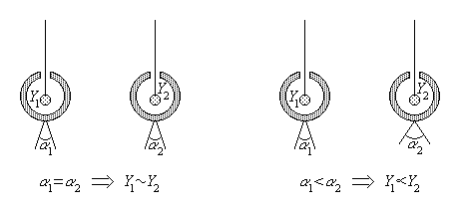
Fig. 2.7. Fig. 2.8.
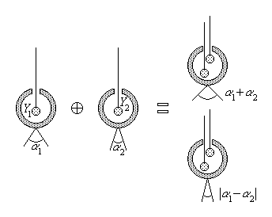
Fig. 2.9.
The angle between the foils is different for differently electrified probes. It constitutes the means of grouping electrified probes into equivalence sets: the electrification states Y₁ and Y₂ are said to be equivalent, Y₁ ~ Y₂ , if the induced deviation angles are equal, α ₁ = α ₂ (fig. 2.7). As well, an ordering relationship can be defined between these equivalence sets saying that Y₁ ∝ Y₂ (meaning that the first probe is less electrified than the second) if α ₁ < α ₂ (fig. 2.8). The composition rule for the electrification state of probes, Y = Y₁ ⊕ Y₂ , consists in simply adjoining (juxtaposing) two such electrified probes and entering the composite probe into the electrometer cavity. Two cases may arise: either the resulted angle is (approximately) the sum of the angles induced by each separated probe, α = α₁ + α₂ , or the resulted angle is (approximately) the difference between the angles induced separately by each electrified probe before juxtaposition, α = ⏐α₁ – α₂⏐ (fig. 2.9). This experimental fact results in the conclusion that there are two opposite types of electrification, which might eventually compensate each other. By convention, the electrification of a glass rod rubbed with a piece of fur was taken as positive, while the electrification of an ebonite (resin) rod rubbed with a piece of cloth was taken as negative. Of course, a corresponding decomposition operation can be defined, at least at a macroscopic level. Finally, supposing very small deviation angles at the electrometer (for which the composition operation corresponds to precise addition or subtraction of angles associated to separate probes), one may construct a correspondence between the electrification state of a probe (a very small electrified object) and a real number q ∈ R , called electric charge, by taking such a number as proportional with the deviation induced by the analysed probe on a given electrometer.

Let a certain electrification state YU be taken by convention as the unitary state, to which it corresponds the unit charge q_{U} and a deviation α_{U} on the electrometer, and let an arbitrary electrification state Y be associated with a corresponding charge q , taken as proportional with the deviation α induced on the electrometer (fig. 2.10),
$\frac{q}{α}=\frac{q_{U}}{α_{U}}$ .
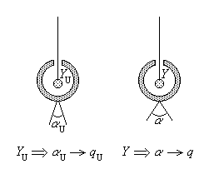
Fig. 2.10.

The electric charge q of a very small electrified object is now readily introduced as the electromagnetic quantity that characterises its electrification state, starting from the previous relation,
$\frac{q}{α}=\frac{q_{U}}{α_{U}} ⇒$$q=\frac{α}{α_{U}} q_{U}$ .
Taking into account the procedure used to define it, the electric charge of a very small object is a scalar primary electromagnetic quantity.
2.1.2. The electric field strength in free space
According with the assumed viewpoint, the electric force between electrified small objects at rest is mediated by an electric field. It is to be remarked that such an electric force is the supplementary force with respect to all known mechanical and thermal forces. The electric field in free space is explored by using an electrified probe of known electric charge, q , that will be also called a point charge in the following. By measuring the electric force ${\vec{F}}_{\text{el},f}$ (fig. 2.11) that is acting upon known point charges placed, at rest, in free space (i.e., vacuum), one concludes that: (1) At each given point, indicated by the position vector $\vec{r}$ , the direction $\vec{e}$ ($\left|\vec{e}\right|=1$) of the electric force acting upon a point charge is fixed and independent on the electric charge q of the probe; (2) At each given point, the projection on $\vec{e}$ of the electric force is proportional to the charge q it is acting upon, that is, ${\text{pr}}_{\vec{e}} {\vec{F}}_{\text{el},f}=E q$ , where the proportionality coefficient E is independent on the probe charge; (3) Both the direction of the electric force, $\vec{e}$ , and the above mentioned proportionality coefficient, E , depend on the point in space where the measurement is taken.
These characteristics can be assembled into a single expression,
${\vec{F}}_{\text{el} , f}\left(\vec{r},q\right)=\vec{e}\left(\vec{r}\right) \left[E\left(\vec{r}\right)q\right]=\left[\vec{e}\left(\vec{r}\right)E\left(\vec{r}\right)\right] q$ ,
where the quantity ${\vec{E}}_{f}\left(\vec{r}\right)=\vec{e}\left(\vec{r}\right)E\left(\vec{r}\right)$ , which is independent on the probe charge, is thus necessary and sufficient to characterise the action of the electric field in free space on a point charge at rest. It simply results the expression of Coulomb's force, i.e., the electric force acting in free space on a point charge at rest,

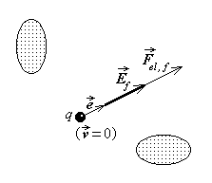
Fig. 2.11.
${\text{ \{}\vec{F}}_{\text{el} , f}=q {\vec{E}}_{f}\left(\vec{r}\right)$ .
The vector quantity entering this formula,
${\vec{E}}_{f}\left(\vec{r}\right)=\frac{{\vec{F}}_{\text{el} , f}\left(\vec{r},q\right)}{q}$ ,
is the primary electromagnetic quantity which characterises the state of the free space electric field, called the electric field strength in free space.
One may note that this formula agrees with the general remark made in the previous section

regarding the general expression of an electromagnetic interaction as a product of quantities characterising the electromagnetic field and the electromagnetic state of the object.
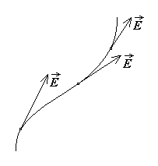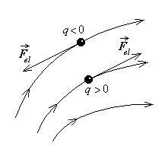
Fig. 2.12. Fig. 2.13.
A common concept related to a field (of vectors), which illustrates the distribution of such vectors attached to each point in space, is the field line: this is the line to which the local field is tangent at any point (fig. 2.12). Moreover, a field is said to be uniform or homogeneous in a region if the vector field is constant (in direction and magnitude) everywhere in that region. An arrow marked on the field line indicates the direction of the local field; however, no indication on its magnitude is given. The electric force acting on a point charge, ${\vec{F}}_{\text{el},f}=q {\vec{E}}_{f}$ , is oriented in the direction of the field (that is, of the field line) if the charge is positive (q > 0) and opposite to the direction of the field if the charge is negative (q < 0), as in fig. 2.13.
2.1.3. The magnetic flux density in free space
There exists another type of force, acting on moving electrified small objects only; such a force is called a magnetic force, and, according to the assumed point of view, it is mediated by a magnetic field. It is to be noted that such a magnetic force is the supplementary force with respect to any other mechanical, thermal and electric forces upon the object under consideration. A magnetic field can be detected near pieces of some natural substances, as magnetite, near moving electrized objects, or near conducting wires connecting oppositely charged conductors or plates of different metals submerged in some acid solution.
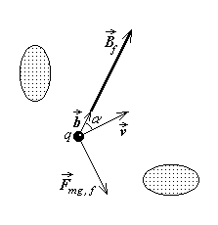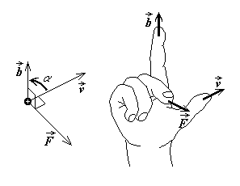
Fig. 2.14. Fig. 2.15.
The magnetic field in free space is explored by using an electrified probe (point charge) of known electric charge, q , moving at a known speed, $\vec{v}$ . By measuring the magnetic force in different experimental circumstances (fig. 2.14), one concludes that: (1) At each given point in space there exists a direction (characterised by the unit vector) $\vec{b}$ ($\left|\vec{b}\right|=1$) , independent on the charge and speed of the probe, such that, if $\vec{v} \left|\right| \vec{b}$ , then no magnetic force is present; (2) At each given point in space, the magnetic force ${\vec{F}}_{\text{mg} , f}$ acting in free space upon the moving point charge is normal to the vectors $\vec{v}$ and $\vec{b}$ (i.e., on their plane); (3) At each given point in space the magnitude of the magnetic force is proportional to the probe charge, the speed magnitude and the sine of the angle α between the vectors $\vec{v}$ and $\vec{b}$ , that is $F_{\text{mg} , f}=B q v \text{sin}α$ , where the proportionality coefficient B is independent on the charge q , the speed v and the sine of the angle α ; (4) Both the particular direction $\vec{b}$ and the proportionality coefficient B depend on the point in space where the measurement is taken; moreover, the direction of the vector $\vec{b}$ can be so taken that the direction of the magnetic force acting upon a moving positive point charge is obtained as the direction along which a right–handed screw advances when rotated from vector $\vec{v}$ to vector $\vec{b}$ by sweeping the lowest angle (the right-hand rule – as in fig. 2.15).
These experimental results can be assembled in a single expression ${\vec{F}}_{\text{mg} , f}=B q \left(\vec{v}×\vec{b}\right)=q \left[\vec{v}×\left(\vec{b} B\right)\right]$ ,
where the quantity ${\vec{B}}_{f}=\vec{b}B$ is independent on the electrification and mechanical state of the probe subjected to the action of this force and so is necessary and sufficient to characterise the magnetic field in free space. It simply results the concise expression of Lorentz's force, i.e., the magnetic force acting in free space on a moving point charge,
${\text{ \{}\vec{F}}_{\text{mg} , f}=q \left(\vec{v}×{\vec{B}}_{f}\right)$ .
This way the primary electromagnetic quantity that characterises the state of the free space magnetic field, called magnetic flux density in free space, is
${\vec{B}}_{f}=B\left(\vec{r}\right) \vec{b}\left(\vec{r}\right)=\frac{{\vec{F}}_{\text{mg} , f M}×{\vec{v}}_{M}}{{\text{qv}}_{M}^{2}}$ ,
where ${\vec{v}}_{M}$ is the probe speed in that direction which determines the maximum ratio of the magnetic force magnitude $F_{\text{mg},f M}$ to the speed magnitude $v_{M}$ at the given point.
2.1.4. The intensity of the electric conduction current
Experiments show that conductors may exhibit a new state, different from known mechanical, thermal and electrification states. Such a state, called electric conduction state, can be identified, for instance, in a conducting wire which connects two objects with opposite electric charges, or in a conducting wire that connects two plates – one of copper and one of zinc – immersed in a water solution of sulphuric acid (fig. 2.16). This new state is identified by noting that some supplementary effects occur in such situations: heat is generated inside the conductor (Joule’s electro–thermal effect), the conductor generates a magnetic field, and is acted upon by a supplementary force when placed in an external magnetic field (electromagnetic effects). Moreover, the solution in the example described above is also in this new state, and, supplementary to the above-mentioned effects, a mass transport takes place in it, resulting in some substances deposited on the metallic plates (electro–chemical effect).
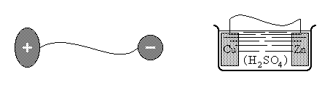
Fig. 2.16.
The electromagnetic force acting on a conductor in electric conduction state, when placed in an external magnetic field, which is supplementary with respect to known mechanic, thermal, or other electric and magnetic forces, is taken as the basis for characterising the conduction state. By measuring the elementary electromagnetic force acting, in a magnetic field of known magnetic flux density in free space ${\vec{B}}_{f}$ , upon an elementary segment of a filamentary conductor $d\vec{r}$ under different experimental conditions (fig. 2.17), one concludes that: (1) The elementary electromagnetic force $d{\vec{F}}_{\text{elmg} , f}$ is normal to the vectors $d\vec{r}$ and ${\vec{B}}_{f}$ (i.e., on their plane); (2) The magnitude of the elementary electromagnetic force is proportional to the magnitudes of the vectors $d\vec{r}$ and ${\vec{B}}_{f}$ and the sine of the angle α between these vectors, i.e., ${\text{dF}}_{\text{elmg} , f}=i \text{dl} B \text{sin}α$ , where the proportionality coefficient i is independent on dr , B , and α for an invariant conduction state.
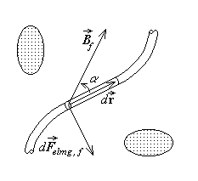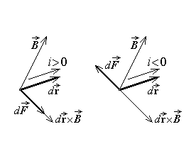
Fig. 2.17. Fig. 2.18.
These experimental results can be assembled in the concise expression of the electromagnetic force (Laplace's force) as
$d{\vec{F}}_{\text{elmg} , f}=i \left(d\vec{r}×{\vec{B}}_{f}\right)$ ,
where the proportionality coefficient i , independent on the magnetic field, the elementary segment and their relative orientation, may depend on the electric conduction state only. The primary electromagnetic quantity that characterises the electric conduction state of an elementary segment of a filamentary conductor, called the intensity of electric conduction current, is thus
$i=±\frac{\left| d{\vec{F}}_{\text{elmg} , f} \right|}{\left| d\vec{r}×{\vec{B}}_{f} \right|}$ .
The plus sign is to be taken when the right-hand rule applied to vectors $d\vec{r}$ and ${\vec{B}}_{f}$ (in this order) coincides with the direction of $d{\vec{F}}_{\text{elmg} , f}$ and the minus sign in the opposite case (fig. 2.18). The sign of the current intensity is thus directly related to the direction of the elementary vector $d\vec{r}$ , which is therefore termed the reference direction of the electric conduction current. This way, the electric current intensity is represented by a scalar algebraic quantity, with respect to a specified reference direction along the filamentary conductor, namely the direction of $d\vec{r}$ .
2.1.5. The electric moment
Insulators can exhibit a new state, different from known mechanical, thermal or electrification states, identified by the fact that such objects are acted upon by supplementary forces and torques when placed in an external electric field, even if they are not electrified and carry no electric conduction current (fig. 2.19). Such a state may be detected in certain substances, as for instance thin needles of barium titanate, and is called an (electric) polarisation state. The characterisation of this new state can be obtained by measuring the actions exerted in electric field in free space on a very small polarised object at rest: when the electric field is homogeneous, these actions reduce to an electric torque, supplementary with respect to known thermo–mechanical or other electric torques. By measuring this electric torque one concludes that: (1) There is a particular direction of unit vector $\vec{π}$ ($\left|\vec{π}\right|=1$) attached to the object, such that if $\vec{π} \left|\right| {\vec{E}}_{f}$ , then no electric torque is present; (2) The electric torque ${\vec{T}}_{\text{el} , f}$ is normal to the vectors $\vec{π}$ and ${\vec{E}}_{f}$ (i.e., on their plane) and its direction is obtained according to the right-hand rule applied to these vectors; (3) The magnitude of the electric torque is proportional to the magnitude of the electric field strength and the sine of the angle α between the vectors $\vec{π}$ and ${\vec{E}}_{f}$, i.e., $T_{\text{el} , f}=p E_{f}\text{sin}α$ , where the proportionality coefficient is independent on both E_{f} and α .

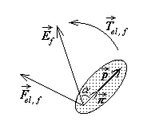
Fig. 2. 19.
These experimental results can be assembled in the formula
${\vec{T}}_{\text{el} , f}=p \left(\vec{π}×{\vec{E}}_{f}\right)=\left[\left(p\vec{π}\right)×{\vec{E}}_{f}\right]$ ,
where the quantity $\vec{p}=p\vec{π}$ is independent on the electric field and so is necessary and sufficient to characterise the (electric) polarisation state. The electric torque acting in free space on a very small polarised object is then concisely expressed as

${\text{ \{}\vec{T}}_{\text{el} , f}=\vec{p}×{\vec{E}}_{f}$ . .
This way, the primary electromagnetic quantity that characterises the state of the small (electric) polarised object, called electric moment, is
$\vec{p}=p\vec{π}=\frac{{\vec{E}}_{f}×{\vec{T}}_{\text{el} , f M}}{{\left|{\vec{E}}_{f}\right|}^{2}}$ ,
where ${\vec{T}}_{\text{el} , f M}$ is the maximum electric torque in the given homogeneous electric field ${\vec{E}}_{f}$ , when the latter is normal to the particular direction $\vec{π}$ in the polarised object. It is easy to see that the electric torque is so acting as to align the electric moment $\vec{p}$ with the external electric field strength ${\vec{E}}_{f}$ .
A very small polarised object is acted upon by a supplementary electric force as well in an inhomogeneous electric field in free space. Experimental investigations show that this force can be expressed as
${\text{ \{}\vec{F}}_{\text{el} , f}= \text{grad} \left(\vec{p}⋅\underset{↑}{{\vec{E}}_{f}}\right)=\vec{i}\frac{∂}{∂x}\left(\vec{p}⋅\underset{↑}{{\vec{E}}_{f}}\right)+\vec{j}\frac{∂}{∂y}\left(\vec{p}⋅\underset{↑}{{\vec{E}}_{f}}\right)+\vec{k}\frac{∂}{∂z}\left(\vec{p}⋅\underset{↑}{{\vec{E}}_{f}}\right)$ ,
where the arrow under the field quantity signifies that the differential operator is applied to the dependence of this quantity on coordinates, and $\vec{i} , \vec{j} , \vec{k}$ are the unit vectors of the x , y , and z axes, respectively. It can be shown that such an electric force is oriented in the direction where the electric field strength E_{f} is greater.
2.1.6. The magnetic moment
There are objects which can exhibit a new state, different from known mechanical, thermal, electrification or electric conduction states, identified by the fact that such objects are acted upon by supplementary forces and torques when placed in an external magnetic field, even if they are not electrified and carry no electric conduction current (fig. 2.20). Such a state may be detected in certain substances, as for instance thin needles of magnetite, and is called a magnetisation state. The characterisation of this new state can be obtained on the basis of measuring the actions exerted in magnetic field in free space on a very small magnetised object at rest: when the magnetic field is homogeneous, these actions reduce to an magnetic torque, supplementary with respect to known thermo–mechanical or other magnetic torques. By measuring this magnetic torque one concludes that: (1) There is a particular direction of unit vector $\vec{μ}$ ($\left|\vec{μ}\right|=1$) attached to the object, such that if $\vec{μ} \left|\right| {\vec{B}}_{f}$ , then no magnetic torque is present; (2) The magnetic torque ${\vec{T}}_{\text{mg} , f}$ is normal to the vectors $\vec{μ}$ and ${\vec{B}}_{f}$ (i.e., on their plane) and its direction is obtained according to the right-hand rule applied to these vectors; (3) The magnitude of the magnetic torque is proportional to the magnitude of the magnetic flux density and the sine of the angle α between the vectors $\vec{μ}$ and ${\vec{B}}_{f}$ , that is, $T_{\text{mg} , f}=m B_{f}\text{sin}α$ , where the proportionality coefficient is independent on both B_{f} and α .

These experimental results can be assembled in the formula
${\vec{T}}_{\text{mg} , f}=m \left(\vec{μ}×{\vec{B}}_{f}\right)=\left[\left(m\vec{μ}\right)×{\vec{B}}_{f}\right]$ ,
where the quantity $\vec{m}=m\vec{μ}$ is independent on the magnetic field and so is necessary and sufficient to characterise the magnetisation state. The concise expression of the magnetic torque results as
${\text{ \{}\vec{T}}_{\text{mg} , f}=\vec{m}×{\vec{B}}_{f}$ .
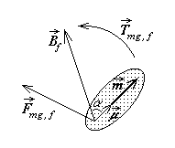
Fig. 2.20.

This way, the primary electromagnetic quantity that characterises the state of the small magnetised object, called magnetic moment, is
$\vec{m}=m\vec{μ}=\frac{{\vec{B}}_{f}×{\vec{T}}_{\text{mg} , f M}}{{\left|{\vec{B}}_{f}\right|}^{2}}$ ,
where ${\vec{T}}_{\text{mg} , f M}$ is the maximum magnetic torque in the given homogeneous magnetic field ${\vec{B}}_{f}$ , when the latter is normal to the particular direction $\vec{μ}$ in the magnetised object. It is easy to see that the magnetic torque is so acting as to align the magnetic moment $\vec{m}$ with the external magnetic flux density ${\vec{B}}_{f}$ .
A very small magnetised object is acted upon by a supplementary magnetic force as well in an inhomogeneous magnetic field in free space. Experimental investigations show that this force can be expressed as
${\text{ \{}\vec{F}}_{\text{mg} , f}= \text{grad} \left(\vec{m}⋅\underset{↑}{{\vec{B}}_{f}}\right)=\vec{i}\frac{∂}{∂x}\left(\vec{m}⋅\underset{↑}{{\vec{B}}_{f}}\right)+\vec{j}\frac{∂}{∂y}\left(\vec{m}⋅\underset{↑}{{\vec{B}}_{f}}\right)+\vec{k}\frac{∂}{∂z}\left(\vec{m}⋅\underset{↑}{{\vec{B}}_{f}}\right)$ ,
where the arrow under the field quantity signifies that the differential operator is applied to the dependence of this quantity on the coordinates, and $\vec{i} , \vec{j} , \vec{k}$ are the unit vectors of the x , y , and z axes, respectively. It can be shown that such a magnetic force is oriented in the direction where the magnetic flux density B_{f} is greater.
2.1.7. Additional experimental relations
It is useful to consider as well some other formulas of electric or magnetic forces, also derived on experimental basis, and confirmed by theoretical considerations, which allow the direct evaluation of some primary quantities.
The direct determination of electric charges of very small electrified objects (point charges) can be based on Coulomb's formula: two point charges are acting on one

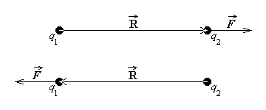
Fig. 2.21.
another in free space with a force
${\vec{F}}_{f}=\frac{q_{1}q_{2}\vec{R}}{4{\text{πε}}_{0}R^{3}}$ ,
where $\vec{R}$ is the position vector of the charge acted upon, with respect to the other charge (fig. 2.21), and

$ε_{0}≈8\text{.}\text{865}⋅{\text{10}}^{−\text{12}}F/m≈\frac{1}{4π⋅9⋅{\text{10}}^{9}}F/m$
is a universal constant called absolute permittivity of free space. This electric force is acting along the straight line defined by the point charges, and it is obvious that charges of the same sign repel each other, while charges of opposite sign attract each other. Experiments also show that a similar expression is valid in the case of a boundless homogeneous medium: the electric force in similar circumstances is reduced ε r times to
$\text{ \{}\vec{F}=\frac{q_{1}q_{2}\vec{R}}{4\text{πε} R^{3}}$ ,
where the absolute permittivity of the medium is given as
$ε≈ε_{0} ε_{r}$
in terms of its relative permittivity εr .
Now, if q₁ is a known charge, and the distance R and the permittivity ε are known, then the second charge q₂ can be determined if the Coulomb's force is measured,
$q_{2}=\frac{4\text{πε} R^{2}}{q_{1}} F$ ;
moreover, if somehow the two very small electrified objects have the same charge q , this can be directly determined, for known distance R and permittivity ε , by measuring Coulomb's force,
$q=\sqrt{ 4\text{πε} R^{2} F}$ .
The direct determination of electric currents carried by rectilinear filamentary conductors is based on Ampere's formula: two infinite parallel rectilinear filamentary conductors, placed a distance d apart, are acting on each other in free space with a so called electrodynamic force
$F_{f}=\frac{μ_{0} i_{1}i_{2} l}{2πd}$ ,
on every segment of length l of conductor (fig. 2.22). Here
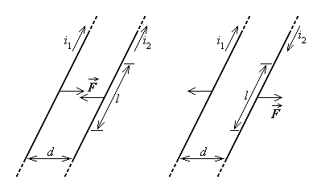
Fig. 2.22.
$μ_{0}=4π⋅{\text{10}}^{−7}H/m$
is a universal constant called absolute permeability of free space. This electrodynamic force is acting normal to the conductors, in the plane defined by the parallel conductors, and it determines attraction when the currents have the same direction and repulsion when the currents have opposite directions. Experiments also show that a similar expression is valid in the case of a boundless homogeneous medium: the magnetic force in similar circumstances is increased µr times to
$F=\frac{μ i_{1}i_{2} l}{2πd}$ ,
where the absolute permeability of the medium is given as
$μ=μ_{0}μ_{r }$
in terms of its relative permeability µr .
Now, if i₁ is a known current intensity, and the distance d and the permeability μ are known, then the second current intensity i₂ can be determined if the Ampère's force is measured,
$i_{2}=\frac{2π d}{μ i_{1} l} F$ ;
moreover, if somehow the two currents are made equal, i₁ = i₂ = i (for instance, by turning the current in one conductor into the second at a very large distance from the region of measurement), then this can be directly determined, for known distance d and permeability μ , by measuring Ampère's force,
$i=\sqrt{ \frac{2 π d}{μ l} F}$ .

2.2. Derived electromagnetic quantities
The primary electromagnetic quantities introduced above are: the free space electric field strength ${\vec{E}}_{f}$ and the free space magnetic flux density ${\vec{B}}_{f}$ , which characterise the state of the electromagnetic field in free space, and the electric charge q of a very small electrified object, the electric current intensity i along an elementary segment of a filamentary conductor in electric conduction state, the electric moment $\vec{p}$ of a very small (electric) polarised object and the magnetic moment $\vec{m}$ of a very small magnetised object, which characterise the electromagnetic states of small objects. All these quantities have been defined on the basis of mechanical actions, corresponding to electric, magnetic or electromagnetic forces or torques. However, these quantities are not appropriate to adequately describe common electromagnetic states of the substance and the states of the electromagnetic field. The definition of derived electromagnetic quantities, more adapted to characterise the electromagnetic states of the substance and the electromagnetic field in common circumstances, is therefore needed.
2.2.1. Characterisation of the electrification state
The primary quantity characterising the electrification state is defined for very small objects only. When operating with electrified objects of arbitrary extent, one has to use the previously defined primary quantity in view to characterise this state. Let the electrified object be separated into very small pieces of elementary volume ΔV ; let Δq be the elementary charge of such a small volume element, which can be measured (fig. 2.23.a). This charge obviously depends on the volume ΔV , so that a local characterisation of the electrification state of the object, independent on ΔV , can be obtained as the limit
$\underset{ΔV→0}{\text{lim}}\frac{Δq}{ΔV}=\frac{\text{dq}}{\text{dV}}=ρ_{V}$ ,
called volume density of electric charge.
If the electrified large object has one dimension negligible with respect to the other two, that is it can be taken as an electrically charged surface, a similar procedure can be used to characterise locally this state. Proceeding as above, one measures the elementary charge Δq of a very small elementary surface element ΔS (fig. 2.23.b) and defines
$\underset{ΔS→0}{\text{lim}}\frac{Δq}{ΔS}=\frac{\text{dq}}{\text{dS}}=ρ_{S}$ ,
called surface density of electric charge.
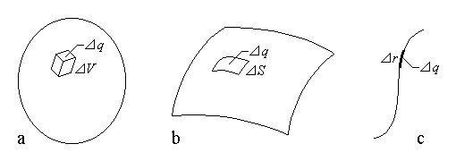
Fig. 2.23.
Now if the electrified large object has two dimensions negligible with respect to the third one, that is it can be taken as an electrically charged filament (curve), the same procedure can be used to characterise locally this state. Proceeding as above one measures the elementary charge Δq of a very small elementary line element Δr (fig. 2.23.c) and defines
$\underset{Δr→0}{\text{lim}}\frac{Δq}{Δr}=\frac{\text{dq}}{\text{dr}}=ρ_{L}$ ,
called line density of electric charge.
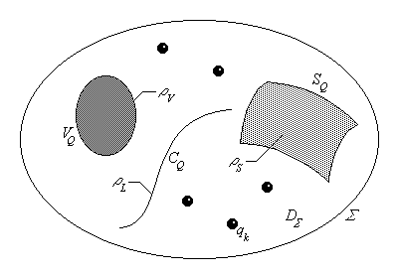
Fig. 2.24.
It is now possible to introduce the electric charge in a domain D_{Σ} as the derived quantity characterising its electrification state and defined as the sum of contributions from all types of charge distribution in the domain,
$q_{D_{Σ}}=\int{ρ_{V} \text{dV}}+\int{ρ_{S} \text{dS}}+\int{ρ_{L} \text{dr}}+\sum_{M_{i}∈D_{Σ}}{q_{i}}$ ,
where V_{Q} , S_{Q} , C_{Q} , {Mi} are the electrically charged volume(s), surface(s), line(s) and points in the domain under consideration (fig. 2.24).
2.2.2. Characterisation of the electric conduction state
The primary quantity characterising the electric conduction was defined for filamentary conductors only. When operating with current−carrying conductors of any extent, one has to use the previously defined primary quantity in view to characterise this state. Let such a filamentary current carrying conductor be considered, and let the distribution of the electric conduction state be considered uniform within it. Then, if $\vec{j}$ is the unit vector in the direction of the conductor, Δi is the elementary current carried by the filamentary conductor, and ΔS_{n} is the transverse cross section of it (fig. 2.25.a), then the density of the electric conduction current is defined as
$\vec{J}=\vec{j} J=\vec{j} \underset{{ΔS}_{n} → 0}{\text{lim}}\frac{Δi}{{ΔS}_{n}}=\vec{j} \frac{\text{di}}{{\text{dS}}_{n}}$ .
Conversely, if the current density is defined as above, then the elementary current di , carried by it across any transverse surface dS of normal unit vector $\vec{n}$ making the angle α with the direction $\vec{j}$ of the current density (fig. 2.25.b), is
$\text{di}=J {\text{dS}}_{n}=J \text{dS} \text{cos}α=\vec{J}⋅\vec{n} \text{dS}$ .
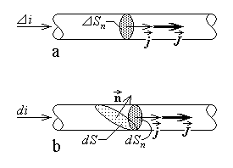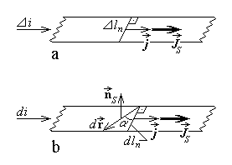
Fig. 2.25. Fig. 2.26.
Apart from solid conductors, the electric conduction current can be carried along extremely thin conducting sheets. Let a filamentary current carrying conducting sheet be considered, and let the distribution of the electric conduction state be considered uniform within it. Then, if $\vec{j}$ is the unit vector in the direction of this conductor, Δi is the elementary current carried by the filamentary conducting sheet, and Δl_{n} is the transverse width of it (fig. 2.26.a), then the surface density of the electric conduction current is defined as
${\vec{J}}_{S}=\vec{j} J_{S}=\vec{j} \underset{{Δl}_{n} → 0}{\text{lim}}\frac{Δi}{{Δl}_{n}}=\vec{j} \frac{\text{di}}{{\text{dl}}_{n}}$ .
Conversely, if the surface current density is defined as above, then the elementary current di , carried by it across any transverse elementary segment $d\vec{r}$ making the angle α with the transverse direction of dl_{n} (fig. 2.26.b), is
$\text{di}=J_{S} {\text{dl}}_{n}=J_{S} \text{dr} \text{cos}α=J_{S}\left|{\vec{n}}_{S}×d\vec{r}\right| \text{cos}α=\left({\vec{n}}_{S}×d\vec{r}\right)⋅{\vec{J}}_{S}=\left({\vec{J}}_{S}×{\vec{n}}_{S}\right)⋅d\vec{r}$ ,
where ${\vec{n}}_{S}$ is the unit vector normal to the conducting sheet. The reference direction of this elementary current is easily seen to be given by ${\vec{n}}_{S}×d\vec{r}$ .
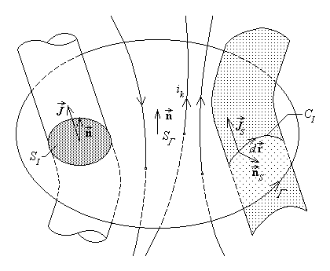
Fig. 2.27.
The electric conduction current crossing a given surface S is then characterised in terms of a derived quantity which involves contributions from all possible solid, surface, and filamentary current carrying conductors. It is thus possible to introduce the intensity of the electric conduction current across a surface Σ , with respect to the reference direction indicated by the normal unit vector $\vec{n}$ , as the derived quantity characterising the electric conduction state and defined as
$i_{S}=\int{\vec{J}⋅\vec{n} \text{dS}}+\int{\left({\vec{J}}_{S}{\vec{n}}_{S}\right)d\vec{r}}+\sum_{M_{k}∈S}{i_{k}}$ ,

where S_{I} , C_{I} , {Mk} are the intersections of surface S and current carrying solid, sheet and filamentary conductors, respectively (fig. 2.27), and ${\vec{n}}_{S}$ is the normal unit vector to the conducting sheet in the direction indicated by $d\vec{r}×\vec{n}$ .
Experiments show that some effects associated with the conduction current, especially the generation of a magnetic field, can also be determined by a macroscopic movement of the electric charge, named electric convection current. The local characterisation of such a macroscopic movement of the electric charge is given by
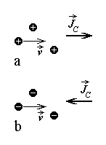
Fig. 2.28.

the density of the electric convection current, defined in terms of the local charge volume density and its velocity as
${\text{ \{}\vec{J}}_{C}=ρ_{V}\vec{v}$ ,
so that the direction of the electric convection current is that of the movement of positive charges (fig. 2.28.a) or opposite to the movement of negative charges (fig. 2.28.b). The intensity of the electric convection current crossing a surface S , with respect to the reference direction indicated by the normal unit vector $\vec{n}$ , is then defined in a similar manner as that of the electric conduction current,
$i_{C S}=\int{{\vec{J}}_{C}⋅\vec{n} \text{dS}}$ .
2.2.3. characterisation of the polarisation and magnetisation states
The electric polarisation state and the magnetisation state of objects have been characterised by a primary quantity only when referring to very small objects. When operating with objects of any extent, which exhibit one of these states, one have to rely on previously defined primary quantities in view to characterise these states.
Let the electrically polarised object be separated into very small pieces of elementary volume ΔV ; let $Δ\vec{p}$ be the electric moment of such small objects, which can be measured (fig. 2.29.a). This elementary electric moment obviously depends on the volume ΔV so that a local characterisation of the electric polarisation state of the object, independent on ΔV , can be obtained as the limit
$\underset{ΔV→0}{\text{lim}}\frac{Δ\vec{p}}{ΔV}=\frac{d\vec{p}}{\text{dV}}=\vec{P}$ ,
called (electric) polarisation.
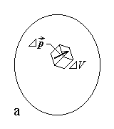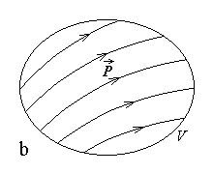
Fig. 2.29.
It is now possible to introduce the electric moment of a large object as the derived quantity characterising its electric polarisation state and defined as
$\text{ \{}\vec{p}=\int{\vec{P} \text{dV}}$ ,
where V is the electrically polarised part of the object (fig. 2.29.b).
The magnetised objects are to be approached in a perfectly analogous manner. Let the magnetised object be separated into very small pieces of elementary volume ΔV; the magnetic moment of such small objects can be measured, and let it be $Δ\vec{m}$ (fig. 2.30.a). This magnetic moment obviously depends on the volume ΔV so that a local characterisation of the magnetisation state of the object, independent on ΔV can be obtained as the limit
$\underset{ΔV→0}{\text{lim}}\frac{Δ\vec{m}}{ΔV}=\frac{d\vec{m}}{\text{dV}}=\vec{M}$ ,
called magnetisation.
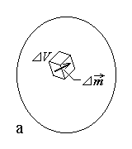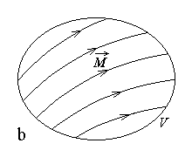
Fig. 2.30.
It is now possible to introduce the magnetic moment of a large object as the derived quantity characterising its magnetisation state and defined as
$\text{ \{}\vec{m}=\int{\vec{M} \text{dV}}$ ,
where V is the magnetised part of the object (fig. 2.30.b).
2.2.4. Characterisation of the electric field in substance
The electric field was studied above in free space only, and characterised by the electric field strength in free space. In view to characterise this field within the substance as well, without introducing additional primary quantities, reference is to be made to the previous situation.
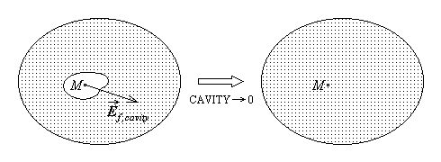
Fig. 2.31.
Let M be a point in some substance, where the electric field is to be characterised. A free space cavity is to be excavated around the point M , and the free space electric field has to be determined at this point, following the procedure used for the corresponding primary quantity. In view to achieve the characterisation of the field at the precise point in substance, the cavity extent is to be reduced to zero at the point M , and consider the limit of the successive determinations of the free space electric field strength in smaller and smaller cavities (fig. 2.31). It can be shown that this limit depends on the cavity shape and, more important still, the excavation of a free space cavity in substance does alter the electric field in the rest of the substance.
However, there exist a special shape of the cavity, namely a disk–shaped cavity, whose excavation does not alter the state of the electric field in the remaining part of the substance (fig. 2.32). When taking the limit, these cavities must retain their shape, that is the height Δh of this extremely flat cylindrical cavity has to be negligible with respect

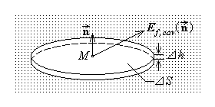
Fig. 2.32.
to the transverse dimensions of the bases of surface ΔS (formally, $Δh≪\sqrt{ΔS}$) . The limit obtained for the measured electric field strength in such disk–shaped cavities depends only on the orientation of the cavity, i.e., on the normal unit vector $\vec{n}$ to the bases, ${\vec{E}}_{f, \text{cav}}\left(\vec{n}\right)$ .

One can then say that the electric field at the given point M in substance is known if the electric field strength is known, in the limit, in the free space of a disk–shaped cavity of any orientation $\vec{n}$ . It can be shown that such knowledge is assured if the free space electric field strength is known in only two cavities of this kind, having specific orientations; that is why it is said that the electric field in substance is characterised by two quantities. A peculiar direction (of unit vector) $\vec{π}$ can be found at each given point M in substance so that, in the limit, the free space electric field is the same in any disk–shaped cavity with $\vec{n} ⊥ \vec{π}$ . One of the quantities defining the electric field in substance, called the electric field strength at the given point, is therefore introduced as the free space electric field strength in the disk−shaped cavity with $\vec{n} ⊥ \vec{π}$ (fig. 2.33. left),
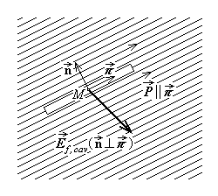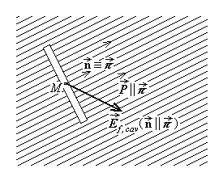
Fig. 2.33.
$\text{ \{}E={\vec{E}}_{f , \text{cav}}\left(\vec{n} ⊥ \vec{π}\right)$ .
The other quantity defining the electric field in substance, called the electric displacement at the given point, is then introduced in relation with the limit of the free space electric field strength in the disk–shaped cavity with $\vec{n} \left|\right| \vec{π}$ (fg. 2.33. right),
$\text{ \{}\vec{D}=ε_{0}{\vec{E}}_{f , \text{cav}}\left(\vec{n} \left|\right| \vec{π}\right)$ ,
where
$ε_{0}≈8\text{.}\text{865}⋅{\text{10}}^{−\text{12}}F/m≈\frac{1}{4π⋅9⋅{\text{10}}^{9}}F/m$
is the universal constant, called the absolute permittivity of free space or the free space electric constant. It is experimentally found out that the direction $\vec{π}$ is the direction of the local polarisation $\vec{P}$ at the given point, which shows that the polarised state of the substance is the reason of needing two quantities to characterise the electric field in substance.
2.2.5. Characterisation of the magnetic field in substance
The magnetic field was studied previously in free space only, and characterised by the magnetic flux density in free space. In view to characterise this field within substance as well, without introducing additional primary quantities, reference is to be made to the previous situation.
Let P be a point in some substance, where the magnetic field is to be characterised. A free space cavity needs to be excavated around the point P , and the free space magnetic flux density is to be determined at this point, following the procedure used for the corresponding primary quantity. In view to characterise the magnetic field at the precise point in substance, the cavity extent is to be reduced to zero at the point P , and consider the limit of the successive determinations of the free space magnetic flux density in smaller and smaller cavities (fig. 2.34). It can be shown that this limit depends on the cavity shape and, more important still, the excavation of a free space cavity in substance does alter the magnetic field in the rest of the substance.
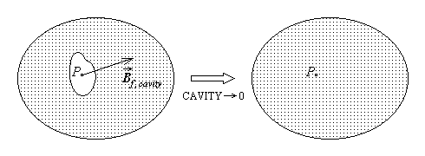
Fig. 2.34.
However, there exists a particular shape of the cavity, namely a disk–shaped cavity, whose excavation does not alter the state of the magnetic field in the remaining part of the substance (fig. 2.35). When taking the limit, these cavities must retain their shape, that is the height Δh of this extremely flat cylindrical cavity has to be negligible with

respect to the transverse dimensions of its bases of area ΔS (i.e., formally, $Δh≪\sqrt{ΔS}$) . The limit obtained for the measured magnetic flux density in such disk–shaped cavities depends only on the orientation of the cavity, i.e., on the normal unit vector $\vec{n}$ to the bases, ${\vec{B}}_{f, \text{cav}}\left(\vec{n}\right)$ .
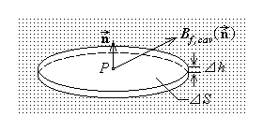
Fig. 2.35.

One can then say that the magnetic field at the given point P in substance is known if the magnetic field strength is known, in the limit, in the free space of a disk–shaped cavity of any orientation $\vec{n}$ . It can be shown that such knowledge is assured if the free space magnetic flux density is known in only two cavities of this kind, having specific orientations; that is why it is said that the magnetic field in substance is characterised by two quantities. A peculiar direction (of unit vector) $\vec{ν}$ can be found at each given point P in substance so that, in the limit, the free space magnetic field is the same in any disk–shaped cavity with $\vec{n} ⊥ \vec{ν}$ . One of the quantities defining the magnetic field in substance, called the magnetic field strength at the given point, is therefore introduced in relation with the magnetic flux density in the disk−shaped cavity with $\vec{n} ⊥ \vec{ν}$ (fig. 2.36. left) as
$\text{ \{}\vec{H}=\frac{1}{μ_{0}}{\vec{B}}_{f,\text{cav}}\left(\vec{n} ⊥ \vec{ν}\right)$ ,
where
$μ_{0}=4π⋅{\text{10}}^{−7}H/m$
is the universal constant, called the absolute permeability of free space or the free space magnetic constant. The other quantity defining the magnetic field in substance, called the magnetic flux density at the given point, is then introduced as the limit of the free space magnetic flux density in the disk–shaped cavity with $\vec{n} \left|\right| \vec{ν}$ (fig. 2.36. right) ,
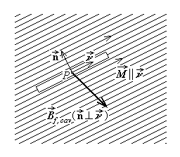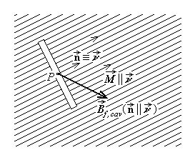
Fig. 2.36.
$\text{ \{}\vec{B}={\vec{B}}_{f , \text{cav}}\left(\vec{n} \left|\right| \vec{ν}\right)$ .
It is experimentally found out that the direction $\vec{ν}$ is the direction of the local magnetisation $\vec{M}$ at the given point, which shows that the magnetised state of the substance is the reason of needing two quantities to characterise the magnetic field in substance.
2.2.6. Additional quantities related to the electric conduction
The (electric) conduction state is interpreted, at the microscopic level, as represented by the relative movement of electrically charged microscopic particles with respect to the conductor, that is, with an electric convection current associated with the movement of some microscopic charges, relative to the conductor. There are circumstances where nonelectric actions are impressed upon such charged microscopic particles and electric conduction effects can be induced: Inertial forces in accelerated objects or diffusion–like forces in inhomogeneous substance are some typical examples. The macroscopic effect of such nonelectric actions can be described in terms of two derived quantities, related to previously introduced derived quantities.
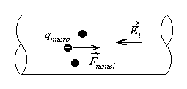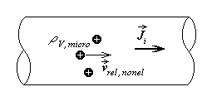
Fig. 2.37. Fig. 2.38.
The impressed electric field strength is introduced as
${\text{ \{}\vec{E}}_{i}=\frac{{\vec{F}}_{\text{nonel}}}{q_{\text{micro}}}$ ,
as the measure of an analogous electric influence equivalent to nonelectric forces, acting upon the microscopic free charge and determining its movement with respect to the conductor (fig. 2.37).
The impressed electric current density is introduced as
${\text{ \{}\vec{J}}_{i}=ρ_{V,\text{micro}}{\vec{v}}_{\text{rel},\text{nonel}}$ ,
implying an equivalence between the density of a nonelectrically induced electric conduction current and the density of an electric convection current associated with a microscopic charge density $ρ_{V , \text{micro}}$ moving at the speed ${\vec{v}}_{\text{rel} , \text{nonel}}$ with respect to the conductor (fig. 2.38).
2.2.7. Electromagnetic field characterisation with respect to a line
The electromagnetic field needs also some global characterisation with respect to some geometric elements. When referring to lines (curves), the voltage is the associated derived quantity to be defined.
The physical support for introducing the voltage is related to the evaluation of the mechanical work. It is reminded that the mechanical work done by a force $\vec{F}$ when its application point is displaced over a distance $d\vec{r}$ is the product of this distance by the projection F_{t} of the force along the direction of displacement (fig. 2.39.a). Denoting by α the angle between the vectors $\vec{F}$ and $d\vec{r}$ , this results finally in the scalar product of the two vectors implied,
$\text{dW}=F_{t} \text{dr}=F \text{cos}α \text{dr}=\vec{F}⋅d\vec{r}$ .
It is obvious that the mechanical work changes its sign if the direction of the elementary displacement vector is reversed, since then the angle α changes into π – α , and the cosine reverses its sign. The mechanical work is thus a scalar quantity, defined with respect to the reference direction indicated by $d\vec{r}$ . In the case of a line C of arbitrary extent, described by the displacement of the application point of the force between extremities A and B , the mechanical work is computed as the sum of such elementary contributions along elementary segments of the line (fig. 2.39.b),
$W_{\left(C\right) \text{AB}}=\underset{\text{dr} → 0 , n → ∞}{\text{lim}} \sum_{k=1}^{n}{{\vec{F}}_{k}⋅d{\vec{r}}_{k}}=\int{\vec{F}⋅d\vec{r}}$ ;
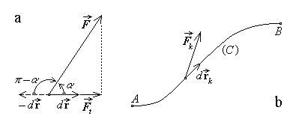
Fig. 2.39.
this results simply in the integral along the considered line of the elementary mechanical work previously defined.
The mechanical work done by the electromagnetic forces acting upon a point charge q , when moving it along the path C , between points A and B , can be now computed, as the work done by the electric and the magnetic forces,
$\vec{F}=q\vec{E}+q \left(\vec{v}×\vec{B}\right)$ .
Since $\vec{v}=d\vec{r}/\text{dt}$ is parallel to $d\vec{r}$ , it follows that
$W_{\left(C\right)\text{AB}}=\int{\vec{F}⋅d\vec{r}}=\int{\left[q\vec{E}+q \left(\vec{v}×\vec{B}\right)\right]⋅d\vec{r}}=$
$=q \int{\vec{E}⋅d\vec{r}}+q \int{\left(\frac{d\vec{r}}{\text{dt}}×\vec{B}\right)⋅d\vec{r}}=q \int{\vec{E}⋅d\vec{r}}$ .
The mechanical work done by the magnetic force is thus always zero, since the magnetic force is always normal to the charge movement, and the mechanical work done by the electromagnetic force, thus reduced to that done by electric forces only, is proportional to the charge acted upon and a quantity related to the line integral of the electric field strength.
The electric voltage along the line C , between points A and B (in this order), is then defined as (fig. 2.40.a)
$u_{\left(C\right)\text{AB}}=\frac{W_{\left(C\right)\text{AB}}}{q}=\int{\vec{E}⋅d\vec{r}}$ .
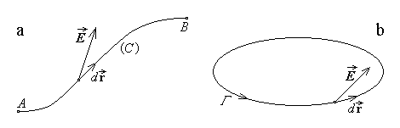
Fig. 2.40.
Analogously, the impressed electric voltage is defined within the same frame as
$e_{i \left(C\right)\text{AB}}=\int{{\vec{E}}_{i}⋅d\vec{r}}$ ;
this quantity is often also termed (somehow misleading) electromotive force. The proper electromotive force along the contour Γ is finally defined as the line integral along the closed line (fig. 2.40.b),
$e_{Γ}=\oint{\vec{E}⋅d\vec{r}}$ .
Similar derived quantities are defined for the magnetic field by analogy. The magnetic voltage along the line C between points A and B in this order) is defined as
$u_{m \left(C\right)\text{AB}}=\int{\vec{H}⋅d\vec{r}}$ .
The magnetomotive force along the closed line Γ is then defined as the line integral along the contour,
$u_{\text{mm} Γ}=\oint{\vec{H}⋅d\vec{r}}$ .
As with the mechanical work, all voltages are thus defined as scalar derived quantities, with respect to the chosen reference direction, represented by the direction from A to B (in the case of open lines) or, more generally, by the direction of the line element $d\vec{r}$ .
2.2.7. Electromagnetic field characterisation with respect to a surface
The electromagnetic field is globally characterised with respect to some surface by another type of derived quantities, namely fluxes.
Let an elementary surface of area dS_{n} be considered, placed in a uniform (constant) electric field of electric displacement $\vec{D}$ normal to the surface (fig. 2.41.a). A measure of how intense the field is over all the points of the considered elementary surface is the product dΨ = D dS_{n} . However, if the same elementary surface is placed in the same uniform field, but the electric displacement $\vec{D}$ has the opposite direction (fig. 2.41.b), then it is quite natural to consider that the measure of how intense the field is over all the considered surface has to be now the opposite product, dΨ = – D dS_{n} . It is therefore necessary to define a reference direction with a view to distinguish between the two situations. Let the normal unit vector $\vec{n}$ to the surface be considered in the direction of the field in the first configuration; then the elementary electric flux over (or across) the elementary surface normal to the field is simply expressed as $dΨ=\vec{D}⋅\vec{n} {\text{dS}}_{n}$ , with reference to the direction of the unit vector $\vec{n}$ .
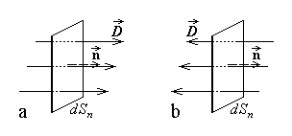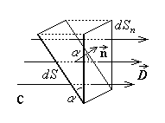
Fig. 2.41.
Let now an elementary surface of area dS be considered, placed in the same uniform electric field of electric displacement $\vec{D}$ , the normal unit vector $\vec{n}$ to the surface making the angle α with the electric displacement (fig. 2.41.c), and let dS_{n} be the projection of the considered elementary surface onto the plane normal to the field. It is obvious that the same field lines cross the surfaces dS and dS_{n} , so that the same elementary electric flux crosses these surfaces. Since the angle between the surfaces is the same as the angle between their normal

vectors, dS = dS_{n} cos α , and one can write
$dΨ=D {\text{dS}}_{n}=D \text{dS} \text{cos}α=\vec{D}⋅\vec{n} \text{dS}$
for the elementary electric flux over (across) the elementary surface dS .
In the case of a surface of arbitrary extent, the electric flux is computed as the sum of such elementary contributions over (across) elementary parts of the surface (fig. 2.42),
$Ψ_{S}=\underset{\text{dS} → 0 , n → ∞}{\text{lim}} \sum_{k=1}^{n}{{\vec{D}}_{k}⋅n_{k} {\text{dS}}_{k}}$ ⇒ $Ψ_{S}=\int{\vec{D}⋅\vec{n} \text{dS}}$ ;
this results simply in the integral over the surface of the elementary flux previously defined. The electric flux across a given surface S is thus defined as the surface integral over the surface of the normal component of the electric displacement.

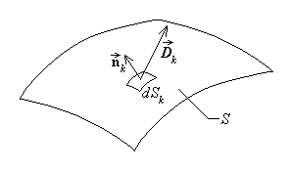
Fig. 2.42.
It is now obvious that the derivation of the electric current intensity across a surface in terms of its density,
$i_{S}=\int{\vec{J}⋅n \text{dS}}$ ,
is just the flux of the latter over the considered surface. Similarly, the generated current intensity across a transverse surface S in a conductor is defined as
$a_{S}=\int{{\vec{J}}_{i}⋅\vec{n} \text{dS}}$ .

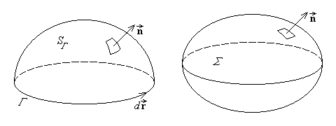
Fig. 2.43.
All fluxes (or, for that matter, current intensities) are derived scalar quantities, with respect to the chosen reference direction represented by the unit normal vector $\vec{n}$ to the surface S . When operating with an open surface SΓ , bordered by a contour Γ , the right–hand rule will be observed when associating the reference direction $d\vec{r}$ along the contour and the reference direction $\vec{n}$ on the surface: when a right–handed screw is rotated in the direction indicated by $d\vec{r}$ , its advance indicates the associated direction of $\vec{n}$ . When operating with a closed surface Σ , the outward normal unit vector $\vec{n}$ will always be considered. These situations are illustrated in fig. 2.43.

